|  |  |
| --- | --- |
| cetlogo ***CHEMICAL ENGINEERING TRANSACTIONS***  ***VOL. 95, 2022*** | A publication of  aidiclogo_grande |
| The Italian Association  of Chemical Engineering  Online at www.cetjournal.it |
| Guest Editors: Selena Sironi, Laura Capelli  Copyright © 2022, AIDIC Servizi S.r.l. **ISBN** 978-88-95608-94-5; **ISSN** 2283-9216 | |

Reliability of the results of an odour field inspection   
- grid method - based on the sample of 104 single measurements within one year

Janina Güntzela, Bettina Mannebecka, Dr. Heike Hauschildta

aOlfasense GmbH, Schauenburgerstr. 116, 24118 Kiel, Germany

The determination of odour in ambient air by using field inspection with the grid method is the method that has been used in Germany for decades to determine the frequency of exposure to odours in an impact area. The method which is currently described in EN 16841-1:2016 is a statistical survey which is applied over a sufficiently long period of time. It delivers a representative map of the exposure to recognizable odour(s) with its distribution over the assessed area.

Within this paper the principle of measurement will be briefly described, as well as the challenges that might occur during a project and the possibilities that arise from the detailed measurement of odour frequencies in the impact area.

Often the question arises whether the sample of 104 single measurements per assessment square and year is sufficient. In the vicinity of an industrial plant, we have been carrying out yearly field surveys since 2009. In contrast to the procedure according to EN 16841-1:2016-11, in this project the field surveys take place on a daily basis. The time of day is varied according to the standard.

Using this extensive data set as an example, the evaluation is now carried out on the full inspection scope (referred to as reference) as well as the data divided into 3 individual field surveys (sample 1 to 3). For each of these data sets the results including the measurement uncertainty according to EN 16841-1:2016 are evaluated for the single assessment squares. With a comparison of the reference (365 days/year) with each of the samples (104 days/year) the reliability of the samples can be determined. As the samples represent the required scope of measurement according to the European Standard EN 16841-1:2016 a validation of the usual extent could be performed. The results of this evaluation show that the sample of 104 measurement days per assessment square within one year is sufficient, taking into account the measurement uncertainty contributions, to make a statement on the compliance with the permissible odour exposure in the impact area.

1. Description of the field measurement - grid method - and the procedure according to EN 16841-1:2016

The method used in this manuscript is based on the European Standard EN 16841 Part 1: Grid measurement [1]. This method describes the determination of the spatial distribution of ambient odour exposure. The unit of the method is the frequency of odour hours which is used to assess the odour exposure on the defined grid squares. If the odour reaches or exceeds 10 % of the measurement duration, then an "odour hour" occurs. Each single measurement is a 10-minute interval consisting of 60 10-second intervals. At each 10-second interval the panel member assesses one breath of air and evaluates if there is no odour or odour and the kind of odour. 6 10-second intervals with odour or more than 6 intervals indicate one odour hour (10% or more of the assessments with odour). In General, as predetermined by the European Standard EN 16841- Part 1, the survey period is one year, consisting of 104 single measurements per assessment square [1] [2]. Often the question arises whether the sample of 104 single measurements per assessment square and year is sufficient to gain a complete insight of the odour impact.

In the vicinity of an industrial plant, we have been carrying out a field inspection since 2009. In this inspection project the single measurements take place on a daily basis. This represents a contrast to the procedure according to EN 16841-1:2016. The time of day is varied according to the standard. We use this daily field inspection by grid measurement for evaluation of the reliability according the number of carried out single measurements. In the following the survey containing all 365 days of inspection is stated as “reference field survey”.

The field survey used for the evaluation of the reliability stated in this paper has been carried out for many years at an industrial facility. The project is running since 2009 with yearly field surveys, each with a scope of 365 single measurements within one year. Three years (2018-2020) of the inspection were used to compare the reliability and measurement uncertainty of the “reference field survey” with a 104-day field inspection required by DIN EN 16841-1:2016. The inspection comprises 8 assessment squares (A-H) with a total of 15 measurement points. In the following, the daily field inspection is used as a reference in comparison to three samples with 104 single measurements each. For each year the three samples are compared with the reference as a basis [4].

Figure 1 shows the location of the assessment squares as well as the location of the measurement points in the assessment area (anonymised).

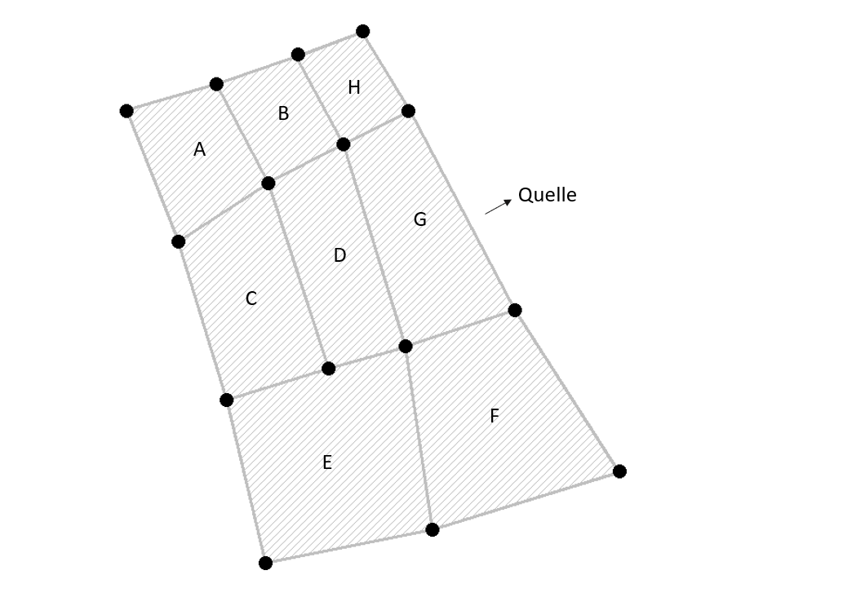

Emission Source

Figure 1: Location of the assessment squares and measurement points in the assessment area [simplified representation through anonymisation].

The statistical distribution of the individual years is shown in the following table. In agreement with the client, cancelled single measurements have not been caught up on a different day.

Table 1: Statistical distribution of the assessments during the assessment period (2018-2020).

|  |  |  |  |
| --- | --- | --- | --- |
| Year | Number of panel members | Number of assessments | Number of cancelled assessments |
| 2018 | 22 | 365 | - |
| 2019 | 19 | 362 | 3 |
| 2020 | 15 | 362 | 3 |

The results of the daily field surveys were divided into three equally distributed samples for the observation of the reliability of information. The statistical requirements for the distribution of weekdays and times of the day are met for the reference as well as for each of the three extracted samples.

2. Investigation of the results with regard to the reliability of three samples within one year in comparison to the reference

The evaluation of the results was carried out over a period of three years (2018-2020). The relative odour frequencies on the assessment squares were calculated out of the measurement results. The odour frequencies of each of the three samples per year were compared with the odour frequencies of the reference. Subsequently, the results including the measurement uncertainty of the survey were considered. The measurement uncertainty is evaluated by determining the upper limit – odour hours arising from single measurements with more than 2 positive observations - and the lower limit - odour hours arising from single measurements with more than 8 positive observations.

The evaluation of the results was carried out according to the specifications of the Guideline on Odour in Ambient Air (GOAA) which was valid at the time of evaluation. The frequency of odour hours on each assessment square is compared with the odour impact values that has to be applied there. For the project considered in this manuscript, the impact value refers to 10% of the annual hours, with odour hour frequencies of more than 10% representing an exceedance of the odour impact value [3].

The calculation of the uncertainty is carried out according to DIN EN 16841-1 [1] on the basis of the variation of percentage odour time. By definition, the odour hour criterion is fulfilled if the odour time reaches or exceeds 10 % (6 positive observations or more out of 60 with plant-related odour). The same calculation is made using different percentage odour times to determine the upper and lower limits for the number of odour hours. For the determination of the upper limit, all single measurements with more than two positive odour samples (counting threshold 3 corresponding to 5 % positive observations) are used, for the determination of the lower limit, all single measurements with more than eight positive observations (counting threshold 9 corresponding to 15 % positive observations) are used. The greater the difference between the measurement result and the odour hour criterion, the lower the probability of an error in the evaluation. Accordingly, the uncertainty range can be determined from the determination of these upper and lower limits. This means a larger survey scope results in a narrower uncertainty range [1].

Figure 2 shows the distribution of odour hour frequencies including the uncertainty range of the total odour exposure for the year 2018.

Figure 2: Results of the total odour exposure including the uncertainty range for the measurement period of 2018; the hatched grey bar represents the “reference survey”, the black bar sample 1, the light green bar sample 2 and the dark grey bar sample 3.

For the year 2018, it can be seen that the results of the three samples are within the result of the reference survey including the uncertainty range on six of the eight assessment squares. Only on the assessment squares B and H the results of sample 2 are higher the uncertainty range of the reference survey. With regard to the compliance with the odour impact value, taking into account the uncertainty range of the reference, there is no different statement for any of the assessment squares. If the uncertainty range of the reference and the samples were neglected, the statement regarding compliance with the odour impact value on assessment squares A and F would change from non-compliance to compliance for sample 2.

It is noticeable that the results of sample 2 are equal to or greater than the results of the reference survey on all assessment squares, while sample 3 shows lower odour hour frequencies than the reference survey on all assessment squares.

Likewise, the results for the year 2019 showed a similar distribution.

Figure 3 shows the distribution of odour frequencies including the measurement uncertainty for the total load for all variants for the year 2019.

Figure 3: Results of the total odour exposure including the uncertainty range for the measurement period of 2019; the hatched grey bar represents the “reference survey”, the black bar sample 1, the light green bar sample 2 and the dark grey bar sample 3.

For the year 2019, it can be seen that the results of the three samples are within the result of the reference survey including the uncertainty range on seven of the eight assessment squares. Only in assessment square E the results of sample 2 are below the uncertainty range of the reference survey. With regard to the compliance with the odour impact value, taking into account the reference’s uncertainty range, there is no changed statement for any of the assessment squares. Neglecting the uncertainty range of the reference survey and the samples, the statement regarding compliance with the odour impact value would change from compliance to non-compliance on assessment square A for sample 2 and on assessment square E for sample 3. On assessment square C for sample 3 and on assessment square F for sample 2, the statement would change from non-compliance to compliance.

Figure 4 shows the distribution of odour frequencies including the measurement uncertainty for the total exposure for all variants graphically presented for the year 2020.

Figure 4: Results of the total odour exposure including the uncertainty range for the measurement period of 2018; the hatched grey bar represents the “reference survey”, the black bar sample 1, the light green bar sample 2 and the dark grey bar sample 3.

For the year 2020, it can be seen that the results of the three samples are within the result of the reference survey including the uncertainty range on four of the eight assessment squares. On the assessment squares B, E, F and G, the results of some of the samples are below the uncertainty range of the reference survey. With regard to compliance with the odour impact value, taking into account the uncertainty range of the reference survey, a changed statement from non-compliance to compliance results only for two of the assessment squares, i.e. for B and G. If the uncertainty range of the respective deviating sample is taken into account for this consideration, the original statement of non-compliance would have to be made similar as for the reference survey. Neglecting the uncertainty range of the reference survey and the samples, the statement regarding compliance with the odour impact value would change from compliance to non-compliance on assessment square A for sample 1 and on assessment square C for sample 3. On assessment square B for sample 1 and on assessment square G for sample 3, the statement would change from non-compliance to compliance.

3 Discussion

The comparison of the results of the frequency of exposure to odours in the three-year period under consideration shows a slight deviation of the mean values of the exposure of the samples compared to those of the reference survey. In contrast, the upper and lower limits of the samples vary more strongly, as expected.

With regard to the reliability of the statement of a field measurement by grid method, it can be stated that on the assessment squares where the samples deviate from the reference, the statement regarding the odour impact value does not change when taking into account the uncertainty range. The results of the samples (evaluated as positive single measurement with 10% of observations with odour) which lead to a change in the statement of exceedance of the exposure limit show results within the fluctuation of the uncertainty range of the reference survey when considering the uncertainty range (5% or 15% of the observations with odour).

When considering the question of whether the exposure limit value is complied with or exceeded, there is also no change when the uncertainty ranges are taken into account. For example, in 2018 the exposure limit value of the reference survey is exceeded on all assessment squares, but is complied with for individual assessment squares (A and F) in the determined samples. Taking into account the uncertainty range on these squares, the exposure limit value is to be evaluated as exceeded. A marginal difference arises only in 2020 for assessment square E, where the statement of all results, reference survey and samples, coincides with "compliance with the exposure limit value" and only when applying the uncertainty range of sample 2 a non-compliance with the exposure limit value would be achieved. In this case, the individual inspections must be checked in detail.

Considering the measurement uncertainties, the fluctuation in all three years can therefore be considered insignificant with regard to the reliability of the statement.

4 Conclusion

The grid measurement method for assessing the frequency of odour exposure in the vicinity of an industrial plant is based on random measurements within a measurement period. According to DIN EN 16841-1:2016, the scope of this random sample is 104 individual measurements within one year. The question arises as to whether this sample is sufficient to make a reliable statement on the exposure limit in the assessment squares.

The results of the last three years of a daily field inspection survey as well as the results from the division of this daily survey into three equally distributed samples were evaluated. Afterwards it was examined to what extent the samples lie within the measurement uncertainty of the reference survey and whether there are any changes regarding the statement of compliance or non-compliance of the exposure limit value.

The evaluation of the results shows that the three samples are within the uncertainty range of the results of the reference survey, except for individual assessment squares. At the same time, it emerges that, taking into account the uncertainty contributions of the reference survey and the determined samples, there is no change in the statement of compliance or non-compliance with the exposure limit value according to GOAA (nowadays Technical Instruction on Air Quality Control (TA Luft)) for any of the assessment squares, not even for the exceptions considered.

Accordingly, it is to be noted that the random sample of 104 measurement days in one year is sufficient to make a statement on compliance with the exposure limit value, taking into account the measurement uncertainty contributions.

EN 16841 Part 1 (2016) -11: Ambient air – Determination of odour in ambient air by using field inspection – Part 1: Grid method; European Committee for Standardisation, November 2016.

Data from the grid measurement reports of an industrial plant (anonymised)

GOAA Detection and Assessment of Odour in Ambient Air (Guideline on Odour in Ambient Air – GOAA), 29 February 2008 with supplement of 10 September 2008. Withdrawn December 2021.

VDI 3940 Part 1 (2006) - 02: Measurement of odour impact by field inspection – Measurement of the impact frequency of recognizable odours Grid measurement; Corrigendum to guideline VDI 3940 Part 1:2006-02 Verein Deutscher Ingenieure, October 2006. Withdrawn in 2017.