CHEMICAL ENGINEERING TRANSACTIONS  VOL. 95, 2022 | A publication of
The Italian Association
of Chemical Engineering
Online at www.cetjournal.it

Guest Editors: Selena Sironi, Laura Capelli
Copyright © 2022, AIDIC Servizi S.r.l.
ISBN 978-88-95608-94-5; ISSN 2283-9216

Odour Impact Assessment from the wider Industrial Area to the City of Volos, Greece
Vasiliki G. Sideri*ª, Apostolos P. Siskosª, Apostolos A. Angelisª, Marios P. Tsakas^{b}
ªEnvirometrics LTD, Technical Consultants, 3 Kodrou str, 152 32 Chalandri, Greece
^{b}Laboratory of Environmental Chemistry, Department of chemistry, National and Kapodistrian University of Athens, 157 71 Zographos, Athens, Greece
vsideri@envirometrics.gr
Odours are currently the main cause of complaints from citizens to local authorities, among air pollutants. This is because some odours are detected at concentrations well below the target limit values in the atmosphere, due to the presence of odorous compounds that have an extremely low detection limit. The city of Volos in recent years has been facing a lot of complaints about episodes of air pollution and especially odours. Due to this issue, measurements carried out in the wider Industrial Area of Volos to determine the level of odour concentration. The research in this study was conducted in six industrial plants as potential sources of odour emission. The purpose of the research is to assess and evaluate the effects of their emissions in the city of Volos. This paper describes the methodology adopted for assessing the odour impact of the industrial area to the city of Volos (Greece).
The combination of olfactometry analysis and dispersion modelling allowed both the quantification of the odour emissions and the evaluation of their potential impact on the surrounding areas and especially on the city of Volos. This paper also presents a comparison between the model results for two different period scenarios.
  - Introduction
Odours are a major environmental issue intensified from industrial activity, wastewater treatment and solid waste landfills. The odour nuisance is due either to direct gas emissions or to by-products of biochemical reactions carried out under anaerobic conditions. The category of odorous compounds includes more than 500 chemical compounds, primarily organic and secondarily inorganic volatile compounds, which even at very low concentrations in the atmosphere can cause nuisance. Volatile organic compounds (VOCs) have long been associated with odour nuisance at urban sites close to emission sources.
The problem of odour nuisance to citizens in the wider area of Volos, Greece is particularly important and seriously concerns the local community and institutions. The Region of Thessaly, for the investigation of this problem and the protection of public health, assigned to ENVIROMETRICS LTD the present research which is a combination of olfactometry and VOC screening with οdour dispersion modelling.
  - Methods
The study was conducted in the wider Industrial Area of Volos and air samples were taken at six industrial plants: production of pelletised dry sea feed, production of steel, production of lime, production of cement, production of lubricants and plastics’ processing.
The following specialized approach and methodology was applied for the above assessment:
- Sampling from the stationary source emissions of the six plants and analyses: a) by olfactometry for the determination of the odour concentration, b) by GC-MS for the Identification of Volatile Organic Compounds and c) by GC-Sniffing for the determination of the intensity and character of the odour.
- Odour dispersion modelling.
To evaluate the contribution of each compound to the total odour of each sample, the odour Activity Value (OAV) of each was calculated. This value is calculated according to the eq. (1):
$$OAV=\frac{Cv}{OTV}$$ | (1)
where Cv is the concentration of each volatile compound and OTV is the odour threshold of each. Volatile compounds with OAV> 1 have a significant contribution to the overall odour of the sample.
This paper presents the Volatile Organic Compounds with OAV> 1 that seem to contribute most to the overall odour emitted by the 6 industrial processes: production of pelletized dry sea feed, production of steel, production of lime, production of cement, production of lubricants and plastics’ processing.
    - Odour and VOC measurements
Samplings were carried out by specialized scientific staff of the ENVIROMETRICS accredited laboratory to EN ISO / IEC 17025: 2017. Samplings were performed according to EN 13725:2003. Specifically, the dynamic pre-dilution technique was applied using a special dynamic pre-dilution probe and pure nitrogen. Pure nitrogen is used as a condensate catalyst as it is diluted with the exhaust gases just at the sampling point and before sample collection. The dynamic dilution probe is adjusted to achieve the correct nitrogen / exhaust dilution ratio, depending on the characteristics of each stack. Any condensate is expelled from a special outlet of the probe before entering the sampling line. Nalophan bags were used for the samplings. Sample bag was placed inside a rigid container evacuated using a vacuum pump. This method called the 'lung principle' was applied to avoid possible contamination by direct pumping.
Samples were kept at a temperature of less than 25 °C during transport and analyzed within 30 h after sampling.
The analysis of the samples for the determination of the odour concentration was performed by dynamic olfactometry according to EN 13725: 2003 at the specialized and accredited laboratory of OLFASENSE in the Netherlands. The measurements were performed with the TO-Evolution olfactometer (ID1357), according to the ‘forced choice’ method by six panel members.
In one of the samples taken at the point emissions of each installation, a specialized chemical analysis (Full VOC Screening) with gas chromatography in combination with mass spectrometry (GC-MS) was performed by the specialized laboratory of OLFASCAN in Belgium for the identification and quantification of the volatile organic compounds. In addition, a specialized GC-SNIFFING analysis was performed to determine the intensity and character of the perceived odour.
    - Odour dispersion model
Calpuff v.6.42 model system was used for the simulation of the odours emission dispersion in the city of Volos, Greece.
The calculations were performed with the highest possible spatial and temporal analysis and were based on meteorological, topographic and land use data obtained from reliable databases of national and international organizations (NOAA, CS3, EMY).
For odour emissions were used: (a) the results of odour concentration measurements carried out at the test facilities according to EN 13725: 2003 (Air quality. Determination of odour concentration by dynamic olfactometry) from the laboratory of ENVIROMETRICS and (b) the data on the flow and temperature of the flue gases and the geometrical characteristics of the chimneys of the installations as provided by the installations themselves.
Given the lack of regulatory atmospheric quality limits for odour concentrations, the results of the dispersion model were compared with the British Environment Agency guidelines (98th percentile of hourly peak concentrations C> 1.5 ouE lower case / m³) and the limit values of the German TA Luft Standard (Odour periods: 6-minutes where odours are detectable (C> 1 ouE / m³).
Specifically, an analysis of the time series odour concentrations was performed both in the wider area and in the city of Volos for the below two different period scenarios:
Scenario1: Period 01.01.2017-31.12.2019, the most recent three years during the initial phase of the study with the available meteorological data for the region of Volos. Hourly meteorological data (ground and upper atmosphere) were used from the numerical forecast model WRF, from the measurements of the EMY station in N. Anchialos and from ERA5 Reanalysis climate analyzes of the European service Copernicus.
Scenario 2: Period 01.08.2020-31.12.2020 where frequent odour episodes were recorded, using the meteorological data of the DESE station in Neapoli Volos and the EMY station in Nea Anchialos, Volos.
  - Results
    - Odour and VOC measurements
Samplings took place on 27-28.01.2021, 01-04.02.2021 and 08.02.2021.
Table 1 presents the aggregate results of the average odour concentration at the point sources (stacks) of each installation, as well as the total concentration of VOCs detected.
Table 1: Results of odour and VOC concentration for each installation
Plant activity | Average Odour Concentration (ouE/m³) | Total VOC Concentration  (μg/m³)
Production of lime | 2,419.00 | 19,696.00
Production of pelletised dry sea feed | 181,932.00 | 3,857.00
Production of cement | 1,223.00 | 613.00
Production of steel | 1,116.00 | 12,173.00
Production of lubricants | 5,133.00 | 7,307.00
Plastics’ processing | 83.00 | 255.00

The odour concentrations varied greatly between plants, which is mainly due to their production process.
The highest odour concentration was detected at pelletised dry sea feed plant (181932 ouE/m³) while the highest VOC concentration was detected in the lime production plant (19696 μg/m³). On the other hand, the lowest both odour (83 ouE/m³) and VOC (255 μg/m³) concentration was detected at the plastics’ processing plant.
To evaluate the contribution of each compound to the total odour of each sample, the odour Activity Value (OAV) of each was calculated. This value is calculated according to eq. (1). Volatile compounds with OAV> 1 have a significant contribution to the overall odour of the sample.
The odour threshold values (OTV) used in the calculation of the odour activity value (OAV) of each compound come from valid bibliographic sources that have been selected in consultation with the Laboratory of Environmental Pollution Control of the Department of Chemistry of Aristotle University of Thessaloniki.
Table 2 presents the results of the VOCs detected by GC-MS of each installation, with OAV>1.
Table 2: Results of VOC by GC-MS with OAV>1 for each installation
VOCs by GC-MS  with OAV>1 | Production of lime | Production of pelletised dry sea feed | Production of cement | Production of steel | Production of lubricants | Plastics’ processing
1-methylethylbenzene | 6.1 | - | - | - | - | -
Decanal | 5.7 | - | 1.6 | 5.8 | - | 1.1
Benzaldehyde | 4.8 | - | - | 2.5 | - | -
Phenol | 2.6 | - | - | - | - | -
2,3-butanedione | - | 244 | - | - | 302 | -
Propanal | - | 7.7 | - | 15 | 3.1 | -
2-methylpropanal | - | 76 | - | - | 15 | -
3-methylbutanal | - | 366 | - | - | - | -
Hexanal | - | 107 | - | - | - | -
Heptanal | - | 14 | - | 22 | - | -
Octanal | - | 4.9 | - | - | - | -
Nonanal | - | 2.4 | - | 4.1 | - | -
1-octen-3-ol | - | 1.5 | - | - | - | -
Eucalyptol | - | 1.1 | - | - | - | -
Butanoic acid | - | 51 | - | - | - | -
Acetic acid | - | 11 | - | - | - | -
2-propenal | - | - | 1.1 | 22 | 11 | -
Styrene | - | - | - | 6.1 | - | -
Indene | - | - | - | 4.5 | - | -
1-octene | - | - | - | 6.4 | - | -
2-methyl-2-propenal | - | - | - | 3.1 | 6.5 | -
Pentanal | - | - | - | 7.7 | - | -
Thiophene | - | - | - | 9.8 | 6.4 | -
S C8 alkene | - | - | - | - | 16 | -

Based on the results of the GC-Sniffing analysis of the six samples, compounds with OAV> 1 were detected in the samples obtained from the pelletised dry sea feed plant and the steel production plant. These results are presented on Table 3.
Table 3: Results of VOC by GC-Sniffing with OAV>1 for each installation
VOCs by GC-Sniffing  with OAV>1 | Production of lime | Production of pelletised dry sea feed | Production of cement | Production of steel | Production of lubricants | Plastics’ processing
Decanal | - | - | - | 1.7 | - | -
Benzaldehyde | - | - | - | 1.1 | - | -
3-methylbutanal | - | 132 | - | - | - | -
Hexanal | - | 49 | - | - | - | -
Heptanal | - | 5.2 | - | - | - | -
Butanoic acid | - | 15 | - | - | - | -
3-methylbutanoic acid |  | 8.6
Styrene | - | - | - | 4.1 | - | -
C8 alkene | - | - | - | 1.3 | - | -
1-nonanol |  |  |  | 2.5

Compering GC-MS and GC-Sniffing analysis, the volatile compounds with OAV> 1 that seem to contribute most to the overall odour emitted by the six plants compared to the others VOC identified are the aldehydes: 3-methylbutanal and decanal.
    - Odour dispersion model
Scenario1: According to the British and German guidelines and the model calculations for the 3-year period, the operation of the examined plants (as a whole and in combination) affects the industrial area and the neighboring villages of Sesklo, as there are exceedances of the proposed limit values (annual limit values of 1.5 ouE / m³ and odour hours / year). Exceedances of the proposed limit values are likely to occur in the villages of Ag. Georgiou and Dimini and in the city of Volos in case of existence and combined effect of other sources of odour emission besides the examined.
Scenario 2: For a more accurate record of the odour emissions effects of the examined plants during the period of odour episodes, calculations were performed with the CALPUFF dispersion model especially for the period August-December 2020 using the meteorological data of the DESE station of the Region in combination with the measurements of the station of N. Anchialos and forecast data.
Due to the lower wind speed, the contribution of the examined plants to the odour concentrations of the area is estimated to be higher during this period compared to the period of scenario 1.
Exceedances of the proposed limit value based on the British Guidelines are observed in most of the study area, including the city of Volos, while based on the German guidelines are observed in the villages of Sesklo, Dimini, Ag. George Ferron and Stefanovikeio. Within the city of Volos, odour hours according to the German guidelines (hours with 6-minute odour concentrations> 1.0 ouE / m³) are recorded at 2% -10% of the time.
The results of the odour dispersion models are represented in maps reporting the isopleths relevant to a) the 98th percentile of the hourly peak concentrations (Figure 1) and b) the 6-minute periods with odour concentration> 1.0 ouE / m³ (Figure 2) for both studied period scenarios.

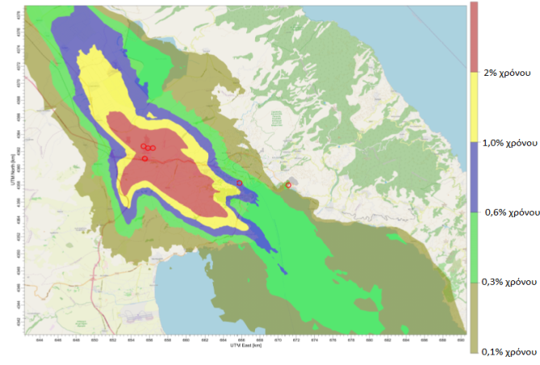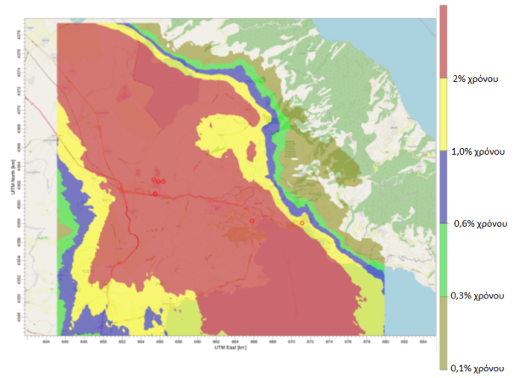
Figure 1: Maps of the 98th percentile of the hourly peak odour concentration values (British guidelines) obtained in scenario 1 (left) and scenario 2 (right)
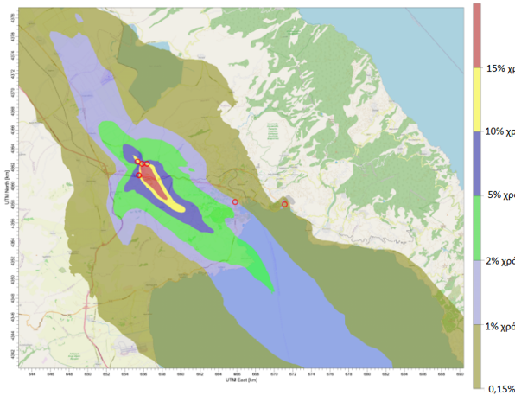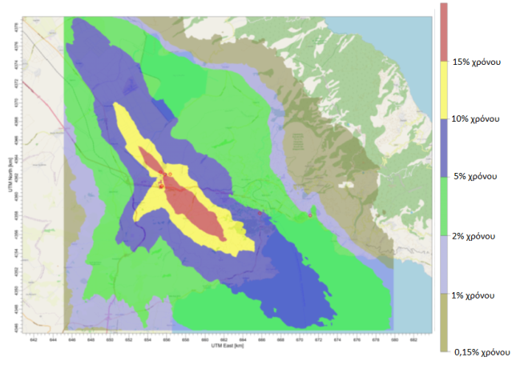
Figure 2: Maps of the 6-minute periods with odour concentration> 1.0 ouE / m³ (German guidelines) obtained in scenario 1 (left) and scenario 2 (right)
The odour emissions from the examined plants as a whole and in combination explain to a very large percentage the disturbances in the industrial area and the neighboring villages (Sesklo, Dimini, Agios Georgios), both based on the results in the basic scenario 1 (period 01.01.2017-31.12.2019) three years, as well as for the period 01.08.2020-31.12.2020 ,5 months of scenario 2.
Odour episodes in the city of Volos are recorded by the competent authority at night and early morning hours that prevail conditions which favor the transfer of odours from the industrial area (westerly winds with low speeds and high humidity).
The frequency of occurrence of high odour concentrations during the scenario 2 period 01.08.2020-31.12.2020 is higher compared to scenario 1 period, which is due to the lower speeds of the meteorological data of the DESE station for the specific period.
Specifically for the city of Volos, where the odour episodes have been recorded, in the period August-December 2020 the percentage of time with odour concentrations higher than the proposed strong odour limit of 10 ouE / m³ in at least one recipient is 5.9% and refers to the most unfavorable for dispersal meteorological conditions.
  - Conclusions
Odour concentrations vary widely from very low to very high concentrations (associated with odour episodes) depending on the prevailing meteorological conditions. Therefore, odour emissions can cause odour problems in the city of Volos under dispersal meteorological conditions (low wind speeds, westerly directions, atmospheric stability, and high humidity), especially if other possible sources of odours are considered.
As there is no detailed spatial and temporal recording of odour episodes in the area so that it is possible to correlate the episodes with the prevailing meteorological conditions and estimate the contribution of the examined facilities, it is proposed the development and operation by the Region of such a system in combination with an automatic meteorological station for the parallel recording of the prevailing meteorological conditions. The above data together with odour and volatile measurements in the villages and in the city of Volos and the combined utilization of the findings of the present study with other studies and measurements in the area may give a more complete picture of the emissions and dispersion of odours in the study area.

References
EN 13725: 2003 Air quality. Determination of odour concentration by dynamic olfactometry.
The Distributed Network for Odour Sensing, Empowerment and Sustainability (D-NOSES) project received funding from the European’s Union Horizon 2020 Science with & for Society Call (SwafS) under grant agreement No. 789315,20
Abdul-Wahab S., Sappurd A., Al-Damkhi A., 2011, “Application of California Puff (CALPUFF) model: a case study for Oman”, Clean Technol Envir, 13, 177-189.
Barclay J. and Scire J., 2011, “Generic Guidance and Optimum Model Settings for the CALPUFF Modeling System for Inclusion into the ‘Approved Methods for the Modeling and Assessments of Air Pollutants in NSW, Australia’”, Prepared For: NSW Office of Environment and Heritage, Sydney Australia.
Busini V., Capelli L., Sironi S., Nano G., Rossi A., Bonati S., 2012, “Comparison of CALPUFF and AERMOD Models for Odour Dispersion Simulation”, Chemical Engineering Transactions, 30, 205-210.
Capelli L., Sironi S., Del Rosso R., Céntola P., Rossi A., Austeri C., 2011, “Olfactometric approach for the evaluation of citizens’ exposure to industrial emissions in the city of Terni, Italy”, Sci Total Environ, 409, 595-603.
Defra ,2010, “Odour Guidance for Local Authorities”, London, March 2010.
Hersbach, H., Bell, B., Berrisford, P., Biavati, G., Horányi, A., Muñoz Sabater, J., Nicolas, J., Peubey, C., Radu, R., Rozum, I., Schepers, D., Simmons, A., Soci, C., Dee, D., Thépaut, J-N. (2018), “ERA5 hourly data on single levels from 1979 to present”, Copernicus Climate Change Service (C3S) Climate Data Store (CDS). (Accessed on < 28-12-2020 >), 10.24381/cds. adbb2d47.
Perry, S. G., 1992, “CTDMPLUS: A dispersion model for sources in complex topography. Part I: Technical formulations”, J.Appl.Meteor., 31, 633-645.
Scire, J.S.; Insley, E.M.; Yamartino, R.J.; Fernan, M.E. 2000a. A User’s Guide for the CALMET Meteorological Model. (Version 5). Earth Tech Inc., Concord, Massachusetts.
Scire, J. S., Robe, F. R., Fernau, M. E., Yamartino, R. J., 2000b. A User’s Guide for the CALPUFF Dispersion Model (Version 5). Earth Tech Inc., Concord, Massachusetts.
Tikvart, Joseph A., June 28, 1989, “Clarification of Stack-Structure Relationships”, Memorandum to Regional Modeling Contacts, Regions I-X.
UK Environment Agency, “Review of Dispersion Modelling for Odour Predictions”. Science Report: SC030170/SR3, Bristol, 2007.
UK Environment Agency,20 “Additional guidance for H4 Odour Management. How to comply with your environmental permit”, Bristol, 2011.
U.S. Environmental Protection Agency, 2017, “Revision to the Guideline on Air Quality Models: Adoption of a Preferred General Purpose (Flat and Complex Terrain) Dispersion Model and Other Revisions”, 40 CFR Part 51 Appendix W, Federal Register,82(10). Vol. 82, No 10, January 17.
J.E. Amoore and E. Hautala. 1983 Odour as an aid to chemical safety: Odour thresholds compared with threshold limit values and volatilities for 214 industrial chemicals in air and water dilution. Journal of Applied Toxicology, 3(6):272-290, 1983.

