CHEMICAL ENGINEERING TRANSACTIONS  VOL. 95, 2022 | A publication of
The Italian Association
of Chemical Engineering
Online at www.cetjournal.it

Guest Editors: Selena Sironi, Laura Capelli
Copyright © 2022, AIDIC Servizi S.r.l.
ISBN 978-88-95608-94-5; ISSN 2283-9216

Odour Nuisance: A New Methodology to Evaluate and Anticipate the Risk
Billy Pottierª, Veronica Artigueª, Jérôme Tixierª, Sylvain Olivier^{b}, Mathilde Chaignaud^{c}, Jean-Louis Fanlo^{c}
ªLaboratory for the Science of Risks (LSR), IMT Mines Ales, Ales, France.
^{b}CHROME, Université de Nîmes, Rue du Docteur Georges Salan, Nîmes, France.
^{c}Olentica, 14 boulevard Charles Péguy, Ales, France
billy.pottier@mines-ales.fr
Odour annoyance is the second most common source of complaints after noise in France. This leads to a direct impact on the quality of life of residents and an indirect impact on economic activities. This is why regulations require each emitting activity to take into account the annoyances it could generate (Grenelle II of the environment). It is clear that the forecasting of these impacts represents a strategic issue.
In this context, this article presents a new methodology to evaluate and predict the risk of odour nuisance on a territory but also the potential economic or social damage associated. The objective is to provide a planning tool to decision-makers, based on maps of the odour impact and the associated risk of nuisance of an existing or future site.
This work follows those conducted on the same theme by Popa (2013). The approach is based on the concept of risk to assess both the potential annoyance of a site and the vulnerability of populations or activities. The annoyance potential is calculated on the basis of the intensity and acceptability of the odour, two messages returned by our olfactory sense. These two parameters are intrinsically linked to the odour concentration. They are therefore calculated in each cell of the studied territory (200x200m) according to the odour concentrations obtained using a Gaussian dispersion software. The risk of odour nuisance is evaluated by combining the potential of annoyance thus calculated and the human vulnerability to odour, defined by the number of inhabitants in the cell. The risk of economic damage is obtained in a similar way, by combining the annoyance potential with the vulnerability of the activities present in each cell. The levels of annoyance potential and associated risks are defined using criticality matrices (Merad, 2004). The results have to be compared with the reports of a panel of residents around the site studied to assess the quality of the model.
  - Introduction
Since the middle of the 18th century, tolerance to odour problems has decreased significantly. The industrialization of societies has multiplied environmental degradation and increased the apprehension of a health risk (Pierrette, 2009). A certain awareness of environmental issues is developing worldwide, making populations increasingly attentive to the quality of their environment, associating sometimes odours to dangerous atmospheric pollutants (Conti et al., 2020). Even if there is no notion of toxicity behind these unpleasant odours, they have an impact on the image of the emitting activity, on the quality of life of the residents and, to a larger extent, on the functioning of the territory. Odour generated by wastewater treatment plants, composting plants, intensive livestock farming, chemical industry, etc. can lead the local residents to nuisance and complaint action.
In this context, several methods have been developed to evaluate odour nuisance. Most of them are a posteriori assessment methods, used to characterize an established situation. The following article focuses on the presentation of a new model able to anticipate odour nuisance. This model is tested around an industrial plant and provides results that must be validated on the field.
  - Method development
    - The odour nuisance considered as a risk
The basic concept in risk assessment is that the overall risk depends on the events probability (hazard) as well as the probable consequences (stakes) if this event occurs (Tixier et al., 2006)(Eq(1)).
$$\begin{aligned}Risk = Hazard Stakes\#\left(1\right)\end{aligned}$$
To quantify this risk, this equation is transposed as follows (Eq(2)).
$$\begin{aligned}Risk = Hazard potential Stakes vulnerability\#\left(2\right)\end{aligned}$$
This equation translates the hazard and the stakes into a typology which can be quantified and qualified. The risk is translated into an index that can be mapped (Tena-Chollet et al., 2013).
Applied to the odour domain, the risk of odour nuisance becomes the combination of the odour annoyance potential, considered as the probability of exposure with a given intensity (impact), and the stakes as the effect on receptors (local population, economic and social activities) (Eq(3)).
$$\begin{aligned}Risk of odour nuisance= Odour annoyance potential Human/Economic/Social stakes vulnerability\#\left(3\right)\end{aligned}$$

Anticipation of odour nuisance caused by an industry requires an odour process description, from emission to its effect on local residents. The model is part of the Source-Pathway-Receptor (S-P-R) concept that is now part of the guidelines for environmental risk assessment and management (Bull, 2018). The S-P-R concept describes the potential relationship between the characteristics of the odour source (S), the pathway (P) which represents exposure on the territory and the receptors (R) that could be impacted. This approach considers both the annoyance and the impacted populations/activities. It characterizes both the source (S) and the receptors (R) of the S-P-R concept. To model the impact of the odour on the territory (P), a Gaussian atmospheric dispersion software (Aria Impact) simulates the transport of odorant molecules in the atmosphere and thus the odour concentration on the ground in a defined spatial and temporal domain (Pottier et al., 2020).
    - Definition of annoyance potential
Annoyance potential is defined as the capacity of an odour to constitute an annoyance. It describes the impact of the odour according to its intensity, acceptability and frequency in time and space.
Its evaluation is based on two of the main information returned by our olfactory sense: the acceptability and the intensity of the odour, which are closely related to the odour concentration. The equation used to calculate a value of intensity and acceptability in each cell is inspired by Weber Fechner's law (Eq(4)). In psychophysics, this law describes the relationship between a mental sensation and the physical magnitude of a stimulus.
$$\begin{aligned}I=k*\log\left(S\right)\#\left(4\right)\end{aligned}$$
Where I is the intensity of the sensation, S the magnitude of the stimulus, k a constant.
Applied to odours, the slope coefficient of the line (k) is determined by olfactometry for each gaseous effluent according to the responses of a sniffing team. This method developed by Olentica measures the intensity and acceptability on an open scale (Chaignaud et al., 2014). The stimulus magnitude (S) corresponds to the concentration in odour units. This equation is used to calculate an intensity value in each cell (Eq(5)).
$$\begin{aligned}I=k*log({C_{od})}+0.5\#\left(5\right)\end{aligned}$$
Where I is the odour intensity value in the cell, k is the constant measured by Olentica, $C_{od}$is the concentration of odour units in the cell and 0.5 is an interception constant (0.5 by definition, since 50% of the population can perceive the odour when the odour concentration is equal to 1 OU_{E}/m³).
The equation used to calculate odour acceptability (Acc) differs slightly from the intensity equation. The interception constant in this case is equal to 0 (at 1 OU_{E}/m³ the odour quality is not perceptible, so the odour acceptability is equal to 0 (neutral odour)).The slope coefficient (k’) is determined in a similar way, based on the answers of a jury. This equation is used to calculate an acceptability value in each cell (Eq(6)).$\begin{aligned}Acc=k'*log⁡({C_{od})}\#\left(6\right)\end{aligned}$
Using the intensity and acceptability values of the odour calculated in each cell, the annoyance potential is evaluated according to this equation, which gives equal importance to both parameters (Eq(7)).
$$\begin{aligned}{Pot}_{annoyance}=I* Acc\#\left(7\right)\end{aligned}$$
The discretization of the variables is based on the range of the two parameters (0 to 20) and on the jury's verbalization scale (very weak/ slightly unpleasant odour, weak/ unpleasant odour, etc.). A level of annoyance potential (1 to 10) is calculated for each cell in our study area (200 × 200 m) (Figure 1).

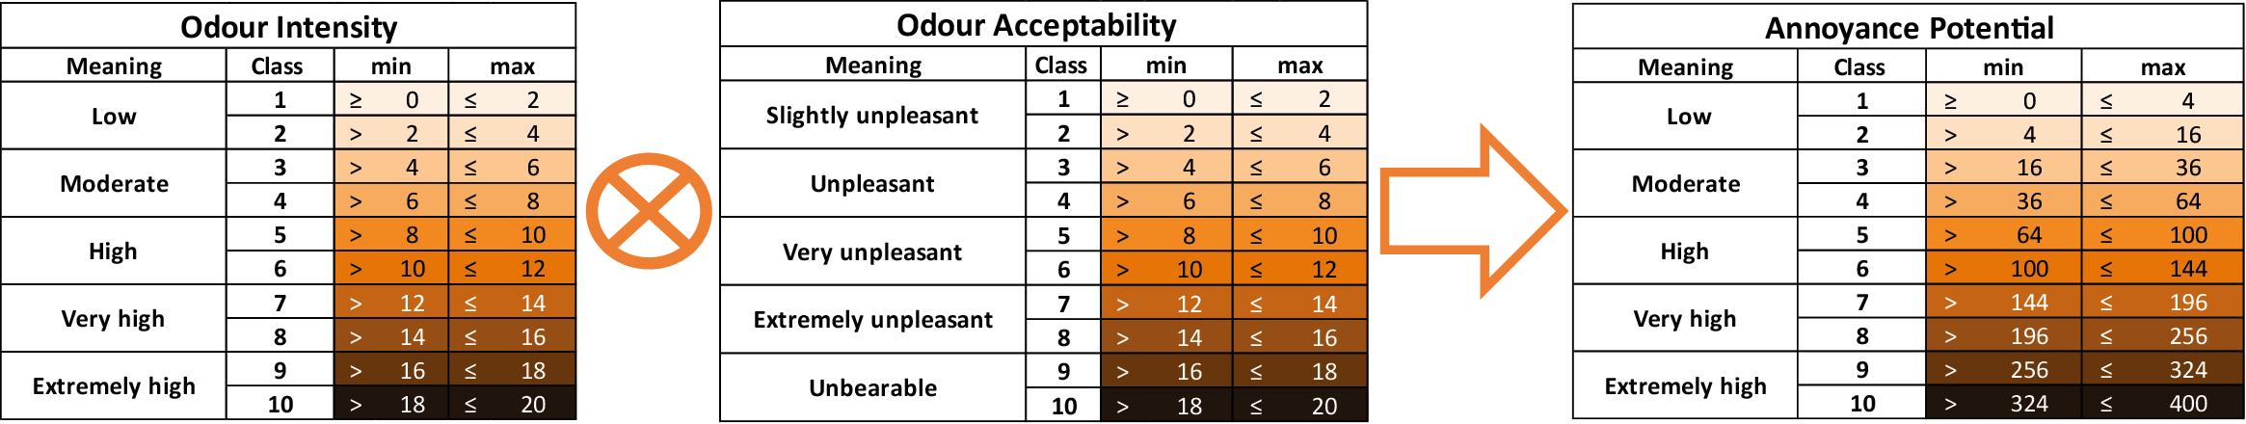
Figure 1: Discretization of odour intensity/acceptability and construction of annoyance potential
    - Defining vulnerability
Vulnerability is considered as "the propensity of a human, material, environmental or economic stake to be damaged". (Renard and Chapon, 2010). In the context of a territory subject to an odour annoyance, only human, economic and social stakes are considered. The objective of this method is to enlighten the decision makers on the odour impact of an existing or future industry under the prism of three types of stakes. Instead of providing a global index of the risk of odour nuisance, several thematic maps are proposed to the actors involved: risk of odour nuisance at home, risk of economic prejudice and risk of social prejudice.
Defining vulnerability at home
Applied to odours, human vulnerability can be defined as the sensitivity of an individual to an odorous compound. This sensitivity depends on a set of complex processes (neurosensorial, cognitive, mnesic, social, cultural, etc.)(Popa, 2013).
The vulnerability of human stakes is reduced to a geo-referenced census of the population on the territory. It corresponds to the vulnerability of people when they are at home. A densely populated cell increases the probability that populations complain against the industrialist and the public authorities.
The population living in the territory is estimated from the LCSQA data (Laboratoire de Contrôle et de Surveillance de la Qualité de l'Air). This annualized data is based on a precise method using the MAJIC files (cadastral information) to estimate the population at the building scale. (Létinois, 2014). This population at home is then aggregated into the 200m INSEE squares, which constitute our analysis grid.
The different levels of vulnerability at home were obtained by dividing the statistical distribution into equal amplitudes. The discretization method is applied from the maximum value observed (2000 inhabitants in a 200×200 m square in a dense urban environment). These matrices, inspired by the assessment of major risks are used to transform a quantitative result into a qualitative result (Figure 2).

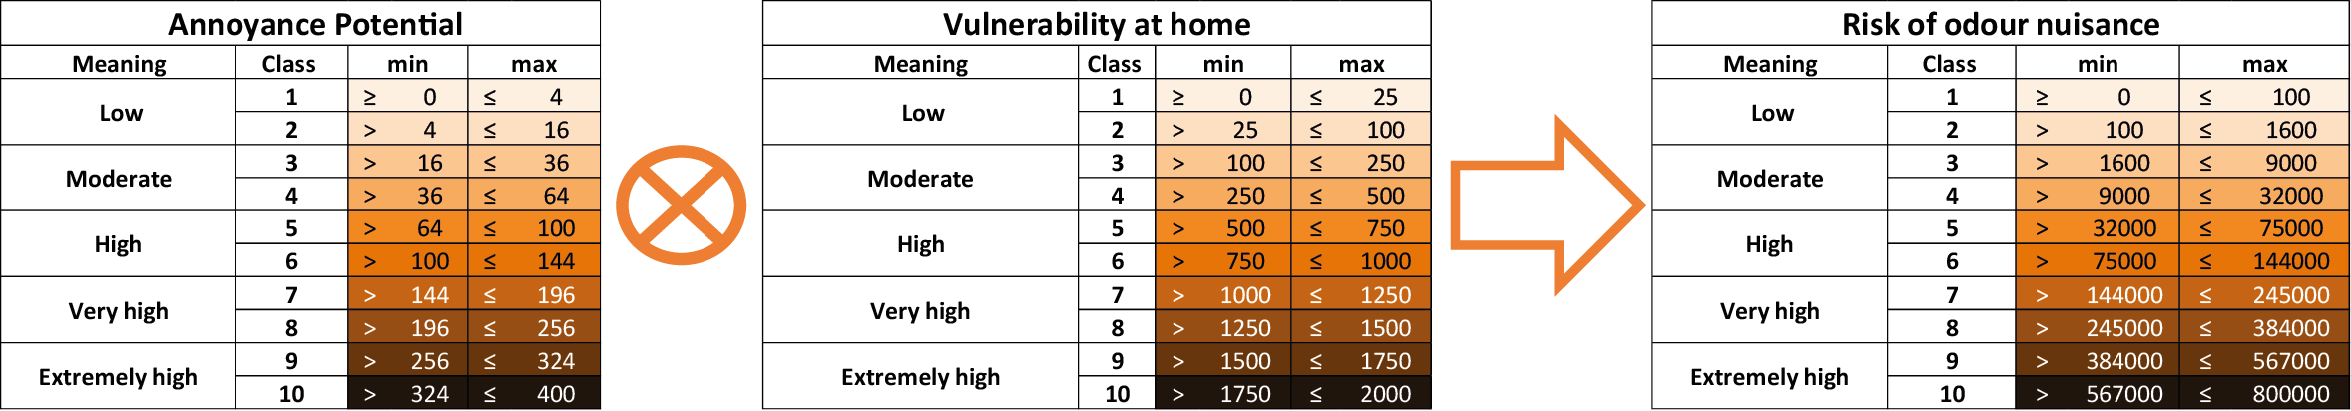
Figure 2: Discretization of vulnerability at home and construction of odour nuisance index
Defining economic vulnerability
Economic vulnerability represents the fragility of economic activities which suffer from an odour annoyance (attendance decrease, change in behaviour, etc.).
For each activity (economic and social) of the Open Street Map nomenclature (224 activities), a sensitivity value is assigned, indicating the level of tolerance of a bad smell in that location. These values were collected through a questionnaire open to all (365 responses have been collected), providing information on the capacity to bear a nasty odour in various situations which allow us to define a sensibility value and rank all the activities according to their sensibility to odour annoyance. (Eq(8)).
$$\begin{aligned}Sensibility=(NbRep1*a1+NbRep2*a2+NbRep3*a3+NbRep4*a4)/(NbRepTot-Nbna)\#\left(8\right)\end{aligned}$$
Where a1, a2, etc. is a weighting factor according to a geometric progression (1, 10, 100, 1000), Nb_Rep1,Nb_Rep2, etc. is the number of responses collected according to each category (a little, moderately, very, extremely bothered) and Nbna the number of people who answered don't know.
In general, it appears that unpleasant odours are not accepted very much, respondents are very sensitive to the presence of an odour, and more particularly at home. In detail, the answers are more nuanced and reveal situations where the presence of an odour is unanimously judged as intolerable (i.e. a negative odour perceived in a restaurant), and others more easily tolerated (i.e. an errand at the tobacconist's). For example, a tennis club or a bakery may have a similar sensibility to the annoyance, but the economic impact on the business will be different.
This sensibility variable is associated with an economic variable: the value-added rate of the activity. It is assumed that a high value-added rate indicates an activity more vulnerable to a decline in attendance. A high value-added rate means that the production cycle creates wealth to cover the other expenses of the business related to its economic model: salaries and expenses. According to the large and simplified nomenclature of the INSEE, a multiplicative factor (1 to 3) is attributed to each activity according to the value-added rate of the sector of activity (Table 1).
Table 1: Allocation of a multiplicative factor according to the nature of the activity and its value-added rate
Value added rate | Less than 25% | 25-40% | 40% and more
Economic factor | 1 | 2 | 3
Examples of OSM objects | Superstore/supermarket/ car dealer/furniture store | Bookstore/butcher shop/clothing store, game store, etc./auto repair | Restaurant/bar/hotel/golf/ amusement park

The economic vulnerability is evaluated for each activity according to this equation (Eq(9)).
$$\begin{aligned}V_{eco}=Sensibility variable*Economic factor\#\left(9\right)\end{aligned}$$
At the cell scale, the economic vulnerability is obtained by adding up all the activities which are present.
Defining social vulnerability
Social vulnerability represents the impact of the odour annoyance on the functioning of public infrastructure and on those who attend it (school, hospital, public space, etc.).
In the same way as economic vulnerability, a multiplicative factor is associated with the sensibility variable of the public infrastructure, in this case related to the average daily attendance. The vulnerability of a public facility is thus considered to depend on its sensitivity to an odour annoyance (impact on the quality of service and/or its functioning) but also on the number of people affected. Each type of public facility is assigned to one of three main attendance classes (Table 2).
Table 2: Allocation of a multiplicative factor according to the public facility and its average daily attendance
Attendance | Less than 100 | Between 100 and 500 | 500 and more
Attendance factor | 1 | 2 | 3
Examples of OSM objects | City Hall/Court/Police | Social center/sports center/jail/ school/college | University/hospital/clinic

Social vulnerability is assessed for each public infrastructure according to this equation (Eq(9)).
$$\begin{aligned}V_{soc}=Sensibility variable*Attendance factor\#\left(9\right)\end{aligned}$$
At the cell scale, the social vulnerability is obtained by adding up all the infrastructure which are present.
  - Results
    - Result of the nuisance index at home
The model is being tested in the surrounding of an industrial site, in France. Originally located outside of the city, the site is currently in the heart of a very dense urban area (10,000 inhabitants/km²). The area is therefore particularly vulnerable to the presence of an odour annoyance (Figure 3(a)).
Figure 3(d) illustrates the levels of annoyance potential evaluated over a period of one year. This time scale gives a global representation of the odour impact on the territory and will be completed later by the modelling of particularly penalizing episodes (calm wind, summer, technical problems, etc.). In each cell, the level of annoyance potential is associated with the number of inhabitants to provide the cartography of the risk of odour nuisance at home (Figure 3(e)). The highest levels of nuisance are mainly located around the site, but also in particularly populated city centers and collective housing areas.
    - Result of the economic damage index
The risk of economic damage is assessed in each cell by combining the annoyance potential (Figure 3(d)) and the economic vulnerability of activities face to an odour annoyance (Figure 3(b)). The aim of this analysis is not to measure or quantify the economic damage but to highlight the cells that are particularly vulnerable. A cell with a high level of risk of economic damage indicates the presence of activities which are particularly vulnerable to the presence of an odour annoyance (hotels, restaurants, etc.), a very high level indicates a clustering of these activities, while a low risk indicates economically less vulnerable activities (Figure 3(f)).
    - Result of the social prejudice index
The risk of social damage is similarly assessed by combining the annoyance potential (Figure 3(d)) with the vulnerability of public infrastructure face to an odour annoyance (Figure 3(c)). The cartography of the risk of social damage (Figure 3(g)) reveals the most critical infrastructures that are impacted by an odour annoyance. These include schools and health care facilities where the presence of an odour annoyance is considered unacceptable. In contrast, a low value indicates the presence of public administration (town hall, police station, etc.) where the presence of odour is comparatively more acceptable.

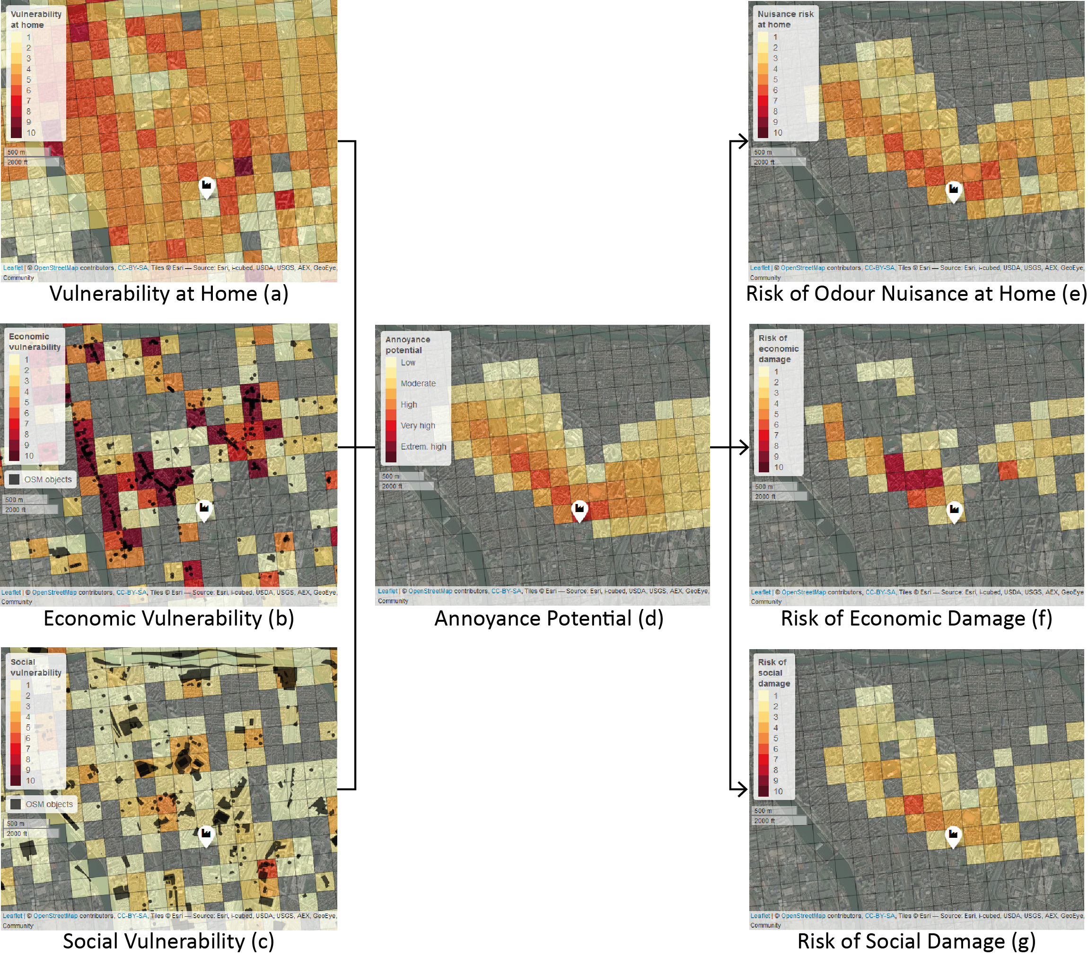
Figure 3: Aggregation of annoyance potential with vulnerability and cartography of odour nuisance levels

These maps should be used to support decision-making. They will provide information to local stakeholders and industrialists to anticipate the impact of the settlement of a new odorous industry.
  - Conclusion
The model integrates the different stages of the process leading to odour nuisance, in accordance with the S-P-R concept. This concept, based on the risk analysis method, provides a spatial and temporal representation of the odour nuisance on a territory.
The initial work initiated by Popa led to a reproducible method requiring less data (64 to 4 variables to describe vulnerability). In an attempt to simplify, sensitive variables such as income or property title are no longer taken into account in the vulnerability assessment. This simplification places everyone on an equal footing when faced with an odour annoyance and simplifies the adaptation of the model to other parts of the world.
Only two sets of geographical data are required (OSM, LCSQA). These data are accessible and regularly updated. The OSM data have the advantage of being available on a global scale, whereas the LCSQA data is limited to the French territory. For a global application, population grids exist, but the analysis scale is sometimes a limit (1 km grid) or the data is not free of rights.
An innovation was introduced in the assessment of the annoyance potential, product of the acceptability and intensity of the odour. These two parameters are measured on an open scale for each type of gaseous effluent (Olentica methodology) and then evaluated according to the concentration of odour units in any point of the territory.
To provide a decision support tool for the stakeholders involved, this model must be validated in Maisons-Alfort by confronting the results with the responses of a panel of local residents around the site. It can then be tested in other areas with different populations, types of odours, topography, etc.
There is a paradigm shift from a posteriori measurement of odour nuisance to a preventive approach used as a decision-making tool. This predictive model is intended for stakeholders and industrialists to proactively manage odour problems. This does not mean that other methods should be abandoned. The British Institute for Air Quality (IAQM) therefore recommends using empirical observation tools, where available and applicable, and combining them with a model. Using these different assessment tools in combination can minimise individual limitations and improve the reliability of conclusions.
References
Bull, M., 2018. IAQM Guidance on the assessment of odour for planning – version 1.1, Institute of Air Quality Management. London.
Chaignaud, M., Cariou, S., Poette, J., Fages, M., Despres, J.-F., Fanlo, J.-L., 2014. A New method to Evaluate Odour Annoyance Potential, in: Chemical Engineering Transactions. pp. 13 – 18. https://doi.org/10.3303/CET1440003
Conti, C., Guarino, M., Bacenetti, J., 2020. Measurements techniques and models to assess odor annoyance: A review. Environ. Int. 134. https://doi.org/10.1016/J.ENVINT.2019.105261
Létinois, L., 2014. Méthodologie de répartition spatiale de la population (Methodology for spatial distribution of the population).
Pierrette, M., 2009. L’environnement olfactif : de la perception à la gêne. Le cas d’un site industriel (The olfactory environment: from perception to annoyance. The case of an industrial site). Www.theses.fr 1.
Popa, V., 2013. Méthode prédictive d’évaluation de la gêne olfactive sur un territoire soumis à une activité industrielle. Approche du potentiel de nuisance et analyse de la vulnérabilité du territoire (Predictive method for the assessment of odor annoyance on a territory submitted to an industrial activity. Olfactory nuisance potential and territory vulnerability approach). www.theses.fr.
Pottier, B., Popa-Artigue, V., Tixier, J., Olivier, S., Fanlo, J.L., 2020. Odour nuisance: Decision support tools to anticipate and represent levels of odour nuisance on a territory. 30th Eur. Saf. Reliab. Conf. ESREL 2020 15th Probabilistic Saf. Assess. Manag. Conf. PSAM 2020 2404–2410.
Renard, F., Chapon, P.M., 2010. An urban vulnerability assessment method applied to the conurbation of Lyon. Espac. Geogr. 39, 35–50. https://doi.org/10.3917/eg.391.0035
Tena-Chollet, F., Tixier, J., Dusserre, G., Mangin, J.F., 2013. Development of a spatial risk assessment tool for the transportation of hydrocarbons: Methodology and implementation in a geographical information system. Environ. Model. Softw. https://doi.org/10.1016/j.envsoft.2013.02.010
Tixier, J., Dandrieux, A., Dusserre, G., Bubbico, R., Mazzarotta, B., Silvetti, B., Hubert, E., Rodrigues, N., Salvi, O., 2006. Environmental vulnerability assessment in the vicinity of an industrial site in the frame of ARAMIS European project. J. Hazard. Mater. 130, 251–264. https://doi.org/10.1016/j.jhazmat.2005.07.020

