CHEMICAL ENGINEERING TRANSACTIONS  VOL. 82, 2020 | A publication of
The Italian Association
of Chemical Engineering
Online at www.cetjournal.it
Guest Editors: Selena Sironi, Laura Capelli
Copyright © 2020, AIDIC Servizi S.r.l.
ISBN 978-88-95608-80-8; ISSN 2283-9216

Advanced data mining for odour emissions monitoring: experimental peak-to-mean calculations and spectral analysis of data derived from IOMS in two waste treatment plants
Federico Cangialosi
T&A - Tecnologia e Ambiente Srl, S.P. 237 per Noci, 8 – 70017 Putignano (BA), Italy
federico.cangialosi@icloud.com

A landfill for non-hazardous waste and a composting plant were equipped with an integrated odour management system made up of instrumental Odour monitoring systems and automated air samplers. Collected data by the instrumental system cover a time span of 8 months and 9 months for the two plants, respectively, and have been used for investigating spatial distribution and statistical properties of peak-to-mean ratios; moreover, a new method of data analysis, not yet employed in the field of odour dispersion modelling, has been proposed. A peak-to-mean value is defined as the ratio between an hourly mediation time and the average duration of a single human breath (few seconds). Data derived from 0.033 Hz sampling frequency by IOMS were used to calculate peak-to-mean for the monitoring period for both plants; the size of samples analysed allowed the implementation of a statistical calculation methodology for peak-to-mean estimation, based on the construction of empirical probability density functions (PDF). Moreover, data collected from instruments installed in different areas of the plants, were used to evaluate how PDF of peak-to-mean values varies with the distance from the odour emission sources. The same data were also used to develop a new method of analysis based on time series processing through the use of the Fourier Transform. Spectral analysis, sometimes used for meteorological variables, more recently has been applied in the study of air pollution data, although this type of analysis makes a decisive contribution to the understanding of cyclical behaviour in the observed data and provides information on temporal and spatial scales of such mechanisms. The aim is therefore to define a viable methodology to time series of odour concentration data collected at the fence of a plant, to be used to gather information on periodic odour variations. Interesting results, which related some periodic behaviours in odour emissions to working periods and composting phases, were observed, demonstrating the usefulness of such methodology to assess whether odour fluctuations are caused by atmospheric conditions variability or plant management operations.
  - Introduction
Using predictive modelling of odour dispersion for Environmental Impact assessment of plants to build, is common in several countries, thus verifying if a plant could impact a human receptor by evaluating the 98th percentile of odour concentration, calculated over 1 or more years by using available meteorological data. With regard to existing plant, odours can be perceived for a few seconds, thus generating complaints for peak events with short duration, although, on average, emissions could not exceed any regulatory-set limit. Two approaches have been adopted in the last years to deal with such problems: developing more complex and refined models taking into account scalar fields fluctuations generated by turbulence (Tinarelli et al 2019); using the models generally employed in dispersion modelling from emission sources, for which the time scale of interest for the variable is at least the hour (the values are hourly-averaged), and correct them with the peak-to-mean factor for taking into account the odour fluctuations. Although empirical values or simplified theoretically derived or relationships are available for estimating Peak-to mean (PTM) ratios as a function of atmospheric stability and distance from the source, very few are the field studies assessing the effectiveness of such approaches, as most of them are limited to short periods of time (Oettl and Ferero, 2017). Besides odour dispersion modelling for future plants, evaluating whether extreme or recurring odour events are related to meteorological or plant operational conditions is relevant for existing plant: the lack of long-term odour monitoring campaign prevented data analysis with the techniques already developed to air pollution data (Tchepel and Borrego, 2010).Two large datasets related to odour emissions from two treatment plants, collected with high-frequency automated Instrumental Odour monitoring systems (IOMS), were employed to study the PTM ratios and to develop a methodology for time series analysis of odour concentrations in the frequency domain. First, a short description of the sites and the integrated odour monitoring system, comprised by IOMS and dedicated software platform for advanced data analysis (Olysis, T&A) is provided and then a brief description of the methodologies for data analysis is shown. Results are discussed in par. 3 as related to peak-to-mean analysis and spectral analysis for both plants.
  - Instruments and methods
    - Site descriptions
The first site is a composting plant located in Puglia, with a total capacity of 91.000 ton/y, equipped with two monitoring stations for odour monitoring, located within the perimeter of the installation, the first being along the northern border, close to the entrance, whereas the second is adjacent to the southern border, close to the entrance of Builiding #3: in this building organic wastes are unloaded in the receiving pit, pre-treated mechanically and then undergo the first phase of biological treatment consisting in Active Composting in which wastes are set in six windrows for the first 6 weeks of treatment, each windrow made of the wastes received during a working week. The compositing plant has two emission points (E1, E2) from stacks. The landfill site was described elsewhere (Cangialosi et al, 2018): two monitoring stations were installed along the northern border, close (20 m) to the daily landfilling area (Lotto 2), whose extension is 110.000 m² and along the southern border, 1300 m away from the that zone.
    - Instruments and data processing
Instruments
Each monitoring station for the two sites consists of an IOMS (MSEM32® by Sensigent, Cal.), an automatic air sampler (OdourPrep®, by Labservice Analytica), an automatic management system (OdourSens®, by Labservice Analytica) and a platform for data analysis (Olysis, T&A). IOMS is a 32-channel multisensor, trained with several samples collected in the sites in the range of concentration 20-2000 ouE/m³. The field validation of IOMS, after the training periods (February -October 2018 for the landfill, May - August 2019 for the composting plant), was carried out according the italian technical standard UNI 11761:2019, showing values for the “I“ parameter of 98.8 and 97.5 for the landfill and composting plant, respectively, whereas the I parameter should be greater than 80 for a good in field validation. For the landfill, the instruments were set to a sampling rate of 0.033 Hz, except for the time period from where the sampling rate was doubled in order to study the influence of such aspect in the calculations of statistical parameters of data distribution. For the composting plant, continuous monitoring started on May 2019; the monitoring stations are located at the northern and southern borders of the installation, even though the southern station is close to the pre-treatment and composting building, so that it is referred as “inner station”, while the northern station is referred as “fence station”. The first emission point (E1) is located 185 m and 100 m from the inner station and fence station, respectively, whereas the second emission point (E2) is located 230 m and 70 m from the inner station and fence station, respectively.
Peak-to-mean analysis
For the landfill site the monitoring period considered in the present study is from May to December 2019, while for the composting plant a 9-month dataset (from May 2019 to January 2020) is considered. All the variables calculated are the ratios between a certain statistic of the concentrations distribution in a given averaging-time and the mean of the concentrations averaged throughout such time, which, in turn, is related to regulatory limits: here we consider the case of an averaging time of 1 hour, used as a reference value since meteorological data used for modelling odour dispersion are on an hourly base. First the “concentration intensity” i_{c}, ratio between the standard deviation of the data collected by the instrument in each hour and hourly-averaged concentration was calculated for each hour (j):
$$i_{c}\left(j\right)=\frac{σ_{c}(j)}{\overline{C}(j)}$$ | (1)
Then the peak-to-mean (PTM) ratio is defined as the ratio between the peak concentration occurred in the averaging time, measured by a high frequency instrument able to acquire data with high sampling rate (in the order of 0.2 Hz, being 5 s the duration of a single human breathe) and the mean value calculated on a one-hour averaging time, for each hour (j) as follows:
$$PTM\left(j\right)=\frac{C_{p}(j)}{\overline{C}(j)}$$ | (2)
The results are underestimated vs the original definition of PTM (Schauberger et a, 2000) due to instruments not able to acquire data with 0.2 Hz sampling frequency: for such reason the influence of the sampling frequency was examined - by using 0.067 e 0.033 Hz - and comparing the results in order to establish to which extent the sampling rate affects the value of PTM both for near-field and far-field measurement points. As suggested by Sozzi et al (2018), the 99th percentile was used to calculate the peak concentration; a Matlab code was written for data analysis, including statistical analysis, calculation of PTM, standard deviation and probability density functions of the variables.
Spectral analysis
By observing the data during the monitoring period, it appeared that the odour concentration varied periodically on daily basis for both sites, as this is clearly associated with the daily operations of waste treatment and landfilling occurring at both sites. In order to verify the significance of other periodic behaviors and gather insights on temporal scales of mechanisms causing odour emissions during waste treatment, spectral analysis was carried out, according to the following method. Pre-processing of the original time series is necessary prior to their analysis: first the missing data in the time series were computed by interpolation from the adjacent non-missing points, then the overall mean is subtracted from the series. The frequency components in a time-varying signal can be isolated by using Fourier transform: in this study, the fast Fourier transform (FFT) is employed to detect the common periodicities to study the variance in the frequency-domain and to identify which frequencies are more important to the variability of the time series. The variable c_{j} (odour concentration) measured over a monitoring period T with a sample frequency F_{s}=1/Dt, is a discrete-time variable measured in N points, where N=T/Dt. The discrete Fourier transform of c_{j} is:
$$C_{k}=\sum_{j=0}^{N-1}{c_{j}e^{i2πjk/N}} k=0,1,….N-1$$ | (2)
Power Spectral Density (PSD) was calculated as follows:
$${P(f}_{k})=\frac{1}{N^{2}}\left[{\left|C_{k}\right|}^{2}+{\left|C_{N-k}\right|}^{2}\right] k=1,2,….(\frac{N}{2}-1)$$ | (2)
PSD represents the strength of the signal at the respective frequency: the highest PSD values reveal the most important cyclic components and the contribution of weekly, daily or hourly fluctuations to the total variance of the odour concentration measurements could be quantified. PSD for all the monitoring stations were calculated and their results are discussed in par. 3.2.
  - Results and discussions
    - Peak-to-mean analysis
Site A: composting plant
First, the i_{c} (odour intensity) for each hour of the monitoring period (6624 hours) has been calculated for both stations: for the fence station, the corresponding 95th percentile is 3.5, which is consistent with the values obtained by other authors (Best et al, 2001) for downstream monitoring station in the near-field. The meteorological conditions (convective, neutral, stable) are the variables associated to the i_{c} variations, and the i_{c} value of 3.5 must be considered the value exceeded only 5% of the time. Table 1 gives the experimentally derived intensity of odour fluctuations, in terms of 75th and 95th percentiles. Since widely-used dispersion models give the hourly-averaged concentrations as output, it is useful to analyze the collected data to calculate PTM ratios, strictly correlated with the concentration intensity i_{c}. For the fence-station, the 95th percentile of PTM ratios is 18.5: the length of the monitoring period (9 months) can be considered sufficient in order to conservatively use a PTM ratio in the near-field equal to 18.5 in dispersion modelling for taking into account odour fluctuations with order of magnitudes of 30 seconds, for a non-buoyant stationary point source such as the emissions from closed biofilters. It is worth pointing out that the 95th percentile of PTM ratios for the near-field station is within agreed levels provided by the guidelines of New South Wales EPA for short stack, i.e. within the influence of building wakes (Katestone Scientific, 1998). In the case of inner station, for most (75%) of the monitoring hours, PTM ratios of the fence station are similar to the inner station, with values around 2.5 at 75th percentile. As regards extreme values, inner station is affected by lower odour fluctuations, which is consistent with the values of i_{c} in Table 1. This aspect is probably related to the fact that the inner station is close to the main composting building and the measured odours are more related to the fugitive emissions from this buildings (when the door is opened for the truck entrance and waste unloading in the receiving pit), rather than the odours emitted from the short stacks: this hypothesis is also confirmed by spectral analysis in which the periodicity of odour fluctuations related to the first composting phase is clearly evident. In such case, the value of PTM ratio around 8 can be explained as intermediate between a surface point and a volume source in near-field (Best et al., 2011).
Table 1: Intensity of odour fluctuations
 | Fence station |  | Inner station
 | i_{c} | PTM | i_{c} | PTM
75th pct | 1 | 2.5 | 1 | 2.5
95th pct | 3.5 | 18.5 | 1.7 | 8
Site B: landfill
During the period May-August 2019, the monitoring stations sampling rate was set to 0.067 Hz (1 sample each 15 seconds). Empirical cumulative distribution frequencies (ECDF) of PTM are plotted for near-field (Figure 1a) and far-field (Figure 1b) monitoring stations. Over the 123-day observational period, where sampling rate was set to 0.067 Hz, the impact of lower frequency sampling was investigated by downsampling the data to 0.033 Hz (1 sample/30 seconds). As far as the northern station is concerned (Figure 1a), the 95th percentile of PTM ECDF is 41 when we consider the original data sampled at 0,067 Hz: during the observational period PTM exceeds 41 only 5% of the time. When we calculate the ECDF of PTM starting from downsampled data (0.003 Hz), lower values are clearly obtained and the 95th percentile of PTM ECDF is 30: the lower the sampling frequency is, the lower the PTM ratio becomes, resulting in losing the odour fluctuations we are interested in studying for evaluating the nuisance on receptors.
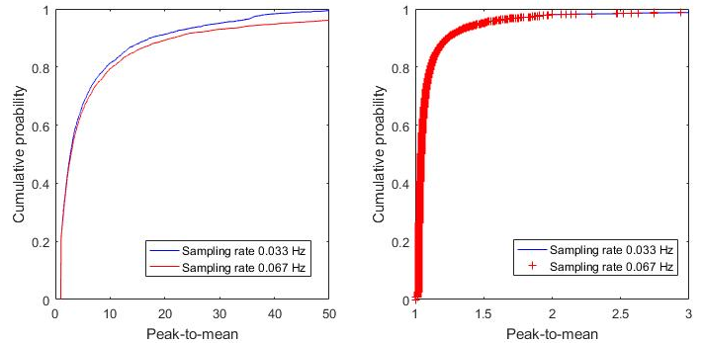
Figure 1: Empirical cumulative distribution for PTM ratios in northern station (a) and southern station (b) as a function of IOMS sampling rate for the period May-August 2019.
On the other hand, sufficiently far from the source (southern station) (Figure 1b), odour fluctuations are less relevant (95th percentile of PTM ECDF is 1.5) and, as a consequence, doubling the sampling time does not influence the PTM rations distribution, as pointed out by Mylne and Mason (1991). The monitoring period duration is also relevant for assessing the PTM ratios: the longer the monitoring periods, the more likely the occurrence of high concentrations during instant measurements is and, consequently, the higher the PTM ratio will be. When 8 months monitoring period is considered (May-December 2019), and the data are adjusted to the sampling frequency of 0.033 Hz (for the first 3 months downsampled data are used, while in the second 3-months period the sampling rate was set to 0.033 Hz), the near-field monitoring station shows a 95th percentile of PTM ECDF equal to 34, slightly greater than the value obtained in the first four months (30). Also, for the far-field station, an increase of 95th percentile of PTM ECDF was observed from 1.5 to 2.5. PTM ratios in near-field for landfill are higher than the composting plant’s, as it is well known that buildings dampen the variations in plume fluctuations (peak-to-mean) ratios, especially for non-buoyant emission sources (Porter, 2006). Far-field values of 95% percentile of calculated PTM ratios over a monitoring period of 8 months is consistent with the value suggested in Italy (Brancher et al., 2017) for correcting the hourly averaged concentrations obtained by odour dispersion models using hourly-averaged wind data and is also consistent with the far-field values for area sources given by the guidelines of New South Wales EPA (Katestone Scientific, 1998) for estimating Peak-to-mean ratios for different source. Near-field values of PTM ratios, on the other hand, are considerably higher (Invernizzi et al, 2020), thus using values of 2.3 clearly underestimates by a factor of ~10 the peak concentrations nearby the source area. A detailed statistical analysis of PTM ratios related to atmospheric conditions (wind velocity, atmospheric stability, etc,,) is under preparation.
    - Spectral analysis
Power Spectral Density (PSD) for composting plant (Figure 2a, b) and landfill (Figure 2c, d) are shown below.

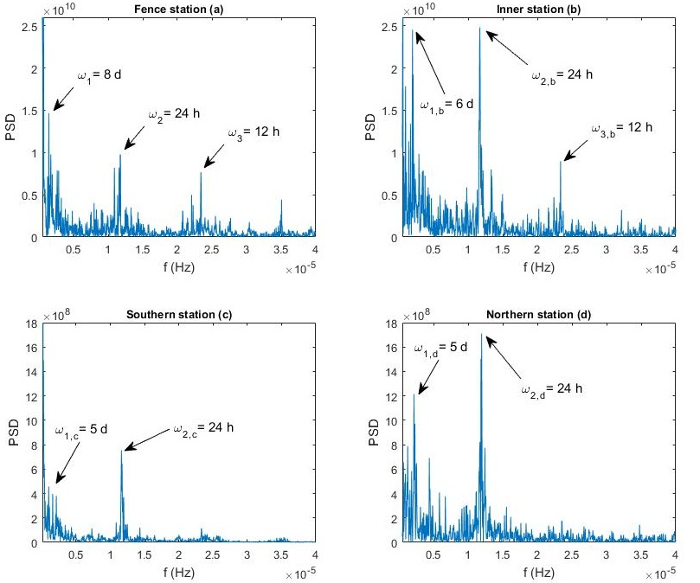
Figure 2: Power Spectral Density of time series: composting plant, fence station (a) and inner station (b); landfill, southern station (c) and northern station (d).
Site A: composting plant
In Figure 2a and 2b, PSD for the fence station and inner station are shown. Odour fluctuations are stronger in the inner station for all the frequency domain: in addition to the harmonic corresponding to daily odour fluctuations, diurnal variations are associated to 12-hour and 8-hour periods, whereas weekly variations are 8 days for fence station and 6 days for inner station. ꞷ₃ harmonic was observed in other studies of spectral analysis of pollution data (Tchepel and Borrego, 2010) and can be associated with the odour variation related to fluctuations of Planetary Boundary Layer (PBL): the decrease in the PBL weakens the vertical diffusion ability of pollutants, thereby increasing the pollutant concentration, while the increase in PBL strengthens the vertical diffusion ability of pollutants, thereby decreasing the pollutant concentration. Since PBL decreases two times during the 24 hours, at night and during the morning, the resulting increase in concentrations is likely to happen during such phases, then causing a concentration variation compatible with a 12-hour harmonic (Xiang, Y., et al, 2019). Harmonic ꞷ_{1,b} at six days are likely to be related to plant waste treatment process and operations. In fact, 6 days is the time for the formation of the first windrows of organic waste in Building #3 after mechanical pre-treatment, so that after 6 days the windrows are turned to go forward in the maturing process.
Site B: landfill
The two monitoring stations located in the landfill showed some analogies to those installed in the composting plant (Figure 2a and 2d). First, the station close to the waste disposal shows higher values of PSD, thus indicating a more evident cyclic component of odour emission. Besides the usual strong component at 24 hours, a cycle of 5 days is observed, which can be related to the weekly operational days of the landfill.
  - Conclusions
A landfill and a composting plant were monitored for 8 and 9 months, respectively, with two IOMS each, located within the borders of the installation. Datasets for the two plants were employed to calculate peak-to-mean ratios for each hour of the monitoring period. For the composting plant, the monitoring point along the northern border is near-field type with reference to the dispersion of short stack non-buoyant emissions from biofilters. 95th percentile of PTM ratios is 18.5, fairly higher than the valued currently indicated by Italian guidelines on odour dispersion modelling (2.3), whereas the inner station showed a lower value, probably related to the emissions coming from the nearby building, so that turbulent fluctuations are attenuated by the buildings. In the case of landfill, while one monitoring point is far-field, with PTM value at 95th percentile of 2.5, the near-field PTM ratio at 95th percentile is 34. The time-series of collected data were used to develop spectral analysis in order to assess the influence of cyclical behavior for atmospheric variables as well as plant operative conditions. The power spectral density values of near field station are higher than the other, with principal harmonics related to daily (24 h) and weekly (5 d) landfilling operations; for the composting plant, harmonic at 12 hours is also evident, mostly connected with PBL diurnal/nocturnal variation, whereas the inner station shows a cyclic component at 6 days, which is the average turning time for windrows during the active composting phase in the building close to the monitoring station.
Acknowledgments
Italcave e Tersan Puglia are gratefully acknowledged for their technical and financial support.
References
Best P.R., Lunney K.E., Killip, C.A., 2001, Statistical elements of predicting the impact of a variety of odour sources, Water Science and Technology Australia, 44, 157-164.
Brancher M., Griffiths K.D., Franco D., de Melo Lisboa H., 2017, A review of odour impact criteria in selected countries around the world, Chemosphere, 168, 1531-1570.
Cangialosi F., Intini G., Colucci D., 2018, On Line Monitoring of Odour Nuisance at a Sanitary Landfill for Non-Hazardous Waste, Chemical Engineering Transactions, 68, 127-132.
TATISTICAL ELEMENTS OF PREDICTING
THE IMPACT OF A VARIETY OF ODOUR SOURCES
STATISTICAL ELEMENTS OF PREDICTING
THE IMPACT OF A VARIETY OF ODOUR SOURCES
Katestone Scientific, 1998, Peak-to-mean ratios for odour assessments, Report from Katestone Scientific to Environmental Protection Agency New South Wales (EPANSW).
Invernizzi, M., Brancher, M., Sironi, S., Capelli, L., Piringer, M., & Schauberger, G., 2020. Odour impact assessment by considering short-term ambient concentrations: A multi-model and two-site comparison. Environment International, 144, 105990.
Mylne, K. R., and P. J. Mason, 1991, Concentration fluctuation measurements in a dispersing plume at a range of up to 1000 m. Q J R Meteorol Soc, 117, 177-206.
Oettl D., Ferrero E., 2017, A simple model to assess odour hours for regulatory purposes, Atmospheric environment, 155, 162-173.
Porter, R.C. and L. Santos, 2006, Peak-to-Mean Ratios for Odour Impacts: A Tracer Study Revisited, Water Environment Federation. Proceedings Odours and Air Emissions
Sozzi R., Bolignano A., Sironi S., Capelli L., 2018, Reflections on odour concentration fluctuations and nuisance, Chemical Engineering Transactions, 68, 199-204
Schauberger, G., Piringer, M. Petz, E., 2000, Diurnal and annual variation of the sensation distance of odour emitted by livestock buildings calculated by the Austrian odour dispersion model (AODM). Atmos. Environ. 34, 4839–4851.
Tchepel O., Borrego C., 2010, Frequency analysis of air quality time series for traffic related pollutants, J. Environ. Monit., 12, 544–550
Tinarelli G.L, Sozzi R., Trini Castelli S., Bisignano A., 2019, Insertion and verification of algorithms for the calculation of peak-to-mean ratio in a particle model, Odour Emissions conference, Ecomondo 7 Nov. 2019
UNI 11761:2019 Emissions and air quality – Odour determination using IOMS
Xiang, Y., Zhang, T., Liu, J., Lv, L., Dong, Y., & Chen, Z., 2019, Atmosphere boundary layer height and its effect on air pollutants in Beijing during winter heavy pollution, Atm. Res., 215, 305-316

