|  |  |
| --- | --- |
| cetlogo ***CHEMICAL ENGINEERING TRANSACTIONS***  ***VOL.*** | A publication of  aidiclogo_grande |
| The Italian Association  of Chemical Engineering  Online at www.aidic.it/cet |
| Guest Editors: Selena Sironi, Laura Capelli  Copyright © 2021, AIDIC Servizi S.r.l. **ISBN** 978-88-95608-xx-x; **ISSN** 2283-9216 | |

Real-time monitoring of odour concentration at a landfill fenceline: performance verification in the field

Carmen Bax\*, Beatrice Julia Lotesoriere, Laura Capelli

Politecnico di Milano, Department of Chemistry, Materials and Chemical engineering “Giulio Natta”, piazza Leonardo da Vinci 32, Milan 20133, Italy;

[carmen.bax@polimi.it](mailto:carmen.bax@polimi.it)

An emerging application of electronic noses in the environmental field concerns the real-time measurement of odour concentration at plants fencelines. One advantage related to the continuous monitoring of odour emissions from the plant, is that the setting of “warning” thresholds for the odour concentration offers useful indications for the plant management: the real-time signaling of the threshold exceedance enables the instantaneous identification of plant malfunctions, thereby allowing rapid intervention and thus preventing odour events at receptors. In Italy, there is an increasing number of new and existing plants for which the IOMS installation at plant fenceline is prescribed in the permits. Thus, the need arises to have specific quality programs capable to ensure the reliability of IOMS outcomes. In this context, this paper presents a case study, in which a procedure for the verification of IOMS quantification capability was applied in the field.

* 1. Introduction

Nowadays, electronic noses or, more generically, Instrumental Odour Monitoring Systems (IOMS), are increasingly applied as air quality monitoring tools (Sohn *et al.*, 2008; Pan and Yang, 2009; Laor *et al.*, 2014; Deshmukh *et al.*, 2015; Licen *et al.*, 2018; Bax *et al.*, 2020a; b). A very common application implies the use of IOMS for a direct assessment of the odour impact at receptors, i.e. directly where the odour nuisance is lamented. To do this, the IOMS, installed at the receptor, provides a real-time detection and classification of odours in ambient air. Then, the odour impact of the plant is usually assessed in terms of the frequency of odour episodes during the monitoring period (Bax *et al.*, 2020a; b).

An emerging application of IOMS in the environmental field concerns the real-time measurement of odour concentration at the plant fenceline. One advantage related to the continuous monitoring of odour emissions from the plant, is that the setting of “warning” thresholds for the odour concentration offers useful indications for the plant management: the real-time signaling of the threshold exceedance enables the instantaneous identification of plant malfunctions, thereby allowing rapid intervention and thus preventing odour events at receptors. In Italy, this approach is gaining acceptability and there is an increasing number of new or existing plants for which the IOMS installation at plant fenceline is prescribed in the permits (Cangialosi *et al.*, 2018).

In such cases, the data produced by the IOMS gain a legal value. For this reason, need arises to have specific quality programs capable to ensure the reliability of IOMS outcomes (Bax *et al.*, 2020a). In recent years, a specific working group (WG41) was established within the CEN TC/264 to draft a European standard related to IOMS, and a national technical norm regarding IOMS qualification has been published in Italy (Uni11761, 2019).

Because of the huge variability of IOMS technologies available on the market, all standards under discussion or already published focus on the verification of IOMS performance claims (i.e., detection, classification and quantification) rather than on hardware requisites of instruments. According to the same principle, our research group has studied and applied an experimental protocol that can be applied in the field to verify if the IOMS is “fit-for-purpose” related to its capability of odour detection and classification, which has the advantage of enabling the performance comparison of different instruments available on the market (Bax *et al.*, 2019; Bax *et al.*, 2020a). The proposed experimental protocol foresees the execution of specific field tests at the monitoring site after the IOMS training and installation, and the assessment of IOMS detection and classification capability in terms of Lower Detection Limit (LDL) and Accuracy Indexes (AI), respectively (Bax *et al.*, 2019; Bax *et al.*, 2020b).

In this paper, we describe a case study regarding the real-time monitoring of odour concentration at the fenceline of a MSW landfill, in which a specific procedure was applied for the verification of the IOMS capability to provide a reliable estimation of the odour concentration in the field. This evaluation involves the comparison of the odour concentration estimated by the IOMS with the one measured by the reference method, i.e. dynamic olfactometry (En13725, 2003) by means of Bland & Altman analysis.

* 1. Materials and methods
     1. The IOMS used for the study

The WT1 (Figure 1) used for the study is an outdoor electronic nose for real-time monitoring of odours and air pollutants, commercialized by RubiX S&I SAS. It is equipped with six commercial sensors: 4 MOS sensors for odours and 2 electrochemical cells specific for H2S and NH3, respectively. This instrument is characterized by a fast response time, and it is capable to supply real-time alerts, based on the combination of the sensors outputs. For this specific case study, the WT1 was installed at the plant fenceline, close to the landfill entrance, along the prevalent wind direction (i.e., from North to South) to detect, classify and quantify odours from the landfill that might generate odour events at the receptor, located at about 2 km south the landfill, where the presence of odour attributable to waste disposal is lamented (Figure 2).

|  |  |
| --- | --- |
| *Figure 1. RubiX WT1 used for the study* | *Figure 2. Location of the WT1* |

* + 1. IOMS training

The IOMS training consists in the creation of a reference dataset, which the instrument will use during the monitoring to provide a characterization of the analysed air.

The first step of the training phase involved the identification and the olfactometric characterization of emission sources potentially responsible of the odour presence at receptors. Fresh waste disposal and pre-treatment sections, landfill gas emitted from the landfill surface, and leachate collection tanks were considered to train the WT1 for the specific monitoring. Two olfactometric campaigns were carried out on different days, characterized by different meteorological conditions (i.e., sunny and foggy), with the purpose of including in the training set the intrinsic variability of landfill emission sources.

To build the Training Set (TS), based on their odour concentration assessed by dynamic olfactometry (EN13725), the odour samples were presented to the WT1 pure or diluted with odourless ambient air. The odour concentration range of training samples should be representative of the concentration level that the WT1 will be exposed in the field. Based on this principle, samples with an odour concentration ranging from 80 to 8000 ouE/m3 were used to train the instrument, which correspond to odour concentration values that would be expected at a landfill fenceline.

During the training, also non-odorous ambient air samples, collected at the monitoring site when no odour could be perceivable by operators, were analysed, to create an olfactory class “Air” as a reference. Thus, the TS included four classes: “Air”, “Fresh Waste”, “Landfill Gas” and “Leachate”. The PCA score plot relevant to the WT1 training set, reported in Figure 3, pointed out the potentialities of the WT1 to differentiate the different landfill odour sources: samples representative of different classes cluster in different regions of the plot. However, some samples belonging to the “Landfill Gas” class, which were sampled at wells collecting the landfill gas produced in an area of the landfill still in cultivation, fall very close to the “Fresh Waste” cluster. Probably, because the process of waste biological degradation was not over, their chemical composition and, thus, their odour fingerprint resulted somewhere in between the fresh waste and the landfill gas classes.

A two-step decisional model was built on the training data. The proposed model involves as first step a 5-NN classifier to provide a classification of the odours detected at the landfill fenceline, and 3 Partial Least Squares (PLS) regression models (i.e., one for each landfill odour class) to provide an estimation of the odour concentration. The model was implemented considering the responses of both 4 MOS sensors and specific H2S and NH3 sensors relevant to the analysis of the training samples.

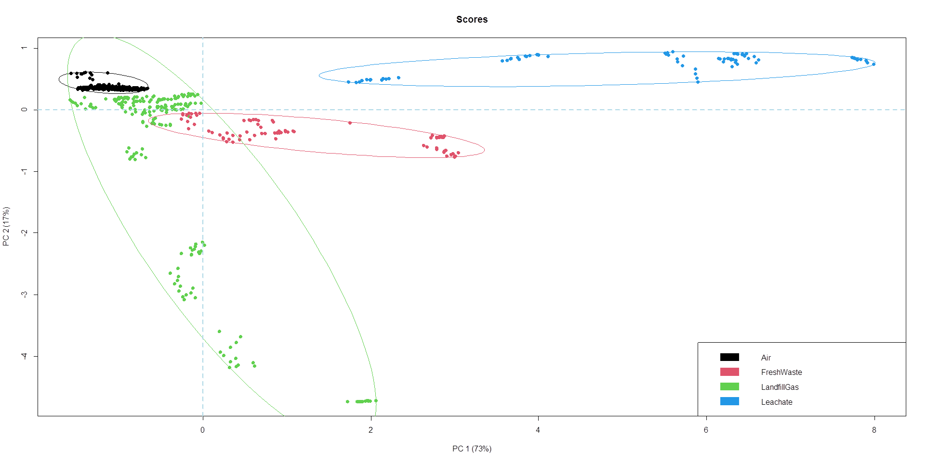

*Figure 3. PCA score plot relevant to the WT1 training set*

* + 1. Testing of the IOMS quantification performance in the field

This paper describes the application of an experimental protocol for the IOMS performance verification in the field, aiming to assess the reliability of the odour concentration values measured by the IOMS at the plant fenceline. To do this, this paper describes the integration of the qualification protocol described in our previous publication (Bax *et al.*, 2020a), concerning the evaluation of the IOMS detection and classification capability, with a specific procedure to verify the IOMS capability to quantify odours.

Because of the uncertainty associated with the reference method for odour quantification (i.e., dynamic olfactometry) the evaluation of the precision of the IOMS estimation of the odour concentration is very challenging. In particular, the choice of the correct statistical approach to assess the degree of agreement between two imprecise measurements is not obvious (Giavarina, 2015).

Correlation and regression studies are frequently proposed in the scientific literature (Liu *et al.*, 2016). However, those techniques are not suitable for the scope, since they study the relationship between one variable and another, by assuming the precision of reference method, and this is not the case of dynamic olfactometry. Based on these observations, in this paper we tried to apply the Bland-Altman (B&A) analysis for the evaluation of the agreement between the IOMS measurements and the odour concentration values determined by dynamic olfactometry. This method has the advantage that it allows to evaluate the agreement between two uncertain quantitative measurements by studying the mean difference (i.e., bias) and constructing limits of agreement (Giavarina, 2015). It is expected that the 95% limits include 95% of differences between the two measurement methods (Bland and Altman, 1995; Bland and Altman, 1999).

Given n samples, with n ranging from 1 to i, and naming X1,i the odor concentration of the i-th sample obtained by dynamic olfactometry, and X2,i the odor concentration of the i-th sample obtained by IOMS, the procedure to be adopted to perform the B&A analysis foresees the evaluation of the arithmetic mean and the difference of each pair of measures for each i-th sample, Xi and di, respectively.

|  |  |
| --- | --- |
| $$\overline{X_{i}}= \frac{{X1}_{i}-{X2}_{i}}{2}$$ | $$d_{i}={X1}_{i}-{X2}_{i}$$ |

Then, the limits of agreement are calculated as follows, where $\overline{d}$ and $s$ represents the arithmetic mean of differences previously evaluated and their standard deviation:

|  |  |
| --- | --- |
| $${LoA}_{U}=\overline{d}+1.96*s$$ | $$\overline{d}= \frac{\sum_{i=1}^{n}{d_{i}}}{n}$$ |
| $${LoA}_{I}=\overline{d}-1.96*s$$ | $$s=\frac{\sqrt{\sum_{i=1}^{n}{{\left(d_{i}-\overline{d}\right)}^{2}}}}{n-1}$$ |

Finally, for each limit of agreement, a confidence interval (CI) is calculated by applying the t-Student distribution, as follows, where $e_{s}$ is the standard error.

|  |  |
| --- | --- |
|  |  |

* 1. Results
     1. Field tests

According to the experimental protocol described in (Bax *et al.*, 2020a), specific field tests were carried out after IOMS training and installation at the monitoring site. Field tests involved the collection of independent odour samples, different from the samples used for the instrument training, at the landfill odour sources, and their characterization by dynamic olfactormetry to assess their odour concentration. These samples were analysed with the IOMS at different concentration levels within the TS concentration range. The analysis protocol in the field involved the alternation of odour samples diluted at different concentrations to samples of odourless ambient air, in order to simulate the odor events that might occur during the monitoring at the landfill fenceline.

Data relevant to the field tests were processed in the same way as the monitoring data, with the purpose to assess the instrument detection, classification and quantification capability (Figure 4).

**

*Figure 4. Projection of data relevant to field tests on the training dataset*

The WT1 detection and classification capability was assessed in terms of accuracy indexes, defined in (Bax *et al.*, 2020a). The WT1 proved capable to detect and correctly classify landfill odours with accuracy indexes above 90% for both the detection and the classification of landfill odours (Table 1).

|  |  |  |  |  |  |  |  |  |  |  |  |
| --- | --- | --- | --- | --- | --- | --- | --- | --- | --- | --- | --- |
| *Table 1. Test characteristics relevant to IOMS detection and classification capability*   |  |  | | --- | --- | | Test characteristics | % (CI95%) | | Accuracy Index detection | 96 (87-100) | | Accuracy Index classification | 92 (75-99) | | *Table 2. Limits of agreement assessed by B&A analysis*   |  |  | | --- | --- | | LoAu | 3.24 | | LoAl | 0.17 | |

In order to evaluate the IOMS performance in terms of odour quantification capabilities, the odour concentration values measured by the WT1 were compared with the values measured by olfactometry by applying the B&A analysis. To do this, the logarithms of the odour concentrations values were considered. Table 2 reports the the limits of agreement determined by B&A method.

The B&A plot, reported in Figure 5, points out a good agreement between IOMS estimations and odour concentrations by dynamic olfactometry. In fact, the IOMS estimations fall within the limits of agreement, except for one sample, i.e., a Landfill Gas samples, misclassified as Fresh Waste, whose estimated odour concentration resulted slightly overestimated, even though it was within the confidence interval of the upper LoA.

Based on these results, it is possible to state that the WT1 and the developed two-step decisional model proved effective to provide reliable real-time odour concentration measurements at the landfill fenceline.

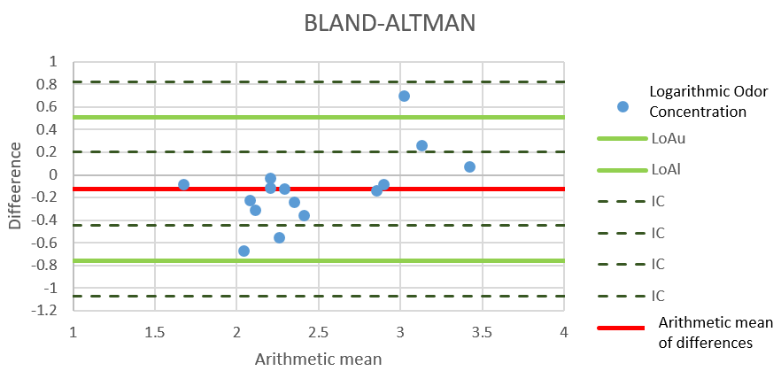

*Figure 5.B&A plot relevant to field tests*

* + 1. Fenceline monitoring

WT1 data relevant to the fenceline monitoring period, which lasted about 30 days, were processed by the two-step decisional model, in order determine odour provenance and estimate odour concentration. The WT1 detected odours attributable to landfill sources for about the 83% of the monitoring period. In detail, the WT1 detected odours attributable to Fresh Waste, Landfill gas and Leachate sources for the 47%, 24% and 12% of the monitoring time, respectively. Figure 6 reports the odour concentration estimated by the IOMS at the fenceline during the monitoring period. In general, the odour concentrations estimated, when Leachate odour events occurred, turned out to be lower than 50 ouE/m3. Conversely, odours attributed to Landfill Gas and Fresh Waste reached concentrations up to 6’00 ouE/m3 and 10’00 ouE/m3, respectively. The high concentrations related to landfill gas detection could be related to the proximity of the WT1 location to the landfill gas pumping station. Instead, the high concentration levels associated with the recognition of the “fresh waste” class could be explained considering that, because of its location, the WT1 analyses could have been affected by the odour caused by the trucks transporting the waste to the landfill.The analysis of results highlighted that when the odour concentration at fenceline was above 600 ouE/m3 and the meteorological condition were favourable (wind blew from north to south) an odour event at receptor occurred.

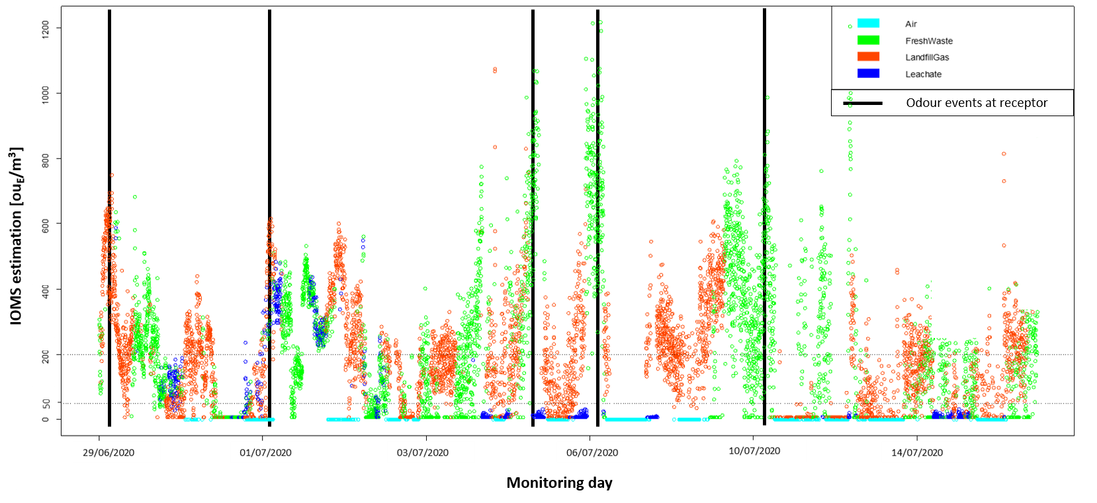

*Figure 6. Odour concentrations measured by the IOMS at the landfill fenceline during the monitoring period*

* 1. Conclusions

This paper describes the monitoring of odorous emissions at the fenceline of a MSW landfill by an IOMS, which proved capable to provide a real-time qualitative and quantitative characterization of the odours in ambient air. In order to assess the IOMS odour quantification capability, this paper applies a specific procedure based on the adoption of the Bland-Altman method. The B&A approach allows evaluating the agreement between two uncertain measurement methods, as it is the case for IOMS and dynamic olfactometry, by studying the mean difference (i.e., bias) and constructing the limits of agreement.

The results achieved proved the effectiveness of the IOMS used for the study and the specifically developed two-step decisional model to provide reliable estimations of the odour concentration at the plant fenceline. These results could be used to set “warning” thresholds at the plant fenceline, with the aim to provide real-time information about the occurrence of odour episodes, which might cause the perception of odours outside the plants, and thus allow rapid interventions to prevent them.

References

Bax, C.; Sironi, S.; Capelli, L. Application and performance verification of electronic noses for landfill odour monitoring. In: CISA, Sardinia2019 17th International Waste Management and Landfill Symposium, 2019.

Bax, C.; Sironi, S.; Capelli, L. Definition and Application of a Protocol for Electronic Nose Field Performance Testing: Example of Odor Monitoring from a Tire Storage Area. Atmosphere**,** v. 11, n. 4, p. 426, 2020a.

Bax, C.; Sironi, S.; Capelli, L. How Can Odors Be Measured? An Overview of Methods and Their Applications. Atmosphere**,** v. 11, n. 1, p. 92, 2020b.

Bland, J.M.; Altman, D.G. Comparing methods of measurement: why plotting difference against standard method is misleading. Lancet**,** v. 346, n. 8982, p. 1085-7.

Bland, J.M.; Altman, D.G. Measuring agreement in method comparison studies. Stat Methods Med Res,v. 8, n. 2, p. 135-60, 1999.

Cangialosi, F.; Intini, G.; Colucci, D. On line monitoring of odour nuisance at a sanitary landfill for non-hazardous waste. Chemical Engineering Transactions,v. 68, p. 127-132, 2018.

Deshmukh, S. Bandyopadhyay, R.; Bhattacharyya, N.; Pandey, R. A.; Jana, A. Application of electronic nose for industrial odors and gaseous emissions measurement and monitoring – An overview. Talanta, v. 144, p. 329-340, 2015.

EN13725: Air Quality-Determination of Odour Concentration by Dynamic Olfactometry. Brussels, Belgium, 2003.

Giavarina, D. Understanding Bland Altman analysis. Biochemia medica, v. 25, n. 2, p. 141-151, 2015.

Laor, Y.; Parker, D.; Page, T. Measurement, prediction, and monitoring of odors in the environment: A critical review. Reviews in Chemical Engineering, v. 30, p. 139-166, 2014.

Licen, S.; Barbieri, G.; Fabbris, A.: Briguglio, S.C.; Pillon, A.; Stel, F.; Barbieri, P. Odor control map: Self organizing map built from electronic nose signals and integrated by different instrumental and sensorial data to obtain an assessment tool for real environmental scenarios. Sensors and Actuators B: Chemical, v. 263, p. 476-485, 2018.

Liu, J.; Tang, W.; Chen, G.; Lu, Y.; Feng, C.; Tu, X.M. Correlation and agreement: overview and clarification of competing concepts and measures. Shanghai archives of psychiatry, v. 28, n. 2, p. 115-120, 2016.

Pan, L.; Yang, S. An Electronic Nose Network System for Online Monitoring of Livestock Farm Odors. Mechatronics, IEEE/ASME Transactions on,v. 14, p. 371-376, 2009.

Sohn, J.H.; Hudson, N.; Gallagher, E.; Dunlop, M.; Zeller, L.; Atzeni, M. Implementation of an electronic nose for continuous odour monitoring in a poultry shed. Sensors and Actuators B: Chemical, v. 133, n. 1, p. 60-69, 2008.

UNI11761: Emissioni e qualità dell’aria – Determinazione degli odori tramite IOMS (Instrumental Odour Monitoring Systems). Milano. 2019.