|  |  |
| --- | --- |
| cetlogo ***CHEMICAL ENGINEERING TRANSACTIONS***  ***VOL. 82,2020*** | A publication of  aidiclogo_grande |
| The Italian Association  of Chemical Engineering  Online at www.cetjournal.it |
| Guest Editors: Selena Sironi, Laura Capelli  Copyright © 2020, AIDIC Servizi S.r.l. **ISBN** 978-88-95608-80-8; **ISSN** 2283-9216 | |

Lights and shadows of the VOC emission quantification

Marzio Invernizzia,\*, Luca Rovedaa, Elisa Polvaraa, Selena Sironia

a Politecnico di Milano, Department of Chemistry, Materials and Chemical Engineering “Giulio Natta”, Piazza Leonardo da Vinci 32, 20133 Milano, Italy

marzio.invernizzi@polimi.it

Nowadays, Volatile Organic Compounds (VOC) are a class of air pollutants increasingly studied in the scientific literature, due to the well-known impact on human health and the environment. They can be emitted from different sources, including various types of industrial plants, such as oil refinery and petrochemical plants. For these reasons, the attention of control agencies on VOC emissions has increased and with it the request to quantify the total amount of VOC emitted by a plant, to monitor and to reduce this emission. However, several critical aspects still exist related to the classification of VOCs and their quantification. Indeed, different definitions of VOC are reported in scientific and technical literature. These diversities result in multiple strategies for quantifying the VOCs emitted by an industrial plant. Therefore, this paper reviews the available regulation about the quantification of VOC emitted from industrial plants, focusing on refineries and petrochemical plants, to underline some formal inconsistencies in VOC estimation procedures. From this comparison, it appears clear that VOC quantification can be addressed in different manners, obtaining a substantial non-uniformity of the VOC emission data. The data difference can conduct to a misleading estimation of emission rate.

* 1. Introduction

Recently, the assessment of the exposure to air pollutants has become a fundamental part of the permitting procedures for industrial plants. Among chemicals of industrial importance, the so-called Volatile Organic Compounds (VOC) represent a ubiquitous class of air pollutants. VOC are produced on a significant scale worldwide in industry trade and households. (Heinrich-Ramm et al., 2000). As reported in Figure 1, the scientific interest in this kind of environmental field is rapidly increasing.

VOC, in effect, play an important role in the tropospheric atmospheric chemistry, for the production of photochemical ozone (O3) and other oxidants (Wei et al., 2014), affect climate through direct and indirect mechanisms, may hazard human health with their toxicity, teratogenicity and mutagenesis (Bo et al., 2008), and can also be responsible of odour nuisance around industrial plants (Invernizzi et al., 2016). Since the emission of VOC is correlated to the odorous impact of an industrial plant, it is possible to make primary assessments on the extent of the problem to be addressed by knowing the amount of VOC emissions of the plant to be investigated (Invernizzi et al., 2018).

A VOC is defined by US EPA as (U.S. EPA, 2021):

*“An organic compound is any of a large class of chemical compounds whose molecules contain carbon. For historical reasons, a few types of compounds such as carbonates, simple oxides of carbon and cyanides, as well as the allotropes of carbon, are considered inorganic. The division between "organic" and "inorganic" carbon compounds is useful, but may be considered somewhat arbitrary”*

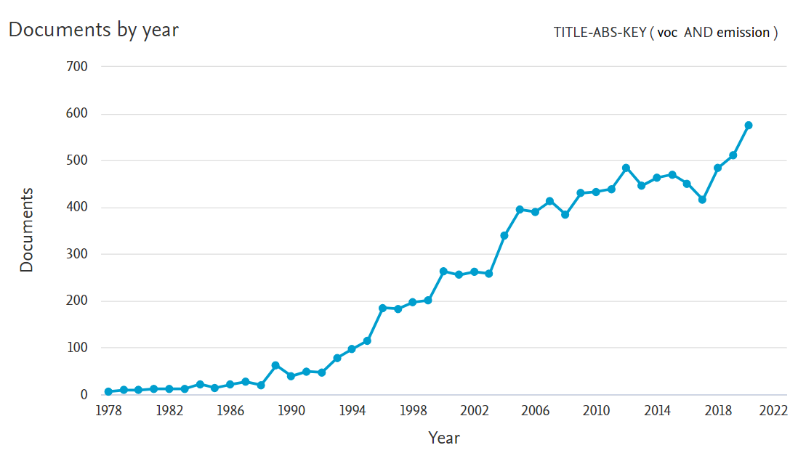

Figure 1: Trend of SCOPUS indexed items using “VOC emission” as key words.

A different, but vague as well, definition is proposed by European Union (European Parliament, 2011):

*“‘Volatile organic compound’ means any organic compound as well as the fraction of creosote, having at 293.15 °K a vapour pressure of 0,01 kPa or more, or having a corresponding volatility under the particular conditions of use”*

Due to these definitions, despite their semantic differences, it appears clear that a precise definition of VOC and a clear identification of which compounds belong to this group are complex: this pollutants class can potentially include an infinite amount of single chemical compounds.

It is important to remark that industries are not the only contributors to the VOC global emissions: both biogenic and further anthropogenic sources play a major role in the total amount of VOC present in the atmosphere (Goldstein and Galbally, 2007).

In terms of absolute quantification, an important easily-understandable difference between the available definitions exists. Indeed sometimes methane is included in the VOC total amount; at other times, the pollutant group is defined as NMVOC (Non-Methane VOC) (European Commission, 2018). A further definition is Total Organic Carbon (TOC), or Total Volatile Organic Carbon (TVOC): in this case, methane is included and is expressed by convention as the concentration of the total gaseous organic carbon atoms (not molecules). Despite these substantial difference, all these terms are often used as synonyms (European Commission, 2015).

In this work, attention will be focused on the available procedures and methods for the quantification of the VOC emission rate from industrial plants, like oil refineries and petrochemical plants, and a critical discussion will be provided in order to underline some formal inconsistencies in the existing procedures for the estimation of VOC emission inventories.

* 1. State of the Art

Annex II of E-PRTR (Protocol of Pollutant Release and Transfer) Regulation lists the pollutant to be quantified, and whose emission rate should be included in the (European Commission, 2006): NMVOC are cited in this list. Moreover, E-PRTR Regulation clearly specifies that the emission inventory shall include not only the conveyed, but also the fugitive and the diffuse emissions (European Commission, 2006). For the compilation of the different emission contributions, three approaches are available: measurements, calculations or non-standardised estimations (essentially based on expert assumptions). Despite mass balance methods are cited as a possible procedure for the estimation of the emission of NMVOC, it is rarely used due to the low amount of the specific emission, which is about 0.0002% as mass fraction of the total hydrocarbon inflow (Roveda et al., 2020).

This regulation mention to follow CEN and ISO standards for the measurement methodologies. In particular, Annex III of the E-PRTR Regulation (European Commission, 2006), for the quantification of NMVOC emission to air, reports only the standard EN 13649. Despite this, this methodology is fit to measure only conveyed emissions. Moreover, different CEN and ISO standards are available for the VOC quantification in industrial emissions: a brief list is reported in Table 1.

Table 1: ISO/CEN measurement standards available for NMVOC quantification in industrial emissions

|  |  |
| --- | --- |
| Standard | Title |
| EN 12619:2013 | Stationary source emissions. Determination of the mass concentration of total gaseous organic carbon. Continuous flame ionisation detector method |
| EN ISO 13199:2012 | Stationary source emissions - Determination of total volatile organic compounds (TVOCs) in waste gases from non-combustion processes - Non-dispersive infrared analyser equipped with catalytic converter |
| EN 13526:2002 | Stationary source emissions. Determination of the mass concentration of total gaseous organic carbon in flue gases from solvent using processes. Continuous flame ionisation detector method |
| CEN/TS 13649:2014 | Stationary source emissions. Determination of the mass concentration of individual gaseous organic compounds. Sorptive sampling method followed by solvent extraction or thermal desorption |
| EN 15446:2008 | Fugitive and diffuse emissions of common concern to industry sectors - Measurement of fugitive emission of vapours generating from equipment and piping leaks |

Within oil refinery and petrochemical plants, disparate kinds of emission which can contribute to the overall NMVOC emission inventory. It is mainly possible to identify the following emissive macro-areas:

* Stationary source emissions: these “classical” sources are generally represented by vents of combustion units or releases from devices such as filters, scrubbers and vapour recovery units. In these cases, the VOC emission is usually measured by EN12619 (CEN, 2013) or EN13649 (PD CEN/TS, 2014).
* Fugitive emissions: emissions from leaks, breaks, and instrument loosening and are not easily traceable to a specific source. An European standard is available for the quantification of fugitive emissions, EN 15446:2008 (CEN, 2008), but it essentially refers to American LDAR (Leak Detection And Repair) protocols (U.S. EPA, 2017, 1995)
* Storage emissions: these emissions result from the venting and routine handling of storage tanks, with consequent emissions of gaseous components into the air. Different thermodynamic simulation methods are historically proposed by US EPA (U.S. EPA, 2020, 1997), also implemented in the freeware software TANKS 4.09D (U.S. EPA, 1999).
* Wastewater diffuse emission: in order to purify the process and meteoric waters, usually in industrial sites are present wastewater treatment basins. A gradual release of VOCs may occur at all water/air interfaces: due to the difficulties in measurement and the variability of the emission rate, to quantify this exchange, emission factors (Concawe, 2014) or simulation techniques (U.S. EPA, 2001) are widely used.
* Residual emission terms: other emissions can be present, like cooling tower, flare, and sewage diffuse release. Due to their low contribution to the overall emission inventory, and the complexity of their estimation, the choice of their inclusion is rare and essentially left to the head of emission inventory.

As it is clear to see, there are various possible methods for the estimation of VOC emission: the operational choice of the expert in charge for the emission inventory is strictly linked to the type of emission.

Unluckily, each method proposes a different approach for the estimation, based often on properly different definitions of VOC. Nevertheless, for the total NMVOC emission inventory, these single terms are summed as if they were homogeneous. A deeper description of the analytical and theoretical methods is presented in the following.

* 1. Critical discussion
     1. EN 12619

This European Standard prescribes the use of a Flame Ionisation Detector (FID) for the measurement of the mass concentration of organic substances in stationary source emissions, in the concentration range up to

1000 mg/m³. The advantages of FID are its robustness and its response, theoretically linear with the amount of organic carbon atoms. In addition,, FID has a negligible sensitivity to inorganic gaseous compounds (e.g. H2O, CO2, NOx).

Propane is the mandatory calibration gas and the measured VOC concentration CTVOC, expressed as TVOC in mgC/Nm3, can be obtained with Eq(1):

|  |  |
| --- | --- |
| $$C_{TVOC}=C_{v,C3H8}∙\frac{3∙12}{22.4}$$ | (1) |

Where Cv,C3H8 is the volume concentration of propane, expressed in ppmV, obtained by the calibration curve, 3 is the number of carbon atoms of propane, 12 is the molecular mass of carbon and 22.4 in the normal molar volume (=22.4 L/mol).

It is important to remark that this method doesn’t quantify the NMVOC concentration, but the TVOC concentration, so including methane. Moreover, FID detector responds linearly with aliphatic and aromatic carbon atoms, but shows a deviation from linear behaviour with olefinic, acetylenic, carbonyl and carboxyl carbon atoms (Kromidas and Kuss, 2009). In addition, oxygen and nitrogen atoms, which may be present in organic molecules, lower the response of the detector: small oxygenated organic molecules, like formaldehyde, aren’t detected by FID (Dojahn et al., 2001).

Last, but not least, this method quantifies only the amount of organic atoms, neglecting the contributions of heteroatoms and hydrogen to the molecular mass.

* + 1. EN 13649

As mentioned, this is the only standard mentioned in E-PRTR Regulation (European Commission, 2006) for the quantification of NMVOC. Despite this, the standard clearly states that it is designed for the analysis of *individual* VOCs. The results obtained, by applying this methodology, are expressed as the mass concentration of the *individual* gaseous organic compounds and that it is not suitable for measuring TOC.

This method is based on a chromatographic separation of VOCs, sampled with a sorbent tube, and detected with FID or Mass Spectrometer, MS.

By this, the total amount of NMVOC can be obtained only in two cases: if all the organic compounds present in the emission are known and a calibration curve is carried for all of them or by doing semi-quantification via a unique-compound calibration curve. Moreover, the introduction of a sampling system for the retarded analysis, and the consecutive chromatographic separation, would introduce a strong uncertainty in the recovery of all the organic molecules present in the emission.

* + 1. LDAR protocol

LDAR program represents both a formalized control procedure and a strategy to reduce fugitive emissions. It is based on successive, usually yearly, surveys and allows the complete surveillance of the source population (e.g. valves, flanges, pumps and compressor seals). The implementation of an LDAR program gives the possibility to identify critical sources and allows the execution of targeted maintenance interventions, which guarantee a significant reduction of emissions, in terms of environmental benefit and product-loss reduction.

This method is based on the measurement of the gas concentration at the interface of a leak, measured with a portable instrument. The instrument response is the Screening Value, SV, that is a relative measure of concentration level, expressed in parts per million by volume (ppmv).

The conversion to obtain a mass emission rate, ER, of a single emitting equipment, is based on a set of historical emission factors and empirical correlations (U.S. EPA, 1995). In particular, the EPA correlation method, estimates the Emission Rate ER, for each equipment, by the SV, via Eq(2):

|  |  |
| --- | --- |
| $$ER=A{\left(SV\right)}^{B}$$ | (2) |

Where A and B are empirical correlation factors dependent on the investigated unit (valve, pump, connector…) and its contained fluid (gas, light liquid, heavy liquid).

The portable VOC detector to be used is not standardized, shall only respond to the compounds being screened. In this way, a huge variety of detectors is exploitable in refinery and petrochemical plants: FID, Photo Ionisation Detector (PID), catalytic oxidiser, infrared absorber (NDIR), Thermal Conductivity Detector (TCD)… The lower detection limit of the detector shall be 10 ppm and have a minimum measurement range up to 50 000 ppm.

The employability of such a wide variety of equipment brings with it a major drawback: the sensitivity is completely non-homogeneous, both in qualitative and quantitative terms. As instance, FID detects methane, while PID doesn’t. Moreover, they use different calibration compounds: for FID methane or propane are used, while isobutylene for PID. From the quantitative point of view, even the same principle-based instruments, like PID, may vary very strongly their response to the same molecule: depending on the lamp’s ionization potential (10.0, 10.6, 11.7 eV) the response factor for heptane may be 11, 2.2 or 0.5 respectively (ION science, 2019).

In refineries and some petrochemical installations, the chemical composition of many streams is not known precisely because it depends on the feedstock quality and on the operating parameters: this fact may prevent the use of a suitable response factor introducing a strong uncertainty in the emission rate estimation. In Figure 2, the differences in the ER estimation in case of a heptane valve, are reported.

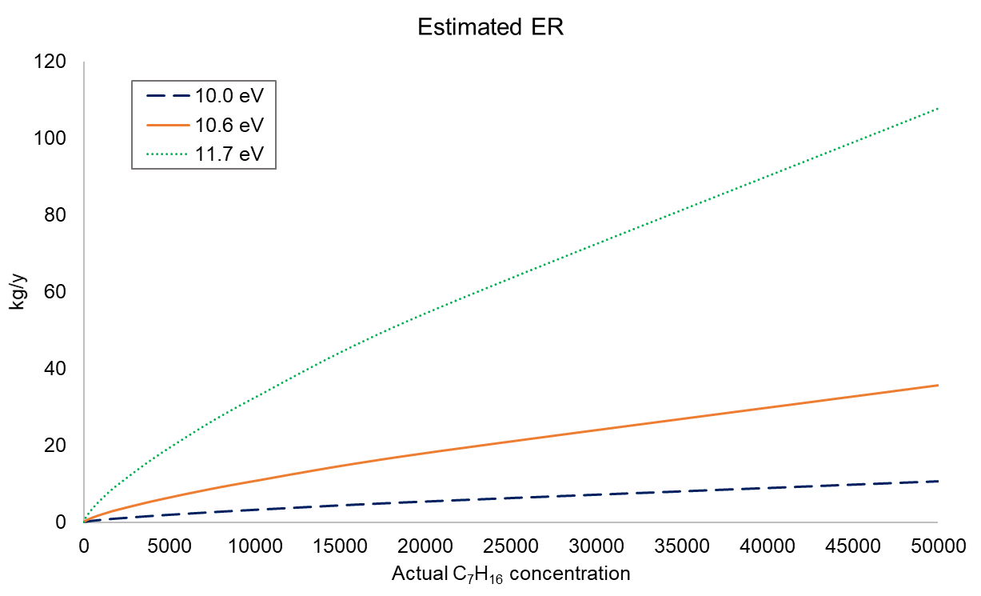

Figure 2: Estimated ER of a valve containing heptane dependent on the use of different PID lamps

* + 1. Storage tanks emission

For the definition of the calculation procedures related to emissions of VOCs form storage tanks, BREF REF (European Commission, 2015) refers to the US EPA protocol "AP-42: Compilation of Air Emissions Factors". Chapter 7, “Liquid Storage Tanks” provides a series of correlations based on thermodynamic, chemical-physical, logistics, and mass balance considerations, aimed at the quantitative description of the phenomena that lead first to the evaporation of organic liquids stored in tanks.

For the calculations, two parameters, linked to the liquid stored in the tank, are crucial: vapour pressure PVA and average vapour molecular weight Mv. Despite these data are easily available in case of pure liquids, for fuel mixtures the situation is far more complex: the recent edition of the protocol (U.S. EPA, 2020) provides Antoine’s Equations for the calculation of PVA at the stock temperature, but sets a fixed Mv, which would be in reality vapour-liquid equilibrium temperature-dependent too.

Moreover, the widespread used freeware software TANKS 4.09D, provides PVA with an upper limit, calculated at the temperature of 100 °F (=37 °C), leading to and underestimation of the emission in case of heated tanks.

* + 1. Wastewater basins emission

In this case, the quantification of the emission rate of VOC is particularly complex. This is due both to the variability in the wastewater composition and to the complex interactions of the emission phenomenon.

Despite different scientific works remark the influences of many different parameters on the emission rate (Invernizzi et al., 2020, 2019), a yearly-constant emission rate is widely used: for example 20 g/m2h for the uncovered oil-water separators (Concawe, 2014; European Commission, 2015; VDI, 2000).

On the other hand, modelling software, like WATER9, are available. The merit of systems like that is the consideration of the influence of meteorological parameters on the emission, even in a simplified way (Calvo et al., 2018), crucial for the accurate estimation of the emission rate. The drawback is the needing for precise chemical characterization of the wastewater, which is variable and often unavailable.

* 1. Conclusions

NMVOC is a major interest pollutant class and has to be considered in the E-PRTR emission inventory. The quantification of VOC is a challenging task due to the potential infinite number of these molecules and the discrepancies in the available definitions. In addition, the sources to be considered for this type of pollutant are not only conveyed, but mainly diffuse. Also because of this, the emission estimation appears to be a particularly challenging task.

This paper gives a brief but focused description of the available methods for the quantification of the VOC emission rate according to the kind of source. What is revealed is a substantial non-uniformity of the emission flow data obtained through the different available methods (i.e. different outputs are obtained from the different measurement standard). In addition, emission estimation is often very simplified or can be subject to measurement instability and very high uncertainties, depending on the user's operational choices.

References

Bo, Y., Cai, H., Xie, S.D., 2008. Spatial and temporal variation of emission inventories for historical anthropogenic NMVOCs in China. Atmos. Chem. Phys. Discuss. 8, 11519–11566. https://doi.org/10.5194/acpd-8-11519-2008

Calvo, M.J., Prata Jr., A.A., Hoinaski, L., Santos, J.M., Stuetz, R.M., 2018. Sensitivity analysis of the WATER9 model: Emissions of odorous compounds from passive liquid surfaces present in wastewater treatment plants. Water Sci. Technol. 2017, 903–912. https://doi.org/10.2166/WST.2018.271

CEN, 2013. 12619:2013 Stationary source emissions. Determination of the mass concentration of total gaseous organic carbon. Continuous flame ionisation detector method. https://doi.org/10.31030/1907768

CEN, 2008. 15446:2008 Fugitive and diffuse emissions of common concern to industry sectors - Measurement of fugitive emission of vapours generating from equipment and piping leaks. https://doi.org/10.31030/9877839

Concawe, 2014. Methods for estimating VOC emissions from primary oil-water separator systems in refineries. Brussels.

Dojahn, J.G., Wentworth, W.E., Stearns, S.D., 2001. Characterization of Formaldehyde By Gas Chromatography Using Multiple Pulsed-Discharge Photoionization Detectors and a Flame Ionization Detector. J. Chromatogr. Sci. 39, 54–58. https://doi.org/10.1093/chromsci/39.2.54

European Commission, 2018. JRC reference report on monitoring of emissions to air and water from IED installations Industrial emissions directive 2010/75/EU (integrated pollution prevention and control). Publications Office of the European Union, Luxembourg. https://doi.org/10.2760/344197

European Commission, 2015. Best Available Techniques (BAT) Reference Document for the Refining of Mineral Oil and Gas. https://doi.org/10.2791/010758

European Commission, 2006. Guidance Document for the implementation of the European PRTR. https://doi.org/https://ec.europa.eu/environment/industry/stationary/e-prtr/pdf/en\_prtr.pdf

European Parliament, 2011. Consolidated text: Directive 2010/75/EU of the European Parliament and of the Council of 24 November 2010 on industrial emissions (integrated pollution prevention and control) prevention and control).

Goldstein, A., Galbally, I., 2007. Known and Unexplored Organic Constituents in the Earth’s Atmosphere. Environ. Sci. Technol. 41, 1514–1521. https://doi.org/10.1021/es072476p

Heinrich-Ramm, R., Jakubowski, M., Heinzow, B., Christensen, J.M., Olsen, E., Hertel, O., 2000. Biological monitoring for exposure to volatile organic compounds (VOCs) (IUPAC Recommendations 2000). Pure Appl. Chem. 72, 385–436. https://doi.org/doi:10.1351/pac200072030385

Invernizzi, M., Bellini, A., Miola, R., Capelli, L., Busini, V., Sironi, S., 2019. Assessment of the chemical-physical variables affecting the evaporation of organic compounds from aqueous solutions in a sampling wind tunnel. Chemosphere 220. https://doi.org/10.1016/j.chemosphere.2018.12.124

Invernizzi, M., Capelli, L., Sironi, S., 2016. Quantification of Odour Annoyance-Nuisance. Chem. Eng. Trans. 54, 205–210. https://doi.org/10.3303/CET1654035

Invernizzi, M., Ilare, J., Capelli, L., Sironi, S., 2018. Proposal of a method for evaluating odour emissions from refinery storage tanks. Chem. Eng. Trans. 68, 49–54. https://doi.org/10.3303/CET1868009

Invernizzi, M., Teramo, E., Busini, V., Sironi, S., 2020. A model for the evaluation of organic compounds emission from aerated liquid surfaces. Chemosphere 240. https://doi.org/10.1016/j.chemosphere.2019.124923

ION science, 2019. ION Science PID Response Factors. Technical/Application Article 02.

Kromidas, S., Kuss, H.-J., 2009. Quantification in LC and GC: a practical guide to good chromatographic data. John Wiley & Sons. https://doi.org/10.1002/jssc.201090016

PD CEN/TS, 2014. 13649:2014 Stationary source emissions. Determination of the mass concentration of individual gaseous organic compounds. Sorptive sampling method followed by solvent extraction or thermal desorption.

Roveda, L., Polvara, E., Invernizzi, M., Capelli, L., Sironi, S., 2020. Definition of an Emission Factor for VOC Emitted from Italian and European Refineries. Atmosphere (Basel). 11, 564. https://doi.org/10.3390/atmos11060564

U.S. EPA, 2021. Technical Overview of Volatile Organic Compounds [WWW Document]. URL https://www.epa.gov/indoor-air-quality-iaq/technical-overview-volatile-organic-compounds

U.S. EPA, 2020. Emission Factor Documentation for AP-42 Organic Liquid Storage Tanks Final Report.

U.S. EPA, 2017. Method 21 - Determination Of Volatile Organic Compound Leaks.

U.S. EPA, 2001. User’s guide for WATER9 software.

U.S. EPA, 1999. User’s guide to TANKS Storage Tank Emissions Calculation Software Version 4.0.

U.S. EPA, 1997. Emission Factor Documentation for AP-42 Organic Liquid Storage Tanks Final Report.

U.S. EPA, 1995. Protocol for Equipment Leak Emission Estimates.

VDI, 2000. VDI 2440 Emission control - Mineral oil refineries.

Wei, W., Cheng, S., Li, G., Wang, G., Wang, H., 2014. Characteristics of volatile organic compounds (VOCs) emitted from a petroleum refinery in Beijing, China. Atmos. Environ. https://doi.org/10.1016/j.atmosenv.2014.01.038