|  |  |
| --- | --- |
| cetlogo ***CHEMICAL ENGINEERING TRANSACTIONS***  ***VOL. 82,2020*** | A publication of  aidiclogo_grande |
| The Italian Association  of Chemical Engineering  Online at www.cetjournal.it |
| Guest Editors: Selena Sironi, Laura Capelli  Copyright © 2020, AIDIC Servizi S.r.l. **ISBN** 978-88-95608-80-8; **ISSN** 2283-9216 | |

Influence of model parameters when simulating landfill odour emission

Francesca Tagliaferria, Marzio Invernizzia,\*, Selena Sironia, Laura Capellia

a Politecnico di Milano, Department of Chemistry, Materials and Chemical Engineering “Giulio Natta”, Piazza Leonardo da Vinci 32, 20133 Milano, Italy

marzio.invernizzi@polimi.it

To assess the impact on citizens living in the surroundings of landfills, atmospheric dispersion models commonly represent the tool suggested by the guidelines in the field of odour. Among all the available dispersion models, the Lagrangian particle models and the puff models currently represent by far the most common tools to simulate odour dispersion from landfill. However, to make the results meaningful, several factors of uncertainty need to be taken into account. One of these is represented by the input data set supplied to the model. This paper discusses the sensitivity of the Lagrangian model SPRAY to the parameter Δz, which characterizes the emission vertical dimension, when assessing odour impact from landfills. A similar parameter is required by the CALPUFF model, which needs the definition of σz0 to set out the initial vertical dimension of the Gaussian puff. The choice of these variables is particularly critical, especially because no clear indications about their setting are available. This study shows a different behavior of the two models. For CALPUFF, the choice of σz0 may result in modelled odour concentrations at receptors that differ by up to a factor 5-6 in the vicinity of the emission source. On the other hand, the definition of Δz does not significantly affect SPRAY results.

* 1. Introduction

Accelerated industrialization has led to an increase in the quantity of waste generated and thus in the number of waste management facilities. As a result, these plants are more and more often built close to residential areas causing odour nuisance and citizens’ complaints. Therefore, the evaluation of the odour impact assessment associated to landfill emission on nearby population is a matter of great concern (Chemel et al., 2012). For this purpose, atmospheric dispersion models commonly represent the tool suggested by the guidelines in the field of odour (Brancher et al., 2016; Brancher et al., 2017), able to evaluate the impact of existing plants, predict the consequences of a future activity or estimate effects associated with process modifications. In addition, this tool enables to assess the compliance of odour emissions with air quality guidelines.

By definition, air quality models approximate atmospheric processes, therefore they require many assumptions and simplifications to translate real phenomena in mathematical equations. Thus, a possible source of error is related to those simplifications and parametrizations: a model can never precisely characterize the considered process. However, previous studies (Russel and Denis, 2000) have revealed that major uncertainties are due to input datasets. First, simplifications and accuracy limitations related to source data and, second, uncertainties in model specific parameters necessary to replicate the physics and the stochastic nature of atmospheric dispersion processes. The value of these parameters may be subject to errors due to a wrong measurement or an inaccurate judgement. Thus, they represent one of the main causes of uncertainty in the model output.

Concerning the first point, the inability to exactly quantify the source term parameters is independent of the type of model considered and it generally arises from the complexity to measure these variables accurately (Invernizzi et al., 2019; Invernizzi et al., 2020 b).

The model specific parameters are, by definition, strongly related to the selected software and the more advanced the model, the greater the degrees of freedom associated to its use. They represent a significant source of uncertainty because, for many of them, clear indications on the numerical values to be adopted are not available. As a result, their definition is left to the professional judgement of the model user.

For these reasons, when using a dispersion model, a sensitivity analysis is strongly recommended to determine how an input parameter variation can affect the results.

In particular, for the case study discussed in the present paper regarding odour emissions from a landfill, the quantification of the landfill area does not involve high uncertainties since it can be easily measured. Indeed, the definition of the emission rate is extremely complex; however, the specific aspects related to the estimation of the odour emissions from the landfill surface are not addressed in this work, since it has been the subject of previous studies (i.e. Capelli and Sironi, 2018; Tagliaferri et al., 2020). On the other hand, the implementation of proper model parameters may represent a critical step. In the present study two Lagrangian models are investigated: the Gaussian puff model CALPUFF (Scire et al., 2000) and the particle model SPRAY (Tinarelli et al., 1992). Indeed, when modelling odour dispersion, Langragian particle models and puff models currently represent by far the most common tools (Invernizzi et al., 2020 a) providing an efficient compromise between reasonable accuracy and manageable computational time.

Considering CALPUFF, the only parameter whose definition may represent a debated issue in the case of extended area sources such as landfills is the initial vertical dispersion coefficient σz0. The choice to examine the influence of this variable is justified by the fact that it is the only model parameter on which the user has a real degree of freedom, because for the others a default value is suggested or they are automatically fixed after defining the source term.

To set the simulations in the particle model SPRAY, a more advanced software, the definition of different model parameters is required. One of these, is the parameter Δz, the vertical dimension of the “emission parallelepiped”, whose definition is mandatory. It may be considered as the counterpart of σz0 in CALPUFF and the investigation of its influence on the output is of great interest since no clear indications are available in literature or in the user’s guide.

Therefore, this work aims to compare the sensitivity of the Lagrangian puff model CALPUFF to the parameter σz0 with the sensitivity of the Lagrangian particle model SPRAY to ∆z when modelling odour emission from landfills. This comparison allows to quantify the effect of possible errors in the investigated input data on predicted model outputs.

* 1. Materials and methods
     1. Set-up of the simulations

The simulations are carried out over a time period corresponding to one month (31 days). Conventionally, a simulation domain of 4x4 km is adopted to model the odour impact of these sources (Capelli et al., 2012; Naddeo et al., 2012). Thus, a square domain of 4x4 km with the source located in the centre and a grid resolution of 100 m is identified.

To characterize the emission source, the most critical aspect is the definition of the specific odour emission rate (SOER), which represents the quantity of odour emitted per unit time and per unit area. Its estimation depends on the source type: in particular, the landfill can be considered as a so-called “semi-passive surface sources”. Indeed, landfills are surely not active area sources, because their outward flow is < 30 m3/m2/h (VDI 3880, 2011), but neither properly passive area sources, which are characterized by the absence of an outward air flow and by mass transfer related to phenomena such as equilibrium or convection. For these sources, the estimation of the SOER is particularly complex and, up to now, no universally accepted methodology for its evaluation has been established. However, the present work does not focus on the assessment of the SOER, since it has already been discussed in other works (Capelli and Sironi, 2018; Tagliaferri et al., 2020).

For the investigated case-study, the emission rate is defined considering a SOER of 0.25 ouE m−2 s −1, which is a value reported in literature deriving from olfactometric measurement conducted on an Italian landfill (Capelli and Sironi, 2018). Then, assuming the landfill area as a square of 55000 m2, this corresponds to an odour emission rate (OER) of 13750 ouE s −1.

Besides comparing the different odour impact maps resulting from the model runs, a further evaluation was carried out by comparing the odour concentration values calculated by the models on a set of selected receptors. More in detail, a receptor nest is created by setting 8 receptors at distances of 300, 500, 750 and 1000 m from the source centre, respectively, giving a total of 32 receptors, according to the scheme shown in Figure 1 (left). In Figure 1 (right) an identification number (from 1 to 32) is associated to each receptor in order to simplify the representation of the results, shown in Paragraph 3.

*Figure 1: Location of the 32 discrete receptors selected for the computation of the odour concentrations (a.) and list of the corresponding identification number for each receptor (b.)*

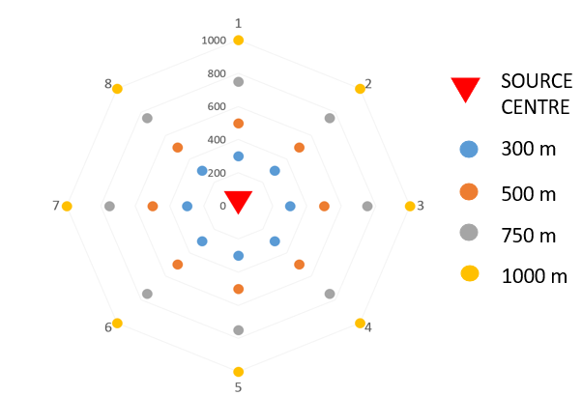

b.

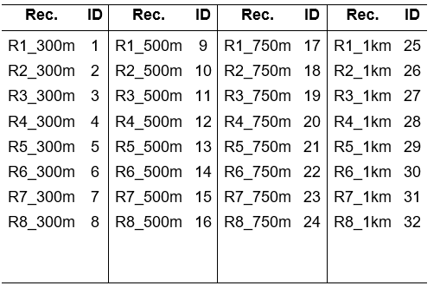

a.

* + 1. Sensitivity analysis

The proposed sensitivity analysis aims to quantify the influence on the model results related to a change in the investigated variables (i.e. σz0 for CALPUFF and Δz for SPRAY).

Concerning CALPUFF, σZ0 represents the initial vertical dimension of the area source plume, as sketched in Figure 2 (a). To set this parameter in Gaussian plume models, it is suggested dividing the vertical dimension of the source by a factor of 2.15 or 4.3, depending on the type of source (US EPA, 2011). However, AERMOD user’s guide specifies that in cases in which the emission may be turbulently mixed near the source and therefore occupy some initial depth, then the σZ,0 shall be set as to account for this initial vertical dimension of the emission (US EPA, 2011), although, unfortunately, it is not specified how to do that. Thus, it becomes crucial to investigate how the choice of different values of σZ,0, may affect the model results. In this work, the lowest investigated value for σz0 is 1 which is the lowest value accepted by the model. Then, it is progressively increased up to a value of 50 m, which corresponds to the length of the landfill divided by the suggested value of 4.3.

As far as SPRAY is concerned, a model specific parameter that has to be defined is Δz, the vertical dimension of the “emission parallelepiped”. As σz0 inCALPUFF, Δz represents the emission vertical dimension: SPRAY generates particles uniformly distributed on a parallelepiped centred in P (X0, Y0, Z0), the coordinates of the emission region centre of gravity, whose vertical dimension is Δz. In other words, this parallelepiped can be thought of as a box in which the particles initially appear. Thus, they are released in a vertical region from Z0– Δz/2 to Z0 + Δz/2, with Z0 coincident with the source height. Figure 2 (b) shows the emission parallelepiped (the purple box), highlighting its vertical dimension Δz and the source height hs.

hs

a.

b.

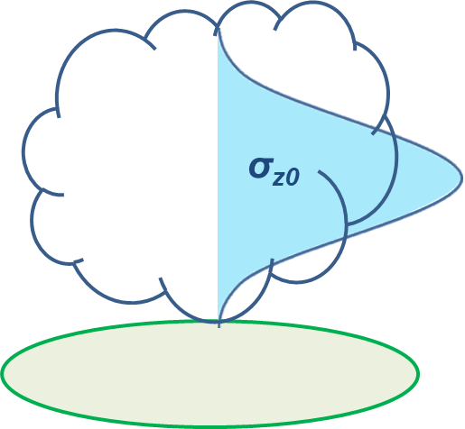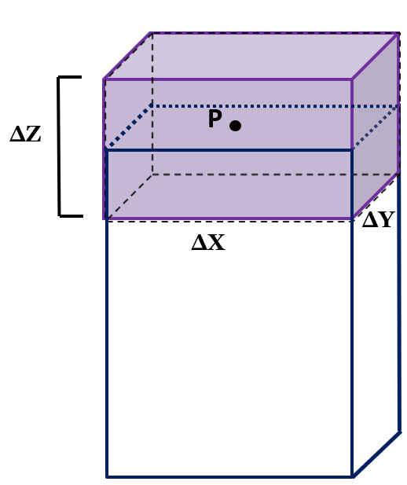

Figure 2: Sketch of the initial vertical dimension σZ0 of the Gaussian puff (a.) and of the emission parallelepiped (purple) with vertical dimension Δz and its position with respect to the emission source (b.)

Unfortunately, to identify a proper value for Δz no indications are available in literature or in the user’s guide. Thus, as for σZ,0 different scenarios are developed to investigate the influence of Δz. In particular, values of 0.2, 0.5, 1 and 2 m are assumed. To justify the selected scenarios, the landfill height should be considered: in view of the definition of Δz and setting an emission height of 1 m, it would be meaningless to assume a Δz value higher than 2 m. In doing so, it would mean that a portion of the “emission parallelepiped” is located underground. Then, from the maximum value (i.e. 2 m), Δz is decreased up to an order of magnitude (i.e. 0.2 m).

* 1. Results and critical discussion

As discussed in Paragraph 2.3, CALPUFF and SPRAY are run by setting different values for σZ,0 and Δz to evaluate their influence on the model output. The simulated odour concentrations resulting from the models are evaluated in terms of 98th percentile hourly peak odour concentration on the receptor grid, as suggested by the Italian guidelines. Figure 3 shows the maps of the 98th percentile values resulting from CALPUFF simulations by setting different values for σZ,0, i.e. 1, 5,10 and 50 m. In order to allow for comparison, the same scale are adopted for the different maps. Figure 4 shows the maps of the 98th percentile concentrations values resulting from SPRAY simulations by setting different values for Δz, i.e. 0.2, 0.5,1 and 2 m.

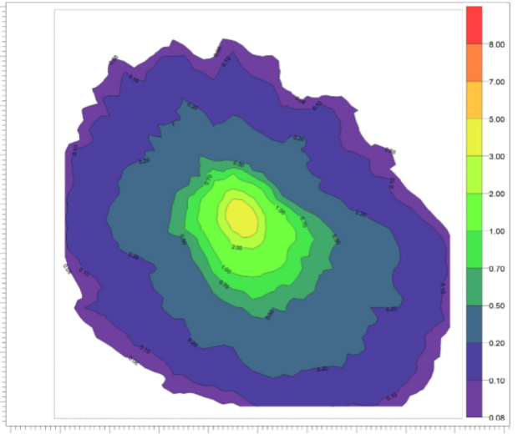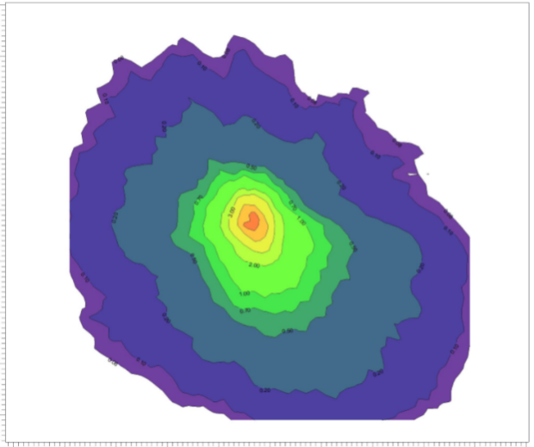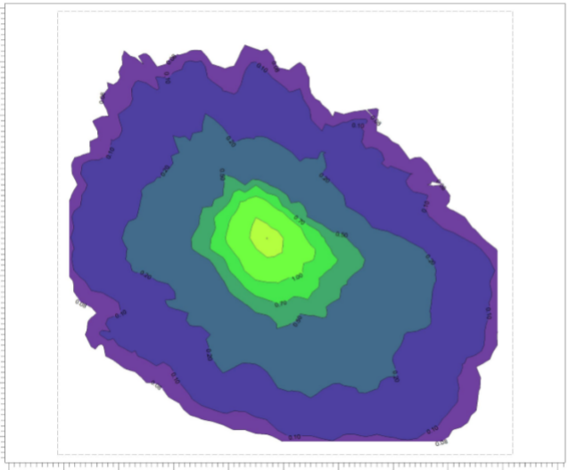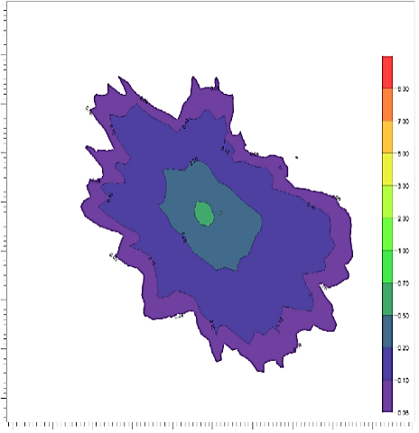

σz0=1 m

σz0=50 m

σz0=10 m

σz0=5 m

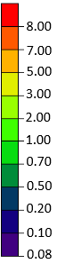

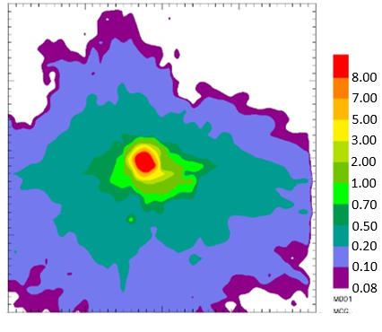Figure 3: Maps of the 98th percentile of the hourly peak concentrations resulting from CALPUFF simulations by changing the σZ,0

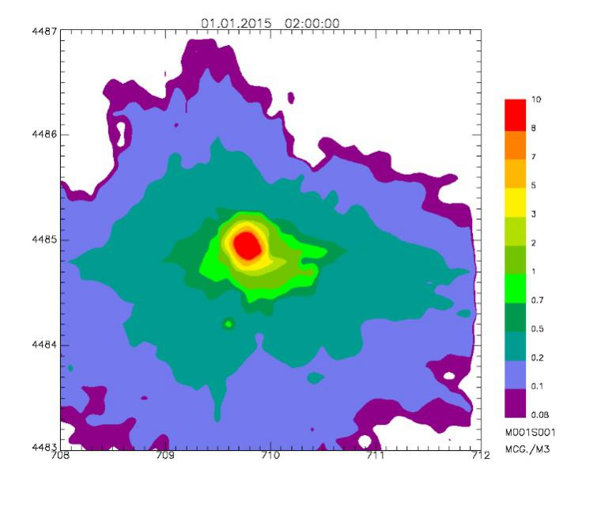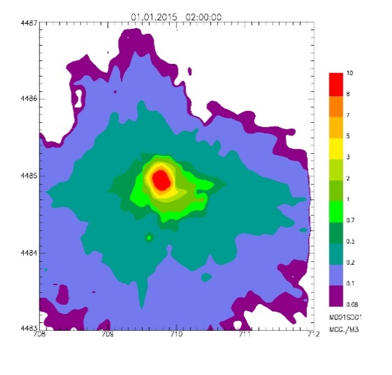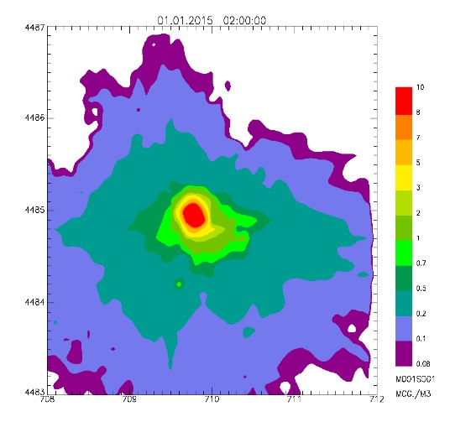

∆z=0.2 m

∆z=0.5 m

∆z=1 m

∆z=2 m

*Figure 4: Maps of the 98th percentile of the hourly peak concentrations resulting from SPRAY simulations by changing the Δz*

Comparing the concentration maps obtained by CALPUFF to those resulting from SPRAY, a different behaviour is observed. In the first case, the maps appear quite different showing a decrease in the odour concentrations as σZ,0 increases. Conversely, for SPRAY they appear almost equal to each other, suggesting a very little influence associated to Δz.

To highlight the different behaviour of the two models, the concentration values are computed on a set of different receptors located at different distances from the source (as discussed in section 2.2). In particular, Figure 5 shows the 98th hourly peak odour concentration values on the 32 receptors resulting from CALPUFF for the different investigated scenarios. The same is done for SPRAY in Figure 6.

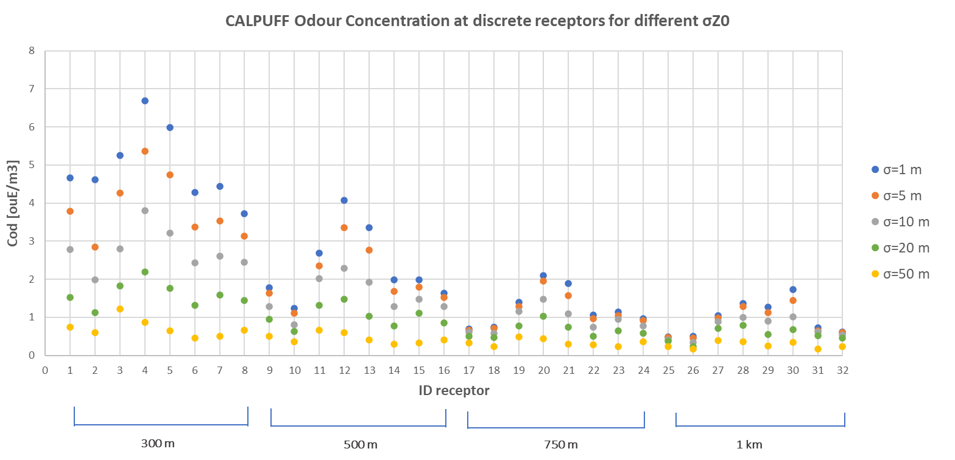

*Figure 5: 98th hourly peak odour concentrations at discrete receptors resulting from CALPUFF simulations by changing the σZ0*

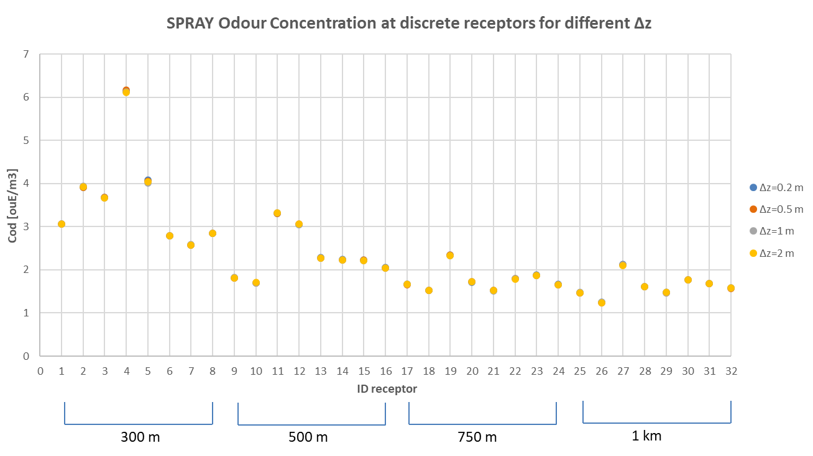

*Figure 6: 98th hourly peak odour concentrations at discrete receptors resulting from SPRAY simulations by changing the Δz*

The results shown in Figure 5 and Figure 6 highlight, for both models, a decrease in the simulated odour concentration moving far from the source, as would be expected since no plume rise occurs for this type of source (i.e. area source). Also, they confirm the results previously discussed for the concentration maps. For CALPUFF, an increase of the dispersion coefficient leads to a decrease of the ground concentration: higher initial dimension of the emission entails a higher dilution of the odour near the source, and thus a lower impact. In particular, when considering the receptors at 300 m from the source centre, by passing from a σZ,0 of 1 m to a σZ,0 of 50 m, the resulting concentration on the receptor decreases by a factor 5-6. This effect is less pronounced at higher distances from the source, whereby the decrease is about the half.

On the other hand, Figure 6 highlights almost equal concentrations for SPRAY regardless of the choice of Δz. By comparing the results obtained from the two models close to the source, where the main higher discrepancies are observed, it seems that medium values of σZ0 (i.e. 5 m or 10 m) are those resulting in the best fit between the two models.

* 1. Conclusions

When modelling the environmental effects of atmospheric pollution, many sources of imprecision and uncertainty should be taken into account. Depending on the model considered, there are numerous potential sources of variability, one of which is attributable to the input data required by the model. Since this uncertainty will be reflected in the final results, the main sources of variability should be identified and assessed. This paper aims to compare the sensitivity of CALPUFF model to the initial vertical dispersion coefficient σz0, with the sensitivity of the Lagrangian model SPRAY to Δz when modelling odour emissions from landfillsIndeed, since no indications relevant to suggested values for the investigated model parameters are available in literature or in the model guides, their definition is a critical issue.

From the results of this study, a different sensitivity of CALPUFF and SPRAY to the selected variables emerges. For the particle model, the Δz leads to negligible output variations. In particular, by changing this parameter of an order of magnitude (i.e. from 0.2 m to 2 m) the simulated concentrations are almost identical. Conversely, the analysis of the CALPUFF sensitivity to the initial vertical dispersion coefficient reveals that the odour concentration is significantly affected by σz0, with a maximum variation (i.e. a factor of 5-6) for receptors close to the emission source. However, even at higher distances the resulting concentration change by a factor of 2-3 increasing σz0 from 1 to 50 m. Thus, CALPUFF turns out to have high model uncertainty associated with the choice of the dispersion coefficient. This outcome is particularly interesting if considering that CALPUFF is often used to assess landfill odour impact for regulatory purposes. Indeed, it indicates that the choice of σz0, left to the professional judgement of the modellist, may result in the compliance or not of regulatory limits.

Another remarkable finding of this study is the general tendency of SPRAY to be in better agreement with the CALPUFF concentrations simulated by medium σZ0 values. However, this behaviour cannot be extrapolated to identify an optimal value of σz0 (i.e. the one which better fits real data), since, in order to assess the accuracy of the modelling results, the sensitivity analysis should be coupled with a model validation technique. Thus, a future challenge could be the development of an ad hoc trial to validate the result of this work.

References

Brancher M., Schauberger G., Franco D., Lisboa H., 2016, Odour Impact Criteria in South American Regulations, Chemical Engineering Transaction, 54, 169-174.

Brancher M., Schauberger G., Franco D., Lisboa H., 2017, A review of odour impact criteria in selected countries around the world, Chemosphere, 168, 1531-1570.

Capelli L., Dentoni L., Sironi S., Guillot J.M., 2012, Experimental Approach for the Validation of Odour Dispersion Modelling, Chemical Engineering Transactions, 40, 151-156.

Capelli L., Sironi S., 2018, Combination of field inspection and dispersion modelling to estimate odour emissions from an Italian landfill, Atmospheric Environment, 191, 273–290.

Daly A., Zannetti P., 2007, Air Pollution Modeling – An Overview, Chapter 2 of Ambient Air Pollution (P. Zannetti, D. Al-Ajmi, and S. Al-Rashied), The Arab School for Science and Technology.

Indumati S., Oza R.B., Mayya Y.S., Puranik V.D., Kushwaha H.S., 2009, Dispersion of pollutants over land-water-land surface: Study using CALPUFF model, Atmospheric Environment, 43 (2), 473-478.

Invernizzi M., Bellini A., Miola R., Capelli L., Busini V., Sironi S., 2019, Assessment of the chemical-physical variables affecting the evaporation of organic compounds from aqueous solutions in a sampling wind tunnel, Chemosphere 220, 353-361.

Invernizzi M., Brancher M., Sironi S., Capelli L., Piringer M., Schauberger G., 2020 a, Odour impact assessment by considering short-term ambient concentrations: A multi-model and two-site comparison, Environment International, 144, 105990.

Invernizzi M., Teramo E., Busini V., Sironi S., 2020 b, A model for the evaluation of organic compounds emission from aerated liquid surfaces, Chemosphere, 240, 124923.

Islam M.A., 1999, Application of a Gaussian plume model to determine the location of an unknown emission source, Water, Air and Soil Pollution, 112, 241-245.

Jung Y., Park W., Park O., 2003, Pollution dispersion analysis using the puff model with numerical flow field data, Mechanism Research Communications, 30(4), 277-286.

Kota S.H., Ying Q., Zhang Y., 2013, Simulating near-road reactive dispersion of gaseous air pollutants using a three-dimensional Eulerian model, Science of the Total Environment, 454-455, 348-357.

Lagzi I., Meszaros R., Gelybo G., Leelossy A., 2013, Atmospheric Chemistry, Eötvös Loránd University.

Leelossy A., Molnar F., Izsak F., Havasi A., Lagzi I., Meszaros R., 2014, Dispersion modelling of air pollutants in the atmosphere: a review”, Central European Journal of Geosciences, 6(3), 257-278.

Liu X., Godbole A., Lu C., Michal G., Venton P., 2015, Optimisation of dispersion parameters of Gaussian plume model for CO2 dispersion, Environmental Science and Pollution Research, 22, 18288-18299.

Murguia W., Pagans E., Barclay J., Scire J., 2014, Case Study: a Comparison of Predicted Odour Exposure Levels in Barcelona using CALPUFF Lite, CALPUFF NoObs and CALPUFF Hybrid Model, Chemical Engineering Transactions, 40, 31-36.

Naddeo V., Zarra T., Giuliani S., Belgiorno V., 2012, Odour Impact Assessment in Industrial Areas, Chemical Engineering Transactions, 30, 85-90.

Novozhilov V., 2001, Computational fluid dynamics modelling of compartment fires, Progress in Energy and Combustion Science, 27, 611-666.

Russel A., Dennis R., 2000, NARSTO critical review of photochemical models and modelling, Atmospheric Environment, 34, 2283-2324.

Santiago J.L., Martìn F., 2008, SLP-2D: A new Lagrangian particle model to simulate pollutant dispersion in street canyons, Atmospheric Environment, 42 (17), 3927-3936.

Scire J.S., Strimaitis D.G., Yamartino R.J., 2000, A user’s guide for the CALPUFF dispersion model, Earth Tech, Inc. Concord, Concord, MA.

Snidar R., Riesenmey C., Batton-Hubert M., Vaillant H., 2012, Odour-impact assessment around a landfill site from 2 weather-type classification, complaint inventory and 3 numerical simulation, Journal of Environmental Management, 93, 85-94.

Sozzi R., 2003, La micrometeorologia e la dispersione degli inquinanti in aria, APAT CTN-ACE, Roma.

Tagliaferri F., Invernizzi M., Sironi S., Capelli L., 2020, Influence of modelling choices on the results of landfill odour dispersion, Detritus Journal, 12, 92-99.

Tinarelli G., Giostra U., Ferrero E., Tampieri F., Anfossi D., Brusasca G., Trombetti F., 1992, SPRAY, a 3-D particle model for complex terrain dispersion, Proc. of 10th Symposium on Turbulence and Diffusion, American Meteorological Society, Portland, Oregon (USA), 29-Sept. 2-Oct, P2.9, 147-150.

US Environmental Protection Agency, 2011, Haul Road Workgroup final report to the Air Quality Modeling Group.

VDI (Verein Deutscher Ingenieure), 2011, VDI 3880, Olfactometry – Static Sampling. Beuth Verlag GmbH, Berlin, Germany.