CHEMICAL ENGINEERING TRANSACTIONS  VOL. 82,2020 | A publication of
The Italian Association
of Chemical Engineering
Online at www.cetjournal.it
Guest Editors: Selena Sironi, Laura Capelli
Copyright © 2020, AIDIC Servizi S.r.l.
ISBN 978-88-95608-80-8; ISSN 2283-9216

Odour Emission Rate estimation methods for hydrocarbon storage tanks
Marzio Invernizzi^{a,}*, Selena Sironiª
ª Politecnico di Milano, Department of Chemistry, Materials and Chemical Engineering “Giulio Natta”, Piazza Leonardo da Vinci 32, 20133 Milano, Italy
marzio.invernizzi@polimi.it
At the time to renew the Integrated Environmental Permit of oil refineries, Italian environmental institutions are nowadays requiring a detailed Odour Monitoring Program, based on the use of dynamic olfactometry and atmospheric dispersion modelling. Oil refineries are complex plants and many of the VOC emission are diffuse. Despite the difficulties of describing these emission phenomena, a characterization of these emissions is needed. The paper describes the state-of-the-art methodologies for the emissions from hydrocarbon tanks, and provides an overview of possible measures and methods useful to implement an accurate odour impact assessment from refineries tank farms.
  - Introduction
Oil refineries are complex industrial sites, composed by a lot of different process units and linked to each other through a wide range of possible configurations.
Emissions to atmosphere represent one of the most important environmental impact of the refineries’ process units. One of the raising issues about gaseous emissions is the estimation of the Volatile Organic Compounds, VOC, emission. Four main diffuse emissions sources can be identified within a refinery:
- Fugitive emissions from leaking equipment in the process area;
- Loading and unloading facilities, including road tankers, barges…;
- Wastewater treatment plants (WWTPs), where a gradual release of VOCs may occur at all water/air interfaces.
- Crude oil and products handling and storage. They typically represent 20-40 % of the refinery emissions (European Commission, 2015).
As concern the case of Italian refineries, in the last four years, at time to renew the Integrated Environmental Permit (Autorizzazione Integrata Ambientale, AIA), the authorities are requiring an odour monitoring program.
The purpose of odour monitoring program is the evaluation, the control and the analysis of the odour impact caused by the potential emission sources of the refinery, according a methodology based on the following phases:
- odour emission characterization and impact quantification, through the identification of the emitted odour units (ou_{E}/m³) and of the associated Odour Emission Rate, OER (ou_{E}/s);
- emissions’ odour impact assessment on the area, by atmospheric dispersion modelling.
As a matter of fact, a focus on the characterization of odour emission from these complex industries, due to the great relevance of diffuse emissions, is worthy. In particular, the present paper will focus on the characterization of the odour emission from hydrocarbon storage tanks: these equipment may produce the most significant amount of diffuse emissions within a refinery and, as requested by AIA, the assessment of the OER emitted by these systems appears mandatory.
The procedures for calculating emissions from hydrocarbon storage tanks with simulation models, according to the BREF REF (Refining of Mineral Oil and Gas) (European Commission, 2015), represent nowadays the only stable and repeatable method for estimating diffuse emissions from tanks. Other technologies, such as OGI (Optical Gas Imaging) and DIAL (DIfferential Absoption LIDAR), present difficulties due to unreliable quantification calibrations and the possibility of interference with nearby sources.
For the definition of the calculation procedures, it is common to use the correlations reported in the American US EPA protocol "AP-42: Compilation of Air Emissions Factors". In particular, Chapter 7 "Liquid Storage Tanks" (U.S. EPA, 2006), provides a series of correlations based on thermodynamic, chemical-physical, management and mass balance considerations, aimed at the quantitative description of the phenomena responsible for the evaporation of organic liquids stored in tanks. This protocol has undergone a series of improvements and revisions over time, which have made it possible to refine the calculation capabilities and resolve a series of limitations and approximations present in the calculations.
The most widespread and widely used version of the document is the one issued in 1997 (U.S. EPA, 1997), mainly in consideration of the fact that the freeware software TANKS 4.09D, released by the US EPA itself (U.S. EPA, 1999), should implement the correlations reported in the cited document. Unfortunately, a series of limitations in terms of compatibility with the most recent operating systems have led the U.S. agency to stop providing assistance. Moreover, the calculation tool also brings with it a series of misplaced chemical/physical considerations that may undermine its reliability.
The TANKS 4.09D simulation model is based on a series of input data, mass balances, thermodynamic equilibria hypothesis, and semi-empirical correlations. A scheme is reported in Figure 1.
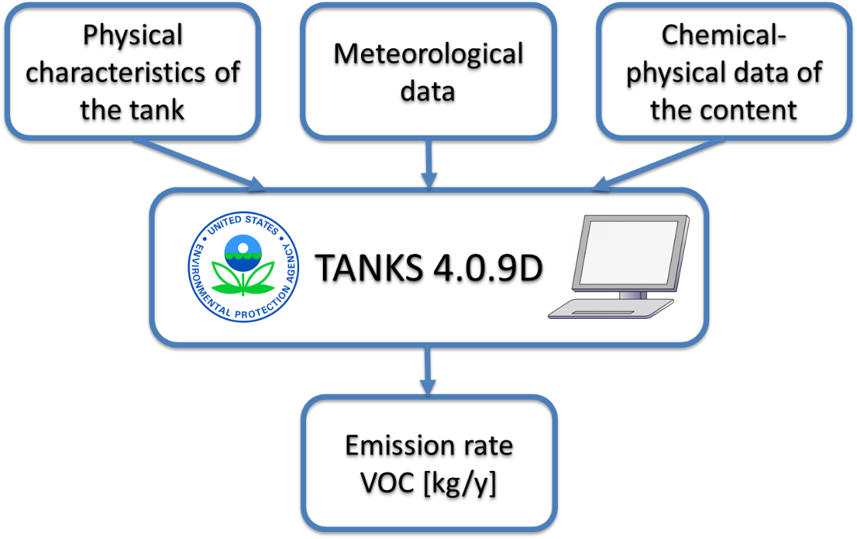
Figure 1: Input-output diagram of US EPA TANKS 4.09D simulation software
As any mathematical model based on physical considerations, in addition to the inherent uncertainty of some assumptions and correlations, it is also affected by the uncertainty (and possibly bias) of the required input. In order to provide a general overview of the model and the possible implementations for usage in the odour field, a brief description of the calculation mechanism is reported in the next paragraphs.
Regarding the case of tanks, first we must distinguish the two main kind: fixed roof tank and floating roof tank. The evaluation of the emission rate, ER, (and Odour Emission Rate, OER) cannot be the same due to the different structure and physics of the tanks type.
  - Fixed roof tanks
Fixed roof tanks (FRTs) are usually employed in refineries for storage of heavy products, such as diesel, bitumen and fuel oils. The upper part of their construction, i.e. the roof, is immobile in relation to the lower part, i.e. the shell. Their contents are normally characterized by low volatility and a true vapor pressure (TVP) of less than 14 kPa (U.S. EPA, 2006).
The VOC emissions typical of these tanks are:
- Filling Losses: in order for the tank to be filled, saturated vapour present inside the tank, above the stored liquid phase, is released into the atmosphere;
- Breathing Losses: the tank is fitted with air-release valves in order to compensate for the pressure and temperature differences generated from day to night.
For standard storage tanks (neglecting emergency or back-up units), the gaseous exchange due to handling of liquids in FRTs is much higher than the one due only to thermal expansion caused by temperature variation.
In Figure 2a is reported a real-case refinery contributions emission estimation. As it is clear to see, Filling Losses are higher in one order of magnitude with respect to Breathing Losses. This general behavior has been underlined by different studies (Elizaryev et al., 2020; Howari, 2015; Lu et al., 2013). Due to this, the focus in the following is put exclusively on Filling Losses.
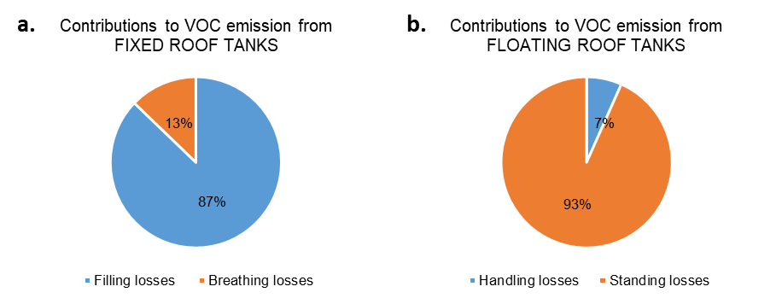
Figure 2: Distribution of the VOC emission contribution of a real-case refinery in Italy. 2a for FRTs; 2b for EFRTs.
    - FRT: U.S. EPA TANKS emission estimation
Eq(1) is widely used to estimate the Filling Losses L_{FILL} from FRTs (U.S. EPA, 2006):
$$L_{FILL}=M_{v}{∙P}_{VA}∙Q∙K_{N}∙K_{P}∙K_{D}$$ | (1)
Where M_{v} is the vapor molecular weight, P_{VA} is vapor pressure at average liquid surface temperature, Q is annual net throughput and K_{N}, K_{P}, K_{D} are empirical coefficients due to the saturation and liquid product and measurement units respectively. Essentially, this equation estimates the VOC emission linearly dependent to the amount of liquid sent into the tank (Q): the raise of the liquid level due to the filling operations, would lead to an increase of the headspace pressure.
    - FRT: OER estimation
Taking into consideration these vented point source emissions, since odour is emitted from a single point (through the vent), it is possible to conduct a simple olfactometric sampling, withdrawing a fraction of the conveyed air flow (Capelli et al., 2013). The evaluation of OER from FRTs is relatively simple (CEN, 2003):
$${OER}_{FRT} =Q_{air}∙C_{OD}$$ | (2)
Where Q_{air} is the volume flow rate at standard condition for olfactometry, and C_{OD} is the odour concentration.
At this point, the tricky problem is to assess the emitted airflow from the vent, Q_{air}. An anemometric measure would be impossible due to a not-isokinetic configuration of the valves; moreover, the emitted airflow is very variable due to the various logistic conditions of each tank.
Considering the narrow range of the pressure that can be usually found in these tanks (i.e. ± 100 mmH₂O), we can assume a volume equivalence of the liquid throughout and the emitted airflow rate, following what is proposed by U.S. EPA in Eq(1).
Usually, the annual throughput for each tank is an easily available data, due to its usage for AP-42 calculation: this can be useful for the determination of annual emission inventory, but it shed information crucial for the odour impact assessment. Odour nuisance is characterized by few peak events through the whole year (i.e. the limits are fixed as percentiles of odour hours over a year (Brancher et al., 2017, 2016)): an annual average emission describes scarcely the possible odour impact. This is particularly true for the storage tanks: the emission is due to filling and withdrawal requirement, making the real OER particularly variable.
The solution here proposed is to obtain the hourly level dataset from the Distributed Control System (DCS) of the refinery: by the variation of the level is possible to assess if the tank has been filled or not, and so calculate the emitted portion of the headspace into the atmosphere. A real-case example of the volume trend of a fuel oil FRT is reported in Figure 3a. As it is clear to understand, the emission from FRT is far from constant, and it is linked to few particular periods when the tank is filled.
By knowing the volume trend, it is then possible to obtain a dataset for the hourly-averaged air flowrate, calculated as the difference of the hourly-averaged liquid volumes. Of course, the emission is present only when the difference is positive (i.e. the amount of the stocked liquid increases).
With these airflow rate data, and by measuring a representative odour concentration of the emission (i.e. 120’000 ou_{E}/m³), with Equation 2 it is then possible to calculate the hourly variable OER.
In Figure 3b, green dots represent the obtained hourly, compared with the mean data (red) that would have been obtained using the annual throughput. Analysing the data, we can observe that, for the 44% of the hours, the emission flow rate is null (due to no changes of decrease in the liquid volume), and the 52% have an OER < 500 ou_{E}/s. The overall average is 2818 ou_{E}/s, while 90th, 98th and 99th percentile of the OER dataset are 5084, 15674 and 19701 ou_{E}/s respectively.

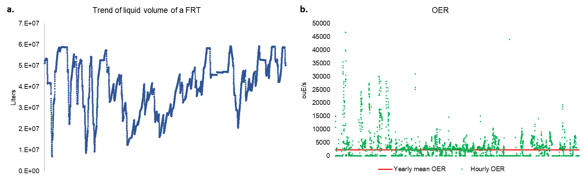
Figure 3: a. Real-case yearly trend of liquid volume of a refinery’s FRT. b. Comparison of variable (green) and constant (red) OER from FRT.
Due to this, the operation of annual averaging of all the loadings would lead to a strong underestimation of the possible odour impact that can derive from the operation of FRTs.
In order to obtain increasingly reliable odour impact assessments of oil refineries, especially due to the great relevance that these tools are gaining from permitting authorities, it appears strongly recommended to consider, for the calculation of the OER from FRTs, the hourly-average liquid trends, in order to avoid the obtainment of misleading odour dispersion modelling results.
  - Floating roof tanks
External Floating Roof Tanks (EFRTs) are constructed with the upper part, i.e. the roof, that lays on the liquid surface and therefore moves jointly with the liquid (U.S. EPA, 2006). Typically, the liquid contained in this type of tank is a light hydrocarbon with a vapour pressure above 14 kPa (European Commission, 2015). The roof floats on the stored liquid (e.g. mineral oil or gasoline) in order to prevent the formation of air-fuel mixtures, which could fall within the explosive limits of the mixture itself. Moreover, an EFRT can provide a 95% reduction in total losses compared to a FRT and therefore a consequent saving also in terms of product stocks (European Commission, 2015).
These tanks have different vapour losses with respect to FRTs, and they are related to:
- Standing Losses: losses from the rim seals and roof equipment. These are mainly influenced by the stock vapour pressure;
- Handling Losses: called also wall losses. During the emptying phase of the tank, a liquid film is left ‘clinging’ to the walls, and its evaporation causes emissions into the atmosphere.
In Figure 2b is reported a distribution of a real-case emission estimation from EFRTs of the cited refinery. Differently from the case of FRTs, for EFRTs the main contributions to the emission appears to be the Standing Losses (i.e. the evaporation through fittings and rim seal). This is due to the high vapour pressure of the mixtures usually stocked in EFRTs.
Despite the advantage of a sensible reduction of the VOC emission, in the case of EFRT none stream of conveyed emission is present: the emission is completely diffuse. This fact makes impossible the olfactometric sampling of an air portion representative of the emission: the European Standard EN13725:2003, is valid only for the measurement of the emission concentration, and not for the ambient odour concentration (CEN, 2003). A solution is found in the assessment of the experimental parameter HCOEC (Invernizzi et al., 2018). This parameter represents the quantity of odour (ou_{E}) that can be associated to the evaporation of a certain quantity of hydrocarbon mixture (kg).
By coupling this experimental parameter and the emission estimation due to thermodynamic simulations (U.S. EPA, 2006), it is then possible to estimate the OER from EFRT:
$${OER}_{EFRT}\left[\frac{{ou}_{E}}{s}\right]=L_{tot}\left[\frac{kg}{s}\right]∙HCOEC\left[\frac{{ou}_{E}}{kg}\right]$$ | (3)
Where L_{tot} is the estimated total hydrocarbon mass losses from the tank and HCOEC is the Hydrocarbon Odour Emission Capacity stored in the considered tank.
    - EFRT: U.S. EPA TANKS emission estimation
As mentioned, Standing Losses from EFRTs (rim seal and deck fitting losses) are independent from tank logistics but are due to the vapour pressure of the stored liquid. As it is easy to imagine, the vapour pressure is temperature-dependent, and it is theoretically calculated at the liquid surface temperature.
For this calculations U.S. EPA provide different libraries: historically, the vapour pressure data were provided only for discretized points (U.S. EPA, 2006, 1997). The modelling software TANKS 4.09D used to interpolate these data to estimate P_{VA}. The huge problem was that if the temperature was higher than 100 °F (~38 °C), the vapour pressure used for the calculations was the maximum available, and so the one at 100 °F.
Despite this, in the case of real heated tanks, the storage temperature can reach also 100 °C (212 °F): in these situations, the mass flux estimation, obtained by the cited thermodynamic model, would lead to a strong underestimation.
To fix this shortcoming, a new version of AP-42 protocol was recently released (U.S. EPA, 2020): the new version of the protocol provides analytical 2-parameters Antoine’s equation, instead of discretized points, to calculate P_{VA}.
Despite this theoretical improvement, the software TANKS 4.09D still incorporates the old discretized dataset (U.S. EPA, 1997), and nevertheless is often still used for the assessment of VOC emission inventory.
This choice can be acceptable when the tanks are maintained at ambient temperature, but would provide underestimated results in the case of heated tanks.
In order to assess the importance of the implementation of the new correlations for the calculation of vapour pressure, an algorithm was developed in order to implement all the correlations of the recent AP-42 protocol (U.S. EPA, 2020), and compare it with the old correlations of TANKS 4.09D (U.S. EPA, 1997). For the calculations, real-case data were used, in terms of meteorology, logistics, dimensions and physical data.
The results are reported in Table 1, grouped for hydrocarbon cut categories.
Table 1: Emission estimation comparison between TANKS 4.09D and new protocol AP-42 (U.S. EPA, 2020)
Cut | N EFRTs | (U.S. EPA, 2020) L_{tot} [kg/y] | TANKS 4.09D  L_{tot} [kg/y] | Under  estimation | Average stock temperature [°C]
Crude oil RVP 5 | 10 | 30025 | 30025 | 0% | 30
Motor Gasoline RVP 7 | 9 | 60169 | 60169 | 0% | 25
Motor Gasoline RVP 10 | 9 | 89827 | 89827 | 0% | 25
Motor Gasoline RVP 13 | 1 | 16907 | 16907 | 0% | 25
Jet naphtha (JP-4) | 9 | 16957 | 16413 | 3% | 26
Jet kerosene | 9 | 542 | 533 | 2% | 27
Distillate fuel oil No. 2 | 30 | 2485 | 1753 | 29% | 41
No. 6 fuel oil | 12 | 889 | 386 | 57% | 64
TOTAL | 89 | 217801 | 216014 | 1% | 37
The overall estimation of the VOC flux from EFRT seems not to be very sensitive to the new method for the calculation of the vapour pressure: the greatest amount of VOC emission is due to light mixture (e.g. gasolines) because of their high vapour pressure. In order to minimize VOC emission, their stock temperature is always less than 37°C. In these cases, the use of Antoine’s equation does not affect the results perceptibly.
On the other hand, the oil cut which are stored at high temperature (up to 80°C), like fuel oil, show high differences with the use of new correlations: it is clear that the vapour pressure, calculated at the real temperature of each tank, is much higher than the maximum available at 100 °F (U.S. EPA, 2006).
Due to these findings, in order to correctly calculate the emission from heavy hydrocarbon tanks, it is strongly recommended the use of most recent AP-42 correlations, in order to consider the proper vapour pressure, above all in case of heated tanks.
    - EFRT: The problem of emission averaging time
Despite the importance of the averaging time on OER, discussed in Section 2.2, for FRTs, all AP-42 protocols state (U.S. EPA, 2020, 1997) :
“All of the emission estimation procedures […] can be used to estimate emissions for shorter time periods by manipulating the inputs to the equations for the time period in question […]. It is important to note that a 1-month time frame is recommended as the shortest time period for which emissions should be estimated using these methodologies”.
Differently from FRT’s correlations, that consider a vapour-liquid equilibrium and a mass balance for the emission, the equations for EFRT are completely semi-empirical. The development of these data was based on long lasting campaigns, thus appears reasonable the indication of monthly calculations as the shortest as possible.
In this way, the use of monthly data is recommended particularly in case of not-heated tanks. As reported in Figure 4, a not-insulated, not-heated jet-naphtha tank may vary its stock temperature by 25 °C during the year, meaning a variation VOC emission by a factor 2.
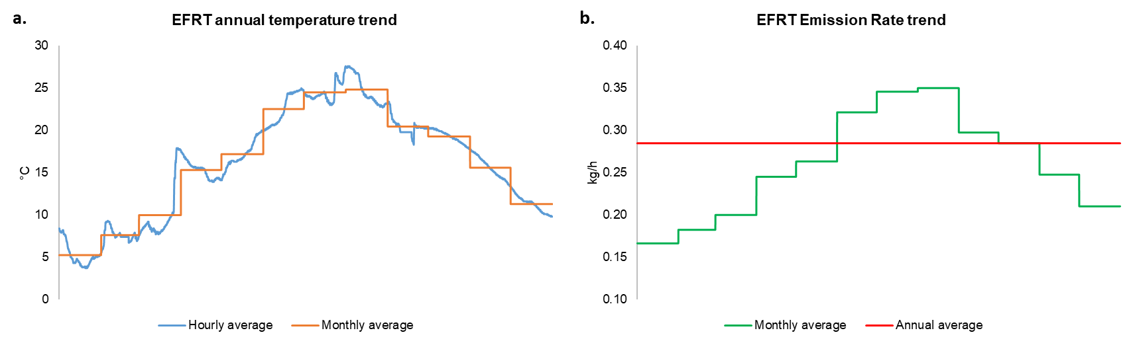
Figure 4: a. Real-case jet naphta EFRT annual temperature trend. b. Real-case jet naphtha EFRT annual VOC emission trend
  - Conclusions
Thermodynamic modelling represents the state of the art for the quantification of VOC ER from hydrocarbon tanks. The correlations, proposed by U.S. EPA, have undergone a number of revisions over the years.
In the case of FRT, the olfactometric characterisation is feasible with a sampling at the vent. In order to obtain an OER trend as accurate as possible, the emission should be linked to the hourly change of the liquid level. This approach avoids the risk of an overall emission average that could shed possible odour events.
In EFRT, only diffuse emissions are present: in this instance, only an indirect approach is possible, coupling an experimental parameter, HCOEC, and VOC ER estimation. Monthly temperature variation can lead to a variation in ER by a factor 2: the consideration of a monthly trend is crucial for odour impact assessment.
References
Brancher, M., Griffiths, K.D., Franco, D., de Melo Lisboa, H., 2017. A review of odour impact criteria in selected countries around the world. Chemosphere 168, 1531–1570. https://doi.org/10.1016/j.chemosphere.2016.11.160
Brancher, M., Schauberger, G., Franco, D., De Melo Lisboa, H., 2016. Odour impact criteria in south American regulations. Chem. Eng. Trans. 54, 169–174. https://doi.org/10.3303/CET1654029
Capelli, L., Sironi, S., del Rosso, R., 2013. Odor sampling: Techniques and strategies for the estimation of odor emission rates from different source types. Sensors (Switzerland) 13, 938–955. https://doi.org/10.3390/s130100938
CEN, 2003. EN 13725:2003 - Air quality - Determination of odour concentration by dynamic olfactometry. https://doi.org/https://dx.doi.org/10.31030/3036135
Elizaryev, A., Tarakanov, Dmitry, Aksenov, S., Tarakanov, Denis, Elizareva, E., Nasyrova, E., Nazyrov, A., 2020. Influence of seasonal changes in climatic conditions on losses at oil tanks filling (on example of the Republic of Bashkortostan). E3S Web Conf. 175. https://doi.org/10.1051/e3sconf/202017512021.
European Commission, 2015. Best Available Techniques (BAT) Reference Document for the Refining of Mineral Oil and Gas. https://doi.org/10.2791/010758
Howari, F.M., 2015. Evaporation losses and dispersion of volatile organic compounds from tank farms. Environ. Monit. Assess. 187, 273. https://doi.org/10.1007/s10661-015-4456-z
Invernizzi, M., Ilare, J., Capelli, L., Sironi, S., 2018. Proposal of a method for evaluating odour emissions from refinery storage tanks. Chem. Eng. Trans. 68, 49–54. https://doi.org/10.3303/CET1868009
Lu, C., Huang, H., Chang, S., Hsu, S., 2013. Emission characteristics of VOCs from three fixed-roof p-xylene liquid storage tanks. Environ. Monit. Assess. 185, 6819–6830. https://doi.org/10.1007/s10661-013-3067-9
U.S. EPA, 2020. Emission Factor Documentation for AP-42 Organic Liquid Storage Tanks Final Report.
U.S. EPA, 2006. Emission Factor Documentation for AP-42 Organic Liquid Storage Tanks Final Report.
U.S. EPA, 1999. User’s guide to TANKS Storage Tank Emissions Calculation Software Version 4.0.
U.S. EPA, 1997. Emission Factor Documentation for AP-42 Organic Liquid Storage Tanks Final Report.

