|  |  |
| --- | --- |
| cetlogo ***CHEMICAL ENGINEERING TRANSACTIONS***  ***VOL. 82,2020*** | A publication of  aidiclogo_grande |
| The Italian Association  of Chemical Engineering  Online at www.cetjournal.it |
| Guest Editors: Selena Sironi, Laura Capelli  Copyright © 2020, AIDIC Servizi S.r.l. **ISBN** 978-88-95608-80-8; **ISSN** 2283-9216 | |

Influence of wind velocity on the emission rate of acetone aqueous solution at different concentrations

Francesca Tagliaferria, Marzio Invernizzia,\*, Selena Sironia

a Politecnico di Milano, Department of Chemistry, Materials and Chemical Engineering “Giulio Natta”, Piazza Leonardo da Vinci 32, 20133 Milano, Italy

marzio.invernizzi@polimi.it

The characterization of passive liquid area sources for the study of Volatile Organic Compounds (VOCs) emission is a matter of great concern. The volatilization of these compounds, which very often cause odour annoyance, is a complex phenomenon, being potentially affected by different parameters. For instance, a parameter of great concern is represented by the wind velocity since the convective mechanism, promoted by the wind, represents the driving force of the emission. In view of this, the present paper aimed at investigating the influence of wind velocity on the emission rate of VOCs from liquid surfaces. In particular, acetone is selected as tested compound manly because of its high aqueous solubility. Using this approach, it is possible to test a wide range of concentrations and, consequently, to investigate whether the wind velocity influences the emission rate in a different way by changing the concentration in water. From this experimental study, it turns out that the investigated parameter does not significantly affect the emission when considering low concentrations of acetone (i.e. below 5 mL/L), whereas this dependence increases, not linearly, while increasing the concentration in liquid phase. Due to this, the approach suggested by the Italian guidelines to take into account a dependence of the odour emission rate on the square root of the wind velocity appears quite consistent with the experimental results obtained at higher concentrations, whereas in more diluted conditions the regulatory approach seems too conservative, with the risk of overestimating the emission rate excessively.

* 1. Introduction

In view of improving life quality and people wellness, odour emissions from sewerage systems and wastewater treatment plants (WWTPs) are becoming a matter of public concern in the last decades (Dincer and Muezzinoglu, 2008; Jiang et al., 2017). Citizens’ complaints resulting from the impacts of such emissions are frequent (Zarra et al., 2008) and the task of ensuring that plant activities are compatible with neighbouring land use is a responsibility of regulatory authorities. For this reason, odours are nowadays subject to control and regulation in many countries.

To assess the odour impact on nearby population, many odour regulations all over the world suggest the application of atmospheric dispersion models (Brancher et al., 2016; Brancher et al., 2017). However, for passive liquid area sources, as this is the case of wastewater treatment tanks, the estimation of a proper emission rate, a fundamental input datum for the modelling study, represents a challenging task for two main reasons.

To quantify this parameter, a preliminary step of odour sampling is required in order to evaluate the odour concentration associated to the source. Up to now, a well-established methodology for the sampling of odour emissions from passive liquid area sources is still debated issue. However, this topic is not addressed in this work, since it has been the subject of previous studies (Lucernoni et al., 2016).

In addition, the release of VOC compounds from this type of sources and their dispersion into the atmosphere represents a phenomenon of complex characterization being potentially affected by different chemical and physical parameters (Invernizzi et al., 2020; Hudson and Ayoko, 2008; Blunden and Aneja, 2007). For instance, a parameter of great concern is represented by the wind velocity since the convective mechanism promoted by the wind represents the driving force of the emission (Watson et al., 1991; Bianchi and Varney, 1996; Upstill-Goddard et al.; 1989).

At the same time, while the behaviour of pure compounds has been widely investigated (Lucernoni et al., 2017; Montes et al., 2010), the scientific and technical literature is quite deficient regarding the emission of VOCs in aqueous solutions.

Currently, there are some studies concerning the influence of wind velocity on the evaporation from liquid surfaces (Invernizzi et al., 2019; Parker et al., 2010; Fingas, 1998; Mihelcic et al., 1993; Jiang and Kaye, 1996). Overall, they propose the existence of two different films at the gas-liquid interface. Depending on which film provides the main resistance to VOC molecules, a different mechanism governs the mass transfer.

In some cases, VOC diffuses rapidly inside the liquid phase reaching the interface in short time. Here, the mass transfer mechanism is mainly controlled by the VOC stripping due to the forced convection promoted by the wind velocity. Parker identifies these compounds as “gas phase controlled” (molecule A in Figure 1).

On the contrary, the emission of molecules, which encounter the major resistance inside the liquid film, should not be affected by the air velocity (compounds referred to as “liquid phase controlled”, molecule B in Figure 1).

Then, there are some species with an intermediate behaviour, the so-called “gas-liquid phase controlled” compounds (molecule C in Figure 1).

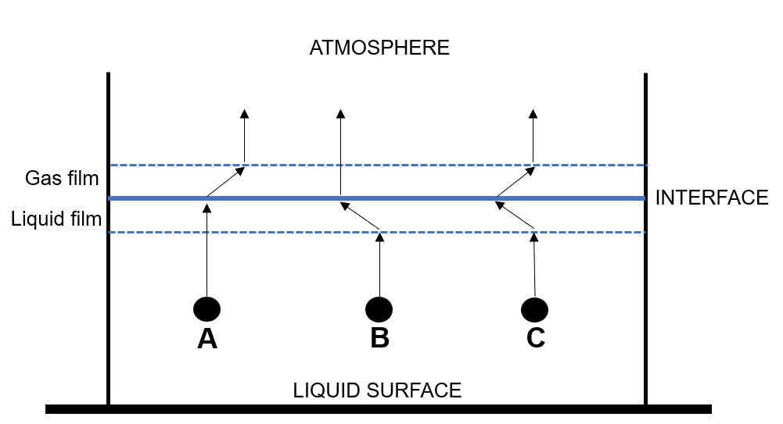

Figure 1: Schematic diagram of the two-film model, representing the emission from a liquid surface of a gas phase controlled molecule (A), liquid phase controlled molecule (B) and a molecule with intermediate behaviour (C).

In particular, Parker enlists a series of the main VOCs and divides them into the three different categories identifying the Henry ’s constant as the major discriminant for the classification.

For Henry constant $K_{H}^{CC}$ values lower than 10-3 the main resistance to transport is located in the gas film (gas phase controlled); if $K_{H}^{CC}$ is higher than 10-1 the compounds are liquid phase controlled; for intermediate values, both of the phases have a strong influence on the volatilization process (for more detail about Henry's law and constants see Sander, 2015).

The guidelines currently available in Italy in the field of odour regulation generally suggest taking into account a dependence of the odour emission rate on the square root of the wind velocity. However, in Lombardy Region, the proposed regulatory approach points out that “other methods to account for the influence of wind velocity may be adopted if justified by scientific evidence”. In addition, in the technical standardization of some regions (e.g. Legge Regionale Puglia n.32, 16 Luglio 2018) the dependence from the air velocity is not mentioned at all. Thus, a universally accepted methodology has not been defined yet and the evaluation is partially left to the professional judgement of the researcher.

In view of this, the present paper discusses an experimental study aimed at investigating the influence of wind velocity on the emission rate of VOCs from liquid surfaces. For the purpose of this study, the behaviour of acetone in solution with water is examined by varying the air velocity inside a low speed wind tunnel system in a range from 0.02 m/s to about 0.06 m/s.

According to the definition proposed by Parker, acetone is a “gas-liquid phase controlled” compound. Indeed, considering the values reported in Sander et al. (2011), it has a $K_{H}^{CC}$ slightly higher than 10-3. Therefore, differently from “gas phase controlled” and “liquid phase controlled” species, acetone should not exhibit a “well defined” behaviour in response to a variation of wind velocity. Thus, the investigation of the influence of air velocity on the emission rate of acetone appears interesting.

Anyway, the choice to test this species is mainly justified by its high aqueous solubility that allows to test a wide range of concentrations. In this way, it is possible to investigate whether the wind velocity influences the emission rate in a different way by changing the concentration in water.

The findings of this work represent an interesting outcome for setting up an odour dispersion modelling study, enriching the scientific debate about the knowledge of these emission phenomena, thereby allowing the implementation of emission rates more consistent with the experimental evidence.

* 1. Materials and methods

As mentioned in the previous paragraph, thanks to its high aqueous solubility, acetone is tested in solution with water at four different concentrations: 0.5 mL/L, 5 mL/L, 50 mL/L and 500 mL/L. In particular, for each concentration, three different air flow rates are investigated (i.e. 1500 sL/h, 2500 sL/h, 4000 sL/h), representative of different wind velocities ranging under the wind tunnel from 0.02 m/s to 0.06 m/s.

The wind tunnel device adopted for this experimental study has a central body with a base area of 0.125 m2 and it was developed by the olfactometric laboratory of Politecnico di Milano, fully described by Capelli et al. (2009) and sketched in Figure 2.

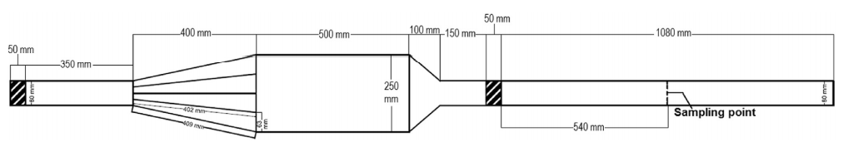

Figure 2: Wind tunnel device adopted for the experimental tests

This hood has an open bottom to be placed over the emissive surface, realized by introducing the tested compound in solution with water inside a [polyethylene](https://context.reverso.net/traduzione/inglese-italiano/polyethylene) container with a capacity of 4 L. A known amount of neutral air flow rate, coming from the compressed air line of the laboratory, is flushed through the wind tunnel device by means of a mass flow regulator. In this way, it is possible to simulate the real emission conditions of liquid area sources promoted by natural ventilation. In order to collect a gaseous sample of the investigated compound at the outlet section, a PET tube is used to connect the outlet of the wind tunnel with a Nalophan® bag (3L of capacity) and a vacuum pump enables the air blown thorough the hood to fill the sampling bag.

For each sample the outlet concentration is measured by means of a portable photoionization detector (PID), ION Tiger LT, since it ensures a reliable response quickly.

It is worth underlining that for each test (i.e. different concentrations and flow rates) three gaseous samples are collected in order to reduce the random error on measured concentration values as much as possible.

Finally, to quantify the emission rate, the measured concentration is multiplied by the flow rate passing through the wind tunnel.

* 1. Results and critical discussion

In this section the results obtained testing different concentrations of acetone in water at different flow rates are presented. For all the experiments, the trend of the emission rates as a function of wind velocity is reported (Figure 3). As previously mentioned, all the samples are collected three times, in order to evaluate the repeatability of the obtained data: the yellow dots on the graphs for each figure report each experimental result whereas the blue dots represent the average values.

In addition, in each plot, the trend line (power line) is drawn highlighting the corresponding equation.

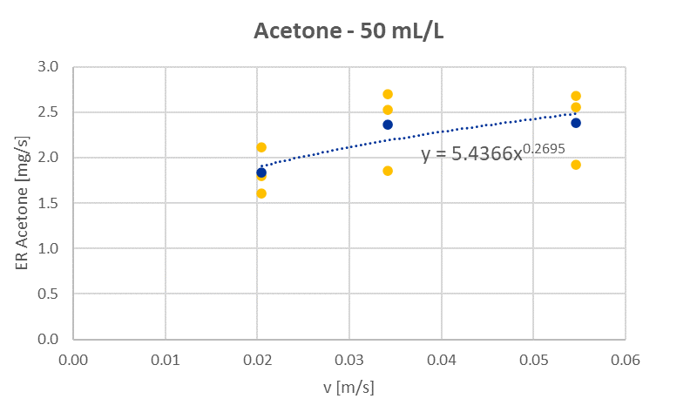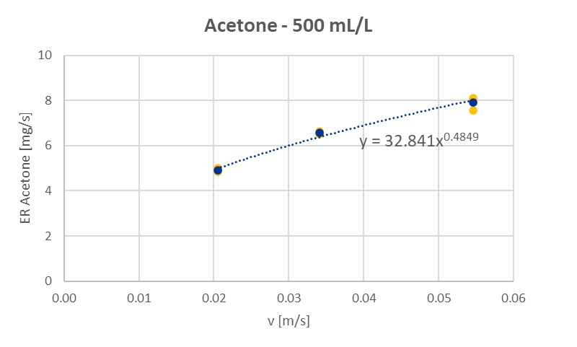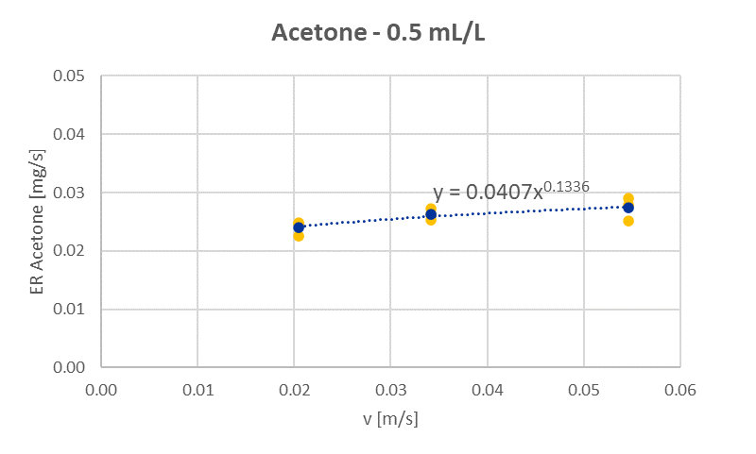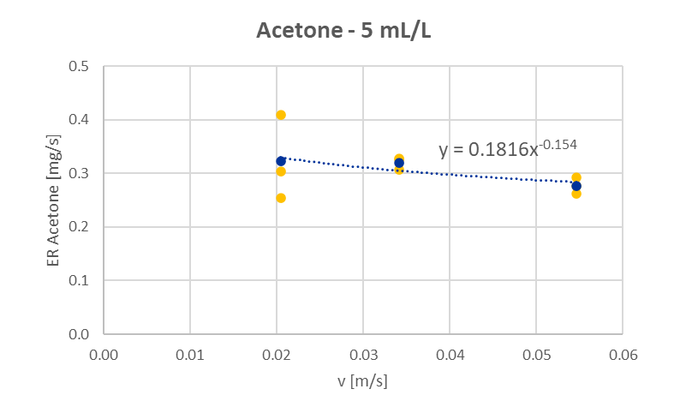

a.

b.

c.

d.

Figure 3: Emission rate of acetone in aqueous solution as a function of air velocity considering a concentration of 0.5 mL/L (a.), 5 mL/L (b.), 50 mL/L (c)., 500 mL/L (d.)

Comparing the different plots, it seems that the influence of wind velocity on the emission rate of acetone is strictly connected to the concentration of VOC dissolved in water. To clarify this, it is interesting to look at the trend line, observing the power exponent to which the independent variable (i.e. air velocity) is elevated. These coefficients, reported in Table 1, are an indication of how much the wind velocity affects the emission rate.

Table 1: Power coefficients of the equations associated to the trend lines obtained for the different investigated concentrations

|  |  |
| --- | --- |
| Acetone concentration [mL/L] | Power coefficient |
| 0.5 | 0.13 |
| 5 | - 0.15 |
| 50 | 0.27 |
| 500 | 0.49 |

Table 1 reports the exponent obtained using a power-law regression of the experimental data: a non-linear increase of the power coefficient at higher concentrations is obtained. More in detail, at low concentrations (i.e. 0.5 mL/L and 5 mL/L) the influence of wind velocity on emission rate appears not or slightly significant, whereas this dependence increases, not linearly, while increasing liquid concentrations.

In view of this, the approach suggested by the Italian guidelines to take into account a dependence of odour emission rate on the square root of the wind velocity appears quite consistent with the experimental results obtained at higher concentrations, where the behaviour of the solution does not deviates too much from that of a pure compound.

However, in more diluted conditions, which is commonly the case of real emission phenomena of wastewater tanks, the proposed regulatory approach appears too conservative, with the risk of excessively overestimate the emission rate.

Finally, it is worth highlighting the sign of the power coefficient. Indeed, when considering the experimental tests at high concentration (i.e. 50 mL/L and 500 mL/L), which are the situations where a significant influence of the wind velocity is detected, the power exponent is always positive, meaning that an increase in the wind velocity results in an increase of the emission rate.

* 1. Conclusions

Many odour regulations all over the world are defined based on the application of dispersion modelling. However, to obtain reliable results from the modelling study, a fundamental input datum is represented by the emission rate whose estimation, in some situations, represents a challenging task.

This experimental study arises from this intent. It evaluates the influence of wind velocity on the emission rate of acetone in aqueous solution. More in detail, a wide range of concentrations (i.e. 0.5 mL/L – 500 mL/L) of the investigated VOC in solution with water is examined with the aim to find out whether the air velocity influences the emission rate in a different way by changing the concentration in water.

From the results of this study, it turns out that, at low concentration values (i.e. <= 5 mL/L), the investigated parameter does not significantly affect the emission rate. However, increasing the concentration, the effect produced by the wind velocity increased in a not linear way.

In view of this, the regulatory approach recommended by the Italian guidelines to implement an odour emission rate dependent on the square root of the wind velocity seems quite consistent with the experimental results obtained at higher concentrations. Conversely, for more diluted conditions, this approach seems too conservative, with the risk of excessively overestimate the emission rate.

This work represents a preliminary step to the deepening of the knowledge about the emission of VOCs in solution with water thereby implementing a more accurate dispersion modelling study.

Anyway, further studies are certainly needed to better understand the effect of other parameters, such as humidity and temperature, on the atmospheric emission of different compounds from liquid solutions.

Other interesting future development might involve the study of compounds which, according to the literature, should exhibit different behaviour (i.e. liquid phase controlled vs. gas phase controlled) with respect to wind velocity.

Finally, a future challenge should be focused on the development of a theoretical model able to predict an emission rate consistent with open-field experimental evidence.

References

Bianchi, A.P., Varney, M.S., 1997, Volatilisation processes in wastewater treatment plants as a source of potential exposure to vocs. Ann. Occup. Hyg. 41, 437-454.

Blunden J., Ajena V.P., 2008, Characterizing ammonia and hydrogen sulfide emissions from a swine waste treatment lagoon in North Carolina, Atmospheric Environment, 42, 3277–3290.

Brancher M., Schauberger G., Franco D., Lisboa H., 2016, Odour Impact Criteria in South American Regulations, Chemical Engineering Transaction, 54, 169-174.

Brancher M., Schauberger G., Franco D., Lisboa H., 2017, A review of odour impact criteria in selected countries around the world, Chemosphere, 168, 1531-1570.

Capelli L., Sironi S., Del Rosso R., Centola P., 2009, Design and validation of a wind-tunnel system for odour sampling on liquid area sources, Water Science and Technology, 59, 1611-1620.

Dincer F., Muezzinoglu A., 2017, Odor-causing volatile organic compounds in wastewater treatment plant units and sludge management areas, Journal of Environmental Science and Health Part A, 43:13, 1569-1574, 2008.

Fingas M.S., 1998, Studies on the evaporation of crude oil and petroleum products II. Boundary layer regulation, Journal of Hazardous Material, 57, 41-58.

Hudson, N., Ayoko, G.A., 2008, Odour sampling. 2. Comparison of physical and aerodynamic characteristics of sampling devices: A review, Bioresource Technolology, 99 (10).

Invernizzi M., Bellini A., Miola R., Capelli L., Busini V., Sironi S., 2019, Assessment of the chemical-physical variables affecting the evaporation of organic compounds from aqueous solutions in a sampling wind tunnel. Chemosphere 220, 353-361.

Invernizzi M., Teramo E., Busini V., Sironi S., 2020, A model for the evaluation of organic compounds emission from aerated liquid surfaces, Chemosphere 240, 124923.

Jiang G., Melder D., Keller J., Yuan K., 2017, Odor emissions from domestic wastewater: A review, Critical Reviews in Environmental Science and Technology, 47:17, 1581-1611.

Jiang K., Kaye R., 1996, Comparison study on portable wind tunnel system and isolation chamber for determination of vocs from areal sources, Water Science and Technology, 34, 583-589.

Lucernoni F., Capelli L., Sironi S., 2016, Odour Sampling on Passive Area Sources: Principles and Methods, Chemical Engineering Transactions 54, 55-60.

Lucernoni, F., Capelli, L., Busini, V., Sironi, S., 2017, A model to relate wind tunnel measurements to open field odorant emissions from liquid area sources, Atmospheric Environment, 157, 10-17.

Mihelcic J.R., Baillod C.R., Crittenden J.C., Rogers T.N., 1993, Estimation of VOC Emissions from Wastewater Facilities by Volatilization and Stripping, Air & Waste, 43:1, 97-105.

Montes, F., Hafner, S.D., Rotz, C.A., Mitloehner, F.M., 2010. Temperature and air velocity effects on ethanol emission from corn silage with the characteristics of an exposed silo face. Atmospheric Environment, 44, 1987-1995.

Parker D.B., Caraway E.A., Rhoades M.B., Cole N.A., Todd R.W., Casey K.D., 2010, Effect of Wind Tunnel Air Velocity on VOC Flux from Standard Solutions and CAFO Manure and Wastewater, ASABE 53 (3), 831-845.

Sander R., 2015, Compilation of Henry's law constants (version 4.0) for water as solvent, Atmospheric Chemistry and Physics, 15, 4399-4981.

Sander S. P., Abbatt J., Barker J.R., Burkholder J. B., Friedl R.R., Golden D.M., Huie R.E., Kolb C.E., Kurylo M.J., Moortgat G.K., Orkin V.L., Wine P.H., 2011, Chemical Kinetics and Photochemical Data for Use in Atmospheric Studies, Evaluation No. 17, JPL Publication 10-6, Jet Propulsion Laboratory, Pasadena.

Upstill-Goddard R.C., Watson A.J., Liss P.S., Liddicoat M.I.,1990, Gas transfer velocities in lakes measured with SF6, Tellus, 42B, 364-377.

Watson A.J., Upstill-Goddard R.C., Liss P.S., 1991, Air-sea gas exchange in rough and stormy seas measured by a dual-tracer technique, Nature, 349, 145-147.

Zarra T., Naddeo V., Belgiorno V., Reiser M. and Kranert M., 2008, Odour monitoring of small wastewater treatment plant located in sensitive environment, Water Science and Technology. 58(1), 89-94.