|  |  |
| --- | --- |
| cetlogo ***CHEMICAL ENGINEERING TRANSACTIONS***  ***VOL. 82, 2020*** | A publication of  aidiclogo_grande |
| The Italian Association  of Chemical Engineering  Online at www.cetjournal.it |
| Guest Editors: Selena Sironi, Laura Capelli  Copyright © 2020, AIDIC Servizi S.r.l. **ISBN** 978-88-95608-80-8; **ISSN** 2283-9216 | |

A Crude Monte Carlo Analysis for treating the influence of Olfactometric Uncertainty

Giacomo Scolieria, Marzio Invernizzia,\*; Selena Sironia

a Politecnico di Milano, Department of Chemistry, Materials and Chemical Engineering “Giulio Natta”, Piazza Leonardo da Vinci 32, 20133 Milano, Italy

marzio.invernizzi@polimi.it

This work discusses the implementation of a Crude Monte Carlo, algorithm applied to an olfactometric case study. In particular, the study analyses the influence of uncertainty of the odour concentration measurement, by dynamic olfactometry, on experimental measurements, which employ a sequence of olfactometric analysis i.e. the estimation of Odour Emission Capacity per unit of volume, OEC.

The evaluation of these physical quantities is function of a fixed number of odour concentrations data. According to the new provisional version of EN13725, each odour concentration measurement is affected by a degree of uncertainty, which follows a lognormal probability distribution function. In order to consider the uncertainty associated to each single odour concentration, a Crude Monte Carlo simulation has been carried out, obtaining 106 iterations of odour concentration datasets. The obtained data have been statistically analysed, highlighting that OEC follows a lognormal distribution function as well.

* 1. Introduction

In last years, the problems related to environmental protection have assumed a significant role in the whole world, by calling a major attention on the industrial activities, because they are viewed as the main source of pollution. In particular, issues linked to environmental odour have arisen, which have led to complaints by citizens. Nowadays the olfactive nuisance is a worldwide social malaise (Brancher et al., 2017). It is well-kwon that the prolonged exposure to the odour annoyance provokes a series of negative health effects, both physiological and psychological. Over the years, the scientific world has developed different tools to evaluate the odour annoyance in order to describe this particular social problem (Oiamo et al., 2015) (Invernizzi et al., 2017).

One of the most important variable to assess the impact of an odour source on the surrounding area is the estimation of the Odour Emission Rate (OER), due to its usage in atmospheric dispersion modelling. Another interesting parameter is the Odour Emission Capacity (OEC), which evaluates the odour potential of a liquid. The method defines OEC as the total amount of odorants, which can be stripped from 1 m3 of the liquid under given standardized conditions (Frechen et al., 1998) (VDI, 2017). In particular, the OEC is expressed in ouE/m3liquid and is measured on a known amount volume of wastewater, which owes its olfactory characteristics to the volatile organic and inorganic compounds dissolved in it (Frechen et al., 1998) (Frechen 2009, 2012).

Different olfactometric analysis are the keystone for the experimental assessment of OEC: this analysis requires 4 odour concentrations, measured at 4 different time steps (Frechen, 2012).

An analogous parameter, which needs several odour concentration measurements over a period of time too, is Hydrocarbon Odour Emission Capacity, (HCOEC): this parameter, expressed in ouE/kghydrocarbon, represents the odour emission potential of a hydrocarbon mixture (e.g. fuel) due to the evaporation of a known mass evaporation (Invernizzi et al., 2018).

The odour concentration is measured through the standardised method EN 13725:2003 (CEN, 2003).

Dynamic olfactometry is affected by an uncertainty due to the dilution mechanism, which is the base of the analysis: every dilution step has a fixed factor, usually equal to 2, which decreases exponentially during the analysis. Due to this particular procedure, odour concentration probability density function belongs to a lognormal distribution. The recent revision of the standard pr-EN 13725:2018 (CEN, 2018), provides the guidelines for the estimation of the within-laboratory uncertainty, through repeated measures. The measurement error is evaluated in full, without specifically quantifying every single contribution (e.g. sampling, panel, dilution…).

The first step of this work is an experimental measurement of the OEC value of a wastewater, in accordance with (VDI, 2017). After that, it is shown an example of a Crude Monte Carlo (CMC) method, with the aim to understand the influence of olfactometric uncertainty on the OEC assessment.

* 1. Materials and Methods
     1. OEC measurement

A volume of a refinery wastewater used for the experiment is equal to 1 L. This volume is quite different with respect to the standardized volume (VDI, 2017) for the OEC analysis (i.e. 30 L): this is due to lab logistics, safety considerations on the potential H2S content and the sufficiently high odour concentrations.

The laboratory instrumentation used for experimental tests is listed below:

* glass bubbler, hermetically sealed with a Teflon® gasket, with 2 sealed ports. In particular, it is used a glass bubbler dip tube model with porous septum and a volume of 1.5 L;
* mass flow controller for the neutral gas, with a suitable work range to perform the analysis;
* Teflon® tubes with a 6 mm diameter;

The stripping gas is nitrogen, whose flow is checked and kept constant at fixed value by the mass flow meter. The value of fluxed nitrogen flow is 100 L/h, because it is necessary to keep the degree of turbulence between 90 h-1 and 110 h-1 (Frechen, 2012).

Downstream of the flow meter, the bubbler is positioned, fitted with two sealed ports. Through the first port enters a Teflon® tube, with a 6-mm diameter, which channels nitrogen to the porous septum positioned on the bottom of the bubbler. In the other port, there is a second Teflon® tube, where it is possible to sample the gas phase enriched of the stripped compounds, using a Nalophan™ bag. After the start of bubbling, off gas samples are withdrawn at fixed time intervals, i.e. 2 min, 6 min, 16 min and 32 min. The odour concentration of each sample is measured by dynamic olfactometry. Figure 1 illustrates a sketch of the flows of the experimental apparatus.

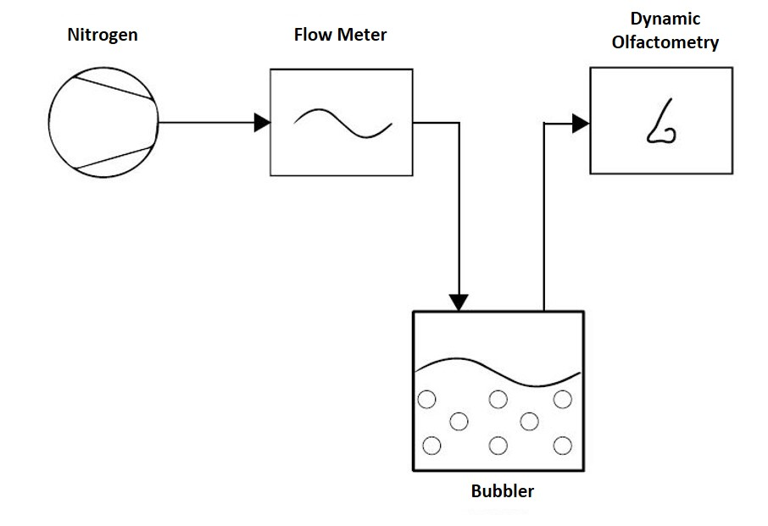

Figure 1: Diagram illustrating the flows of the experimental apparatus

The method used for the OEC measurement depends on the odour concentration (Cod) of the gas phase related to the evaporated wastewater (Frechen et al., 1998). The estimation of OEC value relating to the examined liquid is based on Eq(1):

|  |  |
| --- | --- |
| $$OEC=\int{\frac{\left(C_{od}\left(t\right)-C_{100}\right)}{V_{liquid}}}∙{dV}_{N_{2}}(t)$$ | (1) |

where Cod(t) is the measured odour concentration at the instant t, C100 is the reference value of odour concentration lower limit (i.e. 100 ouE/m3), Vliquid is the volume of analysed liquid and dVN2(t) is the infinitesimal volume of fluxed nitrogen at the instant t. Figure 2 shows the measured odour concentrations (yellow squares) of the gas samples taken during the course of the analysis. The OEC is obtained by the area between the measurement curve and the lower limit of integration, thus the sum of A1, A2, A3, A4. Because during the test the Cod do not fall below C100, it must be added A5, which is the area calculated by linear extrapolation in linear scale. The resulting OEC value is equal to 9.7·104 ouE/m3liquid.

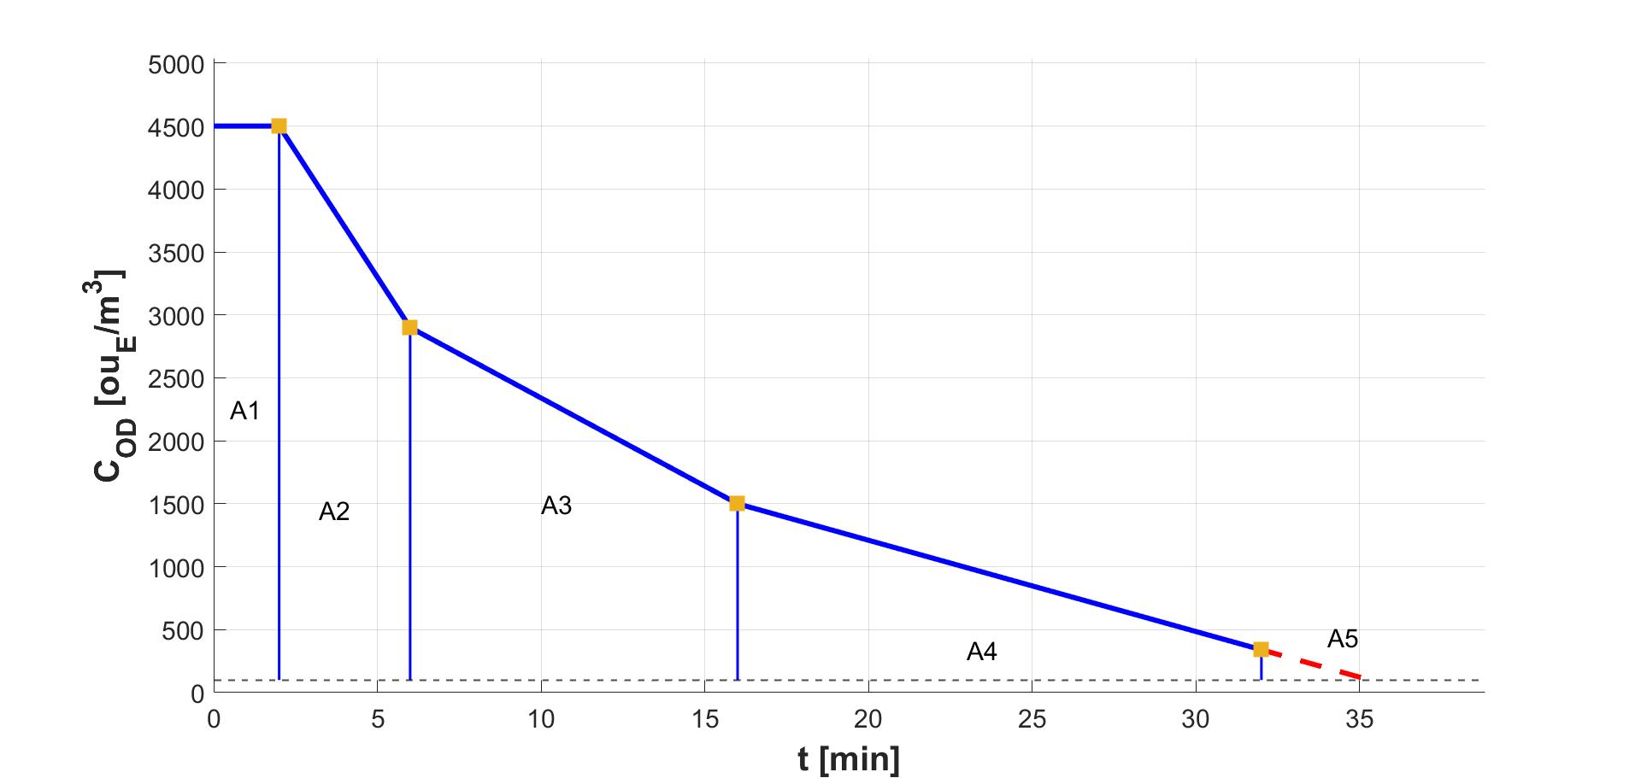

Figure 2: Odour concentration trend during OEC experimental measurement

* + 1. Dynamic olfactometry uncertainty

Uncertainty measurement for odour concentration is not a trivial task. It has been demonstrated that the panel composition, the number of panel members and the olfactory response variation of the individual panel member in time are the main sources of uncertainty in odour measurements.

Methods to assess measurement uncertainty are proposed in the new standard revision pr-EN 13725:2018 (CEN, 2018), both within one laboratory and among different laboratories, using a variety of reference materials, and also using actual undefined real-case odorous gas samples. Both methods involve a series of repeated measurements to assess the overall uncertainty, based on EN ISO 20988:2007 (CEN, 2007), without quantifying the contribution of distinct sources of uncertainty, i.e. the sampling and the storage, the dilution apparatus, the panel member (temporal variation) and the panel composition (variation between panel members), the olfactometry room conditions and measurement procedure. Therefore, any uncertainty assessment shall be carried out considering the contribution of uncertainty resulting from the usage of different panel members and panel compositions.

The uncertainty estimation, within one laboratory, involves two parallel steps:

* repeated measurements of known composition of Certified Reference Material (CRM);
* duplicate real-case olfactometric analysis using different panel composition.

Basically, during the same day, the odour concentration of real-case environmental sample must be measured twice by two different groups of panel members. Before (or after) measuring the odour concentration of the unknown environmental sample, each group must execute the CRM odour concentration test.

The numerical data for the uncertainty estimation are obtained from the n number of odour concentration of the CRM at known chemical concentration, and the m paired measurements of the odour concentrations of m unknown environmental samples (m = n/2). The standard suggests to choose n equal or greater than 20.

This procedure has been applied to 10 different environmental samples coming from sources that cover the whole application field of laboratory (e.g. refinery emissions, poultry manure, natural sulphurous emissions, fresh waste and WWTP). After that, the obtained odour concentrations are elaborated to evaluate the mean bias of the CRM and the expanded uncertainty, necessary to obtain the uncertainty of the laboratory.

Odour concentrations resulting by dynamic olfactometry measurements, under repeatability conditions, follows a lognormal probability distribution function, due to the exponential increase of the difference between adjacent dilutions (Koe et al., 1986). This means that the decimal logarithms of the measured odour concentrations are required to evaluate the statistical parameters. For this reason, the two-side confidence interval for an odour concentration can be expressed as:

|  |  |
| --- | --- |
| $$\log_{10}\left(C_{od}\right)-β_{w, CRM}-U≤ \log_{10}\left(C_{od}\right)≤\log_{10}\left(C_{od}\right)-β_{w,CRM}+U$$ | (2) |

where β*w,CRM* is the mean bias of the Certified Reference Material (CRM), i.e. n-butanol, and U is the expanded uncertainty. In particular, the evaluation of expanded uncertainty needs the definition of the combined standard uncertainty (uc), which considers three different kind of uncertainty. Consequently, the expanded measurement uncertainty, of the logarithm of the odour concentration of environmental samples, is:

|  |  |
| --- | --- |
| $${U=k∙u}_{c}=k∙\sqrt{\sum_{i=1}^{N}{u_{i}^{2}}}=k∙\sqrt{s_{δ}^{2}+s_{IMP}^{2}+u_{type-B}^{2}}$$ | (3) |

where k is the coverage factor (k = 2 is appropriate to express a 95 % coverage probability for the normal distribution), sδ the is standard uncertainty of the bias of a single measurement with respect to the CRM, sIMP is the uncertainty related to the paired odour measurements of identical unknown environmental samples (using different panels) and utype-B is the uncertainty provided by type-B evaluation.

* + 1. Crude Monte Carlo method

Crude Monte Carlo method is a suitable numeric algorithm to describe stochastic phenomena, where the random generation of events according to determined probability distributions, results to be equivalent to a value of definite integral or a sum (Rotondi et al., 2005).

For most practical applications of CMC simulation, pseudo-random number generators are used to draw the random samples. CMC simulation involves the drawing of random samples from a given probability distribution ρ(x), to artificially simulate the uncertainty of an experiment or a phenomenon, in the specific case the odour concentration. In view of this, the implementation of a CMC method may be considered as a tool to evaluate the influence of the dynamic olfactometry uncertainty when a dataset of odour concentrations is taken into account. Knowing the probability distribution of each measured odour concentration (lognormal), and fixing 106 as the number of iterations, the CMC algorithm, implemented through the software Matlab®, returns a number of 106 for each odour concentrations lognormally distributed and inside the limits of probability distribution function of the uncertainty. For each iteration it is calculated the corresponding OEC; thus, a simulated population of 106 value of OEC it is finally obtained. The Eq(4) shows the idea behind of utilised CMC algorithm.

|  |  |
| --- | --- |
| $$OEC_{CMC}=\frac{\sum_{i=1}^{ITER}{\left(\sum_{j=1}^{N}{A_{ij}}\right)}}{ITER}$$ | (4) |

where Aij is the j-th area of the i-th iteration, N is the total number of the necessary areas to evaluate the OEC value and ITER is the total number of iterations of the CMC algorithm.

* 1. Results

As already mentioned, the exponential dilution steps, underpinning the olfactometric analysis, affects each odour concentration measurement and lead to the uncertainty of the olfactometric analysis. In accordance with (VDI, 2017), the evaluation of OEC considers the assessment of the odour concentration due to the stripping of a aqueous solution in a fixed time interval.

The results of the dynamic olfactometry measurements (yellow squares) with the respective error bars are reported in Figure 3.

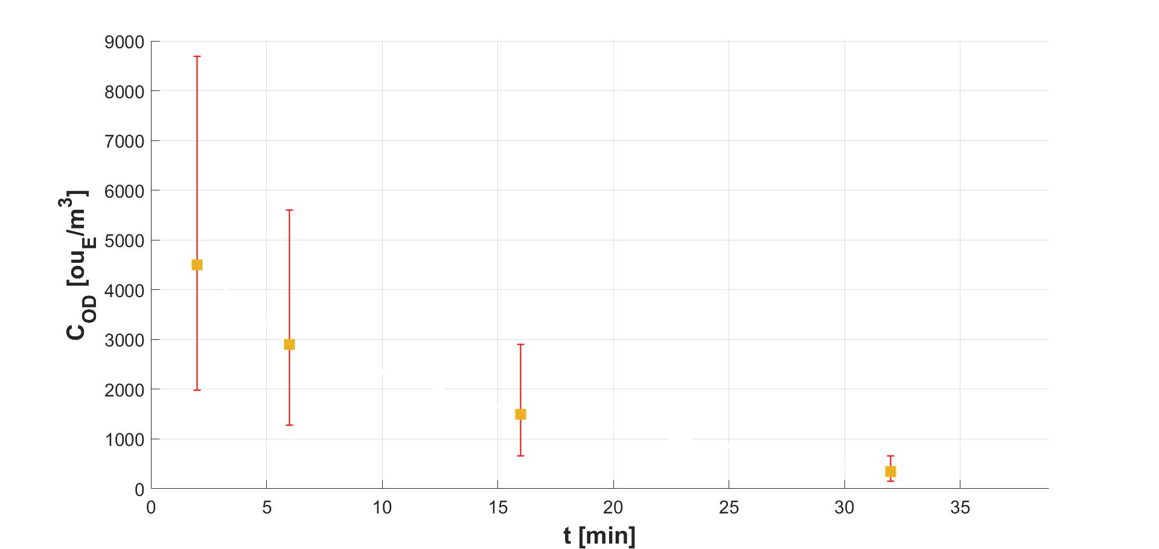

Figure 3: Odour concentrations of the gas samples with their error bars (k = 2).

The implementation of a CMC method allows to consider the influence of dynamic olfactometry uncertainty for this type of analysis, i.e. when more odour measurements are utilized. The mean value of OEC resulting from the algorithm is equal to 9.7·104 ouE/m3liquid in a confidence interval at 95 % between 8.3·104 ouE/m3liquid and 1.2·105 ouE/m3liquid.

In Figure 4, it is illustrated a comparison between the empirical Cumulative Distribution Function (CDF) of the 106 OEC and the theoretical lognormal CDF evaluated with the mean and the standard deviation. It is also shown the values of OEC obtained through the standard method (VDI, 2017) and via the presented CMC method.

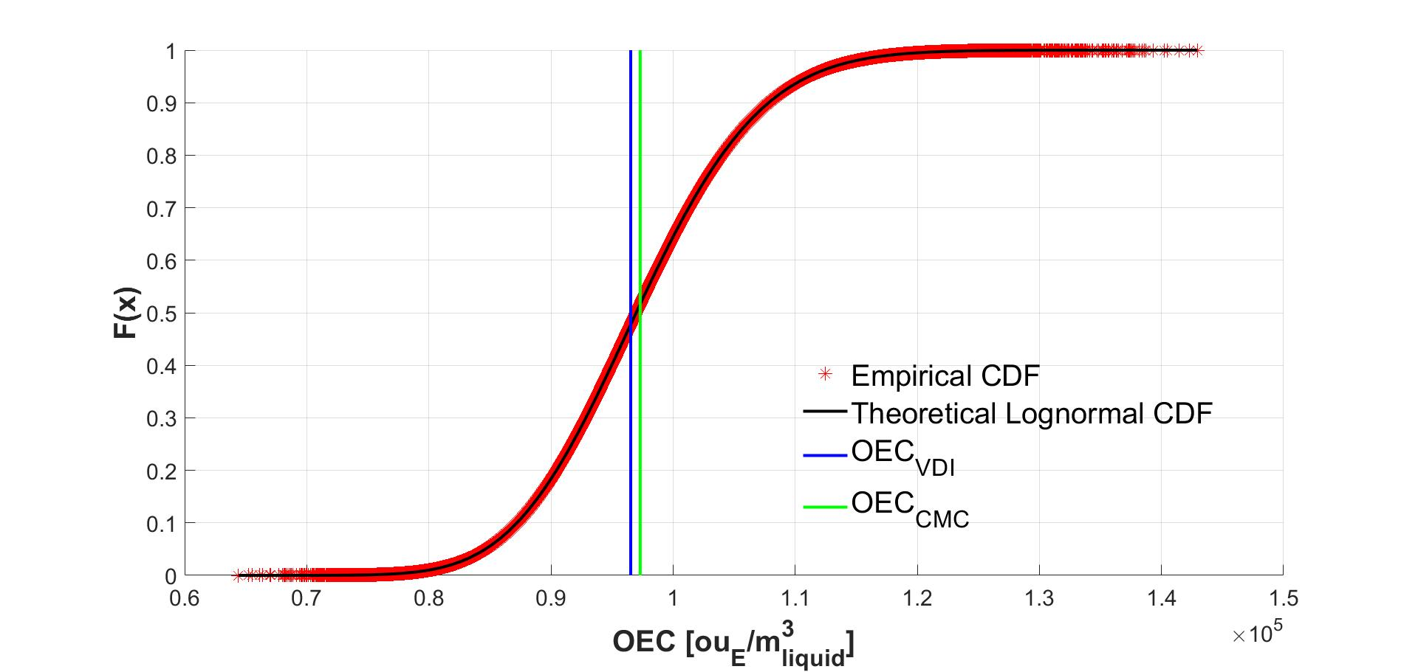

Figure 4: Comparison of empirical CDF and theoretical lognormal CDF

Graphical methods are a good option to test the normality of a dataset, especially when the number of elements exceed 300 the analytical normality tests are not so reliable (Mishra et al., 2019). In Figure 5, the QQ-plots show as the logarithm of the CMC random data fit better a theoretical normal distribution than the only random data theirself. Therefore, the obtained random OEC population appears to belong to a lognormal distribution.

In effect, the multiplicative version of the central limit theorem proves that the product of many independent, identically distributed, positive random variables has approximately a lognormal distribution (Limpert et al., 2001)

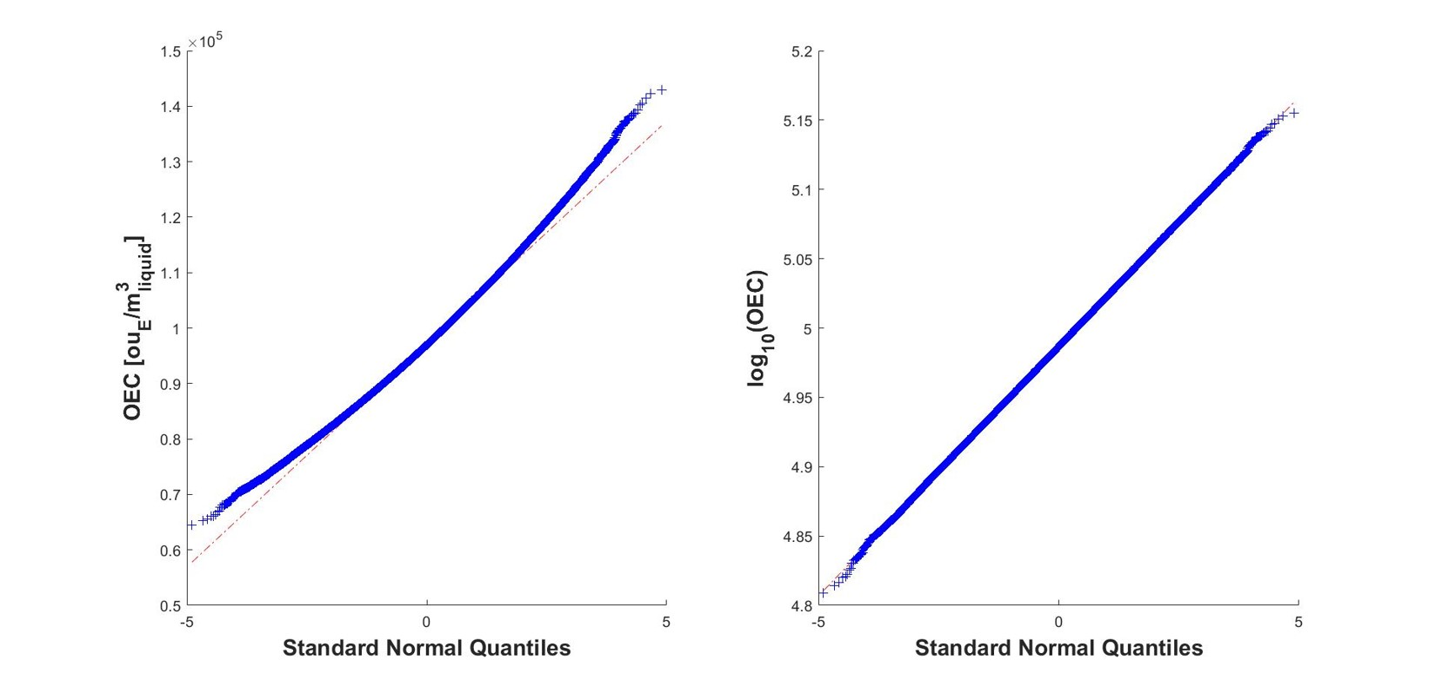

Figure 5: QQ-plot comparison between normal distribution and lognormal distribution

* 1. Conclusions

In the environmental odour research field, it is well-known that the dynamic olfactometry measurements are affected by a certain degree of uncertainty. For this reason, when more odour concentrations are added up together, the overall uncertainty also increases. The pr-EN13725:2018 (CEN, 2018) provides all the indications for the uncertainty estimation, through repeated odour concentration measurements of CRM and different real-case environmental samples. This methodology is focused on taking into account the main sources of error of dynamic olfactometry measurements, i.e. the panel composition, the number of panel members and the olfactory response variation of the individual panel member in time.

The purpose of this work is to suggest an approach for considering the influence of dynamic olfactometry uncertainty in complex experimental odour estimation procedures. Starting with an OEC analysis, the odour concentration of the 4 withdrawn gas samples, is measured, and the OEC related value is evaluated. The implementation of a CMC algorithm allowed considering the dynamic olfactometry uncertainty, lognormally distributed, for the estimation of the OEC value. The results show as the OEC value evaluated through the proposal method, i.e. 9.7·104 ouE/m3liquid in a confidence interval at 95 % between 8.3·104 ouE/m3liquid and 1.2·105 ouE/m3liquid, is comparable with value of the standard method, i.e. 9.7·104 ouE/m3liquid. Furthermore, the cumulative distribution function of the empirical data matches very well the theoretical lognormal cumulative distribution function, evaluated with the mean and the standard deviation. QQ-plots show as the random data of the CMC algorithm fit better a lognormal distribution than a normal distribution.

It can be concluded that Crude Monte Carlo method is a numeric approach very useful for estimations of some types of analysis (e.g. OEC and HCOEC), which usually involves numerous measurements (e.g. odour concentrations) that are affected by uncertainty.

References

Brancher, M., Griffiths, K. D., Franco, D., de Melo Lisboa, H., 2017, A review of odour impact criteria in selected countries around the world, *Chemosphere*, *168*, 1531–1570. https://doi.org/10.1016/j.chemosphere.2016.11.160

CEN, 2003, *EN 13725:2003 - Air quality - Determination of odour concentration by dynamic olfactometry*, Brussels

CEN, 2007, *EN ISO 20988 - Air quality - Guidelines for estimating measurement uncertainty*, Brussels

CEN, 2018, *pr-EN 13725:2018 - Air quality - Determination of odour concentration by dynamic olfactometry and odour emission rate from stationary by sources - Complementary element*, Brussels

Frechen, F.-B., 2009, 10 Years of OEC Measurement: Methodology, Application, Results and Future Development, in *Odour and VOCs: Measurement, Regulation and Control*, Kassel University Press Kassel, 9-17

Frechen, F.-B., 2012, *Evaluation of OEC Data for Preparation of the New VDI Guideline 3885 / 1*, *Chemical Engineering Transactions*, 30, 19–24, https://doi.org/10.3303/CET1230004

Frechen, F.-B., Köster, W., 1998, Odour emission capacity of wastewaters - standardization of measurement method and application, *Water Science and Technology*, *38*(3), 61–69, https://doi.org/10.1016/S0273-1223(98)00451-X

Invernizzi, M., Capelli, L., Sironi, S., 2017, Proposal of odor nuisance index as urban planning tool, *Chemical Senses*, *42(2)*, 105–110. https://doi.org/10.1093/chemse/bjw103

Invernizzi, M., Ilare, J., Capelli, L., Sironi, S., 2018, Proposal of a method for evaluating odour emissions from refinery storage tanks. *Chemical Engineering Transactions*, *68*, 49–54, https://doi.org/10.3303/CET1868009

Koe, L. C. C., Brady, D. K., 1986, Olfactory Quantification of Sewage Odors, *Journal of Environmental Engineering*, *112(2)*, 311–327, https://doi.org/10.1061/(asce)0733-9372(1986)112:2(311)

Limpert, E., Stahel, W., Abbt, M., 2001, Log-normal Distributions across the Sciences: Keys and Clues, *BioScience*, *51(5)*, 341–352, https://doi.org/10.1641/0006-3568(2001)051[0341:lndats]2.0.co;2

Mishra, P., M. Pandey, C., Singh, U., Gupta, A., Sahu, C., Keshri, A., 2019, Descriptive Statistics and Normality Tests for Statistical Data, *Annals of Cardiac Anaesthesia*, *22*, 67–72, https://doi.org/10.4103/aca.ACA\_157\_18

Oiamo, T. H., Luginaah, I. N., Baxter, J., 2015, Cumulative effects of noise and odour annoyances on environmental and health related quality of life, *Social Science and Medicine*, *146*, 191–203, https://doi.org/10.1016/j.socscimed.2015.10.043

Rotondi, A., Pedroni, P., Pievatolo, A., 2005, *Probabilità Statistica e Simulazione: Programmi applicativi scritti con Scilab*

VDI, 2017, *VDI 3885. Olfaktometrie. Messung des Geruchsstofiemissionspotenzials von Flüssigkeiten*, Düsseldorf