CHEMICAL ENGINEERING TRANSACTIONS  VOL. 82, 2020 | A publication of
The Italian Association
of Chemical Engineering
Online at www.cetjournal.it
Guest Editors: Selena Sironi, Laura Capelli
Copyright © 2020, AIDIC Servizi S.r.l.
ISBN 978-88-95608-80-8; ISSN 2283-9216

IMPROVEMENT OF SENSOR TECHNOLOGY FOR MONITORING VOCs IN HARBOUR AND MARITIME AREAS: USE CASE AND FIRST FINDINGS

Antonio Fornaro^{a*}, Enrico Valtancoliª, Francesco Argento ^{b}, Cosimo Rizzo ^{b},
Antonello Grasso ^{b}, Gianluigi De Gennaro^{c}
ª Lab Service Analytica srl, Via Emilia 51/c 40011, Anzola dell’Emilia, Italy]
^{b} ECOTARAS Spa, Via Nitti 45/A 74123, Taranto, Italy corresponding.author@domain.com [Style: CET Email]
^{C} Department of Biology, University of Bari, via Orabona 4, 70126 Bari, Italy

Fugitive emissions of Volatile Organic Compounds (VOCs) resulting from industrial sources (e.g. storage tanks, gas pipelines or exhausted areas) are often sources of great concerns due to the release of unpleasant odors, irrespective if there is, or is not, a potential health impact1. In this regard, trends of total VOCs are useful to detect the release of organic substances into the atmosphere for correlating them with potential odor harassments.
Sensors based on photoionization principle have been successfully tested for continuous monitoring of the volatile organic compounds in ambient air: at the fence of productive plants; close to industrial factories or urban settlements2. PID sensor is already proofed (University of Bari) for providing accurate data with detectable levels in the order of ppb, even in presence of high humidity conditions3.
The aim of this study was the test of an innovative sensor technology (NetPID, Lab Service Analytica) capable of operating in hard weather conditions such as maritime environment, where equipment is exposed to high levels of moisture and condensate marine aerosols (droplet, not solubilized particles)4.
The experimental design required the implementation of several PID detectors, placed on boats for dynamic monitoring of volatile organic compounds in an industrial harbour5. Electronic compensation for suppressing the non-specific contribution of moisture has been improved on these sensors: this led to a sensitivity below the ppb. In addition, flow chambers have been engineered and developed. Sensors have been also integrated on the dedicated smart network platform for collecting real-time data and trends with high resolution.
Thanks to the data given by NetPID by the IoT platform, managers were so able to compare them with periodic information on port activities (storage, unloading, handling of raw and refined products). The setting of specific routines, based on the matching of multiple information levels (Port activities, total VOCs concentrations, weather conditions)6, allowed to adopt the necessary corrective procedures for the mitigation of the impact of fugitive emissions in surrounded areas. Long-term tests have shown a high stability of instrumental responses, high robustness and reliability7.
  - Introduction

Performing an environmental monitoring plan in a dynamic environment such as harbour and maritime areas is very hard, due to the presence of many punctual and diffusive sources and to the typology not stationary of the sources (since they are generated by transport and handling processes of petroleum8. Despite this, however, it’s crucial to have a dashboard with high spatial and temporal resolution monitoring output always available in real-time.

As a result, a network of fixed and mobile sensors has been developed9. The primary focus was to design a new device capable of generating alarms by recognizing concentrations of Organic Compounds in presence of potential odor events that could affect the population living in the urban areas surrounding the refinery plant10.
Given the complexity of positioning multiple monitoring points in the middle of the sea, the concept of dynamic monitoring was adopted for the first time by installing the detecting units directly on the boats11.
Issues related to the exposure of sensors at hard weather conditions such as maritime environments have also been considered in the design concept. A new generation of Photo Ionization Analysers capable of operating even at high levels of moisture and condensate marine aerosols (droplet, not solubilized particles) have been engineered and deployed12.
The measurement units constantly transmit real-time data to an acquisition platform together with GPS coordinates and environmental parameters whether monitoring takes place in fixed and mobile stations. Data on the VOC concentrations measured by the monitoring network, as well as the environmental conditions, can be managed and displayed by the IT platform together with the scheduled information on the day-by-day harbour activities (storage, unloading, handling of raw and refined products)13.
  - Materials and methods
The photoionization detection technology has been widely used in the past decades as a gas chromatography detector which allows the universal detection of organic species from ppb (or sub-ppb) levels up to ppm with good accuracy and linearity of response.
The operating principle consists in the exposure inside a measuring cell of the gas to a mild ionization radiation produced by a local source with low consumption and low cost (Argon lamp 10.6 eV). This controlled irradiation is capable of ionizing organic compounds in relation to their chemical structure. Each compound has its own specific response factor, determined by the electronic arrangement of the valence layers (being the ionizing energy applied capable of intervening only on the external electronic layers and not the internal ones).
These ionic species are discharged onto a specific electrode, determining an electric current linked to the concentration of the species and its ionic affinity.
Various studies and experiences in the field show that this detection mechanism is affected by background variables such as temperatures and humidity, capable of contributing significantly and unpacifically to the measurement result and can give a significant measurement disturbance in devices designed for quantification at ppb or sub-ppb level typical of ambient air applications. For this reason, PID devices with high sensitivity (ppb) will be used, equipped with background condition suppression systems (such as the border electrode) which afflict the measurement, with management protocols and algorithms that have been specifically designed and optimized by specialized companies for applications in ambient air14.
These sensors have already proofed (University of Bari) for providing accurate data with detection levels in the order of ppb, even in presence of a high humidity condition. However, in a port environment it is necessary to face with phenomena of marine aerosol droplet particles. Excessive deposit on the lamp window causes shutdown or early deterioration.
Therefore, a new generation of box-sensors (NetPID) have been developed and engineered, to increase measurement accuracy, reliability and robustness. The new measurement concept is based on the use of a flow-chamber where the sensor is exposed. The chamber is fed by a flow of forced air generated by an internal suction system. The design of the chamber has been optimized to prevent any aerosol particles in the air flow from affecting the PID sensor. In this work, 3 NetPID Boxes have been installed on the boats in suitable positions, so that they couldn’t be significantly affected by the VOCs emitted from the exhaust gas of the engines. 2 more fixed units have been installed in the area.

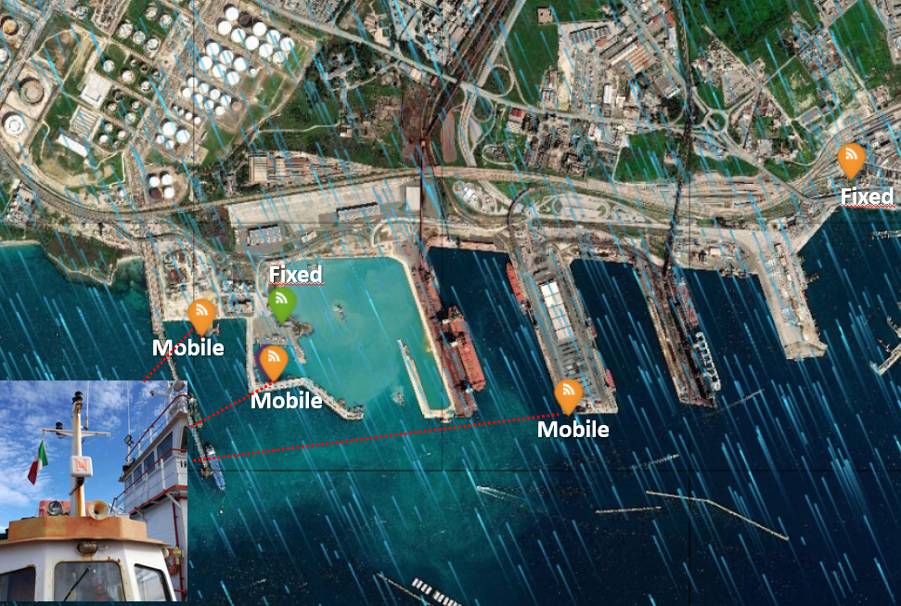
Figure 1: Displacement of fixed and mobile workstations on the site
This work has been set into different operational phases and different evaluation levels.
The main activities of the operating flow are listed below:
Activity 1: Sensor performances evaluation
The first experimental activity was to evaluate the stability of PID sensors in the new design for a two-month trial period. Lamp failure, salt accumulation and instrumental drift and peak events were daily monitored.
Activity 2: Background conditions analysis
Environmental monitoring data from each station were analyzed during the absence of transport and handling activities in the harbor.
Activity 3: Consistency analysis of the network
The measurement trends of each station were analysed over three days by comparing peak events and background conditions during specific activity phases.
Activity 4: First findings from a mobile monitoring data analysis
For the first time, real-time data acquisition tests of the concentration of VOCs from NetPID, suitably connected to the IT platform, were carried out during specific activities at sea.
  - Result and discussion

Activity 1: Sensor performances evaluation
During the two months testing time (February-March) no lamp-fail events were recorded from technicians. At the end of the test period, the lamp windows were carefully inspected. No salts or dust were found on the sensor. No significant instrumental drifts or instrumental shutdowns were observed during the test.
A series of high concentration increasing peaks were found. The analysis of the trends can attribute these peaks with artifact phenomena due to the return of the exhaust gases from the engines and to the warm-up of the sensors during their power up stabilization time.
The statistical study of these artifact events classified them as very short-terms events. Therefore statistical filters have been applied to the raw data, in order to eliminate high-slope concentrations increases (300ppb) of less than 1 minute time.

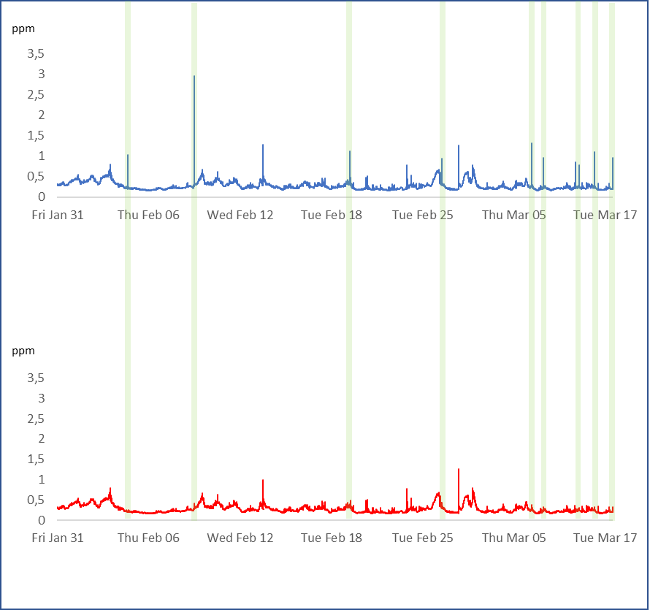

Figure 2: Comparison between the raw data recorded at the frequency of a data every 5 seconds
without any filter applied (top) and the same data with filter applied (bottom)
Activity 2: Background conditions analysis

From each monitoring station data were acquired for a long period (3 days, from 24 to 27 March) in the absence of other emission sources. The aforementioned calm conditions occurred due to the implementation of the Italian National plan against Sars-Cov2-19. Data were collected at the frequency of one data every 5 seconds.

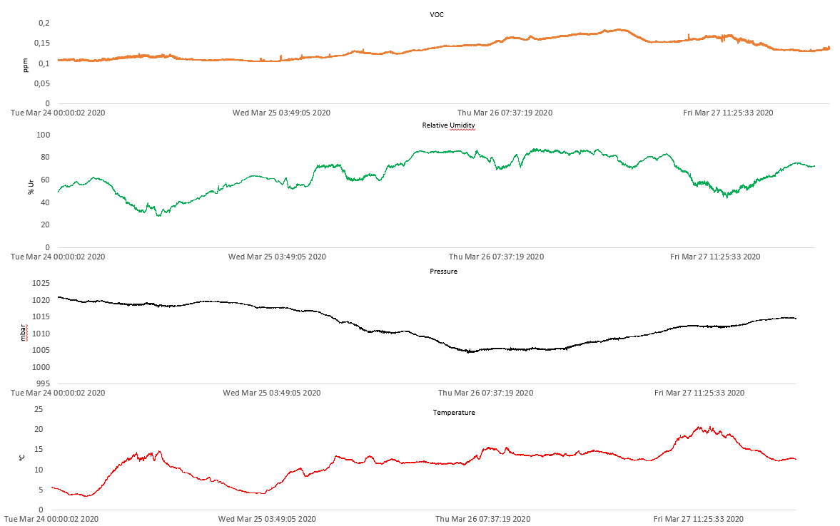

Figure 3: trends of VOC [NetPID], relative humidity, pressure and temperature
in the period from 24th to 27th March, starting from the top.

Trends of the VOCs were compared with the environmental parameters (temperature, pressure and relative humidity) during the testing period. VOCs trends do not show any secondary effects of these parameters on the measured values.
The good performances obtained derive from the patented technology of Ion Science adopted in this work, to the optimization of the flow chamber, and to the onboard electronical data compensation on NetPID units.

Activity 3: Consistency analysis of the network
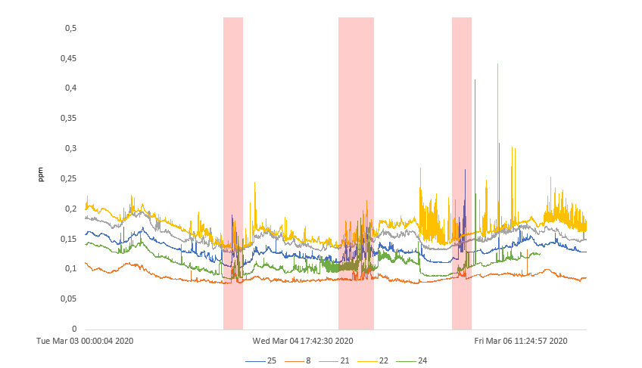

Figure 4: Overlapping of the VOC trends measured by each NetPID during a period of normal site activity.
During the typical operational activities of the site, the data of all the fixed and mobile units were analyzed for a period of three days, from March 3rd until March 7th. The collected data show good consistency both in terms of background conditions and of events detected by different points.

Activity 4: First findings from a mobile monitoring data analysis

Mobile monitoring data was collected and analysed. The monitoring was carried out by circular paths around a ship operating in the port. Increasing radius measurements were performed. The first-one was 40 meters, the second-one 60 meters and the third-one 70 meters.

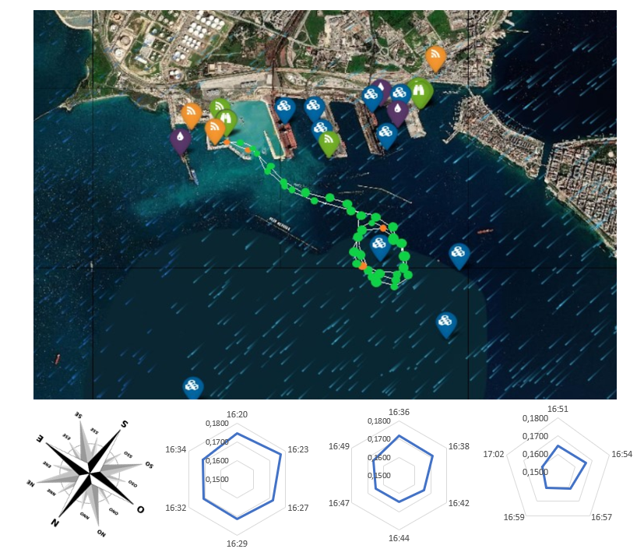
Figure 5: scheme of mobile monitoring paths performed and relative concentration trends for each lap. Measurement plots are not oriented to spatial coordinates of the above map.

The results are in good correlation with the distance from the emission area and with the wind directions and showed a good consistency with monitoring data from fixed station.

  - Conclusions
A first validation and study of sensors' accuracy in the harbour and maritime areas have been completed.
The robustness of the environmental monitoring unit has been supported by analyses of the background as well as of the influence of maritime conditions. The application of a flow chamber allows PID sensor to operate in extreme environmental conditions without any detection troubles. The first measurements with mobile monitoring were conducted. Long-term tests have shown high stability of responses and reliability of PID sensors and IT software solutions either. The overall suitability of the detection unit forms the basis for the next development of a complex platform for the management of harbour activities15.

References

1-G. Manes, R. Fusco, L. Gelpi, A.Manes, D. Di Palma, and G. Collodi, Real-Time Monitoring of Volatile Organic Compounds in Hazardous Sites, chapter 14, Intech Book, Environmental Monitoring, 2011.
2-D. C. Locke and C. E. Meloan, “Study of the photoionization detector for gas chromatography,” Analytical Chemistry, vol. 37, no. 3, pp. 389–395, 1965.
3-Alessia Di Gilio, Jolanda Palmisani, Stefania Petraccone, Antonio Fornaro, Gianluigi de Gennaro, An integrated High temporal resolution approach to monitor VOCs Concentrations and odour annoyance near a petroleum plant. Environmental Engineering and Management Journal. October 2018, Vol.17, No. 10, 2373-2378
4-MiniPID User Manual V1.8, IonScience Ltd, 2018
5-F. Tsow, E. Forzani, A. Rai et al., “A wearable and wireless sensor system for real-time monitoring of toxic environmental volatile organic compounds in ,” IEEE Sensors Journal, vol. 9, no. 12, pp. 1734–1740, 2009.
6-S. Choi, N. Kim, H. Cha, and R.Ha, “Micro sensor node for air pollutant monitoring: hardware and software issues,” Sensors, vol. 9, no. 10, pp. 7970–7987, 2009.
7- Amodio M., Andriani E., Dambruoso P.R., de Gennaro G., Di Gilio A., Intini M., Palmisani J., Tutino M., (2013), A monitoring strategy to assess the fugitive emission from a steel plant, Atmospheric Environment, 79, 455-461.
8-Cetin E., Odabasi M., Seyfioglu R., (2003), Ambient volatile organic compound (VOC) concentrations around a petrochemical complex and a petroleum refinery, Science of the Total Environment, 312, 103-112.
9-Faruolo M., Coviello I., Filizzola C., Lacava T., Pergola N., Tramutoli V., (2014), A satellite-based analysis of the Val d’Agri (South of Italy) Oil Center gas flaring emissions, Natural Hazards and Earth System Sciences, 2, 4101-4133.
10-Kalabokas P.D., Hatzaianestis J., Bartzis J.G., Papagiannakopoulos P., (2001), Atmospheric concentrations of saturated and aromatic hydrocarbons around a Greek oil refinery, Atmospheric Environment, 35, 2545-255
11-R. Szewczyk, A. Mainwaring, J. Polastre, J. Anderson, and D. Culler, “An analysis of a large scale habitat monitoring application,” in Proceedings of the 2nd International Conference on Embedded Networked Sensor Systems, pp. 214–226, November 2004.
12- J. G.W. Price, D. C. Fenimore, P. G. Simmonds, and A. Zlatkis, “Design and operation of a photoionization detector for gas chromatography,” Analytical Chemistry, vol. 40, no. 3, pp. 541– 547, 1968.
13-R. Adler, P. Buonadonna, J. Chabra et al., Design and Deployment of Industrial Sensor Networks: Experiences from the North Sea and a Semiconductor Plant in ACM SenSys, San Diego, Calif, USA, 2005.
14-Calvello M., Esposito F., Lorusso M., Pavese G., (2015), Atwo-year database of BC measurements at the biggest European crude oil pre-treatment plant: a comparison with organic gaseous compounds and PM10 loading, Atmospheric Research, 164–165, 156-166.
15- Capelli L., Sironi S., Del Rosso R., (2014), Electronic noses for environmental monitoring applications, Sensor, 14, 19979-20007.

