|  |  |
| --- | --- |
| cetlogo ***CHEMICAL ENGINEERING TRANSACTIONS***  ***VOL. 85, 2021*** | A publication of  aidiclogo_grande |
| The Italian Association  of Chemical Engineering  Online at www.cetjournal.it |
| Guest Editors: Selena Sironi, Laura Capelli  Copyright © 2021, AIDIC Servizi S.r.l. **ISBN** 978-88-95608-83-9; **ISSN** 2283-9216 | |

Smart tool for olfactory disturbance reports’ analysis: the Calambrone case study

Giuliano Gemma\*, Franco Giovannini, Antongiulio Barbaro

ARPAT “Settore Modellistica previsionale” Area Vasta Centro, via Ponte alle Mosse, 211 Firenze

g.gemma@arpat.toscana.it

During a study concerning the analysis of bad odours complaints collected in the period June 2019 - February 2020 in the north-east area of Livorno, Italy (specifically Calambrone near Pisa and Stagno area near Livorno), a variety of methods and tools have been developed with the aim to evaluate the reliability of the citizens’ odour perceptions and to identify possible sources of annoyance. The tools and the analytical methods were developed making use of some typical “big data analytics", “machine learning” and “data visualization” techniques. It has been therefore possible to define, implement and test on the area a rapid visualization tool of the possible wind flow starting backwards from the time and location of receptor indicated in every report on the local area digital cartography.

The software developed with open source tools makes use of wind data sub-hourly (every 10 or 15 minutes, such as those of the Tuscany Region meteorological network) and is now available for the territorial Offices of ARPAT as a rapid diagnostic tool to analyze the cases of olfactory disturbance reports.

* 1. Introduction

ARPAT (Environment Protection Agency of Region Tuscany) in its institutional role is active in the control of odour emissions through its participation in environmental authorization and environmental impact assessment (EIA) procedures and with the inspection and control activities at industries and installations.

ARPAT also collects annoyance complaints from the population.

In recent years the requests for intervention received by ARPAT due to odours annoyances have significatevely increased.

Due to its characteristics of extreme spatial and temporal variability, subjectivity of human response and variety of sources, the complaints about olfactory annoyance perceived by the population often requires rapid verification and control.

In presence of persistent and full-blown episodes of annoyance, social surveys in which the population involved communicates the presence of disturbing conditions in various forms are activated. In a such case it become necessary to analyze series of situations in which are sometimes present many and different type of potential odour sources in the investigated area, that need therefore to be identified.

In both these situations, retracing back in time the possible path of the air masses at the origin of the nuisance perceived by the receptors can be very helpful for data analysis and for odour sources identification. This approach require meteorological information that may be collected by an observing network or may be produced by high resolution meteorological models (i.e. limited area models or LAM).

This paper describes a simple software tool (backward investigation tool) that allows you to trace, analyze and visualize back trajectories from a given position (receptor, i.e. the one who has complained about odour annoyance). The tool has been implemented together with other methods of analysis during the thesis of a 2nd level Master course at the University of Pisa "’Big data analytics and social mining" (Gemma, 2020). The tool has been used and tested to analyze a real case in which a great number of odour annoyance reports have been collected. This case is described starting from the environmental context.

2. The backward trajectories investigation tool

2.1 Back Trajectories method

The purpose is to assess the likelihood of a bad smell report and its likely source. A report of olfactory disturbance is considered plausible if the trajectory of the air masses, ending at the time and the position where the odour event has been observed, cross the source. For simplicity the source is represented as an area of appropriate radius containing the industry or the installation.

A simplified back-trajectory technique, based on the equations of motion, has the purpose to approximate the effective trajectory of air masses backward in time.

Assumed *T* the time interval in which to calculate the backwards trajectories, if they are known:

* the position *Pn*(*xn*, *yn*, *tn*) of the receptor at the instant *tn* of perception,
* a weather dataset that reports wind speed *v*(*t*) and direction *θ*(*t*) measured in *n* = *T*/Δ*t* instants of time spaced by regular intervals Δ*t*,

it is possible to estimate the trajectory followed by a mass of air from the starting point *P0*(*x0*, *y0*, *t0*) to the position occupied *Pn*(*xn*, *yn*, *tn*) by a receptor at the time of reporting.

This simplified method has some limitations:

* the trajectory of a mass of air is approximated by that of a single particle;
* it is assumed that in each the time interval considered Δ*t* the speed and direction of the wind remain uniform in all points of the territory of interest;
* the orography of the territory is not taken into account, it is therefore assumed that the territory is substantially flat and free from obstacles to the circulation of air masses;
* turbulence or other meteorological parameters are not taken into account;
* trajectories are calculated considering a flat surface on the earth.

The principle used is the following. If *Pi*(*xi*, *yi*, *ti*) is the position of the air particle perceived by the receptor of interest at the instant *ti*, the position *Pi*+1(*xi*+1, *yi*+1, *ti*+1) at the next instant *ti*+1 = *ti*+Δ*t*, is given by the following approximation of the hourly equation:

|  |  |
| --- | --- |
| $\left\{\begin{aligned}x_{i+1}≈x_{i}+v\left(t_{i}\right)⋅∆t⋅senθ\left(t_{i}\right) \\ y_{i+1}≈y_{i}+v\left(t_{i}\right)⋅∆t⋅cosθ\left(t_{i}\right)\end{aligned}\right.$ | (1) |

The approximation is the better the smaller is the interval Δ*t*.

The relationship is repeated *n* times to cover the time period of interest *T* = *tn*-*t0*.The period *T* is appropriately chosen to describe the air masses trajectories from the receptors positions to a sufficiently large area centered in the alleged sources. When it is necessary to analyze perceptions extended over a period τ, a trajectory is produced every Δ*t* and therefore a set of *m=* τ/ Δ*t* trajectories corresponds to the event.

2.2 Software description: Trajectory viewer

Several tools have been developed or employed in order to analyze citizen’s complaints. We will provide a brief summary of the main operations carried out in the various tools, and a short description of the various inputs and outputs.

2.2.1 Complaints processing

Data relating to receptor exposures were processed through Openrefine (openrefine.org). The original data contained in the exhibits are name, surname, address, perceived smell, start and end time of the odor perception. Through Operefine and Openstreetmap API geolocalization services (www.openstreetmap.org), the geographic coordinates of the receptors have been identified starting from the addresses of the signalers. The names have been anonymized and replaced by the conventional identifiers: R1, R2, ..., R19. Reconciliation and data cleaning has finally applied. As result we obtain a dataframe, named *ComplaintsDF*, with this information: receptor id, odour description, start and end time of perception, geographical coordinates.

**2.2.2 Processing and analysis of meteorological data**

Knime Analytics Platform (www.knime.com) has been employed to standardize and cleaning the wind data information coming from the weather stations, in order to build a dataframe, called *MeteoDF*, carrying this information: station name, time, speed and wind directions. The weather datasets obtained were then statistically compared through a special software built in Python.

**2.2.3 Back-trajectories processing**

A Python software has been developed in order to obtain the back-trjectories, the intersection information between the trajectories and the sources, finally the statistical analysis of the intersections. The powerful Python library "Scikit mobility", specialized in Data Mobility analysis, has been employed in order to store and analyze the trajectories (github.com/scikit-mobility/scikit-mobility). The Geopandas (geopandas.org) libraries has been employed with the aim to store and manipulating the information of geometric objects representing the trajectories and areas of interest. The sources, represented by circular areas, are stored as polygonal objects in the GeoDataFrame, called *SourceDF*. The principal inputs are: *ComplaintsDF*, *MeteoDF*, area sources, hydrarbon transfers details.

For each receptor, complaint and weather dataset, the back-trajectories relating to the period of perception are calculated.

The back-trajectories obtained are polygonal objects in order to be able to derive the geometric intersections with the the areas of the sources through the Geopandas overlay function. This function perform a join between two GeoDataframes on the base of the geometric intersection of the objects contained therein, obtaining a dataframe, namely *ResultDF*, with the needed information: receptor id, trajectory, time, geometric intersection, intersected source.

The trajectories objects are stored in a GeoDataFrame named *TrajectoryDF*.

The results are subsequently analyzed in order to:

1. determine and count the intersections with the areas of interest;
2. build graphic plot from results;
3. produce the input data for the graphical trajectory viewer.

2.2.4 **Trajectory** viewer

A graphical viewer of the backward trajectories has been developed in order to allow a full exploration of the individual reports and to deepen the nature of the odor phenomenon. The viewer is a Javascript web application. The Mapbox GL (www.mapbox.com) and the D3 libraries (d3js.org) has been employed in order to draw the trajectories objects on a land map and visualize the associated information (trajectory number, start and end time an the associated complaint date).

Through the viewer it is possible to select:

* the receptor of interest;
* events related to the selected receptor;
* the weather dataset;
* in case of extended perceptions, overall or single trajectories can be showed.

The tool also displays, for each event, receptor and weather dataset, the number of times a trajectory (or more trajectories in the case of extensive reports) intersects an area of interest.

The map is also interactive. By moving the mouse on a trajectory it is possible to view information relating to the trajectory itself. By moving the mouse over an area of interest, information relating to the area itself is also displayed.

The main inputs of the viewer are the dataframes obtained with the previos tool: *TrajectoryDF*, *SourceDF* and *ResultsDF*.

3. The Calambrone case study

The city of Livorno is characterized by a significant port activity and a great number of related industrial activities. Moreover, in the northern area of the city there is an oil refinery and various plants and factories for refinery products processing and storage.

Associated to these activities there are various and significant odour emissions. In fact, for years in the surrounding areas (in particular in the area of Calambrone, on the norther coast, and in Stagno village, to the north-east), frequent and intense episodes of disturbance due to hydrocarbon odours have been reported by the population.

For some years now, an important project promoted by the municipalities of Livorno and Collesalvetti and managed by ARPAT, aimed at reducing and mitigating odour emissions, has been underway. The project has been joined by the industries in the area that are the main sources of odour emissions (ARPAT, 2019).

The tool presented here is considered to be a useful support when ARPAT is required to take action following the odour annoyance complaints. In fact it can allow to evaluate in almost real time or deferred the reliability of the olfactory disturbance reporting and to hypothesize the possible sources that have originated it.

The backward trajectories investigation tool has been developed and tested on odour annoyance reported by the population of Calambrone in the period from June 2019 to February 2020. The reports have been collected by ARPAT in an uncoded way. In particular, it was analyzed the hypothesis made by ARPAT Department of Pisa that some episodes of disturbance were due by oil products transfers during that period from the refinery towards some plants in the area. These transfers take place by pipelines and can take several hours, resulting in significant emissions in atmosphere of hydrocarbon mixtures from the receiving tanks, if they are not equipped with specific abatement systems.

In that period were collecetd 120 complaints from 19 citizens residing in Calambrone area ("receptors" R1, R2, ..., R19). Collected data presented inconsistent information on receptor location. Uncertainty about the position of the receptor is a frequent and sometimes induced condition also for any privacy reasons. In the same period 11 certain hydrocarbon transfer events were identified, and 6 of these occurred in periods compatible with the disturbance reports.

Through the use of the backward trajectories can be evaluated if in correspondence of the odours annoyance complained by the population the air masses have intersected the areas of the odour sources hypothesized. In this way we can evaluate:

* if the cases of transfer of hydrocarbons may have generated the odours annoyances;
* in the whole period, which and how many reports correspond to trajectories coming from the areas of the sources assumed.

3.1 **W**ind data

For the case study, the wind data measured by three meteorological stations with a time step of 10’ or 15' were available. The LaMMA station is located on a building on the Livorno seafront, a few kilometers from the area of the hypothesized odour sources; similarly, the station belonging to the ISPRA national tidal network, located on a quay inside the Livorno harbour. The ENI refinery weather station is the closest to the area of interest, located about 3 km from Calambrone.

Figure 1 shows the wind roses related to the measurements of the three stations in the period of interest.

The backward trajectories analysis was repeated with the three available data sets.

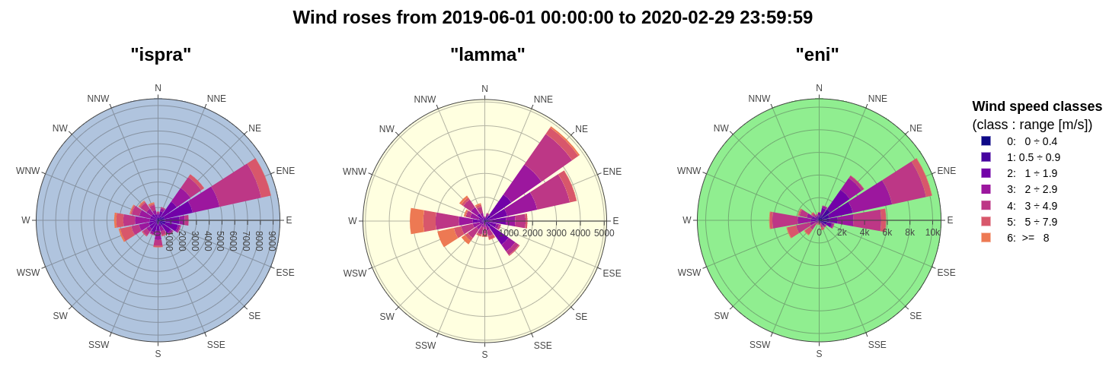Figure 1: *Wind roses from 2019/06/ 01:00:00 to 2020/02/29 23:59:00 for the three weather stations.*

3.2 **S**ummary of the results obtained

In order to evaluate the extent of the phenomenon, the origin of the odours and the compatibility of the annoyance reports with the wind data, the trajectories followed by the air masses that reached the receptors were reconstructed starting from four hours before time of perception.

The Table 1 refers to the entire group of reports: the criterion adopted is that of indicating as "yes" the event in which at least one of the backward trajectories crosses the areas of the sources, “no” otherwise. It is noted that by using the weather datasets of the LaMMA and ISPRA stations the percentage of positive events is less than 50%, while by using the ENI dataset a better agreement is obtained between the backward trajectories and the annoyance reports, with a positive percentage of the order of 66%. The ENI weather station is in fact closer to the area of interest and probably its anemometric measurements are more representative.

Table 1: intersections counting summary

|  |  |  |  |
| --- | --- | --- | --- |
| Reports and intersections | LaMMA | ISPRA | ENI |
| no | 67 | 63 | 41 |
| yes | 53 | 57 | 79 |
| Total events | 120 | 120 | 120 |

In Figure 2 the results are presented with respect to the complaints made by the different weather stations and receptors.

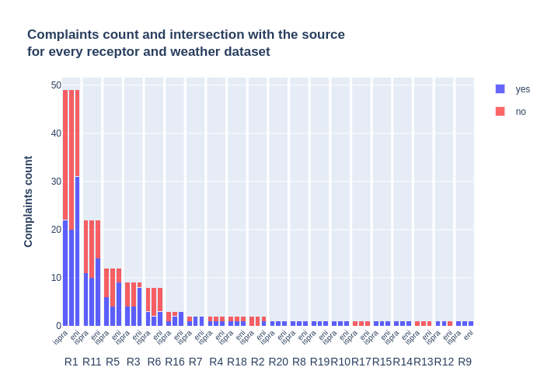Figure *2*: *complaints and intersections count for every receptor and weather station.*

The trajectory viewer is particularly useful in examining individual disturbance events.

The Figure 3 shows the back-trajectory calculated starting from the annoyance report of the R1 receptor on the day 08/11/2019 at 23:50.

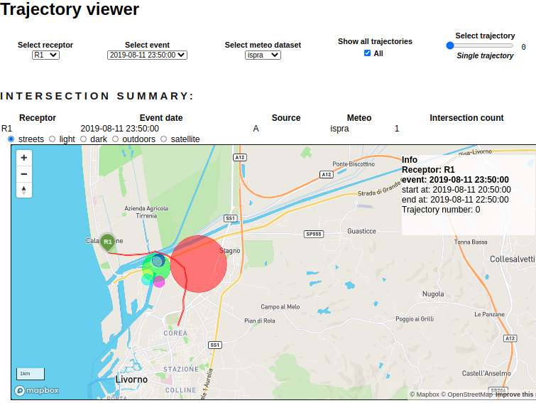Figure *3*: The *t*rajector*y* viewer, single trajectory details.

Figure 4 illustrates the backward trajectories obtained associated with the R9 receptor’s complaint, where a strong hydrocarbon odour were reported from 00:00 to 23:59 on 07/02/2019. We can see how many trajectories actually cross or pass in proximity of the area of interest: therefore it could be concluded that the R9 report is most likely attributable to the odour impact of the sources investigated.

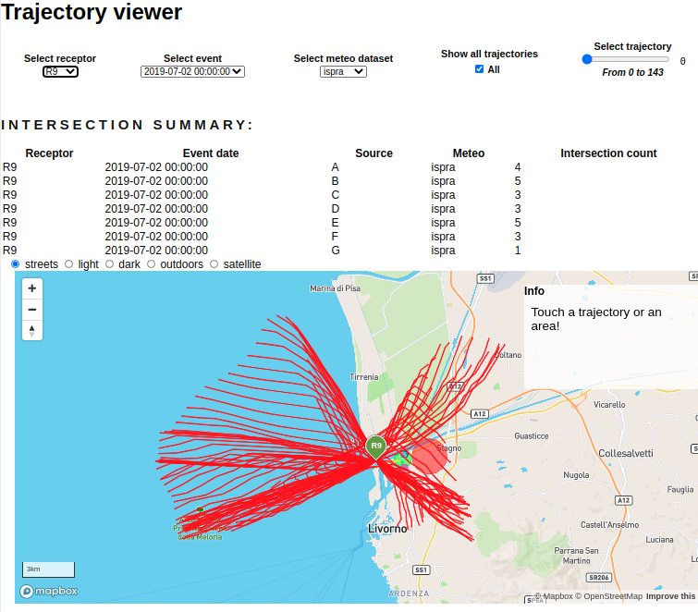Figure *4*: The *t*rajector*y* viewer, *a*ll the *trajectories associated to a time extended odour perception.*

However, the report covers the whole day. The figure clearly shows the phenomenon of daytime and night breezes typical of land-sea interfaces, which during the day mainly blow from the land towards the sea while during the night they blow from the sea towards the mainland.

Therefore, the importance of precise indication of the place and time in which an annoying smell is complained is highlighted.

As for the 11 known hydrocarbon transfers in the period, only 6 of these are temporally compatible with the citizens' complaints. In only two of these last cases, some of the associated backward trajectories intersect the investigated area sources.

4. Conclusions

The back trajectories technique to analyze reports of olfactory disturbance appears to be a promising tool (CNR, 2019). The simple Smart tool developed can therefore constitute a valid help for ARPAT territorial offices to quickly analyze and investigate these events. In order to obtain plausible results it is necessary that the wind measurements are performed on short mediation times (i.e. ≤ 15’); moreover, in general, the closer the measuring point is to the area of interest, the greater the reliability of the reconstructed trajectories. It is also necessary that the information on the temporal characteristics (time and duration of the event) is as accurate as possible.

Acknowledgments

The authors want to thank the colleagues of the ARPAT departments of Livorno and Pisa who made this work possible and for whom the smart tool presented here was designed.

References

ARPAT, 2019, “Collesalvetti e Livorno nord: primo step del piano di controllo delle emissioni odorigene”, [www.arpat.toscana.it/notizie/arpatnews/2017/130-17](http://www.arpat.toscana.it/notizie/arpatnews/2017/130-17), “Collesalvetti e Livorno nord: Piano per la riduzione delle emissioni odorigene”, www.arpat.toscana.it/notizie/arpatnews/2017/071-18, “Collesalvetti: l'incontro sull'attuazione del piano mirato per la riduzione delle maleodoranze”, www.arpat.toscana.it/notizie/arpatnews/2017/039-19.

CNR, 2019, www.cnr.it/it/news/8901/contro-le-molestie-olfattive-parte-la-sperimentazione-di-nose.

Gemma G. 2020, Maleodoranze, ambiente e Big Data Analytics - Tecniche di valutazione del disturbo olfattivo, Master Thesis , Università degli studi di Pisa, Dipartimento di informatica.