CHEMICAL ENGINEERING TRANSACTIONS  VOL. 85, 2021 | A publication of
The Italian Association
of Chemical Engineering
Online at www.cetjournal.it
Guest Editors: Selena Sironi, Laura Capelli
Copyright © 2021, AIDIC Servizi S.r.l.
ISBN 978-88-95608-83-9; ISSN 2283-9216
Operational parameters analysis for the removal of H₂S and NH₃ under transient conditions by a biofiltration system of compost beds
Diana G. Vela-Aparicio^{a,*}, Daniel F. Forero^{b}, Angela Fernandez^{b}, Paola Acevedo^{b}, Pedro F. B. Brandãoª, Iván O. Cabeza^{b}
ªUniversidad Nacional de Colombia, Facultad de Ciencias, Departamento de Química, Bogotá D.C., Colombia
^{b}Universidad Santo Tomás, Facultad de Ingeniería Ambiental, Bogotá D.C., Colombia
dgvelaa@unal.edu.co
Wastewater treatment plants (WWTP) are considered an important source of offensive odors, which are caused mainly by hydrogen sulfide, ammonia and volatile organic compounds. For the elimination of these pollutants, biofiltration offers an economical alternative of high efficiency and low waste generation. The main factors that affect the performance of a biofilter are the characteristics of the packing material, pH, moisture, concentration of pollutants and residence time of the gas in the bed (EBRT). These parameters must be optimized to improve the performance of the bioreactor. For this reason, the purpose of this work was to evaluate the removal efficiency of H₂S and NH₃ with biofilters packed with compost mixtures made from chicken manure and lignocellulosic residues (pruning waste, sugarcane bagasse and rice husk) under different EBRT (60, 45, 33, 25 and 18 s at 40% moisture) and at two levels of pollutant concentration (H₂S: 50 and 250 ppm; NH₃: 4 and 19 ppm). At 60 s, all biofilters had high removal efficiency (higher than 90%) at the two evaluated gas concentrations. The maximum elimination capacity was reached at 25 s, with a removal efficiency of 80% for both gases at the highest concentration. Also, the effect of moisture content over removal efficiency was evaluated at 25 s. When moisture was 30%, the biofilter of compost from manure with pruning waste decreased its efficiency lower than 80%; on the other hand, the biofilters with the compost of manure and sugarcane bagasse and rice husk reduced their efficiency considerably when the moisture content was 20%. The results showed that at 25 s and bed moisture content of 40%, the highest removal efficiency was obtained for the three types of composts beds evaluated. These results suggest that the moisture content of the packaging material has a significant influence on the elimination of contaminants that are soluble in water. These results are valuable to scale up this kind of systems in real applications.
- Introduction
The management and treatment of wastewater are considered significant sources of gaseous emissions, including offensive odors, that cause negative effects over the life quality of the surrounding population. The main compounds that produce odor in a wastewater treatment plant (WWTP) are volatile compounds of sulfur such as hydrogen sulfide (H₂S), nitrogen compounds such as ammonia (NH₃), and volatile organic compounds (VOCs)(Easter et al. 2005). There are a variety of technologies to reduce these emissions and to comply with air quality regulations; for example, biotechnologies require low capital and operating costs and are environmentally friendly compared to physicochemical technologies. Among the available biotechnologies, biofiltration is the most used in industries due to its ease of implementation, maintenance and low cost. In this type of bioreactor, the gases pass through a wet porous bed and are diffused into the aqueous phase of a biofilm containing microorganisms for contaminants degradation, as well as nutrients and oxygen(Delhoménie and Heitz 2005). The main factors that affect the performance of a biofilter are:
- Packing material: It should fulfil the following characteristics to obtain a satisfactory removal of gas: high specific surface area (300-1000 m²/m³); high porosity (0.4-0.9); optimal water retention capacity to maintain the moisture content between 40-70%; presence and intrinsic availability of nutrients; and presence of a large and diverse microbial community (Rene et al. 2013). The use of compost as a biofilter bed is usual because it meets most of the desirable characteristics like optimal water retention capacity to maintain the moisture between 40-70% and intrinsic availability of nutrients, as well as it is a natural material, the beds are usually affordable (Delhoménie and Heitz 2005). The mix of lignocellulosic material with compost helps to prevent a rapid degradation and loss of compost structure that drives to decrease in biofiltration performance (Forero et al. 2018; Pacheco et al. 2019).
- Moisture content: This parameter affects the microbial activity of the biofilter and the gas adsorption in the bed, so it should be between 40-70%. At industrial conditions, the air stream may dry the bed, therefore, diminishing moisture content, which causes a reduction in the microbial activity and leads to the development of bed channels, which finally decrease the efficiency of the elimination (Delhoménie and Heitz 2005).
- Residence time of the gas in the bed (EBRT): This parameter represents the time it takes for the gas to pass through the biofilter, thus depends on the bed volume and gas flow rate. The EBRT affects the removal efficiency since the residence time must be enough for the transfer and degradation of the pollutants. This situation usually occurs at a low flow rate or high EBRT however these conditions imply a high-volume system, which is a common situation in biofilters for the elimination of volatile compounds mixtures or with concentrated gases (Rene et al. 2013). EBRT depends on the characteristics of the bed material, the nature of the pollutants (hydrophobicity and biodegradability) and their concentration (Delhoménie and Heitz 2005).
These parameters must be optimized to achieve the best possible performance of the bioreactor. For this reason, the objective of this work was to evaluate the removal of hydrogen sulfide and ammonia at several EBRT and moisture content of bed, in biofilters packed with compost made of mixtures of lignocellulosic materials (pruning waste-CP, rice husk-CA and sugarcane bagasse-CB) and chicken manure. These mixtures previously showed high efficiency and the capacity to remove higher loads of gases (Vela-Aparicio et al. 2020).
- Materials and Methods

  - Biofiltration system
The packing materials were obtained previously from the composting of one lignocellulosic material in a 1:1 volume ratio with chicken manure to obtain three different mixtures: rice husk + manure (CA), pruning waste + manure (CP), and sugarcane bagasse + manure (CB) (Vela-Aparicio et al. 2020). The characteristics of each compost mixture are shown in Table 1.
Table 1: Characteristics of the three mixtures of compost and lignocellulosic materials used as packing bed
Characteristics | pruning waste + manure (CP) | sugarcane bagasse + manure (CB) | rice husk + manure  (CA)
Density, g/L | 850.45 ± 2.66 | 753.30 ± 1.53 | 796.66 ± 0.58
% Size particle distribution,  > 4.75 mm  4.75- 2.36 mm  2.36 - 1 mm  1 - 0.6 mm  0.65 - 0.25 mm  < 0.25 mm | 77.32  2.08  10.30  0.78  0.73  0.81 | 46.60  16.56  9.74  8.15  6.83  3.51 | 24.40  19.02  21.64  11.51  9.15  8.20
Water holding capacity (WHC), gH₂O/g material | 1.02 | 1.20 | 1.68
Buffer capacity,  mol H⁺/kg material | 0.24 | 0.37 | 2.80

The biofiltration system in a laboratory scale (Figure 1) consisted of two biofilters per packing material, which were constructed in PVC pipes with a diameter of 10.16 cm, a height of 81 cm and a total volume of 0.007 m³ (6.6 L). An ascending gaseous stream through the biofilters was applied using an air compressor (150 pounds). H₂S and NH₃ were volatilized from an acidic solution of Na₂S and NH₄OH 1%, respectively, using a vacuum pump. Afterwards, these gases were mixed with humidified air in a mixing chamber. This mixed stream was finally distributed into the biofiltration system. The bed moisture content was determined in a thermobalance (PCE- MB-120C) and was adjusted with water when necessary.
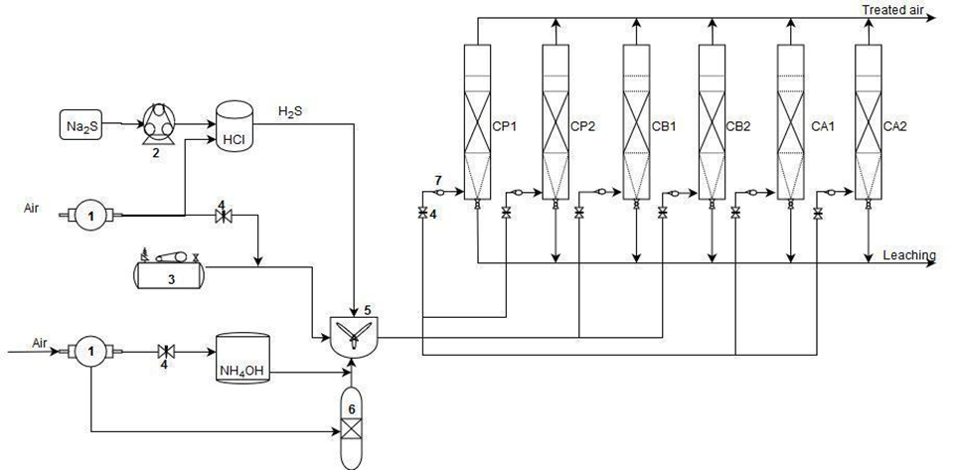
Figure 1: Gas generation system and laboratory-scale biofilters. 1. Vacuum pump, 2. Peristaltic pump, 3. Air compressor, 4. Valve, 5. Mixing chamber, 6. Humidifier, 7. Flowmeters, CP. Pruning waste + manure, CB. Sugarcane bagasse + manure, CA. Rice husk + manure (numbers 1 or 2 indicate replicate biofilter system).
  - Gas analysis
The measurements of H₂S and NH₃ were defined and monitored at the inlet and outlet of the biofilters with a portable multi-gas monitor MultiRAE (PGM-6228 RAE Systems) when H₂S concentrations were lower than 100 ppm; for higher concentrations was used a portable detector with a higher H₂S range (Biogas 5000). The measurements were taken once the gas concentration was steady. The gas sampling was made three times per day, obtaining a daily average of gas removal data. The removal efficiency percentage (%RE) was calculated for each gas using the following equation:
$$\%RE=\frac{{(C}_{i}-C_{o})*100}{C_{i}}$$ | (1)
where C_{i}: gas input concentration (ppm), and C_{o}: gas output concentration (ppm).
The maximum elimination capacity (EC_{max}) was calculated at the gas highest concentration using Eq. (2):
$$EC(\frac{g}{m^{3}h})=\frac{Q_{gas}*(C_{i}-C_{o})}{V_{bed}}$$ | (2)
where Q_{gas}: contaminated air flow rate (m³/h), Ci: gas input concentration (g/m³), C_{o}: gas output concentration (g/m³), and V_{bed}: bed volume (m³).
  - Evaluation of operational parameters
To evaluate the empty bed residence time (EBRT), the gas inlet flow rate (Table 2) was modifying through the adjust of valves installed in the biofiltration system and verified with flowmeters.
Table 2: H₂S and NH₃ load during the evaluation of empty bed residence time (EBRT) at two concentrations
Day | EBRT, s | Flow rate, m³/h | H₂S load, g/m³h |  |  | NH₃ load, g/m³h
1-5 | 60 | 0.39 | 3 |  |  | 0.1
6-9 |  |  | 16 |  |  | 0.6
10-12 | 45 | 0.53 | 4.2 |  |  | 0.2
13-16 |  |  | 20.5 |  |  | 0.8
16-19 | 33 | 0.72 | 5.7 |  |  | 0.2
19-24 |  |  | 28.5 |  |  | 1.1
24-27 | 25 | 0.95 | 7.5 |  |  | 0.3
28-41 |  |  | 37.3-44.3 |  |  | 1.4
42-48 | 18 | 1.31 | 10.3 |  |  | 0.4
49-50 |  |  | 52.2 |  |  | 2.0
58-62 | 25 | 0.95 | 7.5 |  |  | 0.3
63-65 |  |  | 37.3 |  |  | 1.4
Each EBRT was evaluated at two levels of gas concentration: low (50 ppm H₂S and 4 ppm NH₃) and high (250 ppm H₂S and 19 ppm NH₃). These concentrations were established as a result of previous monitoring in the pre-treatment zone of the WWTP El Salitre, Bogotá, Colombia (Vela-Aparicio et al. 2019b).
The EBRT with the highest elimination capacity was selected to evaluate the effect of moisture content on the performance of the biofilter. The bed was dried with a dry air stream; then, the moisture content was determined in the thermobalance and it was adjusted by adding water to obtain the desired value. The moisture content evaluated was 40%, 30%, 25% (dry weight) and finally decreased to 20%. The evaluation was made at a constant concentration of gases of 70 ppm H₂S and 5 ppm NH₃, which correspond to loads between 10-11 g/m³h of H₂S and 0.5-0.6 g/m³h of NH₃. These concentrations correspond to the average emissions of H₂S and NH₃ found during the monitoring (mentioned above) in the dry season.
- Results and Discussion
  - Evaluation of EBRT
The experiments were carried out to identify the optimum EBRT and moisture content for the elimination of H₂S and NH₃ by biofilters, whose bed is made of compost and lignocellulosic material. In the evaluation of residence time, the removal efficiency of H₂S was close to 100% at 60 and 45 s for all biofilters, even at the high level of concentration (Figure 2a). When the EBRT was decreased to 33 s on day 16, the biofilters %RE slightly diminished to 90%. Biofilter CP was the most affected for the high concentration during the evaluation of the residence time of 25 s. This biofilter had a reduction in its %RE at the lower concentration, while in the other biofilters the %RE was higher than 80%. However, the increase of H₂S concentration at 25 s caused a drastic reduction of %RE in all biofilters. A stop period in the gas inlet after the evaluation of 25 s, allowed the biofilters recovery and the efficiency rose again to 80% at the low concentration level and EBRT of 18 s. Nevertheless, when the load increased to 52 gH₂S/m³h, the removal efficiency decreased to below 60%, indicating that the biofiltration system reached its maximum elimination capacity. The posterior re-evaluation of removal efficiency at 25 s on day 58 showed a slight increase in the %RE of H₂S for all biofilters regarding the previous results. This increase could happen because the stop time decreases microorganisms stress caused by the earlier high H₂S load and, thus, could allow the recovery of microbial activity. Cabrol et al. (2016) observed this behavior in the biofiltration of NH₃ and VOCs under transient conditions.
The removal of NH₃ showed a similar behavior (Fig 2b) with a reduction of %RE when EBRT was decreased. However, the changes in the concentration resulted in the variability of the removal efficiency. This result could be a consequence of the inhibition of nitrification caused by the high H₂S loads, a phenomenon described previously by Malhautier et al. (2003).
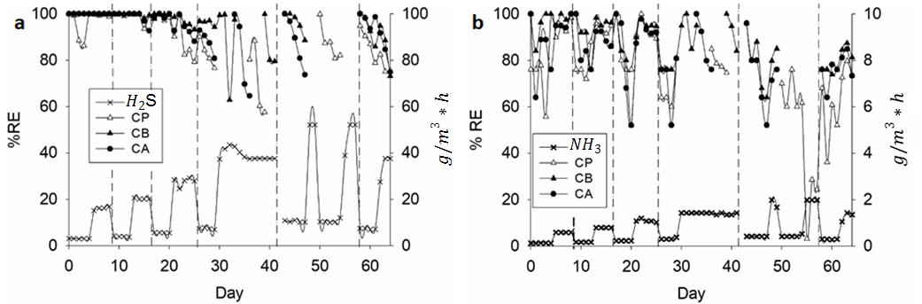
Figure 2. Inlet gas load and removal efficiency of (a) H₂S and (b) NH₃ in biofilters with different compost mixtures. CA, manure + rice husk; CP, manure + pruning waste; and CB, manure + sugarcane bagasse
Although a removal efficiency higher than 90% for biofiltration of H₂S and NH₃ has been reported at EBRT of 10 s (Hou et al. 2016), in this study, similar results were not achieved. The decrease in %RE at low EBRT was possibly due to the accumulation of sulfur and (NH₄)₂SO₄, which decrease the superficial area in the bed and thus, reduce the mass transfer of pollutants in the gas phase to the liquid phase (Kim et al. 2002; Tsang et al. 2015).
According to the results shown in Table 3, the biofilter packed with CP had the lowest removal capacity of H₂S and NH₃. This result could be because almost 80% of this material had a particle size higher than 4.75 mm, so there would be a smaller area for biofilm formation and, therefore, for the transfer and oxidation of gas in the bed, as reported previously in the biofiltration of composting gases using compost from municipal solid waste and pruning residues as a biofilter bed (López et al. 2011).
Table 3: Maximum elimination capacity (EC_{max}) of each biofilter packing bed. These values were reached at an EBRT of 25 s
Packing bed | EC_{max} H₂S, g /m³h | EC_{max} NH₃, g /m³h
CP | 29,3 | 1,1
CB | 32,8 | 1,2
CA | 32,0 | 1,2
Finally, EBRT of 25 s was selected to evaluate the effect of moisture content in the biofiltration of H₂S and NH₃ because the maximum elimination capacity of biofilters was reached in this time and the removal efficiency for both gases was higher than 80% for the highest concentration of gases. For the application in an industrial system, low residence times of the gas are desirable since it would allow treating high loads of the pollutants. Also, the biofilters should maintain a high %RE in transient conditions such as shock loads, as the one applied during this evaluation because these conditions are usual in industrial systems.
  - Evaluation of moisture content
At moisture bed of 40%, the removal efficiency for both gases was above 90% for CA and CB, and 65% for CP (Fig.3). When moisture was reduced to 30% (days 4 to 8), the removal efficiency of NH3 decreased slightly, but the %RE for H₂S diminished almost 15%. As the moisture content was decreased to 20%, the %RE for H₂S of the system diminished to less than 40% for the CB and CP beds. In the case of biofilter CA, the decrease in %RE was not so severe and was 75%. This difference could occur due to the physical characteristics of each material, like the water holding capacity, which is related to the retentivity, i.e., how easily water is retained in the packing material independently of the moisture content (Dorado et al. 2010). Since the water holding capacity is higher for the CA bed than in the other two packing materials (Table 1), this material could maintain for a longer time the water in the biofilter and avoid a drastic decrease in the microbial activity.
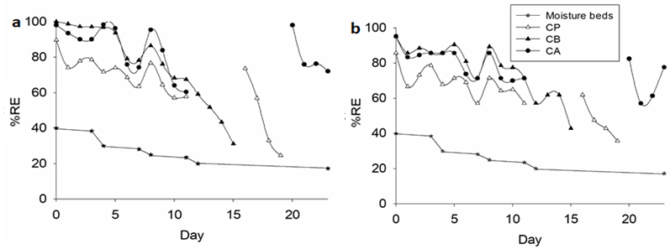
Figure 3. Moisture content and removal efficiency of (a) H₂S and (b) NH₃ in biofilters with different compost mixtures; CA, manure + rice husk; CP, manure + pruning waste; and CB, manure + sugarcane bagasse.
The reduction in the removal efficiency as the moisture decreases could occur due to the loss of the microbial biofilm present on the surface of the bed particles, thus affecting the adsorption, transfer and degradation of the gases. This reduction could also be caused by the formation of preferential channels in the beds because the gas distribution is not homogeneous and causes a decrease in the contact area with the biofilm (Rene et al. 2013). According to these results, 40% is the optimum moisture content for the biofiltration of H₂S and NH₃ with the compost mixtures used. These packing materials have adequate water availability and optimal aeration for the physicochemical process and microbial activity.
- Conclusions
For the biofiltration of gas pollutants, the residence time of the gas and moisture content of the bed are critical parameters to obtain high performance. In the elimination of H₂S and NH₃ by biofilters with packing bed of compost mixture of lignocellulosic wastes and chicken manure, EBRT of 25 s allows high removal efficiency and the highest elimination capacity for both gases. In the evaluation of moisture content, 40% was suitable for the elimination of this type of contaminants by the evaluated compost biofilters. Finally, the compost mixture of bagasse and chicken manure showed the highest removal efficiency and elimination capacity for the elimination of H₂S and NH₃. Thus, this packing bed is recommended for additional studies to evaluate its use at an industrial level in the elimination of offensive odors in WWTP and other industries, such as solid waste management and composting.
Acknowledgments
This work was financially supported by the Research Unit from the Universidad Santo Tomás (FODEIN 2019), Bogotá, Colombia. D. G. Vela-Aparicio acknowledges Colciencias for a doctoral fellowship (727 - Support to National Doctoral Program) and financial support to the work. Physicochemical analyses were supported by research assistant Maria Fernanda Paternina.
References
Cabrol L, Poly F, Malhautier L, Pommier T, Lerondelle C, Verstraete W, Lepeuple AS, Fanlo JL, Roux X Le (2016) Management of Microbial Communities through Transient Disturbances Enhances the Functional Resilience of Nitrifying Gas-Biofilters to Future Disturbances. Environ Sci Technol 50:338–348 . doi: 10.1021/acs.est.5b02740
Delhoménie M-C, Heitz M (2005) Biofiltration of air: a review. Crit Rev Biotechnol 25:53–72 . doi: 10.1080/07388550590935814
Dorado AD, Lafuente FJ, Gabriel D, Gamisans X (2010) A comparative study based on physical characteristics of suitable packing materials in biofiltration. Environ Technol 31:193–204 . doi: 10.1080/09593330903426687
Easter C, Quigley C, Burrowes P, Witherspoon J, Apgar D (2005) Odor and air emissions control using biotechnology for both collection and wastewater treatment systems. Chem Eng J 113:93–104 . doi: 10.1016/j.cej.2005.04.007
Forero DF, Acevedo P, Cabeza IO, Peña C, Hernandez M (2018) Biofiltration of acetic acid vapours using filtering bed compost from poultry manure - pruning residues - rice husks. Chem Eng Trans 64:511–516 . doi: 10.3303/CET1864086
Hou J, Li M, Xia T, Hao Y, Ding J (2016) Simultaneous removal of ammonia and hydrogen sulfide gases using biofilter media from the biodehydration stage and curing stage of composting. Environ Sci Pollut Res 23:20628–20636 . doi: 10.1007/s11356-016-7238-4
Kim HS, Kim YJ, Chung JS, Xie Q (2002) Long-term operation of a biofilter for simultaneous removal of H₂S and NH₃. J Air Waste Manage Assoc 52:1389–1398 . doi: 10.1080/10473289.2002.10470871
López R, Cabeza IO, Giráldez I, Díaz MJ (2011) Biofiltration of composting gases using different municipal solid waste-pruning residue composts : Monitoring by using an electronic nose. 102:7984–7993 . doi: 10.1016/j.biortech.2011.05.085
Malhautier L, Gracian C, Roux JC, Fanlo JL, Le Cloirec P (2003) Biological treatment process of air loaded with an ammonia and hydrogen sulfide mixture. Chemosphere 50:145–153 . doi: 10.1016/S0045-6535(02)00395-8
Pacheco MP, Ramirez CA, Hernández MA, Cabeza IO (2019) Acetic acid and pentane treatment by a biofiltration system based on organic beds under transient conditions. Chem Eng Trans 74:295–300 . doi: 10.3303/CET1974050
Rene ER, Kennes C, Veiga MC (2013) Biofilters. In: Kennes C, Veiga MC (eds) Air Pollution Prevention and Control: Bioreactors and Bioenergy, First. John Wiley & Sons, Ltd., pp 60–72
Tsang YF, Wang L, Chua H (2015) Simultaneous hydrogen sulphide and ammonia removal in a biotrickling filter: Crossed inhibitory effects among selected pollutants and microbial community change. Chem Eng J 281:389–396 . doi: 10.1016/j.cej.2015.06.107
Vela-Aparicio DG, Muñoz Lasso CC, Brandão PF, Cabeza IO, Hernandez MA (2019) Evaluation of H₂S, NH₃ and Volatile Organic Compounds Emissions in a Waste-Water Treatment Plant in Bogota, Colombia. In: Air Pollution Conference Brazil | 4th CMAS South America. Belo Horizonte, Minas Gerais, Brazil, p Session 10
Vela-Aparicio D, Forero DF, Hernández MA, Brandão PFB, Cabeza IO (2020) Simultaneous biofiltration of H₂S and NH₃ using compost mixtures from lignocellulosic waste and chicken manure as packing material. Environ Sci Pollut Res. In press. doi: 10.1007/s11356-020-10817-w

