|  |  |
| --- | --- |
| cetlogo ***CHEMICAL ENGINEERING TRANSACTIONS***  ***VOL. 85, 2021*** | A publication of  aidiclogo_grande |
| The Italian Association  of Chemical Engineering  Online at www.cetjournal.it |
| Guest Editors: Selena Sironi, Laura Capelli  Copyright © 2021, AIDIC Servizi S.r.l. **ISBN** 978-88-95608-83-9; **ISSN** 2283-9216 | |

From nose to nuisance

Sofia A. Teixeira\*, Paulo D. Pereira, Francisco C. Ferreira

a CENSE – Center for Environmental and Sustainability Research, NOVA School of Science and Technology, NOVA University Lisbon, Campus de Caparica, 2829-516, Caparica, Portugal

[sad.teixeira@fct.unl.pt](mailto:sad.teixeira@fct.unl.pt)

Odour nuisance has been an ignored environmental problem, an invisible face of air quality analysis and monitoring in Portugal. Local and governmental authorities have been receiving odour complaints, but just only in recent years has this concern been seen as an issue in itself and not only treated as a matter of licensing and inspection. This fact and the lack of specific odour regulation of ambient air in Portugal originated a bottom up approach focused on citizens and in their contribution to a more comprehensive analysis.

Despite the existence of odour measuring instruments, the human nose is a universal sensor with higher sensitivity that allows to access the impact of discomfort on sensitive receptors. From this point of view, a sensorial method has been conducted with community’s neighbors of odour emission sources in several odour cases studies as an integrative approach to the problem and a complementary vector to a quantitative analysis. The human nose used as a “tool”, allows to address the issue instantly and at a local level, which is not always possible with other methodologies. In addition, it allows to assess the odour perception even in situations where the detection limit is reduced and therefore not measurable with certain equipment. Nevertheless, this human tool is the one who triggers formal complaints to the authorities whether it is the national guard, the municipality authorities or the environmental regulators. But the lack of an unified form to register the complaints is a mandatory issue to help addressing the right odour sources and better understand the problem. So, this sensorial approach also aims to develop a tool to aggregate the needed elements to a valid form, so that the complaints can be verified and validated in order to have a comparison and a record history database, at the odour emitter level or at local and national level.

The results obtained with this method have led to the application of several actions at different levels such as the real knowledge of the problem from an industrial operator perspective, inclusion of public stakeholders, and the design and implementation of odour management plans with the purpose of the establishment of mitigation measures.

Keywords: Odour nuisance; odour complaints; human nose sensor; sensorial methodology; citizen participation; field panel assessment; industrial odour pollution, bottom-up approach, collaborative data creation.

* 1. Introduction

The interoperability of the civil society in scientific research projects is an integrative way for, in addition to co-creating essential data for analysis, promote the inclusion of elements that, through their experience, can assist in the mechanisms of data collection and in the development of measures to improve the context that surrounds them. In environmental assessment and monitoring projects, the inclusion of citizens promotes a more active role for individuals and, above all, the strengthening of the triangulation relationship between community, academia and institutions. The approach of non-scientists participation in the resolution of emergent environmental issues is a way of besides empowering the citizens, promote transformative social innovation, discussing the matter between citizens and stakeholders.

Having groups of people with the ability to register odour complaints in standard forms is an added value for the study of emission sources and the causes that led to the nuisance impacts, such as industrial activities, meteorological conditions, or atmospheric dispersion.

This sensorial approach isn’t developed in an isolated way, having in consideration another techniques to assess the odour monitoring, particularly, field inspections with the use of a portable olfatometer and meteorological analysis. But the sensorial approach is the trigger to evaluate odour nuisance and to develop a management strategy to address it.

* 1. Collaborative data creation: observers panels

The objective of the formation of observers panels (OP) is to create a net of voluntary citizens without connection between them besides the odour nuisance, without direct connection with any industrial operator that can be odour emitter and with the particularity of perceiving ambient odours in their homes or workplaces. This way it is possible to empower the citizens by giving them a way to be heard and to be part of the environmental problem evidence to the public (industrial, municipal, national) (Bonney et al., 2016).

Forming an Observers Panel is a way to have, on one hand, a longer measurement period in contrast to other techniques normally used in this type of assessment. On the other hand, it is possible to have independent instant evaluations at several locations at the same time addressing the problem. Simultaneously, this approach tries to promote the engagement of the community by boosting their citizenship with the aim of resolving potential emerging conflicts between industrial emitters and neighbours, trying to decrease the nimby (not in my back yard) effect (Dettori, 2020). This way, on one hand, the data created by the Observers Panel makes the odour emitter gain awareness that its industrial activity may cause impacts on sensitive receptors, and in the other hand, on a long term, the group may better understand the characteristics of the odour emissions and in case of harmless effects, monitor the situation.

It must be taken in to account that this kind of data production cannot be just a way to have free manpower, because the idea is to really engage the community in the science process in a way that they don’t feel used, but part of the solution achievement (Senabre, 2021). So, a guidance strategy is required so that the researcher’s team may motivate the data production continuously in time. Also, a data disclosure policy is needed to give information to the elements of the achievements of the monitoring to make them a real part of the process.

A conceptual pyramid framework of four dimensions of analysis is required to understand the collaborative data creation trough OP. The intent of participate is on the base of this methodology because it’s a reaction motivated by the desire of communication of an environmental issue. On the second level, the knowledge of the theme (in this case, of ambient air odours) promotes a learning of the issue given by the researchers. On the third, the action, which promotes the sensorial evaluation and record of the odours in ambient air by the volunteers. Finally, on the top of the pyramid are the results produced by the OP elements, validated by the researchers, shared with all the group. This results could led to an odour records map of a given area which could highlight the most affected locations.

* + 1. Managing OP

How to reach people? Can anyone participate? How to start? First it is essential to define criteria of participation to target the right people. In the odour case, for the selection of the human panel sample, a survey is applied to ascertain some essential criteria (namely the olfactory sensitivity; residence area/workplace, odour perception, health condition) for the analysis. Then it is important to disseminate the activity through flyers, social media, environmental associations, face-to-face interactions, mailing-lists, snowball techniques and in case of a list of complainers invite them to collaborate. It is important that the participants have availability, and make a pre-registration. After that, the sample will be chosen through the application of a survey. Subsequently, a monthly form of odour records is distributed to the selected elements or a link to a google form in a smartphone can be used (Figure 1). This two options evaluates some odour characteristics, namely: type, frequency, duration, intensity, location (FIDOL factors, Nicell, 2009), as well as the perceived weather and wind. Subsequently, these data are subject to validation through complementary analysis methodologies developed by the researcher’s team. This should be developed with a defined timeline and in two different meteorological periods so that the participants don’t be unmotivated and to see the impact of some weather conditions in the analysis (e.g. 3 months in winter time and 3 months in summer time).

To manage the collaborative work it is important to develop some actions such as: establish communication between the researchers and the OP members (e.g. phone calls, sms, chat apps, e-mail) keep them informed of the project by giving them some feedback of the group results and be available for any doubt along the monitoring.

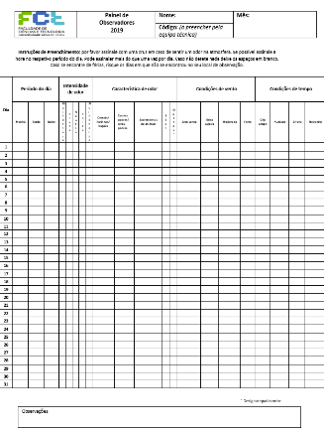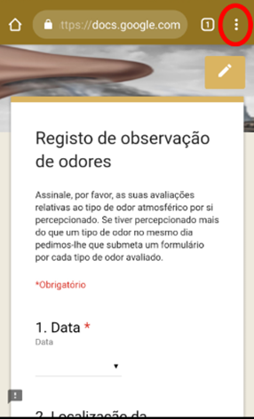

Figure 1: Tools to record odour perceptions of the observers panel

* + 1. Combine to validate

This collaborative method, with a bottom up approach has to be combined with an analytic one (top down approach) (e.g. quantitative assessment with field inspections) to accomplish a mutual validation of the data produced by this different strategies. In this sense, after the data collection (which can be automatically when using an online form) the validation process in mandatory. It takes in account several dimensions such as meteorological analysis, the existence of more than one record at the same time in different locations, the data collected by a control group (formed by the researchers team that can perform odour evaluations in a certain area) and the record of the industrial operator activities (e.g. number of days working or in technical shutdown). With this combined strategy it is possible to assure data quality and thus, the replicability of the adopted methodology in several case studies.

* + 1. Results of the OP approach: a case study of an oilseeds industry in Lisbon Metropolitan Area.

An odour monitoring plan was conducted in 2019-2020 in the surroundings of an oilseeds processing plant. Besides the collaborative approach, the monitoring strategy was composed by a meteorological evaluation, field inspections with a portable olfatometer within the surrounded area and inside the industrial perimeter. Focusing only on the OP, in this case, it was formed with a total of 45 citizens (of which 5 elements from municipality authorities) distributed in the municipality (Figure 2). This OP monitored the ambient air during 213 days (July to September of 2019 and February to May of 2020) even with the pandemic COVID 19 conditions. The most used record tool was the online form (60%), followed by the paper form (40%).

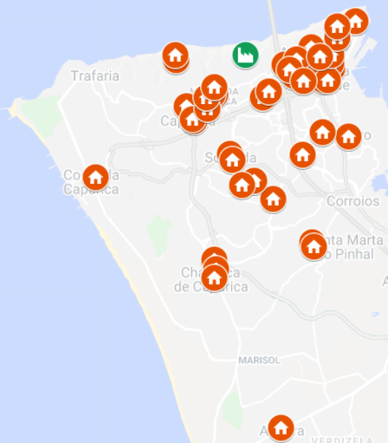

Figure 2: Distribution of the OP elements in the surrounding area of an oilseeds industry

The results showed 87 odour records, 75 concerning the type of odour “cereal/flours/feeds” (assigned to the type of industry under analysis) (Figure 3 a). In this case, in 77, 5% of the time no odour was perceived.

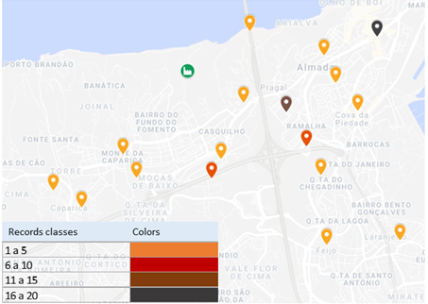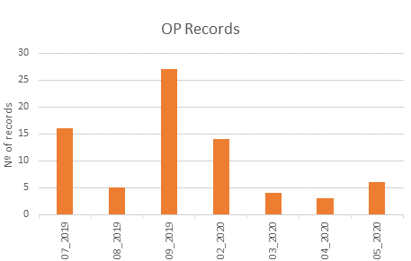

Figure 3

a) Geographic location of the “cereal/flours/feeds” odour records b) OP odour records by monitoring month

The odour perceptions were made mainly in the afternoon period with meteorological conditions predominance of winds from the Northwest, of light breeze and clear sky, thus poor atmospheric dispersion conditions. The atmospheric conditions may have influenced a higher number of odour records in locations at east, south and southeast of the emitting source. The intensity level detected was strong in a likert scale of 6 categories. According to Figure 3 b), during the winter period there was a decrease in the number of records despite the fact that the emitting source continued its normal operation and the lockdown situation (COVID 19).

The OP data made it possible to make a comparison between the oilseeds industry operation (with two processing plants) and the number of odour records for “cereal/flours/feeds” (Figure 4). As it is showed, the operation of the plant one may had a bigger influence on the perception of the odour by the OP, because of the higher number of records made when it is “on” and because of the decrease of them when it is “off”. The absence of odour records when the oilseeds industry operation was in shut down for technical reasons also validate the importance of the OP data for the monitoring program (the OP didn’t had access to the information about the oilseeds operation).

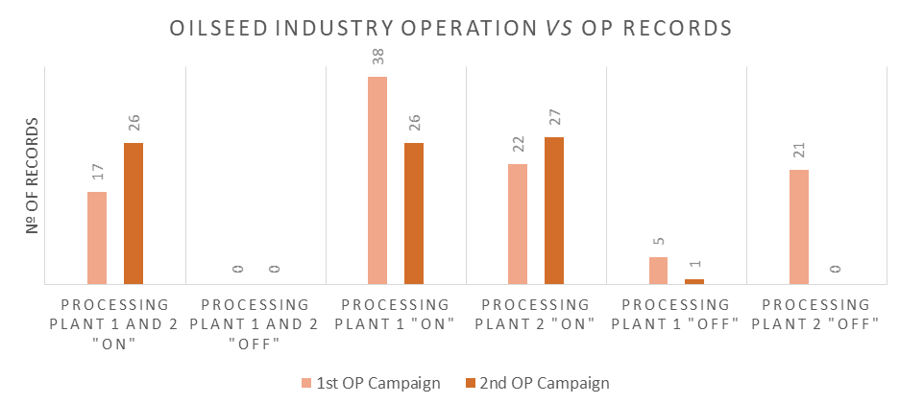

Figure 4: Comparison between the OP records and the oilseeds industry operation

* + 1. The outcomes of having a collaborative approach

The results of the OP data and of all the approaches conducted in the odour monitoring program, led to the need of the oilseeds industry to implement some measures to decrease the impact of its activity on sensitive receptors. The most important measure with low cost- higher efficiency, short term implementation and with direct impact on the sensitive receptors was the implementation of an odour management plan, which is not a monitoring program with a defined timeframe but a group of procedures that will be permanently available by the operator. One of the elements of this plan is a tool for manage the reception of odour complaints and thus the complaint investigation by the operator with the aim of a response to the complainer. This tool is available for everyone who wants to make a complaint related to the activity of the operator either a citizen or a local power institution (parish, municipality local associations). This management is composed by a complaint form according to the FIDOL approach so that the complaints assemble all the elements needed to be investigated. Then, a decision making tree was developed to guide the operator in the complaint investigation process (Figure 5). This decision tree was also transformed in a guidance for intern support with all the steps in detail for employees. The decision tree has also to have in account a response to the complainer, either the complaint is considered valid or invalid. In the first case, a response will be given after an internal investigation and a meteorological analysis. In the second case, a response will be send to ask for more elements (if the complaint lacks some information) or to address that the odour emission source could not be the one responsible for the nuisance.

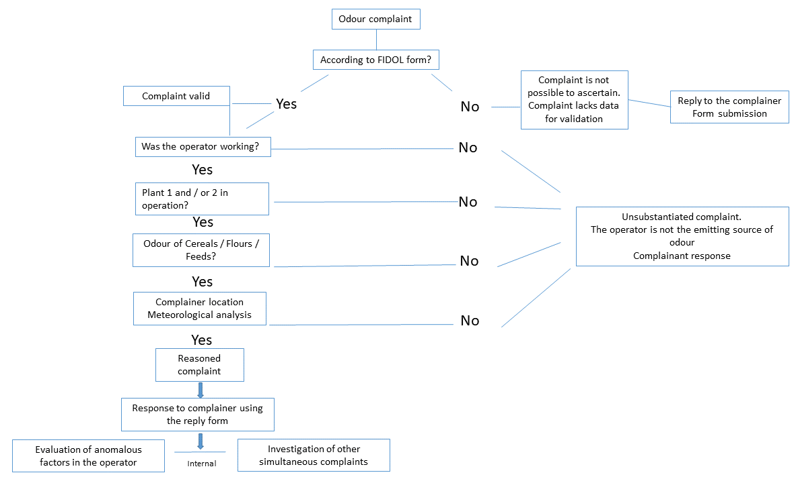

Figure 5: Decision making tree to evaluate odour complaints

This odour management plan is an innovation for the oilseed operator since there is no guideline for the odour matter in ambient air (only for emissions, shortly in the Best available techniques REFerence Documents-BREF) in Portugal and it was an opportunity to implement a training tool for the use of the employees that could also have some knowledge on the odour issue for the first time. All the complaints will be integrated in to a data base, so that an historical record may be developed to assist further internal analysis.

It is to be set on place a defined joint strategy with local stakeholders (e.g. the municipality) and with the academia for the capacity building of a target of the population with some dynamization activities in schools.

The odour management plan has become also an opportunity for the operator to give a step further on the odour matter showing this developments to the portuguese environmental agency.

* 1. Conclusions

The collaborative methodology with the OP has some advantages and disadvantages. The first ones are the possibility of public engagement with science, the scientific knowledge that can help on the decision making (e.g. of formalizing or not an odour complaint), low cost to higher benefits, major data diversity and major closer to local reality. The second ones are to not consider at any time the volunteers as manpower only to collect data, the difficulties to maintain the enthusiasm and the accountability of the volunteers so they don’t give up the task, and to assure the data quality through the application of validation methods.

This bottom-up approach with the collaborative data creation of the OP has given the possibility of the development of some tools to manage the odour nuisance and to make some advances in the odours theme in Portugal, given we are one step behind other countries.

References

Arias R., Capelli L., Diaz Jimenez C., 2018, A new methodology based on citizen science to improve environmental odour management, Chemical Engineering Transactions, 68, 7-12 DOI: 10.3303/CET1868002

Bull et al, 2018, IAQM Guidance on the assessment of odour for planning – version 1.1, Institute of Air Quality Management, London.

Bonney, R., Phillips, T. B., Ballard, H. L., & Enck, J. W., 2016, Can citizen science enhance public understanding of science?. Public Understanding of Science, 25(1), 2-16. https://doi. org/10.1177/0963662515607406

Dettori M, Pittaluga P, Busonera G, et al., 2020, Environmental Risks Perception Among Citizens Living Near Industrial Plants: A Cross-Sectional Study. International journal of environmental research and public health, 17(13). doi:10.3390/ijerph17134870

Nicell, J., 2009, Assessment and regulation of odour impacts, Atmospheric Environment, 43, pp.196-206.

Senabre Hidalgo E., Perelló J., Becker F., Bonhoure I., Legris M., Cigarini A., 2021, Participation and Co-creation in Citizen Science, Vohland K. et al. (eds) The Science of Citizen Science, Springer, Cham. https://doi.org/10.1007/978-3-030-58278-4\_11

Teixeira S., Pereira P., Ferreira F., 2018, Atmospheric odours: monitoring of an urban waste operator with citizen participation, Chemical Engineering Transactions, 68, 91-96 DOI: 10.3303/CET1868016