CHEMICAL ENGINEERING TRANSACTIONS  VOL. 82, 2020 | A publication of
The Italian Association
of Chemical Engineering
Online at www.cetjournal.it
Guest Editors: Selena Sironi, Laura Capelli
Copyright © 2020, AIDIC Servizi S.r.l.
ISBN 978-88-95608-80-8; ISSN 2283-9216

USE OF DRONE TO MEASURE ODOR GASES IN A REFINERY PLANT
Rafael G. Serta^{a*}, Angelo Breda^{b}, Márcio Barreiro^{a,} Jonas D. Oliveiraª, Fernando T. Rodriguesª
ªAmbiental RB, quitanda street, 30, Rio de Janeiro, Brazil.
^{b}University of Newcastle, Newcastle, NSW, Australia
rafaelserta@gmail.com
The objective of this study was to identify and quantify odor sources throughout the production process of an oil refinery located in Rio Grande do Sul State, Brazil. The NH₃ (ammonia), H₂S/CH₄S (hydrogen sulphide/methylmercaptan), SO₂ (sulfur dioxide) and VOCs (volatile organic compounds) gases were measured during 14 consecutive days around emission sources and throughout the company's production process. The monitoring was performed on main stacks, tanks vent, production process and wastewater treatment station. To measure over the stacks, it was used a Drone DJI to suspend a set of integrated electrochemical sensors that analyze the air continuously. This system made it possible to record the emission from stacks at heights of up to 120 meters above ground level, which was previously impossible to accomplish. Cairpol’s electrochemical sensors were used to provide automatic and continuous measurement. This equipment records the measurements in ppb (part per billion) every minute and stores them in an internal data logger. During the monitoring period, an anemometer was installed to record wind direction and wind speed data every 5 minutes to correlate with gas measurements. The results of odorous gases analysis showed that the largest sources of emissions are the industrial effluent treatment, the flare stack and the Sulfur Recovery Unit’s stack. However, the coverage radius for the effluent treatment station is small due to the emission characteristics, as the emissions at ground level come from the effluent dumping, the aerated lagoon and the float. The main sources of odor emission that can spread and annoy the neighborhood are the stacks as they presented the higher concentrations, henceforth their odor emission can be perceived from kilometers of distance.
  - Introduction
Odor complaints in the vicinity of industries have increased substantially in recent years, and oil refineries are one of the sectors with the highest potential for odor emission, in addition, people who live nearby are concerned about impacts on health due to emissions of gases (Luginaah, 2002). The most common effects reported are nausea, sinus congestion, throat irritations, headaches, sleep problems, besides that, odor perception and annoyance increase the perception of health impacts (Luginaah, 2000).
In a petroleum refinery the characteristic odors are sulfur compounds (e.g. hydrogen sulfide, mercaptans), nitrogen compounds (e.g. Ammonia, amines) and volatile organic compounds (VOCs) with high odor concentration (Han, 2018).
Emissions in refineries can be fugitive, emitted through valves, pumps and tank reliefs or generated by combustion processes, sulfur recovery unit (SRU), storage tanks, flares and wastewater treatment. However, the majority of odor emissions are related emission to the point sources and with less contribution to passive and fugitive emissions from wastewater treatment pond and contributions from storage tanks (Damuchali & Guo, 2020).
There are several methods for odor evaluation, olfactometry techniques (Vieira et al., 2016), use of e-noses (Milan, 2016) and chemical analyses (Kim and Park, 2008). In some processes, the main gases emitted responsible for the odor can be used as indicators of the analyzed activity (Capelli, 2013). However, the in situ measurement of these gases is generally limited to spot monitoring at ground level.
The measurement of vertical profiles of atmospheric pollutants using unmanned aerial system (UAS) has increased in popularity. This technique has been using for aerosols (Chen et al., 2018) and VOCs (Hien et al., 2019). Given the high-resolution data provided by UAS recordings of odor components and other pollutants, it is possible to extend the diagnosis of the spatial distribution to smaller scales and, also, to analyse the physical processes acting in the diffusion of each monitored compound (Hien et al., 2019). Moreover, as such pieces of equipment are relatively easy to use, meanwhile purchase and maintenance costs are within a low budget, one can expect a broad expansion of pollutant monitoring using UAS.
In Brazil there are laws regulating air quality, but there are no limits on odor emissions or ambient concentrations (Brancher, 2017). This lack of regulation reinforces the need for odor monitoring work, regardless of the method used, to assist in the creation of national laws.
This paper describes the methodology for monitoring odorous gases in an oil refinery located in southern Brazil, applying electrochemical sensors to assess chemical substances on the primary sources of odor and in the production process.
  - Materials and methods
The present research was conducted in an oil refinery located in the Rio Grande do Sul State, Brazil. The oil refinery process 32,000 m³ of crude oil per day in a total area of 5.8 square kilometers in order to supply the regional market. The main produced products are diesel fuel, gasoline, gas, fuel oils, aviation fuel, solvents, asphalt, coke, sulfur and propene.
All measurements were performed out from 11/18/19 to 12/02/19, at 53 points inside the refinery. Such measurements were conducted at ground level to estimate the fugitive odor emission. In these cases, the sensors were mounted 1.5 meters from the ground on a tripod (Figure 1). Additionally, measurements were made at the stacks (SRU and flares), over the wastewater treatment lagoon and at the breathing of the storage tanks. A drone (quadricopter) was assembled to bring the monitoring sensors at these particular spots. A support was built to hold the sensors, which was tied to the drone with a string of approximately 4 meters. This distance was defined so that the movement of the drone propellers had no interference in the outcomes of the measurements (Figure 2).
Measurements were performed in the following process areas: Hydrotreating (HDT), SRU, acidic water and waste tanks, oil-water separator, wastewater treatment and flares. All measurements were carried out using Cairpol electrochemical sensors, which provide automatic and continuous recordings of gases concentration. This equipment records the measurements in ppb (part per billion) every minute. All four sensors used in the field campaign are listed in Table 1.
Table 1: Electrochemical sensors
Sensor | Range (ppb)
H₂S/CH₄S | 0 – 1,000
NH₃ | 0 – 25,000
nmVOC | 0 – 16,000
SO₂ | 0 – 1,000

The monitoring data were stored every minute. Ground-level points were measured for at least 30 minutes, while at the stacks, it was about 15 minutes long using the drone at each location. During the monitoring period, an anemometer was installed to record wind direction and wind speed data every 5 minutes to correlate with gas measurements. These data were compared with the data from the meteorological station installed in the air quality station, 2 km far from the refinery.

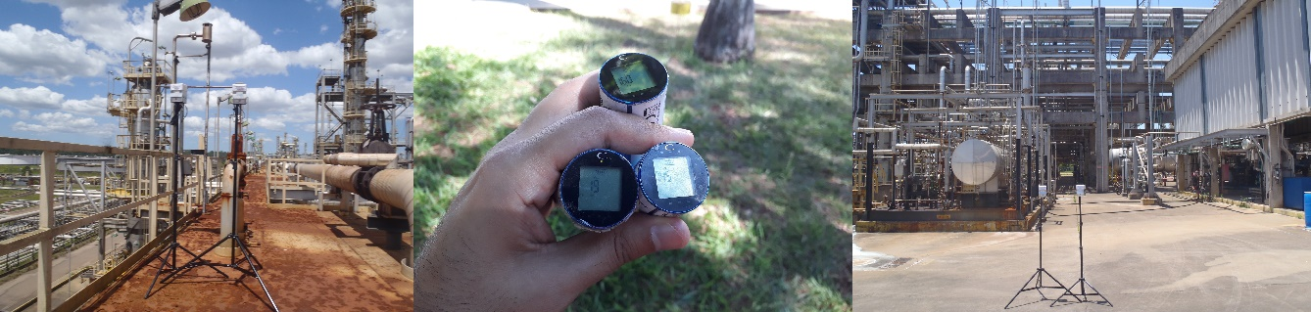
Figure 1: Ground measurement station and monitoring sensors
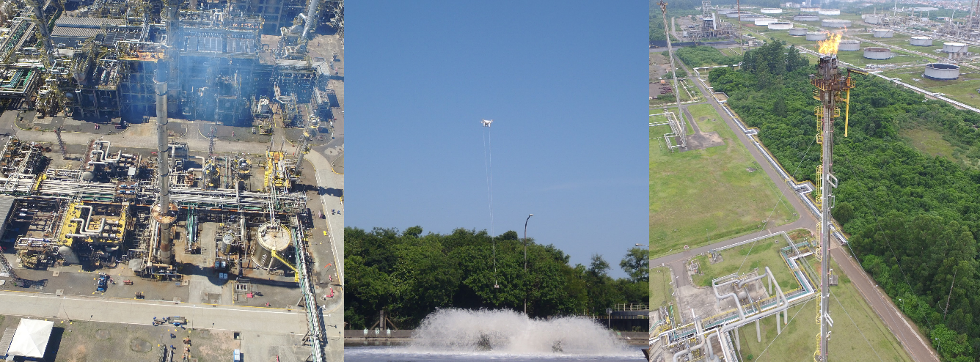
Figure 2: Unmanned air vehicle (quadricopter drone) used to take the monitoring sensors close to stack SRU, aerated lagoon and Flare
  - Results and discussion
The odorous gases emitted in the industrial process are from both fugitive and point (stacks) sources. In such conditions, it is not possible to measure the individual contribution of each source as their emissions overlap each other.
The results of the monitored maximum values of H₂S/CH₄S, NH₃, COVs e SO₂ were interpolated using a squared distance weighting average to obtain a better outlook and overlap the aerial image of the study area. The data used in the interpolation was the highest concentration of 1 minute from each monitored location. Thus, the results presented next show the worst odor pollution condition.
All NH₃ measurements were below the odor perception limit of 1,580 ppb (Nagata, 2003).
The maximum values monitored of H₂S/CH₄S are located at wastewater treatment, where the highest concentrations were at the raw effluent (point 12) and at the float (point 13). The emission in this process is practically constant in an open area and without a treatment system. Depending on the weather conditions, this odor can spread outside the company.

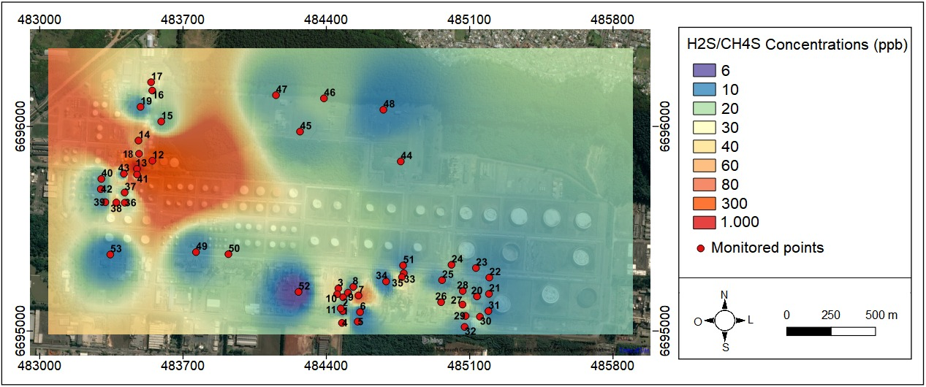
Figure 3: Map of H₂S/CH₄S concentration (in ppb). Red dots show the monitored spots
The highest concentrations of VOCs were in the wastewater treatment, primarily at the raw effluent, float and around the lagoon. Near to the merox process (point 7) there was also a high concentration of VOCs with a noticeable odor. In addition, the oil-water separator (point 36 and 38) had a continuous emission of VOCs and a strong odor as well. As this facility is an open place with no emission control, the odor can travel to other areas and outside the company, according to meteorological conditions.

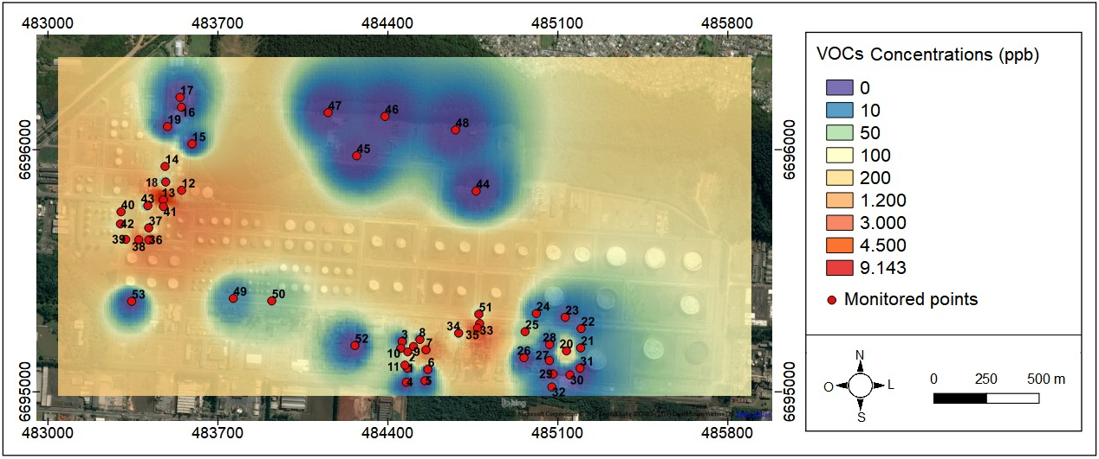
Figure 4: Map of VOCs concentration (in ppb). Red dots show the monitored spots
The SO₂ gas was present in all areas of the refinery uninterruptedly. However, only one monitored value was above the odor perception limit of 870 ppb (Nagata, 2003). Depending on weather conditions or atypical emission conditions, peaks with high concentration and short duration inside the plant may occur, like as the maximum value of 1,000 ppb identified in point 27, located in the SRU.

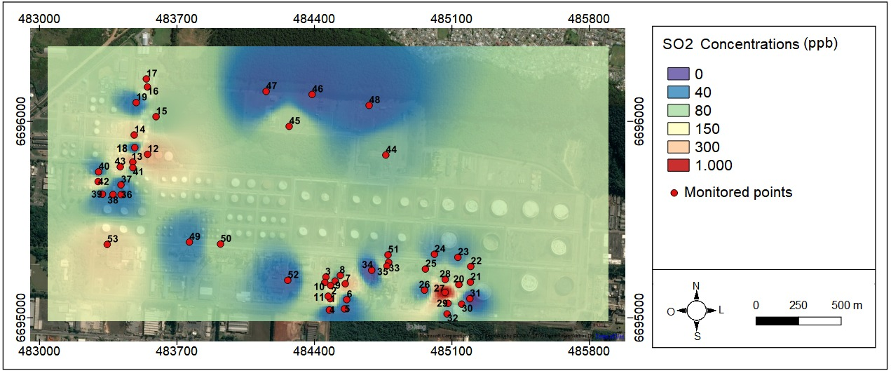
Figure 5: Map of SO₂ concentration (in ppb). Red dots show the monitored spots
The drone measurements carried out near the stacks showed that these sources are potential emitters of a substantial concentration of odorous gases, which can raise a concern by the community around the refinery. Nevertheless, the measurements on the flares (Figure 6) indicate a significant variation in the emissions, as some records present high concentrations of SO₂ and low of H₂S/CH₄S, while the opposite situation was observed in another day. It was also evident the lower emissions in Flare 1 compared to Flares 2 and 3. For safety reasons, measurements were made close to the height of the flame, but approximately 70 meters distant from it. Even this far, significant concentrations of gases were detected, which may be higher at atypical moments in the process. These sources (flares) can be characterized as having a great potential to cause odor in the surroundings, because, due to the height of the flare and the emitted concentration, the odor can travel for a few kilometers.

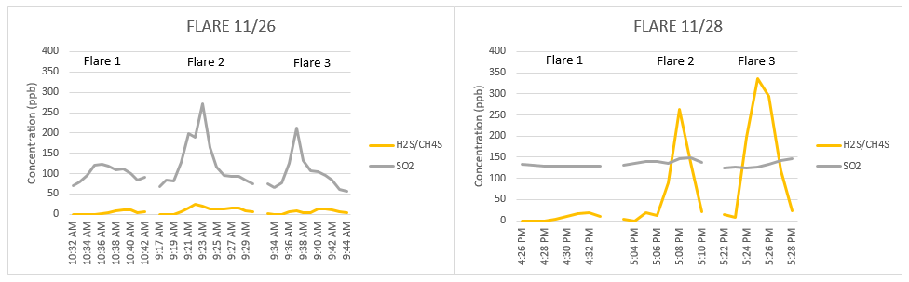
Figure 6: Measurements on Flares
The measurements near the SRU stack (Figure 7) show the highest concentrations of SO₂ and H₂S/CH₄S emitted by this process. The maximum value recorded for both gases was 1,000 ppb, the upper limit of the sensors. Even measuring at a distance of approximately 50 meters from the stack gas outlet, concentrations were high, indicating that H₂S/CH₄S emissions can spread to the community. As the odor perception threshold is low, within the range of 30 to 50 ppb in outdoor environments (Collins and Lewis, 2000), such intense emission can lead to bad odor events depending on weather conditions.

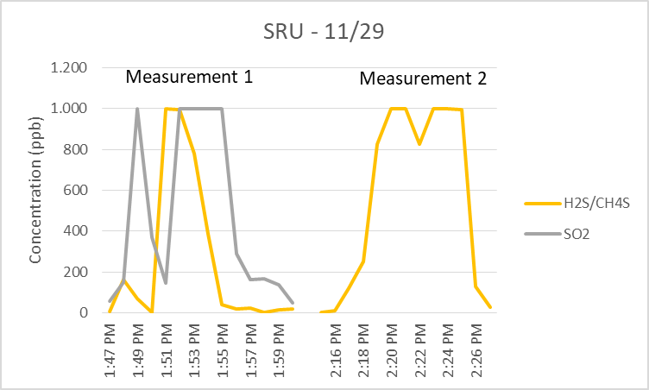
Figure 7: Measurements on SRU
  - Conclusion
Those measurements carried out at ground level around the oil-water separator and the wastewater treatment showed a continuous emission of odor gases. These emissions occur in an open and uncontrolled location, also, close to the boundary of the industrial plant. For this reason, such sources have the potential to cause a bad odor in the vicinity of the refinery. The emission from the oil-water separator is primarily of VOCs, while for the wastewater treatment the emission is a composition of VOCs, H₂S/CH₄S and may also include NH₃ in some moments.
Drone measurements showed that the stack of the SRU and the Flares are the main sources of H₂S/CH₄S. Due to the characteristics of these sources and the low odor threshold this gases, when they are emitting significant amounts of odoriferous gases, they can spread to the surroundings of the refinery and cause discomfort in the community, or even being noticed in a few kilometers away.
The drone made it possible to carry out measurements in places of difficult access or without any previous access. Such measurements, like those in the middle of the wastewater treatment pond and at the top of the flares, were recorded for the first time. Moreover, the UAVs can be used to assess emissions in critical odor episodes and also during periods of adjustment in the process. A disadvantage of this method is the flight autonomy of drones, which reduce with an increase in the number of sensors and also the limitation of the range of sensors that can be used.

References
Brancher M., Griffiths K.D., Franco D., Lisboa H.M., 2017, A review of odour impact criteria in selected countries around the world, Chemosphere, 168, 1531 – 1570.
Collins J., Lewis D., 2000, Hydrogen Sulfide: Evaluation of current California air quality standards with respect to protection of children, California Office of Environmental Health Hazard Assessment, 1 – 25.
Capelli L., Sironi S., Del Rosso R., Guillot J., 2013, Measuring odours in the environment vs. dispersion modelling: A review, Atmospheric Environment, 79, 731 – 743.
Chen Y.C., Chang C.C., Chen W.N., Tsai Y.J., Chang S.Y., 2018, Determination of the vertical profile of aerosol chemical species in the microscale urban environment, Environmental Pollution, 243, 1360 – 1367.
Damuchali A.M. & Guo H., 2020, Developing an odour emission factor for an oil refinery plant using reverse dispersion modelling, Atmospheric Environment, 222, 117167.
Han B., Liu Y., W J., Feng Y., 2018, Characterization of industrial odor sources in Binhai New Area of Tianjin, China, Environmental Science and Pollution Research, 25:14006 – 14017.
Hien V.T.D., Lin C., Thanh V.C., Oanh N.T.K., Thanh B.X., Weng C., Yuan C., Rene, E.R., 2019, An overview of the development of vertical sampling technologies for ambient volatile organic compounds (VOCs), Journal of Environmental Management, 247, 401 – 412.
Kim, K.-H., Park, S.-Y., 2008, A comparative analysis of malodor samples between direct (olfactometry) and indirect (instrumental) methods, Atmospheric Environment 42, 5061 – 5070.
Luginaah I. N., Taylor S. M., Elliott S. J., Eyles J. D., 2000, A longitudinal study of the health impacts of a petroleum refinery, Social Science & Medicine, 50, 1155 – 1166.
Luginaah I. N., Taylor S. M., Elliott S. J., Eyles, J. D., 2002, Community responses and coping strategies in the vicinity of a petroleum refinery in Oakville, Ontario, Health & Place, 8, 177 – 190.
Milan B. J. B., Bootsma S. S. K., Bilsen I., 2016, eNoses as a Tool to Measure Odour Nuisance Caused by Restaurants, Chemical Engineering Transactions, 54, 61 – 66.
Nagata, Yoshio, 2003, Measurement of Odor Threshold by Triangle Odor Bag Method, Japan Ministry of the Environment, Tokyo.
Vieira M.M., Schirmer W.N., Lisboa H.M., Filho, P.B., Guillot J., 2016, Pragmatic evaluation of odour emissions from a rendering plant in southern Brazil, Environ Sci Pollut Res, 23:24115 – 24124.

