|  |  |
| --- | --- |
| cetlogo ***CHEMICAL ENGINEERING TRANSACTIONS***  ***VOL. 85, 2021*** | A publication of  aidiclogo_grande |
| The Italian Association  of Chemical Engineering  Online at www.cetjournal.it |
| Guest Editors: Selena Sironi, Laura Capelli  Copyright © 2021, AIDIC Servizi S.r.l. **ISBN** 978-88-95608-83-9; **ISSN** 2283-9216 | |

Outcomes of a citizen science methodology and traditional odour impact evaluation techniques applied in a Chilean pilot study

Gerhard Schleensteina,\*, Natalia Muñoza, Mara Balestrinib, Valeria Righib, Lucia Errandoneab

aEcotec Ingeniería, José Victorino Lastarria 70 of. 213, Santiago, Chile

bIdeas For Change, Ronda Universitat 33, 1, 1B, Barcelona, Spain

gs@ecotec-ingenieria.cl

The EU Horizon 2020 call ‘’Science with & for Society’’ funded the D-NOSES project (Distributed Network for Odour Sensing, Empowerment and Sustainability), which aims to develop a methodology based on participatory strategies and collaboration among different stakeholders using an extreme citizen science approach. This paper presents the findings of this approach applied to a Chilean case study concerning a small community impacted by a municipal wastewater treatment plant. Results of odour observations gathered by citizens during a three-month period are compared with the traditional odour impact evaluation techniques such as field inspections. An adapted odour annoyance index showed a better accuracy for each assessment square compared to the odour impact characteristics. It also points out challenges of citizen participation and opportunities of combining both approaches.

* 1. Introduction

For more than 30 years, technical standards and criteria have been developed to quantify odour concentrations, and odour characteristics such as intensity, hedonic tone and odour impacts. Within these “traditional methods”, except for the VDI 3883 series, and most of the odour regulations around the world, the capacity and knowledge of citizens are largely excluded from the analysis. However, involving citizens in gathering data about odour nuisance can significantly reduce the cost of odour studies, while giving citizens the knowledge and tools to address the odour pollution that affect them.

The D-NOSES project aims to investigate how citizen science approaches can empower citizens to take a leading role in tackling odour pollution. Building on action research and participatory design (Foth et al., 2006), the goal of the project is to support and guide a collaborative journey to tackle odour pollution with the active involvement of key stakeholders from the public sector, business, civil society, and academia. In the D-NOSES project, citizens are part of this process by framing odour issues in their affected areas. This is done through identifying local odour problems, collective data collection, collective analysis of the results and co-designing measures to tackle odour pollution. Data collected by citizens shows a real, local understanding of the problem, and reduces costs of odour pollution measurements at the same time.

* 1. Materials and methods
     1. The studied site

As part of the D-NOSES project, a pilot study has been conducted in Los Alamos, Chile. The city of Los Alamos (15.000 inhabitants) has a municipal wastewater treatment plant (WWTP) that has been operating for about 20 years. This WWTP and the surrounding neighbourhoods have been selected as a single-source case-study. Modifications to the WWTP were introduced in 2018, including a technology shift from SBR to Activated Sludge and scrubbers and biofilters for odour abatement. The closest inhabitant of Los Alamos lives on a 20 meter distance from the WWTP, and the WWTP impacts a total of three neighbourhoods with 1000 households, spread over two social housing neighbourhoods, Villa Esperanza (“hope” in Spanish) and Kintupi Ruca (“searching for a home” in the indigenous language Mapudungun) which were established in 2011 and 2015. As is visible in figure 1, these houses are located in the dominant wind direction and therefore impacted by the odours of the WWTP.

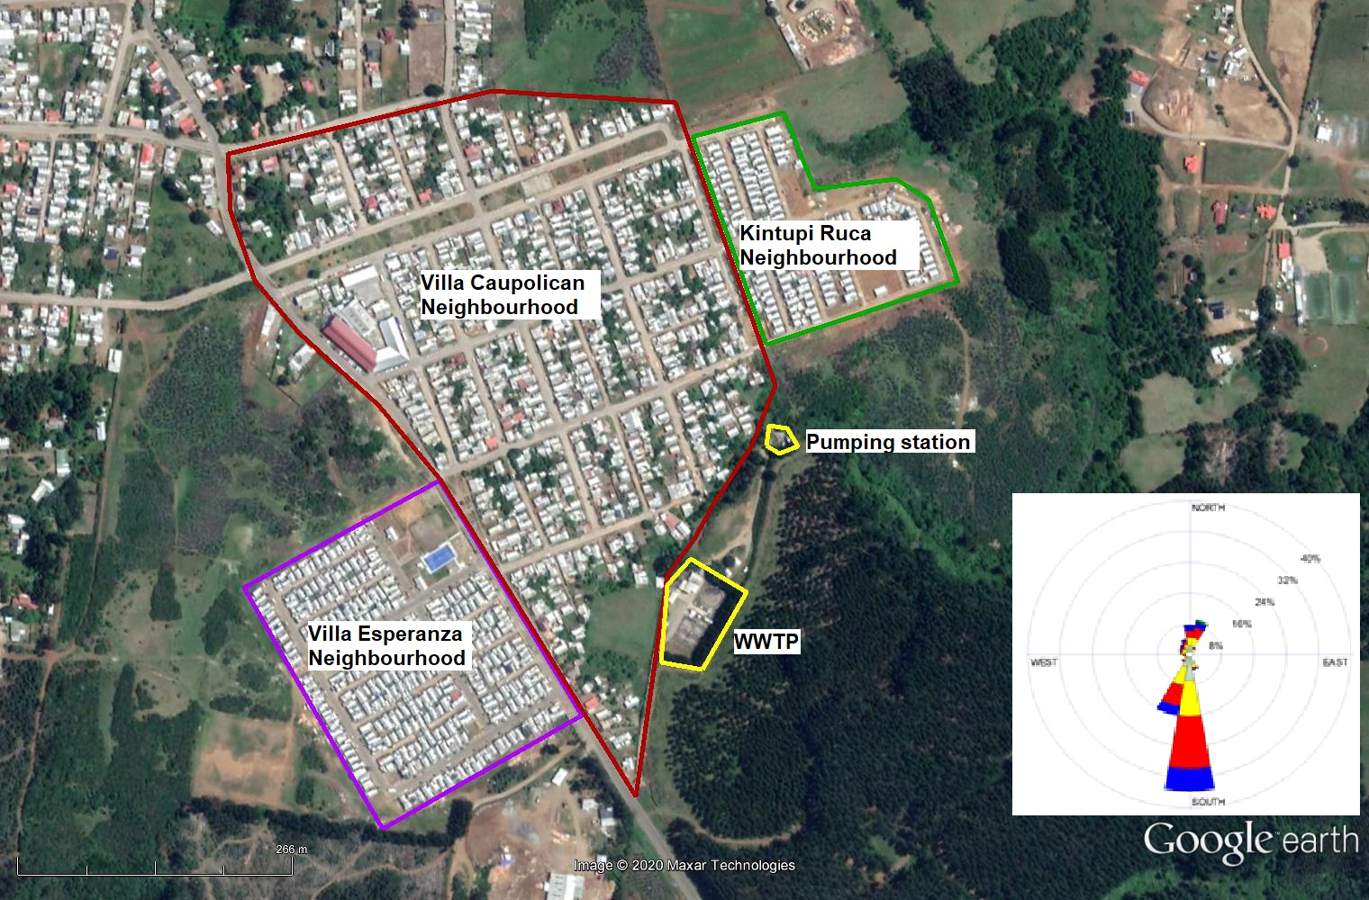

Figure 1: Study site, indicating odour sources (yellow lines), residential areas and wind rose

* + 1. Odour annoyance assessment through questionnaires

The case study started with an odour annoyance assessment questionnaire as described in VDI 3883 part 1, homologated in Chile by technical standard NCh 3387:2015 in June 2019. The sample questionnaire K module with core questions was used with some minor modifications. The questionnaire was administered by an interviewer. The areas where the survey was conducted are the three neighbourhoods presented in figure 1. The neighbourhood of Villa Caupolicán was divided in two parts households within close proximity to the WWTP and households within at least 200 meter distance to the odour sources. The aim of the odour annoyance assessment was to have a clear, not biased, image of the affected areas, in order to have an improved focus of the citizen engagement strategy.

* + 1. Field inspections

Field inspections were carried out in December 2018 to determine the impact frequency of recognizable odours in terms of odour hours, using the grid method described in VDI 3940 part 1, which was homologated in Chile, with some slight differences, by technical standard NCh 3533/1:2017. In addition, the environmental license of the WWTP considered some deviations to the method: The survey period was seven consecutive days during one week, every three months (in December, March, June and September), with measurements being evenly distributed between 6 am and 12 pm. The assessment area covered the three neighbourhoods indicated in figure 1 with 17 assessment squares defined by 29 measurement points, following the regular street grid of 100 m x 100 m (figure 2).

* + 1. Participatory approach and citizen observations

The D-NOSES methodology (Balestrini et al, 2018; Arias et al., 2019) aims to involve the affected communities to collect observations on episodes of odour nuisances. By following the D-Noses methodological framework, the Chilean pilot study has developed an engagement strategy that encompasses pilot design and data collection stages. The main stakeholders involved were: three neighbourhood organizations that legally represent the local residents, the local municipality, the WWTP operator and the D-NOSES consortium member that acted as mediator. A stakeholder map was elaborated to identify neighbourhood organizations, places of worship and other social and economic activities. The aim of this stage was to understand the hot spots where people usually gather and potential community champions.

Data collection started at the end of November 2019. Participants were asked to use either OdourCollect, a smartphone app that allows to gather real-time odour observations, or a pen-and-paper odour diary to report episodes of odour when they occurred. However, despite substantial engagement efforts (e.g. meetings at neighbourhood centres, house-to-house visits), the motivation to participate was rather low. To overcome this issue, in addition to the random observations collected with the aforementioned methods, in mid-January 2020 a group of about eight local residents were trained as panellists to realize twice a day a predefined 1.8 km track covering 17 of the 29 measurement points considered in the field inspections (see figure 2 on the right), reporting odour observation by using the OdourCollect app. The citizen panellists were asked to remain at each point for about 2 to 3 minutes and then report the main odour they perceived. The app enables to report odours (“what does it smell like?”), sub-types of odours, intensity, hedonic tone, and comment on the duration of the odour episode and the potential source. Geographic coordinates, date and time of the odour observations are automatically recorded.

* 1. Results and discussion
     1. Odour annoyance assessment through questionnaires

From a sample of 55 participants, 41 had acceptable response rate; six interviews were excluded from further analysis due to implausible data while comparing the verbal and the thermometer scale. The Pearson product-moment (PM) correlation r was 0.96 which indicates a “strong” and plausible relation between odour annoyance values measured with the verbal and the thermometer scale. The latter ranges from 0 (not annoyed at all) to 10 (extremely annoyed).

Table 1: Description of the four survey zones

|  |  |  |  |  |
| --- | --- | --- | --- | --- |
| Survey zone | Villa Esperanza | Villa Caupolicán (close to source) | Villa Caupolicán (distant to source) | Kintupi Ruca |
| Assessment squares | A, H, I, J | B, C, D, E, F, P, Q | K, L, M | G, N, O |
| Total households | 300 | approx. 275 | approx. 275 | 150 |
| Survey area | 5 ha | 10 ha | 9 ha | 3 ha |
| Number of interviews | 9 | 12 | 6 | 8 |

The number of interviews in all survey zones was relatively low (Table 1). Still, the differences of arithmetic means between the Villa Caupolicán (close to source), Villa Caupolicán (distant to source) and Villa Esperanza are 3.0 and 3.1 respectively, thus highly exceeding the 0.7 criteria for significant differences.

Table 2: Odour annoyance on thermometer scale for the four survey zones

|  |  |  |  |  |
| --- | --- | --- | --- | --- |
| Survey zone | Villa Esperanza | Villa Caupolicán (close to source) | Villa Caupolicán (distant to source) | Kintupi Ruca |
| Arithmetic mean | 1.8 | 5.7 | 1.7 | 3.4 |
| Standard deviation | 3.2 | 3.4 | 2.6 | 3.2 |
| Min/Max | 0/9 | 0/10 | 0/5 | 0/8 |
| Median | 0.0 | 7.0 | 0.0 | 3.5 |

* + 1. Field inspections

The assessment square-related odour impact characteristic is shown in figure 2 (left). Sample size after five surveys was 35 for all assessment squares except for the triangle Q (45). No odour impact was observed for Villa Esperanza and distant to source zone at Villa Caupolicán. Close to the source zone at Villa Caupolicán and Kintupi Ruca largely have odour impact characteristics below the 10 % threshold value, but assessment squares P and G close to the pumping station exceed the threshold. The preliminary investigations revealed that the affected area was smaller than initially envisaged, this meant that the focus of citizen engagement would be the neighbourhoods Villa Caupolicán,and Kintupi Ruca, close to the WWTP and the most affected.

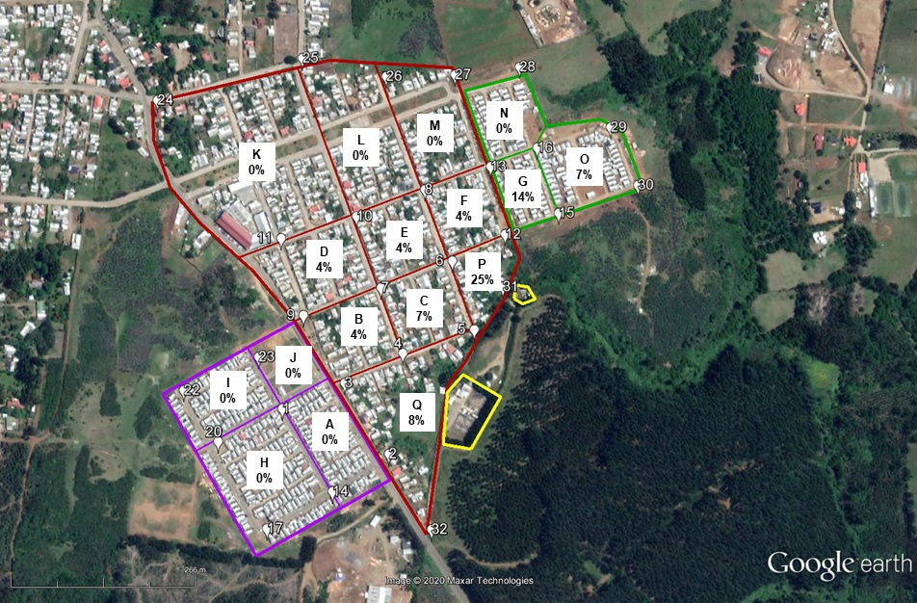 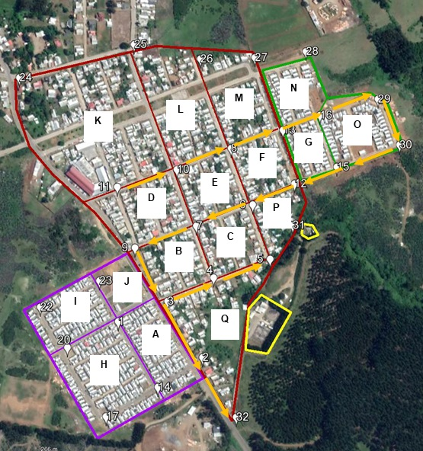

Figure 2: Assessment square-related odour impact characteristics by field inspections with trained assessors (left). Walking route (orange) for coordinated citizen observations (right). Odour sources in yellow lines.

* + 1. Citizen observations

Citizen motivation to participate in the pilot project was rather low, despite an engagement and communication campaign. Only 20 people used the OdourCollect app, most of them in rather few opportunities. After one month, in January, the most committed community champions were trained to become field inspectors and contributed to the methodology and characteristics of the WWTP while using the field olfactometer. Observation hours were not distributed evenly during the day, but at early mornings (7 am to 10 am consisted of 37 % of all observations) and evenings (6 pm to 8 pm, 32 %) with more adverse dispersion conditions. Data analysis comprises 2,209 individual observations made during ten weeks (end of January until beginning of April) by eight trained citizens (figure 3, right). Data pre-processing included assignment of observation coordinates to measurement points on the regular grid, amongst others. The OdourCollect app lacked a “no odour” observation; therefore an agreement had to be established to report absence of odour. Odour observations were grouped in nice (flowers, …), urban (smoke, waste, …) and waste water related odour. Observations frequencies were calculated for each assessment zone (see table 3), using the grid method evaluation described in VDI 3940 part 1. An odour hour was assumed for each positive “waste water” type observation. Figure 4 (left) shows the same findings for “waste water”. Observation frequencies for assessment zones A, J, K, L, M, N are overestimated (up to factor 2), as only two measurement points closer to the WWTP were considered on the route. Citizen had not been trained on VDI 3882 part 1 (odour intensity) nor on VDI 3882 part 2 (hedonic tone), but both characteristics can be reported with the OdourCollect app. The observed relation between hedonic tone and intensity can be described as linear functions as shown in figure 3 (left).

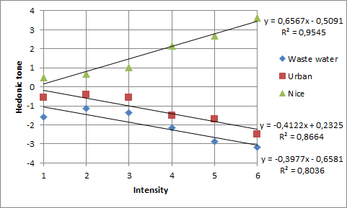

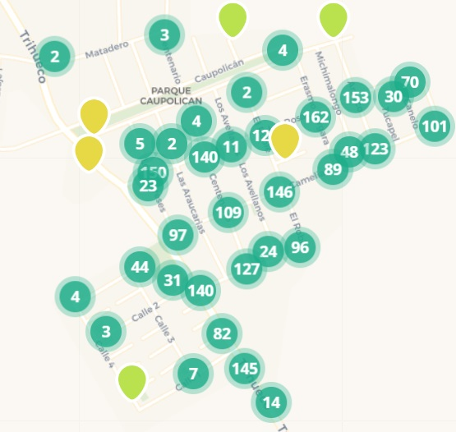

Figure 3: Relation between hedonic tone and perceived intensity (left). OdourCollect app observations (right).

Table 3: Observation frequencies for trained citizen observations

|  |  |  |  |  |  |  |  |
| --- | --- | --- | --- | --- | --- | --- | --- |
| Assessment zone | Survey zone | No odour | Nice odours | Urban odours | Waste water | Incoherent observation | Number of observations |
| A\* | V. Esperanza | 7 % | 31 % | 46 % | 15 % | 2 % | 280 |
| B | V. Caupolicán (close to source) | 7 % | 28 % | 44 % | 20 % | 1 % | 522 |
| C | V. Caupolicán (close to source) | 7 % | 18 % | 36 % | 39 % | 1 % | 503 |
| D | V. Caupolicán (close to source) | 10 % | 35 % | 44 % | 9 % | 1 % | 536 |
| E | V. Caupolicán (close to source) | 9 % | 26 % | 47 % | 17 % | 1 % | 541 |
| F | V. Caupolicán (close to source) | 6 % | 17 % | 37 % | 39 % | 1 % | 529 |
| G | Kintupi Ruca | 6 % | 19 % | 25 % | 49 % | 0 % | 534 |
| J\* | V. Esperanza | 8 % | 30 % | 49 % | 11 % | 2 % | 265 |
| K\* | V. Caupolicán (distant to source) | 12 % | 39 % | 39 % | 9 % | 1 % | 284 |
| L\* | V. Caupolicán (distant to source) | 8 % | 30 % | 48 % | 14 % | 0 % | 276 |
| M\* | V. Caupolicán (distant to source) | 5 % | 18 % | 41 % | 35 % | 0 % | 273 |
| N\* | Kintupi Ruca | 8 % | 23 % | 31 % | 39 % | 0 % | 276 |
| O | Kintupi Ruca | 5 % | 37 % | 27 % | 30 % | 1 % | 528 |
| P\* | V. Caupolicán (close to source) | 6 % | 12 % | 27 % | 54 % | 1 % | 368 |
| Q | V. Caupolicán (close to source) | 5 % | 30 % | 32 % | 31 % | 1 % | 616 |

VDI 3883 part 2 uses annoyance categories with weighting factors for calculation an annoyance index. This index is a stepped scale from 0 to 100 of the annoyance reactions averaged and weighted over all test subjects. To calculate an adapted annoyance index out of the data retrieved by the OdourCollect app, the simplifications show in table 4 for obtaining the annoyance category out of the odour intensity for waste water related odours were considered. Other odour types were associated to a weighting factor of zero.

Table 4: Adopted simple relation between odour intensity and annoyance category

|  |  |  |
| --- | --- | --- |
| Odour intensity | Annoyance category i | Weighting factor *Wi* |
| 0 not perceptible | 0 no odour | 0 |
| 1 very weak | 0 no odour | 0 |
| 2 weak | 1 not annoying | 0 |
| 3 distinct | 2 slightly annoying | 25 |
| 4 strong | 3 annoying | 50 |
| 5 very strong | 4 very annoying | 75 |
| 6 extremely strong | 5 extremely annoying | 100 |

The weekly annoyance index *Ik* in the k-th observation week was then calculated with Eq(1) for each assessment square. *Nk* refers to the total numbers of observations in the k-th week and *Nik* to the number of observations in annoyance category *i* in the k-th week. Results given in table 5 also include the median and the 90-percentile of the odour annoyance indices. The latter is the level which is exceeded 10 % of the time.

|  |  |
| --- | --- |
|  | (1) |

Table 5: Weekly annoyance index for evaluation period 27/01/2020 to 05/04/2020

|  |  |  |  |  |  |  |  |  |  |  |  |  |  |
| --- | --- | --- | --- | --- | --- | --- | --- | --- | --- | --- | --- | --- | --- |
| Assessment zone | Survey zone | W1 | W2 | W3 | W4 | W5 | W6 | W7 | W8 | W9 | W10 | Median | 90-Percentile |
| B | V. Caupolicán | 8.3 | 6.9 | 11.5 | 4.4 | 2.8 | 4.2 | 5.4 | 2.7 | 2.3 | 0.0 | 4.3 | 11.2 |
| C | V. Caupolicán | 20.1 | 22.0 | 27.2 | 17.7 | 14.8 | 17.5 | 13.7 | 10.7 | 11.0 | 2.5 | 16.1 | 26.7 |
| D | V. Caupolicán | 2.6 | 3.5 | 3.3 | 0.8 | 0.5 | 12.3 | 1.4 | 2.2 | 0.0 | 0.0 | 1.8 | 11.4 |
| E | V. Caupolicán | 6.3 | 4.8 | 5.9 | 5.9 | 0.0 | 9.3 | 3.2 | 3.0 | 3.1 | 0.0 | 4.0 | 9.0 |
| F | V. Caupolicán | 19.1 | 16.8 | 22.5 | 21.2 | 9.9 | 13.3 | 13.1 | 7.9 | 10.3 | 6.3 | 13.2 | 22.3 |
| G | Kintupi Ruca | 21.6 | 20.5 | 27.5 | 25.2 | 15.1 | 12.1 | 17.4 | 8.1 | 10.6 | 9.4 | 16.3 | 27.2 |
| O | Kintupi Ruca | 9.3 | 9.7 | 10.3 | 11.7 | 7.3 | 2.5 | 6.6 | 3.2 | 5.1 | 3.1 | 6.9 | 11.6 |
| P | V. Caupolicán | 23.2 | 25.2 | 29.7 | 23.1 | 18.8 | 25.1 | 16.1 | 12.5 | 14.3 | 6.7 | 20.9 | 29.2 |
| Q | V. Caupolicán | 15.5 | 18.1 | 22.9 | 13.7 | 13.5 | 13.6 | 12.4 | 12.5 | 7.8 | 2.0 | 13.5 | 22.5 |

The annoyance index declined from week eight onwards the end of the summer period, due to lower temperatures and more favourable meteorological conditions in general. Figure 4 (right) shows the median annoyance index for the different assessment zones.

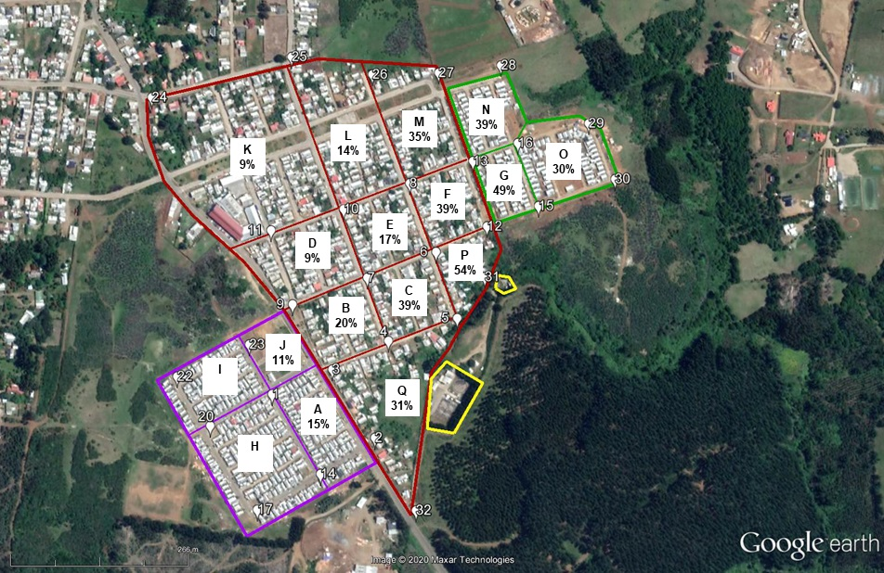 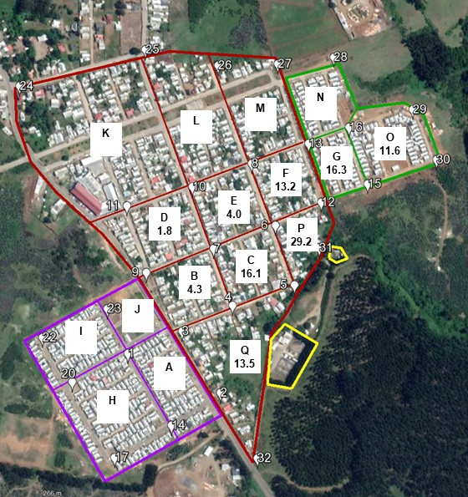

Figure 4: Assessment square-related odour impact characteristics determined with coordinated citizen observations (left). Median annoyance index (right). Odour sources are indicated by yellow lines.

* 1. Conclusions

In odour studies, citizens are usually not considered as independent and objective sensors. This study has showed drawbacks and potentials of combining three different approaches in which citizens takes an active role: 1) Odour annoyance assessment through questionnaires; 2) Citizen observations when the annoyance is perceived; 3) Citizens panellist that gather information systematically. Results showed that less than 10% of observations were classified as “no odour”, highlighting the persistence of the problem perceived in the area. Waste water related assessment square odour impact characteristics exceed by far those obtained by field inspections with trained assessors. This may indicate higher intolerance to these types of odours. The data collection method can be considered as hybrid between field inspection and repeated brief surveying citizen panellists. The adapted odour annoyance index seems to give more accurate results for each assessment square compared to the odour impact characteristics results, as odour observations are weighted by odour intensity as simplified equivalent for odour annoyance. The results indicate a probable stronger impact by the pumping station than the WWTP itself. Local problems in the vicinity to the main sewer leading to the pumping station also must be further investigated and quantified to reduce emissions.

Acknowledgments

This project has received funding from the European Union’s Horizon 2020 Research and Innovation Programme under Grant Agreement No 789315. This study was possible due to the participation of the citizens of Los Alamos.

References

Arias R, Romero Gonzalo F. and Motjer Ayats E, 2019, Citizen science for odour impact assessment considering the real perception of the receptors: The case of Barcelona. In proceedings of Sardinia Symposium 2019: The 17th International Waste Management and Landfill Symposium.

Balestrini M., Creus J., Errandonea L., Arias R., Salas N., 2018, Map of odour issues and priorities. Multilevel engagement plan for stakeholders and communities, D-NOSES, H2020-SwafS-23-2017-789315. <dnoses.eu/wp-content/uploads/2019/01/D4.1-Map-of-Odour-Issues.pdf> accessed 03.04.2020.

Foth M., Axup, J., 2006, Participatory Design and Action Research: Identical Twins or Synergetic Pair? In: G. Jacucci, F. Kensing, I. Wagner, J. Blomberg (Eds.) Participatory Design Conference 2006: Expanding Boundaries in Design, August 1-5, Trento, Italy.