CHEMICAL ENGINEERINGTRANSACTIONS  VOL. 82, 2020 | A publication of
The Italian Association
of Chemical Engineering
Online at www.cetjournal.it
Guest Editors: Selena Sironi, Laura Capelli
Copyright © 2020, AIDIC Servizi S.r.l.
ISBN978-88-95608-80-8; ISSN 2283-9216

Deodormatic, the first modular semi-industrial self-monitored odour abatement system specifically designed to treat indoor odour.
C. Díaz^{a,}*, C. Izquierdoª, A. Antónª, J. Lozano^{b}, A. Cabrera^{c}, M. Martín^{c}, J. L. Recaj^{d}, J. Balfagón^{d}, R. Muñoz^{e}, R. Lebrero^{e}, M. Mendicute^{f}
a. Olores.org, Bilbao, Spain.
b. Industrial Enginineering Faculty. University of Extremadura, Badajoz,Spain
c. LEQUIA, Institute of the Environment. University of Girona, Campus Montilivi, 17071 Girona, Catalonia, Spain
d. Alphachem, Barcelona, Spain
e. Institute of Sustainable Processes- University of Valladolid, Valladolid, Spain
f. Signal Theory and Communications, Electronics and Computing Dpt., Mondragon Unibertsitatea, Spain
* carlosdiaz@olores.org

Indoor air quality is becoming increasingly important. In workplaces where air quality is not optimal. Staff comfort decreases, especially in offices and work places of odour-generating activities with an insufficient ventilation, with the subsequent decrease in productivity. Nowadays, there are many domestic devices for purifying the air, but they all focus on purifying particles, formaldehyde or other gases. In addition, the air flow rate of these devices is not sufficient for large rooms and the odour control system is usually a thin active carbon cartridge , which neither by design nor by dimensions is suitable on a semi-industrial scale. There are also other types of industrial odour abatement systems that are normally designed and selected in a case by case basis depending, among many other factors, on cost, flow and concentration of the gas to be treated. There is currently no specific system exclusively for odour treatment in indoor ambient air at a medium industrial scale for offices of odour emitting industries. The aim of this conceptual paper is to present the features to be included in Deodormatic, the first indoor air treatment system at semi-industrial scale specifically focused on odour abatement.
  - Introduction
When there is an issue related to odour impact around a community, the measures commonly employed by plant managers focus on preventing, minimizing and/or mitigating the impact of odours by acting directly on the processes that generate this impact. Often, these measures are based on air/odour treatment technologies, where the equipment is usually quite large and often designed to be an end-of-pipe in order to balance cost/efficiency of the flow treated.

Unfortunately, little care is taken on the comfort of the staff that work in these activities. It is normally assumed that sensory adaptation will make its job, and after a while the staff working inside a plant will get used to the smell. However, this is not the case if the person is moving around different places coming in and out of the offices and meeting rooms. Also it is not the case when customers and suppliers are visiting the offices of an odour emitting plant coming from outside.

Nowadays, there are many domestic devices for purifying the air, but they all focus on purifying particles, formaldehyde or other gases. In addition, the air flow rate of these devices is not sufficient for large rooms and the odour control system is usually a thin active carbon cartridge, which neither by design nor by dimensions is suitable on a semi-industrial scale. Currently, more and more domestic devices are incorporating sensors to measure air quality, and in some cases they even include sensors to monitor one or two odorants, however, no domestic abatement system incorporates an Instrumental Odour Monitoring System (IOMS) to control flow or to continuously evaluate the efficiency of the odour abated.

There is a need in the market for equipments that provide a solution to the problem of indoor odour in open offices, meeting rooms or large lounges, with a size, purification capacity and other characteristics adapted to this type of use.

This is why the idea of developing Deodormatic arose. This device will consist of a high-capacity odour abatement equipment specifically designed for use in rooms such as offices, meeting rooms, etc., in industries where potentially odour-generating activities are carried out and where workers, such as administration staff are in need of more comfort at work.

The concept of Deodormatic, is that of a modular odour abatement system. Usually industrial odour abatement systems are tailor-made in order to optimize the relation cost-efficiency of these equipments. On the other hand, domestic air abatement systems have a fixed design, that allow little variation on the flow or the filters to be used. The idea is to build a system able to detect odours with an IOMS and adapt its regime to the ambient odour present. This system can be adapted in a modular design to easily swap between or sequentially combineactivated carbon, UV +TiO2 or a biotechnology, depending on the characteristics of the odour to be treated.

A group of different experts and professionals from both private companies and universities have joined forces to try to develop this system.

The aim of this concept paper is to present the first initiative, to our knowledge, of a semi-industrial self-monitored modular odour abatement system for the specific treatment of odours in large spaces with insufficient ventilation and problems of odour impact in indoor spaces such as open offices or meeting rooms of industrial odour-emitting activities.
  - Methodology
The proof of concept of Deodormatic, is being right now designed and a first prototype is expected to be ready by the end of 2020. Once the first prototype is ready, it will be tested in several odour emitting plants such as an animal by-product plant, a WWTP and/or an oil refinery. The present project has been divided in several tasks that will be carried out by a multidisciplinar consortium of experts in different fields.

Signal processing will be addressed with a specific IOMS. The system will be in charge not only of measuring inlet and outlet odour concentration but also on checking saturation state of the filters by measuring pressure drop continuously. Deodormatic will need a wifi connection in order to send the raw data to an external server to analyze repeated patterns to record not only changes in gas composition in the room, but also how this parameters change with different variations such as keeping a door opened or closed or with an HVAC system turned on.

The external server that will receive all raw data, will have a software recognition protocol to identify the odours to be abated. The signals will be interpreted by this software and compared with an existing database of patterns in order to regulate the flow of the system, replace the filter used or even send an alert message to the owner in case of an emergency.

The second part of the project will deal with the specific task of abating odours. Three types of technologies have been selected for this purpose: biotechnologies, adsortion and UV+TiO2. Each of the technologies is carried out by a different group. The goal is to be able to run different filtration equipments, either separately or sequentially, to get the best available technique each time.

Finally, the last part of this project will deal with how the whole system is integrated by means of a low-cost CPU-based embedded system, which will be responsible for capturing all the information processed by the sensors and for acting accordingly in order to control the flow, the filter saturation and all the parameters of interest. This embedded system will be connected to the cloud through a wireless interface, allowing for local (using a smartphone) or remote (through the cloud) monitorization and control of the complete indoor odour abatement system.
    - Design and structure
Although there is still not a real definition of the dimensions of the device, some ideas have been proposed, and a first draft of the structure can be seen in the Figure 1.

The material of the structure should be considered to be non-corrosive in the specific rooms/areas where the device is going to be working on, such as PVC., in order to be resistant.
The cylindrical design is based on lower pressure drop, uniform flow distribution, better fluid dynamic properties, better sealing and no stagnation at the corners, as in the vast majority of stacks.
Inside this structure, a fan will be installed, with a VFD (Variable Frequency Driver), in order to change the speed of the fan depending on each case scenario (higher concentration of odorants, night or day mode, etc.) The maximum fan speed will not exceed the maximum decibels of the national/regional noise legislation.
Besides, depending on the specific odorants to be abated, the fan will change the flow direction in order to treat compounds more or less dense than the ambient air.
Finally, as some of this equipment will be at office rooms or fancy meeting room, a stylish and trendy design has try to be developed. In any case, with a height of approximately 2 meters, deodormatic will not fit in small rooms.
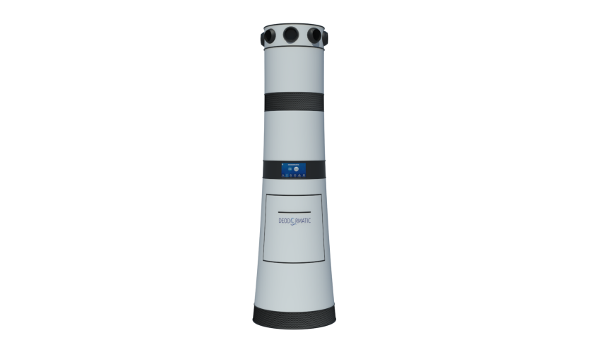
Figure 1: Deodormatic device render
    - IOMS
An IOMS is are sensor-based machines olfaction capable of discrimination between a variety of simple and complex odours. Like human olfaction, IOMS or Electronic noses (e-noses) are based on “an array of electronic-chemical sensors with partial specificity to a wide range of odorants and an appropriate pattern recognition system” [45]. In comparison with traditional odour measurement systems, there is a need for small, low-power devices for odour monitoring.

IOMS basically is a combination of gas sensors and machine learning technologies. In the field of gas sensors suitable for e-noses, there are five main types: resistive, surface acoustic wave, catalytic, optical, and electrochemical. Resistive gas sensors are the most commonly used in portable and miniaturized devices due to their small size and low power consumption, in particular those based on semiconductor metal oxides (MOx). Typical gas sensors based on metal oxide technology that have been used in electronic noses for decades are not appropriate for miniaturized instruments due to their high power consumption and size. MEMS technology has allowed the integration of gas sensors within CMOS technology modules, which embed signal processing, A/D converter, and communication circuits. The e-nose used in Deodormatic is a miniaturized electronic nose (39 mm × 33 mm) with Bluetooth communication [Arroyo 2020]. It incorporates four new generation digital gas sensors. These MOx-type sensors incorporate a microcontroller in the same package, being also smaller than the previous generation [Suarez 2018]. It is shown in the next figure.

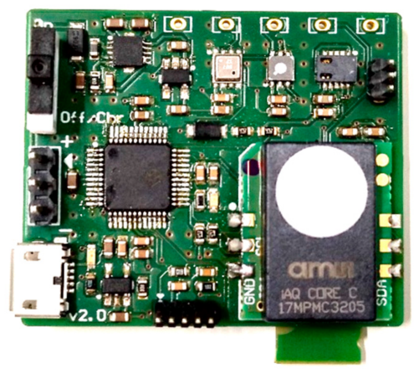
Figure 2. IOMS used in Deodormatic.
The device includes a power supply, four different gas sensors, a 32 bit microcontroller and a Bluetooth Communication module.

    - Odour abatement: biotechnologies
In the past decades, biotechnologies have emerged as potential alternatives o complementary solutions to physical-chemical methods for indoor air pollution control. Biofiltration has been widely proven as a cost-effective, environmentally friendly and robust technology for the abatement of off-gases from industrial sources and odor control (Estrada et al. 2015). Biotechnologies are based on the biocatalytic action of microorganisms capable of using organic and inorganic odorants as carbon and/or energy source. Additionally, the ability of plants to assimilate and metabolize indoor air pollutants has been also engineered for enhancing indoor air quality. Botanical-based technologies, which consists of a vegetable plant and a packing material-substrate, combine the activity of the microbial community in the soil with plant’s ability to uptake volatile organic pollutants (Luengas et al. 2015).

The development of compact and cost-effective biological technologies for indoor air treatment requires the engineering of a new generation of high-mass-transfer bioreactors. Enhancements in the gas-microorganisms mass transfer of indoor air pollutants can be achieved via an increase in the concentration gradient governing pollutant mass transport or in the volumetric mass transfer coefficient (K_{l}a_{G/A}). On the one hand, the implementation of a new concept of biotechnologies based on “gas-to-cell” direct pollutant mass transport (in contrast to the classical gas-water-cell pollutant transport pathway) can increase the gas-microorganism concentration gradient available for mass transport, and therefore enhance the overall volumetric pollutant biodegradation rates. On the other hand, Taylor flow monolith bioreactors could eventually support an enhancement in the gas-liquid mass transport and biodegradation of indoor air pollutants as a result of their inherently high K_{l}a_{G/A} values (~ one order of magnitude larger than conventional gas-liquid contactors at similar energy inputs)

    - Odour abatement: adsorbers (activated carbons)
Adsorption and Chemisorption has been widely used for odour abatement for many years. Basically there are two types of products (Shammay, Ari 2016): impregnated and not impregnated products. In not impregnated products a porous element is used to physically adsorb malodourous gases. In impregnated products, a porous support with an special porous size is impregnated with a chemical agent to get rid of the gases in three processes: 1- Adsorption inside the porous support; 2- Absorption where the gas is dissolved in the water of the same suport or using the air moisture; 3.- Chemissorption, where the dissolved gas reacts with the impregnant, changing its nature to a non-stinging product and being retained inside the porous matrix.

Adsorption is used to retain volatile gases with a high molecular weight. Basically activated carbon is used in this case. The most used supports for chemisorption are: activated carbons, activated aluminas and zeolites. Depending on the impregnating agents, different types of gases will be removed: with an acid impregnation, ammonia, ammines and basic gases will be eliminated. With a caustic impregnation acid gases will be removed and if oxidants are used a wide range of different type of gases will be discomposed. Special activated carbon, named catalytic carbon is also used for some type of gases with a high capacity.

This technology is very easy to implement, very flexible to use in the different scenarios of concentrations and type of gases and have a very high efficiency, but depending on the concentrations the cost of replacing the filters must be taken in consideration.

    - Odour abatement: UV Visible with catalysts
Conventional air cleaning methods for gaseous contaminants abatement are limited to physical procedures, yet an effective technology to destroy these pollutants has not been produced at industrial scale. Activated carbon filters (ACF) are currently used as an efficient and safe process to remove a broad range of volatile organic compounds (VOC). The main drawbacks of ACFs are their low capacity to adsorb several toxic compounds, such as the carcinogenic and widespread formaldehyde, and the need for periodical regeneration of the exhausted activated carbon.

To overcome the disadvantages of ACFs, photocatalytic oxidation (PCO) is a promising emerging Advanced Oxidation Process (AOP) that can be applied to air cleaning. It consists on an oxide-based photocatalyst placed under a light source which interaction with airborne water molecules generates active radicals that initiate oxidative reactions to break down the contaminant molecules into less harmful products (CO2 and H2O).

The lab-scale reactor consisted on an immersion Xenon lamp (novaLIGHT TXE150) submerged in a 800 mL reactor. The air flow, spiked with a mixture of VOCs and VMSs, was bubbled from the bottom of the reactor, and 2 g of photocatalyst was suspended in the liquid phase. The outlet gas composition was continuously analyzed by means of a GC-MS equipped with a gas-sampling valve. TiO2 is the photocatalyst considered in this study.

    - CPU and integration
The integration of all the sensors and actuators will be based on an embedded system using an extended CPU-based architecture, such as a Rasberry Pi. The embedded system will read and process the information from all the sensors and will transmit the control signals to the actuators, such as fans, in order to maintain a closed-loop control of the odour. The system, which will contain a WiFi module, will be monitored and controlled by the user using three different interfaces: a simple touchscreen located on the equipment itself, an app running on a smartphone (connected directly through WiFi) or over the Internet, following a cloud-based operation.

The architecture of the embedded system will be unique and will adapt to any specific implementation of the modular indoor odour abatement system. According to the number and types of sensors and the operation profile selected by the user, the system will implement an optimized control algorithm. Since the system will be able to connect to the Internet, the information provided by all the installed devices will be used to improve the control strategies and algorithms. The embedded system will also be able to send event or alarm information to the user through the local screen or the smartphone app, in order to notify the need of immediate actions or equipment-related problems.

  - Conclusions
In the present article the technical idea of manufacturing a device for odour abatement at a semi-industrial level has been presented as a proof of concept to evaluate its efficiency in odour abatement.
The goal is to develop the first prototype and test it in real life conditions. The prototype will consist of an IOMS and it will be designed with a modular character so that it will be possible to swap filters or to run them sequentially. The technologies selected for odour abatement in this case are biotechnology, adsorption or UV with TiO2.

Acknowledgments
The finantial support for the Spanish Ministry of Science, Innovation and Universities is gratefully acknowledged (CTM-096441-B-I00 ).
References
Ari Shammay, Eric C. Sivret, Nhat Le-Minh, Raquel Lebrero Fernandez, Ian Evanson, Richard M. Stuetz,. Review of odour abatement in sewer networks, Journal of Environmental Chemical Engineering, Volume 4, Issue 4, Part A,2016,Pages 3866-3881,ISSN 2213-3437, https://doi.org/10.1016/j.jece.2016.08.016.
Estrada J.M., Lebrero R., Quijano G., Kraakman B., Muñoz R., 2015, Odour abatement technologies in WWTPs: energy and economic efficiency. In: K Tsagarakis, K Stamatelatou (Ed) Sewage Treatment Plants: Economic Evaluation of Innovative Technologies for Energy Efficiency, IWA Publishing, 163-187. ISBN: 9781780405018.
JI Suárez, P Arroyo, J Lozano, JL Herrero, M Padilla. Bluetooth gas sensing module combined with smartphones for air quality monitoring. Chemosphere 205, 618-626
Luengas A., Barona A., Hort C., Gallastegui G., Platel V., Elias A, 2015, A review of indoor air treatment technologies., Rev Environ Sci Biotechnol, 14, 499–522.
P Arroyo, F Meléndez, JI Suárez, JL Herrero, S Rodríguez, J Lozano. Electronic Nose with Digital Gas Sensors Connected via Bluetooth to a Smartphone for Air Quality Measurements. Sensors 20 (3), 786
S.O. Hay, T. Obee, Z. Luo, T. Jiang, Y. Meng, J. He, S.C. Murphy, S. Suib, The viability of photocatalysis for air purification, Molecules. (2015). doi:10.3390/molecules20011319.

