CHEMICAL ENGINEERING TRANSACTIONS  VOL. 85, 2021 | A publication of
The Italian Association
of Chemical Engineering
Online at www.cetjournal.it
Guest Editors: Selena Sironi, Laura Capelli
Copyright © 2021, AIDIC Servizi S.r.l.
ISBN 978-88-95608-83-9; ISSN 2283-9216

Adsorption of gases by internal combustion of trimobiles using activated carbon filter of Mauritia flexuosa and Cocos nucifera.
Ana N. Sandoval*ª, Jhon Tavera^{b}, Fernando Vela^{b}, Kriss M. Calla^{b}, Rafael A. Alba^{b}, Herry Lloclla^{c}, Jhonny W. Valverde Flores^{d}

ªUniversidad Nacional de San Martín, Jr. Amorarca N° 334 Morales, San Martín, Perú

^{b}Universidad César Vallejo, Carr Marg Norte F.B.T KM 8.5 Sec. Maronilla, Cacatachi, San Martín, Perú

^{c}Universidad San Martín de Porres Mz B Lote 19 Chiclayo Perú.
^{d}Universidad Nacional Agraria La Molina, Av. La molina s/n, Lima, Perú

*ansandoval@unsm.edu.pe

Air pollution in urban areas is a severe problem such as intense traffic by different types of vehicles, deforestation, gas emissions from factories, which turn the air into real smog clouds, directly affecting the health of people and negatively contributing to climate change. Therefore, the objective of the research was to evaluate the adsorption of gases by internal combustion of trimobiles using the activated carbon filter of Mauritia flexuosa and Cocos nucífera. Regarding the methodology, 148 g of Mauritia flexuosa seed and Coco nucifera endocarp were used. The samples were washed to be incinerated in a muffle oven at 600 ° C for 30 minutes, obtaining 87g of carbon from Mauritia flexuosa and 105g of Cocos nucifera, the activation of the carbon was by chemical activation using 50% H₃PO₄. The activated carbon filter was constructed to join the trimobil exhaust pipe. The amount of activated carbon was determined taking into account the volume of the filter and the diameter of the carbon, 87 g of activated carbon from Mauritia flexuosa and 105 g of Cocos nucifera were weighed on an electronic scale to be placed in the activated carbon filter, an internal combustion gas analyzer was used before and after applying the filters, the measurement was made at 0, 6, 12 and 18 hours making 3 repetitions for each time and species. The percentage difference formula was used to determine the percentage of efficiency of the activated carbon filters. The results reflect that there is an efficiency of gas adsorption with activated carbon filters, the most efficient being Cocos nucifera at 0, 6, 12 and 18 hours there was a CO adsorption of 51.4%, 52.5%, 54.3% and 60.9% respectively and with HC 54.5%, 62.8%, 65.8% and 67.3%, considerably minimizing the emission of gases, being a viable and ecologically friendly investigation.
  - Introduction
Air pollution in urban areas is a serious problem in many metropolises on the planet, the intense traffic from different types of vehicles, deforestation, gas emissions turn the air into real smog clouds, directly affecting health and negatively contributing to the climate change. The transport sector is one of the main energy consumers in the world, representing 40% of the total energy consumed in each country, as a consequence of which greenhouse gas emissions are produced (Tran, 2019). Air pollution is causing extreme consequences for the socioeconomic development of the population due to its activities; therefore, it is important to know its projection so that the authorities develop an environmentally friendly transport (Emberger, 2016).

One promising approach is to transform agricultural waste into activated carbon for environmental protection, especially for gas adsorption (Yan et al., 2019). This has led to several studies on low-cost, accessible, and eco-friendly adsorbent alternatives with the environment around us; that is why agricultural waste is considered as the best source of adsorbent for air filters (Sidheswaran et al., 2012) water purification (Dabioch et al., 2013), adsorption of metals in industrial wastewater (Mosa, 2014 ), chemical adsorption washing with active liquids (Miltner, Makaruk and Harasek, 2017), and aqueous solutions (Abdul et al., 2019), microbubbles in water (Abate and Valverde, 2017; Valenzuela and Valverde, 2018), among others

Activated carbon is frequently used for adsorption due to its surface area, microporosity, thermal stability, high capacity of waste removal, compared to other materials such as porous silica, clay or organic metal, it should be noted that the property of its surface, that is, the volume of the pores, and their chemistry, determine the overall adsorption performance, and with it the capacity in the treatment of contaminants (Shah, 2015; Barelli et al., 2017; Lanzini et al., 2017). Activated carbon is a very versatile material and this characteristic is given by its texture properties and the possibility of adapting the chemistry of the surface depending on a specific application, the elaboration consists of two processes: the precursor (waste plant material) carbonizes at high temperatures and leads to the formation of thermally stable carbon (Dieguez et al., 2015); After the carbonization process, it is subjected to the activation technique to increase the surface area, with a physical or chemical activating agent (Hagemann et al., 2018). The implementation of sustainable transports is important, which must be designed with clean technology to save energy, the application of intelligent transports using waste matter as gas adsorption filters would be a new alternative to reduce greenhouse emissions and air pollution (Contreras et al., 2016)

Methods
    - Vegetable material
100 grams of leaves of Mauritia flexuosa and Cocos nucifera were used for their taxonomic identification, which were collected by researchers in the Cacatachi district of the San Martín region, at 295 m. above sea level and 12 km at Northern Tarapoto city (6° 29'40 "south latitude and 76° 27'57" west longitude). The samples were placed in vacuum bags at an ambient temperature of 35 °C, they were labeled with their names, then they were taken to the Truxillense Herbarium of the National University of Trujillo for identification and deposit with registration code for each species: Cocos nucifera (COD. 59603), Mauritia flexuosa (COD. 59611), using only Mauritia flexuosa seeds for experimentation and endocarp of Cocos nucifera for the production of activated carbon.
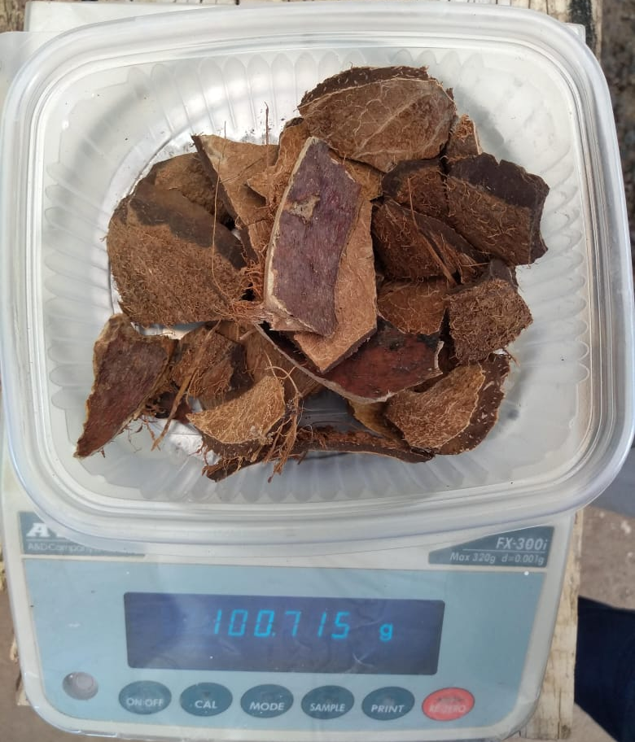
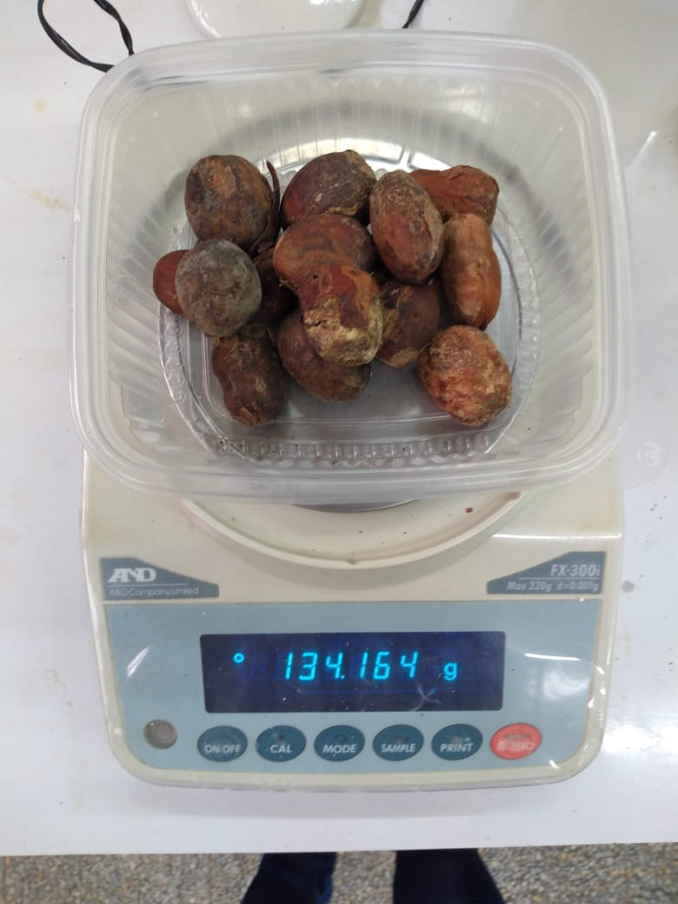
(b)
(a)

Figure 1. (a) Seed of Mauritia flexuosa. (b) Endocarp of Cocos nucifera

    - Carbon Manufacturing

148 g of Mauritia flexuosa seeds and Cocos nucifera endocarp were weighed on an electronic scale (FX-300i, AND), washed and allowed to dry for 24 h at 35 °C. Subsequently, what was obtained was carbonized in the soil laboratory of the National University of San Martín located in Tarapoto city, using a muffle (NABERTHERM, N3P), at 600 °C, for 30 minutes (Ahiduzzaman and Sadrul, 2016; Grima et al., 2016), each sample was deposited in a mortar to refine the particles, then sieved to separate the carbon from the ashes, obtaining as final product 87g of Mauritia flexuosa and 105g of Cocos nucifera.

    - Preparation and activation of carbon

Phosphoric acid (H₃PO₄) was chosen as the activating agent, in a ratio of 1:1 until obtaining a 50% activating agent (Obregón and Sun, 2014). In two glass containers were placed 87g of Mauritia flexuosa carbon and 105g of Cocos nucifera, adding to each container 5ml of H₃PO₄ in order that the solution was impregnated in the carbon (activation process) for 1 hour at 35 °C After activation, it is washed with distilled water to remove excess acid, allowing to dry for 4 h at 35 °C, obtaining activated carbon with a diameter of 1 - 3mm of Mauritia flexuosa and 2 – 5mm of Cocos nucifera, measuring the particles in a digital Vernier (Stanley).

(b)
(a)

Figure 2. (a) Charred precursor of Mauritia flexuosa. (b) Charred precursor of Cocos nucifera

    - Design of filter device for gas adsorption
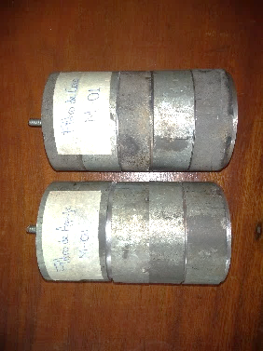
The prototype filter was designed in order to be assembled to the trimobil exhaust pipe, a pressure adjustment was created to prevent gas leakage and achieve accurate results. The filter containing the activated carbon was made. The amount was determined taking into account the volume of the filter and the surface of the carbon. 87 g of Mauritia flexuosa activated carbon were weighed on an electronic scale (FX-300i, AND) to be placed in the adsorption filter and 105 g of Cocos nucifera.
Figure 3. (a) Filtration device for gas adsorption. (b) activated carbon filters from Mauritia flexuosa and Cocos nucifera
(b)
(a)

    - Measurement of gases by internal combustion

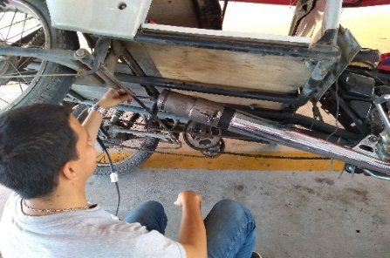
For gas measurement, the trimobiles were taken to a vehicle technical inspection center, a control group (trimobil without activated carbon filter) and two experimental groups (trimobiles with activated carbon filter for Mauritia flexuosa and Cocos nucifera) were used using a gas analyzer (HGA 400 4GR) to measure the concentration of gases hidrocarbons (HC) exit the engine's internal combustion chamber through the exhaust without being properly burned and carbon monoxide (CO) it is a by-product of the incomplete combustion of gasoline, wood, propane, coal, and other fuels at 0, 6, 12 and 18 h, making 3 repetitions for each time and species.

Figure 4. Gas measurement with the gas adsorption filter device installed in the trimobil
    - Determination of the adsorption efficiency of the experimental group

The percentage difference formula was used to determine the percentage of efficiency, taking into account the control group and the experimental groups, as follows:

Adsorption efficiency (%)$=\left[\frac{CGC-EGC}{CGC}\right]$ x 100

(1)

Where:

CGC: Control group Concentration

EGC: Experimental group Concentration
  - Results and discussion

Table 1: Gas adsorption time before and after the activated carbon filter of Mauritia flexuosa and Cocos nucifera
T (hours) | Control Group |  | experimental Group
 |  |  | Mauritia flexuosa |  | Cocos nucifera
 | CO  % | HC  ppm | CO  % | HC  ppm | CO  % | HC  ppm
0 | 3.7 | 66 | 2.6 | 55 | 1.8 | 30
6 | 4 | 94 | 2.1 | 43 | 1.9 | 35
12 | 3.5 | 120 | 1.7 | 46 | 1.6 | 41
18 | 4.6 | 260 | 2.1 | 95 | 1.8 | 85

Table 1 shows the results of the control group (without activated carbon filter), with respect to time 0, 6, 12 and 18 hours, there was a CO adsorption of 3.7, 4, 3.5 and 4.6% respectively and with HC 66 , 94, 120 and 260 ppm respectively; with the experimental group (activated carbon filter) with Mauritia flexuosa at 0, 6, 12 and 18 hours there was a CO adsorption of 2.6, 2.1, 1.7, 2.1% respectively and with HC 55, 43, 46, 95 ppm respectively; with Cocos nucifera at 0, 6, 12 and 18 hours there was a CO adsorption of 1.8, 1.9, 1.6 respectively and 1.8 with HC 30, 35, 41 and 85ppm respectively. It is important to indicate that activated carbon could improve the adsorptive capacity to capture and eliminate internal combustion gases.
Figure 4: Percentage of gas adsorption efficiency with activated carbon filter of Mauritia flexuosa and Cocos nucifera

Figure 4 shows the results of the efficiency percentage of the activated carbon filters of Mauritia flexuosa at 0, 6, 12 and 18 hours, there was a CO adsorption of 29.7%, 47.5%, 51.4% and 54.3% respectively and with HC 16.7%, 54.3%, 61.7% and 63.5% respectively; with Cocos nucifera at 0, 6, 12 and 18 hours there was a CO adsorption of 51.4%, 52.5%, 54.3% and 60.9% respectively and with HC 54.5%, 62.8%, 65.8% and 67.3% respectively. As the time elapses, the percentage of gas adsorption is higher, evidencing that the Cocos nucifera activated carbon filter has a high hydrocarbon adsorption capacity, this due to its greater adsorptive area, greater adsorption capacity, being a physical process, the capture of Carbon molecules (adsorbate) in the micropores of the activated carbon of Cocos nucifera develops in a better way since its surface area or granulometry is of 2 to 5mm in contrast to Mauritia flexuosa 1 to 3mm. (Luis et al., 2018).
It is worth mentioning that the adsorptive process is a physical process of capturing molecules (adsorbate) through the micropores of the activated carbons (adsorbent); That is why, molecules with higher atomic weight such as C (carbon), HC (unburned hydrocarbons) and CO2 (carbon dioxide) adhere to the micropores, thus breaking the chemical bond, as a result of which the emissions that are expelled after treatment through the filtration device has a lower concentration of these pollutants and a higher concentration of O2.

  - Conclusions

A comparison was made between the two activated carbon filters Mauritia flexuosa and Cocos nucifera, the latter having a higher percentage of efficiency in gas adsorption with 60.9% for the CO parameter, and 67.3% for HC at 18 hours.

Activated carbon is an essential material for various uses such as in industry, technology, medicine, ecology, etc; its different functions can make a less polluted environment and thereby contribute to new proposals for a sustainable and sustainable ecosystem, unlike other adsorbents such as Silicatite or Zeolite, which are more expensive alternatives and with inefficient adsorption performance.

Importance of the development of a filtration device for the adsorption of pollutants from the internal combustion of trimobiles using activated carbons of affordable and free origin, being considered economically and ecologically viable, since they are made of waste that is little used and normally discarded, therefore it could be used as a control method for CO and HC emissions.

The lifetime of activated carbon adsorption filters is determined according to the saturation time of the surface area of ​​the adsorbent as a function of the saturation mass (adsorbate) and the exposure time to the emission flow, a time is projected estimated 1800 hours, since the saturation of activated carbons was 20% in 18 hours.

References
Abate B., Valverde J., 2017, Reduction of Thermotolerant Coliforms Present in the Sea Water by Means of Micro-Nanobubbles of Air-Ozone of the Beach Los Pavos, Lima, Peru, Chemical Engineering Transactions, 60, 313-318
Abdul A.R., Rabat N.E., Johari K., Saman N., Mat H., 2019, Removal of lead (ii) ions from aqueous solution using desiccated coconut waste as low-cost adsorbent, Chemical Engineering Transactions, 72, 169-174
Ahiduzzaman M y Sadrul A.K., 2016, Preparation of porous bio-char and activated carbon from rice husk by leaching ash and chemical activation. Springerplus, 5 (1):1248.
Barelli L., Bidini G., Arespacochaga N.D., Pérez L., Sisani E., 2017, Biogas use in high temperature fuel cells: Enhancement of KOH-KI activated carbon performance toward H₂S removal. International Journal of Hydrogen Energy, 42, 10341–10353
Contreras, K.D., Mejia, A., Nhu, P.Q., Tacderas, M., Patdu, K., Daudey, L., Tuan, N.A., Bakker, S., 2016, Tracking sustainable transport in Vietnam: Data and policy review for energy efficiency and climate change 2015, ASEAN-German Technical Cooperation, Bonn and Eschborn, Germany.
Dabioch M., Skorek R., Kita A., Janoska P., Pytlakowsha K., Zerzucha P., Sitko R., 2013, A study on adsorption of metals by activated carbon in a large-scale (municipal) process of surface water purification. Cent. Eur. J. Chem, 11, 742 - 753.
Dieguez A.A., Anca C.A., Zobel N., Behrendt F., 2015, Understanding the primary and secondary slow pyrolysis mechanisms of holocellulose, lignin and wood with laser-induced fluorescence, 153, 102 - 109.
Emberger, G., 2016, Urban transport in Ho Chi Minh City, Vietnam, sustainable Ho Chi Minh City: Climate policies for emerging mega cities, Springer, Berlin, Germany.
Grima O.C., Ramírez G.Á., Gómez L.D., Clemente J.C., 2016, Activated carbon from flash pyrolysis of eucalyptus residue, Journal Heliyon, 2 (9).
Hagemann N., Spokas K., Schmidt H.P., Kägi R., Böhler M., Bucheli T., 2018, Activated Carbon, Biochar and Charcoal: Linkages and Synergies across Pyrogenic Carbon’s ABCs. Water, 10, 182.
Lanzini A., Madi H., Chiodo V., Papurello D., Maisano S., Santarelli M., Herle J.V., 2017, Dealing with fuel contaminants in biogas-fed solid oxide fuel cell (SOFC) and molten carbonate fuel cell (MCFC) plants: Degradation of catalytic and electro-catalytic active surfaces and related gas purification methods. Progress in Energy and Combustion Science, 61, 150 – 188.
Luis V.H., Rodriguez M.C., Mondragon F.A., Chazaro L.F., Rangel J.R., 2018, Coconut endocarp and mesocarp as both biosorbents of dissolved hydrocarbons in fuel spills and as a power source when exhausted, Journal of Environmental Management, 211, 103 -111.
Miltner M., Makaruk A. y Harasek M., 2017, Review on Available Biogas Upgrading Technologies and Innovations Towards Advanced Solutions, Journal of Cleaner Production.
Mosa S.M., 2014, Adsorption of some heavy metals and (Mg2+, Ca2 +) ions from aqueous solutions by using different environmental residuals as a cheap adsorbent at optimum conditions. Sci. J. Chem, 4, 1-5.

Shah I., Adnan R., Wan W.S., Mohamed N., 2015, Iron Impregnated Activated Carbon as an Efficient Adsorbent for the Removal of Methylene Blue: Regeneration and Kinetics Studies. PLoS ONE, 10(4)

Sidheswaran M.A., Destaillats H., Sullivan D.P., Cohn S., Fisk W.J., 2012, Energy efficient indoor VOC air cleaning with activated carbon fiber (ACF) filters. Build Environ, 47, 357 - 367.

Obregón V.D y Sun K.M., 2014, Comparative cadmium adsorption study on activated carbon prepared from aguaje (Mauritia flexuosa) and olive fruit stones (Olea europaea L.), Journal of Environmental Chemical Engineering, 2, 2280 - 2288.
Tran T.T., 2019, Mitigating greenhouse gas emissions from passenger transport sector in megacities: a case of ho chi minh city, Chemical Engineering Transactions, 72, 85 - 90
Valenzuela L., Valverde Flores J., 2018, Reduction of Lead and Silicon in Wastewater from Gas Scrubbing of a Company using Micronanobubbles of Air-Ozone, Chemical Engineering Transactions, 67, 517-522
Yan K.Z., Ahmad M.A., Arsad A., Nasri N.S., 2019, Rubber seed shell based activated carbon by physical activation for phenol removal, Chemical Engineering Transactions, 72, 151 - 156

