|  |  |
| --- | --- |
| cetlogo ***CHEMICAL ENGINEERING TRANSACTIONS***  ***VOL. 82, 2020*** | A publication of  aidiclogo_grande |
| The Italian Association  of Chemical Engineering  Online at www.cetjournal.it |
| Guest Editors: Selena Sironi, Laura Capelli  Copyright © 2020, AIDIC Servizi S.r.l. **ISBN** 978-88-95608-80-8; **ISSN** 2283-9216 | |

Electronic Nose for the Classification of Honeys of Different Floral Origins

Federica Borgonovo a, Stefania Marzorati a,\*, Lucia Piana b, Rita Rizzi c, Sara Panseri d, Luisella Verotta a, Marcella Guarino a

a Università degli Studi di Milano, Dipartimento di Scienze e Politiche Ambientali, Via Celoria 2, 20133 Milano

b Piana Ricerca e Consulenza, via Umbria 41 - Frazione Osteria Grande, 40025 Castel San Pietro Terme (BO)

c Università degli Studi di Milano, Dipartimento di Medicina Veterinaria, via dell'Università 6, 26900, Lodi

d Università degli Studi di Milano, Dipartimento di Scienze Veterinarie per la Salute, la Produzione Animale e la Sicurezza Alimentare, Via Celoria 10, 20133 Milano

stefania.marzorati@unimi.it

The electronic nose contributes, together with other chemical analyses, to identify botanical and geographical origin of honey. Two different honey samples were analysed: Italian Sainfoin (*Sulla coronaria* (L.) *Medik.*) and Eucalyptus (*Eucalyptus camaldulensis Dehnh.*). Aromatic profiles were evaluated using an electronic nose with a sensor array made up of 10 metal oxide semiconductor sensors (MOS). The maximum value for each sensor was used to plot data on a radar graph and for Principal Component Analysis (PCA). The PCA plot revealed a clear separation of samples.

A complementary analysis of the volatile species in honeys was carried out using the head space solid phase microextraction coupled to gas chromatography and mass spectroscopy (HS-SPME-GC-MS) and the chemical profile of each sample was derived. Chemical data were compared to the results obtained with the electronic nose and confirmed the assignment of the different unifloral samples.

The results showed that the electronic nose, combined with chemical identification of the volatile species, allows to classify and discriminate the different types of honey and to assign them to groups that have similar taste and aroma characteristics.

* 1. Introduction

More than 300 monofloral honey types are nowadays produced and commercialized worldwide, being Central African Republic, New Zealand and Slovenia the top *per capita* consumers. According to a 2019 report, the average annual production of honey worldwide was about 1.86 million metric tons in 2017 (Shahbandeh, 2019).

Honey quality and its relative methods of analysis are regulated at international level by the FAO/WHO Codex Alimentarius (CODEX STAN 12-19811) and, at European level, by the Council Directive 2001/110/EC2.

Due to the width of the market, the European Commission has regularly recorded the presence, in a non-negligible proportion, of honey that may not meet the composition criteria laid down by the international laws, sometimes resulting from production processes differing from what is required by the legal definition of honey (European Commission, 2018). For these reasons, the development of efficient analytical methods is necessary in order to avoid disturbance of the market and frauds. The determination of the botanical origin is part of the quality analysis of honey. Melissopalynological analysis is the reference method based on the identification and quantification of pollen grains in the honey sediment. Since it involves a very time-consuming and laborious counting procedure requiring specialized expertise in the interpretation of results, the technique in not well-adaptable to routine analysis (Etzold and Lichtenberg-Kraag, 2008). Therefore, many efforts have been made to search for alternative methods for honey authentication. Besides many studies have been addressed to the topic, there is still a general lack in the identification of the proper method or methods set for a fast determination of honey origin for a quality control and eventual frauds detection. Infrared spectroscopy is commonly used in routine analysis of honey, for example in the determination of hydroxymethylfurfural concentration with respect to law restrictions (Cozzolino et al., 2011). However, FTIR was not considered suitable to replace the standard methods in general (Etzold and Lichtenberg-Kraag, 2008). High-performance liquid chromatography (HPLC), gas chromatography and high-performance anion-exchange chromatography are also routinely performed in quality determination of honey, but these methods are still considered time consuming and require the use of organic solvents, with related issues for their storage and disposal (Wang et al., 2010).

In addition, the complexity of most food aromas makes them difficult to be characterized only with conventional flavour analysis techniques such as gas chromatography (Castro-Vázquez et al., 2003).

An automated and non-destructive technique to characterize many food flavours, becoming more and more popular, is the electronic nose (E-nose). In this context, it has already been successfully applied to the measurement of honey’s aroma features (Tian et al., 2018). It has the strengths of cost- and time-effectiveness, high sensitivity and correlation with data from human sensory panels and ease of operation (Guillot et al., 2016; Pearce et al., 2008; Peris and Escuder-Gilabert, 2009). The E-nose technique has been often complemented with principal component analysis (PCA) or other statistical methods to generate scatter plots of different biogenic samples and to detect adulteration (Huang et al., 2015; Long et al., 2019; Zakaria et al., 2011).

Even if the electronic nose has the potential to enter laboratories daily life, keeping apart more sophisticated chemical laboratories and skilled scientists, there are still many drawbacks to be solved in the field before its commercialization as diagnostic tool for routine analysis, and much research is still necessary in the interpretation of results.

Considering the successful results in the literature achieved by combining chromatographic data of extracts containing volatile species with principal components analysis (Clemente et al., 2011), in this work, a fusion techniques approach is proposed for two different reasons: a) validate data from electronic nose employing head space solid phase microextraction coupled to gas chromatography and mass spectroscopy (HS-SPME-GC-MS) together with PCA statistical analysis; b) identify a potential techniques array able to univocally determine the floral origin of honey samples. Italian Sainfoin and Eucalyptus honeys were selected as reference honey samples to assess the floral origin identification strategies.

* 1. Materials and Methods
     1. Experimental Design

Experiments were performed on 20 honey samples (10 samples of Italian Sainfoin honey and 10 samples of Eucalyptus honey) received from Osservatorio Nazionale Miele and conferred for evaluation to experts to the Great Honey of Italy competition. The honey samples used in the research, according to the evaluation of the experts, are the ones that come closer to the standard of unifloral honey.

Before being analysed, all honey samples were kept at controlled temperature (0-4 °C).

* + 1. Electronic Nose System

The Electronic Nose PEN3 (WinMuster Airsense Analytics, Schwerin, Germany) was used in this study. It has 10 metal-oxide sensors (MOS), and each sensor is sensitive to a specific group of compounds (Brambilla et al, 2009; Castrica et al., 2019; Loutfi et al. 2015). Its response is expressed as G/G0, that is the ration between the sample conductance (G) and the conductance of activated-carbon-filtered air (G0). The instrument (PEN3) consists of three units: (i) a sampling and washing unit, (ii) a chamber, consisting of an electrochemical gas sensor array, and (iii) a pattern recognition system.

Honey samples were taken from the refrigerator and transported to the laboratory for the analysis. An aliquot of 3.0 ± 0.1 g was taken from each sample (10 samples analysed for Italian Sainfoin honey and 10 samples analysed for Eucalyptus honey) and was placed in a small sealed glass vial with a capacity of 40 ml. During the analysis, honey samples were kept a constant temperature in a thermostatic water bath at 40.0 °C ± 0.5 for 5 minutes in order to produce the correct headspace. The air saturated with volatile organic compounds (VOCs) was withdrawn using a hypodermic needle introduced through the rubber septum into the vials. A second needle avoided excessive depression inside the vials by introducing filtered ambient air using activated carbon. The headspace gas in that vials was pumped from the sampler through the sensor array at 400 ml min-1. Before and after each measurement, the sensors were cleaned by air using carbon filters. Sensor response data were recorded every second. The analysis protocol was defined by setting up the E-nose parameters (flow rate, duration of measurement, etc.) according to the manufacturer’s instructions. The analysis of each honey samples lasted 360 seconds. The set of signals derived from the electronic nose during the analysis takes the form of a pattern. The pattern data were analysed using WinMuster (version 1.6.2., 17 May 2014, copyright Airsense Analytics GmbH).

* + 1. Volatile compounds profile analyses

Honey samples were analysed to investigate the volatile compounds profile (VOCs) according to Panseri et al. (Panseri et al., 2013). Briefly, samples were prepared by weighing exactly 5.00 g of honey in a 20 ml glass vial, fitted with cap and equipped with silicon/PTFE septa (Supelco, Bellefonte, PA, USA) and by adding 1 ml of the internal standard solution in water (1,4-cineol, 1 𝜇g ml-1, CAS 470-67-7) to check the degradation of the fibers also. At the end of the sample equilibration period (1 hour), a conditioned (1.5 h at 280 °C) 50/30 𝜇m Divinylbenzene/ Carboxen/polydimethylsiloxane (CAR/PDMS/ DVB) StableFlex fibre (Supelco, Bellefonte, PA) was exposed to the headspace of the sample for the extraction (180 min) by CombiPAL system injector autosampler (CTC analytics, Switzerland). The extraction temperature of 25 °C was selected in order to prevent possible matrix alterations (oxidation of some compounds, particularly aldehydes and furans). To keep a constant temperature during analysis, the vials were maintained on a heater plate (CTC Analytics, Zwingen, Switzerland). As demonstrated in other researches in which the VOCs profile of food is investigated, the use of high extraction temperature can lead to *ex novo* formation of volatile compounds or to the production of artefacts (Panseri et al., 2013).

* + 1. Gas Chromatography-Mass Spectrometry Detection of VOCs

Head Space Solid Phase Microextraction (HS-SPME) analysis was performed using a Trace GC Ultra (Thermo-Fisher Scientific, Waltham, MA, USA) Gas Chromatograph (GC) coupled to a quadrupole Mass Spectrometer Trace DSQ (Thermo-Fisher Scientific, Waltham, MA, USA) and equipped with an Rtx-Wax column (30m; 0.25mm i.d.; 0.25 𝜇m film thickness, Restek, USA). The oven temperature program was: from 35 °C, hold 8 min, to 60 °C at 4 °C min-1, then from 60 °C to 160 °C at 6 °C min-1, and finally from 160 °C to 200 °C at 20 °C min-1. Carryover and peaks originating from the fiber were regularly assessed by running blank samples. After each analysis, fibers were immediately thermally desorbed in the GC injector for 5 min at 250 °C to prevent contamination. The injections were performed in splitless mode (5 min). The carrier gas was helium at a constant flow of 1 ml min-1. The transfer line to the mass spectrometer (MS) was maintained at 230 °C, and the ion source temperature was set at 250 °C. The mass spectra were obtained by using a mass selective detector with the electronic impact at 70 eV, a multiplier voltage of 1456 V, and by collecting the data at rate of 1 scan s-1 over the m/z range of 30-350. Compounds were identified by comparing the retention times of the chromatographic peaks with those of authentic compounds analyzed under the same conditions, when available. The identification of MS fragmentation patterns was performed either by comparison with those of pure compounds or using the National Institute of Standards and Technology (NIST) MS spectral database. Volatile compounds measurements from each headspace of honey extracts were carried out by peak area normalization (expressed in percentage). All analyses were done in duplicate.

* + 1. Statistical analysis

Data obtained from electronic nose were processed using multivariate statistical techniques, specifically Principal Component Analysis (PCA). PCA is a statistical method useful for exploring large datasets and displaying differences between different samples (Bro and Smilde, 2014).

For each honey sample, data coming from sensors of the electronic nose (PEN3) were analysed taking the maximum G/G0 values. All statistical procedures were carried out using R software version 3.1.0 (2014-04-10), copyright © 2014 The R Foundation for Statistical Computing.

* 1. Results and Discussion

As a first step, radar charts were obtained to observe whether pattern differences were developed between Italian Sainfoin and Eucalyptus honey samples. Radar charts are a graphical method of displaying multivariate data in the form of more quantitative variables represented on axes starting from the same point. These results were obtained making an average of the maximum G/G0 values observed for Italian Sainfoin and Eucalyptus honey samples. In both types of honey, it was observed that among the 10 MOS sensors of the electronic nose, four sensors never showed a peak; for this reason, they were deleted from the analysis.

From the comparison of the two radar graphs, obtained for Italian Sainfoin and Eucalytpus honeys, two different “fingerprints” were observed. Figure 1 (A and B) shows the change of the signal generated by the sensor array in the two types of honey. The E-nose provided a very well-differentiated odour print useful to discriminate between Italian Sainfoin and Eucalyptus honey samples. Moreover, from this analysis it was possible to observed that in both types of honey the sensors with the highest G/G0 values were 7-W1W (reacting on sulfur compounds or terpenes and sulfur organic compounds) and 9-W2W (reacting with aromatic compounds and sulphur organic compounds). Moreover, Eucalyptus honey has higher G/G0 values also for the 2-W5S sensor, sensitive to aromatic compounds (Table 1).

Table 1: Average of the maximum G/G0 values from E-nose.

|  |  |  |  |  |  |  |
| --- | --- | --- | --- | --- | --- | --- |
| Sample | 2-W5S | 6-W1S | 7-W1W | 8-W2S | 9-W2W | 10-W3S |
| Italian Sainfoin | 1.39±0.09 | 1.44±0.11 | 1.91±0.16 | 1.43±0.13 | 2.36±0.40 | 1.26±0.14 |
| Eucalyptus | 5.71±1.45 | 1.97±0.18 | 5.38±0.96 | 2.29±0.33 | 6.23±1.09 | 1.54±0.17 |

PCA showed good ability to discriminate between Italian Sainfoin and Eucalytpus samples (Figure 1C), in particular the first and second principal components explain respectively 86.6% and 6% of the total variance. It shows that two distinct groups of honey samples, corresponding to Italian Sainfoin and Eucalyptus honey, are well distinguished. It can be seen that the honeys of Italian Sainfoin and Eucalyptus, having different sensory characteristics, are arranged far apart (Marcazzan et al., 2015; Sabatini et al., 2007). The samples corresponding to Eucalyptus honey are found in the lower right quadrant, corresponding to high values of the first main component (PC1). On the other hand, the values relating to the Italian Sainfoin honey are related to low values on the same component (PC1).

**A**

**B**

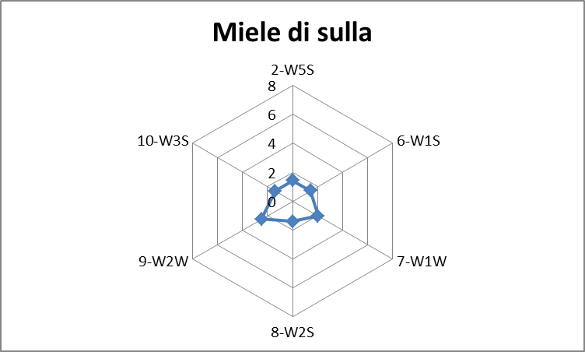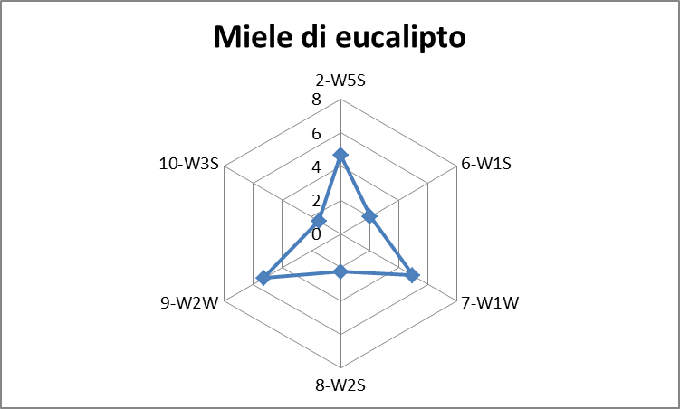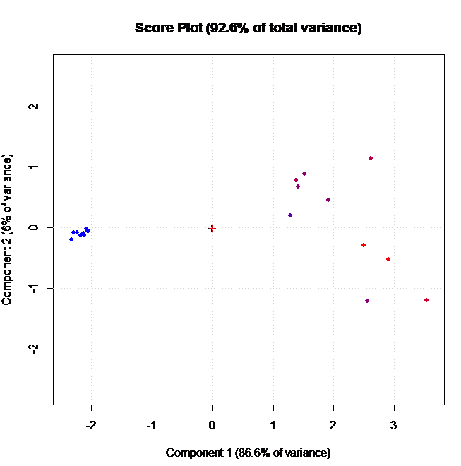

**C**

Eucalyptus

Italian Sainfoin

Figure 1: Radar charts: A) Italian Sainfoin honey; B) Eucalyptus honey. C) PCA: projection of the two types of honey according to the two main components.

A search of the relevant literature shows that there are several applications of use for electronic nose. Most applications for E-noses concentrate on four major areas; (i) food, (ii) medical diagnosis, (iii) environmental monitoring and bioprocess control (Scott et al., 2006). In particular, in the food industry, an E-nose is one of the best methods for (i) agrifood quality monitoring, (ii) freshness and shelf-life evaluation, and (iii) investigating and differentiating between different types of products (Rahman et al., 2013).

As highlighted by Haddi *et al.*, the different sensor responses could be due to changes in the concentration of the volatile organic compounds that were emanated from each type of food products (Haddi et al., 2015).

Specifically, unifloral honeys possess distinctive flavours, mainly related from their nectar sources, indicating the presence of volatile components (such as terpenes, *nor*-isoprenoids, and aromatic compounds) (Pérez et al., 2002). This hypothesis was confirmed by gas chromatography results.

Honey volatiles are a very complex mixture of substances frequently occurring at very low concentration and with poor chemical stability. Thus, as reported also by many authors, the use of headspace solid-phase-microextraction and gas chromatography coupled to mass-spectrometry, a very sensible and solvent-free method for extraction and analyses of this chemical fraction, is particularly suitable (Panseri et al., 2013; Plutowska et al., 2011; Wolski and Tambor, 2006).

Examining through HS-SPME-GC-MS the volatile profile of the two honey varieties, the compounds grouped according their chemical classes, expressed as samples mean value (n=10), are presented in Figure 2. In general, the most abundant compounds characterizing honey samples were ketones, fatty acids, alcohols, aldehydes followed by terpenes and furans. Eucalyptus honey was rich in ketones, free fatty acids and terpenes compared to Italian Sainfoin samples. Linanool oxide, linalool, eucalyptol and beta ionone represented the predominant terpene detected in eucalyptus variety according to other researches (Castro-Vázquez et al., 2003). Lilac aldehyde isomers (A, B and C), benzaldehyde and benzenacetaldehyde characterised Italian Sainfoin honeys. (Detailed analytical results are available upon request)

In our research, the differences found among the two type of analysed honey samples can be related to the different marker compounds originated in the two floral source. In particular, these marker compounds were therefore found to be useful for the identification of the botanical origin of honey. As observed by Ampuero *et al.*, these marker compounds are predominantly originating in the floral source, or produced by the bee through biochemical transformations of the nectar compounds. Some compounds, such as alcohols, branched aldehydes and especially furan derivatives are mainly related to microbiological purity or to processing and storage conditions (Ampuero et al., 2002).

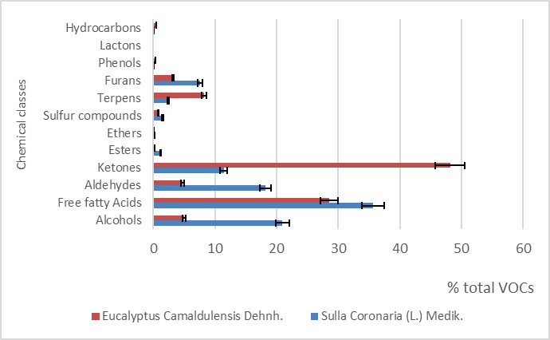

Figure 2: Volatile profile compounds distribution according to their chemical classes among honey samples (bar represents the mean standard deviation; n =10).

* 1. Conclusions

This study has shown that a combination of E-nose, PCA statistical analysis and head space solid phase microextraction coupled to gas chromatography-mass spectrometry is able to discriminate between volatile organic compounds (VOCs) emitted by Italian Sainfoin and Eucalytpus honey samples. Since VOCs are closely associated to aroma, the use of their profiles combined with multivariate statistical techniques seems to be an appropriate possibility for the determination of the botanical origin of honey. Electronic nose, combined with chemical identification of the volatile species, allows to classify and discriminate the different types of honey and to assign them to groups that have similar taste and aroma characteristics. Further studies including other unifloral honey types are however necessary to confirm the utility of these technique for the characterization of honeys.

Acknowledgments

Authors thank Osservatorio Nazionale Miele for kindly providing honey samples.

References

Ampuero S., Bogdanov S., Bosset J. O., 2004, Classification of Unifloral Honeys with an MS-Based Electronic Nose Using Different Sampling Modes: SHS, SPME and INDEX, European Food Research and Technology, 218, 198-207.

Brambilla M., Navarotto P., Guarino M., 2009, Case Study of the Monitoring of Ultra-High Temperature Processed Partly Skimmed Milk Production Batches by Means of an Electronic Nose, Transactions of the ASABE, 52, 853-858.

Bro R., Smilde A.K., 2014, Principal Component Analysis, Analytical Methods, 6, 2812-2831.

Castrica M., Panseri S., Siletti E., Borgonovo F., Chiesa L., Balzaretti C.M., 2019, Evaluation of Smart Portable Device for Food Diagnostics: A Preliminary Study on Cape Hake Fillets (*M. capensis* and *M. paradoxus*), Journal of Chemistry, 2019, 2904724.1-2904724.7.

Castro-Vázquez L., Pérez-Coello M.S., Cabezudo M.D., 2003, Analysis of Volatile Compounds of Rosemary Honey. Comparison of Different Extraction Techniques, Chromatographia, 57, 227-33.

Clemente G. J., Williams J. D., Cross M., Chambers C. C., 2011, Analysis of Garlic Cultivars Using Head Space Solid Phase Microextraction/Gas Chromatography/Mass Spectroscopy, The Open Food Science Journal, 6, 1-4.

Cozzolino D., Corbella E., Smyth H.E., 2011, Quality Control of Honey Using Infrared Spectroscopy: A Review, Applied Spectroscopy Reviews, 46, 523-38.

Etzold E., Lichtenberg-Kraag B., 2008, Determination of the Botanical Origin of Honey by Fourier-Transformed Infrared Spectroscopy: An Approach for Routine Analysis, European Food Research and Technology, 227, 579-86.

European Commission, Directorate-General, Joint Research Centre, Directorate F-Health, Consumer & Reference Materials, 2018, Technical Round Table on Honey Authentication, Geel (Belgium).

Guillot J., 2016, E-noses: Actual Limitations and Perspectives for Environmental Odour Analysis, Chemical Engineering Transactions, 54, 223-228.

Haddi Z., El Barbri N., Tahri K., Bougrini M., El Bari N., Llobet E., Bouchikhi B., 2015, Instrumental Assessment of Red Meat Origins and Their Storage Time Using Electronic Sensing Systems, Analytical Methods, 7, 5193-5203.

Huang L., Liu H., Zhang B., Wu D, 2015, Application of Electronic Nose with Multivariate Analysis and Sensor Selection for Botanical Origin Identification and Quality Determination of Honey, Food and Bioprocess Technology, 8, 359-370.

Long Q., Li Z., Han B., Hosseini H. G., Zhou G., Wang S., Luo D., 2019, Discrimination of Two Cultivars of Alpinia Officinarum Hance Using an Electronic Nose and Gas Chromatography-Mass Spectrometry Coupled with Chemometrics, Sensors,19, 572.

Loutfi A., Coradeschi S., Mani G.K., Shankar P., Rayappan J.B.B., 2015, Electronic Noses for Food Quality: A Review, Journal of Food Engineering, 144, 103-11.

Marcazzan G.L., Magli M., Piana L., Savino A., Stefano M.A., 2015, Sensory Profile Research on the Main Italian Typologies of Monofloral Honey: Possible Developments and Applications, Journal of Apicultural Research, 53, 426-437.

Panseri S., Manzo A., Chiesa L.M., Giorgi A., 2013, Melissopalynological and Volatile Compounds Analysis of Buckwheat Honey from Different Geographical Origins and Their Role in Botanical Determination, Journal of Chemistry, 2013, 1-11.

Pearce T.C., Schiffman S.S., Nagle H.T., J.W. Gardner (Ed.), 2008, Handbook of Machine Olfaction: Electronic Nose Technology, WILEY-VCH Verlag GmbH & Co. KGaA, Weinheim, Germany.

Pérez R.A., Sánchez-Brunete C., Calvo R.M., Tadeo J.L., 2002, Analysis of Volatiles from Spanish Honeys by Solid-Phase Microextraction and Gas Chromatography-Mass Spectrometry, Journal of Agricultural and Food Chemistry, 50, 2633-2637.

Peris M., Escuder-Gilabert L., 2009, A 21st Century Technique for Food Control: Electronic Noses, Analytica Chimica Acta, 638,1-15.

Plutowska B., Chmiel T., Dymerski T., Wardencki W., 2011, A Headspace Solid-Phase Microextraction Method Development and Its Application in the Determination of Volatiles in Honeys by Gas Chromatography, Food Chemistry, 126, 1288-98.

Rahman S., Usmani T., Saeed S.H., 2013, Review of Electronic Nose and Applications, Internatonal Journal of Computing and Corporate Research, 3, 1-9.

Sabatini A.G., Bortolotti L., Marcazzan G.L., 2007, Conoscere Il Miele, Avenue media, Bologna, Italia.

Scott S.M., James D., Ali Z., 2006, Data Analysis for Electronic Nose Systems, Microchimica Acta, 156, 183-207.

Shahbandeh M., 2019, Honey Market Worldwide and in the U.S.-Statistics & Facts, <www.statista.com/topics/5090/honey-market-worldwide> accessed 24.03.2020.

Tian H., Shen Y., Yu H., Chen C., 2018, Aroma features of honey measured by sensory evaluation, gas chromatography-mass spectrometry, and electronic nose, International Journal of Food Properties, 21, 1755-1768.

Wang J., Kliks M.M., Jun S., Jackson M., Li Q.X., 2010, Rapid Analysis of Glucose, Fructose, Sucrose, and Maltose in Honeys from Different Geographic Regions Using Fourier Transform Infrared Spectroscopy and Multivariate Analysis, Journal of Food Science 75, C208-C214.

Wolski T., Tambor K., 2006, Identification of Honey Volatile Components by Solid Phase Microextraction (SPME) and Gas Chromatography/Mass Spectrometry (GC/MS), 50, 115-26.

Zakaria A., Shakaff A. Y. M., Masnan M. J., Ahmad M. N., Adom A. H., Jaafar M. N., Ghani S. A., Abdullah A. H., Aziz A. H. A., Kamarudin L. M., Subari N., Fikri N. A., 2011, A Biomimetic Sensor for the Classification of Honeys of Different Floral Origin and the Detection of Adulteration, Sensors; 11, 7799-7822.