CHEMICAL ENGINEERINGTRANSACTIONS  VOL. 82, 2020 | A publication of
The Italian Association
of Chemical Engineering
Online at www.cetjournal.it
Guest Editors:Selena Sironi, Laura Capelli
Copyright © 2020, AIDIC Servizi S.r.l.
ISBN978-88-95608-80-8;ISSN 2283-9216

Is it possible to set a universal odour limit?
C. Diaz*, C. Izquierdo, A. Antón
Olores.org, Bilbao, Spain.
* carlosdiaz@olores.org
Analysis of international legislation related to odour impact management shows a wide variety of approaches and limits to tackle odour emissions. One of the most common approaches is setting a limit in odour units at the receptor. Dynamic olfactometry measurement at the source coupled with dispersion modelling is often used although there are other approaches very much valid, such as field inspections. The Odour Impact Criteria (OIC) set are different, depending, for example, on the hedonic tone of the odours. A stricter limit is set to a waste water treatment plant than to the much pleasant odours emitted by a bakery. To this effect some legislations around the world have tables with different odour limits depending on the hedonic tone of the odour emitted by different activities. Resulting in several limits that might not reflect the real odour impact in some cases. In some provinces of the Netherlands it is frequently used a hedonic tone weighted limit. This way an odour limit is tuned depending on the hedonic tone. However, there are other factors important to take into account when dealing with the analysis of the odour impact, being the most common ones the frequency, intensity (vs concentration), duration, offensiveness and sensitivity of the receptors. This concept paper will deal with the development of a simple odour limit for any kind of activity based on the weighting of these five factors. This way legislations on odour impact can be more simply drafted.
  - Introduction
Historically, the measurement systems in use were based on the dimensions of the human body, so the units of measurement tended to vary not only depending on individuals but also on where they were located. In the case of smell, something similar happens. The perception of odour depends not only on the sensitivity of each individual or community, but also on the number of times this odour occurs, how intense it is, how unpleasant it is, and the duration of the odour episodes once they are perceived. Odour perception also varies depending on the experience, expectations, motivation and degree of alertness of the recipient.
To try to assess the odour impact experienced by a community, a mixture of factors should be considered that may influence this impact, the most relevant being Frequency, Intensity, Offensiveness, Duration and Sensitivity to the odours of the receivers. This sequence is called FIDOS.
Odour legislation needs to be simple and at the same time properly assess all the complexities involved in the odour impact of a Potential Odour Impact Generating Activity (APGIO). A regulation has to be simple to understand and to apply, but at the same time it has to provide tools for those cases that require more complex approaches.
Several attemps have been made in order to describe a mathematical function that addresses all the factors mentioned beforehand (Rossi A. 2015; Invernizzi M, et. al. 2017), but there is a need to include the last findings of psichometry in the equations defined by the authors. In addition, the evaluation of the odour dose is key to better evaluate odour frequency.
The simplest way to set a limit value is for it to be unique regardless of the type of APGIO.
In this paper we will define the Odour Impact Index (OII) as the threshold unit above which an odour impact is a nuisance to a community.
The following factors should be considered by the OII:
- It must be able to understand the difference in the offensiveness of an odour between, for example, an oil refinery and a cake manufacturing plant.
- It should be able to assess the impact of an APGIO operating 24 hours a day, of a similar one operating for example only 6 hours a day.
- It shall be able to understand what is the maximum concentration or intensity that a receiver can accept.
- Be able to differentiate the type of receiver when it is a small group of scattered houses from when it is a neighborhood in a large city.
- Be able to evaluate the difference between a newly developed APGIO and an identical one that has been in place for years causing odour nuisance.
- Be able to differentiate different odour emission processes from an APGIO.
The OII may have a unit of reference, but it will be difficult for it ever to be a unit of the International System as the latter are based on fundamental physical phenomena, not chemical, or even sensorial magnitudes.
The aim of this paper is to detail how to weight frequency, intensity, offensiveness, duration and sensitivity in an attempt to establish the value of an OII.

  - Weighing up the offensiveness
In countries where dynamic olfactometry is already fully implemented, odour regulation is often started on the basis of odour concentrations rather than odourant concentration. Also, different limit values are usually set depending on the offensiveness or hedonic tone of the odours.
For example, in Colombia, Resolution 1541 of 2013 of the Ministry of the Environment and Sustainable Development establishes limit values of 3, 5 and 7 ou_{E}/m³ that should not be exceeded for more than 175 hours per year, depending on whether the odour of an APGIO is more or less unpleasant.
This regulation criterion is the same as that which exists in several countries, in that a different limit odour concentration is set for a certain frequency, of a certain duration, depending on the offensiveness of the odours. This offensiveness is fixed by placing activities within a table, from more offensive to less offensive.
However, these tables have limitations because neither are all the APGIOs that are, nor are all the APGIOs that are. That is, they are a quick way to estimate the offensiveness of the APGIOs. However, it is possible to determine the actual offensiveness of an APGIO with some methodology of calculating the hedonic tone. These are supra-threshold calculations that usually cost more than the odour concentration calculation, but are necessary when refinement of the impact of an activity is required.
It is important to note that the degree of offensiveness of an odour is dependent on the odour concentration. In other words, the offensiveness of an odour usually varies as the odour concentration varies. For example, an odour is usually less offensive or less intense at low concentrations.
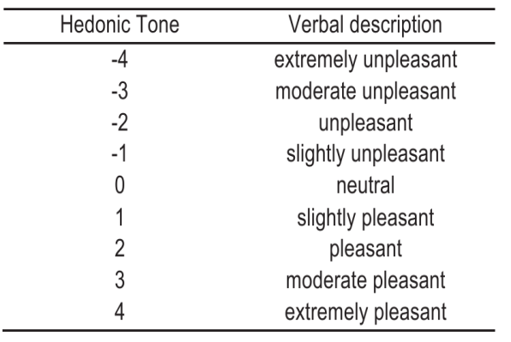
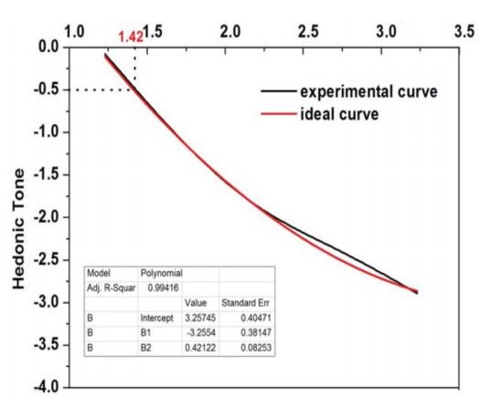
The following graph (Li J. et al.) shows for example how the offensiveness of ammonia varies, on a scale from +4 (very pleasant odour) to -4 (very unpleasant odour) as the odour concentration decreases.
Figure 1. (Left) Scale of Hedonic tone from VDI 3882-2, and (right) graph from Li J. et al. showing how the offensiveness of ammonia varies depending on odour concentration.
The graph shows that at a log concentration of 1.42 (i.e. 26 ou_{E}/m³) the smell of ammonia is no longer offensive.
It is possible to normalize the odor concentration according to the offensiveness of an odor. For example, in the province of North Brabant in the Netherlands the odour limit varies between 0.5 and 100 offensively standardised odour units.
The standardisation is done in the following way: assuming that a focus gives an odour emission rate of, for example, 630,000 ou_{E}/h, and that odour is slightly annoying at a concentration of 7 ou_{E}, then the offensively weighted odour concentration would be 90,000 ou_{E}/h resulting from the division of the original odour concentration by the odour concentration at which it is slightly offensive.
The OIU should therefore be a function of the odour concentration weighted to the offensiveness of an odour.
  - Weighting the intensity
Odour intensity is also a function of concentration and is different for each type of odour. A classically cited example is that of Misselbrook et al. These researchers tried to find the relationship between concentration and intensity in the odour from pig slurry once it was spread on agricultural land and the odour from chicken farms.
To do this they took samples with a wind tunnel after the application of slurry and in two chickens units. All bags were analysed by dynamic olfactometry and then supra-threshold intensity measurements were made following the methodology of the German standard VDI 3882 part 1. The following table shows the different levels of odour intensity according to this standard.
Table 1. Intensity scale according to VDI 3882 part 1
Odour | Intensity level
Not perceptible | 0
Very weakly perceptible | 1
Weakly perceptible | 2
Distinguishable | 3
Strong | 4
Very strong | 5
Extremely strong | 6

These authors represented the logarithmic odour concentration versus intensity and calculated the equations that related both parameters. The following graphs relate both parameters.
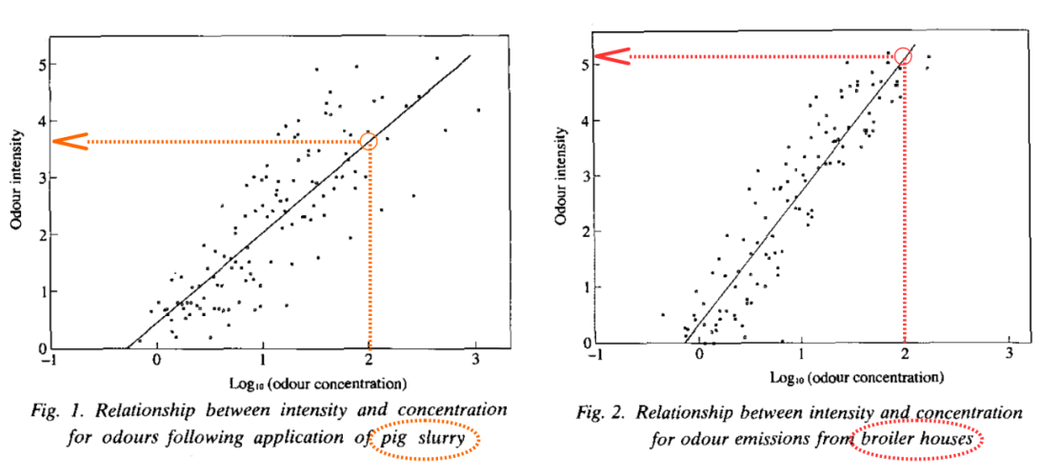
Figure 2. Examples of variation of odour concentration vs intensity for pig slurry (left) and broiler houses (right) (Misselbrook et al.)
Looking at the graphs above it can be seen that for example for a log concentration of 2 (i.e. 100 uo_{E}/m³) the intensity varies between distinguishable-strong when coming from pig slurry and between very strong and extremely strong for the smell coming from chicken farms.
This allows the concentration to be weighted for a certain intensity. Following the example above, the authors found that for the case of a chicken farm the equation relating intensity to odour concentration was as follows.
I=2,35(log10 C)+0,30 (1)
If the emission rate of a chicken farm gives a value of e.g. 630,000 ou_{E}/h and that odour is distinguishable (I=3) at a concentration of 14 ou_{E}, then the intensity-weighted odour concentration would be 45,000 ou_{E}/h resulting from dividing the original odour concentration by the odour concentration at which the odour is distinguishable.
If this odour were also, for example, slightly annoying at a concentration of 5 ou_{E}, the intensity and offensiveness weighted odour rate would be 9000 ou_{E}/h.
However, some research (Both R. et al. 2004) suggests that intensity is not as relevant a parameter in odour annoyance as the frequency of occurrence. Other studies (McGinley C. et al. 2018) suggest that there a need to take into account intensity. With the space available in this paper it is not possible to discuss further on this issue, however it is possible that intensity has to be weighted before weighting concentration.
  - Weighting the frequency
The limit value for the frequency of occurrence of an odour varies in different regulations around the world. For example, in Germany an odour can be perceived up to 876 hours per year in a residential area and not be a violation of the current regulations. In contrast, for example in New Zealand, an odour at certain odour concentrations should not be perceived more frequently than 44 hours.
Limiting the maximum frequency of occurrence of an odour has several disadvantages. The most important issue is the treatment of intermittent or discontinuous sources of odour emission.
A few years ago, a client of ours who had an animal by-product processing (rendering) plant was asked by environmental management to evaluate its odour impact. This plant operated about 6-8 hours a day, so when evaluating the year-round impact with a suitable dispersion model, it was found to be well within the limit set at less than 175 hours a year for 3 uo_{E}/m³.
However, despite what the model said, this plant had an odour impact problem, because even when it operated a few hours a day, people's demonstrations and news in the media usually followed each other. The problem was not the model, but the frequency of occurrence taken as a reference.
The lesson to be learned here is that selecting a fixed percentile as an odour frequency limit has many limitations as it does not allow the total odour dose perceived by a receiver to be assessed. In order to calculate the total odour perceived by a population, it is necessary to evaluate only one percentile, but all possible percentiles, and thus calculate the total odour load or dose.
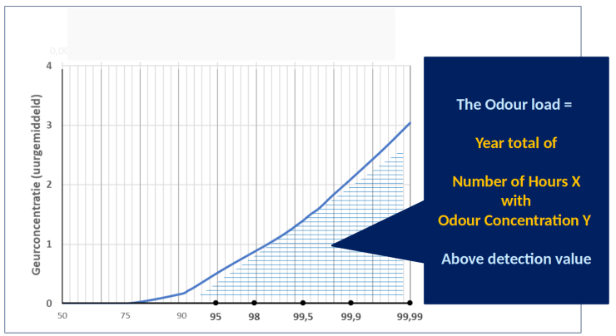
It is possible to evaluate all possible percentiles using what is known as an odour frequency distribution diagram. Work is currently underway in this direction during the revision of the Dutch standard NTA 9065. The following graph shows the relationship between the dose of odour received over a year for different percentiles.
Figure 3. Relationship between odour concentration and percentiles.
The aim here is to evaluate all possible percentiles of impact by odour over a year. The odour load would be the area under the curve and would correspond to the total odour dose received in a receiver over the whole year.
The odour dose is therefore the area under the percentile curve, i.e. the integral of the function that describes the intensity-hedonic-weighted concentration for different percentiles in the vicinity of concentrations between 1 and infinity.

  - Weighing up the duration
When the calculation of odour doses is made for hourly percentiles, the duration of odour episodes can be weighted by what are normally referred as peak to mean ratios (Piringer et. al. 2012), which is simply multiplying the concentration by a correction factor.
Therefore the resulting function would be no more than multiplying by a more or less variable factor called k.
The best alternative, however, is to use weather data on a scale of less than one hour to calculate subhourly percentiles.

  - Weighing up the sensitivity
In classical psychometry, it is usually indicated that the 4 basic factors that affect the sensitivity of individuals are experience, expectations, motivation and the degree of alertness of the receiver.
In the field of odour management, and above all when dealing with groups of receivers, there are other factors that affect the sensitivity of a population affected by odour impact (Rossi et. al. 2015) such as, the amount of population affected (large city, town, scattered houses, etc), the use of the land where it is located (industrial, rural, hospital, school, etc), the housing uses (continuous, occasional, fortuitous, repeated passage, etc), or even the type of protection that the impacted area may have (historical site, natural site, etc).
The weighting of the sensitivity of the receptors can be assessed using traditional psychometric tools or better still by comparing when odour observations occur in a citizen science experiment and comparing them with the results of dispersion models to calculate the threshold value of intensity and offensively weighted odour concentration that triggers an odour observation.
In other words, sensitivity pruning can be carried out by adding a factor that establishes the actual odour nuisance of an activity at the closest receptors.
As an example, the results of a project made with an animal by-product plant (Diaz et. al. 2016) was presented. This study consisted of mapping odours using citizen science and analysing odour ambient air with a suitable dispersion model. After comparing modelled with perceived odour observations, we found out that when the concentration in ambient air reached 2,1 ouE on average, an odour complaint was received in the system. For this number a peak to mean was used to better tune duration, that is why this number is weighted to the duration.
Taking the example mentioned above of odour rate weighted to the intensity and offensiveness of 9000 ou_{E}/h we could weight this odour rate to the sensitivity of the population by finding out at which concentration an odour complaint is triggered, by just dividing this concentration by 2.1 just for this particular animal by-product plant, which results in a maximum allowable odour emission rate weighted to the intensity the offensiveness the duration and the sensitivity of 9000/2,1 = 4286 ou_{E}/h.
Last step of this evaluation would be to find out the integral of the function that describes the evolution of this rate at different percentiles between P0 and P100 with the condition that the odour weighted concentration should be higher than 1. This would give the total odour load perceived by the population.
  - Conclusions
In this work we have tried to construct a formula to calculate the impact by odour in a community so that neither the type of plant that emits odour, nor the people who receive it, nor the region/country where the impacted area is located, are relevant.

This formula can be described matematically by using integrals and matrixes to better weight factors. More over, we propose that the ratio of change of the odour concentration can be described with partial derivatives, which will give more information on the sensitivity of the number obtained with this approach.

In practical example, from an emission rate of 630,000 ou_{E}/h we have found out that we could weight this odour rate to the intensity, hedonic tone, duration and sensitivity reaching a value of 4286 ou_{E}/h.

We have also proposed to use the concept of odour dose described in the NTA 9065 to further weight this value to the frequency of the odours perceived.

References
Both R., Sucker K., Winneke G., Koch E., 2004, Odour intensity and hedonic tone - Important parameters to describe odour annoyance to residents? Water Science & Technology. DOI: 10.2166/wst.2004.0227
Department of Environment and Heritage Protection, Queensland Government. (2012). Guideline. Odour Impact Assessment from Developments. Queensland, Australia, 2012. Accessed from: https://www.ehp.qld.gov.au/licences-permits/business-industry/pdf/guide-odour-impact-assess-developments.pdf
Determination and Evaluation of Odour Immissions – Guideline on Odour in Ambient Air GOAA (1994/1999/2004). (Feststellung und Beurteilung von Geruchsimmissionen - Geruchsimmissions-Richtlinie) Länderausschuss für Immissionsschutz, LAI- Schriftenreihe No. 5, Berlin (in German); revised version 1999.
Diaz Jimenez C., Izquierdo Zamora C., Cartelle D., Vellon J., Rodriguez A., 2016, Comparison of Predicted Versus Real Odour Impacts in a Rendering plant with PrOlor, Chemical Engineering Transactions, 54, 199-204
Gómez, D. & del Busto, A. 1999. Cap. 5: Control de malas hierbas. En: La lechuga y la escarola. Coedición: Fundación Caja Rural Valencia y Ediciones Mundi-Prensa. Madrid, Spain.
Haug, R.T. 1993. The practical handbook of compost engineering. Lewis Publishers, Boca Raton (Florida-USA).
Marzio Invernizzi, Laura Capelli and Selena Sironi., Proposal of Odor Nuisance Index as Urban Planning Tool. Chemical Senses, 2017, vol 42, 105-110
Kośmider J. (2010) Estimando las Molestias por Olores en una Granja Porcina Convencional. www.olores.org.
http://www.olores.org/index.php?option=com_content&view=article&id=141%3Aestimating-odour-nuisance-from-a-conventional-swine-farm&catid=1%3Acontenido&Itemid=40&lang=es. Accessed date: 07/07/2012.
Li J., Li W., Geng J., Zhai Z., Yang W. 2017. Determination of the hedonic odour tone in China and the behavior curve of ammonia” Austrian Contributions to Veterinary Epidemiology. Vol. 9, 7-14
Misselbrook T. H., Clarkson C. R., Pain B. F., 1993, Relationship between concentration and intensity of odours for pig slurry and broiler houses, J. agric. Engng Res. 55, 163-169
Murillo, J.M., Cabrera, F., López, R. & Martín-Olmedo, P. 1995. Respuesta de Lolium multiflorum Lam. cv Tewera a la aplicación de un compost urbano. Actas III Congreso Internacional de Química de la ANQUE. Puerto de la Cruz (Tenerife) 5-7 december 1994. p. 103-110.
NTA 9065. Air quality - Odour measurements - Odour measurement and calculation. Luchtkwaliteit - Geurmetingen - Meten en rekenen geur. ICS 13.040.99.
Piringer, Martin & Schauberger, Gunther & Petz, Erwin & Knauder, Werner. (2012). Comparison of two peak-to-mean approaches for use in odour dispersion models. Water science and technology : a journal of the International Association on Water Pollution Research. 66. 1498-501. 10.2166/wst.2012.357.
Rossi A. L'impatto olfattivo delle emissioni in atmosfera: la classificazione dei ricettori sensibili. ECOMONDO 2015.
VDI 3882 Part 1, 1992, Olfactometry; determination of odour intensity, German Engineering Association VDI/DIN Commission on Air Pollution Control (KRdL), Germany.
VDI 3882 Part 2, 1994, Olfactometry - Determination of hedonic odour tone, German Engineering Association VDI/DIN Commission on Air Pollution Control (KRdL), Germany.

