|  |  |
| --- | --- |
| cetlogo ***CHEMICAL ENGINEERING TRANSACTIONS***  ***VOL. 82, 2020*** | A publication of  aidiclogo_grande |
| The Italian Association  of Chemical Engineering  Online at www.cetjournal.it |
| Guest Editors: Selena Sironi, Laura Capelli  Copyright © 2020, AIDIC Servizi S.r.l. **ISBN** 978-88-95608-80-8; **ISSN** 2283-9216 | |

**Comparative evaluation of commercial packing materials for odour removal in biotrickling filters**

María Collantes1, Raquel Lebrero1, Carlos De Juan2, Geir Norden2, Kim Rosenbom2, Raúl Muñoz\*1

1. Institute of Sustainable Processes, University of Valladolid, Dr. Mergelina s/n, Valladolid, Spain
2. LECA Norway, Årnesvegen 1, Nordby, Norway

\*-Corresponding author e-mail: [mutora@iq.uva.es](mailto:mutora@iq.uva.es)

This study comparatively evaluated the potential of conventional plastic rings (Kaldnes) and two materials from the company LECA International (Saint Gobain), namely Filtralite® AIR 10-20 mm and Filtralite® Air AC, for the abatement of an odorous emissions (containing 22 ± 1.7 ppmv of H2S, 2.3 ± 0.4 mg toluene m-3 and 3.8 ± 0.3 ppmv of methyl mercaptan) in biotrickling filters. The PVC biotrickling filters (BTF) used were packed with 2.5 L of packing material and operated with a constant recirculation of mineral salt medium at 2 m/h, a liquid medium exchange rate of 2.5 L/g H2S fed and decreasing gas residence times (120, 60 30 and 15 s). The removal of H2S at gas residence times of 120, 60, 30 and 15 s was complete regardless of the packing material. Filtralite materials supported a more effective acclimation of the toluene degrading microbial communities, which completely degraded toluene (> 97%) by day 5, 12 and 35 in the BTF packed with Filtralite® Air AC, Filtralite® 10-20 mm and Kaldnes rings, respectively. The superior performance of Filtralite materials during toluene biodegradation was also confirmed under process operation at 15 s of gas residence time, where toluene removal efficiencies averaged 100 %, 98% and 71 % for Filtralite® Air AC, Filtralite® 10-20 mm and Kaldnes, respectively. Similar methyl mercaptan removal efficiencies were recorded in the three BTF evaluated. A complete removal of this odorant was only achieved at 120 and 60 s, which confirmed that methyl mercaptan removal was mass transfer limited. Interestingly, all packing materials provided comparable pressure drops at the different gas residence time tested. Finally, Filtralite® Air AC was able to buffer the recirculation medium and maintain the pH > 6. This study confirmed the superior performance of Filtralite materials as packing of biotrickling filter for odour abatement.

* 1. Introduction

Odour abatement from industrial activities, in particular from wastewater or waste management activities, still represents a significant concern to plant operators due to the gradual encroachment of cities on industrial park and the ever stricter environmental regulations (Hayes et al., 2017). Despite odorant prevention strategies are applied at source, the implementation of active *end-of-the-pipe* technologies is often needed to mitigate odour nuisance. In this context, physical-chemical technologies such as incineration, activated carbon adsorption or chemical scrubbing exhibit high operating costs and environmental impacts, which has recently paved the way to odour-treatment biotechnologies (Alfonsin et al., 2015). Biotechnologies are based on the biocatalytic action of fungi and bacteria to oxidize, at ambient pressure and temperature, the malodorous compounds present in industrial emissions at significantly lower operating costs and environmental impacts than their physical-chemical counterparts. Bioscrubbers, biofilters and biotrickling filters rank among the most popular biotechnologies for odour abatement, although biotrickling filters (BTFs) are increasingly implemented due to their low footprint, reduced operating cost and high efficiency (Estrada et al., 2015, Lebrero et al. 2010).

Despite the significant advances in biological odour removal technologies occurred in the past 20 years, packing material selection still represents the most uncertain design variable in biofiltration systems. This is paradoxical since packing material ultimately determines odorant removal efficiency and process operating costs (i.e. pressure drop across the bed and frequency of packing replacement). Organic packing materials are preferred in full-scale biofilters, wood chips and compost being the most popular supports due to their low price, wide availability, high microbial diversity and nutrient content. However, these packing materials offer lower lifespans as a result of their inferior structural properties and their faster deterioration compared with inorganic materials such as polyurethane foam, activated carbon, plastic rings or lava rock (Lebrero et al. 2014). On the other hand, biotrickling filtes are commonly packed with inert carriers, their properties significantly varying from one material to another: density, void fraction, roughness of the surface, etc. These characteristics will ultimately determine the performance and operating costs of the biotrickling filter, since important aspects such as the adhesion of microorganisms (and therefore the start-up period), the water retention capacity, the adsorption capacity, or the resistance to physical, chemical and/or biological deterioration widely vary form one material to another (Kennes and Veiga, 2002).

This study comparatively assessed the performance of conventional plastic rings and two materials from the company LECA International (Saint Gobain), namely Filtralite® AIR 10-20 mm and Filtralite® Air AC, for the abatement of an odorous emission in biotrickling filters operated at multiple gas residence times.

* 1. Materials and methods
     1. Inoculum and mineral medium preparation

The BTFs were inoculated with 0.2 L of fresh activated sludge from Valladolid wastewater treatment plant (Spain). The mineral salt medium (MSM) used in both bioreactors was composed of (g/L): K2HPO4 (0.7); KH2PO4 ·3 H2O (0.917); KNO3 (3); NaCl (0.2); MgSO4·7H2O (0.345) and CaCl2·2H2O (0.026). Trace elements were supplied by adding 2 ml/L of SL-4 stock solution containing (g L-1): EDTA (0.5); FeSO4·7H2O (0.2); ZnSO4·7H2O (0.01); MnCl2· 4H2O (0.003); H3BO3 (0.345); CoCl2· 6H2O (0.02); CuCl2· 2H2O (0.001); NiCl2·6H2O (0.002); Na2MoO4·6H2O (0.003).

* + 1. Experimental and Analytical procedure

The experimental set-up built for malodorous air treatment consisted of three identical PVC biotrickling filters packed with 2.5 L of three different materials: Filtralite® AIR 10-20 mm (BTF-F), Filtralite® AIR AC (BTF-HMR) and Kaldnes K2 plastic rings (BTF-K). Each BTF was constructed with a 0.5 L holding tank. The air stream entering the system was first pumped through an activated carbon filter, where any residual pollutant of atmospheric air was eliminated (Figure 1). The air was then humidified in a water column, entering afterwards a mixing chamber. In the mixing chamber, the clean air stream was mixed with a synthetic mixture of H2S, toluene and methyl mercaptan in N2 (purchased from Abelló Linde, Spain), resulting in an emission containing 22 ± 1.7 ppmv of H2S, 2.3 ± 0.4 mg toluene/m3 and 3.8 ± 0.3 ppmv of methyl mercaptan. The polluted stream was divided into three identical streams by means of rotameters with air flows varying from 2 minutes to 7.5 seconds of empty bed residence times (GRT). The individual streams were then fed at the bottom of each biotrickling filter. The liquid is continuously recycled through the packed beds at a flowrate of 0.15 L/min counter-currently with the polluted stream, resulting in a trickling velocity of 2 m/h. A MSM medium exchange rate of 2.5 L/g H2S fed was set in all BTFs in order to prevent nutrient limitation and sulphate accumulation.

Pollutant concentrations were measured periodically both at the inlet and outlet of the biotrickling filters. Toluene was analyzed in a gas chromatograph equipped with a flame ionization detector and a HP-5-MS (30 m × 0.25 mm × 0.25 µm) column. Solid-phase microextraction (SPME) was used as a pre-concentration technique during toluene analysis using 250 glass bulbs as sampling ports. On the other hand, H2S and methylmercaptan were analyzed using portable detectors with specific sensors: Dräger X-am 5000 and Dräger X-am 7000, respectively.

Liquid samples were also withdrawn periodically from the holding tanks in order to determine pH, total organic carbon, inorganic carbon, total nitrogen and sulfate concentrations. The pH was daily measured using a pHmeter Eutech Cyberscan pH 510 (Eutech Instruments, Netherlands). Both the inorganic carbon, the total organic carbon and the total nitrogen were determined in a TOC-VCSH analyzer coupled with a TNM-1 chemiluminescence module (Shimadzu, Japan). Finally, the pressure drop across the columns were also periodically determined using a U-meter filled with water as the manometric fluid.

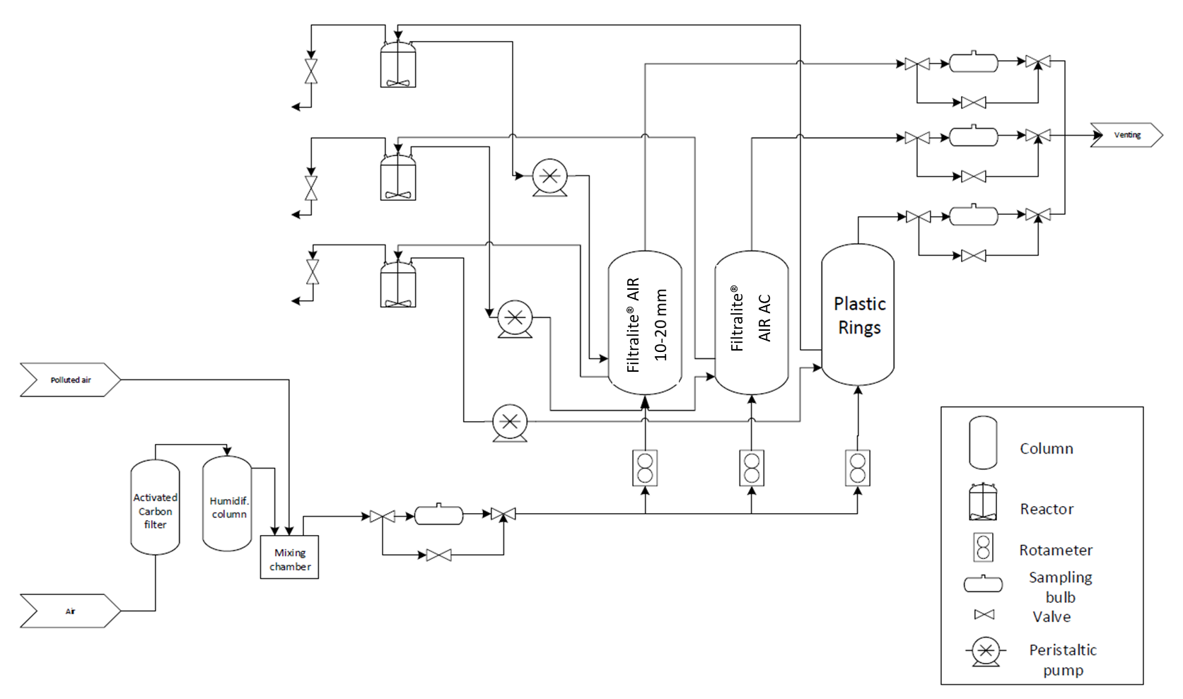

Figure 1: Schematic diagram of the experimental set-up composed of 3 biotrickling filters packed with kaldnes rings, Filtralite® AIR 10-20 mm and Filtralite® AIR AC.

* 1. Results
     1. Abiotic test

A 9-days abiotic test was performed prior inoculation of the BTFs in order to evaluate the potential physical-chemical abiotic removal of the target pollutants by the packing materials. Under abiotic conditions, Filtralite® AIR 10-20 mm supported a complete removal of H2S, while Filtralite® AIR AC removed more than 90%. The performance of Filtralite material without inoculation outcompeted the removal efficiency of conventional plastic rings, which supported a 50 % removal of H2S. No significant removal of toluene was recorded in the BTF packed with plastic rings or Filtralite® AIR 10-20 mm, while a gradual decrease in the toluene outlet concentration to 0.54 mg/m3 was supported by Filtralite® AIR AC.

* + 1. H2S removal

The results showed that the three BTFs were capable of degrading inlet H2S concentrations of ~22 ppmv at GRT of 2 min and 1 min (Figure 2). BTF-HMR completely removed H2S before inoculation of the systems, while BTF-F and BTF-K rapidly achieved a complete H2S removal 2 and 4 days after inoculation, respectively. The residence time was reduced to 30 and 15 s by days 50 and 64, respectively, with no concomitant deterioration of the H2S removal performance observed in any of the BTFs.

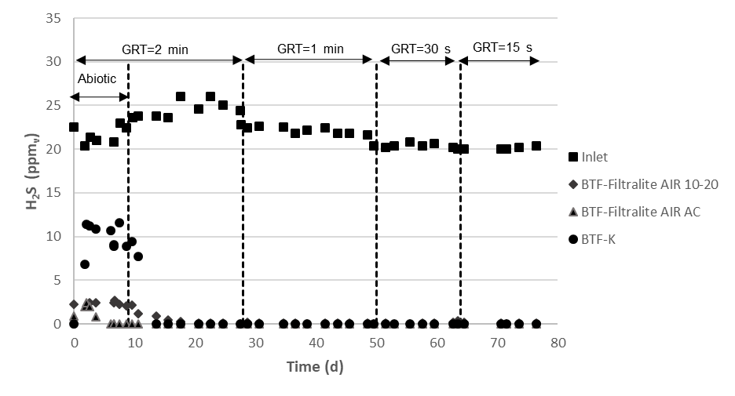

**Figure 2**. Time course of H2S concentration in the inlet (■) and outlet of the three biotrickling filters: BTF-F (♦), BTF-HMR (▲) and BTF-K (●).

* + 1. Toluene removal

In the particular case of toluene, no removal was observed for the BTF packed with Kaldnes plastic rings during the first 27 days of operation, despite this biotrickling filter was inoculated with activated sludge by day 9 (Figure 3). On the contrary, both BTF-HMR and the BTF-F reached toluene removal efficiencies of >99 % within 11 and 15 days after inoculation at a GRT of 2 min. Surprisingly, a decrease in the residence time to 1 min promoted the abatement of toluene in BTF-K, likely due to a higher turbulence and therefore an improved transfer of toluene to the liquid phase (which ultimately triggered the establishment of an effective toluene degrading community, whose growth was likely limited by the low pH of the trickling solution), achieving removals of >99 % from day 37 onwards at this GRT. These high toluene removals were also maintained in the three BTFs at a GRT of 30 s. However, a further reduction in the GRT to 15 s resulted in a decrease in the toluene removal performance of the BTF packed with plastic rings, increasing the outlet toluene concentration up to 0.65 mg/m3 (which corresponded to a removal efficiency of 72 %). On the contrary, both BTF-F and the BTF-HMR were able to maintain toluene removal efficiencies > 99 %, which highlights the good performance of Filtralite packing materials.



**Figure 3.** Time course of toluene concentration in the inlet (■) and outlet of the three biotrickling filters: BTF-F (♦), BTF-HMR (▲) and BTF-K (●)

* + 1. Methylmercaptan removal

Methylmercaptan was only analyzed from day 17 onwards of the experiment due to analytical issues in the optimization of the method by SPME-GC-FID at the initial stages of the project. No methylmercaptan was observed in the outlet gas stream of any BTF at GRTs of 2 and 1 min. However, when the GRT was reduced to 30 seconds, the outlet concentration of methylmercaptan increased to 2.5 mg/m3 in BTF-F and 2 mg/m3 in the BTF-K and BTF-HMR, resulting in removal efficiencies of 28 % and 42 %, respectively. In the last operating stage, at GRT of 15 s, no methylmercaptan removal was recorded in any of the BTFs (Figure 4). At this point it should be highlighted that the Henry’s law constants of H2S, toluene and methyl mercaptan are 1×10-3, 1.5 ×10-3 and 3.5 ×10-3 mol/(m3Pa), which rules out a potential mass transfer limitation causing the deterioration of methylmercaptan removal based only on the mass transfer gradient. The gas-liquid mass transfer in BTFs depends, not only on the gas-liquid concentration gradient, but also on the mass transfer coefficient (KLa), which itself is a function of the pollutant. Indeed, KLa is proportional to the (molar volume of the pollutant)^0.4, where the molar volume for H2S, toluene and methylmercaptan are 33, 106 and 55 mL/mol (Estrada et al. 2014). Therefore, the results suggest that Filtralite® AIR AC was able to support better methylmercaptan removal efficiencies due to the higher metabolic activity of the microbial community as a result of the higher pH values provided by Filtralite® AIR AC compared to plastic rings.

***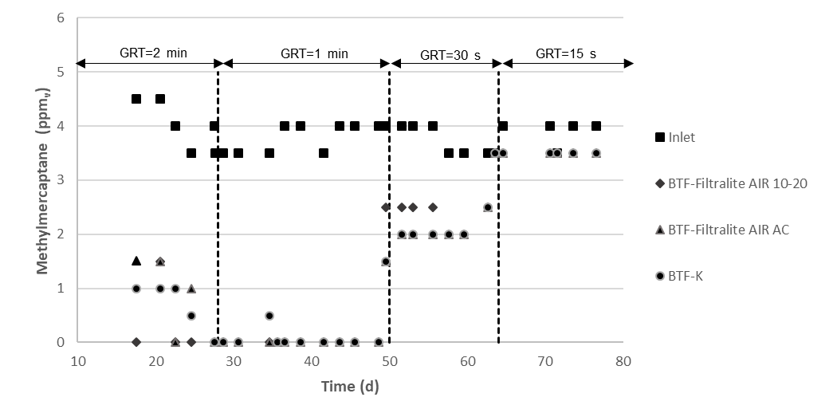***

**Figure 4**. Time course of methylmercaptan concentration in the inlet (■) and outlet of the three biotrickling filters: BTF-F (♦), BTF-HMR (▲) and BTF-K (●)

* + 1. pH

The pH measurements started during the biotic phase of the process in the recycling liquid. pH remained roughly stable in the BTF-HMR, with initial values of 6.4 ± 0.0 and a final value of 6.2 ± 0.0 in the last operating stage at a GRT of 15 s (Figure 5). On the contrary, a significant pH drop was observed in the BTF packed with plastic rings, reaching minimum values of 2.8 after 15 days of operation. This low pH was detrimental for microbial activity and might explain the lower pollutant removal performance observed in the biotrickling filter with plastic rings. After this initial drop, the pH in the BTF-K stabilized at ~ 2-2.2. In the case of BTF-F, after the initial pH stabilization by day 20, a sharp drop was recorded along with the increase in H2S load, reaching values of ~ 3.3 by day 36. From this day onwards, a steady decrease was observed in the pH of the recycling liquid, reaching values of 2.3 ± 0.1 when operating at a GRT of 15 s. At this point it should be stressed that the aerobic oxidation of H2S to sulphate was responsible for this decrease in pH in the recirculation liquid solution.

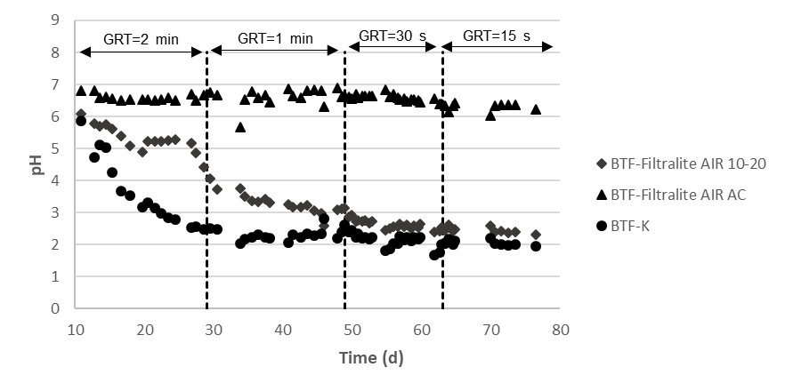

**Figure 5** Time course of the pH in the trickling liquid of the three biotrickling filters: BTF-F (♦), BTF-HMR (▲) and BTF-K (●).

* + 1. Pressure drop

The pressure drop remained stable in the three systems at values of ~9 mmH2O/mbed in the Filtralite® AIR AC and plastic rings BTFs and was slightly lower in the Filtralite® AIR 10-20 mm BTF at ~6 mmH2O/mbed when working at a GRT of 2 min. Concomitant increases in the pressure drop were recorded when decreasing the GRT, reaching values of 15 mmH2O/mbed at 1 min, 19 mmH2O/mbed at 30 s and 35 mmH2O/mbed at 15 regardless of the BTF (Figure 6). Interestingly, Filtralite materials provided pressures drops at low as classical plastic rings, which foresees a good performance of these materials in terms of energy demand during odour abatement.

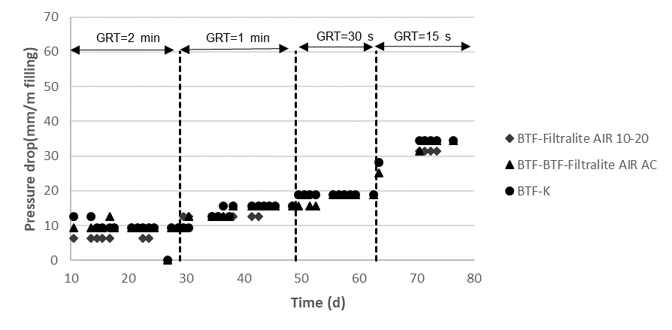

**Figure 6** Time course of the sulphate concentration in the trickling liquid of the three biotrickling filters: BTF-F (♦), BTF-HMR (▲) and BTF-K (●).

* + 1. Sulphate concentration

A stable sulphate concentration of ~1650 mg SO4-2/L was recorded in the trickling liquid of the BTF packed with Filtralite® AIR 10-20 mm for the first 22 days of operation. Then, sulphate concentration fluctuated from a minimum value of 1186 mg SO4-2/L on day 51 to a maximum of 1811 mg SO4-2/L on day 36. This value increased from 796 to 1605 mg SO4-2/L and from 264 to 753 mg SO4-2/L from days 9 to 16 of operation in BTF-HMR and the BTF-K, respectively. Then, the concentrations of SO4-2 gradually increased reaching a maximum of 1897 mg SO4-2/L in BTF-HMR by day 71 of operation and 1672 mg SO4-2/L by day 64 in BTF-K. These concentrations were far below inhibitory concentrations of sulphate for H2S degrading bacteria (Muñoz et al. 2015).

* 1. Conclusions

The results confirmed the superior performance of Filtralite materials as packing materials in biotrickling filters. Both Filtralite® AIR 10-20 mm and Filtralite® AIR AC supported higher H2S and toluene removal efficiencies than conventional plastics rings, and a significantly faster process start-up. The benefits of Filtralite materials during biotrickling filtration derive from its superior ability to favor the development of biofilms and to maintain higher pH values in the trickling solution. Filtralite materials can provide an outstanding odour removal at gas residence times of 15 s at pressure drops comparable to conventional plastic rings.

Acknowledgments

This work was funded by LECA Norway and also supported by the regional government of Castilla y León and the EU-FEDER (CLU 2017-09, UIC 71 and VA281P18).

**References**

Alfonsin C., Lebrero R., Estrada J.M., Muñoz R., Kraakman N.J.R., Feijoo G., Moreira M.T., 2015, Selection of odour removal technologies in Wastewater Treatment Plants: a guideline based on Life Cycle Assessment. Journal of Environmental Management. 149(1), 77-85.

Estrada J., Dudek A., Muñoz R., Quijano G., 2014, Fundamental study on gas-liquid mass transfer in a biotrickling filter packed with polyurethane foam, Journal of Chemical Technology and Biotechnology. 89, 1419-1424.

Estrada J.M., Lebrero R., Quijano G., Kraakman B., Muñoz R., 2015, Odour abatement technologies in WWTPs: energy and economic efficiency. In: K Tsagarakis, K Stamatelatou. (Ed.), Sewage Treatment Plants: Economic Evaluation of Innovative Technologies for Energy Efficiency,IWA Publishing. 163-187.

Hayes J.E., Stevenson R.J., Stuetz R.M., 2017, Survey of the effect of odour impact on communities, Journal of Environmental Management, 204, 349-354.

Kennes C., Veiga M.C., 2002, Inert filter media for the biofiltration of waste gases – characteristics and biomass control. Reviews in Environmental Science and Biotechnology 1(3), 201-214.

Lebrero R., Quijano G., Torio I., Martínez B., Muñoz R., 2010, A comparative study of two biological processes for odour treatment: biofiltration vs. activated sludge diffusion. Chemical Engineering Transactions 23, 333-338.

Lebrero R., Estrada J.M., Muñoz R., Quijano G., 2014, Deterioration of organic packing materials commonly used in air biofiltration: Effect of VOC-packing interactions. Journal of Environmental Management 137, 93-100.

Muñoz R., Meier L., Diaz I., Jeison D., 2015, A critical review on the state-of-the-art of physical/chemical and biological technologies for an integral biogas upgrading, Reviews in Environmental Science and Bio/Technology, 14, 727-759.