|  |  |
| --- | --- |
| cetlogo ***CHEMICAL ENGINEERING TRANSACTIONS***  ***VOL. 85, 2021*** | A publication of  aidiclogo_grande |
| The Italian Association  of Chemical Engineering  Online at www.cetjournal.it |
| Guest Editors: Selena Sironi, Laura Capelli  Copyright © 2021, AIDIC Servizi S.r.l. **ISBN** 978-88-95608-83-9; **ISSN** 2283-9216 | |

Improving the Impact of Odour Nuisance in Thessaloniki: A Stakeholder Engagement Approach

Stavros Vlachosa,\*, Charikleia Karakostaa,Vasiliki Sideria,Konstantinos Antoniadisa, Apostolos Siskosa

aEnvirometrics Karea 20 11636 Athens, Greece

svlachos@envirometrics.gr

Nowadays, it is widely acknowledged that the problem of odour pollution is extremely important and requires immediate action. The problem is high also at European Union’s political agenda, which highlights the issue of odours at European level and seeks to apply innovative tools, such as direct citizen participation and education, modelling and mapping tools, in order to tackle the problem and propose a related legislative framework and establish rules for controlling and reducing odour disturbances.

In this context, a key feature is the creation of an exchange of views to inform and understand the nature of odour incidents, with the joint involvement of authorities, citizens, universities and odour producers, with the aim of exploring mutually acceptable solutions.

To the best of our knowledge, there are very few studies that deal with the issue of odour nuisance, even less that focus on the western part of the city of Thessaloniki. The treatment of odour annoyance associated with industrial and other activities in the area of Dendropotamos, Menemeni, Kalochori is considered as an appropriate case for the implementation of this study. The combination of the odour issue and at the same time the environmental impact on the area make this case extremely interesting.

The current study aims at proposing a methodology that is based on Citizen Science and stakeholder engagement, which provides for active participation in scientific endeavours that generate new knowledge or perceptions. The proposed approach is part of the methodology initiated by the European Commission Horizon 2020 Project D-NOSES. The main objective of the study is to understand the problem and through stakeholder engagement and the active involvement of as many parties as possible, who are affected by the problem, to improve the impact of odours in the area. Training seminars, bilateral interviews and discussions assisted in developing a common understanding and goals, while an electronic application, the Odour Collect, developed for this purpose can report 'real-time' odour incidents and give them qualitative features. The results from the case study of Thessaloniki are presented in this paper and could further assist decision makers and key player to propose measures for improving the current situation.

Key words: Odour Nuisance; Odour; Citizen Science; Stakeholder Engagement; Stakeholders Consultation; Participatory Approach; Statistical Analysis; Thessaloniki

* 1. Introduction

Nowadays, it is widely acknowledged that the problem of odour pollution is extremely important and requires immediate action. The problem is high also at European Union’s political agenda, which highlights the issue of odours at European level and seeks to apply innovative tools, such as direct citizen participation and education, modelling and mapping tools, in order to tackle the problem and propose a related legislative framework and establish rules for controlling and reducing odour disturbances.

Stakeholder engagement is becoming an important component of all policy- and decision- support processes (Phillipson et al., 2012). Dialogue or knowledge exchange with stakeholders is a very enriching experience, as it allows scientists or researchers to get exposed to different views, approaches, and expectations on outcomes (Welp et al., 2013). It also enables them to collect feedback and suggestions from a variety of individuals having complementary skills and backgrounds (Beringer et al., 2013; Kelley et al., 2016; Yang et al., 2009).

The involvement of key stakeholders is very useful to get an alternative perspective (Haddaway et al., 2017), which stimulates the scientists or researchers to shift the focus from related activities to intended results at an early stage and to clearly communicate main ideas about the problem in terms of objectives, milestones and outputs. It is important to become fully aware of the implications of a participatory process with external experts and to define clear boundaries for stakeholder involvement (Pacheco and Garcia, 2012).

A key feature in this respect when thinking the odour nuisance problem, is a participatory approach for the creation of an exchange of views platform to inform and understand the nature of odour incidents (Winooski et al., 2021). The approach is based on the joint involvement of authorities, citizens, universities and odour producers, with the aim of exploring mutually acceptable solutions (Elelman and Feldman, 2018).

The western part of Thessaloniki is characterized by numerous industrial activities that cause major odour incidents in the area (Conti et al, 2020) . Simultaneously, various urban activities, such as illegal burning of improper material, further affects the environmental deterioration of the region (Weitensfelder et al, 2020). In addition, a stream, which is a part of the hydrographic network that runs through the area, receives the untreated effluent of wastewater from this part of the city. The untreated wastewater ends up in Thermaikos gulf, thus, causing not only excruciating odours, but also environmental damage and pollution. To the best of our knowledge, there are very few studies that deal with the issue of odour nuisance, even less that focus on the western part of the city of Thessaloniki.

The aim of the paper is to propose a methodology based on Citizen Science and stakeholder engagement, which provides an active participation in scientific endeavors that generate new knowledge or perceptions. The main objective of this study is to understand the problem and through stakeholder engagement and the active involvement of key parties to reduce the impact of odours in the area. Training seminars, bilateral interviews and discussions assisted in developing a common understanding and goals, while an electronic application, the Odour Collect, developed for this purpose offered reports of 'real-time' odour incidents and provide qualitative features. The results from the case study of Thessaloniki are presented in this paper and could further assist decision makers and key player to propose measures for improving the current situation. Finally, it should also be mentioned that the proposed approach is part of the methodology initiated by the European Commission Horizon 2020 Project D-NOSES.

* 1. Proposed engagement framework

Today, the term “stakeholder engagement” is emerging as a means of describing a broader, more inclusive, and continuous process between a project and those potentially impacted that encompasses a range of activities and approaches and spans the entire life of a project. Therefore, developing a stakeholder engagement plan (Balestrini et al., 2018) is crucial, to:

•Prioritise the main topics/issues that deserve discussion with stakeholders;

•Set the desired outcomes;

•Identify the main communication channels for dialoguing and exchanging with them;

• Clarify the right point in time when stakeholders need to be mobilised, in order to be more effective and maximise the chances of getting valuable inputs when needed;

•Develop a dissemination strategy, including follow-up.

The particular paper proposes a methodological framework, which could act as a concrete stakeholder engagement plan and consists of a series of concurrent and consecutive steps to involve stakeholders throughout the process. In the following paragraphs these steps are described in brief.

The proposed engagement framework is highly inclusive and aims to involve participants affected by odour issues regardless its socio-economic and socio-cultural realities, its gender, its literacy level, religious affiliation, age, and disabilities, amongst others. Since all people are affected by odour issues the aim is to involve them to co-create together the actions needed within the engagement phases (Figure 1).

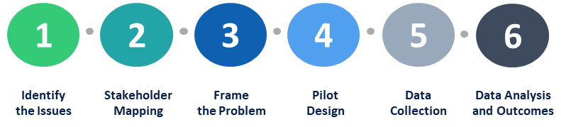Figure 1. Engagement Phases

Step 1: Identify the Issues

In this step the methodology identifies the key odour issues, as well as if these issues are affecting a particular group of people. A list of the different local groups encountered is developed, in order to construct a stakeholder map in the following phase (Karakosta et al., 2015; Pacheco and Garcia, 2012).

Step 2: Stakeholder Mapping

All groups affected and affecting by the issue are included in the map. Key contacts, conversations and meetings with the already identified stakeholders start to identify more factors to be included. These contacts are also used to understand potential motivations and barriers to participate in the pilot, as well as mitigation strategies for the stakeholder participation. Through workshops and meetings participants are introduced to the methodology and principles of stakeholder engagement approach in order to be part of the treatment.

Step 3: Frame the Problem

At this stage the framing of the problem takes play, trying to understand the initial priorities of the issue, as well as the social, cultural, urban, political and economic context of the area including a wide variety of views.

Step 4: Pilot Design

Following the stakeholder map, the methodology sets the pilot actions based on specific strategy according to each stakeholder group (Karakosta and Flamos, 2016). The strategy defines where public consultations are planned and the communication methods, the audience for each engagement, the frequency, and the tools that will be used to efficiently implement the pilot are identified. It is important to take into account when the communications are planned, as some tools/ means require more effort to be organised and implemented than others. Several techniques to approach stakeholders are recruited, including emailing, phone interviews, face-to-face meetings, questionnaires, distribution of dissemination material, focus groups, workshops, thematic discussions, in order to attract stakeholders’ interest and input.

Step 5: Data Collection

During this step relevant data is collected by using several identified means of stakeholder engagement. In the pilot area the data collection process is based on citizens records about odour incidents and their experience in terms of density, frequency, location and odour type.

Step 6: Data Analysis and Outcomes

Are you aware of language adaptation and potential barriers for participants in order to be understandable for everyone?

How do you consider including participant’s voices in data analysis?

Key outcomes are summarised, while also adapting language and methods to share outcomes with all engaged in the process stakeholders.

* 1. Pilot application: Thessaloniki

The unmapped and everlasting issue of odour annoyance associated with industrial and other activities in the area of Dendropotamos, Menemeni, Kalochori of Thessaloniki is considered as an appropriate case for the implementation of this study. The combination of the odour issue and at the same time the environmental impact on the area make this case extremely interesting.

The pilot application of the proposed methodology in particular for the case of Thessaloniki is presented in brief in the following paragraphs.

Step 1: Identify the Issues

The Thessaloniki pilot has established an active network of key stakeholders. Local governmental authorities, researchers, local universities, schoolteachers and residents of the affected area have been identified as key stakeholders. The initial contact was the Regional Authority of Central Macedonia that described the odour and environmental issues Western Thessaloniki encounters. The contribution of the Chemistry Department of Aristotle University was to support and provide further data on the case. Further to the above, we have contacted with research and consulting firms, that are active in the field of engaging citizens into science projects. Bilateral meetings with citizens were essential for the identification of specific geographic and qualitative characteristics of the odour nuisance.

Step 2: Stakeholder Mapping

For the purposes of this step, several workshops and meetings have been withheld, mapping all stakeholders affected within the geographic area of interest. Apart from the above-mentioned stakeholders, it was essential to get in contact with major economic and commercial institutions at the area. These included three five-star hotels, the port authority, the police and the local church which is a focal point for citizens. This procedure added value to our approach since we had a better understanding of the issue as well as the fact that we verified the existing information on the qualitative characteristics of the problem

Step 3: Frame the Problem

Mainly the Regional Authority, the local University (Aristotle University) and several citizen groups and individuals, which are the key players in the area have contributed to frame the problem. Stakeholder engagement showed that except for the area of interest, which is included in the initially proposed refinery area, another area to the south was added in the examination. This concerns a river that receives effluent from non-treated municipal wastewater.

Step 4: Pilot Design

More than 38 community meetings have been held in the area of interest with local governments, researchers, university professors, teachers and citizens of the affected area. Dedicated to the particular problem questionnaires developed and a smartphone application called “Odour Collect” were the citizens’ tools in order to report odour issues.

Table 1: Community meetings in the area of interest

|  |  |  |  |  |
| --- | --- | --- | --- | --- |
| Stakeholder  type | Number of  meetings | Number of participants | Men  Participating | Women  Participating |
| Affected communities | 19 | 155 | 89 | 66 |
| Industry | 1 | 3 | 3 | 0 |
| Public Sector | 12 | 89 | 56 | 33 |
| Researchers | 6 | 17 | 12 | 5 |
| Total | 38 | 264 | 160 | 104 |

Step 5: Data Collection

Apart from questionnaires that were filled in and the “Odour Collect” application, schools from the affected area are involved in the data collection process in the context of environmental education, hence, increasing the number of observations and raising awareness as well.

Step 6: Data Analysis and Outcomes

In about 3 months, approximately 400 observations were recorded, thus, providing evidence about significant odour issues in the area. Dissemination activities have also been held in the local press in order to raise awareness, support active citizenship and promote environmental justice. The analysis from the observations so far, depicts the existing problem in qualitative and quantitative terms. Most of the observations refer to industrial or urban smells. The vast majority concerns unpleasant smells with medium intensities.

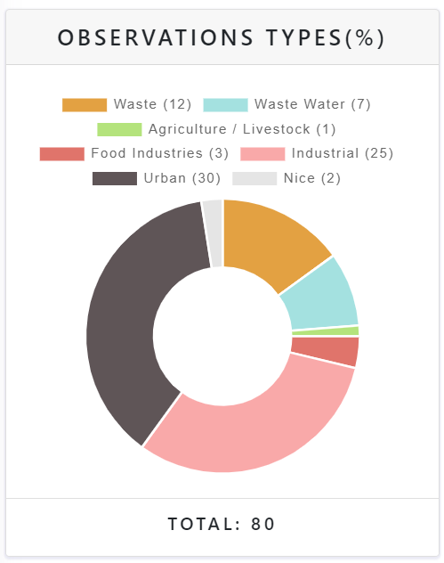

Figure 2: Observation types

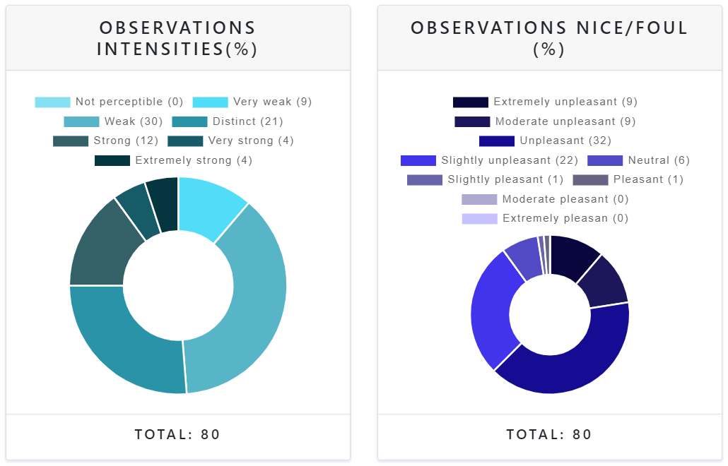*Figure 3: Observation intensities and quality criteria (Source: D-NOSES, 2020)*

* 1. Conclusions

The current study proposed a methodology that is based on citizen science and stakeholder engagement to better understand the problem of odour nuisance for the case of Thessaloniki. In particular for the under-examination area, the proposed approach facilitated in receiving the necessary feedback, observations and key input from the stakeholders. The case study withheld bilateral meetings, workshops and field visits, while used as a facilitative instrument related questionnaires. Questionnaires proved to be a very important mean for gathering observations, since during the general lockdown and summertime odour collect observations collection was not very high.

The study and the methodology followed indicated several general benefits of an active participatory process including:

* Clearer identification of problems;
* Improving the quality of the resulting plans;
* Developing a common basis for action programmes;
* Raising awareness and encouraging changes in behaviour;
* Overcoming conflicts and streamlining implementation;
* Initiating social empowerment of participants.

The proposed methodological framework provides stakeholders, such as policy makers, local authorities, business, NGOs and citizens with a novel and effective opportunity to identify the information needs on the future measures for improving the current situation and their impacts on stakeholders’ decisions. It ensures that at different policy- and decision-making levels within the EU, decisions are taken on the basis of the best available knowledge including an increased understanding of opportunities for business and society.

Acknowledgments

The current paper is based on the research conducted with the framework of the EU Horizon 2020 project “D-NOSES - Distributed Network for Odour Sensing, Empowerment and Sustainability” (grant 789315, https://dnoses.eu/). The contents of the paper are the sole responsibility of its authors and do not necessarily reflect the views of the EC.

References

Balestrini M., Creus J., Errandonea L., Arias R., Salas Seoane N., 2018, Map of odour issues and priorities, Multilevel engagement plan for stakeholders and communities, D-NOSES, H2020-SwafS-23-2017-789315.

Beringer C., Jonas, D., Kock, A., 2013, Behavior of internal stakeholders in project portfolio management and its impact on success, International Journal of Project Management, 31, 830 – 846.

Conti C., Guarino M., Bacenetti J., 2020, Measurements techniques and models to assess odor annoyance: A review, Environment International, Vol 134, 105261.

D-NOSES 2020. Odour Collect Application. D-NOSES, H2020-SwafS-23-2017-789315.

Elelman R., Feldman D. L., 2018, The future of citizen engagement in cities—The council of citizen engagement in sustainable urban strategies (ConCensus), Futures, Vol 101, 80-91.

Haddaway N. R., Kohl C., Rebelo da Silva N., Schiemann J., Spök A., Stewart R., Sweet J. B., Wilhelm R., 2017, A framework for stakeholder engagement during systematic reviews and maps in environmental management. Environmental Evidence, 6, 11.

Karakosta C., Dede P., Flamos, A., 2015, Identification of knowledge needs on climate policy implications through a participatory process, Proceedings of the 8th International Scientific Conference on Energy and Climate Change, Contributing to deep decarbonization, 7-9 October 2015, Athens, Greece.

Karakosta, C., Flamos, A. ,2016, Managing Climate Policy Information Facilitating Knowledge Transfer to Policy Makers. Energies. 9, 4554.

Kelley, K., Feldman S., Gravely S., 2016, Chapter 4 - Engaging and Sustaining Stakeholders: Towards Governance, Editor(s): Brian E. Dixon, Health Information Exchange, Academic Press, 59 – 76.

Pacheco C., Garcia I., 2012, A systematic literature review of stakeholder identification methods in requirements elicitation Journal of System Software, Vol 85, Issue 9, 2171 – 2181.

Phillipson, J., Lowe P., Proctor A., Ruto E., 2012, Stakeholder engagement and knowledge exchange in environmental research, Journal of Environmental Management, 95, 56 – 65.

Weitensfelder, L., Moshammer, H., Öttl D., Ingrid P., 2019, Exposure-complaint relationships of various environmental odor sources in Styria, Austria, Environ Sci Pollut Res, 26, 9806–9815, Austria.

Welp, M. Vega – Leinert, A., Stoll – Kleemann, S., Jaeger, C., 2006, Science-based stakeholder dialogues: Theories and tools. Global Environmental Change, 16, 170 – 181.

Winooski M., Adam S., Jarosław P., Grażyna P., Jerzy S., Turek P., Mariusz S., 2021, The influence of the methods of measuring odours nuisance on the quality of life, Environmental Impact Assessment Review, Vol 86, 106491.

Yang, J., Shen, G.Q., Ho, M., 2009, An overview of previous studies in stakeholder management and its implications for the construction industry, Journal of Facilities Management, 7, 159-175.