CHEMICAL ENGINEERING TRANSACTIONS  VOL. 82, 2020 | A publication of
The Italian Association
of Chemical Engineering
Online at www.cetjournal.it
Guest Editors: Selena Sironi, Laura Capelli
Copyright © 2020, AIDIC Servizi S.r.l.
ISBN 978-88-95608-80-8; ISSN 2283-9216

Modelling the Quality of Odour Mixtures in Environment: A New Approach using the Experimental Mixture Design Combined with the Langage Des Nez®
Charbel Hawko^{a,b,}*, Marie Verrieleª, Nicolas Hucher^{b}, Sabine Crunaireª, Celine Leger^{c}, Nadine Locogeª, Geraldine Savary^{b}
ªIMT Lille Douai, SAGE, Université de Lille, F-59500 Douai, France
^{b}URCOM, Université Le Havre Normandie, F-76600 Le Havre, France
^{c}Atmo Normandie, F-76000 Rouen, France
charbel.hawko@univ-lehavre.fr

Odour nuisance can be caused by industrial emissions. Sensory analyses are efficient approaches when assessing these odours. However, two obstacles may interfere with sensory analyses and make odour sources identification harder: the subjectivity of the human panel and the poorly understood effect of odour mixtures on the quality of the final odour, when industrial emissions get mixed.
To answer that question, an approach is proposed in this article combining the experimental mixture design with the Langage des Nez®, a method that uses chemical referents as odour descriptors reducing the subjectivity of the panel. Three odorous compounds were studied: propyl mercaptan, α-pinene and furfuryl mercaptan. They were mixed at different odour activity values. For each mixture, a sensory analysis was made to describe the odour with the Langage des Nez®. The variation of the odour profile with the composition was modelled. The obtained models were validated and represented in a 3D space enabling the visualisation of the evolution of the models.
This approach is considered a cornerstone in better understanding the effect of odours mixtures thus removing this obstacle when assessing odour nuisance with the objective of identifying the odour sources using sensory analyses.
  - Introduction
Odour nuisance is the cause of many complaints. Emissions from industrial sites may be the cause of odour nuisance. This could lead to health problems and affect negatively the real estate market and local economy (Blanes-Vidal et al., 2012). Odour nuisance may be studied by sensory analyses for many reasons like offering sensory information on the studied odour emissions and maybe more practical to execute than chemical analyses (Nicell, 2009).
Sensory analyses include quantification of an odour (intensity assessment, odour concentration) and qualification (odour nature, hedonic tone). It is usually done by a human panel. However, sensory analyses have some major flaws:
- The subjectivity of the human panel;
- The interactions that occur when odorous emissions get mixed in the air.
The subjectivity in the human panel comes from the assessor sensibility differences which leads to a different perception of intensities. For the odour intensity assessment, the subjectivity of a panel may be amended by using an Odour Intensity Reference Scale (OIRS) (Deshmukh et al., 2014) or the panel selection for the determination of the odour concentration (EN13725, 2003). However, the assessment of the odour nature leads to subjectivity resulting from memories and experiences (Baccino et al., 2010). For this reason, odour nature is not usually studied and odour nuisances are characterized by five factors: Frequency, Intensity, Duration, Offensiveness and Location. These factors are known as FIDOL (Nicell, 2009).
Odour nature may be assessed objectively using odour references methods such as the Langage des Nez® (LdN) or the field of odours® (Jaubert et al., 1995). These methods are based on the comparison of the odour of interest to the odour of a similar chemical referent. The LdN comprises a collection of 26 well-defined odour referents represented in a 3D space (Figure 1). Referents are grouped in poles based on their similarities. The more similar a referent odour is to the pole, the closer it is represented.

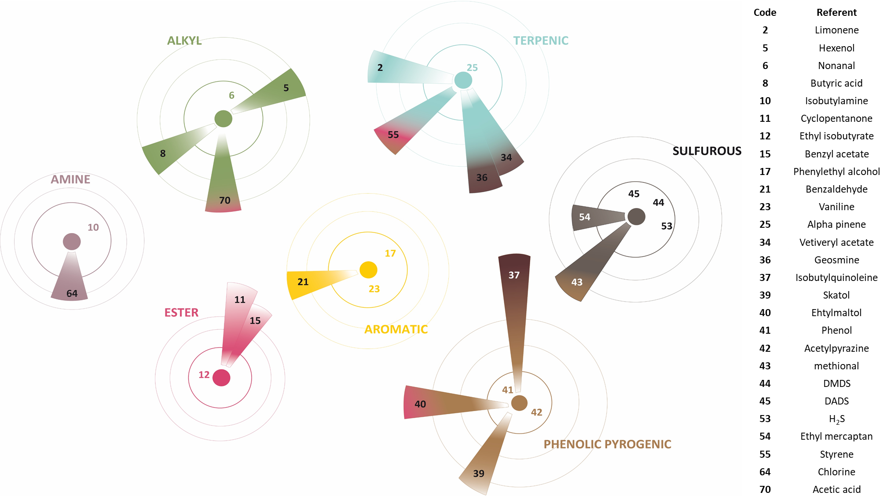
Figure 1: LdN odour referents 3D representation showing the seven poles with their referents. The referents represented in the first circle surrounding the nucleus are the pole referents.
On the other hand, the sensory interactions in mixtures still pose a problem. Odour emissions in industrial cities get mixed in the atmosphere. Many types of research were conducted to understand the effect of mixing several odorants on the global intensity and quality of the mixture. The effect on the global intensity is well described for binary and complex mixtures (Ferreira, 2012a). Nonetheless, it is not so easy for the qualification of the mixture. This may be due to the fact that the human nose can identify up to 3-4 odorants (odorous compound) at the same time in a complex mixture (Ferreira, 2012b). Furthermore, the carried tests asked the subjects to assign the quality of the mixture, rather than describing it (Ferreira, 2012b) e.g. for a binary mixture of A and B, assessors were asked to assign qualities of A, B or AB. Thus, some questions surrounding the quality of odour mixtures remain unanswered.
Odour nature assessment using LdN has proved to be effective in surveying air odorous quality in the Normandy France with the help of a web of assessors deployed all over the region (Capo and Leger, 2017). Results from the assessors are compared to an olfactory imprint created for each industry to identify odour nuisance sources (Muñoz et al., 2010). However, even if the problem of subjectivity is solved, the effect of mixtures is still an obstacle. Many Industries are adjacent and their odorous emissions get mixed, hence, the need to better understand mixtures interactions is a must. To answer this question, a new model is proposed that would help better understand the effect of mixtures on the odour nature. In this study, the combination of the LdN method with the experimental mixture design is examined to model the different sensory interactions that take place in a complex mixture of odorants.
  - Materiel and methods
    - Odour perception threshold
Odorants chosen were furfuryl mercaptan (roasted coffee odour, experts represent it attached to the pyrogenic pole with a tendency towards the sulphurous pole), propyl mercaptan (oniony/garlicky odour, sulphurous pole) and α-pinene (coniferous) from the terpenic pole (Figure 1). They were chosen because they are attached to different poles. Besides, propyl mercaptan and furfuryl mercaptan were found before in the region of Normandy.
These odours were mixed at different odour activity values (OAV) in pure Nitrogen (alphagaz 2 Nitrogen, Air Liquide, P ≥ 99.9999%). OAV is the chemical concentration divided by the olfactory detection threshold (Eq 1).
$OAVi=\frac{C_{i}}{C_{ot,i}} \left(1\right)$
where Ci the chemical concentration of odorant i and C_{ot,i} is the odour perception threshold of i.
Detection thresholds vary in literature making OAV calculation inaccurate. To solve this problem, the odour perception threshold of each odorant was determined for the panellists involved during this study. Odorants were prepared in Nalophan® bags and diluted in dry N₂ (preparation of bags is detailed in part 2.3). The panel consisted of 9 assessors (4 women and 5 men) between 24 and 80 years old. All experts are well trained to use the LdN method. Odour perception thresholds were determined using the triangle odour bag with forced-choice (Ueno et al., 2009).
    - Software
NEMROD-W software (Version 2017, D. MATHIEU, J. NONY, R. PHAN-TAN-LUU, A. BEAL, Marseille, France) was used for generation and evaluation of the statistical experimental design.
    - Odour mixtures preparation
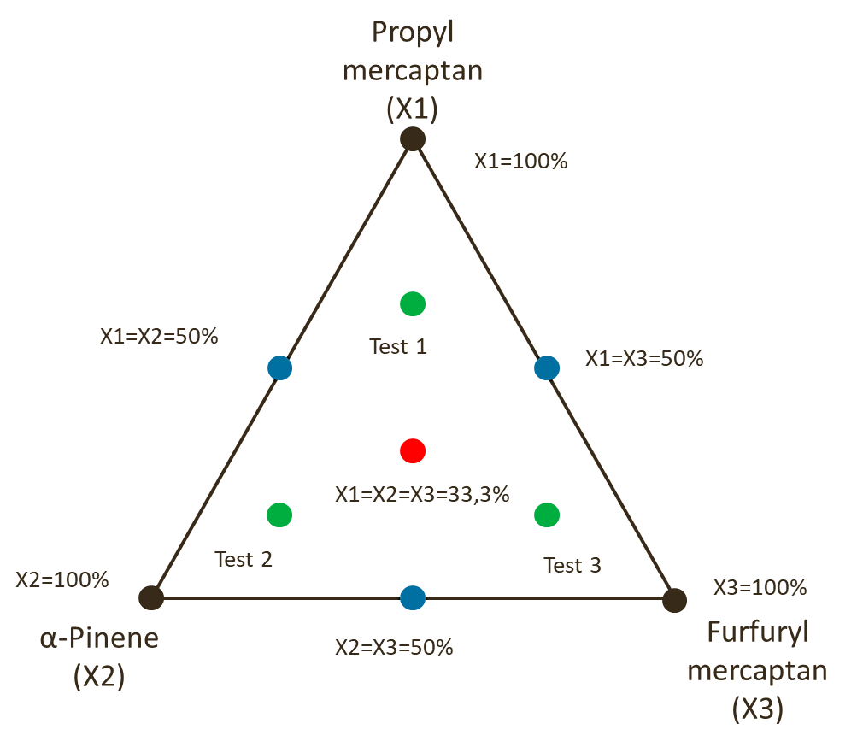
Odorants were mixed at different proportions (X_{i}) of OAV. Each X_{i} varies between 0 and 1 (100%) with the sum of X=1. The 100% level is equivalent to the SOAV (sum of OAVs- Eq 2) in the bags which was maintained at 30. The different odorants proportions varied according to the experimental matrix provided by the NEMROD-W software (Table 1).
$SOAV=\sum_{1}^{i}{{OAV}_{i}} (2)$
Table 1: odorants proportions for the different mixtures analysed.
Mixture number | OAV/SOAV (100%)
 | Propyl mercaptan  X₁ | α-Pinene  X₂ | Furfuryl mercaptan  X₃
1 | 1 | 0 | 0
2 | 0 | 1 | 0
3 | 0 | 0 | 1
4 | 0.5 | 0.5 | 0
5 | 0.5 | 0 | 0.5
6 | 0 | 0.5 | 0.5
7 | 0.333 | 0.333 | 0.333
Test 1 | 0.666 | 0.167 | 0.167
Test 2 | 0.167 | 0.667 | 0.167
Test 3 | 0.167 | 0.167 | 0.667

Figure 2: The experimental domain represented by a ternary plot. Different dots refer to different representations of different mixtures.

The seven main mixtures were used to build the models and the three test mixtures were used to validate those models. They are presented in an n-1 (n number of components) space with an experimental domain limited by n corners; a simplex. In this case, it is a ternary plot in a 2D space (Figure 2). Mixtures are represented by dots on the simplex. The mixtures were prepared in 10L Nalophan® Bags. The calculated quantities were introduced in the bags from odorants gas stock then filled with pure nitrogen. The stability of the odorants in the bags was tested by chromatography.
    - Sensory analysis
Mixtures were analysed by the panel using the poles of LdN (Figure 1) as descriptors. Odours were described as being far or close to the poles by using a score over 9 as a degree of representativity, called the odour score. However, they could only choose up to three poles. In case of choosing two or three poles as odour nature descriptors, the sum of the given scores must be equal to nine. If only one pole was chosen, the given score is automatically considered 9. Decimals were not used. Each pole is represented by referents displayed in the first concentric circle around the nuclei of the pole (Figure 1). This olfactory space is based on the olfactory space of the Field of Odours® method (Jaubert et al., 1995). Panellists are well trained to use the proximity of an odour towards the pole as a description. Analysis sessions lasted one hour with a break halfway. For each mixture, 8 odour descriptors were studied: phenolic, pyrogenic, sulphurous, terpenic, alkyl, aromatic, amine and esteric. They were coded as Y₁, Y₂…Y₈ respectively. The mean of the panellists’ results was calculated for each descriptor.
  - Results and discussion
    - Detection thresholds
Detection thresholds of the three odorants are shown in Table 2 and can be compared to already published values. There are some differences that may be due to the difference of sensitivity from a population to another. However, the difference is not very significant i.e. 37.5 times greater than literature for propyl mercaptan, 24 times for α-pinene and 5.65 times for furfuryl mercaptan as sometimes differences of 100 times and more are found between different works (Cariou et al., 2016).
Table 2: Comparison between detection limits determined experimentally and detection limits from the literature for the three odorants propyl mercaptan, α-pinene and furfuryl mercaptan.
Detection thresholds (ng/L) | Propyl mercaptan | α-Pinene | Furfuryl mercaptan
Experimental | 1.5 | 2,400 | 0.13
Literature | 0.04 (Nagata, 2003) | 100 (Nagata, 2003) | 0.023 (Rowe, 2000)
    - Modelling
Three descriptors were mainly used: terpenic, sulphurous, pyrogenic and phenolic (Table 3). The phenolic character found in some mixtures may be the result of some odours emitted from the bags themselves. These odours were reported when smelling pure nitrogen from the bags. For that, they will not be studied. The results for other descriptors were zero.
Table 3: The mean of the odour scores given for descriptors for each mixture. Other descriptor had no odour scores given thus they are not shown.
Mixture | Propyl mercaptan (X₁) | α-Pinene (X₂) | Furfuryl mercaptan (X₃) | Pyrogenic | Terpenic | Sulphurous | Phenolic
1 | 1 | 0 | 0 | 1.3 | 0.3 | 7.3 | 0.0
2 | 0 | 1 | 0 | 0.3 | 7.3 | 1.3 | 0.0
3 | 0 | 0 | 1 | 5.7 | 0.0 | 3.3 | 0.0
4 | 0.5 | 0.5 | 0 | 1.3 | 2.6 | 4.7 | 0.4
5 | 0.5 | 0 | 0.5 | 3.3 | 0.0 | 5.7 | 0.0
6 | 0 | 0.5 | 0.5 | 2.6 | 4.4 | 1.3 | 0.7
7 | 0.333 | 0.333 | 0.333 | 2.6 | 2.8 | 3.7 | 0.0
Test 1 | 0.666 | 0.167 | 0.167 | 2.1 | 0.9 | 5.7 | 0.3
Test 2 | 0.167 | 0.667 | 0.167 | 1.3 | 3.0 | 4.0 | 0.7
Test 3 | 0.167 | 0.167 | 0.667 | 3.7 | 1.3 | 3.8 | 0.2

The used model was a reduced cubic (synergic of the third degree) model which takes into interactions between 3 components. The equation of the model had the following form (Eq 3):
$Y_{i}=b_{1}X_{1}+b_{2}X_{2}+b_{3}X_{3}+b_{1-2}X_{1}X_{2}+b_{1-3}X_{1}X_{3}+b_{2-3}X_{2}X_{3}+b_{1-2-3}X_{1}X_{2}X_{3}$ (3)
The coefficients b₁, b₂ … b₁₋₂₋₃ of each descriptor model were calculated from the means of the odour scores.
For each descriptor, a model was built (Eq 4,5 &6)
$Ypyrogenic=1.3X_{1}+0.3X_{2}+5.7X_{3}+2X_{1}X_{2}-0.8X_{1}X_{3}-1.6X_{2}X_{3}+5.7X_{1}X_{2}X_{3}$ (4)
$Yterpenic=0.3X_{1}+7.3X_{2}+0X_{3}-4.8X1X_{2}-0.6X1X_{3}+3X_{2}X_{3}+14X1X_{2}X_{3}$ (5)
$Ysulphurous=7.3X_{1}+1.3X_{2}+3.3X_{3}+1.6X_{1}X_{2}+1.6X_{1}X_{3}-4X_{2}X_{3}-4.8X_{1}X_{2}X_{3}$ (6)
These equations were transformed into a 3D representation of the variation of the odorant profile with the composition of the mixture (Figure 3).
When comparing the models’ representations, the pyrogenic and terpenic characters tend to dominate the odour of the mixture when the furfuryl mercaptan and the α-pinene respectively have X₂ and X₃ over 75% (Figure 3). This is not the case of the sulphurous character which tend to dominate the odour of the mixture (an odour score <5/9) at lower proportions.
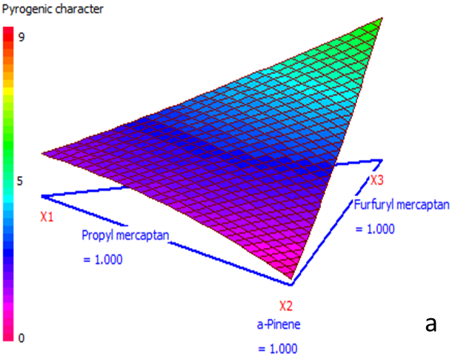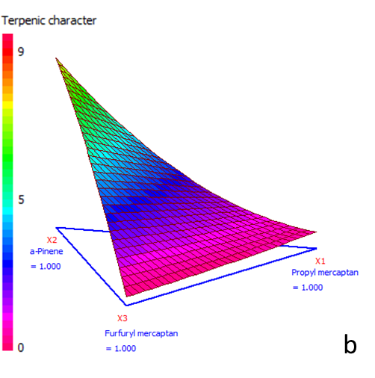
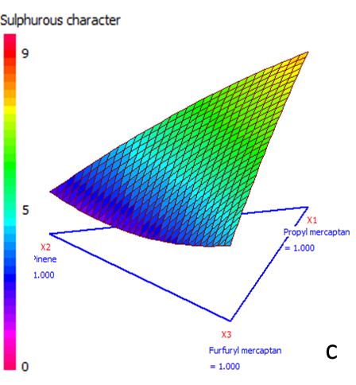
Figure 3: 3D representations of the evolution of the odorous character with the mixture composition (a) pyrogenic character, (b) terpenic and (c) sulphurous. The ternary plot constitutes the x-y plane. The z-axis refers to the evolution of the odour character from 0 to 9. The axe is coloured to facilitate the value assessment i.e. cyan coloured areas refer to an odour score of ~4.5.

As seen in Figure 3c, the odour score of the sulphurous character tends to be 5-6 over 9 when the composition is 40% propyl mercaptan and 60% α-pinene or 20% propyl mercaptan and 80% furfuryl mercaptan, so relatively lesser propyl mercaptan in the mixture than other odorants. This shows a dominance of the sulphurous character over pyrogenic and terpenic characters.
    - Models validation
The validation was made using the test mixtures. These mixtures are represented with green dots in Figure 2 that were not used for models construction. The validation was done by comparing experimental results from the sensory analyses to the theoretical results from the model equations. The comparison was made using a t-test with α=0.05.
Table 4: Theoretical (rounded numbers) and experimental results of each of the three characters for each test mixture.
 | Theoretical results |  |  | Experimental results
Tests | Pyrogenic | Terpenic | Sulphurous | Pyrogenic | Terpenic | Sulphurous
Test 1 | 2 | 1.2 | 5.8 | 2.1 | 0.9 | 5.7
Test 2 | 1.5 | 5 | 2.5 | 1.3 | 3 | 4
Test 3 | 4 | 1.6 | 3.4 | 3.7 | 1.3 | 3.8
The risk to reject the hypothesis that the difference between the means is 0, is 63.1 % for the sulphurous model, 55 % for the terpenic model and 90.42 % for the pyrogenic model. This shows that there is no significant difference between theoretical and experimental results in sulphurous and pyrogenic models. The differences found in the terpenic model may be explained by the presence of a phenolic odour (as explained in part 3.2). Being only smelled in bags containing pinene, the phenolic odour appears to be a result of the synergy between this odour and the pinene odour i.e. the intensity of the phenolic odour is amplified by the presence of pinene. Thus, they might interfere with the terpenic character as seen for example in test 2, where the odour of the mixture must have a terpenic OS of 5 (Table 1), but instead, it was 3 while it had an OS=0.7 for the phenolic character (Table 3). As a result, this interference might have lowered the OS of the terpenic character and biased these specific results.
  - Conclusion
The effect of mixtures on odorous emissions still poses a problem when assessing odour nuisance by masking the odour source. To answer this question, this study aimed to develop an approach to model the variation of the odour nature of a mixture of odorants using an objective odour description method, the Langage des Nez®. The experimental mixture design allowed modelling the variation of the overall odour nature of a mixture of three components when varying their odour activity values.
This method forms the cornerstone of understanding the different sensory interactions that take place between odorants in a mixture. Indeed, only three odorants were studied, but the approach might be applied with other odorants. Thus, odour modelling helps to unmask how different emissions from industries in industrial cities affect and contribute to the overall odour smelled by the population. This might allow unravelling the exact odour sources in order to treat them and reducing the odour nuisance in the future.
Acknowledgments
This study has been supported by Communauté Urbaine Le Havre Seine Métropole and by Atmo Normandie. The authors sincerely thank financers and the assessors for their contributions.
References
Baccino, T., Cabrol-Bass, D., Candau, J., Meyer, C., Scheer, T., Vuillaume, M., Wathelet, O., 2010. Sharing an olfactory experience: The impact of oral communication. Food Quality and Preference 21, 443–452. https://doi.org/10.1016/j.foodqual.2009.11.001.
Blanes-Vidal, V., Suh, H., Nadimi, E.S., Løfstrøm, P., Ellermann, T., Andersen, H.V., Schwartz, J., 2012. Residential exposure to outdoor air pollution from livestock operations and perceived annoyance among citizens. Environment International 40, 44–50. https://doi.org/10.1016/j.envint.2011.11.010.
Capo, S., Leger, C., 2017. The first French companies’noses network. The noses of the Estuary – Companies from Le Havre. Presented at the Atmo’sFair, Lyon, France.
Cariou, S., Chaignaud, M., Montreer, P., Fages, M., Fanlo, J.-L., 2016. Odour concentration prediction by gas chromatography and mass spectrometry (gc-ms): importance of vocs quantification and odour threshold accuracy. Chemical Engineering Transactions 67–72. https://doi.org/10.3303/CET1654012.
Deshmukh, S., Jana, A., Bhattacharyya, N., Bandyopadhyay, R., Pandey, R.A., 2014. Quantitative determination of pulp and paper industry emissions and associated odor intensity in methyl mercaptan equivalent using electronic nose. Atmospheric Environment 82, 401–409. https://doi.org/10.1016/j.atmosenv.2013.10.041.
EN13725, 2003. EN13725, Air quality—Determination of odour concentration by dynamic olfactometry.
Ferreira, V., 2012a. Revisiting psychophysical work on the quantitative and qualitative odour properties of simple odour mixtures: a flavour chemistry view. Part 1: intensity and detectability. A review.: Intensity and detectability of odor mixtures. Flavour and Fragrance Journal 27, 124–140. https://doi.org/10.1002/ffj.2090.
Ferreira, V., 2012b. Revisiting psychophysical work on the quantitative and qualitative odour properties of simple odour mixtures: a flavour chemistry view. Part 2: qualitative aspects. A review.: Qualitative odour properties of odour mixtures. Flavour and Fragrance Journal 27, 201–215. https://doi.org/10.1002/ffj.2091.
Jaubert, J.-N., Tapiero, C., Dore, J.-C., 1995. The field of odors: toward a universal language for odor relationships. Perfumer & flavorist 20, 1–16.
Muñoz, R., Sivret, E.C., Parcsi, G., Lebrero, R., Wang, X., Suffet, I.H. (Mel), Stuetz, R.M., 2010. Monitoring techniques for odour abatement assessment. Water Research 44, 5129–5149. https://doi.org/10.1016/j.watres.2010.06.013.
Nagata, Y., 2003. Measurement of odor threshold by triangle odor bag method. Odor measurement review 118, 118–127.
Nicell, J.A., 2009. Assessment and regulation of odour impacts. Atmospheric Environment 43, 196–206. https://doi.org/10.1016/j.atmosenv.2008.09.033.
Rowe, D., 2000. More Fizz for Your Buck: High-impact Aroma Chemicals. Perfumer & Flavorist 25, 1–19.
Ueno, H., Amano, S., Merecka, B., Kośmider, J., 2009. Difference in the odor concentrations measured by the triangle odor bag method and dynamic olfactometry. Water Science and Technology 59, 1339–1342. https://doi.org/10.2166/wst.2009.112.

