 CHEMICAL ENGINEERING TRANSACTIONS  VOL. 82, 2020 | A publication of  
The Italian Association
of Chemical Engineering
Online at www.cetjournal.it
Guest Editors: Selena Sironi, Laura Capelli
Copyright © 2020, AIDIC Servizi S.r.l.
ISBN 978-88-95608-80-8; ISSN 2283-9216

Identification of VOCs responsible of odour during field retting of hemp stems
Stephane Cariouª, Brahim Mazian^{a,b}, Jean-Louis Fanlo^{a,c}, Mathilde Chaignaud^{c}, Anne Bergeret^{c}, Luc Malhautierª
ª IMT mines Alès, Laboratoire Génie de l’Environnement Industriel, 6 avenue de Clavières, F-30319 Ales Cedex, France
^{b} IMT mines Alès, Centre des matériaux des Mines d’Alès, 6 avenue de Clavières, F-30319 Ales Cedex, France
^{c} Olentica sas ,14 boulevard Charles Peguy, 30100 Alès
stephane.cariou@mines-ales.fr

Incorporation of natural fibres into polymers to strengthen them is a means of limiting the environmental impact of these materials. However, the quality of the fibres is essential for them to fulfil their assigned role. The recovery of fibres from hemp stems requires a retting stage. Retting is a bioprocess applied to the plant stems to easily draw fibers from the central woody part. Nowadays, this process is made directly on field in an empirically way due to its dependence on environmental conditions which could cause problems of the inconsistency of the hemp fibres quality.
During the few weeks of retting, odours are generated by the degradation of plant material by microorganisms. The modification of these odours can be correlated with the progress of the retting of hemp stems. This change in odour is obviously combined with a change in the type and quantity of VOCs emitted. Identifying odours and VOCs emitted when the retting is optimal can lead to make sensors able to survey the progress of the biological process. Then, if this process is well controlled, much higher quality with more uniform fibres could be produced.
This article will focus on the identification of the odour emitted when the optimal retting of the stems is reached as well as the identification of the VOCs analyzed at this stage.
  - Introduction
The increasing depletion of fossil energy resources is forcing people to define alternative strategies to limit the use of these non-renewable resources by promoting the development of renewable resources while ensuring the protection of the environment. Hemp fibres have specific mechanical properties (ratio between the mechanical property considered and the density (Aziz & Ansell, 2004)) identical to those of glass fibres commonly used for the reinforcement of composite materials (Joshi et al., 2004). Hemp fibres are obtained through various transformations. The retting process is the first step in the treatment of plant stems facilitating the extraction of lignocellulosic fibres. This process consists in the degradation of natural cements (pectic and woody) which constitute the gummy resinous material in which the fibre bundles of textile plants are contained (Pakarinen et al., 2012). The quality of the fibres obtained depends on this stage (Mazian et al., 2018).
Many VOCs compounds are naturally emitted by the hemp plant (Cannabis sativa L) (Turner et al. 1980; El Sohly and Slade 2005) as terpenes, alcohols, aldehydes. Depending on the plant hemp situation during growth and retting, emitted VOCs would differ. Some of them are odorous; therefore the resulting odour must be different as well. Thus, following these gaseous emissions and odours would give some data about the retting-level progress.
Historically, to identify molecules at the origin of odours, only a physico-chemical analysis was carried out coupled with an expertise on the potentiality of molecules to generate an odour. Then, the approach by calculation of odour activities has been developed (Anet et al., 2013; Kamarulzaman et al., 2019; Parker et al., 2013; Sivret et al., 2016). However, due to certain biases (precision of physico-chemical quantification, unavailability of perception thresholds, and uncertainty of existing data) (Cariou et al., 2016), the identification of the molecules causing odours was still incomplete. To remedy this shortcoming, this paper proposes to complete the odour activity value approach by a search for a relationship between the different odour notes perceived by the evaluators and the individual odour qualities of the molecules identified previously.
  - Materials and methods
    - Hemp cultivation and sampling
Hemp plants (cannabis sativa L., Cultivar ‘Santhica 27’) were cultivated in south of France near Alès and harvested at the seed maturity. The retting of plants was conducted on the field for nine weeks. Regularly hemp stems were collected (each week until week 7 and then two weeks later at the end of the retting period). At each sampling time, 100g of stems was introduced in a Nalophan© bags. This bag was then filled with 40L of dry compressed air and let in a room with stable thermal conditions until stabilization.

    - Physico-chemical and olfactometric analyses
Physico-chemical analyses by thermal desorption-gas chromatography-mass spectrometry and odour concentration analyses were conducted according the protocol described in Mazian et al. (2019). The best possible quantification is realized for each compound: if the compound was used as standard the real concentration is calculated if not the mean of standard for each family is used to quantify the compound.
Odour concentration is measured according the EN 13725 (2003).
Odour quality is evaluated according a non-oriented method developed by Olentica and LGEI and presented in Medjkoune (2018).
    - Determination of VOCs responsible of odours

VOCs responsible of odour during the retting process are identified by calculating odour activity values (OAV) for all the identified compounds (Cariou et al., 2016).
$${OAV}_{i}=\frac{C_{i}}{{ODT}_{i}}$$
${OAV}_{i}$ : Odor Activity Value of compound i (dimensionless)
$C_{i}$ : Chemical concentration of compound i (mg.m⁻³)
${ODT}_{i}$ : Odor Detection Threshold of compound i (mg.m⁻³)

Odour detection thresholds (ODT) are not available for all compounds. So, if the ODT was measured in the lab, the value is used to calculate OAV. If an individual ODT is referenced in the literature ((Van Gemert, 2011), the geometric mean of all values for the compound is used and if no ODT is available, the geometric mean of all ODT of the compound chemical family is used to estimate an individual ODT.
Then, the sum of all the odour activity values is compared with odour concentration. If the two values are in the same order of magnitude, all the molecules responsible of odours are considered in our opinion. To confirm this hypothesis, the odour quality obtained with our method is compared with individual quality of identified molecules. If all the olfactory notes are recovered by the individual odour qualities of the different molecules identified then the method is considered valid. If not, odour quality of molecules with an OAV<1 is checked.
  - Results
    - Odour concentration versus sum of odour activity value
Table 1 displays the comparison between the sum of OAV and odour concentration measured by olfactometry according the EN13725 standard.
Table 1: evolution of calculated OAV sum and measured odour concentration
 | W0 | W1 | W2 | W3 | W4 | W6 | W9
OAV Sum | 2201 | 1724 | 726 | 426 | 120 | 170 | 124
Odour concentration (UO_{E}/m³) | 1467 | 770 | 358 | 564 | 253 | 396 | 86

As a first approach, the OAV sum is in the same order of magnitude that the odour concentration measured. Moreover, a correlation factor of 0.91 is obtained between the two data sets. So, it can be concluded that all major molecules responsible of odour are identified by our approach.
Considering the evolution of odour concentration over the nine-weeks retting period, a clear decrease can be observed. Indeed, the odour concentration is around 1500 UO_{E}/m³ at the beginning of the retting process and then falls by a factor 5 and stabilizes from week 4.

    - Evolution of individual odour activity value
Table 2 shows the evolution of odour activity value for all the molecules with an OAV upper than 1 on the nine weeks of retting.
Table 2: Evolution of calculated OAV sum and measured odour concentration
CAS | Nom | W0 | W1 | W2 | W3 | W4 | W6 | W9
431-03-8 | 2,3-butanedione | 998 | 1054 | 480 | 272 | 86 | 140 | 99
470-82-6 | eucalyptol | 468 | 84 | 74 | 33 | 10 | 8 | 4
80-56-8 | alpha-pinene | 273 | 40 | 32 | 16 | 6 | 11 | 14
590-86-3 | 3-methylbutanal | 152 | 325 | 78 | 77 | 8 | 1 | 2
66-25-1 | hexanal | 81 | 43 | 17 | 9 | 5 | 6 | 1
96-17-3 | 2-methylbutanal | 80 | 122 | 23 | 8 | 1 | 0 | 0
75-18-3 | dimethylsulfide | 49 | 12 | 0 | 0 | 0 | 0 | 0
75-07-0 | acetaldehyde | 43 | 5 | 4 | 1 | 1 | 1 | 0
79-31-2 | 2-methylpropanoïc acid | 18 | 13 | 10 | 4 | 4 | 3 | 2
64-17-5 | ethanol | 13 | 4 | 1 | 1 | 0 | 0 | 1
78-84-2 | 2-methylpropanal | 12 | 12 | 3 | 2 | 0 | 0 | 0
110-62-3 | pentanal | 3 | 1 | 0 | 0 | 0 | 0 | 0
123-38-6 | propanal | 2 | 2 | 2 | 0 | 0 | 0 | 0
26882-03-1 | α-Campholenal | 2 | 0 | 0 | 0 | 0 | 0 | 0
123-51-3 | 3-methyl-1-butanol | 1 | 0 | 0 | 0 | 0 | 0 | 0

At the seed maturity of hemp and at the beginning of the retting process (W0), TD-GC-MS analysis leads to identify 69 VOCs belonging to eleven different chemical families more or less odorous as presented in (Mazian et al., 2019).
When calculating OAV, only fifteen VOCs seem to have an impact on odour (Table 2). First, 2,3-butanedione, eucalyptol and alpha-pinene represent almost 80% of OAV sum at the beginning of the retting process (W0). Then, 2,3-butanedione is the biggest contributor to the OAV sum during the nine weeks of the process but an increase of the percentage of 3-methyl butanal and 2-methyl butanal instead of eucalyptol and alpha-pinene modify the odour quality from week one to week three.
At week four, six and nine, the molecules responsible of odour are at very low level and stable and should generate a stable odour quality.

    - Evolution of odour quality
Figure 1 shows the evolution of odour quality description from the beginning to the end of the hemp retting process.

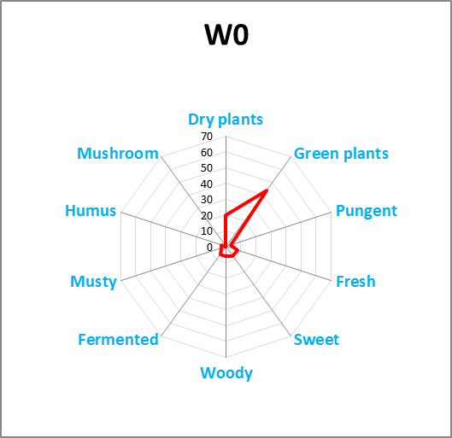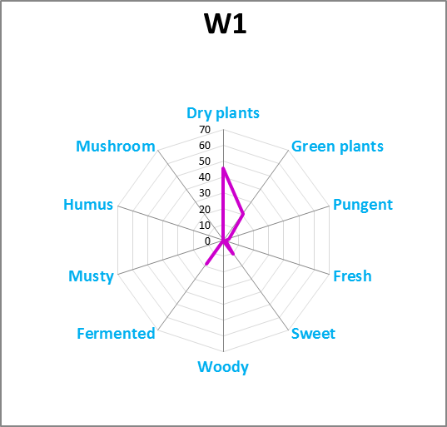
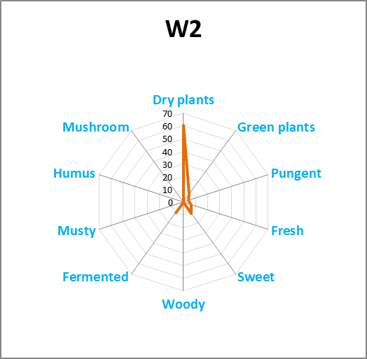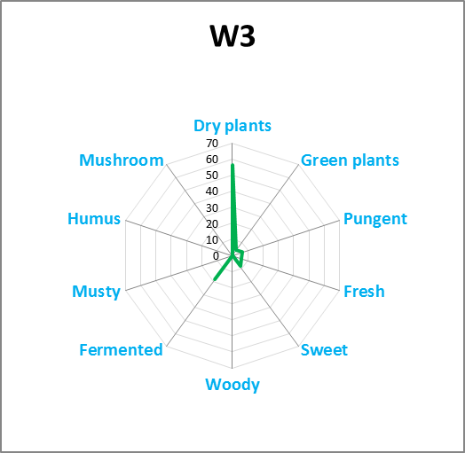
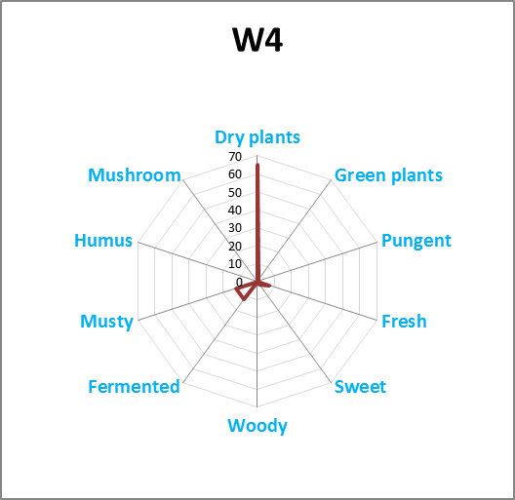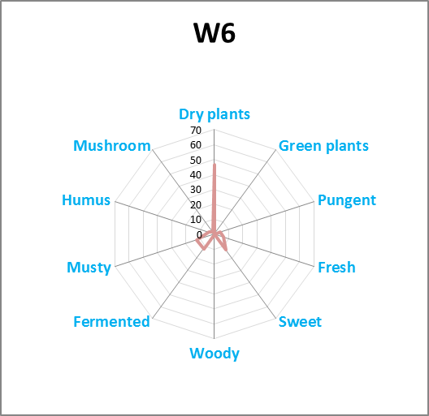
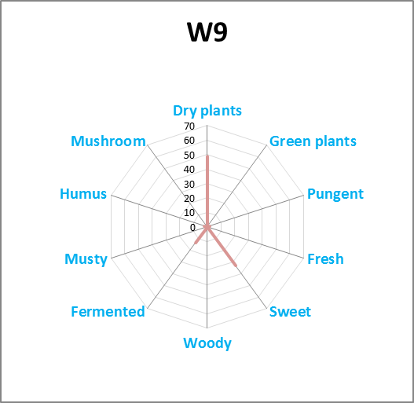

On the day of the harvest (W0), the odour is described with a predominantly green vegetal note and a secondary note of dry plant. It is to be noted the presence of a sweet note for all samples but at a very low level.
As the retting process progresses, the green plant notes disappear and the smell of dried plant becomes predominant. A note of fermentation also appears during the following weeks.
At week 9 it is important to note that the sweet note becomes the second most intense note.
All the other minor notes (pungent, fresh, woody, musty, humus and mushroom) appear only once or twice in the descriptor of the evaluators.
  - Discussion
The most important olfactory notes to explain are therefore those of green plant, dried plants, fermentation and sweetness. A database (The good scents company) is used to identify the odour quality associated with each molecule.
When looking at the molecules identified with the OAV calculation (table 2), many of them are described in the literature by a green note. In our case, eucalyptol, alpha-pinene and hexanal can explained the odour perceived by the evaluators. This note, well perceived at week 0 is correlated with the importance of OAV for these molecules. Until week 2, their OAV decreased and the evaluators described this note less and less.
The presence of 3-methyl butanal, 2-methyl butanal, hexanal and pentanal is responsible of the fermentation note. These compounds have a real impact on odours perceived at week 1, 2 and 3.
The sweet note can only be explained by the presence of 2,3-butanedione in the gaseous emissions of the retting process. This molecule is present all along the process with an impact that increases with the disappearance of other important molecules.
Other minor notes can also be explained by the presence of identified molecules
- Pungent: acetaldehyde, 2-methylpropanoic acid, 2-methyl propanal
- Musty: 2-methyl butanal, propanal
- Woody : propanal
But a major note, the dry vegetal one, is not correlated with any molecule with an OAV upper than 1 (table 2). If we considered the other molecules identified but without an OAV upper than 1, Beta-pinene is described in literature with an odour of hay in some case, so it might explain the dry vegetal note identified by jury members. In our analyses, beta-pinene never appears with an OAV upper than one; a bad quantification due to a calibration not made with this molecule or the use of a wrong odour detection threshold may lead to a misidentification of VOCs responsible of odour. The approach conducts in this paper add a new validation of VOCs identification with a first step with the OAV calculation and a confirmation with the search for correlation between the olfactory notes and the identified molecules.
  - Conclusions
Odours generate by retting evolve regularly during the nine weeks studied both in terms of concentration and quality. From green vegetal, the dominant note at the beginning, the odour evolves towards a note of dried vegetal with minor notes of fermentation and sweetness. This evolution is correlated with the modification of the gaseous emissions. From a majority of terpenes, the VOCs emitted evolve to aldehydes and alcohols. This modification is the result of biodegradation of hemp stems.
The approach developed in this paper brings an additional brick in the methods of identification of VOCs at the cause of odours. Some points still need to be improved; for example, quantification in physico-chemical analyses and odour detection threshold accuracy are important to obtain the more accurate OAV and finally the most detailed identification.
In addition, the database of molecule odour qualities found in the literature is very incomplete. Indeed, besides the missing data, the quality of an odour is dependent on its concentration, which the available data do not provide, leading to difficult interpretations.

References
Anet, B., Lemasle, M., Couriol, C., Lendormi, T., Amrane, A., Le Cloirec, P., Cogny, G., & Fillières, R. (2013). Characterization of gaseous odorous emissions from a rendering plant by GC/MS and treatment by biofiltration. Journal of Environmental Management, 128, 981‑987. https://doi.org/10.1016/j.jenvman.2013.06.028
Aziz, S. H., & Ansell, M. P. (2004). The effect of alkalization and fibre alignment on the mechanical and thermal properties of kenaf and hemp bast fibre composites : Part 1 – polyester resin matrix. Composites Science and Technology, 64(9), 1219‑1230. https://doi.org/10.1016/j.compscitech.2003.10.001
Cariou, S., Chaignaud, M., Montreer, P., Fages, M., & Fanlo, J.-L. (2016). Odor concentration prediction by gas chromatography and mass spectrometry (GC-MS) : Importance of VOCs quantification and odor detection threshold accuracy. Chemical Engineering Transactions, 54, 67‑72. https://doi.org/10.3303/CET1654012
EN 13725, Air Quality – Determination of odor concentration by dynamic olfactometry, AFNOR, 2003.
Joshi, S. V., Drzal, L. T., Mohanty, A. K., & Arora, S. (2004). Are natural fiber composites environmentally superior to glass fiber reinforced composites? Composites Part A: Applied Science and Manufacturing, 35(3), 371‑376. https://doi.org/10.1016/j.compositesa.2003.09.016
Kamarulzaman, N. H., Le-Minh, N., Fisher, R. M., & Stuetz, R. M. (2019). Quantification of VOCs and the development of odour wheels for rubber processing. Science of The Total Environment, 657, 154‑168. https://doi.org/10.1016/j.scitotenv.2018.11.451
Mazian, B., Bergeret, A., Benezet, J. C., & Malhautier, L. (2018). Influence of field retting duration on the biochemical, microstructural, thermal and mechanical properties of hemp fibres harvested at the beginning of flowering. Industrial Crops and Products, 116(November 2017), 170‑181. https://doi.org/10.1016/j.indcrop.2018.02.062
Mazian, B., Cariou, S., Chaignaud, M., Fanlo, J.-L., Fauconnier, M.-L., Bergeret, A., & Malhautier, L. (2019). Evolution of temporal dynamic of volatile organic compounds (VOCs) and odors of hemp stem during field retting. Planta, 250(6), 1983‑1996. https://doi.org/10.1007/s00425-019-03280-6
Medjkoune, M. (2018). Vers une approche non orientée pour l’évaluation de la qualité des odeurs [Phdthesis, Université Montpellier]. https://tel.archives-ouvertes.fr/tel-01866751
Pakarinen, A., Zhang, J., Brock, T., Maijala, P., & Viikari, L. (2012). Enzymatic accessibility of fiber hemp is enhanced by enzymatic or chemical removal of pectin. Bioresource Technology, 107, 275‑281. https://doi.org/10.1016/j.biortech.2011.12.101
Parker, D. B., Gilley, J., Woodbury, B., Kim, K. H., Galvin, G., Bartelt-Hunt, S. L., Li, X., & Snow, D. D. (2013). Odorous VOC emission following land application of swine manure slurry. Atmospheric Environment, 66, 91‑100. https://doi.org/10.1016/j.atmosenv.2012.01.001
Sivret, E. C., Wang, B., Parcsi, G., & Stuetz, R. M. (2016). Prioritisation of odorants emitted from sewers using odour activity values. Water Research, 88, 308‑321. https://doi.org/10.1016/j.watres.2015.10.020
The Good Scents Company. (2020). The Good Scents Company. http://www.thegoodscentscompany.com/. Accessed on 04/15/2020
Van Gemert, L. J. (2011). Odour thresholds. Compilations of odour threshold values in air, water and other media (second enlarged and revised edition). Oliemans Punter & Partners BV PO Box 14167 3508 SG Utrecht The Netherlands www.opp.nl.

