CHEMICAL ENGINEERING TRANSACTIONS  VOL. 85, 2021 | A publication of
The Italian Association
of Chemical Engineering
Online at www.cetjournal.it
Guest Editors: Selena Sironi, Laura Capelli
Copyright © 2021, AIDIC Servizi S.r.l.
ISBN 978-88-95608-83-9; ISSN 2283-9216

CFD modelling of odour-causing impact on vicinity of a waste water treatment plant
Aina M. Martinez^{a,}*, Jose V. Herrera^{b}, Javier Climent^{b}, Caros Domínguez^{b}, Jose María Santos^{b}, Sergio C. Vicentª
ªUniversitat Jaume I, Departament of Mechanical Engineering and Construction, Avda. Vicent Soso Baynat, s/n, 12071 Castellón de la Plana, Castellón, Spain
^{b} EPSAR, C/ Álvaro Bazán nº 10 Entlo., 46.010 Valencia. Spain
amacias@uji.es eteorological Model, Version 5, Earth Tech Inc., Concord, Massachussets, USA

Due to the fast growth of cities and populations, residential areas are increasingly close to Waste Water Treatment Plants (WWTPs), causing odour impact on neighbourhood and complaints. The present study focuses on assessing the impact on the residential vicinity of a WWTP in Valencia (Spain) of different superficial odour sources using Computational Fluid Dynamics (CFD) simulations. Together with other software, CFD simulation is used as a complementary study to model pollutant dispersion. Unlike other simulation tools, CFD is bounded to smaller domains (1 or 2km). However, it performs more meaningful calculations and provides more detailed results, which allow obtaining resolutions at a scale below centimetre. The precise mesh generated in this work facilitates the study of the effect of the turbulence and the eddies caused by different obstacles (buildings, walls, etc.).

  - Introduction
The perception of odours to the receivers can change from one individual to another by different causes such as meteorological factors, environmental surroundings, and the proximity to the emission source, not being directly related to the concentration of the odoriferous compounds. Generally, the impacts of odours arise from a variety of interacting factors as intensity, frequency, duration, offensiveness, and location (Nicell, 2009).

Complex odours emissions arise from several points at wastewater treatment facilities causing impacts to the quality of life of the surrounding community, by generating nuisance and discomfort. For this reason, many efforts have been implemented to develop techniques to measured odours just like to prevent and mitigate their impact.

In general, the model that is most commonly used for odour dispersion modelling purposes is CALPUFF that is a non-steady-state Lagrangian Gaussian puff model containing different modules for complex terrain effects and simple chemical transformations, among others (Scire et al., 2000). Limited to conditions of low turbulence, these models are not suited for the simulation of the micro-scale dispersion.
CFD modelling has been widely used for studying pollutant dispersion around buildings in urban environments (Blocken, 2014). Such models are used for extremely time and spatially detailed simulations, considering the presence of obstacles explicitly in the model, and are currently applied also to odour dispersion modelling (Capelli et al., 2013).
  - Description of the Study Area
The case study is conducted in a WWTP in Valencia with a 1.500.000 population equivalent. Figure 1 shows the treatment plant area (yellow line), the contiguous residential zone (red line), and the industrial park (green line). It is observed the number of treatment units, many of them directly exposed to the ambient atmosphere.

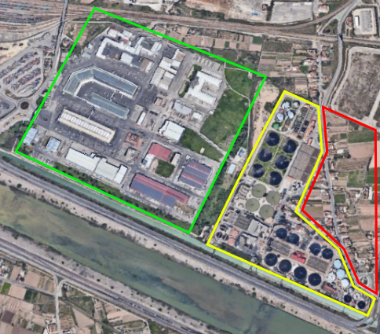
Figure 1: Case study area and surroundings

Table 1 shows the results of a previous monitoring campaign in terms of emission odour concentration of sources, expressed in normalized odour units.

Table 1: Monitoring campaign results.
 | WWTP I | WWTP II
Treatment | Normalized Odour Concentration (%) | Normalized Odour Concentration (%)
Primary Sedimentation | 3.07 | 1.22
Secondary Clarifier | 0.33 | 0.28
Tank to remove sand | 2.30 | 4.88
Filter sieve | 2.44 | -
Flotation | 1.30 | 3.63
Thickener | 0.58 | 2.05
Digester | 18.42 | 9.32
Screen | 2.44 | -
Discharge channel overflow | 14.20 | 5.64
Biological Reactor | 0.46 | 0.40
Screen and grille | - | 13.48
Sand filter | - | 0.42
Sludge Buffer | - | 4.56
Lamella settler | - | 0.55
Coagulation-flocculation | - | 0.70

  - CFD simulations
    - Computation geometry, domain and grid
The computational geometry is composed of the three areas showed in Figure 1. Due to the number and variety of building dimensions of the case study area, the elaboration of the computational geometry results in a laborious and complex task; for this reason, all the buildings are generated from the data provided by the cadastre. The 3D CAD result is showed in Figure 2.

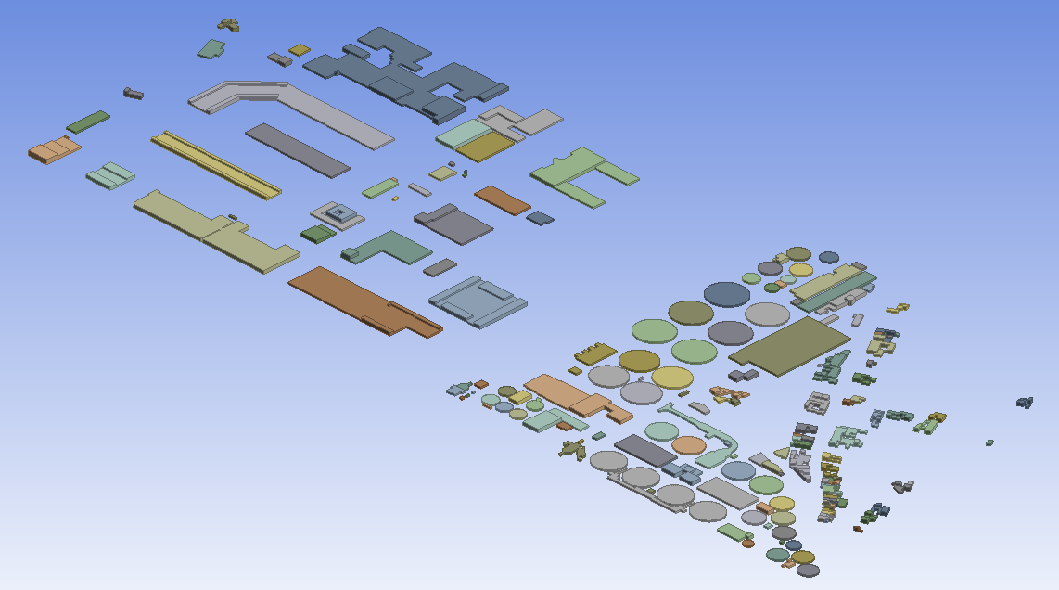
Figure 2: Study area model (CAD data).

The dimensions of the computational domain are chosen according to the AIJ guidelines proposed by Tominaga et al. (2008). Therefore, simulation is performed in a 1,910 m (L) x 1,568 m (W) x 123 m (H) domain. The computational domain is divided into three different grid distribution with different grid resolutions (coarse, basic, and fine grid) (Figure 3). Region 1 contains the WWTP and the vicinity urban area. It has a fine grid with a minimum grid interval of 0.02 m near the ground (Figure 4). The whole computational domain is divided into 2,900,000.

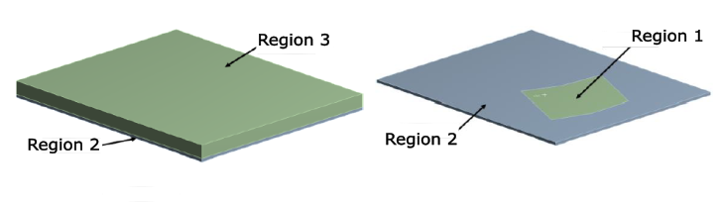
Figure 3: Domain regions with different grid resolutions.

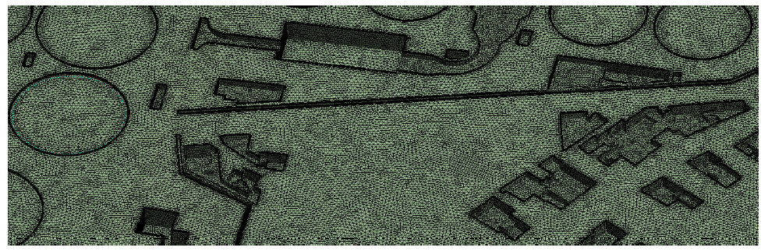
Figure 4: Computational grid for Region 1.

    - Boundary conditions
At the inlet of the computational domain, the mean wind speed profile is prescribed by the logarithmic law with the aerodynamic roughness length z₀=0.2 m according to the updated Daveport roughness classification (Wieringa, 1992). The predominant wind direction and velocity wind are selected from the wind rose (Figure 5a). At the outlet, zero static pressure is imposed. At the sides and the top of the domain, symmetry boundary conditions are imposed. The no-slip conditions are imposed on the buildings and the ground. Constant odour emission values are imposed in each odour source of the WWTP (Table 1).

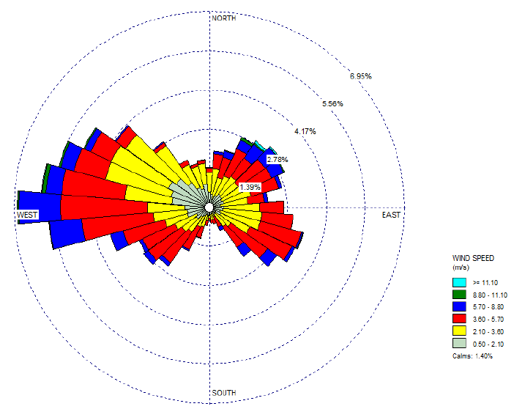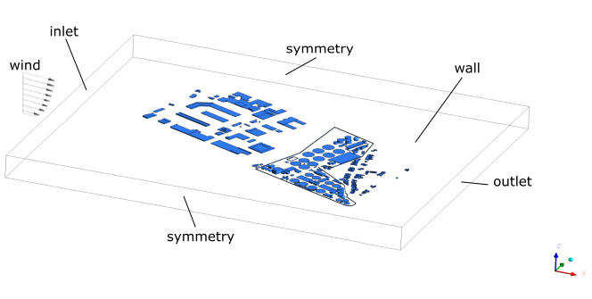
Figure 5a: Wind rose at the study area. Figure 5b: Computational domain with boundary conditions.

    - Computational settings
The CFD simulations are performed for neutral atmospheric boundary layers and isothermal conditions using the commercial software ANSYS CFX based on the finite volume method. The 3D steady RANS equations are solved in combination with the standard k-ԑ model (Jones and Launder,1972) for closure for incompressible turbulent flow. The time-step value is 0.4 s, which corresponds to a total simulation time of 4,200 s. The residual controls for convergence criteria are set to 1 x 10⁻⁶ for all variables.

  - Results and Discussion
Due to the difficulty to establish a correlation between the odour concentrations and human olfactory sensibility, the emissions of each source have proportionally normalized to their odour concentration emission (OU_{E}/m³) so they can be expressed in a sensory scale (Figure 6).

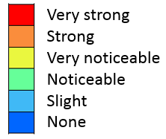
Figure 6: Sensory scale used in the CFD analysis.

It is noticed odour emissions are essentially caused by primary sedimentation, thickeners, and digesters (Figure 7). The wall around the treatment plant causes an important effect on odour dispersion in the contiguous residential zone, especially in those emission sources are situated at a lower height.
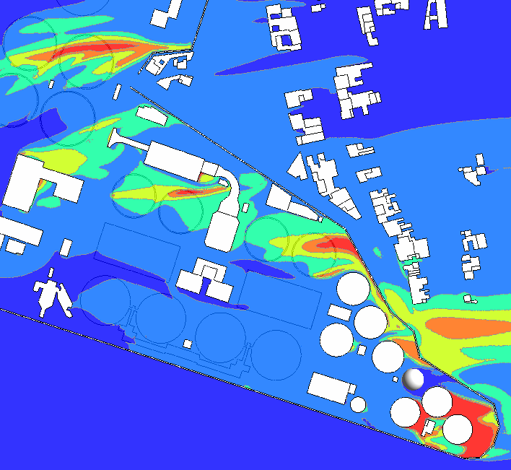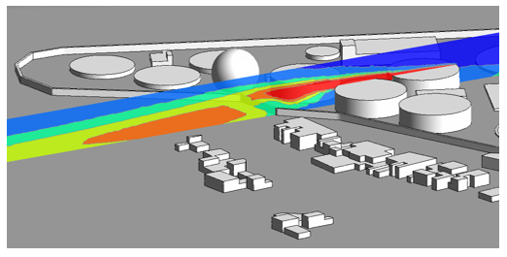
Figure 7: Distribution of normalized odour concentration.

The precise grid generated in Region 1 (Figure 4) provides a large amount of aerodynamic information. Figure 8 shows how the turbulence model successfully contributes to the reproduction of flow patterns behind the surrounding buildings. The odour concentration can increases in the wakes of the buildings due to the velocity gradients ad eddies.

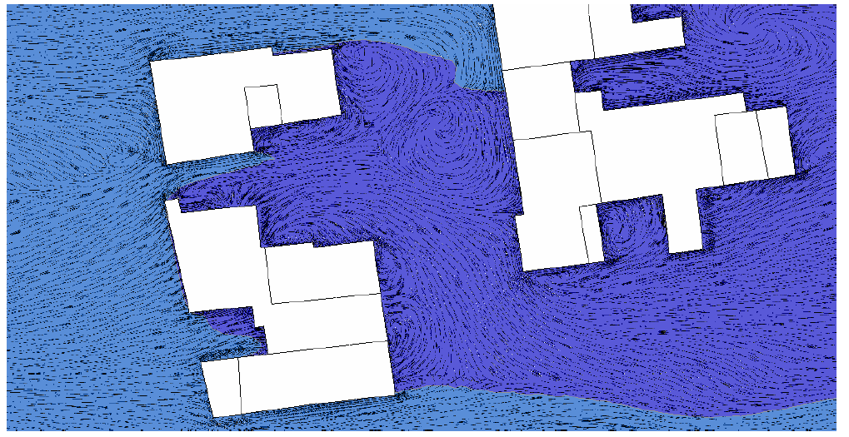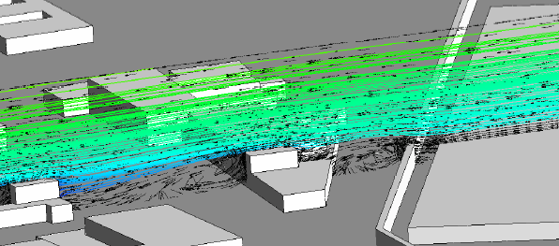
Figure 8: Vortex behind buildings.

  - Conclusions
In this work, CFD simulations of near-field odour dispersion causing an impact on the vicinity of a WWTP are predicted. After the analysis of the simulations carried out, the following remarks can be drawn:

- CFD simulation facilitates the study of the effect of the turbulence and eddies caused by different obstacles (houses, walls, etc.). It is presented as a very powerful complement to other simulation tools like CALPUFF.
- After analyzing the shadow effects produced both by the buildings themselves and by the perimeter wall, it can be concluded that a good design of this wall can help keep high concentrations of odour from the population away. Therefore, designing a wall so that it is above the emission sources would reduce the impact produced on the population when the wind blows in certain directions.

References
Blocken, B., 2014, 50 years of Computational wind engineering: past, present and future, J. Wind Eng. Indus. Aerodynamics 129, 69-102.
Capelli, L., Sironi, S., Rosso, R., Guillot, J. 2013, Measuring odours in the environment vs. dispersion modelling: A review, Atmospheric Environment, 79, pp. 731-743.
Jones, W.P., Launder, B.E., 1972, The prediction of laminarization with a two-equation model of turbulence, International Journal of Heat and Mass Transfer 15, 301-314.
Nicell, J. 2009, Assessment and regulation of odour impacts, Atmospheric Environment, 43, pp.196-206.Launder, B.E., Spalding, D.B., 1972, Mathematical Models of Turbulence, Academic Press, New York.
Scire J.S., Robe F.R., Fernau M.E., Yamartino R.J., 2000, A User’s Guide for the CALMET Meteorological Model, Version 5, Earth Tech Inc., Concord, Massachussets, USA.
Tominaga, Y., Mochida, A., Yoshie, R., Kataoka, H., Nozu, T., Yoshikawa, M., et al. (2008), AIJ guidelines for practical applications of CFD to pedestrian wind environment around buildings, Journal of Wind Engineering and Industrial Aerodynamics, 96(10–11), 1749–1761.
Wieringa, J., 1992, Updating the Davenport roughness classification, J. Wind Eng. Ind. Aerodyn, 44, 357–368.

