 CHEMICAL ENGINEERING TRANSACTIONS  VOL. , 2025 | A publication of  
The Italian Association
of Chemical Engineering
Online at www.cetjournal.it

Guest Editors:
Copyright © 2025, AIDIC Servizi S.r.l.
ISBN 979-12-81206-XX-X; ISSN 2283-9216
Changing the Electrical Conductivity of PEDOT:PSS Films via Hybrid Doping with Inorganic and Organic Semiconductors
M. Recupero^{a,*}, L. De Guglielmo^{b}, V. Vaiano^{c}, V.Venditto^{d}, O.Sacco^{d}
ª Department of Information and Electrical Engineering and Applied Mathematics, University of Salerno, Via Giovanni Paolo II 132, 84084 Fisciano, Italy
^{b} EXELING SRL, Contrada S.Tommaso 18/F, 83100 Avellino, Italy
^{c} Department of Industrial Engineering, University of Salerno, Via Giovanni Paolo II 132, 84084 Fisciano, Italy
^{d} Department of Chemistry and Biology “A. Zambelli”, University of Salerno, via Giovanni Paolo II, 132, 84084, Fisciano, SA, Italy
* mrecupero@unisa.it

In the search for sustainable alternatives to conventional transparent electrodes, PEDOT:PSS stands out for its transparency, aqueous processability, and flexibility. However, its low conductivity in the pristine state, mainly due to the insulating PSS component, limits its application. In this work, two separate doping approaches were investigated: the first involved the addition of an inorganic semiconductor (TiO₂ nanoparticles) to the PEDOT:PSS dispersion, while the second consisted of blending PEDOT:PSS with the organic semiconductor poly(N-vinylcarbazole) (PVK). The hybrid films were obtained through spin coating and then annealed to enhance their morphological uniformity.
A custom-built four-point probe system was developed to perform accurate electrical characterization of the hybrid films.
Experimental results show an increase in sheet resistance upon doping. This effect is ascribed not only to morphological disorder and limited percolation pathways, but also to the absence of photoexcitation in the dopant semiconductors under dark conditions, which prevents their contribution to charge transport.

  - Introduction
Conductive polymers have revolutionized flexible electronics, enabling solution-processable optoelectronic devices such as organic photovoltaics (OPVs), light-emitting diodes (OLEDs), and biosensors. Their widespread adoption is largely attributed to their low weight, facile processability, and excellent mechanical flexibility (Nowsherwan et al., 2024).
Among these, poly(3,4-ethylenedioxythiophene):poly(styrenesulfonate) (PEDOT:PSS) dominates as a benchmark material due to its unique combination of optical transparency (>90% in thin films), mechanical flexibility(Shankar et al., 2022), and tunable conductivity (10⁻⁵ to 10³ S/cm) (Huang et al., 2024). These properties make it indispensable as a hole transport layer (HTL) or transparent electrode in devices like perovskite solar cells and organic electrochemical transistors (Kirchmeyer & Reuter, 2005), (Groenendaal et al., 2000).
Despite its versatility, pristine PEDOT:PSS suffers from limited conductivity (typically 0.1-1 S/cm for commercial formulations), prompting extensive research into doping strategies (Fan et al., 2019), (Shi et al., 2015). Among these, post-treatment with acidic additives has emerged as one of the most effective and scalable approaches. (Xia & Ouyang, 2010).
Although acid treatments have been shown to significantly improve the conductivity of PEDOT:PSS, they often involve corrosive or environmentally hazardous substances. Recent advances have therefore focused on alternative strategies that avoid the use of strong acids, aiming to optimize the electrical performance of PEDOT:PSS films through more sustainable and versatile approaches.
In recent years, inorganic nanoparticles, such as TiO₂ and ZnO, have been incorporated to simultaneously modulate electrical conductivity and optical behavior. These nanoparticles induce changes in the dielectric properties of the composite layer and introduce interfacial band alignment effects that can simultaneously improve photon harvesting and reduce interfacial recombination (Park et al., 2016), (Semaltianos et al., 2010).
In contrast, the use of organic dopants in PEDOT:PSS remains relatively unexplored, despite their inherent compatibility with organic semiconductors and their potential to modulate the material’s electronic properties through tailored structural modification. One particularly promising example is poly(9-vinylcarbazole) (PVK), a polymer known for its relatively high hole mobility (Reimer & Bässler, 1979). However, PVK’s incompatibility with aqueous PEDOT:PSS formulations poses significant processing challenges, requiring alternative strategies to obtain uniform and stable hybrid films.
This work systematically investigates how the incorporation of inorganic (TiO₂ nanoparticles, chosen for their superior chemical stability compared to other metal oxides) and organic (PVK) dopants modifies the electrical conductivity of PEDOT:PSS films.
To investigate the effect of incorporating TiO₂ nanoparticles and PVK into PEDOT:PSS-based layers, thin films were fabricated by spin-coating and characterized through sheet resistance measurements performed in the dark, without any illumination source.
Two different structural configurations were explored:
• Nanocomposite systems, where the additives were directly mixed into the PEDOT:PSS solution, resulting in a single-layer blend;
• Bilayer architectures, obtained by sequential spin-coating of the individual components.

  - Experimental
This section describes both the chemical procedures involved in the preparation of the doped PEDOT:PSS solutions and the fabrication of thin films on glass substrates, as well as the electrical characterization performed using a custom-built four-point probe measurement system.

    - Materials
The high-conductivity polymer PEDOT:PSS (poly(3,4-ethylenedioxythiophene):poly(styrenesulfonate)) in 3–4% aqueous dispersion and the hole-transporting polymer PVK (poly(N-vinylcarbazole)) were supplied by Sigma-Aldrich. The solvents used for solution processing included anhydrous ethylene glycol (EG), with a purity of ≥99.8%, and chlorobenzene (≥99.0% purity), both purchased from Sigma-Aldrich. As the inorganic semiconductor phase, TiO₂ nanoparticles (Aeroxide® P25) were used, supplied by Evonik Industries. The latter consists of a well-known mixture of anatase and rutile crystalline phases and is commonly employed in photocatalytic and optoelectronic applications.
    - Preparation of coating solutions
Two different polymer-based coating solutions were prepared for the experiments.
In the first case, the commercial PEDOT:PSS dispersion was diluted with distilled water to obtain a final solid content of 1.5 wt%. To this diluted solution, 5% v/v of anhydrous ethylene glycol (EG) was added as a conductivity enhancer, followed by the addition of 1.5 wt% of TiO₂ P25 nanoparticles (calculated with respect to the PEDOT:PSS solid content). The resulting mixture was stirred for 10 minutes and then sonicated for 30 minutes at room temperature to ensure homogeneous dispersion of the inorganic phase.
The second solution was prepared in two steps. First, 10 mg of PVK were dissolved in chlorobenzene under magnetic stirring for 20 minutes on a hot plate at 40 °C, to ensure complete dissolution. This step was necessary to promote compatibility between the PVK and the aqueous PEDOT:PSS dispersion. The resulting PVK solution was then added to a PEDOT:PSS dispersion previously diluted to 1.5 wt% and containing 5% v/v of EG. The final concentration of PVK was adjusted to 0.05 wt% relative to the PEDOT:PSS solid content. Gentle stirring was applied to obtain a macroscopically uniform blend, where the organic and aqueous components could coexist as a single-phase mixture suitable for film deposition.
    - Film preparation
Glass substrates (2.5 cm × 2.5 cm) were thoroughly cleaned before film deposition to ensure optimal surface conditions and improve wettability. The cleaning protocol consisted of three sequential ultrasonic baths, each lasting 30 minutes, carried out in acetone, isopropanol, and finally deionized water.
After cleaning, the substrates were dried in a ventilated oven at 80 °C for 30 minutes to ensure complete evaporation of residual solvents.
Five different film configurations were prepared by spin coating the respective solutions onto cleaned and dried glass substrates, as reported in Table 1.

Table 1. Sample identification and corresponding layer configurations on glass substrates, including single layers, blends, and multilayer structures based on PEDOT:PSS, TiO₂ nanoparticles (NPs), and PVK.
N° | Sample
1 | Single layer PEDOT:PSS
2 | Single layer PEDOT:PSS + TiO₂ NPs
3 | 1st layer PEDOT:PSS + TiO₂ NPs + 2nd layer PEDOT:PSS
4 | Single layer PEDOT:PSS + PVK (blend)
5 | 1st layer PEDOT:PSS + 2nd layer PVK

All coatings were deposited using a programmable spin coater set to 3600 rpm for 60 seconds, with an acceleration of 30 rpm/s. After deposition, the films were annealed at 130 °C for 30 minutes in a ventilated oven to ensure solvent evaporation and film stabilization. For multilayer samples (3 and 5), the deposition and annealing steps were repeated identically for the second layer.
    - Experimental setup
The experimental setup (Figure 2) was specifically designed in collaboration with and supplied by Exeling S.r.l. to enable the electrical characterization of thin films, focusing on their conductive properties under various illumination conditions. The system allows implementation of four-point probe measurement techniques, including the van der Pauw method and Kelvin-connected current-voltage (I–V) analysis.
The characterization kit is composed of the following elements:
• Top panel: made of a printed circuit board (PCB), this component hosts four electrical terminals ensuring contact with the sample. It also includes a central window, enabling direct illumination of the film during measurements, and four accessible test points electrically connected to each terminal, allowing the integration of external measurement instrumentation such as source meters or multimeters (Figure 1a).
• Bottom panel: identical in size to the top panel, the bottom panel serves as a stable platform for holding the sample under test. It is compatible with a wide range of substrate dimensions, ensuring versatility for different experimental needs (Figure 1b).

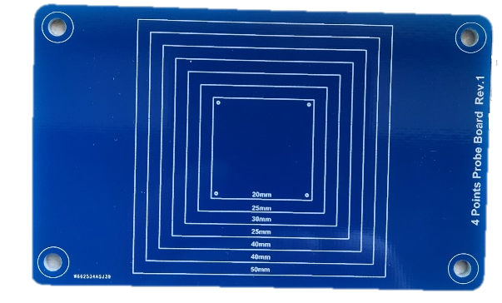
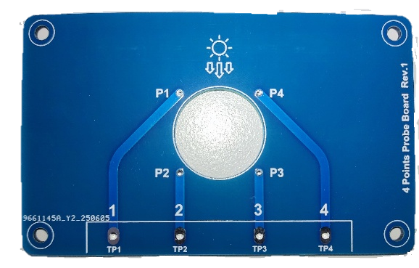
Figure 1a: Top panel of the custom-built experimental setup for four-point probe measurements.
Figure 1b: Bottom panel of the custom-built experimental setup for four-point probe measurements.

• Spring-loaded “pogo pin” type terminals: the contact terminals allow partial axial displacement. This configuration ensures constant and controlled contact pressure, providing a reliable electrical connection even on flat and fragile surfaces such as glass.
• Fixing pins/screws: these components allow the vertical distance between the two panels to be finely adjusted. This ensures optimal mechanical stability and uniform pressure over the contact area, regardless of the sample’s thickness.
The modular and adjustable setup enables reproducible and accurate measurements on thin films, adapting to substrates of various dimensions and material properties, including both rigid and flexible supports.
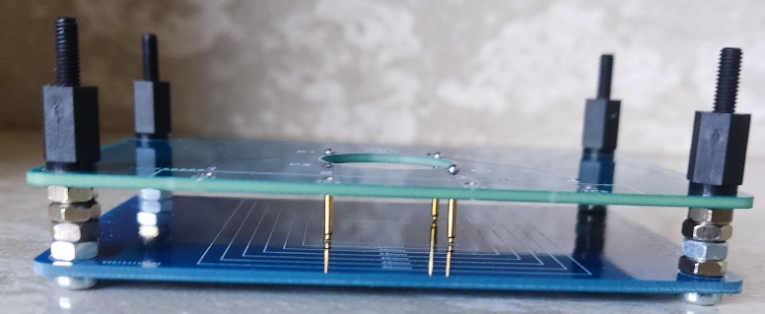
Figure 2: Complete view of the custom-built four-point probe setup for sheet resistance measurements
    - Electrical conductivity characterization
To evaluate the sheet resistance R_{S} of the polymeric films, the van der Pauw method (Sun et al., 1996) was employed using the custom-built four-point probe system described in the previous section.
A constant current of 1 mA was applied to two selected terminals of the sample using an AIM TTI EXT52M laboratory DC power supply. The corresponding voltage drop across the opposite pair of terminals was measured using a Fluke 8846A benchtop multimeter.
The measurement protocol involves sequential injection of current and sensing of voltage across distinct pairs of contacts among the four terminals positioned at the sample edges. Specifically, two resistance values were measured as defined by Eq. (1) and Eq. (2): in the first configuration, current is applied between terminals 1 and 2 (I₁₂) while the voltage drop is measured between terminals 3 and 4 (V₃₄) (Figure 3a); in the second configuration, current is applied between terminals 2 and 3 (I₂₃) with the corresponding voltage measured across terminals 4 and 1 (V₄₁) (Figure 3b).

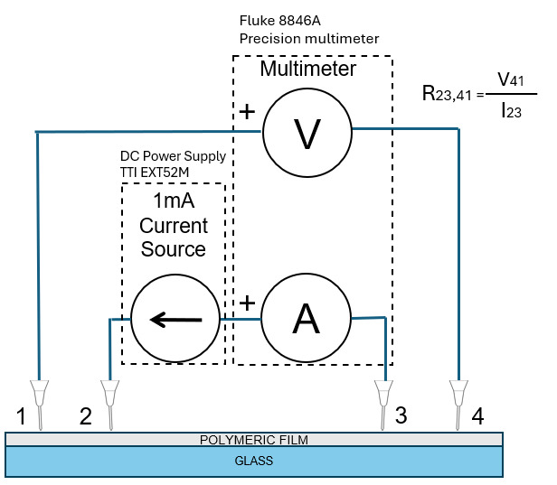
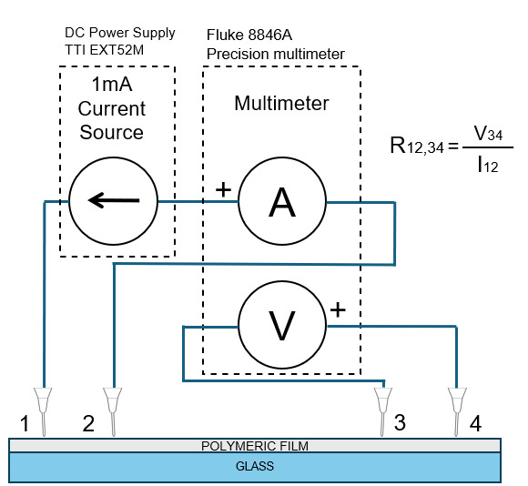
Figure 3b: Schematic representation
of the experimental setup used for the
R_{23,41} measurements.

Figure 3a: Schematic representation
of the experimental setup used for the
R_{12,34} measurements.

$${\text{R}}_{\text{12}\text{,}\text{34}}\text{=}\frac{{\text{V}}_{\text{34}}}{{\text{I}}_{\text{12}}}$$ | (1)

$${\text{R}}_{\text{23,41}}\text{=}\frac{{\text{V}}_{\text{41}}}{{\text{I}}_{\text{23}}}$$ | (2)

These values are subsequently applied in the van der Pauw equation, as described in Eq. (3).
$${\text{e​}}^{\text{-π}{\text{R}}_{\text{12,34}}\text{​/}{\text{R}}_{\text{S}}}\text{+}{\text{e}}^{\text{-π}{\text{R​}}_{\text{23,41}}\text{/}{\text{R}}_{\text{S}}\text{​}}\text{=1}$$ | (3)

Since the van der Pauw equation has a transcendental nature, it cannot be solved analytically. Therefore, the sheet resistance R_{S} is determined by applying an iterative numerical method.
  - Results and Discussion
The sheet resistance Rₛ of the different polymeric film configurations was evaluated using the van der Pauw method, as described in Section 2.5. The iterative numerical approach allowed for the accurate determination of Rₛ values by calculating the voltage response to an applied current. All measurements reported here were performed in dark conditions. The results are summarized in Table 2.
Table 2: Sheet resistance values of PEDOT:PSS-based films with different layer configurations and dopants (TiO₂ nanoparticles and PVK), measured in dark conditions using the van der Pauw method.
Sample | Rₛ [Ω]
Single layer PEDOT:PSS | 227.5
Single layer PEDOT:PSS + TiO₂ NPs | 2598.7
1st layer PEDOT:PSS + TiO₂ NPs + 2nd layer PEDOT:PSS | 567.2
Single layer PEDOT:PSS + PVK (blend) | 1007.9
1st layer PEDOT:PSS + 2nd layer PVK | 1164.2

As expected, the pristine PEDOT:PSS film exhibited the lowest sheet resistance, confirming its well-known high conductivity in thin film applications. The introduction of TiO₂ nanoparticles into the PEDOT:PSS matrix led to a significant increase in Rₛ (2598.7 Ω), likely due to the semiconducting nature of TiO₂ and the disruption of the conductive polymer network.
However, when an additional PEDOT:PSS layer was deposited on top of the TiO₂-containing layer, the resistance dropped considerably to 567.2 Ω, indicating partial recovery of the conductive pathways, possibly due to improved film continuity and interface integration among the polymer chain.
Regarding the PVK-containing samples, both the blend and bilayer architectures showed higher Rₛ values than pristine PEDOT:PSS. In the blend (1007.9 Ω), the increase is attributed to the poor conductivity of PVK and potential phase separation effects. The bilayer configuration (PEDOT:PSS + PVK) exhibited an even higher resistance (1164.2 Ω), likely due to the PVK layer acting as a barrier to charge transport.
These results clearly demonstrate that the electrical conductivity of the films is highly sensitive to both their composition and structural arrangement. In particular, the presence of inorganic semiconductors such as TiO₂ nanoparticles and PVK, which under illumination may exhibit semiconducting behavior, acted predominantly as insulating components in dark conditions. This underlines the fundamental importance of carefully engineering the interfaces and controlling the formulation of polymer-based thin films to effectively tune their conductive properties.
  - Conclusions
In this study, the sheet resistance of various PEDOT:PSS-based thin films was evaluated under dark conditions using a custom-built four-point probe system implementing the van der Pauw method. The results revealed that the incorporation of TiO₂ nanoparticles led to a significant increase in sheet resistance compared to pristine PEDOT:PSS. This behavior is attributed to the semiconducting nature of TiO₂ in the absence of photoexcitation: without incident light, no electron–hole pairs are generated, and the nanoparticles hinder charge percolation across the film.
The addition of a second PEDOT:PSS layer on top of the TiO₂-containing film partially recovered conductivity, likely by improving surface coverage, continuity, and interfacial contact between the conducting domains.
Similarly, both the blending and layering of PEDOT:PSS with poly(9-vinylcarbazole) (PVK) resulted in increased sheet resistance. Since PVK exhibits low intrinsic conductivity in its neutral ground state and does not generate photoexcited charge carriers, its incorporation disturbs the conductive pathways within the PEDOT:PSS matrix, resulting in reduced overall charge transport. These findings serve as a reference for the intrinsic conductive behavior of films in the absence of illumination.
Considering that many of these materials are designed for optoelectronic applications, where light plays a critical role in modulating electronic properties, future work will focus on investigating their photoresponse. Measuring the evolution of sheet resistance under controlled illumination will offer valuable insights into light-induced charge generation, mobility, and recombination phenomena in these hybrid systems.
Further studies will also examine how different dopants affect the films’ mechanical properties, such as flexibility, as well as their optical behavior, including transparency and absorption.
Nomenclature
R_{S} – sheet resistance, Ω
Acknowledgments
The authors gratefully acknowledge Dottorato di Interesse Nazionale “Photovoltaics”.

References
Fan, X., Nie, W., Tsai, H., Wang, N., Huang, H., Cheng, Y., Wen, R., Ma, L., Yan, F., & Xia, Y. (2019). PEDOT:PSS for Flexible and Stretchable Electronics: Modifications, Strategies, and Applications. Advanced Science, 6(19), 1900813.
Groenendaal, L., Jonas, F., Freitag, D., Pielartzik, H., & Reynolds, J. R. (2000). Poly(3,4-ethylenedioxythiophene) and Its Derivatives: Past, Present, and Future. Advanced Materials, 12(7), 481–494.
Huang, Y., Tang, L., & Jiang, Y. (2024). Chemical Strategies of Tailoring PEDOT:PSS for Bioelectronic Applications: Synthesis, Processing and Device Fabrication. CCS Chemistry, 6(8), 1844–1867.
Kirchmeyer, S., & Reuter, K. (2005). Scientific importance, properties and growing applications of poly(3,4-ethylenedioxythiophene). Journal of Materials Chemistry, 15(21), 2077–2088.
Nowsherwan, G. A., Ali, Q., Ali, U. F., Ahmad, M., Khan, M., & Hussain, S. S. (2024). Advances in Organic Materials for Next-Generation Optoelectronics: Potential and Challenges. Organics, 5(4), Articolo 4.
Park, Y., Müller-Meskamp, L., Vandewal, K., & Leo, K. (2016). PEDOT:PSS with embedded TiO2 nanoparticles as light trapping electrode for organic photovoltaics. Applied Physics Letters, 108(25), 253302.
Reimer, B., & Bässler, H. (1979). Fast hole transport in polyvinylcarbazole. Physica Status Solidi (a), 51(2), 445–451.
Semaltianos, N. G., Logothetidis, S., Hastas, N., Perrie, W., Romani, S., Potter, R. J., Dearden, G., Watkins, K. G., French, P., & Sharp, M. (2010). Modification of the electrical properties of PEDOT:PSS by the incorporation of ZnO nanoparticles synthesized by laser ablation. Chemical Physics Letters, 484(4–6), 283–289.
Shankar, U., Oberoi, D., & Bandyopadhyay, A. (2022). A review on the alternative of indium tin oxide coated glass substrate in flexible and bendable organic optoelectronic device. Polymers for Advanced Technologies, 33(10), 3078–3111.
Shi, H., Liu, C., Jiang, Q., & Xu, J. (2015). Effective Approaches to Improve the Electrical Conductivity of PEDOT:PSS: A Review. Advanced Electronic Materials, 1(4), 1500017.
Sun, Y., Shi, J., & Meng, Q. (1996). Measurement of sheet resistance of cross microareas using a modified van der Pauw method. Semiconductor Science and Technology, 11(5), 805.
Xia, Y., & Ouyang, J. (2010). Significant Conductivity Enhancement of Conductive Poly(3,4-ethylenedioxythiophene): Poly(styrenesulfonate) Films through a Treatment with Organic Carboxylic Acids and Inorganic Acids. ACS Applied Materials & Interfaces, 2(2), 474–483.

