 CHEMICAL ENGINEERING TRANSACTIONS  VOL. , 2025 | A publication of  
The Italian Association
of Chemical Engineering
Online at www.cetjournal.it

Guest Editors: Paolo Ciambelli, Luca di Palma
Copyright © 2025, AIDIC Servizi S.r.l.
ISBN 979-12-81206-20-5; ISSN 2283-9216

Multiscale Characterization of Graphene/ITO Hybrid Electrodes for Solar Cells
Noor ul Ain Ahmed^{a*}, Vidmantas Gulbinas^{b}, Aniello Pelella^{c}, Antonio Di Bartolomeo^{c}, Renata Adami^{c}, Maria Sarno^{c}, Claudia Cirillo^{c}, and Patrizia Lambertiª.
ªDepartment of Information and Electrical Engineering and Applied Mathematics, University of Salerno, Fisciano (SA), Italy
^{b}Center for Physical Sciences and Technology, Vilnius, Lithuania
^{c}Department of Physics “E. R. Caianiello”, University of Salerno, Fisciano, Salerno, Italy.
*Corresponding author: nahmed@unisa.it

Electrodes play a crucial role in the efficiency, stability and overall performance of electronic and optoelectronic devices, particularly solar cells. Indium tin oxide (ITO) functions as a transparent conductive electrode in solar cells because it provides high conductivity together with high transparency. The performance of ITO-based devices suffers because of non-negligible sheet resistance and brittleness that cause deterioration mostly in flexibly designed or large-area applications. The exceptional electrical conductivity and mechanical strength with high transparency of graphene has made it a potential candidate as an electrode. The independent application of graphene fails to exhibit essential anti-reflectance characteristics; nevertheless, it brings exceptional conductivity when used to enhance traditional transparent conductive oxides like ITO by optimizing their properties alongside improved electrical performance. In this research, a monolayer graphene film, obtained by cold wall chemical vapour deposition (CVD) on copper substrate, was transferred on commercial ITO electrodes. Scanning electron microscopy (SEM) and Energy Dispersive X-ray analysis (microscale) provide evidence showing that the graphene layer uniformly coats ITO with no damage to its structure. Four-probe (macroscale) measurements show that the addition of a graphene layer to ITO can leads to a 23% increase in conductivity.
  - Introduction
Transparent conductive electrodes (TCEs) are important components of current optoelectronic devices such as touch screens, organic LEDs, flat-panel displays, and solar cells (Liu et al.,2020). The efficiency of a solar cell is significantly influenced by the performance of the front contact, often a transparent conducting electrode (TCE), which governs its two fundamental processes: light absorption and carrier collection efficiencies. The illuminated side of a solar cell must demonstrate excellent optical transmittance to facilitate efficient light absorption and charge carrier production within the active layer. High electrical conductivity combined with transparency is essential for effective photo charge generation and collection (Kumar, 2017). Among the widely used TCE materials, indium tin oxide (ITO) is considered the most commercially feasible option because of its high optical transparency (>85%) and electrical conductivity. Nonetheless, ITO stand alone is mechanically brittle, expensive and rare. Therefore, alternative carbon-based materials are proven to be a potential candidate as an electrode (Shi et al.,2023) (Tran et al.,2019) (Muchuweni et al.,2022). Graphene, a monolayer of sp²-bonded carbon atoms arranged in a honeycomb lattice, has emerged as a potential alternative for TCEs due to its exceptional electrical conductivity (up to 1.5×10⁶ S/m), remarkable optical transparency (approximately 97.7%), and extraordinary mechanical strength and flexibility (Woo et al.,2019) (Di Bartolomeo, 2016). The independent application of graphene fails to exhibit essential anti-reflectance characteristics needed for various applications (Torres et al.,2021), nevertheless, it has potential when combined with other materials. Diverse methods for graphene manufacturing include mechanical exfoliation, chemical exfoliation, epitaxial growth, and chemical vapor deposition (CVD), with the latter offering enhanced scalability and material quality. However, the transfer of CVD-grown graphene onto certain substrates has challenges, such as wrinkles, cracks, and residual contamination (Song et al.,2021). Defects often result from the insufficient removal of transfer polymers like polymethyl methacrylate (PMMA), which can alter doping levels and reduce the overall electrical performance of graphene-based films (Zhang et al.,2022). Researchers are investigating different approaches to improve the optoelectronic ability of graphene. This includes chemical doping, surface alterations, and hybridization with other electrodes of conductive or semiconductive materials (Hu et al.,2022). One of the most promising strategies is based on the incorporation of graphene with other well-known transparent conductive materials like ITO. This method takes advantage of the high electrical conductivity of graphene in enhancing the conductivity of ITO based devices while preserving the anti-reflection and transparency of the oxide. The hybrid Graphene/ITO electrodes produced by a dual-step CVD can reduce sheet resistance and improve mechanical endurance as demonstrated by (Liu et al., 2016). (Harindu et.al.,2018) use electroless deposition technique involving vacuum annealing to uniformly deposit ITO nanoparticles (25–35 nm) on CVD grown graphene. The resultant ITO–graphene hybrid demonstrated enhanced electrical conductivity, evidenced by a 28.2% decrease in sheet resistance, while preserving high optical transparency (>85%) within the visible spectrum. (Bourahla et.al., 2025) introduced an efficient TCE achieved by integrating CVD obtained graphene with ITO, further improved by the incorporation of silver nanowire (Ag-NWs) doping. The optimized hybrid structure demonstrated a low sheet resistance of 42.4 Ω/sq and a high optical transmittance of 87.3%, making it well-suited for optoelectronic applications. (Harindu et al., 2017) detailed the creation of a transparent conductive bi-layer film composed of graphene and ITO, utilizing CVD graphene and sol-gel ITO films, all while excluding organic additives. Furthermore, the hybrid structure's morphology is distinguished by its enhanced conductivity, with a sheet resistance of approximately 117 Ω/sq for the film, with an observed transmittance of 88.66%. These properties make the material an appealing candidate for further application in optoelectronics. In this contest, CVD has emerged as a potential method for the industrial fabrication of graphene films, offering notable control and homogeneity. In traditional hot-wall CVD systems, graphene films produced via CVD suffer surface contamination due to gas-phase reactions during high-temperature development. The cold-wall CVD technique effectively suppresses gas-phase reactions, enabling the controlled and superclean development of graphene films (Jia et al., 2020).

The purpose of this study is to develop a simple yet effective method to enhance the electrical performance of commercially used ITO electrodes by profiting from the high electrical conductivity of graphene. In this respect, our study introduces an efficient and scalable approach to improve commercially obtained ITO-based transparent electrodes (Ossila) through the incorporation of a monolayer graphene, grown by cold wall CVD, subsequently transferred on ITO-coated glass. Unlike traditional methods that depend on high-temperature transfer techniques or complex manufacturing processes, this configuration employs a synthesis and transfer protocol that preserves the quality of graphene and ensures clean and uniform deposition.

To the best of our knowledge, no prior study has been reported on the manufacturing of graphene/ITO hybrid electrodes via cold wall CVD. The novelty lies in the temperature-controlled synthesis and industrial compatibility offering a more regulated way of bridging the gap between high-performance nanomaterials and scalable device fabrication, thus enabling practical “lab to market” transition. Scanning electron microscopy (SEM) verifies the successful and homogeneous deposition of graphene on the ITO substrate. Energy Dispersive X-ray analysis (EDX) confirms this deposition by elemental analysis. Four probe measurements performed on the graphene–ITO hybrid devices demonstrate thermal stability around 300-400K and 23% enhancement in conductivity, evidencing the effect of graphene in reducing sheet resistance relative to bare ITO. The enhanced performance marks a significant advance in the design of transparent electrode technology. The obtained hybrid material is well suited to be use as a front electrode in optoelectronic devices where transparency and conductivity are critical to maximize overall device efficiency.
  - Material and Methods
    - Commercially obtained ITO electrodes
ITO electrodes 20 mm × 15 mm and a thickness of 1.1 mm were purchased from Ossila Ltd. (Sheffield, UK). Fully oxidized 100 nm indium tin oxide (ITO) is deposited on the glass surface polished soda lime float glass. The detailed ITO configuration is represented in Figure 1 (b). These electrodes were used as the transparent conductive base layer in hybrid electrode formation without further modification.
    - Graphene monolayer growth on Cu foil and transfer on ITO substrates
Monolayer graphene was synthesized on copper foil (10 × 30 mm², no. 46365, 25 μm thick, annealed, uncoated, 99.8%, Alfa Aesar), using a cold-wall CVD process, following the optimized protocol for sample 8 as described by Sarno et al. (2018). The synthesis was carried out in a Moorfield nanoCVD-8G cold-wall reactor using high-purity gases: methane (99.998%), hydrogen (99.998%), and argon (99.999%). The copper substrate was pre-treated with nitric acid (HNO₃), then annealed at 900 °C for 120 seconds under a flow of 120 sccm argon and 10 sccm hydrogen. The temperature was then raised to 1000 °C and maintained for 900 seconds under the same Ar/H₂ flow to increase copper grain size. Graphene growth was initiated by introducing methane at 20 sccm for 700 seconds, keeping the temperature and pressure constant at 1000 °C and 8 Torr, respectively. After growth, the system was cooled to 100 °C over 630 seconds under Ar/H₂ flow, followed by cooling to room temperature in ambient air. The resulting monolayer graphene film was then transferred from the copper substrate onto commercially obtained ITO-coated glass (Ossila Ltd., UK) using the same thermal release tape method reported by Sarno et al. (2018). In this process, the backside of the Cu foil was first polished with nitric acid to remove unwanted graphene, and the copper was etched in a 1 M FeCl₃ solution. After rinsing, the graphene film supported on the tape was transferred to the ITO/glass substrate by applying heat to release the tape. This method allows for a clean and uniform transfer without damaging the ITO layer. Table 1 summarizes the CVD process steps and parameters. Following the above-mentioned deposition procedure, transparent electrodes were prepared and shown in Figure 1 (b). The four silver dots visible on the surface were applied using conductive silver paste to enable electrical contact points for subsequent characterization.
Table 1: Optimized cold-wall CVD process parameters used for the deposition of monolayer graphene as adapted from (Sarno et al., 2018).
Step | Temp (°C) | CH₄ (sccm) | Time (s) | Purpose
1 | 900 | 0 | 120 | Pre-treatment (Ar/H₂‚ only)
2 | 1000 | 0 | 900 | Annealing no methane yet
3 | 1000 | 20 | 700 | Graphene growth phase
4 | 100 | 0 | 630 | Cooling phase
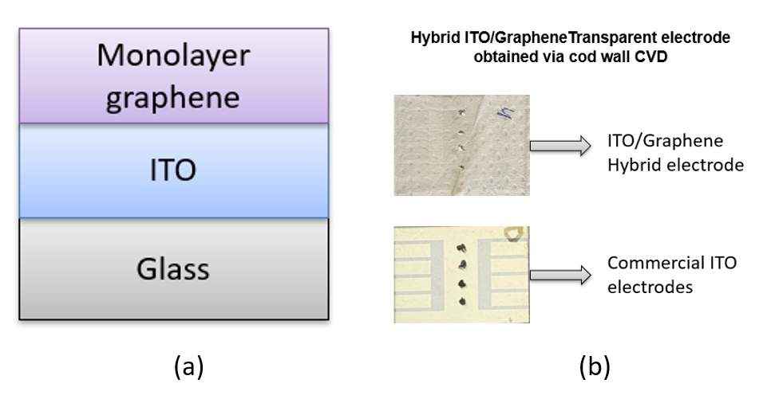
Figure 1: (a): Schematic of proposed geometry (b): Bottom: Commercially sourced patterned ITO electrodes. The light grey area corresponds to glass and rest of the part is ITO coated. Top: Transparent hybrid electrode prepared via cold-wall CVD. The graphene monolayer, grown on copper foil, was transferred on the complete ITO-coated glass.
  - Results and Discussion
    - Electrical properties
Four-probe measurements were performed utilizing a Keithley 4200-SCS Semiconductor Parameter Analyzer with a Janis probe station. A current sweep from 0 to 10 mA was executed in increments of 0. 5 mA, and the voltage drop across the material under test was measured. The obtained I-V curves confirms that adding a graphene overlayer reduces the resistance of the ITO electrodes shown in Figure 2 (Sun et al.,2023). The ITO-only sample shows a four-probe resistance of 9.3 Ω, corresponding to a sheet resistance of approximately 3.1 Ω/□ measured using Rs = R·W/L, where R is the resistance and W = 0.5 mm and L = 1.5 mm are the width and the length of the sample area under test, respectively. R is evaluated by taking the inverse value of the slope of the I-V curves, reported in Figure 2. In contrast, the graphene–ITO composite yields 7.1 Ω over the same geometry, i.e. about 2.4 Ω/□. The ~23% reduction in sheet resistance reflects the additional highly conductive pathway provided by graphene. Such a decrease in resistive losses is significant for optoelectronic applications; a lower sheet resistance in the front contact ensures more efficient current flow with minimal ohmic losses. In perovskite solar cells, for example, the improved conductivity of the graphene–ITO electrode can directly translate to higher fill factors and enhanced power conversion efficiency (You et al., 2015). Notably, this enhancement is achieved without appreciable sacrifice in transparency since monolayer graphene is nearly invisible optically (Amer et al., 2020) Combining graphene with ITO thus offers a transparent conducting electrode with superior electrical performance, aligning with reports that graphene-based transparent electrodes can simultaneously deliver low sheet resistance and high transmittance in solar cells (Fernandez et al.,2019). The results endorse the viability of graphene–ITO composite films as superior transparent electrodes in optoelectronic applications, especially for perovskite solar cells where front contact is extremely important for the maximum utilization of natural sunlight (Kasparavičiuset al., 2024).

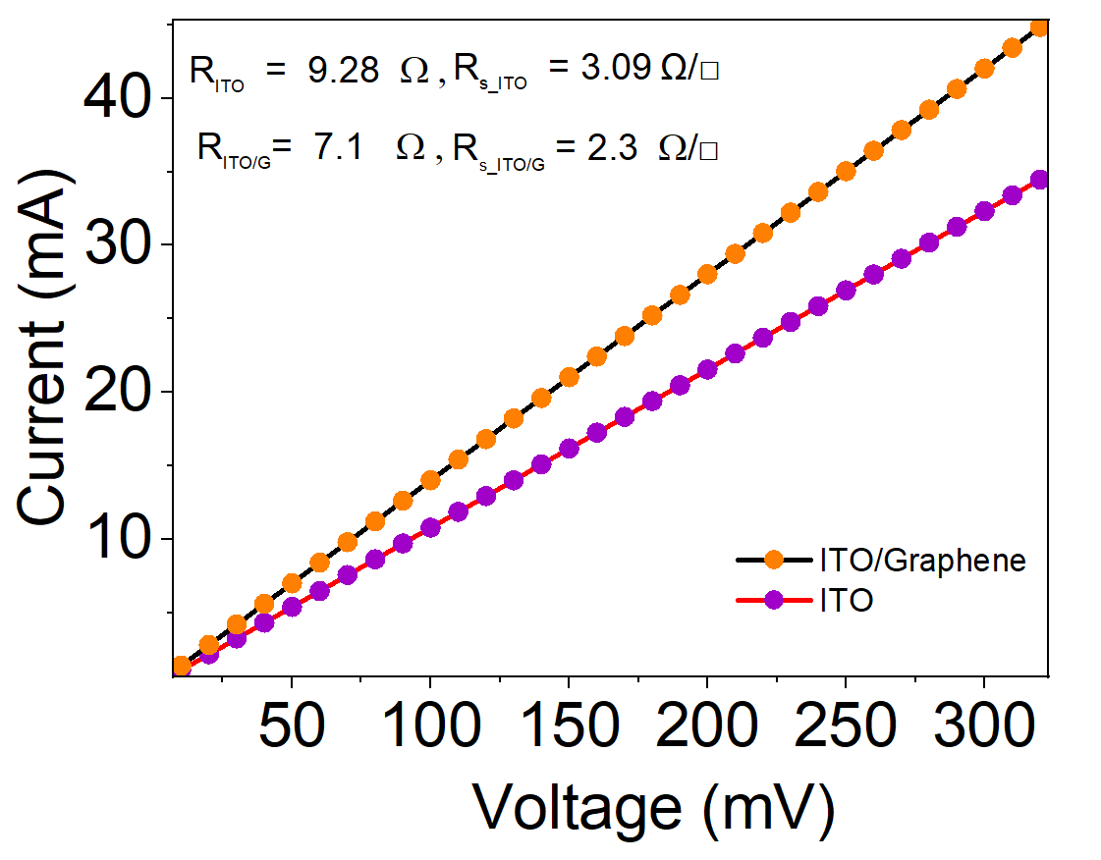
Figure 2: Comparison of Current voltage (I-V) characteristic of ITO and ITO/Graphene hybrid electrode with four probe measurement.
    - Temperature-Dependent Sheet Resistance
Figure 3 (a) shows the IV curve measurement for ITO/Graphene electrode at different temperatures while 3(b) depicts the fluctuation in sheet resistance (Ω/□) graphene-coated ITO (ITO/Graphene) as a function of temperature within the range of 300–400 K.

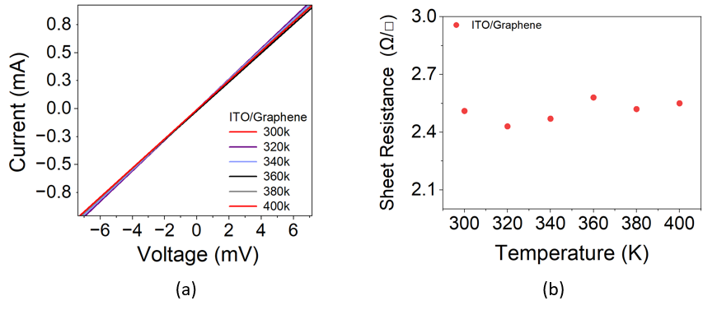
Figure 3: (a) I-V curve and Temperature-dependent sheet resistance (b) of hybrid ITO/graphene electrodes measured from 300 K to 400 K.
The ITO/Graphene sample consistently exhibits reduced sheet resistance, ranging from 2.4 to 2.6 Ω/□, throughout the whole temperature range. Furthermore, its resistance is largely unaffected by temperature, signifying a considerable degree of thermal stability in its electrical transport characteristics. This effect is due to the graphene coating, which creates a parallel, high-conductivity channel that alleviates the temperature-sensitive transport properties of the underlying ITO (Chen et al., 2013) (Seo et al., 2018). The decrease in sheet resistance due to the incorporation of graphene validates graphene function in improving charge carrier mobility. The graphene layer efficiently connects surface imperfections and grain boundaries of the ITO film, therefore reducing contact resistance and enhancing overall conductivity. The thermally stable sheet resistance highlights the synergistic impact of integrating graphene with ITO to create a hybrid transparent conductive electrode with exceptional electrical and thermal properties (Wang et al., 2021).
3.3 SEM and EDX Analysis
SEM images of full view and zoomed-in part of ITO and ITO/Graphene hybrid electrode are shown in Figure 4. The highlighted part represents fingers between cells which is bare glass in case of ITO sample (b) and graphene monolayer on glass for the ITO/Graphene hybrid electrode (c). Figure 4(b) shows a SEM image of glass, while 4(c) confirms the graphene particles and uniform coating of graphene monolayer on glass. Figure 5 presents the spectrum of EDX analysis of the ITO/Graphene sample. The C peak indicates the presence of graphene, while the In peak corresponds to indium. The additional Si, O, and Al peaks are related to the ITO-coated glass substrate. This hybrid configuration can serve as a mechanically robust reinforcement for brittle ITO, by bridging micro-cracks and enhancing flexibility due to graphene’s high strain tolerance ~25% (Hwang et al., 2020). This hybrid configuration is capable to maintain resistance stability over 1000 bending cycles under strain (Lee et al., 2017).

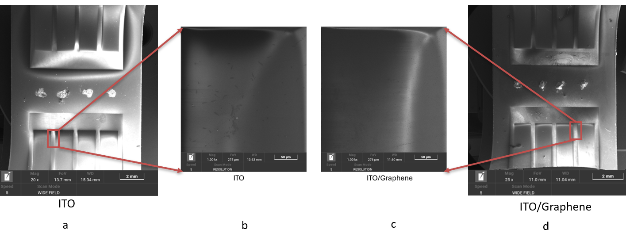
Figure 4: SEM images of ITO (a-b) and ITO/Graphene (c-d) electrodes showing full view (2 mm scale) and zoomed-in finger region (50 µm) used for surface morphology analysis.
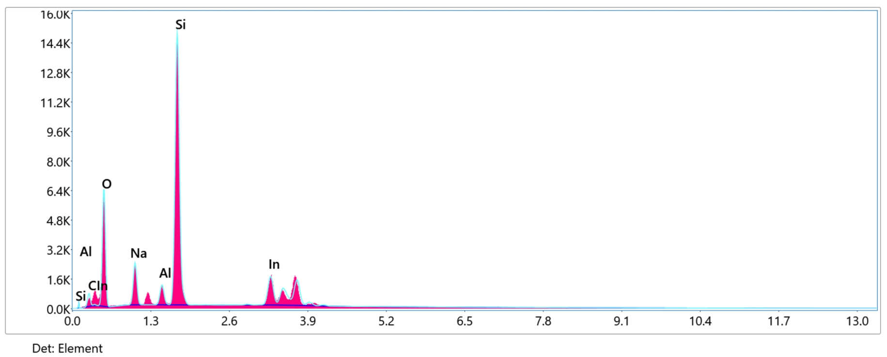
Figure 5: EDX Spectra of ITO/Graphene
  - Conclusions
We have demonstrated a multiscale evaluation of hybrid ITO/graphene electrodes produced by cold-wall CVD. Four-probe measurements revealed a sheet resistance from 2.4 to 2.6 Ω/□, lower than commercial ITO, with negligible fluctuation from 300 K to 400 K. Complementary SEM and EDX analyses confirmed that a defect-free monolayer graphene film uniformly blankets the soda-lime glass gaps between ITO fingers, providing a continuous conductive path. Linking these microscale observations to device-scale I-V behaviour shows 23% electrical improvement arising directly from the graphene overlayer. The method delivers a transparent, low-resistance electrode through a well-controlled transfer process, avoiding polymer contamination and preserving the quality of both graphene and ITO substrates, making it attractive for large-area displays and solar cells.
References
Amer, M.S.; Al Mafrage, A.M.; Mohammed, M.K. On the Production, Mechanical and Electro-Optic Properties of Large-Area Monolayer Graphene Films Using Langmuir-Blodgett Technique. Materials Research Express 2020, 7, 015024.
Chen, R.; Das, S.R.; Jeong, C.W.; Khan, M.R.; Janes, D.B.; Alam, M.A. Co‐Percolating Graphene‐Wrapped Silver Nanowire Network for High Performance, Highly Stable, Transparent Conducting Electrodes. Advanced Functional Materials 2013, 23.
Di Bartolomeo A. Graphene Schottky diodes: An experimental review of the rectifying graphene/semiconductor heterojunction. Physics Reports 2016, 606, 1-58
Fernández, S.; Boscá, A.; Pedrós, J.; Inés, A.; Fernández, M.; Arnedo, I.; González, J.P.; de la Cruz, M.; Sanz, D.; Molinero, A.; et al. Advanced Graphene-Based Transparent Conductive Electrodes for Photovoltaic Applications. Micromachines 2019, 10.
Harindu, N.; Kim, J.-K.; Lee, J.-M. Synthesis and Characterization of Graphene/ITO Nanoparticle Hybrid Transparent Conducting Electrode. Nano-Micro Letters 2018, 10, doi:10.1007/s40820-017-0174-0.
Hu, Z.; Zhao, Y.; Zou, W.; Lu, Q.; Liao, J.; Li, F.; Shang, M.; Lin, L.; Liu, Z. Doping of Graphene Films: Open the Way to Applications in Electronics and Optoelectronics. Advanced Functional Materials 2022, 32.
Hwang, Yooji & Choi, Junhee & Kim, Ji-Weon & Lee, Jin-Woo & Kim, Jae & Hwang, Ha & Choi, Kwang & Lee, Wang-Hoon & Ju, Byeong-Kwon. (2020). Ag-fiber/graphene hybrid electrodes for highly flexible and transparent optoelectronic devices. Scientific Reports. 10. 5117. 10.1038/s41598-020-62056-1.
Jia K, Ci H, Zhang J, et al. Superclean Growth of Graphene Using a Cold-Wall Chemical Vapor Deposition Approach. Angew Chem Int Ed Engl. 2020;59(39):17214-17218.
Kasparavičius, E.; Franckevičius, M.; Driukas, S.; Gulbinas, V. Charge Carrier Dynamics at the Perovskite Interface with Self-Assembled Monolayers. ACS Applied Materials & Interfaces 2024, 16, doi:10.1021/acsami.4c10223.
Kumar, A. Predicting Efficiency of Solar Cells Based on Transparent Conducting Electrodes. Journal of Applied Physics 2017, 121, 014502.
Sang Jin, Lee & Kim, Yekyung & Hwang, Jun-Yeon & Lee, Ju-Ho & Jung, Seungon & Park, Hyesung & Cho, Seungmin & Nahm, Sahn & Yang, Woo-Seok & Kim, Hyeongkeun & Han, Seung. (2017). Flexible Indium–Tin Oxide Crystal on Plastic Substrates Supported by Graphene Monolayer. Scientific Reports. 7. 10.1038/s41598-017-02265-3.
Liu, J.; Yi, Y.; Zhou, Y.; Cai, H. Highly Stretchable and Flexible Graphene/ITO Hybrid Transparent Electrode. Nanoscale research letters 2016, 11.
Liu, L.; Cao, K.; Chen, S.; Huang, W. Toward See-Through Optoelectronics: Transparent Light-Emitting Diodes and Solar Cells. Advanced Optical Materials 2020, 8, 2001122.
Muchuweni, E.; Mombeshora, E.T.; Martincigh, B.S.; Nyamori, V.O. Recent Applications of Carbon Nanotubes in Organic Solar Cells. Frontiers in Chemistry 2022, Volume 9-2021, doi:10.3389/fchem.2021.733552.
Sarno, M.; Rossi, G.; Cirillo, C.; Incarnato, L. Cold Wall Chemical Vapor Deposition Graphene-Based Conductive Tunable Film Barrier. Industrial & Engineering Chemistry Research 2018, 57, 4895–4906.
Seo, Y.-M.; Cho, H.-J.; Jang, H.-S.; Jang, W.; Lim, J.-Y.; Jang, Y.; Gu, T.; Choi, J.-Y.; Whang, D. 2D Doping Layer for Flexible Transparent Conducting Graphene Electrodes with Low Sheet Resistance and High Stability. Advanced Electronic Materials 2018, 4.
Shi, X.; Chen, S. Carbon-Based Electrodes for Organic Solar Cells. ChemPlusChem 2023, 88, e202300008.
Song, Y.; Zou, W.; Lu, Q.; Lin, L.; Liu, Z. Graphene Transfer: Paving the Road for Applications of Chemical Vapor Deposition Graphene. Small 2021, e2007600.
Sun, J.; Zhang, K.; Han, Y.; Ni, C. Enhanced Performance of GaN-Based Long-Wavelength Blue Light-Emitting Diodes with Graphene-ITO Composite Film as Transparent Conductive Electrode. Materials Research Express 2023, 10
Torres, I.; Fernández, S.; Fernández-Vallejo, M.; Arnedo, I.; Gandía, J.J. Graphene-Based Electrodes for Silicon Heterojunction Solar Cell Technology. Materials 2021, 14, doi:10.3390/ma14174833.
Tran, V.-D.; Pammi, S.V.N.; Park, B.-J.; Han, Y.; Jeon, C.; Yoon, S.-G. Transfer-Free Graphene Electrodes for Super-Flexible and Semi-Transparent Perovskite Solar Cells Fabricated under Ambient Air. Nano Energy 2019, 65, 104018.
Wang, P.; Jian, M.; Zhang, C.; Wu, M.; Ling, X.; Zhang, J.; Wei, B.; Yang, L. Highly Stable Graphene‐Based Flexible Hybrid Transparent Conductive Electrodes for Organic Solar Cells. Advanced Materials Interfaces 2021, 9.
Woo, Y.S. Transparent Conductive Electrodes Based on Graphene-Related Materials. Micromachines 2019, 10, doi:10.3390/mi10010013.
You, P.; Liu, Z.; Tai, Q.; Liu, S.; Yan, F. Efficient Semitransparent Perovskite Solar Cells with Graphene Electrodes. Advanced Materials 2015, 27, 3632–3638.
Zhang, D.; Zhang, Q.; Liang, X.; Pang, X.; Zhao, Y. Defects Produced during Wet Transfer Affect the Electrical Properties of Graphene. Micromachines 2022, 13, doi:10.3390/mi13020227.

