 CHEMICAL ENGINEERING TRANSACTIONS  VOL. , 2025 | A publication of  
The Italian Association
of Chemical Engineering
Online at www.cetjournal.it

Guest Editors: Paolo Ciambelli, Luca di Palma
Copyright © 2025, AIDIC Servizi S.r.l.
ISBN 979-12-81206-20-5; ISSN 2283-9216

Computer-aided Investigation of the Performance of Water-based Metal Oxide Nanofluids
Hamed Nazerian, Tommaso Angiolini, Maurizio Ferretti, Andrea P. Reverberi, Marco Vocciante*
Dipartimento di Chimica e Chimica Industriale, Università degli Studi di Genova, Genova, Italy
marco.vocciante@unige.it
Computational Fluid Dynamics (CFD) has emerged as a powerful tool for simulating the behavior of nanofluids in thermal systems, providing a cost-effective alternative to experimental studies. This contribution presents a comprehensive computational modelling approach to study the flow and heat transfer characteristics of nanofluids, based on experimental data from synthesized prototypes of CuO (1 wt %, 5 wt %) and Al₂O₃ (1 wt %, 5 wt %) nanoparticles in water. The modeling was performed using OpenFOAM, an open-source CFD Software that allows a high degree of customization of simulation parameters. The study involved the development of detailed CFD models to investigate the influence of nanoparticle morphological properties on the thermal performance of nanofluids. Different multiphase schemes were used to accurately simulate the complex interactions between nanoparticles and base fluids. The simulation results were compared with experimental and literature data to validate the models and ensure their reliability. The validated models were then used to extend the experimental campaign, exploring the potential of different nanoparticle compositions and concentrations to optimize thermal efficiency. The results demonstrate that CFD modeling can effectively predict the behavior of nanofluids, providing a robust framework for optimizing their performance in real-world applications. The study underscores the importance of integrating experimental and computational approaches to achieve a comprehensive understanding of nanofluid dynamics. The insights gained from this research contribute to the advancement of nanofluid technology, offering practical solutions for enhancing heat transfer efficiency in industrial processes.
  - Introduction
Efficient heat transfer is essential for many industrial processes, including power generation, cooling electronics and automotive systems, and chemical processing. However, conventional heat transfer fluids, such as water, oil, and ethylene glycol, exhibit limited thermal conductivity, which limits the performance of heat exchangers. To address this issue, researchers have focused on improving heat transfer characteristics through advanced working fluids. Nanofluids (NFs), engineered suspensions of nanoscale solid particles dispersed in conventional fluids (Choi and Eastman, 1995), have demonstrated significant improvements in thermal conductivity, heat transfer rates, and overall thermal efficiency (Sajid and Ali, 2019), especially when combined with more efficient devices to further increase savings (Vocciante and Kenig, 2021). The addition of nanoparticles, such as metal oxides, metals, and carbon-based materials, significantly increases the effective thermal conductivity of the base fluid (Yu and Xie, 2012). This enhancement arises primarily due to mechanisms such as nanoparticle Brownian motion, thermophoresis, particle-fluid interface layering, and enhanced conduction pathways (Mahian et al., 2013). Experimental investigations have demonstrated notable improvements in convective heat transfer coefficients and overall heat transfer performance when employing nanofluids, even at relatively low particle concentrations (Saidur et al., 2011).
As a result, the use of NFs in different applications has recently been explored showing encouraging potential (Sathishkumar et al., 2024). This is not limited to the industrial sector, including for instance buildings application, where it not only improves energy efficiency, but also enhances the resilience of buildings to climate change (Peri et al., 2024). This is in line with recommendations from various European and national directives (Cirrincione et al., 2023a). Indeed, energy-efficient, smart and flexible energy storage and exchange systems (Cirrincione et al., 2023b), including integrate renewable solutions (Cirrincione et al., 2020), are vital for sustainable energy management within district energy systems (Cirrincione et al., 2022).
Despite their promising performance, nanofluids present practical challenges, including particle sedimentation and agglomeration, as well as associated stability concerns (Reverberi et al., 2022). These challenges limit scalability, create difficulties in maintaining consistent thermal properties, and make experimental studies complex, costly, and often time-consuming. Consequently, numerical simulations, in particular Computational Fluid Dynamics (CFD), have emerged as a powerful, complementary approach to predict, analyze, and optimize nanofluid performance under different conditions.
CFD simulations may offer significant advantages, providing detailed insights into fluid flow and thermal behavior, reducing the reliance on extensive experimental setups, and enabling rapid exploration of numerous design parameters. Through CFD, researchers can accurately simulate various particle-fluid interactions, assess heat transfer enhancements, and systematically optimize nanofluid formulations for targeted industrial applications. Of the various available tools, OpenFOAM, an open-source CFD software package, is particularly advantageous due to its flexibility, cost-effectiveness, and ability to model complex multiphase interactions using advanced numerical schemes (Weller et al., 1998).
This study utilizes CFD simulations performed with OpenFOAM (OF) to investigate the thermal and flow characteristics of CuO-water and Al₂O₃-water nanofluids. By validating numerical models against rigorous experimental data, the research ensures high prediction accuracy. The models are also extended to investigate the performance implications of hybrid nanoparticle mixtures and various particle concentrations, providing a thorough and comprehensive approach to optimizing heat exchanger designs. The outcomes of this study aim to provide practical insights and guidelines for the effective implementation of nanofluid technology in various thermal management applications, promoting energy efficiency and improving the thermal performance of industrial processes.
  - Material and Methods
    - Nanofluid Preparation and Properties
Nanofluids were prepared using distilled (DI) water as the base fluid. To improve dispersion stability, 1 vol % of sodium dodecyl sulfate (SDS) surfactant was added to the DI water. The mixture was then stirred at 500 rpm for 15 min to ensure uniform distribution. Commercially sourced CuO and Al₂O₃ nanoparticles, with average diameters of approximately 30 nm and 50 nm, respectively, were then measured using a precision balance. The masses were selected to achieve target nanoparticle weight fraction of approximately 0.1 % and 0.5 %, calculated using the following formula:
$w= \frac{m_{np}}{m_{np}+ρ_{f}∙V_{f }}$ , $ϕ = \frac{\frac{m_{np}}{ρ_{np}}}{V_{f }+\frac{m_{np}}{ρ_{np}}}$ | (1)
where $m_{np}$ and ​$ρ_{np}$ refer to nanoparticle mass and density, and ​$ρ_{f}$ and $V_{f}$ refer to the solvent density and volume, respectively.
The nanoparticle-surfactant-based fluid mixture underwent a two-step dispersion protocol. First, the suspension was mechanically stirred at 700 rpm for 45 minutes. Then, ultrasonication was performed in a bath sonicator for 120 minutes to break up any agglomerates and ensure a stable colloidal suspension. In accordance with current best practices in nanofluid synthesis (Hong et al., 2020), the stability of the nanofluids was monitored visually over 48 hours and quantified using zeta potential measurements and UV–vis spectroscopy.
Meanwhile, the effective thermophysical properties at room temperature (20 °C) for the simulation process, taken from Xuan and Li (2000), are given in Table 1.
Table 1: Thermophysical properties at 20 °C, derived from Xuan and Li (2000)
Fluid | ρ (kg/m³) | μ (Pa·s) | Cₚ (J/kg·K) | k (W/m·K)
Water | 998 | 1.00 × 10⁻³ | 4,182 | 0.60
CuO–water (1 wt %) | 1,003 | 1.00 × 10⁻³ | 4,050 | 0.59
CuO–water (5 wt %) | 1,025 | 1.15 × 10⁻³ | 3,750 | 0.64
Al₂O₃–water (1 wt %) | 1,000 | 1.05 × 10⁻³ | 4,100 | 0.62
Al₂O₃–water (5 wt %) | 1,030 | 1.20 × 10⁻³ | 3,800 | 0.69
    - CFD Simulation Setup
2.3.1 Computational domain and discretization
The computational domain consisted of a straight circular tube of inner radius r = 5 mm and length L = 0.1 m (L/D = 20). By exploiting the axial symmetry of the problem, it was possible to simplify the study by working in a two-dimensional representation (r-z) as shown in Figure 1. For the domain discretization, a free triangular mesh with four boundary‐layer rows on the heated wall (first layer y₁ = 1.6 mm, stretching factor = 1.2, target y⁺ ≈ 50) was used. The core domain employed “custom” element sizing with a minimum size of 1.6 mm and varying maximum sizes. The grid has been generated by using OF release 12. The meshes obtained had up to over 7 million cells, as explained in the section 2.3.3.
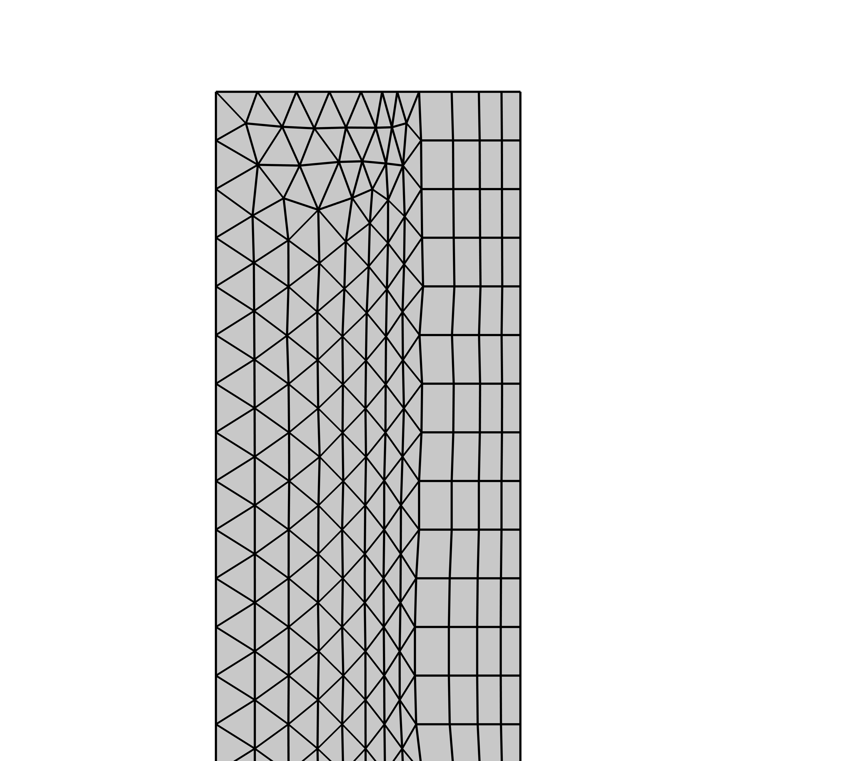
Figure 1: Computational mesh of the pipe domain with boundary-layer refinement
2.3.2 Governing equations and boundary conditions
Numerical simulations to obtain the thermal and hydrodynamic fields within the pipe were carried out by solving the steady, axisymmetric Reynolds‐averaged Navier–Stokes (RANS) and energy equations with a standard k–ε turbulence closure. This closure provides a reliable balance between accuracy and computational cost in fully developed turbulent pipe flow (Launder and Spalding, 1974). At the inlet, a uniform axial velocity of 0.50 m/s and a fixed temperature of 293.15 K were imposed. A constant heat flux of 10,000 W/m² was applied to the inner wall, and zero-gauge pressure was maintained at the outlet. Mesh refinement and solver settings were held constant across all cases to ensure mesh‐independent, directly comparable results.
To verify that the flow remains turbulent in all fluids, the Reynolds number, defined as in Eq(2) has been evaluated for all the systems by using of the related thermophysical properties at 20 °C as reported in Table 2.
$$\text{Re}=\frac{ρ u D}{μ}$$ | (2)
Table 2: Reynolds number in the operating conditions
Fluid | ρ (kg/m³) | μ (Pa·s) | Re
Water | 998 | 1.00 × 10⁻³ | 4,990
CuO–water (1 wt %) | 1,003 | 1.00 × 10⁻³ | 4,490
CuO–water (5 wt %) | 1,025 | 1.15 × 10⁻³ | 3,480
Al₂O₃–water (1 wt %) | 1,000 | 1.05 × 10⁻³ | 4,580
Al₂O₃–water (5 wt %) | 1,030 | 1.20 × 10⁻³ | 3,350

All cases exhibit Re > 3,000, which is well above the laminar–turbulent transition (approximately 2,300) and thus warrants the use of a turbulent closure. The steady RANS energy equation Eq(3) was solved.
$ρC_{p} u⋅\text{∇}\text{T}=\text{∇}⋅\left[\left(k+k_{t}​\right)∇T\right]$ , $k_{t}=\frac{μ_{t}C_{p}}{{Pr}_{t}} , {Pr}_{t}=0.9$ | (3)
Wall‐averaged temperature Tₛ and bulk‐averaged Tᵦ were obtained via coupling operators. Then, the heat‐transfer coefficient and Nusselt number were computed as:
$$h=\frac{q^{''}}{T_{s}-T_{b}}, \text{Nu}=\frac{h \left(2r\right)}{k}$$ | (4)
2.3.3 Mesh Convergence
A convergence study on pure water was conducted prior to the simulation campaign to assess the grid‐independence of the results. Figure 2 shows the relative error, defined as in Eq(5), between the point values of temperature obtained along the outlet section of the pipe evaluated with the various meshes.
$$Relative error=\frac{x_{M_{i}}-x_{M_{i+1}}}{x_{M_{i}}}∙100$$ | (5)
As shown in Table 3, this study revealed that Mesh 6 (≈180,000 elements) yields outlet‐temperature changes of less than 0.002 K relative to a 660,000‐element reference (< 0.001 %).
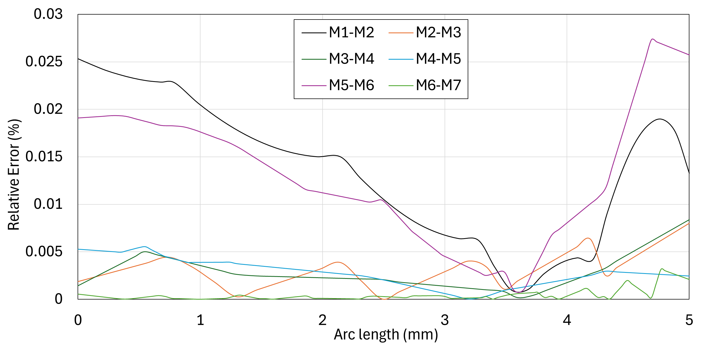
Figure 2: Relative error on the temperature along the outlet section between the considered meshes
Table 3: Average outlet‐temperature convergence
Mesh | Elements | Tₒᵤₜ [K] | ΔT vs prior [K]
1 | 1,736 | 296.79971 | ---
2 | 3,200 | 296.72458 | –0.07512
3 | 8,002 | 296.73201 | +0.00743
4 | 16,020 | 296.72586 | –0.00615
5 | 50,020 | 296.74152 | +0.01566
6 | 180,022 | 296.79830 | +0.05678
7 | 7,660,048 | 296.79981 | +0.00151

Mesh 6 was therefore adopted for all fluids to ensure mesh-independent results. Thus, differences in the Nusselt number and the convective heat‐transfer coefficient observed arise solely from their distinct thermophysical properties. All cases – water and nanofluids (CuO, Al₂O₃ at 1 wt % and 5 wt %) – used identical geometries, meshes, boundary conditions, and solver tolerances (residuals < 10⁻⁶). This enabled a direct, mesh-independent comparison of convective performance.
  - Results and Discussion
    - Heat Transfer Performance
From the simulated datasets, a significant enhancement in heat transfer was observed when nanofluids replaced pure water. The heat transfer coefficient values for the nanofluids were consistently higher, demonstrating their ability to improve thermal performance. Specifically, Al₂O₃–water at 5 wt % showed the highest enhancement, which can be attributed to its superior thermal conductivity and specific heat capacity, as shown in the thermophysical properties table.
Moreover, the outlet temperature of the fluid, which is used as a practical performance indicator, demonstrated clear thermal gains with nanofluids. Compared to an outlet temperature of 298.1 K for pure water, the outlet temperature reached 299.0 K for CuO–water at 5 wt %, and 299.3 K for Al₂O₃–water at 5 wt %. These increases reflect the enhanced thermal absorption and convective transport capacity of the nanofluids under identical heat flux conditions. CuO–water nanofluids at both 1 and 5 wt % concentrations also exhibited considerable improvement compared to pure water, although slightly less effective than Al₂O₃–water nanofluids.
Consistent with these observations, the Nusselt number, a dimensionless metric for convective heat transfer performance, was also found to be significantly higher for nanofluids. As shown in Figure 3, the highest Nusselt number was recorded for Al₂O₃–water at 5 wt %, followed by CuO–water at 5 wt %; both clearly outperformed pure water. These enhancements can be directly linked to the increased thermal conductivity of the nanofluid, improved thermal boundary layer behavior, and intensified turbulence effects. Therefore, the Nusselt number trends further validate the improved convective heat transfer efficacy of the tested nanofluids.
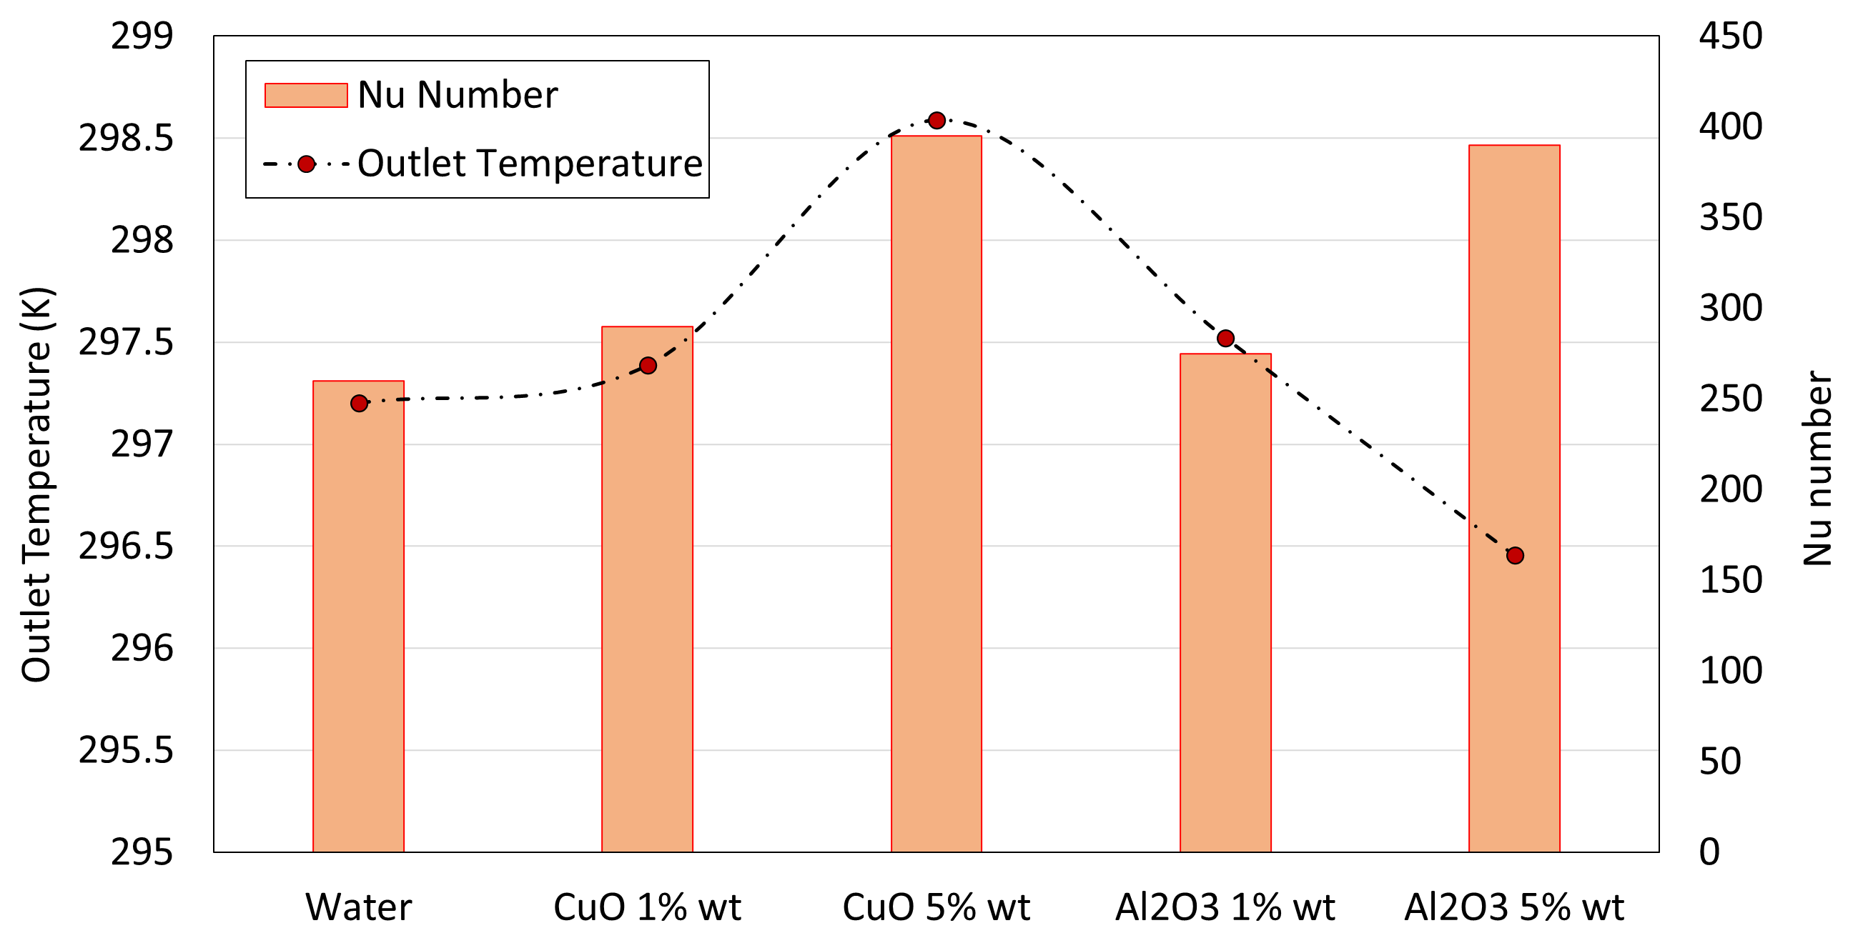
Figure 3: Average outlet temperature and Nusselt number
    - Temperature Distribution and Thermal Gradients
Detailed temperature profiles along the radial and axial directions highlighted the effectiveness of nanofluids in mitigating thermal gradients. CFD results revealed that nanofluids substantially reduced peak temperatures along the heated pipe wall. This is important for practical applications where thermal stresses can affect system reliability. Among all tested fluids, Al₂O₃–water (5 wt %) recorded the lowest peak temperatures, indicating superior heat dissipation characteristics.
    - Pressure Drop and Flow Dynamics
Turbulent flow simulations using the standard k–ε model indicated that, although nanofluids enhance heat transfer, they also increase pressure drop due to their higher viscosity compared to pure water. Among the nanofluids tested, CuO–water at 5 wt % had the highest viscosity and consequently the most substantial increase in pressure drop, followed by Al₂O₃–water at 5 wt %. Although these pressure drops increased, they remained within manageable limits for typical industrial pumping systems (Table 4).
Table 4: Reynolds Numbers and Pressure Drop Summary
Fluid | Reynolds Number | Pressure Drop  (kPa) | Pressure Drop over water (%)
Water | 4,990 | 1.115 | ---
CuO–water (1 wt %) | 4,490 | 1.206 | 8.32 %
CuO–water (5 wt %) | 3,480 | 1.348 | 21.2 %
Al₂O₃–water (1 wt %) | 4,580 | 1.175 | 5.22 %
Al₂O₃–water (5 wt %) | 3,350 | 1.256 | 8.32 %
    - Reynolds Number and Flow Regime Stability
The Reynolds numbers computed using the provided thermophysical properties confirmed that all fluids exhibited turbulent flow under the tested conditions, ensuring consistency across the simulations. Water had the highest Reynolds number (Re = 4,990), followed by CuO–water (1 wt %) with Re = 4,490 and Al₂O₃–water (1 wt %) with Re = 4,580. At higher concentrations (5 wt %), both nanofluids showed a notable decrease in Reynolds number, indicating a higher resistance to flow attributed to increased viscosity.
    - Computational Considerations
Solver configurations, including the use of the Smoothed Aggregation Algebraic Multigrid (AMG) solver with appropriate relaxation factors, ensured stable and accurate convergence of results across all tested fluids. The mesh independence study ensured that the simulation results were not affected by further mesh refinement. Additionally, solver convergence was ensured using a nonlinear residual threshold of 20, providing a balance between computational efficiency and solution accuracy.
  - Conclusions
The results strongly support the viability of nanofluids as superior heat transfer media in heat exchanger applications, with Al₂O₃–water at 5 wt % being particularly promising. Despite the higher pressure drops associated with increased viscosity, the substantial improvements in thermal performance justify their consideration in energy-efficient thermal management systems. Future research may focus on further optimizing particle concentration and exploring hybrid nanofluids to balance thermal efficiency and flow resistance through CFD simulations to support and best direct the necessary experimentation for full industrial deployment.
Acknowledgments
This study was developed in the framework of the research activities carried out within the Project “Network 4 Energy Sustainable Transition — NEST”, Spoke 8: Final use optimization, sustainability \& resilience in energy supply chain, Project code PE00000021, Concession Decree No. 1561 of 11.10.2022 adopted by Ministero dell’Università e della Ricerca (MUR), CUP UNIPA B73C22001280006, Project funded under the National Recovery and Resilience Plan (NRRP), Mission 4 Component 2 Investment 1.3 - Call for tender No. 341 of 15.03.2022 of Ministero dell’Università e della Ricerca (MUR); funded by the European Union – NextGenerationEU.
References
Choi S.U., Eastman, J.A., 1995, Enhancing thermal conductivity of fluids with nanoparticles, Argonne National Lab. (ANL), Argonne, IL, United States.
Cirrincione L., Malara C., Marino C., Nucara A., Peri G., Pietrafesa M., 2020, Effect of the thermal storage dimensions on the performances of solar photovoltaic-thermal systems, Renewable Energy, 162, 2004–2018.
Cirrincione L., La Gennusa M., Peri G., Rizzo G., Scaccianoce G.,2022, Foster carbon-neutrality in the built environment: A Blockchain-based approach for the energy interaction among buildings, Proceedings in 2022 Workshop on Blockchain for Renewables Integration (BLORIN), IEEE, 167–171.
Cirrincione L., Gennusa M.L., Peri G., Scaccianoce G., Camarda M.C., 2023a, Towards the energy optimization and decarbonization of urban settings: Proposal of a strategy at Neighbourhood Level to Foster Nearly Zero and Positive Energy Districts, Proceedings in 2023 IEEE International Conference on Environment and Electrical Engineering.
Cirrincione L., Geropanta V., Peri G., Scaccianoce G., 2023b, Enhance Urban Energy Management and Decarbonization Through an EC-based Approach, Proceedings in 2023 IEEE International Conference on Environment and Electrical Engineering.
Hong W.X., Che Sidik N.A., Saidur R., 2020, Impact of different surfactants and ultrasonication time on the stability and thermophysical properties of hybrid nanofluids, International Communications in Heat and Mass Transfer, 110, 104389.
Launder B.E., and Spalding D.B., 1983, The numerical computation of turbulent flows, In Numerical prediction of flow, heat transfer, turbulence and combustion (pp. 96-116). Pergamon.
Mahian O., Kianifar A., Kalogirou S.A., Pop I., Wongwises S., 2013, A review of the applications of nanofluids in solar energy, International Journal of Heat and Mass Transfer, 57(2), 582–594.
Peri G., Cirrincione L., Mazzeo D., Matera N., Scaccianoce G., 2024, Building resilience to a warming world: A contribution toward a definition of “Integrated Climate Resilience” specific for buildings - Literature review and proposals, Energy and Buildings, 315, 114319.
Saidur R., Leong K.Y., Mohammed H.A., 2011, A review on applications and challenges of nanofluids, Renewable and Sustainable Energy Reviews, 15(3), 1646–1668.
Sajid M.U., Ali, H.M., 2019, Recent advances in application of nanofluids in heat transfer devices: a critical review, Renewable and Sustainable Energy Reviews, 103, 556–592.
Sathishkumar A., Sundaram P., Cheralathan M., Kumar P.G., 2024, Effect of nano-enhanced phase change materials on performance of cool thermal energy storage system: A review, Journal of Energy Storage, 78, 110079.
Reverberi A.P., Vocciante M., Salerno M., Soda O., Fabiano B., 2022, A sustainable, top-down mechanosynthesis of carbohydrate-functionalized silver nanoparticles, Reaction Chemistry & Engineering, 7(4), 888–897.
Vocciante M., Kenig E.Y., 2021, Pillow-plate heat exchangers: an overview on advances, limitations and prospects, Chemical Engineering Transactions, 88, 865–870.
Weller H.G., Tabor G., Jasak H., Fureby C., 1998, A tensorial approach to computational continuum mechanics using object-oriented techniques, Computers in Physics, 12(6), 620–631.
Xuan Y., Li Q., 2000, Investigation on convective heat transfer and flow features of nanofluids, International Journal of Heat and Mass Transfer, 43 (19), 3701–3707.
Yu W., Xie H., 2012, A review on nanofluids: preparation, stability mechanisms, and applications, Journal of Nanomaterials, 2012 (1), 435873.

