 CHEMICAL ENGINEERING TRANSACTIONS  VOL. , 2025 | A publication of  
The Italian Association
of Chemical Engineering
Online at www.cetjournal.it

Guest Editors: Paolo Ciambelli, Luca di Palma
Copyright © 2025, AIDIC Servizi S.r.l.
ISBN 979-12-81206-20-5; ISSN 2283-9216

A study on the impact of temperature variations on the pyrolysis of corn-cob waste (Zea mays) for bioenergy production.
Juliana Puello-Mendezª, Jorgelina C. Pasqualino^{b} , Glicerio Leon-Mendez^{c}, Shirley Osorio-Herrera^{d}, Miguel Cuesta-Peña^{d}, Henry A. Lambis-Miranda^{e}*
ªGICI Research Group, Chemical Engineering Department, Universidad de San Buenaventura Cartagena, Diag. 32 # 30- 966, Cartagena, Colombia. jpuello@usbctg.edu.co ORCID: 0000-0003-0185-1053
^{b}GISAH Research Group, Environmental Engineering Program, Universidad Tecnológica de Bolívar, Campus Tecnológico, km 1 vía Turbaco Cartagena, Cartagena, Colombia. jpasqualino@utb.edu.co ORCID: 0000-0002-8731-762X
^{c}CIPTEC Research Group, Fundación Universitaria Tecnológico Comfenalco, Cartagena, Colombia.
ORCID: 0000-0002-9899-5872.
^{d}Processes and Systems program, Fundación Universitaria Tecnológico Comfenalco, Cartagena, Colombia. ORCID: 0000-0003-0485-8293
^{e*}Processes and Systems program, CIPTEC Research Group, Fundación Universitaria Tecnológico Comfenalco, Cartagena, Colombia. ORCID: 0000-0002-6261-4062.
*hlambis@tecnocomfenalco.edu.co
Thermogravimetric analysis (TGA) characterized the thermal stability and degradation of corn-cob waste (Zea mays). Results indicate that exposure to temperatures exceeding 240 °C causes approximately 50% mass loss. At this temperature, the drying stage removed traces of moisture and some low molecular weight aromatic molecules..
The degradation of corn-cob waste was carried out through pyrolysis in a Nitrogen (N₂) atmosphere, with these tests being carried out at 500, 550 and 600 °C, in order to observe how the variation in temperature affects the characteristics of the solid products obtained, to know their stability, tests are carried out on each of the solid products at each indicated temperature; While 550 °C exhibited the highest percentage of weight loss, 600 °C was selected. This choice maintains a gradual progression in the percentage of weight loss, even though 500 °C and 600 °C showed similar mass loss values.
Finally, FTIR tests are implemented, which are responsible for decoding the signal, which results in the generation of spectra that are used to identify or quantify the material existing in the samples. According to the results, it is inferred that the pyrolysis of corn-cob waste has caused the elimination of the molecules responsible for the vibrations of the O-H, C-H, and C-O bonds. This loss could be explained by the degradation of polysaccharides; Instead, the bonds CO, CH, C=C, C=O, CO and CH are conserved, the latter being commonly found in ethers and aromatic compounds that include hydroxyl groups.

  - Introduction
The valorization of corn-cob waste through pyrolysis has emerged as a promising alternative for the production of high-energy value products. In this context, the analysis of temperature as a relevant factor in this process becomes a fundamental aspect of study, in order to understand its behavior, thereby optimizing its efficiency and maximizing the generation of desired products. Solid waste generated from productive and consumer activities has the potential to become an economic resource. Valorization is an alternative that seeks to harness its utility through the recycling of inorganic substances and metals, energy generation, the production of compost, fertilizers, and other biological transformations. Components can also be recovered, and soils treated or remediated, among other options that avoid their final disposal (Gosgot Angeles et al., 2021; Singh & Sawarkar, 2020).
The primary objective of this work is to evaluate the effect of temperature on the distribution of solid products during the pyrolysis of corn-cob waste, using nitrogen (N₂) as an inert gas. To achieve this, an exhaustive characterization of the physicochemical and thermal properties of the aforementioned residues was conducted to determine the appropriate temperature conditions for an optimal pyrolysis process.
Furthermore, thermogravimetric analysis (TGA) was utilized to identify the ideal temperature conditions for pyrolysis, and Fourier-transform infrared spectroscopy (FTIR) was employed to analyze the solid products generated from different process temperatures. The obtained results will enable the establishment of optimal temperature conditions to maximize the generation of high-quality solid products from maize residues, thereby contributing to the valorization of these residues and the sustainability of the agro-industrial sector(Hernandez-Fernandez et al., 2023; Kanwal et al., 2019).
Maize (Zea mays) is a fundamental cereal for food consumption in Colombia; however, the country heavily relies on imports to meet domestic demand. In 2021, 42% of Colombia's food imports consisted of maize. Out of the 14 million tons of food imported by Colombia in 2021, 42% was maize, totaling 6,017,059 tons (5,654,325 tons of yellow maize plus 362,734 tons of white maize) (Forero-Sandoval, 2020).
This is considered in light of the fact that agro-industrial residues have significant exploitation potential due to their diverse chemical composition, which has led to the creation of various alternatives for their reuse. These residues can be converted into raw materials for different processes and products of environmental, social, or economic interest. Additionally, they are used to remediate environments contaminated by textile effluents, heavy metals, and hydrocarbons. They are also employed in the production of bioenergetic fuels such as biodiesel, bioethanol, biogas, and energy biomass, as well as in the manufacture of organic fertilizer, animal feed, bricks, paper, and biomaterials. These uses contribute to preventing negative environmental impacts resulting from inadequate waste management and unsustainable industry practices(Alexandra Vargas Corredor & Ibeth PÉREZ PÉREZ, 2018; AZUBUIKE, 2023).
The objective of this work was to evaluate the effect of temperature on the distribution of products (solids) from the pyrolysis process of corn-cob (Zea mays) using Nitrogen (N₂) as an inert gas. Using Fourier Transform Infrared Spectroscopy (FTIR) and Thermogravimetry (TGA) techniques. This article presents an analysis of the most important functional groups present in a resource with great potential as a raw material for the development of new biofuels, using pyrolysis as a means of exploitation.
  - Methodology
    - Geographical origin of corn-cob (Zea mays) samples
Of the wide variety of waste generated in the different stages of corn cultivation, this project uses corn-cob as its raw material, limiting itself to corn produced in Bolívar, in Pasacaballos town, in northern Colombia.

2.2 Physicochemical characterization

The crude corn-cob was dried at room temperature, it was placed in the sun for 4 days in a row, after which it should be subjected to high temperatures (45 °C) by using an oven for 8 or 12 hours, seeking to reduce the humidity of the raw material by up to 10%. In addition, the Fiber, Protein and Ashes were calculated using the method described in (Ferreira-Villadiego et al., 2018)
Subsequently, the grinding and sieving process must be applied, in order to guarantee homogeneous fractions within the thermal degradation, the above, in compliance with the ASTM E 11/95 standard, which establishes the size of the mesh that the sieves must have, ensuring that it is around 4-5 mm. TGA tests are continued, in order to complete the characterization of the sample in TGA-50 (Shimadzu®) device.
Table 1: Parameters for TGA testing of samples.
Parameter | Value
Atmosphere | Nitrogen
Flow rate (ml/min) | 20
Sample weight (mg) | 7.902
Heating ramp (ºC/min) | 20
Max. Temperature(ºC) | 800

Samples of corn-cob were analyzed in a FT-IR SHIMATZU® 8400S spectrophotometer, using the KBr pellet method according to the ASTM-E168 and ASTM-E1252 standards, to obtain information on the characteristic functional groups (Ajibola et al., 2022). To obtain information about the composition of the samples and their thermal stability, a Thermogravimetric Analysis (TGA) test was carried out by the ASTM E1131-98 standard. Each sample of corn-cob is heated at a rate of 20°C/min, in a nitrogen(N₂) atmosphere between 50 and 600°C,(Castro et al., 2021). The weight loss over specific temperature indicates the composition of the sample, including volatiles and inert filler, as well as indications of thermal stability. Table 1 below lists the operational conditions under which the TGA analysis of the samples was carried out and Table 2 shows the details of the FTIR tests (Liu et al., 2014).
Table 2: Parameters for FTIR testing of samples.
Parameter | Value
Intensity mode | % Transmittance
No. of Scans | 15
Resolution (cm⁻¹) | 400-4000
  - Results
    - Assessment of solid products from the corn-cob waste pyrolysis process, based on temperature using FTIR
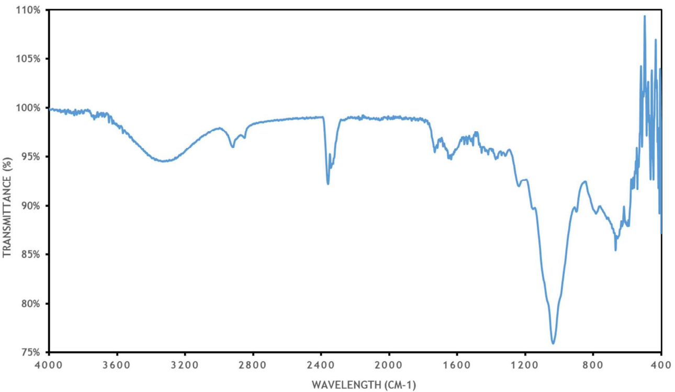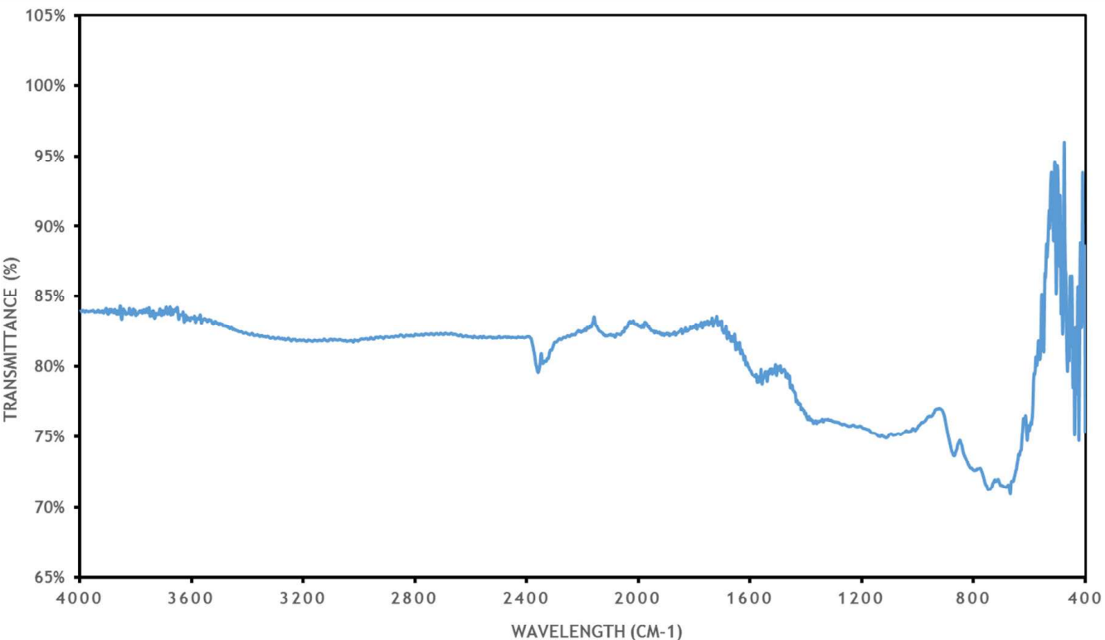Figure 1: FTIR spectrum of corn-cob waste, before a) and after pyrolysis, b) at 600 °C.
b)
a)

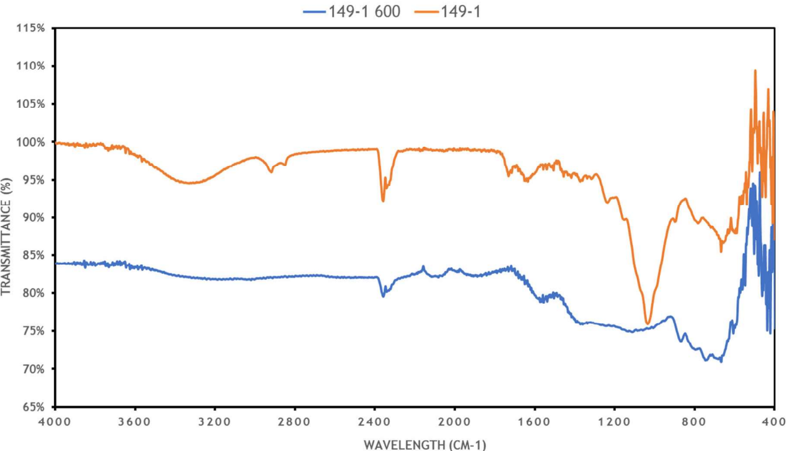

Figure 2: Comparison of FTIR spectra of the sample before and after pyrolysis (600 °C)

The Figure 1a) shows the results of the experiment performed on corn-cob before pyrolysis, from which the presence of O-H bonds is determined due to the broad band at 3331.07 cm⁻¹, this is certainly due to the high presence of fiber in its structure. Similarly, the bands at 2918.30 and 2850.79 cm⁻¹ correspond to C-H bonds present in the sample molecules. Since there are no bands in the range of 2500 cm⁻¹ to 2000 cm⁻¹, the presence of molecules with C-C and C-N triple bonds is ruled out. The band at 1730.15 cm⁻¹ corresponds to C=O bonds, which are generally found in compounds with carbonyl groups, such as aldehydes, ketones, esters and carboxylic acids. The band at 1633.71 cm⁻¹ is possibly associated with C=C bond vibrations, mainly in stretching of aromatic and other groups. Finally, the band at 1075 cm⁻¹ is characteristic of C-O bond stretching.
In Figure 1b), different bands are observed in the spectrum. The bands at 2358.91 cm⁻¹ and 2341.58 cm⁻¹ correspond to C=O bonds. Furthermore, the bands at 1568.13 cm⁻¹ and 1556.55 cm⁻¹ possibly indicate the vibration of C=C bonds. Finally, the bands between 1000 cm⁻¹ and 1200 cm⁻¹ are characteristic of the vibrations of CO and CH bonds, which are generally present in ethers and aromatic compounds containing hydroxyl groups.
Figure 2 shows a comparison between two FTIR analyses, one performed before the pyrolysis process and another after subjecting the biomass to a temperature of 600 °C in a nitrogen atmosphere. From the graph, it can be concluded that the biomass residue subjected to pyrolysis has lost the molecules that generate the vibrations of the O-H bonds, as well as the C-H and C-O bonds. This loss could be attributed to the degradation of the polysaccharides present in the corn-cob waste.

    - Thermogravimetric analysis of solid waste from the pyrolysis process at different temperatures.

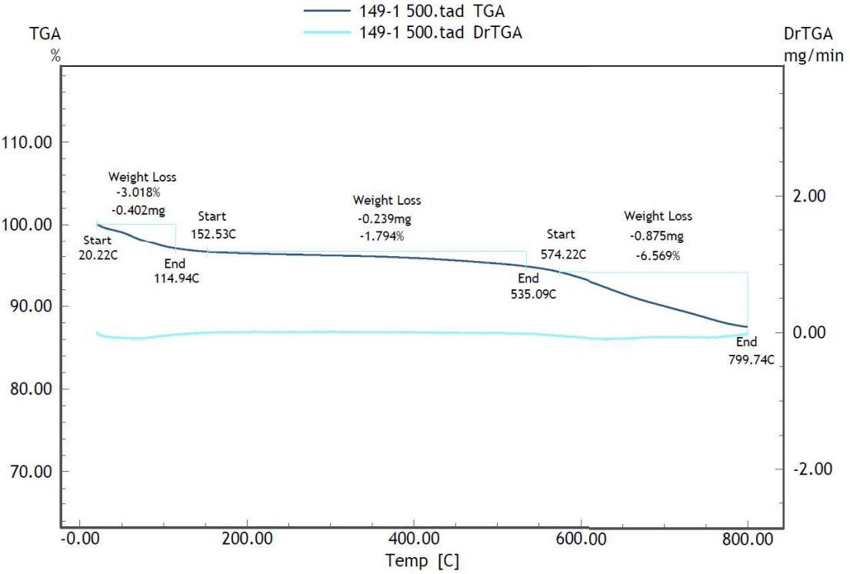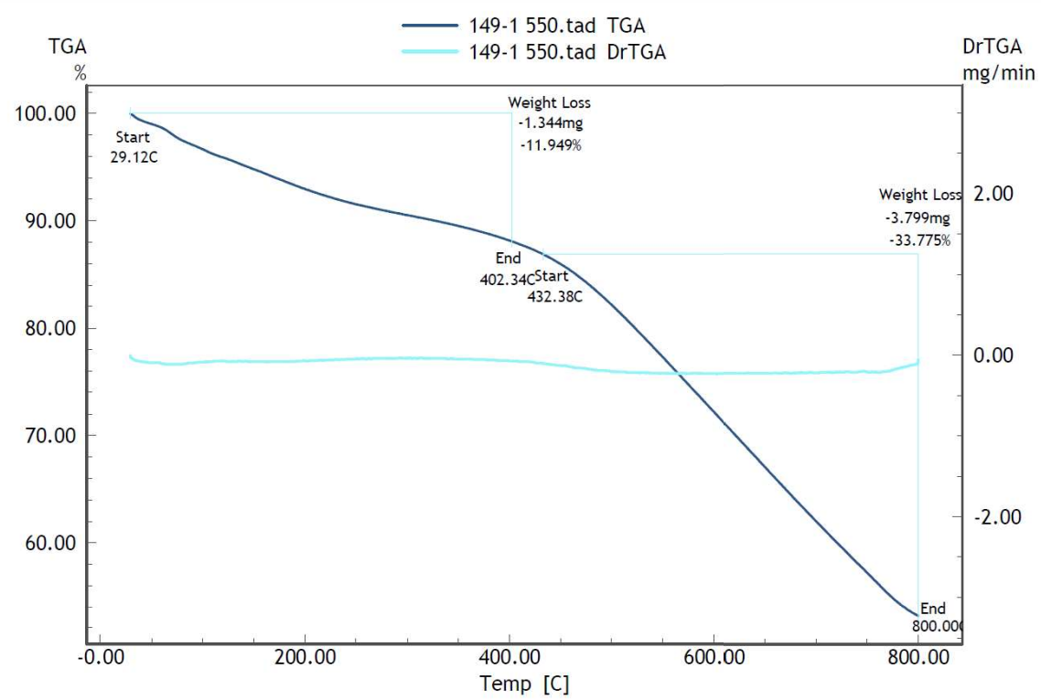
b)
a)

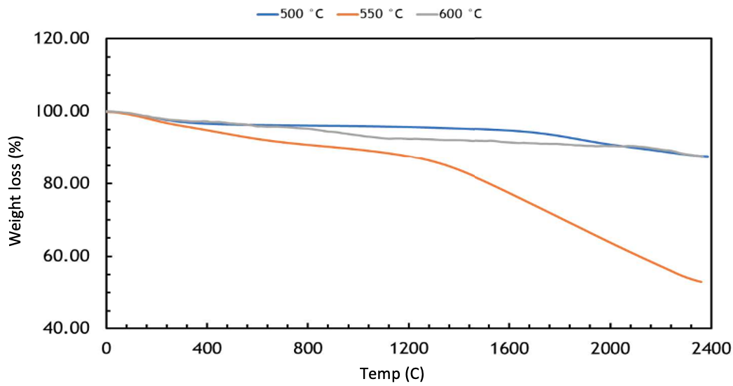
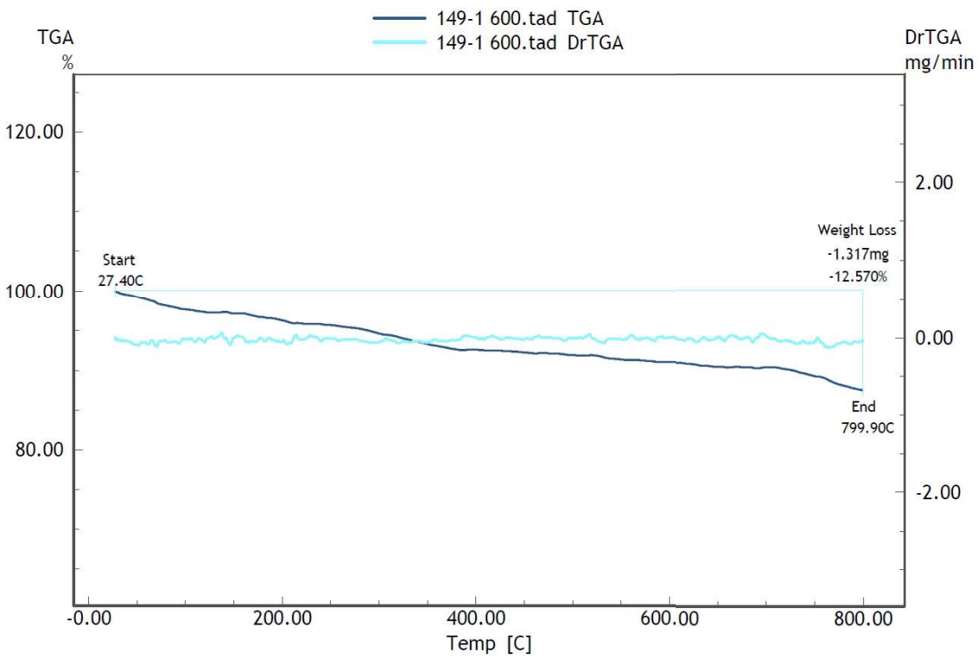
d)
c)

Figure 3: TGA of solid waste from the pyrolysis process of corn-cobs (a, b and c) and Comparison of percentage mass loss of solid pyrolysis residues at three temperatures (d).

The TGA test from corn-cob residue after pyrolysis process in nitrogen atmosphere and up to 500 °C was carried out in a TGA-50 device (Shimadzu®). The sample was heated from room temperature to 800 °C at a rate of 20 °C/min using 13320 mg of sample. Figure 3a) shows the results obtained, from which it was established that the decomposition of the material consists of three stages. In the first, there is a loss of 3.018% in mass of material; In the second phase, the remaining biomass changes its mass by 1.794% between temperatures of 152.53 °C and 535.09 °C. Finally, there is a loss of 6.569% of the mass of the material at temperatures above 574.22 °C.
The results of the TGA test at 550 C are shown in Figure 3b), a sample amount of 11.248 mg was used. The test results show that the decomposition of the material occurs in two distinct stages. The first stage covers temperatures between 29.12°C and 402.34°C, during which a mass loss of 11.949% occurs in the biomass residue. In the second stage, a mass loss of 33.775% is observed above 432.38°C.
In the TGA test at 600 C, 10,477 mg of the sample were used. The results showed that the decomposition of the material occurred in a single stage, gradually, within the temperature range established for the experiment. During this stage, 12,570% of the initial mass of the material was lost, as seen in Figure 3c).
From the previous graphs (3a), 3b) and 3c)), a comparison is made between the three analyses recorded in this section Figure 3d) shows that biomass residue undergoes greater thermal degradation when pyrolyzed at 550°C compared to samples subjected to 500°C and 600°C. It is also observed that the biomass residues subjected to pyrolysis at 500°C and 600°C show a similar percentage of mass loss when heated to 800°C.

The similar mass loss values observed at both 500 °C and 600 °C when heated to 800 °C further supported the choice of 600 °C. While 550 °C showed the highest thermal degradation, the comparable performance of 500 °C and 600 °C in terms of overall mass loss, combined with the desire for a consistent progression, led to the selection of 600 °C for continued study of the solid products from the pyrolysis process. This approach allows for a systematic understanding of the pyrolysis process across a temperature range where the material exhibits similar degradation characteristics, facilitating a more controlled investigation into product characteristics.

  - Conclusions

- The implementation of Thermogravimetric Analysis (TGA) laboratory tests allowed us to determine the thermal stability and degradation of corn-cob waste, where it is observed that they should not be exposed to temperatures above 240 °C.

- Based on the TGA, the temperature at which the highest percentage of weight loss is observed is 550 °C, even though the temperatures of 500 and 600 °C present similar loss values, a temperature of 600 °C is chosen to maintain a gradualness in terms of the percentage of weight loss.

- According to the FTIR results, it is inferred that the pyrolysis of corn-cob waste has caused the elimination of the molecules responsible for the vibrations of the O-H, C-H and C-O bonds. This loss could be explained by the degradation of the polysaccharides.

Acknowledgments
This work was funded by Fundación Universitaria Tecnológico Comfenalco and the University of San Buenaventura (Cartagena), and the Universidad Tecnológica de Bolivar is acknowledged for supporting the preparation of this article.
References
Ajibola, M. T., Agbaji, V. O., & Yashim, E. B. (2022). Properties of Upgraded Bio-oil from Pyrolysis of Waste Corn Cobs. Original Article Journal of Sustainability and Environmental Management, 1(2), 120–128. <nepjol.info/index.php/josem>
AZUBUIKE, C. (2023). Preparation and characterization of corn cob cellulose acetate for potential industrial applications. THE NIGERIAN JOURNAL OF PHARMACY, 57(2). https://doi.org/10.51412/psnnjp.2023.31
Castro, B., Rodríguez, J., Hernández, W., Camargo, G., & Agudelo, N. (2021). Evaluation of the pyrolysis process with corn and coconut wastes in CO2 atmosphere. Av. cien. ing, 12(2), 33–46. <dialnet.unirioja.es/servlet/articulo?codigo=8081180>
Ferreira-Villadiego, J., García-Echeverri, J., Vidal, M. V., Pasqualino, J., Meza-Castellar, P., & Lambis-Miranda, H. A. (2018). Chemical modification and characterization of starch derived from plantain (Musa paradisiaca) peel waste, as a source of biodegradable material. Chemical Engineering Transactions, 65, 763–768. https://doi.org/10.3303/CET1865128
Forero-Sandoval, J. D. (2020). Corn cob: a renewable energy source. Revista Universitas Científica, 16(2), 62–65. <revistas.upb.edu.co/index.php/universitas/article/view/1686>
Gosgot Angeles, W., Rivera López, R. Y., Rascón, J., Barrena Gurbillón, M. Á., Ordinola Ramirez, C. M., Oliva, M., & Montenegro Santillan, Y. (2021). Valorización energética de residuos orgánicos mediante pirolisis. Revista de Investigación de Agroproducción Sustentable, 5(2), 26. https://doi.org/10.25127/aps.20212.766
Hernandez-Fernandez, J., Lambis, H., & Reyes, R. V. (2023). Application of Pyrolysis for the Evaluation of Organic Compounds in Medical Plastic Waste Generated in the City of Cartagena-Colombia Applying TG-GC/MS. International Journal of Molecular Sciences, 24(6). https://doi.org/10.3390/ijms24065397
Kanwal, S., Munir, S., Chaudhry, N., & Sana, H. (2019). Physicochemical characterization of Thar coal and torrefied corn cob. Energy Exploration and Exploitation, 37(4), 1286–1305. https://doi.org/10.1177/0144598719834766
Liu, X., Zhang, Y., Li, Z., Feng, R., & Zhang, Y. (2014). Characterization of corncob-derived biochar and pyrolysis kinetics in comparison with corn stalk and sawdust. Bioresource Technology, 170, 76–82. https://doi.org/10.1016/j.biortech.2014.07.077
Singh, S., & Sawarkar, A. N. (2020). Pyrolysis of corn cob: Physico-chemical characterization, thermal decomposition behavior and kinetic analysis. Chemical Product and Process Modeling, 16(2), 117–127. https://doi.org/10.1515/cppm-2020-0048
Vargas Corredor, Y. A., & Pérez Pérez, L. I. (2018). Use of agro-industrial waste in improving the quality of the environment. Historia Del Artículo Resumen | Abstract |, 14(1), 59–72. https://doi.org/10.18359/rfcb.3108

