 CHEMICAL ENGINEERING TRANSACTIONS  VOL. , 2025 | A publication of  
The Italian Association
of Chemical Engineering
Online at www.cetjournal.it

Guest Editors: Paolo Ciambelli, Luca di Palma
Copyright © 2025, AIDIC Servizi S.r.l.
ISBN 979-12-81206-20-5; ISSN 2283-9216

Thermodynamics and kinetics of CO₂ adsorption on nanoporous WV1050 activated carbon at 20 °C and pressures up to 35 bar
Ana L.N. Santos^{a,b}, Deborah C. Silva^{b,c}, Ladislane S. Bastos^{a,b}, Fábio P. Nascimento^{a,b}, Reinaldo C. Mirre^{a,b}, Karen V. Pontes^{a,c}, Silvio A.B. Vieira de Melo^{a,b,c}*
ªGraduate Program in Industrial Engineering (PEI), Polytechnic School, Federal University of Bahia, Rua Aristides Novis, 2, Federação, Salvador, Bahia 40210-630, Brazil;
^{b}LABCO2, Interdisciplinary Center in Energy and Environment (CIENAM), Federal University of Bahia, Rua Barão de Jeremoabo, S/N, Ondina, Salvador, Bahia 40170-115, Brazil;
^{c}Department of Chemical Engineering (DEQ), Polytechnic School, Federal University of Bahia, Rua Aristides Novis, 2, Federação, Salvador, Bahia 40210-630, Brazil.
sabvm@ufba.br
Thermodynamic and kinetic investigations are essential to understanding the mechanisms involved in adsorbent-adsorbate interaction and evaluating adsorption capacity and time to achieve separation. In this study, the adsorption equilibrium isotherm and the adsorption kinetics of pure CO₂ on WV1050, a granular commercial activated carbon, were investigated experimentally in a gas sorption analyzer coupled with a magnetic suspension at 20 °C and pressures up to 35 bar. Using a volumetric apparatus, the adsorption equilibrium isotherm determined agrees with previously measured isotherm data. The adsorption kinetics was modeled using the experimental equilibrium data measured and GNU Octave software for pseudo-first order, pseudo-second order, and Avrami models. The best results were provided by the Avrami model, which usually presents a time-dependent adsorption rate coefficient. Further studies are underway to use this model in the simulation and design of the gas adsorption bed.
Introduction
Mitigating the effects of CO₂ emissions is an important challenge to address climate change and the energy transition. Adsorption is one of the most important and widely used technologies due to its relatively simple design and operation, cost-effectiveness, and energy efficiency (Tan and Hameed, 2017). It is promising for CO₂ capture (Moubarak et al., 2023). A key application is CO₂ separation from associated gas streams in the Brazilian pre-salt, which has a high content of CO₂. It should be reduced to a maximum of 3% mol for natural gas commercialization (ANP, 2008). Adsorbent selection is crucial to improve efficiency and economic and operational criteria (Regufe, 2019). Activated carbon is one of the most used materials in Pressure Swing Adsorption (PSA) and Temperature Swing Adsorption (TSA) due to its higher adsorption at relatively high pressures compared to other materials (Jribi et al., 2017). One of the most accurate techniques for obtaining adsorption data is the gravimetric method with the gas analyzer coupled to a magnetic suspension balance. It allows weight measures with very low errors covering large temperature and pressure ranges without further analytical instrumentation (Yang et al., 2023). This gravimetric apparatus is widely used to obtain equilibrium adsorption isotherm data, providing adsorptive capacity versus pressure plots. During the experiments, gas is dosed to reach the next pressure step after collecting equilibrium data at a given pressure. Then, the adsorbed amount against time is recorded until a new equilibrium is reached. These data can be used for adsorption kinetics studies (Tan and Hameed, 2017). Investigating thermodynamics and kinetics is essential to understanding the PSA and TSA mechanisms involved in adsorbent-adsorbate interactions. Industrial applications require a rapid adsorption rate, which is understood through adsorption kinetics, and high capacity and selectivity, which are provided by thermodynamics (Álvarez-Gutiérrez et al., 2017; Jribi et al., 2017). The external diffusion influences the adsorption rate, the internal diffusion in the pores of the adsorbent, and the adsorption on active sites of the adsorbent (Loganathan et al., 2014). Usually, adsorption kinetics have been described by the classical pseudo-first-order (PFO), the pseudo-second-order (PSO) models, and the Avrami equation (Tan and Hameed, 2017). PFO and PSO have been applied to evaluate various systems, such as biomass to nanomaterials as adsorbents and heavy metals to pharmaceuticals as adsorbates (Revellame et al., 2020). The Avrami equation was originally developed to study phase transition and crystal growth rates, but has been successfully applied to describe the adsorption of gases on solids as a model that presents a time-dependent adsorption rate coefficient (Revellame et al., 2020). Estimated kinetics models and their parameters are useful in bringing new insights about CO₂ adsorption sites and adsorbent performance and identifying operational conditions (Tan and Hameed, 2017). The present work preliminarily evaluated the thermodynamics and kinetics of CO₂ adsorption on WV1050, a granular commercial activated carbon (AC), to provide insight for the simulation and design of the gas adsorption bed.
Methodology
Experimental runs to plot the adsorption equilibrium isotherms and determine the kinetics of pure CO₂ adsorption on WV1050 (Rios et al., 2011) were carried out in a gas sorption analyzer coupled with a magnetic suspension balance (Rubotherm Series IsoSORP SA, model 150-350 S-SC) at 20 °C and pressures up to 35 bar. The textural characteristics of WV1050 were taken from the literature (Rios et al., 2011) with a BET area of 1615 m²g⁻¹, micropore volume of 0.76 cm³g⁻¹, total pore volume of 1.04 cm³g⁻¹ and average pore width of 2.55 nm. The PSA method was used to build the equilibrium isotherms of pure CO₂ in the gravimetric analyzer. This apparatus measures equilibrium data but also provides the mass adsorbed over time until reaching the equilibrium, which was used to analyze the adsorption kinetics in each pressure step using the pseudo-first-order (PFO), pseudo-second-order (PSO), and Avrami models (Revellame et al., 2020; Songolzadeh et al., 2015; Tan and Hameed, 2017). GNU Octave (2024) allowed for model fitting by parameter estimation based on the sum of the absolute differences between experimental and predicted values. Querejeta et al. (2022) state that these simpler relations are preferred because they are more readily solved and do not require much computer effort, which is important to apply in industrial plant simulations. The PFO assumes that the adsorption rate is proportional to the number of free available sites on the adsorbent surface. At the same time, PSO is proportional to the square of free available sites on the adsorbent surface (Singh and Kumar, 2016). PFO and PSO are given by Eq(1) and Eq(2), respectively.
$$\frac{dq}{dt}=k_{1} (q^{*}-q)$$ | (1)

$$\frac{dq}{dt}=k_{2} (q^{*}-q)^{2}$$ | (2)
where $q$ is the adsorption capacity (mmol g⁻¹), $q^{*}$ is the experimental adsorption capacity in equilibrium (mmol g⁻¹), $k_{1}$ is the pseudo-first-order rate constant (min⁻¹), and $k_{2}$ is the pseudo-second-order rate constant (g mmol⁻¹ min⁻¹). The rate constant can describe how fast the adsorption equilibrium is achieved (Plazinski et al., 2009). Wang and Guo (2020) conclude that PFO can determine the initial stage of adsorption and adsorption in a few actives site of the adsorbent, while PSO can describe the final stage of adsorption and the existence of many active sites in the adsorbent.

The Avrami equation model has a time-dependent rate coefficient (Tan and Hameed, 2017) and can describe the kinetics of crystallization, accounting for random nucleation and their growth (Querejeta et al., 2022). Eq(3) shows the equation (Songolzadeh et al., 2015):
$$\frac{dq}{dt}=k^{n}t^{(n-1)} (q^{*}-q)$$ | (3)
where $k$ is the Avrami kinetic constant (min⁻¹) and $n$ is a model constant related to the adsorption mechanism. If $n$ equals 1, the equation reduces to PFO (Tan and Hameed, 2017). $t$ is the time in minutes.
To evaluate the fit and determine the best model, the sum of squared errors (SSE), the coefficient of determination (R²), and the Akaike criterion (AIC) (Dávila-Jiménez et al., 2014) were estimated by Eq(4), Eq(5) and Eq(6), respectively.
$$SSE = \sum{{(q}_{t,exp}-q_{t,pred})²}$$ | (4)
$$R^{2}=1-\left(\frac{\sum_{i=1}^{N}{{(q}_{t,exp}-q_{t,pred})²}}{\sum_{i=1}^{N}{{(q}_{t,exp}-\overline{q_{t,exp}})²}}\right)$$ | (5)
$$AIC=N\ln\left(\frac{SSE}{N}\right)+2p+ \frac{2p(p+1)}{N-p-1}$$ | (6)
where $q_{t,exp}$ and $q_{t,pred}$ are the experimentally measured and model-predicted adsorptive capacity (mmol g⁻¹), respectively; $N$ is the number of data points and $p$ is the number of parameters of the model.
Results and Discussion
The isotherm obtained in the present study using a gravimetric method and the data measured by Rios et al. (2013) using a volumetric apparatus are compared in Figure 1 for the same conditions, as well as fitted using the Langmuir model (Rios et al., 2013). The experimental uncertainty in this study was calculated using a Monte Carlo Simulation, and the error bars were plotted considering a confidence level of 95% (coverage factor k = 2). Although Rios et al. (2013) do not report uncertainties, it is possible to notice a good agreement, especially at low pressures, since most points show the same tendency and are almost overlapping. According to Burress et al. (2017), the volumetric technique employed by Rios et al. (2013) tends to present larger experimental errors at higher pressures, which may explain the differences between the two techniques observed in this region.
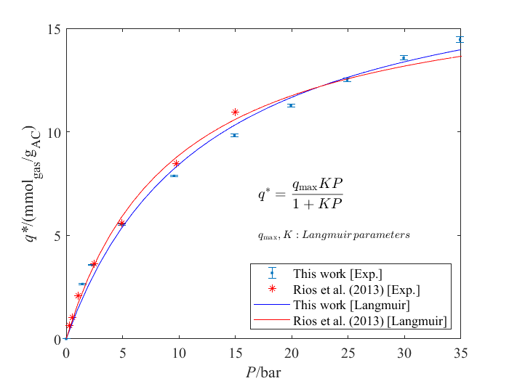
Figure 1: WV1050 CO₂ equilibrium adsorption ($q^{*}$) at 20 °C.
Table 1 shows the results of parameter estimation of the Langmuir model for the CO₂ adsorption experimental data measured in the present work and those by Rios et al. (2013). The lower the SSE value, the closer the prediction is to the experimental value. For R², values closer to 1 indicate a better model fit to the experimental data. This work presents a performance superior to Rios et al. (2013) when SSE and R² values are compared. Since the R² value is close to 1, the Langmuir model’s assumptions adequately explain the adsorption phenomenon.
Table 1: Model evaluation and adjusted parameters for the Langmuir isotherm for CO₂ adsorption on WV1050 at 20 °C from vacuum to 35 bar.
This work |  |  |  | Rios et al. (2013)
SSE | R² | q_{max} (mmol g⁻¹) | K (bar⁻¹) | SSE | R² | q_{max} (mmol g⁻¹) | K (bar⁻¹)
1.724 | 0.987 | 18.954 | 0.0792 | 2.582 | 0.983 | 17.396 | 0.104

Kinetic experimental data and adjusted parameters are plotted against pressure in Figure 2. Experimental data (Figure 2a) had behavior like the one reported by Jribi et al. (2017), with specific kinetic curves for each interval between two equilibrium points. Since there is no tendency in the adjusted parameters for pressure range (Figure 2b), it was impossible to define one representative parameter to cover all pressures investigated for each equation.
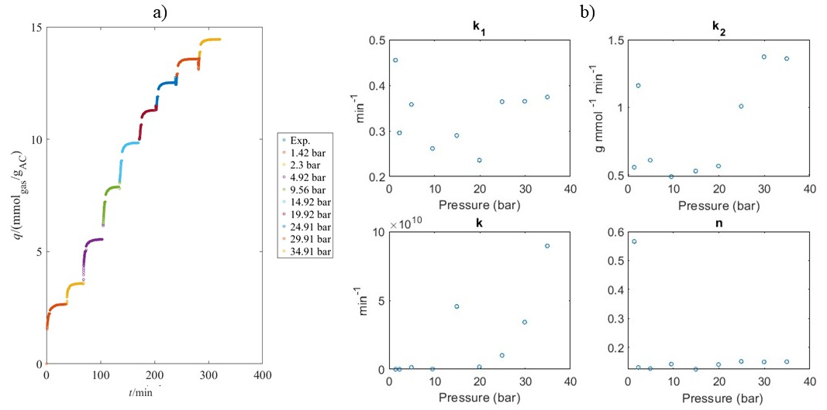
Figure 2: (a) experimental data of WV1050 kinetics of CO₂ adsorption ($q$) at 20 °C and pressure up to 35 bar; (b) adjusted parameter for Eq(1), Eq(2) and Eq(3) plotted against pressures up to 35 bar.
Kinetic model data are needed to model the breakthrough curves and the cyclic processes of separation of CO₂ from other gases. Therefore, it is interesting to determine adjustable parameters that work for all ranges instead of defining parameters for isolated points. Hence, this work discusses kinetics model fitting for pressure up to 1.42 bar, a pressure range where most of the CO2 adsorption as a capture process occurs, especially CO2 separation from natural gas using Temperature Swing Adsorption (TSA) and Vacuum Swing Adsorption (VSA). Concerning the kinetic study, the fitting results using PFO, PSO, and Avrami models are shown in Table 2 for 20°C and pressure up to 1.42 bar. The model fitting results for the PFO, PSO, and Avrami equations are reported in Table 3 for the same conditions. The Akaike criterion (AIC) was used to compare models' performance with different parameters since PFO and PSO have one adjusted parameter, but the Avrami model has two. This allows a fair comparison of these models, preventing the Avrami model from being considered the best because it has one more parameter than the others. AIC evaluates the trade-off between model simplicity and efficiency. So, when models are compared, the lower the AIC values, the more accurate the prediction is. The best results for model evaluation are indicated by bold numbers in Table 3.
Table 2: Kinetic model parameters for CO₂ adsorption on WV1050 at 20 °C up to 1.42 bar.
Pressure (bar) | Pseudo-first order | Pseudo-second order | Avrami model
Pressure (bar) | $k_{1}$ (min⁻¹) | $k_{2}$ (g mmol⁻¹ min⁻¹) | $k$ (min⁻¹) | $$n$$
0 – 1.42 | 0.455 | 0.558 | 0.240 | 0.566
Table 3: Model evaluation for CO₂ adsorption on WV1050 at 20 °C up to 1.42 bar.
Pressure (bar) | Pseudo-first order |  |  | Pseudo-second order |  |  | Avrami model
Pressure (bar) | SSE | R² | AIC | SSE | R² | AIC | SSE | R² | AIC
0 – 1.42 | 2.883 | 0.868 | -1352.000 | 1.215 | 0.944 | -1605.200 | 0.044 | 0.998 | -2576.200

The PFO model characterizes the physisorption well when the surface diffusion is the control step of the gas-solid adsorption process. In turn, the PSO model is normally used for the chemisorption process controlled by chemical interaction. Avrami equation considers different mechanisms, such as surface diffusion, intraparticle diffusion, and physical and chemical interactions between the adsorbate and the adsorbent (Vega, Días-Faes and Barriocanal, 2024). The Avrami model reduces to PFO when $n$ is closer to 1, but this is not the case in this study, as reported in Table 2. The best result in Table 3 is for the Avrami model. Aligning with that, Figure 3 presents the models’ prediction compared to the experimental values for CO₂ adsorption kinetics for the same condition. It is also possible to see that the Avrami model predictions are closer to the experimental values in Figure 3. For a time less than 1 minute, PFO and Avrami have similar results, which are closer to the experimental values of PSO. After that, Avrami provides results that better represent the experimental data, while PFO and PSO underestimate or overestimate capacity values. Álvarez-Gutiérrez et al. (2017) and Querejeta et al. (2019) also gave results for CO₂ adsorption in activated carbon from biomass, and both also had a better fit for the Avrami model. The CO₂ adsorption increases rapidly in the first minutes (less than 5 minutes), possibly due to the availability of more active sites. This implies that the rate significantly decreases until equilibrium is reached. Since WV1050 is a microporous material, adsorption occurs as the empty porous material is filled with CO₂ molecules, and volume controls its filling process. For this reason, pore volume and superficial area can be decisive in CO₂ adsorption in the micropores of the activated carbons.
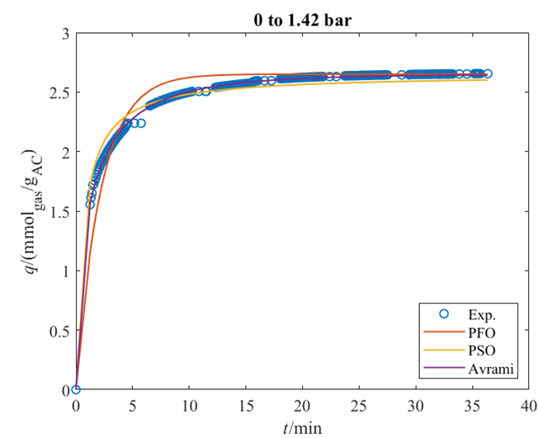
Figure 3: WV1050 kinetics of CO₂ adsorption ($q$) at 20 °C and pressure up to 1.42 bar. Symbols are experimental data, and lines are calculated with PFO, PSO, and Avrami models.
For equilibrium isotherm determination, experimental conditions of higher pressures were explored to achieve a better model fitting. Since the gravimetric analyzer allows high-pressure experiments with high accuracy, this key property was used to collect more points and to reach values closer to maximum adsorption. Isotherm model fitting allowed the identification of parameters that evaluate the interaction between adsorbent and adsorbate. Higher values for these parameters indicate that the adsorbate molecules are more attracted to solid surfaces and have a higher capture rate of the adsorbate. Therefore, choosing the best model for the isotherm is important to determine equilibrium data. Moreover, kinetic models are important in modeling fixed-bed adsorption since they depend on the adsorption rate. Identifying the best model to describe the phenomenon allows more accurate simulator predictions. Hence, identifying the most suitable isotherm and kinetic models is essential for guiding future studies on fixed-bed systems and simulations.
Conclusions
This work evaluated the kinetic study of CO₂ adsorption in the granular commercial activated carbon WV1050 at 20 °C in the range up to 1.42 bar. Experimental isotherm equilibrium data were obtained up to 35 bar and showed good agreement with the literature-reported data. A kinetics study was performed to fit the models to the experimental data, considering pseudo-first-order, pseudo-second-order, and Avrami equations. The Avrami equation better predicted the adsorbent capacity for this pressure range. Moreover, the best fit for the Avrami equation indicates that the kinetics of CO₂ adsorption on WV1050 have complex pathways, including surface diffusion, intraparticle diffusion, and physical and chemical interactions. Furthermore, kinetic studies can give information about the adsorption rate, adsorbent performance, and possible mass transfer mechanisms that can later be related to textural properties. Therefore, the data reported here are the preliminary results that can assist in the simulation and design of the gas adsorption bed to be carried out. Future experiments with the same adsorbent but with different gases, such as CO₂ and CH₄ binary mixture, can help to better understand the separation and capture of CO₂ in offshore applications.
Nomenclature
K – Langmuir parameter, bar⁻¹
$k_{1}$ – pseudo-first order rate constant, min⁻¹
$k_{2}$ – pseudo-second order rate constant, g mmol⁻¹ min⁻¹
$k$ – Avrami kinetic constant, min⁻¹
$N$ – number of points for model fit
$n$ – model constant related to adsorption mechanism in the Avrami equation
$p$ – number of parameters of the model
$q$ – adsorption capacity, mmol g⁻¹
$q^{*}$ – experimental adsorption capacity in equilibrium, mmol g⁻¹
q_{max} – Langmuir model parameter (maximum capacity), mmol g⁻¹
$q_{t,exp}$ – experimentally measured adsorption capacity in $t$ minutes, mmol g⁻¹
$q_{t,pred}$ – model predicted adsorption capacity in $t$ minutes, mmol g⁻¹
$t$ – time, minutes

Acknowledgments
The authors thank the Brazilian National Agency for Petroleum, Natural Gas and Biofuels (ANP) and CNPC Brasil for subsidising this research project through the R&D Clause. They also thank Professor Moises Bastos-Neto (Federal University of Ceará) for providing the WV1050 activated carbon sample.
References
Álvarez-Gutiérrez, N., Gil, M.V., Rubiera, F., Pevida, C., 2017. Kinetics of CO₂ adsorption on cherry stone-based carbons in CO₂/CH₄ separations. Chemical Engineering Journal 307, 249–257.
ANP, 2008, Resolution 16, Brazilian National Agency for Petroleum, Natural Gas. and Bioguels.<https://atosoficiais.com.br/anp/resolucao-n-16-2008> last accessed 18.02.2025.
Burress, J., Bethea, D., Troub, B., 2017. Combination volumetric and gravimetric sorption instruments for high-accuracy measurements of methane adsorption. Review of Scientific Instruments 88, 053902.
Dávila-Jiménez, M.M., Elizalde-González, M.P., García-Díaz, E., González-Perea, M., Guevara-Villa, M.R.G., 2014. Using Akaike Information Criterion to Select the Optimal Isotherm Equation for Adsorption from Solution. Adsorption Science & Technology 32, 605–622.
GNU Octave, 2024, GNU Octave version 9.2.0 [Software] <https://www.gnu.org/software/octave/> last accessed 18.02.2025.
Jribi, S., Miyazaki, T., Saha, B.B., Pal, A., Younes, M.M., Koyama, S., Maalej, A., 2017. Equilibrium and kinetics of CO₂ adsorption onto activated carbon. Int J Heat Mass Transf 108, 1941–1946.
Loganathan, S., Tikmani, M., Edubilli, S., Mishra, A., Ghoshal, A.K., 2014. CO₂ adsorption kinetics on mesoporous silica under a wide range of pressure and temperature. Chemical Engineering Journal 256, 1–8.
Moubarak, E., Moosavi, S.M., Charalambous, C., Garcia, S., Smit, B., 2023. A Robust Framework for Generating Adsorption Isotherms to Screen Materials for Carbon Capture. Ind Eng Chem Res 62, 10252–10265.
Plazinski, W., Rudzinski, W., Plazinska, A., 2009. Theoretical models of sorption kinetics including a surface reaction mechanism: A review. Adv Colloid Interface Sci 152, 2–13.
Querejeta, N., Rubiera, F., Pevida, C., 2019. Enhanced capacity for CO₂ sorption in humid conditions with a K-doped biocarbon. Journal of Energy Chemistry 34, 208–219.
Querejeta, N., Rubiera, F., Pevida, C., 2022. Experimental Study on the Kinetics of CO₂ and H₂O Adsorption on Honeycomb Carbon Monoliths under Cement Flue Gas Conditions. ACS Sustain Chem Eng 10, 2107–2124.
Regufe, M.J.B., 2019. CO₂ Capture from Flue Gases by Electric Swing Adsorption (PhD Thesis). University of Porto, Porto.
Revellame, E.D., Fortela, D.L., Sharp, W., Hernandez, R., Zappi, M.E., 2020. Adsorption kinetic modeling using pseudo-first order and pseudo-second order rate laws: A review. Clean Eng Technol 1, 100032.
Rios, R.B., Bastos-Neto, M., Amora, M.R., Torres, A.E.B., Azevedo, D.C.S., Cavalcante, C.L., 2011. Experimental analysis of the efficiency on charge/discharge cycles in natural gas storage by adsorption. Fuel 90, 113–119.
Rios, R.B., Stragliotto, F.M., Peixoto, H.R., Torres, A.E.B., Bastos-Neto, M., Azevedo, D.C.S., Cavalcante Jr, C.L., 2013. Studies on the adsorption behavior of CO₂-CH₄ mixtures using activated carbon. Brazilian Journal of Chemical Engineering 30, 939–951.
Singh, V.K., Kumar, E.A., 2016. Comparative Studies on CO₂ Adsorption Kinetics by Solid Adsorbents. Energy Procedia 90, 316–325.
Songolzadeh, M., Soleimani, M., Takht Ravanchi, M., 2015. Using modified Avrami kinetic and two component isotherm equation for modeling of CO₂ /N₂ adsorption over a 13X zeolite bed. J Nat Gas Sci Eng 27, 831–841.
Tan, K.L., Hameed, B.H., 2017. Insight into the adsorption kinetics models for the removal of contaminants from aqueous solutions. J Taiwan Inst Chem Eng 74, 25–48.
Vega, M.F., Díaz-Faes, E., Barriocanal, C., 2024. Kinetic and mechanistic study of CO₂ adsorption on activated hydrochars. Journal of CO2 Utilization 81, 102716.
Wang, J., Guo, X., 2020. Adsorption kinetic models: Physical meanings, applications, and solving methods. J Hazard Mater 390, 122156.
Yang, X., Kleinrahm, R., McLinden, M.O., Richter, M., 2023. The Magnetic Suspension Balance: 40 Years of Advancing Densimetry and Sorption Science. Int J Thermophys 44, 169.

