 CHEMICAL ENGINEERING TRANSACTIONS  VOL. , 2025 | A publication of  
The Italian Association
of Chemical Engineering
Online at www.cetjournal.it

Guest Editors: Paolo Ciambelli, Luca di Palma
Copyright © 2025, AIDIC Servizi S.r.l.
ISBN 979-12-81206-20-5; ISSN 2283-9216

Effect of glycerol on the growth of BZT-BCT thin film obtained by sol-gel method
Enrica Luzziª, Paola Sabrina Barbato^{b}, Christian Verrengia Caporossi^{b}, Valeria Casuscelli^{b}, Domenico Caputoª, Paolo Aprea^{a,}*
ªACLabs, Dipartimento di Ingegneria Chimica, dei Materiali e della Produzione Industriale, Università degli Studi di Napoli Federico II, Naples, Italy
^{b}Analog, MEMS & Sensors Group STMicroelectronics, Arzano, Italy
*paolo.aprea@unina.it
Barium Zirconate Titanate-Barium Calcium Titanate (BZT-BCT) is a promising piezoelectric material, whose properties make it a lead-free alternative to Lead Zirconate Titanate (PZT) to produce thin films for micro-electro-mechanical systems (MEMS). Among the possible techniques suitable to produce BZT-BCT thin films, sol-gel based processes appear particularly interesting because of their flexibility and cost-effectiveness. To obtain a thin layer of BZT-BCT via sol-gel deposition, a precursor solution must be prepared and spin-coated on a suitable support, that is subsequently heated to induce the evaporation of the solvents and the formation of a gel. A further thermal treatment at high temperature produces the crystallization of the desired phase.
In this work, with the aim of obtaining thick, homogeneous BZT-BCT thin films, the effect of the presence of glycerol in the precursor solutions was investigated. To the purpose, a set of solutions was prepared with different amounts of glycerol. The solvents in each of the prepared sample were evaporated to assess the crystallinity of the residual gels. The gels were also calcined to evaluate the effect of glycerol on BZT-BCT in its bulk form. The solutions were then spin coated on supports and thermally treated, and the structural features of the obtained films were assessed by means of X-ray diffraction and profilometry. Results showed that glycerol was effective in inhibiting the crystallization of undesired phases from the solutions and promoted the formation of homogeneous films in the range of 168 up to 280 nm, depending on the glycerol content.
  - Introduction
Since the 4th Industrial Revolution, the use of microelectromechanical systems (MEMS) in sensing applications for detecting physical parameters (temperature, humidity), human motion and health is constantly increasing (Trolier-Mckinstry and Muralt, 2004). MEMS devices offer advantages such as reduced weight and inertia, low power consumption, and short response times (Hu, 2018). PiezoMEMS, a class of MEMS integrating piezoelectric elements primarily as thin films, leverage these benefits (Trolier-Mckinstry et al., 2004).
Lead zirconate titanate (Pb Zr_{x}Ti_{1-x}O₃, PZT), a material with a perovskite-like structure, is the most widely used ferroelectric-piezoelectric ceramic in both bulk and thin film form, despite its high lead content (~70% by weight) and associated environmental concerns (Shen and Liu, 2018). The production, use, and disposal of PZT release toxic substances harmful to the environment and human health, prompting legislative actions such as the EU Directive 2011/65/EU, which limits lead content in consumer goods and identifies PZT as a hazardous material to be replaced. In response, the scientific community is extensively investigating lead-free alternatives.
Notable candidate materials include sodium potassium niobate (K_{0.5}Na_{0.5}NbO₃, KNN), bismuth sodium titanate (Bi_{0.5}Na_{0.5}TiO₃, BNT), and barium zirconate titanate - barium calcium titanate (x(BaZr_{0.2}Ti_{0.8}O₃)-(1-x)(Ba_{0.7}Ca_{0.3}O₃, BZT-BCT) (Malic et al., 2018). Among these, BZT-BCT shows a response comparable to PZT, particularly for sensors operating at room temperature, despite its narrower temperature range (<110°C).
To produce ceramic thin films, the sol-gel technique is widely adopted due to its ability to finely tune stoichiometry, which is crucial for complex perovskitic materials like BZT-BCT (Shen and Liu, 2018). Commonly, precursor solutions are prepared with metal alkoxides and metal acetates used as source of metals, and several chelating agents are added as stabilizers to prevent their rapid hydrolysis. Among the possible non-toxic solvents/chelating agents, like alcohols, acetic acid, and glycols (Livage et al., 1994), ethylene glycol is a common choice, also because, due to its high viscosity, it acts as a film thickener, crucial when the solutions are deposited via spin coating. A few studies, mostly focused on PZT, have also explored glycerol as a chelating agent and film thickener. Yi and Sayer (1992) found that adding long-chain alcohols or glycols to the solution reduces cracking of the gel film, while Yoon and Song (2002) observed that gel films prepared from solutions containing glycerol present very small pore sizes or even no pores at all. Some studies focused on the preparation of piezoelectric materials using glycerol: Shao and coworkers (2015) produced BaTiO₃ nano powders via the Non-Hydrolytic Sol-Gel method. However, except for PZT, no studies have been conducted on the deposition of thin films using glycerol.
In previous works (Barbato et al., 2021a and 2021b), the authors successfully synthesized BZT-BCT thin films starting from a 0.25 M precursor solution using ethylene glycol, but the film thickness per layer was as low as approximately 35 nm. In a subsequent study (Barbato et al., 2023), Nb-doped BZT-BCT was synthetized using a 0.35 M precursor solution, increasing the thickness to about 55-60 nm. Despite this improvement, some issues remained concerning the homogeneity of the precursor solutions, as evidenced by the presence of some crystalline phases (mainly acetates) in the dried powders. To address these issues, in this work, glycerol has been employed as film thickener and its effect on the properties of BZT-BCT, produced either in bulk or in thin film form, was investigated. Glycerol addition helped in maintaining gel homogeneity, thus preventing its premature crystallization. This in turn improved the crystallization of BZT-BCT at lower temperatures and enhanced its purity, allowing for the obtainment of thin film at increased thickness and optimized crystalline quality.
  - Synthesis and characterization of precursor solutions
BZT-BCT precursor solutions were prepared with reagent-grade chemicals all purchased by Merck. Barium acetate (Ba(CH₃COO)₂), calcium acetate monohydrate (Ca(CH₃COO)₂∙H₂O), titanium isopropoxide (Ti(OC₃H₇)₄) and zirconium butoxide (Zr(OC₄H₉)₄, 80% solution in 1-butanol) were used as source of metals. 1-butanol was used as solvent, while ethylene glycol and acetic acid were used as film thickener and chelating-agent, respectively. By following a procedure already reported in (Barbato et al, 2023), a reference precursor solution of stoichiometric composition 0.5(BaZr_{0.2}Ti_{0.8}O₃) - 0.5(Ba_{0.7}Ca_{0.3}O₃) and a total BZT-BCT concentration equal to 0.35 M (corresponding to a BZT-BCT content of 10% wt./wt.) was prepared. To limit moisture presence, the preparation was carried out in a nitrogen glove box. In detail, weighted amounts of titanium and zirconium alkoxides were mixed in a flask with 15 mL of glacial acetic acid and stirred continuously for 1 hour before adding 30 mL of anhydrous 1-butanol and the remaining acetic acid. The flask was sealed with a silicone cap and set aside for subsequent use. Meanwhile, weighted amounts of calcium and barium acetates were mixed with 100 mL of 1-butanol in a flask connected to a rotating evaporator and kept in oil bath at 85 °C until completely dissolved. Then, the liquid was put under vacuum and the temperature was raised to 125 °C to achieve salt dehydration, which took approximately 15 minutes. The temperature was then lowered to 50 °C, and the previously prepared solution was slowly added to the dehydrated salts. The resulting solution was left under rotation until it became clear. The flask was then transferred back to the glove box to add the ethylene glycol and the remaining 1-butanol. Table 1 reports the composition of the precursor solution of ethylene glycol, hereafter indicated as EG.
Table 1: Chemical composition of the EG solution.
Reagent | Amount
Ba acetate, g | 7.6
Ca acetate, g | 0.93
Ti propoxide, g | 9.14
Zr butoxide, g | 1.69
acetic acid, mL | 28
Ethylene glycol, mL | 42
1-butanol, mL | 21

Three other samples were produced by substituting the ethylene glycol with glycerol in different amounts. In this case, since the glycerol was not anhydrous, another dehydration step at 110 °C was performed (see Figure 1).
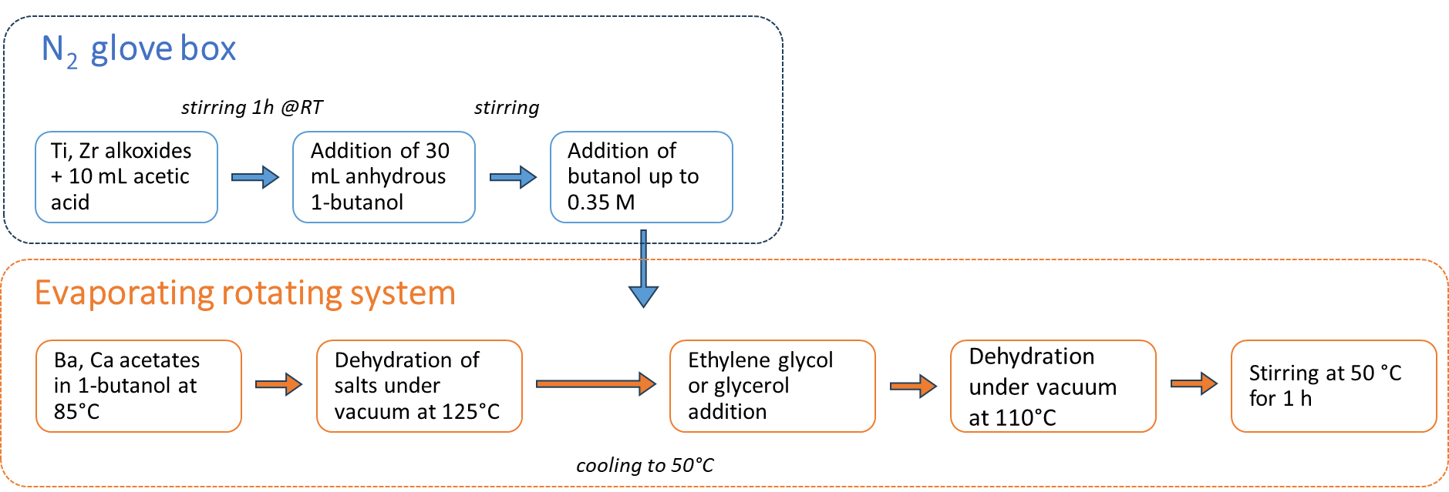
Figure 1: Flow diagram of the preparation of the precursor solutions.
The obtained solutions will be indicated as GLY_x%, where x stands for the percentage of glycerol. Table 2 reports the amount of 1-butanol and glycerol of the GLY solutions. The two more concentrated samples, GLY_15% and GLY_30%, were used to investigate the effect of glycerol on the properties of the obtained BZT-BCT powder and thin films, while GLY_10% was employed to confirm the found trends.
Table 2: Glycerol and 1-butanol content of the GLY_x% samples.
Reagent | GLY_10 | GLY_15 | GLY_30
1-butanol | 53 | 48 | 33
Glycerol | 10 | 15 | 30

A preliminary characterization of the precursor solutions was carried out by drying about 15 mL of sample to induce the formation of a precipitate gel, that was subsequently subjected to X-ray diffraction analysis (PANalytical, X'Pert Pro, CuKα radiation; operating voltage and current: 40 kV, 40 mA; scanning range: 5 to 80 °2θ; step size: 0.0131° 2θ; counting time: 8.67 seconds per step) and high temperature thermogravimetric analysis (NETZSCH, STA 409 Luxx, thermal scan from room temperature to 1200 °C at a heating rate of 10°C/min under nitrogen flow). Afterwards, the gels were calcined at 1400 °C and subjected to XRD analysis to verify the formation of BZT-BCT.
  - Deposition and characterization of thin films
Thin films were grown on commercial 700 μm -thick Pt/TiO₂/SiO₂/Si substrates by adopting a spin coating process followed by a suitable thermal treatment route. Accordingly, each precursor solution was dispensed on the substrate, previously loaded in a spin coater (Specialty Coating Systems, model P.6712), and, immediately after the dispensing, subjected to the spinning program reported in Table 3. After deposition, a pyrolysis treatment at 350 °C was carried out in a slowly depressurized glove box. Finally, the films were calcined in a muffle at 750 °C with a thermal ramp of 10 °C/min. The presence of the desired crystalline phase was checked by XRD analysis in grazing incidence (ω = 1°; scanning range: 10 to 60° 2θ; step size 0.0131° 2θ; counting time: 18.87 s per step), while a XP-1 Stylus Profilometer (Ambios Technology) was used to measure the thickness of the thin films.
Table 3: Spinning route adopted for the thin films production.
Step | Speed, RPM | Time, s
A | 1000 | 30
B | 2000 | 200
C | 750 | 20
  - Characterization of the precursor solutions
All the precursor solutions were successfully prepared and resulted in a transparent, homogeneous liquid. Stability over time was assessed by storing the sealed vials under the dark and periodically checking the aspect of the solution: no sign of gelation, segregation or precipitation was observed up to 1 month, indicating a satisfying stability. EG, GLY_15% and GLY_30% solutions were then dried at 120 °C on a petri dish to obtain precipitate powders. It is to be noted that the presence of glycerol made it more difficult to obtain a solid residue: while the EG sample formed a fine precipitate powder, the GLY_30% and GLY_15% resulted in gummy gels. Figure 2 reports the diffraction patterns of the samples after drying. The EG sample appeared quite crystalline, as evidenced by the several peaks present in the diffraction pattern, identified as barium acetate (ICDD PDF 5+ database ref. n. 00-026-0131). On the contrary, the more glycerol was present in the parent solution, the more amorphous the diffraction pattern appeared. This evidence suggests that glycerol, by hindering the nucleation of crystalline phases, preserves the gel homogeneity at atomic scale, that would allow for the crystallization of a better layer of BZT-BCT in the final thin film, in turn improving its properties.
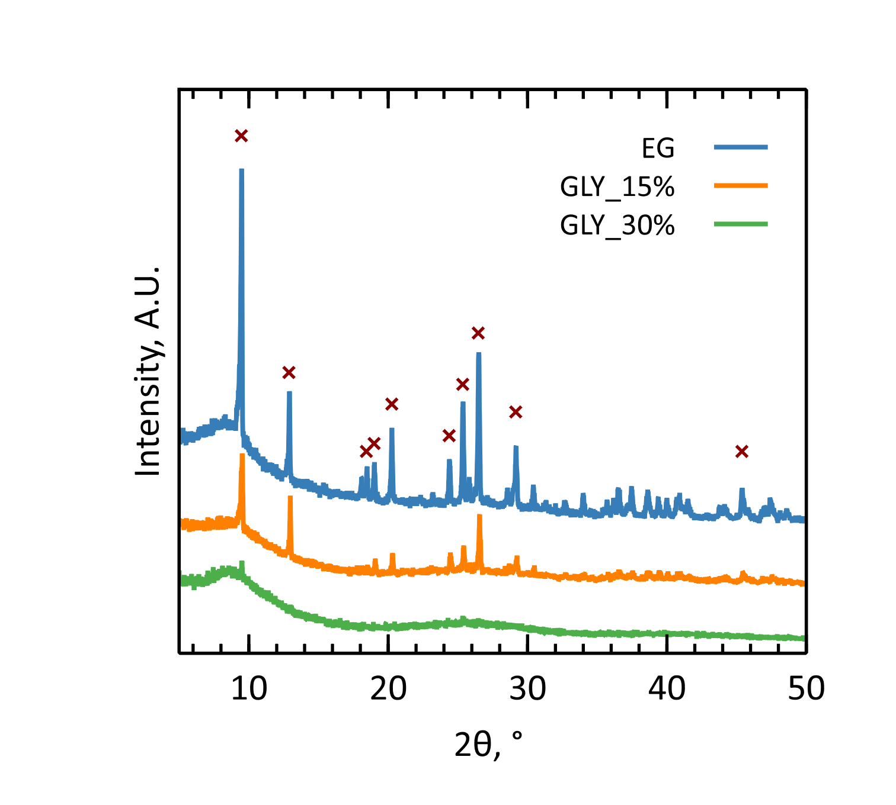
Figure 2: From top to bottom: XRD pattern of the EG, GLY_15% and GLY_30% samples. Red x marks stand for reference positions of barium acetate (ICDD PDF 5+ database ref. n. 00-026-0131)
Figure 3 shows the thermogravimetric analysis (TGA) and the derivative thermogravimetric analysis (DTG) of EG, GLY_15% and GLY_30% samples. The EG sample presents four main thermal events: the first, at around 140 °C, is related to the evaporation of residual solvents. The next two events (334 °C and 454 °C) are due to the decomposition of the resulting gel and the initial crystallization stage of BZT-BCT, together with the production of barium and calcium carbonates. The last thermal event (1039 °C) is related to the decomposition of carbonates and the completion of the BZT-BCT crystallization process. The addition of glycerol (Figure 3b and c) lowered the temperature of the third and fourth thermal events. Considering the crystallization temperature, its variation has been found to be linearly dependent on the glycerol amount (Figure 3d), according to the following linear regression results:
$$T=-8.13g+1051.7, R^{2}=0.969$$ | (1)
with T = temperature (°C), g = glycerol content (%). This evidence can be considered beneficial for the thin film production process, since it would permit to lower the operating temperature of the thermal treatment.

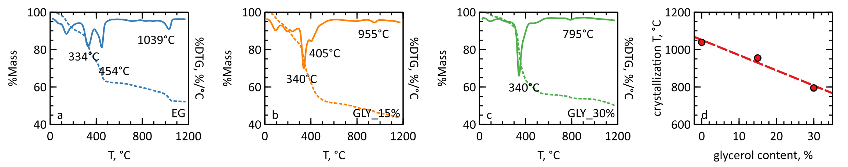
Figure 3: TGA (continuous line) and DTG (dashed line) of a) EG, b) GLY_15%, and c) GLI_30%. d) Crystallization temperature as a function of the glycerol content of the samples.
Interesting results were also obtained after the calcination of the dried gels. As Figure 4 illustrates, all the samples treated at 1400 °C showed the characteristic peaks of the BZT-BCT perovskitic structure (ICDD PDF 5+ database ref. n. 01-086-8337). In the EG sample, though, clear signs of impurities, identified as barium calcium titanium oxide (ICDD PDF 5+ database ref. n. 00-042-0535), were also evident in the range from 28 to 32 °2θ. This indicates a certain degree of segregation during the nucleation stage, that, being not present in the glycerol-containing samples, confirms the beneficial effect of glycerol in improving the homogeneity of the gel. To have an estimation of the crystallinity of the samples, the analysis of the most intense peak (located at about 31.5 °2θ) has been performed. The results (Figure 4b,c) show that the peak area and Full Width at Half Maximum (FWHM) decrease with the glycerol content. This indicates that the crystalline fraction (related to the peak area) slightly decreases with the glycerol content, but the size of the crystallites (related to the FWHM) increases with the glycerol content.

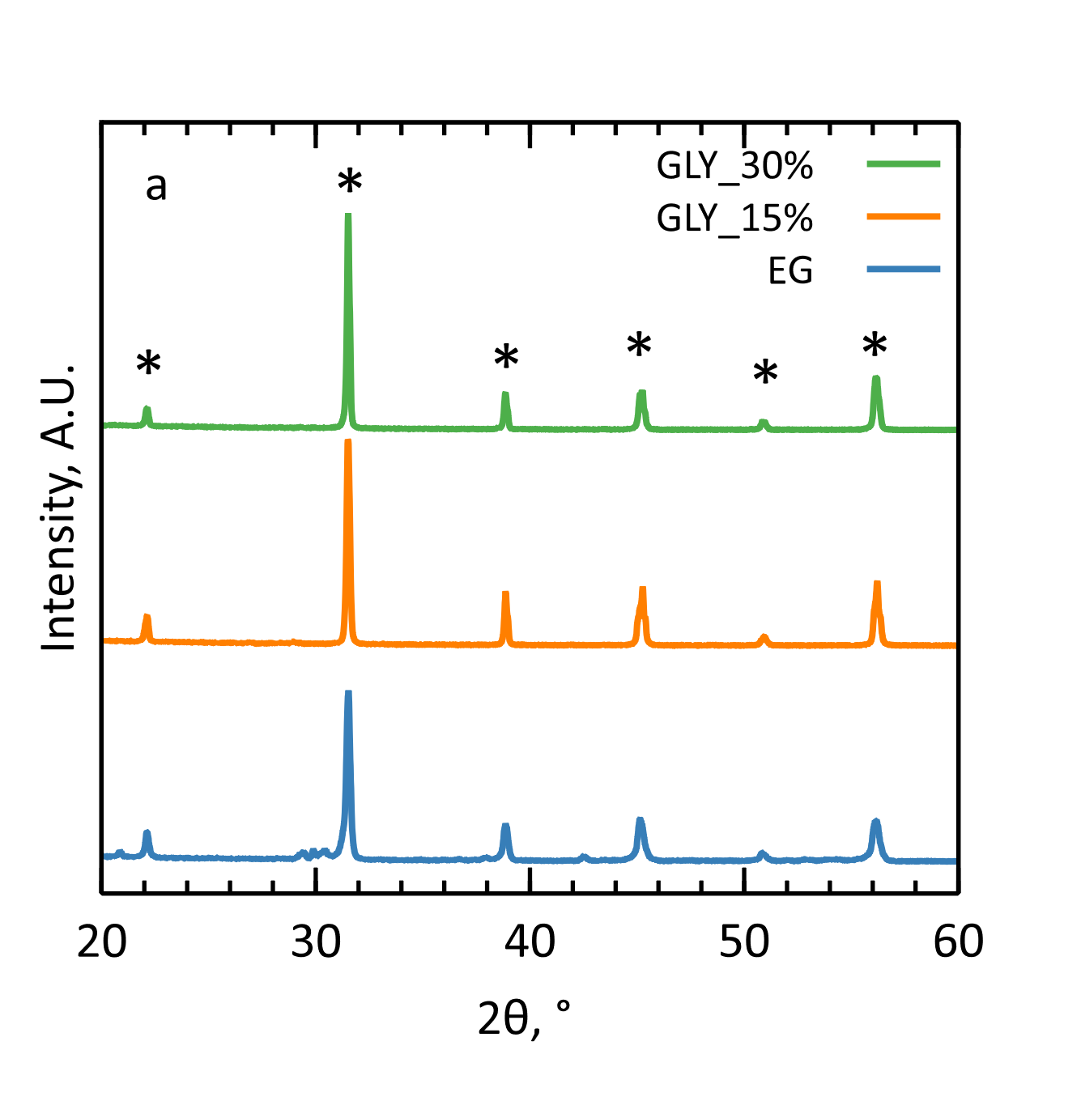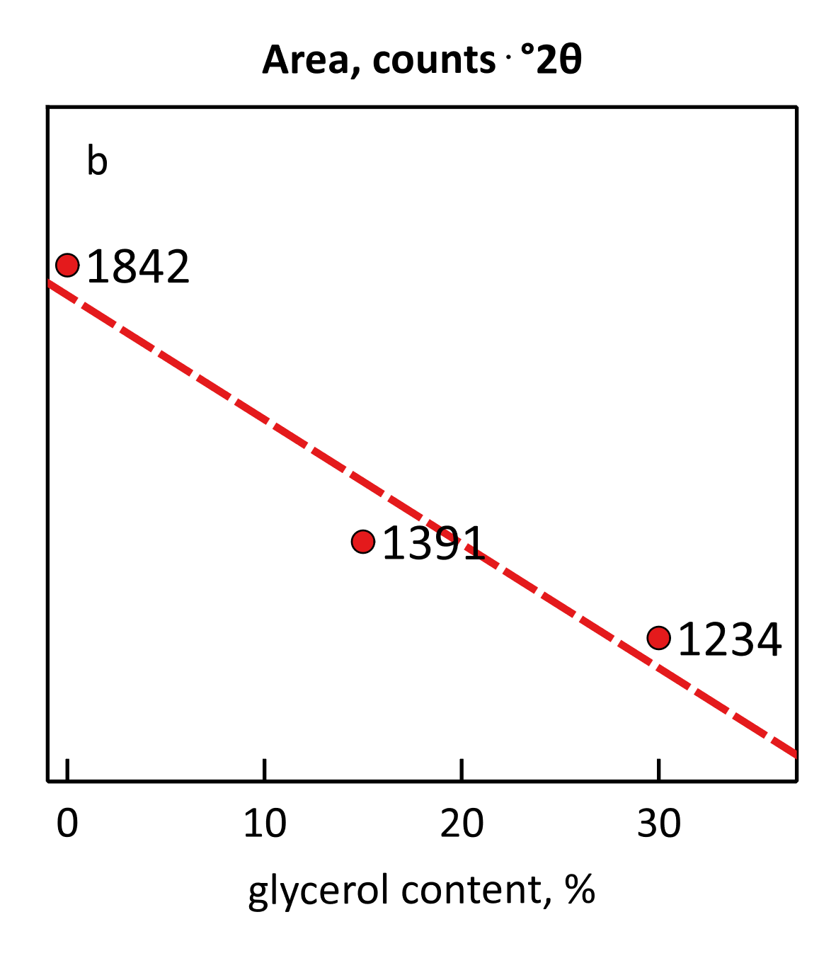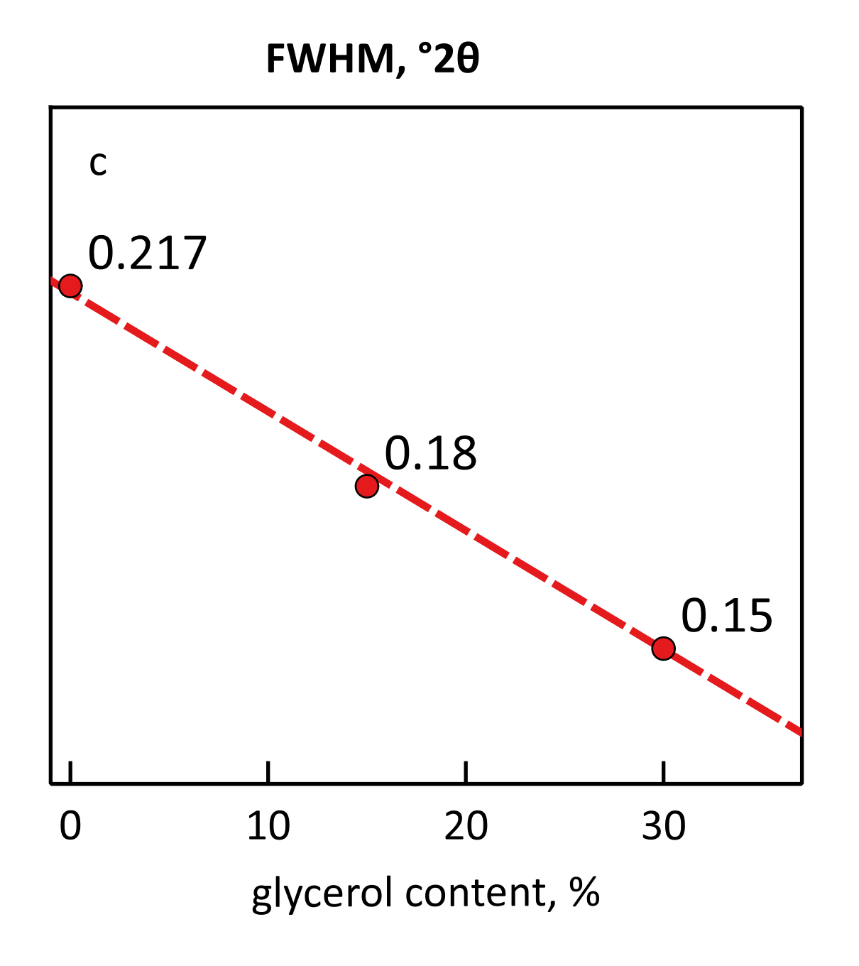
Figure 4: a) XRD patterns of the EG, GLY_15% and GLY_30% dried powders after calcination. b) Main peak area and c) FWHM as a function of the glycerol content.
  - Characterization of thin films
Once assessed the effect of glycerol on the properties of the bulk BZT-BCT, the precursor solutions were used to produce thin films, whose crystal structure and thickness were investigated. Every film deposited (Figure 5a) showed the characteristic peaks of the perovskite phase. In the EG sample no signal of spurious phases was detected. This could derive from the spin coating process, that, thanks to the faster evaporation of the solvents, helped in preserving the homogeneity of the gel, but, given the very low intensity of the pattern, could be more likely due to the detection limit of the instrument, that did not reveal the low traces of the spurious phase. Regarding the analysis of the main diffraction peak, the results did not follow a monotone dependency on the glycerol content: the peak area (Figure 5b) reached its maximum in the GLY_15% film and then decreased in the GLY_30% sample. A similar trend has been found for the FWHM (Figure 5c). This could suggest 15% as the optimum glycerol content to produce thin films of adequate quality, in terms of crystalline fraction and crystallite size. Concerning the thickness, the thin films (Figure 5d) showed a good linear correlation with the glycerol content, estimated by the following equation:
$$t=5.67g+115.3, R^{2}=0.988$$ | (2)
with t = film thickness (nm), g = glycerol content (%). Notably, the GLY_10% sample perfectly fit the trend obtained from the other samples.

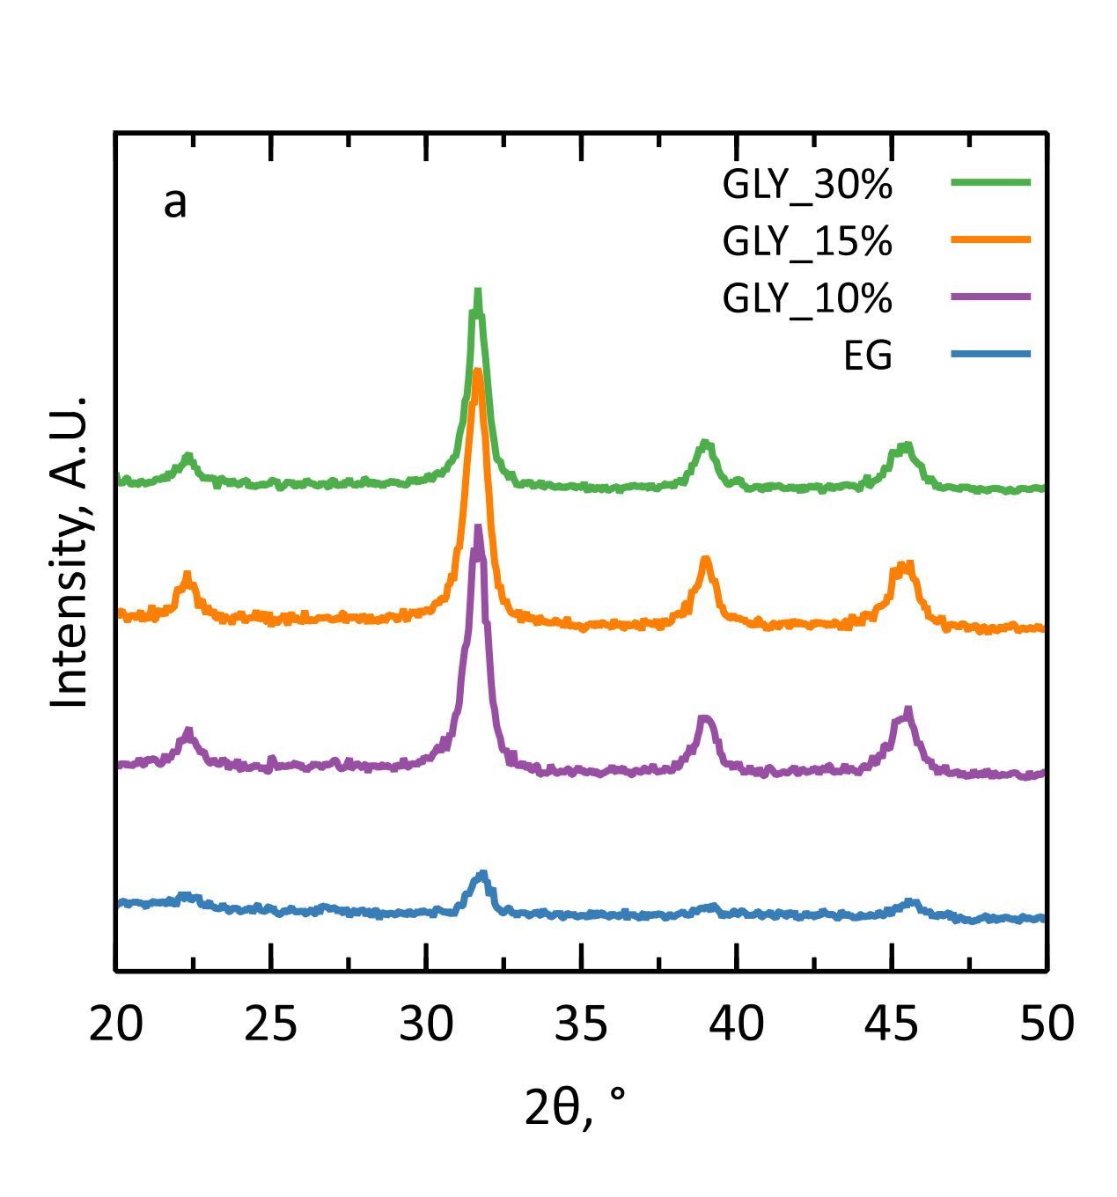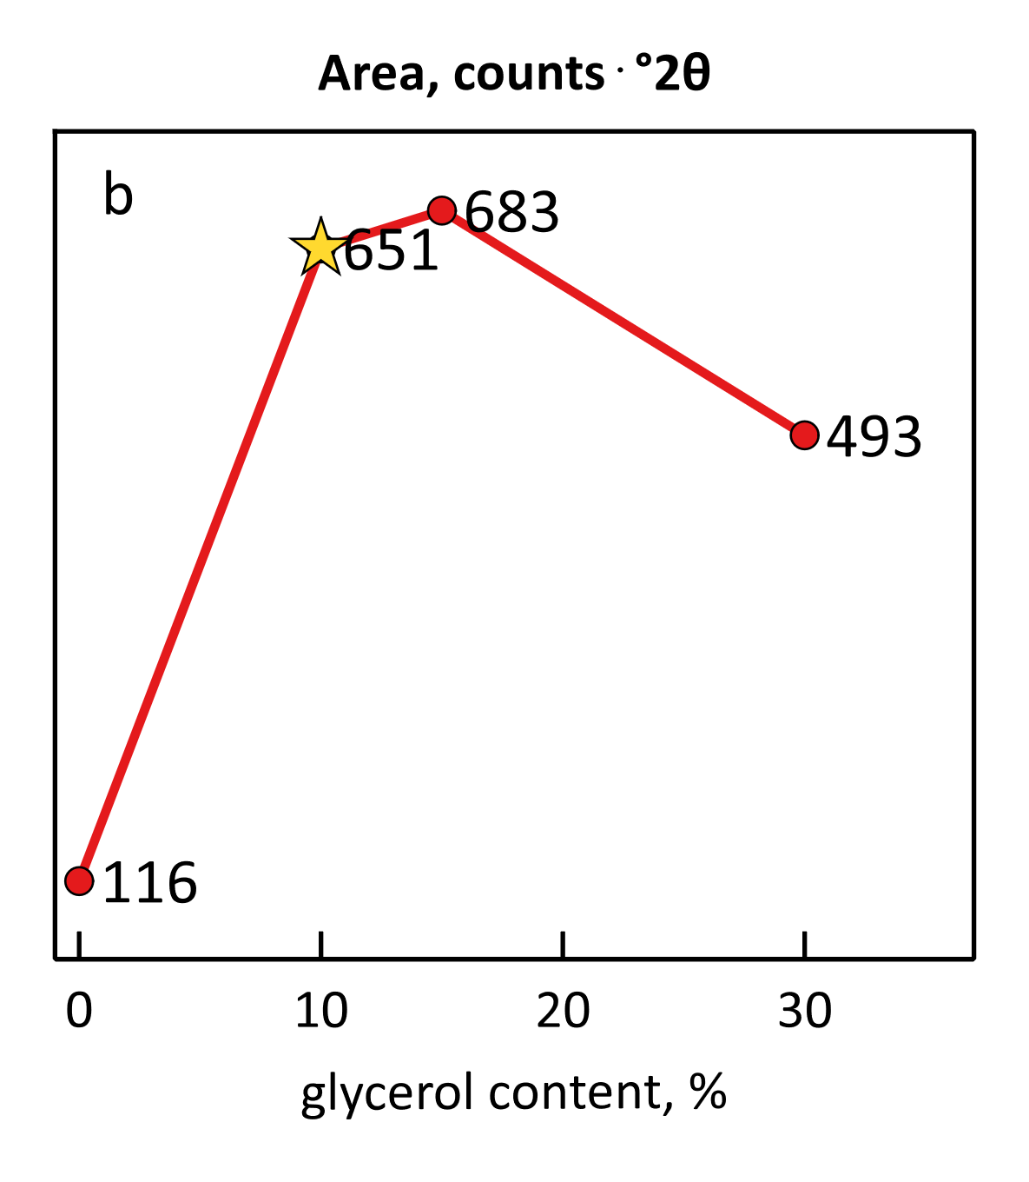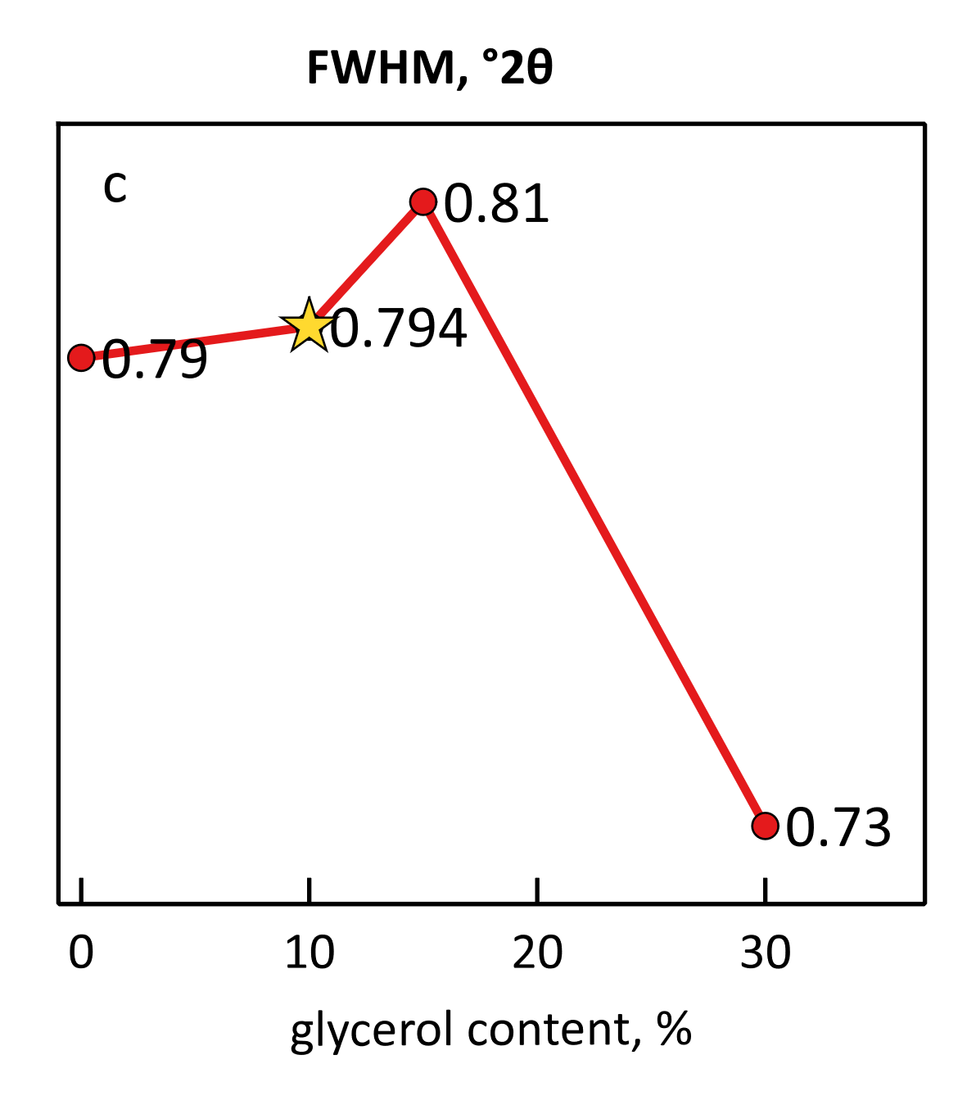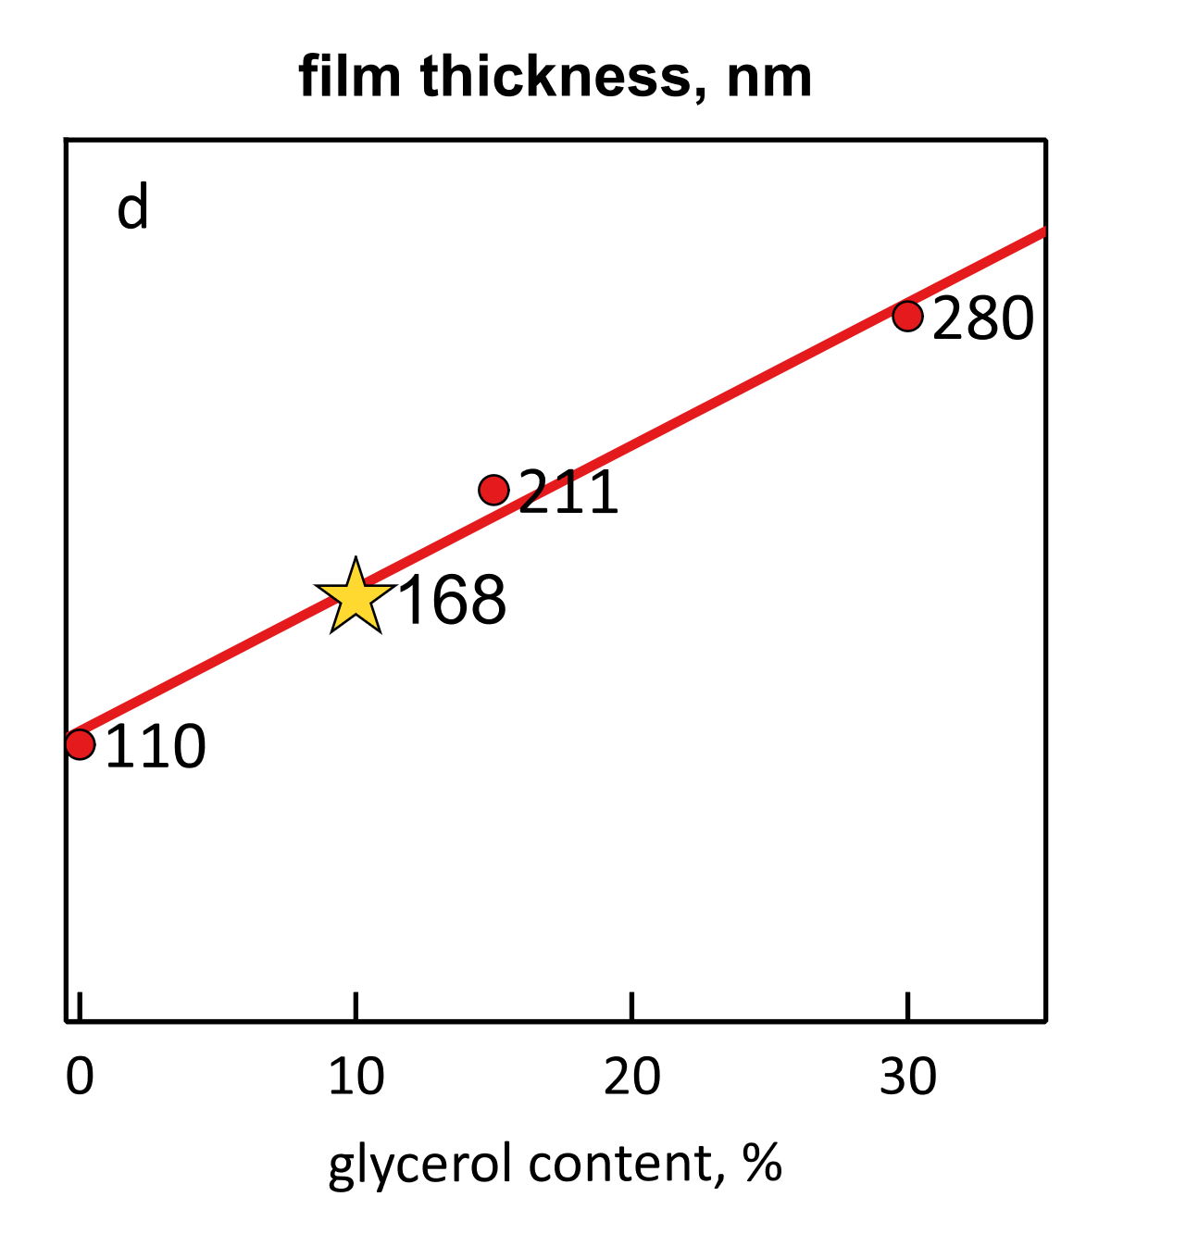
Figure 5: a) XRD patterns of the samples EG, GLY_10%, GLY_15% and GLY_30%. b) Peak area, c) FWHM and c) thickness of the obtained thin films as a function of the glycerol content. The star-shaped marker indicates the GLY_10% sample.
  - Conclusions
In this work, glycerol-containing BZT-BCT precursor solutions have been prepared, characterized and processed to evaluate the effect of this additive on the structural properties of the obtained piezoelectric ceramic, either in bulk or in thin film form. On the bulk material, glycerol helped to keep the gel amorphous after the evaporation of the solvents, thus preserving its homogeneity and, in turn, preventing the segregation of spurious phases during the nucleation stage. The crystallization of BZT-BCT was also improved, either in terms of the lower temperature required (about 8 °C less per glycerol wt. % added), or in terms of the better quality of the obtained crystals. Concerning the properties of the deposited thin films, the addition of glycerol mainly turned out in thicker layers (about 5 nm more per glycerol wt. % added), even if the best BZT-BCT yield in terms of crystalline fraction and crystallite size was reached at an amount of 15 wt. %. While these findings suggest that the use of glycerol in the formulation of the precursor solutions is highly advisable, future studies will be aimed at assessing the ferroelectric and piezoelectric performance of the obtained thin films.

References
Barbato, P.S., Barretta, L., Scaldaferri, R., Aprea, P., Esposito, A., Casuscelli, V. and Caputo, D., 2023. Green Synthesis of Piezoelectric Thin Films based on Niobium Doped Barium Zirconate Titanate - Barium Calcium Titanate (Nb-BZT-BCT). Chemical Engineering Transactions.
Barbato, P.S., Casuscelli, V., Aprea, P., Scaldaferri, R. and Caputo, D., 2021. Optimization of the production process of BZT–BCT sol–gel thin films obtained from a highly stable and green precursor solution. Materials and Manufacturing Processes, 36(14), pp.1642-1649.
Barbato, P.S., Casuscelli, V., Aprea, P., Scaldaferri, R., Pedaci, I. and Caputo, D., 2021. Green Production of Lead-free BZT-BCT Thin Films for Applications in MEMS Devices. Chemical Engineering Transactions, 84, pp.97-102.
Hu, P., 2018. Study on high precision MEMS inertial sensor with increased detection capacitance driven by electromagnetism. Chemical Engineering Transactions, 66, pp.1273-1278.
Kang, G., Yao, K. and Wang, J., 2012. (1-x)Ba(Zr0.2Ti0.8)O3–x(Ba0.7Ca0.3)TiO3 ferroelectric thin films prepared from chemical solutions. Journal of American Ceramic Society, 95, pp.986-991.
Lin, Y., Wu, G., Qin, N. and Bao, D., 2012. Structure, dielectric, ferroelectric, and optical properties of (1-x)Ba(Zr0.2Ti0.8)O3–x(Ba0.7Ca0.3)TiO3 thin films prepared by sol–gel method. Thin Solid Films, 520(7), pp.2800-2804.
Livage, C., Safari, A. and Klein, L.C., 1994. GLYcol-based sol-gel process for the fabrication of ferroelectric PZT thin films. Journal of Sol-Gel Science and Technology, 2, pp.605–609. Available at: https://doi.org/10.1007/BF00486318.
Shao, Z.P., Jiang, W.H., Feng, G., Liu, J.M., Miao, L.F., Zhang, Q. and Wu, Q., 2015. Study on the Preparation of BaTiO3 Nano Powder via Non-Hydrolytic Sol-Gel Method. Advanced Materials Research. Available at: https://doi.org/10.4028/www.scientific.net/amr.1104.107.
Shen, Y. and Liu, Y., 2018. Properties of piezoelectric ceramics nanofilm from sol-gel process. Chemical Engineering Transactions, 66, pp.61-66.
Trolier-McKinstry, S. and Muralt, P., 2004. Thin Film Piezoelectrics for MEMS. Journal of Electroceramics, 12, pp.7–17.
Wang, Z., Zhao, K., Guo, X., Sun, W., Jiang, H., Han, X., Tao, X., Cheng, Z., Zhao, H., Kimura, H., Yuan, G., Yin, J. and Liu, Z., 2013. Crystallization, phase evolution and ferroelectric properties of sol-gel-synthesized Ba(Zr0.2Ti0.8)O3–x(Ba0.7Ca0.3)TiO3 thin films. Journal of Materials Chemistry C, 1, pp.522-530.
Yi, G. and Sayer, M., 1992. In: M. Liu, A. Safari, A. Kingon and G. Haertling, eds. Proceedings of the 8th International Symposium on Applications of Ferroelectrics. IEEE Press, Piscataway, NJ, p.289.
Yoon, J.G. and Song, T.K., 2002. Fabrication and characterization of ferroelectric oxide thin films. In: H.S. Nalwa, ed. Handbook of Thin Films. Academic Press, pp.309-367. ISBN 9780125129084. Available at: https://doi.org/10.1016/B978-012512908-4/50041-2.

