 CHEMICAL ENGINEERING TRANSACTIONS  VOL. , 2025 | A publication of  
The Italian Association
of Chemical Engineering
Online at www.cetjournal.it

Guest Editors: Paolo Ciambelli, Luca di Palma
Copyright © 2025, AIDIC Servizi S.r.l.
ISBN 979-12-81206-20-5; ISSN 2283-9216

Mechanical Recycling for Sustainable Polyurethane Foams: a Life Cycle Assessment study
Claudia Cirillo°, Luca Gallucci°*, Mariagrazia Iuliano°, Maria Sarno
Department of Physics “E.R. Caianiello” and Centre NANO_MATES (Research Centre for Nanomaterials and Nanotechnology at the University of Salerno) University of Salerno, Via Giovanni Paolo II, 132 - 84084 Fisciano (SA), Italy.

°These three authors contribute equally
*lgallucci@unisa.it
Polyurethane (PU) is a versatile and widely used polymer, essential in applications such as thermal insulation, furniture cushioning, and transportation. However, while its functional benefits are well-established, its end-of-life management remains a critical challenge. Due to its low biodegradability and complex composition, traditional disposal methods like landfilling and incineration pose severe environmental challenges and are increasingly unsustainable. To address these challenges, this study investigates the feasibility of mechanical recycling as a sustainable strategy for managing PU foam waste generated during the decommissioning of buses and trains. To evaluate the environmental implications of this recycling pathway, a comprehensive Life Cycle Assessment (LCA) was conducted, covering all stages from waste collection and mechanical treatment to the production of new foam materials.
The results highlight the potential of mechanical recycling as an effective and sustainable approach to PU foam waste management, with relevance to the transportation sector. Integrating such recycling processes into conventional industrial workflows can significantly contribute to meeting waste reduction targets, improve the environmental footprint of polyurethane production, and promote stronger adherence to circular economy principles.
  - Introduction
Polyurethane is one of the most important and widely used polymers across various sectors and applications, thanks to its long-term stability and resistance to external factors such as light, heat, and chemicals (Yamane S. et al., 2020). According to Rossignolo et al. (2024), this material can be classified as follows:
- Thermoplastic polyurethane
- Rigid polyurethane
- Flexible polyurethane
- Ionomers polyurethane
- Waterborne polyurethane

The flexible type of polyurethane foam, for example, is widely used in the automotive industry for interior components and as cushioning material. In 2024, the flexible polyurethane foam market was estimated at 5.91 billion dollars and is expected to grow at a rate of 6.14% from 2025 to 2030 (Grand View Research, 2024).
In this scenario, the automotive and transportation sectors play a dominant role in the market as this material provides comfort, passenger support, low weight, and an excellent strength-to-weight ratio. Thanks to these properties, flexible polyurethane foam is particularly appealing and well-suited for the transportation sector, which accounted for 49.3% of the market share in 2024 (Grand View Research, 2024). However, the excellent resistance properties that characterize polyurethane foam also pose challenges in its end-of-life treatment, due to its low degradability and complex chemical composition. Traditional disposal methods, such as landfilling and incineration, present significant environmental concerns (Odetoye, T. E., 2011).
To overcome this issue, recycling polyurethane foam has emerged as a promising alternative to landfill and incineration. Among the most important recycling techniques, mechanical recycling stands out thanks to its simplicity and eco-friendly approach to the recycling process. Yang et al. (2012) describe the advantages and disadvantages of chemical recycling, which can serve as an alternative to mechanical methods. Although this process enables the recovery of high-purity raw materials that can be directly reused in the production of new products, it also involves high temperature and pressure requirements, safety risks, purification steps, and difficulty in controlling by-product formation. On the other hand, despite the potential reduction in product performance in some market applications and lower economic returns, mechanical recycling remains advantageous for its operational simplicity, low emissions, high throughput, and minimal investment in equipment.
According to Datta et al. (2018), mechanical recycling can be divided into different categories:
- Grinding and powdering: grinding of the polyurethane foam into fine powder that can be used as feedstock for other recycling processes (both mechanical and chemical)
- Rebonding: powdered foam is mixed with polyols or other components during the polyurethane foam synthesis
- Adhesive pressing: it involves the heated hydraulic pressing of adhesive binder sprayed on powdered foam
- Compression molding, Injection molding, and extrusion: in compression molding, powdered foam is compressed under suitable pressure and heat; in injection molding and extrusion, the process involves mixing, heating, and pressing the material.
Among the various methodologies, grinding and rebonding represent an easy and simple approach to adopt, requiring only minimal modifications to existing production operations to implement the grinding machine and polyurethane powder addition step to the polyurethane synthesis.
To estimate the differences in the end-of-life treatment of polyurethane waste, the use of the life cycle assessment (LCA) methodology has been considered. LCA is a tool used to evaluate the environmental impacts associated with the product’s life cycle. The life cycle assessment methodology is defined by the ISO 14040-2006 and ISO 14044-2006.
  - Materials and Methods
According to the ISO 14040-2006, an LCA study consists of four phases:
- the goal and scope definition phase
- the inventory analysis phase
- the impact assessment phase
- the interpretation phase
    - Goal and Scope Definition
It was proposed to evaluate the environmental impact associated with two different scenarios for the end-of-life treatment of the polyurethane foams:
- Scenario 1: Landfill
- Scenario 2: Mechanical recycling
The system boundaries for Scenario 1 and Scenario 2 are shown in Figure 1. In Scenario 1, the process begins with the initial synthesis of polyurethane foam by mixing polyol and isocyanate, followed by the transportation of the foam and its use phase. The final stages of this scenario include transportation of the waste and its disposal in a landfill.
In Scenario 2, the first three stages, foam production, transportation, and use, are identical to those in Scenario 1. In this scenario, the use phase is followed by the transportation of the waste foam to a recycling facility, made of a drying process, followed by a mechanical grinding of the waste foam and a new polyurethane foam synthesis process in which part of the virgin polyol and virgin isocyanate are replaced by waste polyurethane foam powder used as filler.

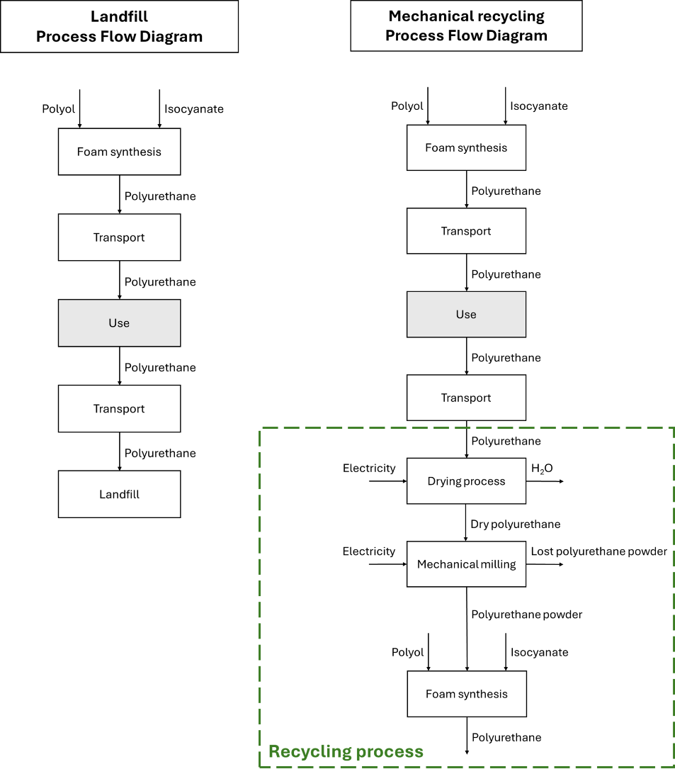
Figure 1 a) Scenario 1 and b) Scenario 2 Processes Flow Diagram
Regarding Scenario 2, four more sub-scenarios have been considered based on the substitution percentage:
- Scenario 2a: 0.5%
- Scenario 2b: 1%
- Scenario 2c: 5%
- Scenario 2d: 10%
The substitution percentage refers to the amount of polyurethane foam powder incorporated into the production process of new polyurethane foam, as detailed in Table 1. The maximum substitution level is constrained by the viscosity of the polyol–fine powder mixture; therefore, a maximum threshold of 10% has been assumed (Nikje M.M.A. et al., 2011). Mechanical recycling of polyurethane foam has been successfully applied, particularly in the recycling of automotive seating, due to the excellent performance characteristics of the newly moulded seats (Banik J. et al., 2023).
Table 1 Substitution percentage in polyurethane foam production
Substitution percentage, % | Isocyanate, kg | Polyol, kg | Polyurethane powder, kg | Polyurethane foam produced, kg
0 | X | Y | - | 1,000
0.5 | X - 2.5 | Y - 2.5 | 5 | 1,000
1 | X - 5 | Y - 5 | 10 | 1,000
5 | X - 25 | Y - 25 | 50 | 1,000
10 | X - 50 | Y - 50 | 100 | 1,000

A reference flow was defined as 1,000 kg of polyurethane foam, either disposed of in a landfill (Scenario 1) or produced through the recycling process (Scenario 2).

The introduction of a recycling process in Scenario 2 requires the proper allocation of environmental impacts associated with the input flows to the recycling system.
According to ISO 14044:2006, allocation is defined as the partitioning of input and output flows of a process or product system among the product system under study and one or more other product systems.
A 50:50 allocation method has been applied to account for the environmental impacts associated with the polyurethane foam input flow to the recycling steps (Zimmermann R.K. et al., 2022). Recycling one product into another results in both a reduction in the disposal of the original product and a decreased need for virgin raw materials in the production of the new one.
One approach to reflect this dual benefit is the 50:50 allocation method, in which 50% of the environmental impacts from production are attributed to the original product, and the remaining 50% to the recycled product (Obrecht T.P. et al., 2021).
Limitations and assumptions
Regarding the environmental impact assessment of the different end-of-life treatments, a cradle-to-grave approach has been adopted. The use phase has not been explicitly modelled, as it is assumed to have a comparable environmental impact in both scenarios.
Furthermore, throughout the recycling process, it has been assumed that no additional cleaning steps are required, and that foam separation can be performed with relative ease. During the mechanical milling stage, an estimated 3% material loss of polyurethane foam powder occurs.
The energy consumption related to mechanical milling and drying has been estimated using experimental data and technical documentation.
Additionally, although the presence of additives may introduce further complexity in the recycling process, in this study, additives have been excluded from the environmental impact assessment.

    - Life Cycle Inventory Analysis (LCIA)
The Goal and Scope Definition phase is followed by the Life Cycle Inventory (LCI) Analysis, which establishes the quantitative relationships between the different processes, based on the functional unit.
The data used in this study were obtained from laboratory experiments, peer-reviewed scientific literature, and technical data sheets.

    - Impact Evaluation
The Life Cycle Assessment (LCA) study was conducted using openLCA software (version 2.1.0).
The impact assessment was performed using the Ecological Scarcity method, which applies eco-factors to quantify and weigh the environmental impacts of a process.
Eco-factors are calculated based on the level of emissions or resource consumption relative to predefined environmental targets and are expressed in “eco-points”.
An eco-factor is derived from three elements: characterization, normalization, and weighting.
- Characterization is the measure of the relative harmfulness of a pollutant emission compared to a reference substance within a given impact category (i.e., global warming potential).
- Normalization is the contribution of a unit of pollutant or resource use to the total current load/pressure in a region per year.
- Weighting is the relationship between the current pollutant emission or resource consumption (current flow) and the consumption target (critical flow) (Frischknecht R et al., 2009).
  - Results and Discussion
The impact assessment results of the five different scenarios considered are presented in Table 2 as absolute values in UBP (eco-points), while in Figure 2 the value of the impact categories for the different scenarios are reported as a percentage of the highest impact value in that same category, i.e. for carcinogenic substances into air – total all the impact values percentages are calculated based on the impact of Scenario 1.
Table 2 Life cycle assessment results for the different scenarios considered.
Impact categories | Unit | Scenario 1 | Scenario 2a | Scenario 2b | Scenario 2c | Scenario 2d
carcinogenic substances into air - total | UBP | 8,822.55 | 933.25 | 951.75 | 1,099.77 | 1,284.79
energy resources - total | UBP | 0 | 0 | 0 | 0 | 0
global warming - total | UBP | 4.89E+05 | 4.67E+05 | 4.67E+05 | 4.67E+05 | 4.68E+05
heavy metals into air - total | UBP | 1.16E+05 | 1.11E+05 | 1.11E+05 | 1.11E+05 | 1.12E+05
heavy metals into soil - total | UBP | 4,497.82 | 8.08 | 8.24 | 9.53 | 11.14
heavy metals into water - total | UBP | 3.73E+05 | 3.58E+05 | 3.58E+05 | 3.60E+05 | 3.61E+05
land use - total | UBP | 0 | 0 | 0 | 0 | 0
main air pollutants and PM - total | UBP | 4.97E+05 | 4.24E+05 | 4.25E+05 | 4.29E+05 | 4.34E+05
mineral resources - total | UBP | 47.90 | 45.84 | 45.85 | 45.97 | 46.12
non radioactive waste to deposit - total | UBP | 0 | 0 | 0 | 0 | 0
ozone layer depletion - total | UBP | 1.34E+04 | 1.28E+04 | 1.28E+04 | 1.29E+04 | 1.30E+04
pesticides into soil - total | UBP | 0 | 0 | 0 | 0 | 0
POP into water - total | UBP | 5.1E-4 | 4.9E-4 | 4.9E-4 | 4.9E-4 | 4.9E-4
radioactive substances into air - total | UBP | 2.5E-4 | 5.88E-05 | 5.99E-05 | 6.93E-05 | 8.1E-05
radioactive substances into water - total | UBP | 0 | 0 | 0 | 0 | 0
radioactive waste to deposit - total | UBP | 0 | 0 | 0 | 0 | 0
total - total | UBP | 1.51E+06 | 1.38E+06 | 1.38E+06 | 1.39E+06 | 1.40E+06
water pollutants - total | UBP | 7,950.55 | 7,617.50 | 7,620.90 | 7,648.13 | 7,682.16
water resources - total | UBP | 0 | 0 | 0 | 0 | 0

Figure 2 Ecological Scarcity impact categories results for Scenario 1, Scenario 2a, Scenario 2b, Scenario 2c, Scenario 2d
Regarding the carcinogenic substances in air impact category, Scenario 1 exhibits a burden nearly ten times higher than that of the Scenario 2 cases. This is primarily due to landfill disposal, which alone contributes to approximately 90% of the impact in this category for Scenario 1.
In the heavy metals into soil category, Scenario 1 is up to 500 times more impactful than the Scenario 2 cases, again as a result of landfill disposal, which accounts for more than 99% of this impact.
Regarding the main air pollutants and PM impact category, Scenario 1 is characterized by a higher impact compared to Scenario 2. The major contribution in each scenario regards the isocyanate employed in the production of the polyurethane foam. The 20% difference between Scenario 1 and Scenarios 2 is mainly due to landfill disposal.
In the radioactive substances into air category, the higher impact of Scenario 1 is primarily due to landfill disposal, which contributes approximately 80% of the total impact. In contrast, in Scenario 2, the impacts are mainly related to electricity consumption during the recycling process and transportation of polyurethane foam.

In the impact categories of global warming, heavy metals into air and water, mineral resource depletion, ozone layer depletion, and water pollutants, the impacts are comparable across all scenarios. However, the slightly lower impacts observed for Scenario 2 can be attributed to the reduced use of virgin polyol and isocyanate. For these categories, electricity consumption is slightly higher in Scenario 2, due to the additional energy required for the recycling process.
In the persistent organic pollutants (POP) into water category, Scenario 1 shows greater impacts, mainly driven by the contributions of virgin polyol and isocyanate.
Finally, the total impact category gives an overall view of the impact of the whole process. This category shows that Scenario 1 represents the most impactful process compared to the ones in Scenario 2. Among the different Scenario 2 cases, instead, there is a slight increase in the impact value with the increase in substitution percentage. This can be explained by the increase in substitution percentage, which leads to an increase in the weight of the impact results of the first polyurethane foam process on the recycled foam.
  - Conclusions
In conclusion, in this study, different end-of-life scenarios have been considered for polyurethane foams. The difference in landfill disposal and mechanical recycling at different substitution percentages has been studied. The results obtained in this study have been calculated employing the OpenLCA software, based on modelled scenarios and data derived from literature and databases.
The LCA results obtained using the Ecological Scarcity impact assessment method showed that in three impact categories, landfill disposal was the most impactful process in Scenario 1. Thanks to the recycling of polyurethane foam, these impacts could be avoided or at least reduced.
In conclusion, since the total impact category is characterized by lower values in Scenario 2, it can be stated that there is an advantage in the mechanical recycling of polyurethane foam compared to landfill disposal.
Acknowledgments
This research was supported by the "Horizon Europe" program, funded by the European Union (C&G Kiel Italia srl -Italy, project leader. Project n. F/310234/03/X56– REA - Introduzione di mateRiali e tEcnologie circolari e sostenibili nell'industria del trasporto di massA - Introduction of circular and sustainable materials and technologies in the mass transport industry).
References
Banik J., Chakraborty D., Rizwan M., Shaik A.H., Chandan M.R., 2023, Review on disposal, recycling and management of waste polyurethane foams: A way ahead, Waste Management & Research, 41(6), 1063-1080
Datta J., Glowinska E., Wloch M., 2018, Mechanical Recycling via Regrinding, Rebonding, Adhesive Pressive, and Molding, Plastics Design Library, 57-65.
Frischknecht R., Steiner R., Jungbluth N., 2009, The ecological scarcity method—eco-factors 2006. A method for impact assessment in LCA. Federal Office for the Environment (FOEN), Bern.
Grand view research, 2024, Flexible Polyurethane foam Market Size, Share & Trends Analysis Report By Application (Automotive, Aviation, Mass Transit), By Region, And Segment Forecasts, 2025-2030. <grandviewresearch.com/industry-analysis/flexible-polyurethane-foam-market-report> accessed 05.02.2025.
Hicks D., Krommenhoek M., Soderberg D., Hopper, J., 1994, Polyurethanes recycling and waste management, Cellular Polymers, 13, 259–276.
Kylili A., Seduikyte L., Fokaides P., 2018, Life cycle analysis of polyurethane foam wastes. Plastics Design Library, 97–113.
Nikje M.M.A., Garmarudi A.B., Idris A.B., 2011, Polyurethane Waste Reduction and Recycling: From Bench to Pilot scale, Designed Monomers and polymers, 14, 395-421.
Obrecht T.P., Jordan S., Legat A., Saade M.R.M., Passer A., 2021, An LCA methodology for assessing the environmental impacts of building components before and after refurbishment, Journal of Cleaner Production, 327.
Odetoye, T. E., 2011, Recycling of Polyurethane foams: A strategy in waste Management and
control. Nigerian Journal of Technological Development, 8, 25-35.
Rossignolo G., Malucelli G., Lorenzetti A., (2024), Recycling of polyurethanes: where we are and where we are going, Green Chem., 26, 1132-1152.
Yamane S., Watanabe R., Ata S., Mizukado J., Shinzawa H., 2020, Solvent-induced degradation of polyurethane studied by two-dimensional (2D) infrared (IR) correlation spectroscopy, Vibrational Spectroscopy, 108.
Yang W., Dong Q., Liu S., Xie H., Liu L., Li J., 2012, Recycling and disposal methods for polyurethane foam wastes, Procedia Environmental Sciences, 16, 167-175.
Zimmermann R.K., Rasmussen F. N., Kanafani K., Eberhardt L.C.M., Birgisdóttir H., 2022, Reviewing allocation approaches and modelling in LCA for building refurbishment. IOP Conf. Ser.:Earth Environ. Sci. 1078

