 CHEMICAL ENGINEERING TRANSACTIONS  VOL. , 2025 | A publication of  
The Italian Association
of Chemical Engineering
Online at www.cetjournal.it

Guest Editors: Paolo Ciambelli, Luca di Palma
Copyright © 2025, AIDIC Servizi S.r.l.
ISBN 979-12-81206-20-5; ISSN 2283-9216

Efficient recycling of polyurethane waste via Fe₃O₄@MgAl magnetic catalyst glycolysis
Claudia Cirillo°, Mariagrazia Iuliano°*, Luca Gallucci°, Maria Sarno
Department of Physics “E.R. Caianiello” and Centre NANO_MATES (Research Centre for Nanomaterials and Nanotechnology at the University of Salerno) University of Salerno, Via Giovanni Paolo II, 132 - 84084 Fisciano (SA), Italy.
°these three authors contribute equally
*maiuliano@unisa.it
Polyurethanes (PU) are extensively used in the transportation sector, particularly for seat padding in buses and trains, due to their exceptional properties, including high durability, flexibility, low density, and excellent thermal insulation. However, conventional disposal methods, such as landfilling and incineration, present significant environmental and economic drawbacks.
To overcome these challenges, chemical recycling, and in particular glycolysis, has emerged as a promising and industrially feasible strategy. A key factor in the efficiency of the glycolysis process is the choice of glycolytic agent and catalyst, which significantly affect the reaction kinetics and the quality of the recovered polyols. In this context, the use of magnetic catalysts offers an innovative and sustainable solution, as they can be recovered and reused over multiple cycles without a significant decline in catalytic activity.
In the present study, a magnetic Fe₃O₄@MgAl catalyst was developed and optimized for the glycolysis of PU waste. The experimental results showed that the Fe₃O₄@MgAl catalyst greatly enhances the glycolysis reaction, achieving 75 wt.% degradation of PU foam and yielding high-purity polyols.
The recovered polyols underwent detailed and thorough analysis to evaluate their chemical and physical properties, ensuring their quality and suitability for reuse.
  - Introduction
Polyurethanes are known for their exceptional properties, including high durability, flexibility, low weight, and excellent thermal insulation (Wieczorek et al., 2024; Heiran et al., 2021). These characteristics make polyurethane foam an ideal material for use in the transportation industry, particularly in the development of comfortable and long-lasting seating solutions (Deng et al., 2003).
Polyurethanes are synthesized through the chemical reaction between a polyol, a molecule containing hydroxyl groups (-OH), and a diisocyanate, a molecule containing isocyanate groups (-N=C=O). The reaction is shown in Figure 1.
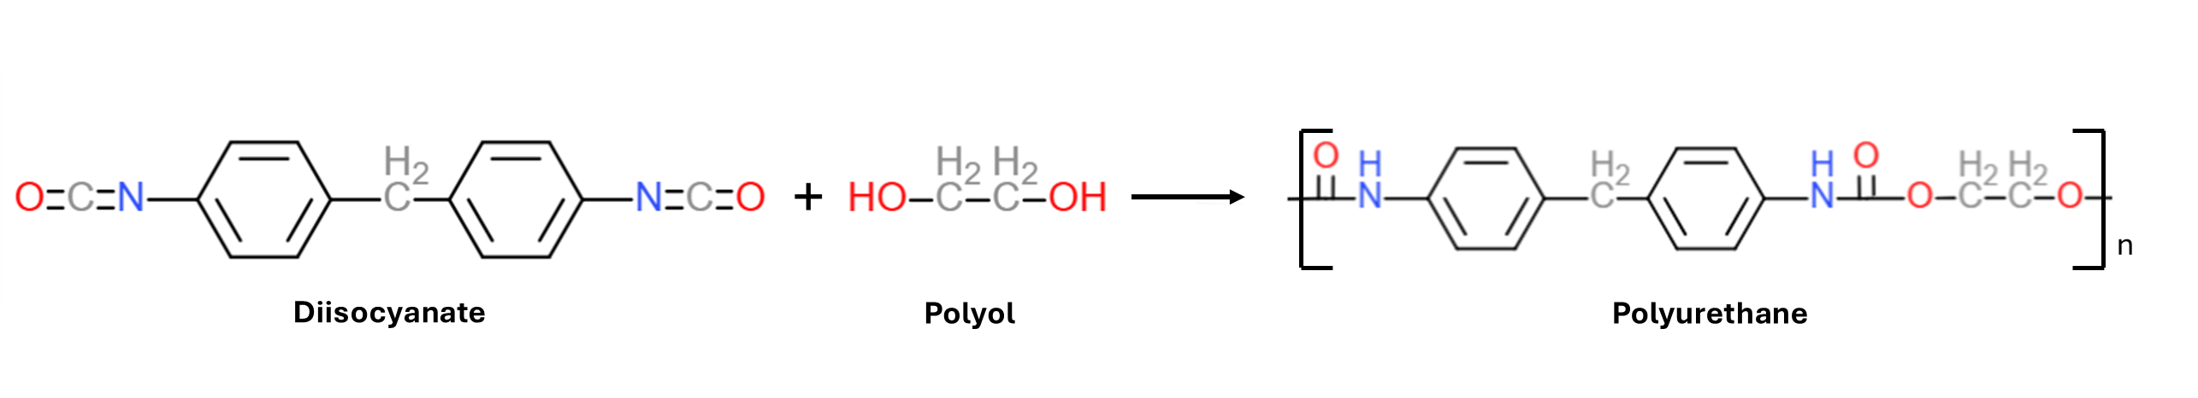
Figure 1 Polyurethane synthesis
The growing use of polyurethanes in the transportation sector raises concerns about the disposal of this material, particularly regarding landfilling and incineration. According to Yang et al., 2012, polyurethane foam is characterized by low density, which leads to suboptimal space utilization in the landfill. Moreover, polyurethane wastes are very difficult to decompose in the natural environment. Regarding the incineration of polyurethane foam, on the other hand, it can reduce volume by 99% but if the process is incomplete, it will produce poisonous gas and polluting agents.
For these reasons, recycling is receiving increasing attention as a sustainable method for the disposal of polyurethane foam waste, encompassing both physical and chemical recycling approaches.
In the case of physical recycling, regrinding techniques produce fine polyurethane powder, which can be reused as a filler in the production of new foam materials. Conversely, chemical recycling involves the cleavage of polyurethane bonds using suitable reagents, enabling the recovery of valuable components, such as polyols, which can subsequently be reused in the synthesis of new polyurethane foams.
Zia et al., 2007, describe the different chemical recycling techniques and divide them into: Glycolysis, which produces polyol as the main reaction product; Hydrolysis, which produces polyol and amine intermediates; Pyrolysis, creates gas and oil; Hydrogenation, creates gas and oil like pyrolysis, but the hydrogen produced is purer. Among all these methods, glycolysis is the most widely used chemical recycling technique, being the most convenient (Heiran et al., 2021), most promising recycling route (Donadini et al., 2023b), and the obtained polyol can be used to produce new polyurethane foam. Polyurethane foam glycolysis is achieved through the reaction between the polyurethane foam powder, obtained from a milling process, and a glycolytic agent, typically ethylene glycol (EG), diethylene glycol (DEG), poly polyethylene glycol (PEG) (Heiran et al., 2021). A possible reaction pathway is illustrated in Figure 2.

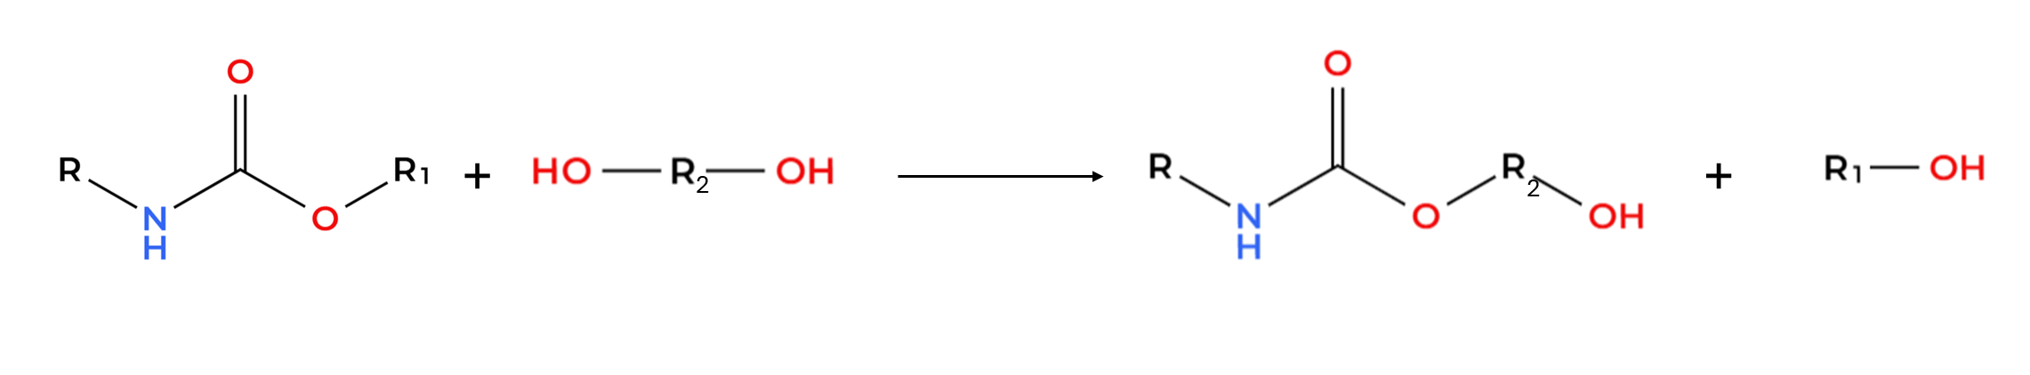
Figure 2 Possible glycolysis reaction of polyurethane foam
Glycolysis can be performed without a catalyst, but the use of an appropriate catalyst is recommended to achieve a higher conversion rate of the urethane (-NCOO-) groups (Wu et al., 2003). In the absence of a catalyst, the reaction proceeds very slowly under mild conditions (Molero et al., 2006). According to Wieczorek et al. (2024), catalysts used in glycolysis can be classified as either homogeneous or heterogeneous. Homogeneous catalysts are preferred for their high activity, efficiency, and ease of use, but they are difficult to separate from the reaction mixture after completion. Heterogeneous catalysts, on the other hand, are easier to recover, but typically have a lower active surface area. A promising compromise between the advantages of both types is offered by magnetic nanoparticles, which combine a high surface-to-volume ratio (due to their nanometric size) with easy separation via magnetic recovery. For this reason, a Fe₃O₄@MgAl nano catalyst has been investigated for its performance in the glycolysis of polyurethane foam.
  - Experimental
    - Materials
Iron (III) chloride hexahydrate (FeCl₃*6H₂O), iron (II) chloride tetrahydrate (FeCl₂*4H₂O), ammonium hydroxide (NH₄OH), magnesium hydrate hexahydrate (Mg(NO₃)₃*6H₂O), sodium carbonate (Na₂CO₃), ethylene glycol, hydrochloric acid (HCl), and ethanol were purchased from Sigma-Aldrich. Aluminium nitrate nonahydrate (Al(NO₃)₃*9H₂O) was purchased from Thermo Scientific Chemicals, and sodium hydroxide (NaOH) was purchased from Carlo Erba Reagents. All reagents were of analytical grade. Polyurethane foam was provided by C&G Kiel Italia S.r.l.
    - Preparation of Fe₃O₄@MgAl nanoparticles
The synthesis of the Fe₃O₄@MgAl nanocomposite was performed in a two-step procedure. In the first step, Fe₃O₄ nanoparticles were synthesized by dissolving 10.1 g of FeCl₃·6H₂O and 5 g of FeCl₂·4H₂O in 150 mL of deionized water. The solution was vigorously stirred at 85 °C under a nitrogen atmosphere. Once the temperature reached 85 °C, 25 mL of NH₄OH were added dropwise, and the reaction was maintained under stirring for 15 minutes. The mixture was then allowed to cool to room temperature. The resulting Fe₃O₄ nanoparticles were separated using an external magnet, washed several times with deionized water, and dried at 60 °C for 10 hours. In the second step, the Fe₃O₄@MgAl nanocomposite was synthesized by dispersing 1.93 g of Fe₃O₄ nanoparticles in 150 mL of deionized water, followed by sonication for 15 minutes to ensure uniform dispersion. The suspension was then stirred vigorously at 60 °C, while 50 mL of an aqueous solution containing 12.8 g of Mg(NO₃)₂·6H₂O and 9.38 g of Al(NO₃)₃·9H₂O was added dropwise.
Subsequently, the pH was adjusted to 10 by adding a solution of 6.75 g of NaOH and 5.29 g of Na₂CO₃ dissolved in 50 mL of water. The resulting precipitate was washed with deionized water, magnetically separated, and then dried at 60 °C for 10 hours.
    - Glycolysis reaction
To carry out polyurethane foam glycolysis, the first step involved reducing the particle size of the material. This was achieved using an ultra-centrifugal mill (ZM 200, RETSCH) equipped with a 0.8 mm sieve. The glycolysis reaction was conducted in 15 g of diethylene glycol (DEG), with 0.195 g of catalyst, under vigorous stirring at 190 °C in a nitrogen atmosphere, using a water-cooled reflux condenser. Once the reaction temperature was reached, polyurethane foam powder was gradually added at regular intervals (2.5 g every 15 minutes). After the final addition, the system was maintained at reaction conditions for an additional hour, then cooled to room temperature. At the end of the reaction, the mixture separated into two distinct phases: the upper phase containing the recovered polyol, and the lower phase composed of residual glycol and reaction by-products.
To extract the polyol, acidified water (pH 4–5) was added at a 1:1 weight ratio to the polyol phase. The extraction was carried out at 60 °C under a nitrogen atmosphere, with vigorous stirring and reflux condensation for 10 minutes. Following extraction, the mixture was allowed to cool to room temperature and then centrifuged at 3000 rpm for 10 minutes to isolate the extracted polyol. The final product was dried in an oven at 100 °C for 10 hours.
  - Results and discussion
    - Fe₃O₄@MgAl Nanoparticles Characterization
The synthesized Fe₃O₄@MgAl nanocomposite was characterized using a combination of analytical techniques, including Fourier-transform infrared (FT-IR) spectroscopy, thermogravimetric analysis (TGA), X-ray diffraction (XRD), transmission electron microscopy (TEM), and scanning electron microscopy (SEM), coupled with energy-dispersive X-ray spectroscopy (EDX) for elemental analysis.
For the FT-IR spectroscopy, a Nicolet iS50 spectrophotometer was utilized to analyze the FTIR spectrum of the nanocomposite, shown in Figure 3a. The FTIR spectrum shows vibrational bands at 547.14 cm⁻¹ belonging to Fe-O stretching and the torsional mode of Fe₃O₄ (Racuciu M., 2009). At 3,371.44 cm⁻¹, O-H stretching vibrations of water on the surface of the nanoparticles are visible. Vibrational bands at 695.14 cm⁻¹ and 755.41 cm⁻¹ are associated with Mg and Al (M-O, O-M-O, M-O-M where M=Mg and Al) (Subhan M. et al., 2017; Jamil N. et al., 2015; Prabu S. and Wang H., 2020; Mozaizh A.A.B. et al., 2022). 1,371.87 cm⁻¹ is associated with asymmetric stretching of NO₃⁻ (Verma S.K. and Deb M.K., 2007). 1,629.67 cm⁻¹ is due to the hydroxyl deformation mode of water molecules (Ai et al., 2011).
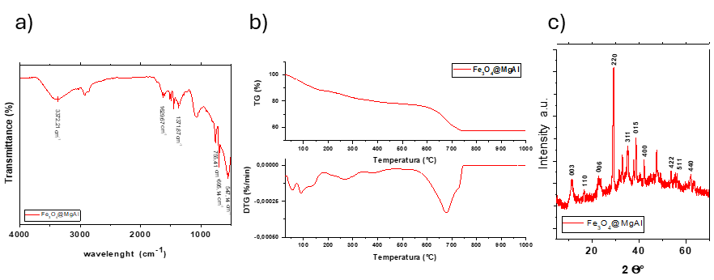
Figure 3 a) Fe₃O₄@MgAl nanocomposite FTIR spectrum, b) Fe₃O₄@MgAl nanocomposite TG-DTG analysis, and c) Fe₃O₄@MgAl nanocomposite XRD analysis
Figure 3b shows the thermogravimetric analysis of Fe₃O₄@MgAl, which is characterized by various weight losses. The initial weight loss, observed below 100 °C, can be attributed to the evaporation of moisture from the material (Sarita Chandran A. et al., 2023), and the second, at 150 °C, is associated with the dehydration of hydroxyl groups (Spiridigliozzi H., 2023). The third weight loss step is located between 250 °C and 300 °C and is related to the dihydroxylation of Al(OH)₃ (Spiridigliozzi H., 2023), and the last weight loss, around 650 °C and 700 °C, can be associated with the thermal decomposition of carbonates intercalated into the structure of the nanoparticle (Spiridigliozzi H., 2023).
The XRD spectrum of Fe₃O₄@MgAl was acquired by a Bruker D2 Phaser X-ray diffractometer, using CuKα radiation; the results are shown in Figure 3c. According to Wu X. et al, 2017, the diffraction peaks at 2theta values and Miller indices (in brackets) 29.24° (220), 35.33° (311), 42.31° (400), 53.88° (422), 56.23° (511), 62.18° (440) come from Fe₃O₄ and the diffraction peaks at 11.25° (003), 16.78° (110), 22.77° (006), 38.79° (015) come from MgAl.
The morphology of the surface of Fe₃O₄@MgAl nanoparticles was analysed by scanning electron microscopy (SEM) (TESCAN-VEGA LMH; 230 V). Figure 4a and Figure 4b show irregular-shaped particles constituted of NPs. The size of Fe₃O₄@MgAl nanocomposite was measured by transmission electron microscopy (TEM) (FEI Tecnai 20 operating at 200 kV with LaB₆ filament as the electron source). From the TEM image, shown in Figure 4c, it is possible to determine the nanoparticles' size of about 10 nm. This confirms the nanometric dimension of the synthesized catalyst.
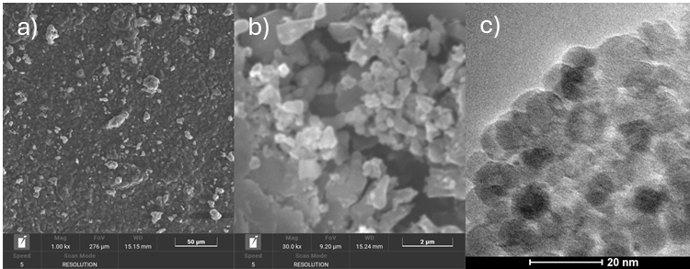
Figure 4 SEM images of Fe₃O₄@MgAl nanocomposite at magnification of a) 1.00 kx, b) 30.00 kx, and c) TEM images of Fe₃O₄@MgAl
In Table 1, the EDX analysis of the sample is shown. It can be seen the presence of iron, oxygen, magnesium, and aluminium from the Fe₃O₄@MgAl nanocomposite, chlorine, nitrogen, and sodium come from the synthesis procedure, and chromium from the necessary metallization of the sample to perform the SEM analysis.
Table 1 Element composition of the Fe₃O₄@MgAl nanocomposite
Element | N K | O K | Na K | Mg K | Al K | Cl K | Cr K | Fe K
Weight % | 14.6 | 57.6 | 19.9 | 1.3 | 0.8 | 0.2 | 1.5 | 4.1
Atomic % | 18.3 | 63.2 | 15.2 | 0.9 | 0.5 | 0.1 | 0.5 | 1.3
    - Polyol characterization
The polyol obtained from the glycolysis was then characterized by FT-IR spectroscopy, thermogravimetric analysis, and ¹H NMR spectroscopy (Bruker Advance 400). The FTIR spectrum in Figure 5 shows high-purity polyol as compared with a commercial one. Vibrational bands at 3,316.11 cm⁻¹ for the OH group, 1,704.86 cm⁻¹ from the ester carbonyl group, 1,221.48 cm⁻¹ from C-O from ester, ether, and hydroxyl group, 1,085.68 cm⁻¹ from C=O. 2,917.14 cm⁻¹, 2,872.63 cm⁻1, 1,452.43 cm⁻¹, 1,407.93 cm⁻¹ are related to the bending of alkane C-H (Radojcic D. et al., 2013). The presence in FTIR analysis of the typical vibrational bands corresponding to OH, C-O, and C=O can be related to a successful degradation of polyurethane foams and a sign of similar structure and properties to conventional polyether polyols, both for the polyol obtained with Fe₃O₄ and Fe₃O₄@MgAl catalyst (Ivashchuk O.S. et al., 2025).
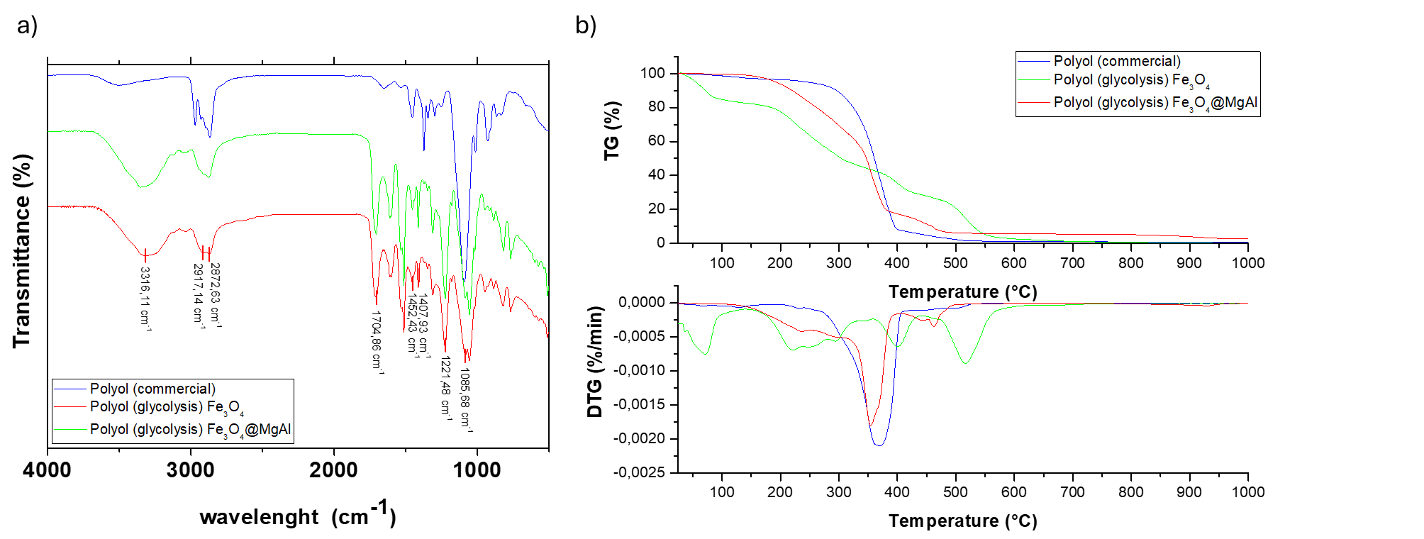
Figure 5 a) Comparison of polyol from glycolysis (Fe₃O₄ and Fe₃O₄@MgAl) and commercial polyol FTIR spectra, and b) comparison of polyol from glycolysis (Fe₃O₄ and Fe₃O₄@MgAl) and commercial polyol TG-DTG analysis
The thermogravimetric analysis of polyol is shown in Figure 5b. The polyol from glycolysis with Fe₃O₄@MgAl is characterized by a weight loss starting at 150 °C, probably due to bound water, followed by a polyol degradation, which occurs in agreement with the commercial polyol analysis. The polyol obtained from glycolysis with Fe₃O₄, instead, shows a greater weight loss below 100 °C, which is associated with water in the sample, followed by polyol degradation in agreement with the other two samples. The higher water content in the sample from Fe₃O₄ glycolysis can lead to side reactions in the polyurethane foam production. Isocyanates react with water to form carbamic acid, which decomposes to primary amine and subsequently to polyureas (Suryawanshi Y. et al., 2018). This reaction path reduces the amount of isocyanate available for the reaction with polyols, and so it requires either a higher amount of isocyanate or a further purification process in order to remove the excess water. The thermogravimetric analysis reveals that while the commercial polyol undergoes a single weight loss event between 300 °C and 400 °C, the recycled polyols exhibit a two-step degradation process within the 200 °C to 400 °C range. This behavior is likely related to variations in the molecular weight distribution of the glycolysis-derived products (Kiss G. et al., 2020). Moreover, since the range from 200 °C to 400 °C is associated with polyol degradation, it is possible to determine process yield by measuring the weight loss of the sample in this range. In particular, the degradation yield can be measured to be 42 wt.% for the Fe₃O₄ sample and 75 wt.% for the Fe₃O₄@MgAl sample. Therefore, it can be stated that the use of the nanocomposite shows higher polyol recovery compared to the Fe₃O₄ catalyst.
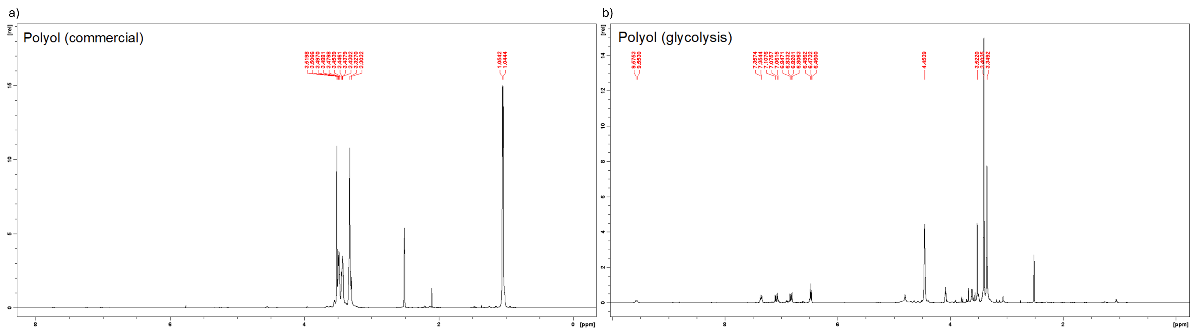
Figure 6 H-NMR spectra of a) polyol (commercial) and b) polyol (glycolysis)
Figure 6 shows the ¹H-NMR spectra of the commercial polyol and the polyol obtained via glycolysis. In the commercial polyol, peaks at 3.3032–3.5198 ppm are attributed to hydroxyl groups, while 1.0444 and 1.0542 ppm correspond to methyl groups (Fu K. et al., 2025; Briones R. et al., 2011; Dragunski D.C. and Pawlincka A., 2001). The glycolysis-derived polyol exhibits similar −OH peaks (3.3492–3.5220 ppm), a signal at 4.4539 ppm from a −CH₂−O− group near an aromatic ring, and aromatic and urethane −NH peaks between 6.4600–9.5753 ppm (Tang Q. and Gao K., 2017; Pegoraro M. et al., 2002).These peaks may indicate residual byproducts or impurities from the glycolysis process.
  - Conclusions
In this study, a Fe₃O₄@MgAl nanocomposite was synthesized and employed as a catalyst for the glycolysis of polyurethane foam. The characterization of the nanocomposite, supported by a comprehensive comparison with literature data, confirmed the successful synthesis of the material. The catalyst demonstrated effective activity in producing polyol from polyurethane foam waste, attributed to its high surface area at the nanoscale. Additionally, its magnetic properties enabled easy recovery after the reaction. The resulting polyol was characterized and compared with a commercial reference polyol. Both FTIR spectroscopy and thermogravimetric analysis (TGA) showed that the glycolysis-derived polyol exhibited comparable properties to the commercial product, supporting its potential as a sustainable alternative to fossil-based polyols in polyurethane foam production.
Acknowledgments
This research was supported by the "Horizon Europe" program, funded by the European Union (C&G Kiel Italia srl -Italy, project leader. Project n. F/310234/03/X56– REA - Introduzione di mateRiali e tEcnologie circolari e sostenibili nell'industria del trasporto di massA - Introduction of circular and sustainable materials and technologies in the mass transport industry).
References
Ai L., Zhang C., Meng L., 2011, Adsorption of Methyl Orange from Aqueous Solution on Hydrothermal Synthesized Mg-Al Layered Double Hydroxide, Journal of Chemical & Engineering Data, 56.
Briones R., Serrano L., Younes R.B., Mondragon I., Labidi J., 2011, Polyol production by chemical modification of date seeds, Industrial Crops and Products, 34, 1035-1040.
Sarita Chandran A., Ushami M., Krishnaraj M.V., 2023, International Journal of Advanced Research in Science, communication and Technology (IJARSCT), 3.
Deng R., Davies P., Bajaj A.K., 2003, Flexible polyurethane foam modelling and identification of viscoelastic parametera for automotive seating applications, Journal of Sound and Vibration, 262, 391-417.
Donadini R., Boaretti C., Lorenzetti A., Roso M., Penzo D., Lago E. D., Modesti M., 2023a, Chemical recycling of polyurethane waste via a Microwave-Assisted glycolysis process. ACS Omega, 8(5), 4655–4666.
Donadini R., Boaretti C., Scopel L., Lorenzetti A., Modesti M., 2023b, Deamination of Polyols from the Glycolysis of Polyurethane, Chemistry – A European Journal, 30.
Dragunski D.C., Pawlicka A., 2001, Preparation and characterization of starch grafted with toluene poly (propylene oxide) diisocyanate, Materials Research, 4(2), 77-81.
Fu K., Hou L., Yang X., Lin Y., Tian H., Zhao S., Chang C., Han X., 2025, Efficient glycolysis of polyurethane (PU) foam using biobased crude glycerol for oil-water separation sponge and rigid PU foam preparation: Optimization and techno-economic evaluation, Separation and Purification Technology, 369, 133174
Heiran R., Ghaderian A., Reghunadhan A., Sedaghati F., Thomas, S., Haghighi, A. H., 2021, Glycolysis: an efficient route for recycling of end of life polyurethane foams. Journal of Polymer Research, 28(1).
Ivashchuk O.S., Suprun W.Y., Atamanyuk V.M., Kurhanskyi V.S., Nahurskyi A.O., Chyzhovych R.A., 2025. Depolymerization of rigid polyurethane waste by catalytic glycolysis with diethylene glycol, South African Journal of Chemical Engineering, 52, 61-67.
Jamil N., Mehmood M, Lateef A., Nazir R, Ahsad N., 2015, MgO Nanoparticles for the Removal of Reactive dyes from Wastewater. Advanced Materials: TechConnect Briefs.
Kiss G., Rusu G., Peter F., Tanase I., Bandur G., 2020, Recovery of flexible polyurethane Foam Waste foe Efficient Reuse in Industrial Formulations. Polymers, 12(7), 1533.
Lalhmangaihzuala S., Laldinpuii Z., Khiangte V., Lallawmzuali G., Thanhmingliana N., Vanlaldinpuia K., 2023, Orange peel ash coated Fe3O4 nanoparticles as a magnetically retrievable catalyst for glycolysis and methanolysis of PET waste. Advanced Powder Technology, 34(7), 104076.
Molero C., De Lucas A., Rodriguez J.F., 2006, Recovery of polyols from flexible polyurethane foam by “split-phase” glycolysis with new catalysts, Polymer Degradation and Stability, 91, 894-901.
Mokaizh A.A.B., Shariffuddin J.H., Baarimah A.O., Al-Fakih A., Mohamed A., Baarimah S.O., Al-Mekhlafi A.A., Alenezi H., Olalere O.A., Saeed A.A.H., 2022, Elucidating the Effects of Reaction Time on the Physicochemical Characterization of Valorized Synthesized Alumina. Mechanical Properties of Advanced Materials and Structures, 15(9), 3046.
Pegoraro M., Galbiati A., Ricca G., 2002, ¹H nuclear magnetic resonance study of polyurethane prepolymers from toluene diisocyanate and polypropylene glycol, Journal of Applied Polymer Science, 87, 347-357.
Prabu S., Wang H., 2020, Enhanced hydrogen generation from graphite-mixed aluminum hydroxides catalyzed Al/water reaction, International Journal of Hydrogen Energy, 45, 33419-33429.
Racuciu M., 2009, Synthesis protocol influence on aqueous magnetic fluid properties, Current Applied Physics, 9, 1062-1066.
Radojcic D., Ionescu M., Petrovic Z.S., 2013, Novel potentially biodegradable polyurethanes from bio-based polyols, Contemporary Materials, 4, 9-21.
Simón D., García M., De Lucas A., Borreguero A., Rodríguez J., 2012, Glycolysis of flexible polyurethane wastes using stannous octoate as the catalyst: Study on the influence of reaction parameters. Polymer Degradation and Stability, 98(1), 144–149.
Spiridigliozzi H., 2023, Bottom-up strategy for the development of optically transparent and nanostructured MgAl2O4 spinel ceramics. Materials Science, Université Paris-Nord - Paris XIII
Subhan M., Saha P., Uddin N., Sarker P., 2017, Synthesis, Structure, Spectroscopy and Photocatalytic Studies of Nano Multi-Metal Oxide MgO•Al₂O₃•ZnO and MgO•Al₂O₃•ZnO Curcumin Composite. Int. J. Nanosci. Nanotechnol., 13(1), 69-82.
Suryawanshi Y., Sanap P., Wani V., 2018, Advances in the synthesis of non-isocyanate polyurethanes, Polymer Bulletin, 76, 3233-3246.
Tang Q., Gao K., 2017, Structure analysis of polyether-based thermoplastic polyurethane elastomers by FTIR, ¹H NMR and ¹³C NMR, International Journal of Polymer Analysis and Characterization, 1563-5341.
Verma S.K., Deb M.K., 2007, Nondestructive and rapid determination of nitrate in soil, dry deposits and aerosol samples using KBr-matrix with diffuse reflectance Fourier transform infrared spectroscopy (DRIFTS), Analytica Chimica Acta, 582, 382-389.
Wieczorek K., Bukowski P., Stawiński K., Ryłko I., 2024, Recycling of polyurethane foams via glycolysis: a review. Materials, 17(18), 4617.
Wu C.H., Chang C.Y., Cheng C.M., Huang H.C., 2003, Glycolysis of waste flexible polyurethane foam, Polymer Degradation and Stability, 80, 103-111.
Wu X., Li B., Wen X., 2017, Synthesis and adsorption properties of hierarchical Fe₃O₄@MgAl-LDH magnetic nanospheres, Journal of Nanoparticles Research, 19.
Yang W., Dong Q., Liu S., Xie H., Liu L., Li J., 2012, Recycling and disposal methods for polyurethane foam wastes, Procedia Environmental Sciences 16, 167-175.
Zia K.M., Bhatti H.N., Bhatti I.A., 2007, Methods for polyurethane and polyurethane composites, recycling and recovery: A review, Reactive and Functional Polymers, 67, 675-692.

