 CHEMICAL ENGINEERING TRANSACTIONS  VOL. , 2025 | A publication of  
The Italian Association
of Chemical Engineering
Online at www.cetjournal.it

Guest Editors: Paolo Ciambelli, Luca di Palma
Copyright © 2025, AIDIC Servizi S.r.l.
ISBN 979-12-81206-20-5; ISSN 2283-9216

Mechanical recycling of interior coverings in public transport: a Life cycle assessment study
Luca Gallucci°, Claudia Cirillo°, Mariagrazia Iuliano°, Maria Sarno*
Department of Physics “E.R. Caianiello” and Centre NANO_MATES (Research Centre for Nanomaterials and Nanotechnology at the University of Salerno) University of Salerno, Via Giovanni Paolo II, 132 - 84084 Fisciano (SA), Italy.
°These three authors contribute equally
*msarno@unisa.it
The public transportation sector, particularly railways and bus network, plays a critical role in advancing sustainable mobility models. Interior materials, especially in seating, are primarily composed of synthetic polymers such as polyester, polyurethane, and polyamides, which are chosen for their durability, resistance to wear, and user comfort. Nonetheless, they often face inadequate management at the end of their life cycle, leading to environmentally unsustainable disposal methods, such as landfilling or incineration.
Mechanical recycling of technical textiles has emerged as a promising solution for addressing these challenges. This method involves physically processing synthetic materials, breaking them down into fibers or granules that can be repurposed for new applications. Evaluating the environmental performance of mechanical recycling requires a life cycle assessment (LCA) approach, which quantifies the environmental impacts across the entire process—from collection and sorting to the production of secondary raw materials. This study investigates the potential of mechanical recycling for polymeric interior materials used in buses and trains, focusing on their environmental, technological, and economic aspects. Life cycle assessment (LCA) is employed to evaluate the sustainability of mechanical recycling compared to other end-of-life scenarios, such as landfilling, highlighting how mechanical recycling represents a sustainable and effective solution for managing end-of-life polymeric interior materials in the public transportation sector.
  - Introduction
Transportation is one of the largest application sectors for technical textiles. Textiles are required to meet very high-performance specifications such as wear resistance, flame retardancy, and UV resistance (Fung, 2000). According to a global surface material for transportation market report, the market was valued at 33.61 billion dollars in 2023. Fabrics represented approximately 38% of the surface materials for the transportation market in 2022 (Research and Markets, 2024).
Among the different materials that can be used to create fabrics for the automotive industry, polyester accounts for 42% (Saricam and Okur, 2018) thanks to its physical properties, high mechanical strength, and relatively low cost (Matsuo, 2008). The exploitation of polyester fabric in such high percentages leads to problems associated with the disposal of the material at the end of its life. Some of the disposal methods include landfilling and incineration. These processes, though, are environmentally concerning and unsustainable due to their impact on the environment.
Mechanical recycling of polyester fabric represents a viable alternative to the aforementioned disposal methods. According to Dissanayake and Weerasinghe 2021, mechanical recycling can be categorized into two paths:
- First path: shredding, crushing, grinding, melting, and re-extruding to produce new fibers
- Second path: cutting, shredding, and heat pressing to produce panels or sheets
To compare mechanical recycling with the landfill disposal method, the first path has been chosen, which produces the same fibers from the recycling process.
To estimate the differences in end-of-life treatments, in this work, the life cycle assessment (LCA) methodology has been used. LCA is a powerful tool that evaluates the environmental burdens of a product’s life cycle. This methodology is defined by the ISO 14040-2006 and ISO 14044-2006.
  - Materials and Methods
According to the ISO 14040-2006, an LCA study is made of four phases:
- the goal and scope definition phase
- the inventory analysis phase
- the impact assessment phase
- the interpretation phase

    - Goal and Scope Definition
This work aimed to evaluate the environmental impact associated with the different end-of-life treatments for polyester fabric. In particular, two scenarios were considered:
- Scenario 1: Landfill
- Scenario 2: Mechanical recycling

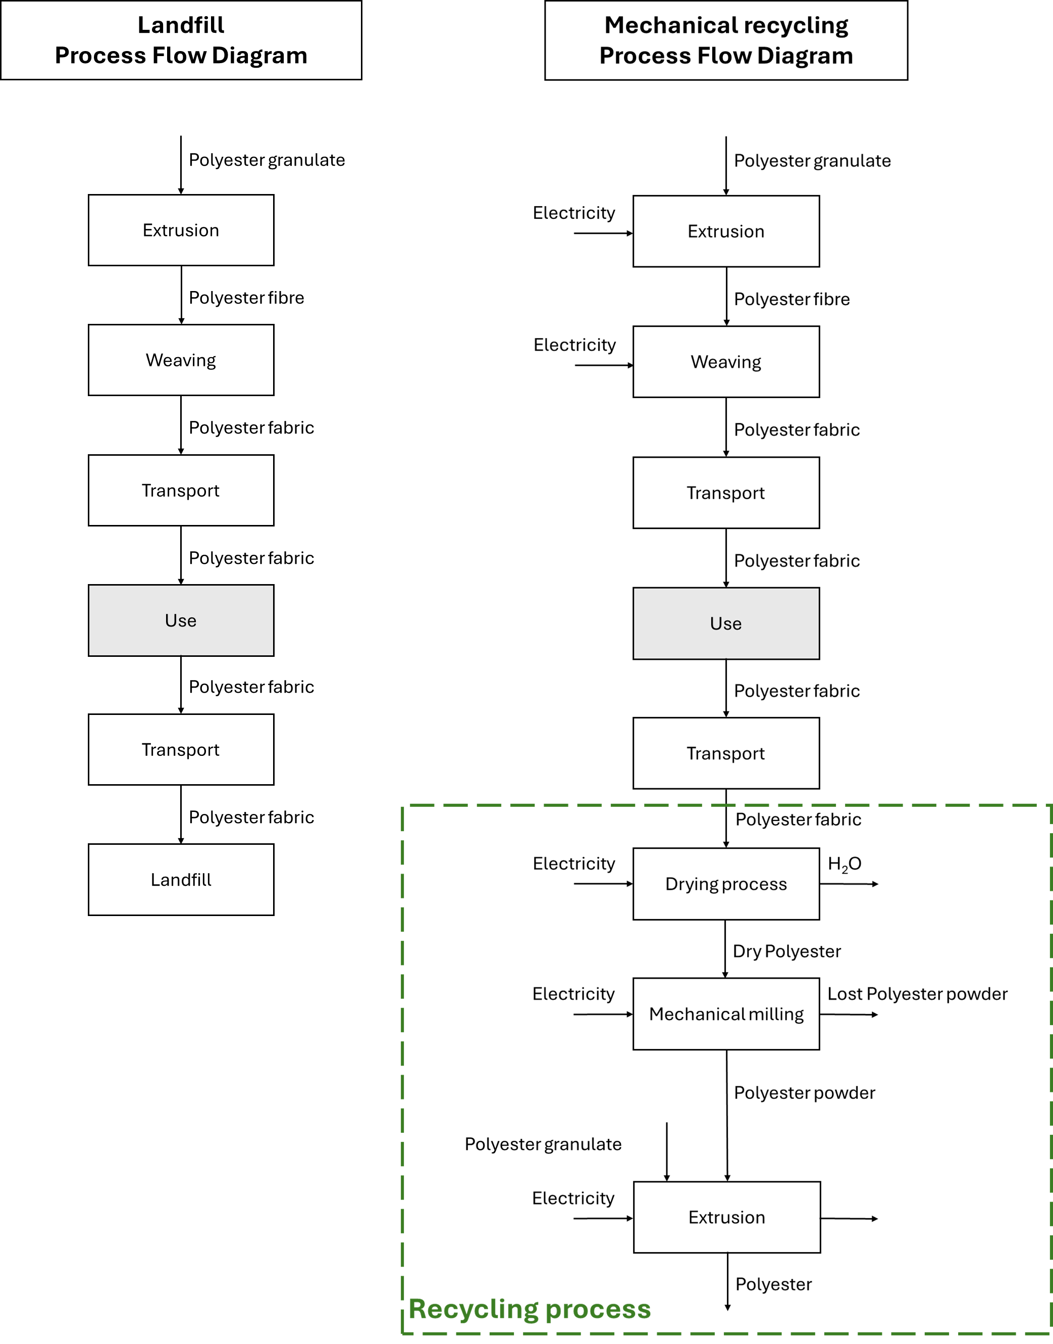
Figure 1 a) Scenario 1 and b) Scenario 2 Processes Flow Diagram
The system boundaries for Scenario 1 and Scenario 2 are shown in Figure 1. In Scenario 1, the material starts as a polyester granulate, which is then transformed into fiber through an extrusion step. The fiber is then woven into fabric and transported to the use phase. This latter phase is not modeled since it is assumed to be the same for both scenarios. After the use phase, the material is transported to a landfill for disposal.
In Scenario 2, the process is identical to Scenario 1 up to the end of the use phase. However, instead of being landfilled, the polyester fabric is transported to a recycling facility. The recycling process consists of a drying process, followed by mechanical milling, which produces polyester fiber powder. Eventually, the powder can be used to create new fiber, replacing part of the virgin polyester granulate in the extrusion process.

Considering Scenario 2, four more conditions have been considered in the recycling process, based on the substitution percentage:
- Scenario 2a: 25%
- Scenario 2b: 50%
- Scenario 2c: 75%
- Scenario 2d: 100%
In which the substitution percentage is determined as the amount of polyester powder that replaces the virgin polyester granulate, as expressed in Table 1.
Table 1 Substitution percentage in polyester fiber production
Substitution percentage, % | Polyester granulate, kg | Polyester powder, kg | Polyester fiber produced, kg
0 | X | - | 1,000
25 | X*0.75 | X*0.25 | 1,000
50 | X*0.5 | X*0.5 | 1,000
75 | X*0.25 | X*0.75 | 1,000
100 | - | X | 1,000

A reference flow was defined as 1,000 kg of polyester fiber disposed of in a landfill and 1,000 kg of polyester fiber produced in the recycling process.
In Scenario 2, recycling introduces the need to allocate the impacts of the input flows to the recycling process. According to ISO 14044:2006, allocation is defined as the partitioning of the input and output flows of a process or product system between the product system under study and one or more other product systems.
For this reason, a 50:50 allocation method has been considered, regarding the environmental impacts associated with the polyester fabric input flow to the recycling steps (Zimmermann et al., 2022).
Recycling leads to both a reduction in disposal of the original product and the generation of secondary raw materials for a new product. To account for this, the 50:50 method allocation can be used, in which half of the environmental impacts of the production are associated with the first product, and the second half is associated with the second product (Obrecht et al., 2021).

    - Life Cycle Inventory Analysis (LCIA)
The Goal and Scope Definition phase is followed by the Life Cycle Inventory Analysis, which defines the connections between the different activities with quantitative data according to the functional unit.
The data used for this study come from laboratory measurements, publications in scientific papers, and technical data sheets.

    - Impact evaluation
The life cycle assessment study was performed on openLCA software (2.1.0). The impact assessment was carried out employing the Ecological Scarcity methodology, which is based on the application of “eco-factors”. The eco-factors are based on the level of emissions or consumption of a substance compared to the consumption target and are measured in “eco-points”.
An eco-factor is calculated based on three elements:
- Characterization: the measure of the relative harmfulness of a pollutant emission compared to a reference substance within a given impact category
- Normalization: contribution of a unit of pollutant or resource to the total current load/pressure in a region per year
- Weighting: the relationship between the current pollutant emission or resource consumption (current flow) and the consumption target (critical flow) (Frischknecht, 2009).

  - Results and discussion
For the five different scenarios considered, the results are shown in Table 2 as absolute values in UBP (eco-points), while in Figure 2 the impact results are shown as percentage of the highest impact value in that same category, i.e. for carcinogenic substances into air – total all the impact values percentages are calculated based on the impact of Scenario 1.
Table 2 Life cycle assessment results for the different scenarios considered
Impact categories | Unit | Scenario 1 | Scenario 2a | Scenario 2b | Scenario 2c | Scenario 2d
carcinogenic substances into air - total | UBP | 18,397.9 | 11,257.7 | 12,079.1 | 12,900.4 | 13,721.8
energy resources - total | UBP | 0 | 0 | 0 | 0 | 0
global warming - total | UBP | 1.84E+06 | 2.06E+05 | 4.02E+05 | 5.98E+05 | 7.94E+05
heavy metals into air - total | UBP | 2.57E+05 | 7.72E+04 | 1.46E+05 | 2.15E+05 | 2.84E+05
heavy metals into soil - total | UBP | 4,489.90 | 5.98 | 11.95231 | 17.93 | 23.90
heavy metals into water - total | UBP | 2.60E+06 | 6.81E+05 | 1.36E+06 | 2.04E+06 | 2.72E+06
land use - total | UBP | 0 | 0 | 0 | 0 | 0
main air pollutants and PM - total | UBP | 1.07E+06 | 5.58E+05 | 7.52E+05 | 9.46E+05 | 1.14E+06
mineral resources - total | UBP | 168.77 | 51.22 | 93.38102 | 135.54 | 177.70
non radioactive waste to deposit - total | UBP | 0 | 0 | 0 | 0 | 0
ozone layer depletion - total | UBP | 5.24E+04 | 1.60E+04 | 2.98E+04 | 4.35E+04 | 5.73E+04
pesticides into soil - total | UBP | 0 | 0 | 0 | 0 | 0
POP into water - total | UBP | 1.84E-3 | 5.1E-4 | 1E-3 | 1.48E-3 | 1.96E-3
radioactive substances into air - total | UBP | 0,00019 | 4.38E-05 | 8.76E-05 | 1.30E-04 | 1.80E-04
radioactive substances into water - total | UBP | 0 | 0 | 0 | 0 | 0
radioactive waste to deposit - total | UBP | 0 | 0 | 0 | 0 | 0
total - total | UBP | 5.85E+06 | 1.55E+06 | 2.71E+06 | 3.87E+06 | 5.02E+06
water pollutants - total | UBP | 10,527.1 | 2,967.98 | 5,723.978 | 8,479.97 | 11,236
water resources - total | UBP | 0 | 0 | 0 | 0 | 0

As shown in Figure 2, increasing the substitution percentage results in a higher environmental impact across several categories for the Scenario 2 cases.

Regarding the carcinogenic substances in the air impact category, the highest impact is associated with Scenario 1, while the recycling process gives a reduction in the impact. The difference between Scenario 1 and Scenario 2 is due to the landfill disposal, which alone contributes to almost 45% in this category. The increase in this category with the increase of substitution percentage is associated with the increase in electricity consumption for the recycling process.

In the global warming impact category, the recycling process reduces the impact by approximately 10% in Scenario 2a compared to Scenario 1. Although higher substitution percentages lead to increased impacts in this category, Scenario 2d still shows a 40% lower impact than Scenario 1. The increase in impact is mainly associated with the energy-intensive extrusion and weaving processes.

For the heavy metals into soil impact category, a clear distinction is observed between the scenarios. Scenario 2 exhibits a near-zero impact, in contrast to Scenario 1, where landfill disposal accounts for nearly 100% of the impact. In Scenario 2, the primary contributors are electricity consumption and transportation, given the absence of landfilling.

In the radioactive substances in air impact category, the recycling process consistently reduces the impact across all substitution percentages. In Scenario 1, landfill disposal is responsible for almost the entire impact, whereas in Scenario 2, electricity use and transportation are the main contributors.

Finally, the total impact category shows that for every Scenario 2 considered, the overall impact is less than Scenario 1, even for Scenario 2d, which, in some categories, is characterized by a slightly higher impact.

Figure 2 Ecological scarcity impact categories results for Scenario 1, Scenario 2a, Scenario 2b, Scenario 2c, Scenario 2d

  - Conclusions
In conclusion, this study compared two end-of-life treatment options for polyester fabric: landfill disposal and mechanical recycling.
To compare the different scenarios, the life cycle assessment has been analysed using the Ecological Scarcity method to determine the environmental impacts. It can be seen that, in general, recycling can reduce the environmental burdens of the polyester waste in Scenarios 2a, 2b, and 2c. Scenario 2d, instead, even though it is characterized by slightly higher impact in some categories compared to Scenario 1, in the total impact category is still less impactful than landfill disposal.
Overall, it can be stated that recycling, for every percentage considered, helps in reducing the impact on the environment of polyester waste.

Acknowledgments
This research was supported by the "Horizon Europe" program, funded by the European Union (C&G Kiel Italia srl -Italy, project leader. Project n. F/310234/03/X56– REA - Introduzione di mateRiali e tEcnologie circolari e sostenibili nell'industria del trasporto di massA - Introduction of circular and sustainable materials and technologies in the mass transport industry).

References
Abagnato S., Rigamonti L., Grosso M., 2024, Life cycle assessment applications to reuse, recycling and circular practices for textiles: A review, Waste Management, 182, 74–90.
Dissanayake D.G.K., Weerasinghe D.U., 2021, Fabric Waste Recycling: a Systematic Review of Methods, Applications, and Challenges, Materials Circular Economy, 3.
Frischknecht R., Steiner R., Jungbluth N., 2009, The ecological scarcity method—eco-factors 2006. A method for impact assessment in LCA. Federal Office for the Environment (FOEN), Bern.
Fung W., 2000, Textiles in transportation in Handbook of technical textiles, Woodhead Publishing Limited, 490-528
Guo Z., Eriksson M., De La Motte H., Adolfsson E., 2020, Circular recycling of polyester textile waste using a sustainable catalyst, Journal of Cleaner Production, 283, 124579.
Matsuo T., 2008, Automotive applications, Chapter in Polyesters and Polyamides, Woodhead Publishing Limited, Cambridge, 525-541.
Obrecht T.P., Jordan S., Legat A., Saade M.R.M., Passer A., 2021, An LCA methodology for assessing the environmental impacts of building components before and after refurbishment, Journal of Cleaner Production, 327.
Oliveux G., Dandy L. O., Leeke G. A., 2015, Current status of recycling of fibre reinforced polymers: Review of technologies, reuse and resulting properties, Progress in Materials Science, 72, 61–99.
Peng Y., Yang J., Deng C., Deng J., Shen L., Fu Y., 2023, Acetolysis of waste polyethylene terephthalate for upcycling and life-cycle assessment study, Nature Communications, 14(1).
Research and Markets, Surface Materials for Transportation Market Report 2024: In 2022, Leather Accounted for Around 44.1%, Fabric Around 38.0%, Vinyl Held Around 9.8% - Global Forecast to 2033. <globenewswire.com/news-release/2024/04/03/2857026/28124/en/Surface-Materials-for-Transportation-Market-Report-2024-In-2022-Leather-Accounted-for-Around-44-1-Fabric-Around-38-0-Vinyl-Held-Around-9-8-Global-Forecast-to-2033.html> accessed 06.02.2025
Saricam C., Okur N., 2018, Polyester Usage for Automotive Applications, Chapter in Polyester: Production, Characterization and Innovative Applications, InTech, Rijeka, Croatia
Zimmermann R.K., Rasmussen F. N., Kanafani K., Eberhardt L.C.M., Birgisdóttir H., 2022, Reviewing allocation approaches and modelling in LCA for building refurbishment, IOP Conf. Ser.:Earth Environ. Sci. 1078

