 CHEMICAL ENGINEERING TRANSACTIONS  VOL. , 2025 | A publication of  
The Italian Association
of Chemical Engineering
Online at www.cetjournal.it

Guest Editors: Paolo Ciambelli, Luca di Palma
Copyright © 2025, AIDIC Servizi S.r.l.
ISBN 979-12-81206-20-5; ISSN 2283-9216

LCA of polyurethanes from glycolysis of waste upholstery a sustainable recycling approach
Claudia Cirillo°*, Luca Gallucci°, Mariagrazia Iuliano°, Maria Sarno
Department of Physics “E.R. Caianiello” and Centre NANO_MATES (Research Centre for Nanomaterials and Nanotechnology at the University of Salerno) University of Salerno, Via Giovanni Paolo II, 132 - 84084 Fisciano (SA), Italy.
°These three authors contribute equally
*clcirillo@unisa.it
Polyurethanes (PUs) are widely used materials with a broad spectrum of applications. Their versatility and ability to adapt to various needs arise from their segmented structure, which consists of both rigid and flexible segments, and the control of variables such as chemical composition, functionality, and the molecular weight of the reagents.
However, PU foam waste accumulation, resulting from de-commissioning of aging vehicles, poses a significant environmental challenge. The need to reduce the ecological impact of PU foam waste has led to the exploration of sustainable solutions, such as chemical recycling, specifically glycolysis, which enables the recovery of polyols from PU foam waste for reuse in the production of new materials. Glycolysis is a chemical recycling process in which waste polyurethane materials are broken down using glycol-based agents.
In this context, this study presents a Life Cycle Assessment (LCA) model to evaluate the environmental impact of polyurethanes derived from the glycolysis of PU waste. By adopting this methodology, the project aims to demonstrate that recycled PU foam waste use through glycolysis not only reduces waste but can also significantly contribute to a lower ecological footprint, promoting a more sustainable life cycle for the materials used in passenger transport seat cushions.

  - Introduction
Polyurethane foams are among the most widely used materials in the construction, automotive, furniture, and industrial sectors. Their versatility, safety, insulation properties, and comfort make them an ideal choice for all these applications.
Polyurethane foam’s properties can be attributed to its chemical structure. A typical reaction path for the synthesis of polyurethane foams is shown in Figure 1.

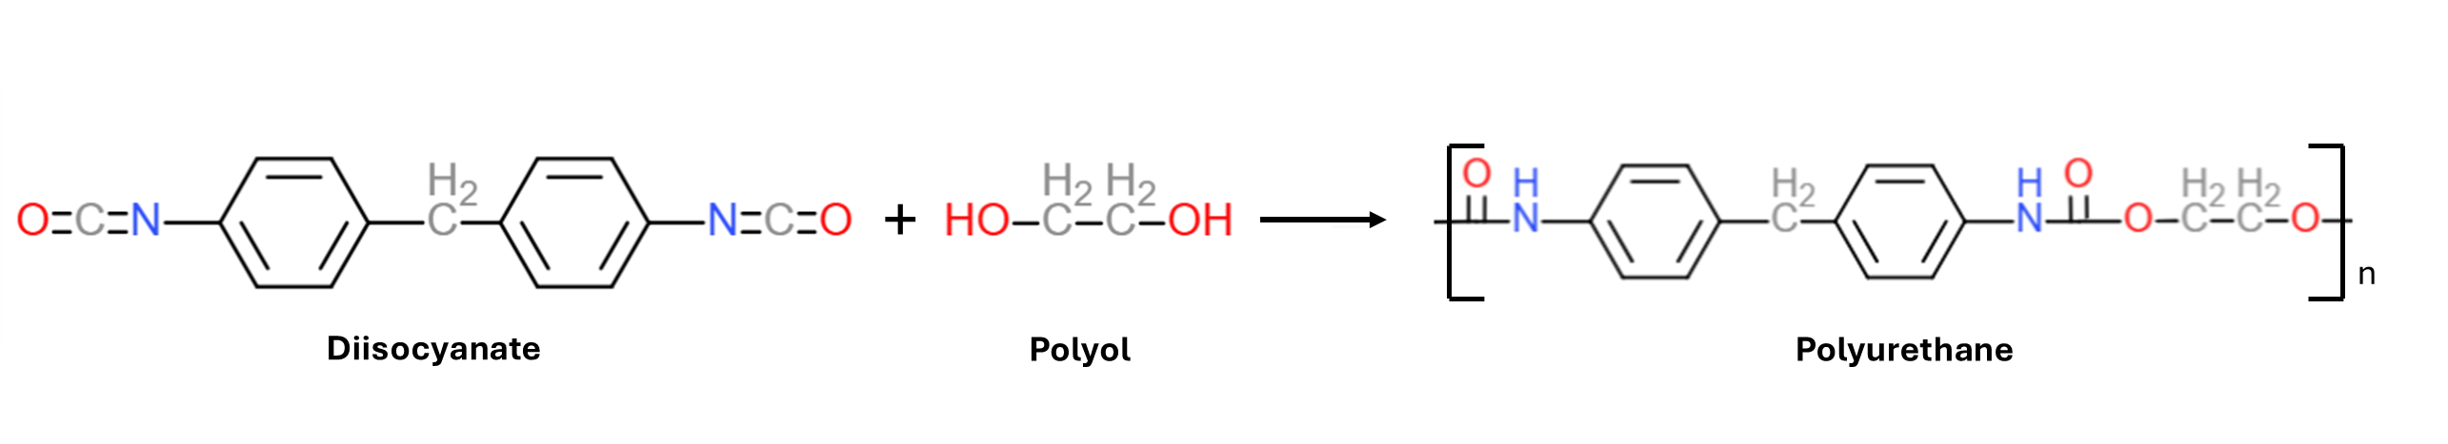
Figure 1 Polyurethane synthesis
The reaction takes place between a diisocyanate, a molecule that contains isocyanate groups (-N=C=O), and a polyol, a molecule that contains hydroxyl groups (-OH).
Due to aging and de-commissioning, polyurethane foam needs to be replaced and so a polyurethane foam waste disposal problem emerges. Generally, polyurethane foam is disposed of in landfill, causing environmental damage associated both with the potentially hazardous chemicals generated from its decomposition and with the large amount of space it takes in the landfill which could otherwise fit other unavoidable wastes (Roobankumar R. and SenthilPandian M., 2024).
Due to these problems, alternatives to landfill disposal, like chemical recycling, need to be considered. Chemical recycling processes can be divided into alcoholysis, hydrolysis, glycolysis, hydroglycolysis and aminolysis (Zia K.M. et al., 2007). Among the chemical recycling processes, glycolysis is considered to be the most convenient way to chemically recycle polyurethane foams (Heiran R. et al., 2021) and it is also the most promising for industrial scale-up (Donadini R. et al., 2023).
Glycolysis is a transesterification reaction between the hydroxyl group of the glycolytic agent and the ester part of the urethane group of the polyurethane (Donadini R. et al., 2023). Typically, the most used glycolytic agents are ethylene glycol and diethylene glycol (Wieczorek K. et al., 2024; Heiran R. et al., 2021; Xiaohua G. et al., 2021).
To evaluate the advantages of recycling compared to landfill disposal, a life cycle assessment method can be used to describe the environmental impact of the two different scenarios. Life cycle assessment is a methodology that evaluates the environmental burdens caused by a product during its life cycle. The life cycle assessment methodology is defined by ISO 14040-2006 and ISO 14044-2006.

  - Materials and Methods
According to ISO 14040-2006 an LCA study consists of four phases:
- the goal and scope definition phase
- the inventory analysis phase
- the impact assessment phase
- the interpretation phase

    - Goal and Scope Definition
To assess the environmental impact associated with the end-of-life treatment of polyurethane foam, two scenarios have been considered:
- Scenario 1: Landfill
- Scenario 2: Chemical recycling
The system boundaries are shown in Figure 2. Regarding Scenario 1, the process begins with the polyurethane synthesis by mixing the polyol and isocyanate, followed by transportation and the use phase (which has not been modelled considering that the use phase can be assumed to be identical between Scenario 1 and Scenario 2). Finally, a last transportation step and landfill disposal complete the life cycle of Scenario 1.

Regarding Scenario 2, on the other hand, up to the second transportation block, there are no differences compared to Scenario 1. However, in this case, the waste polyurethane foam is transported to the recycling process which consists of a drying process, mechanical milling step and glycolysis reaction in order to remove humidity, reduce the size of the foam and recover polyol respectively.
Additionally, for Scenario 2, four sub-scenarios have been considered based on the percentage of virgin polyol substitution:
- Scenario 2a: 25%
- Scenario 2b: 50%
- Scenario 2c: 75%
- Scenario 2d: 100%
The substitution percentage represents the amount of polyol obtained through glycolysis that replaces virgin polyol in the polyurethane synthesis. The variation in polyol composition is shown in Table 1.
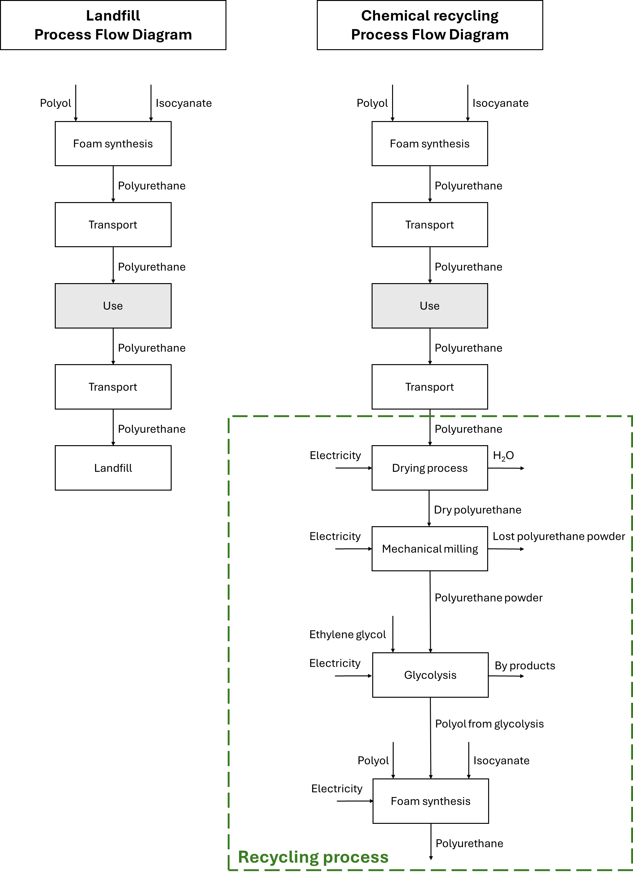
Figure 2 a) Scenario 1 and b) Scenario 2 Processes Flow Diagram
Table 1 Substitution percentage in polyurethane foam production
Substitution percentage, % | Isocyanate, kg | Polyol, kg | Polyol from glycolysis, kg | Polyurethane foam produced, kg
0 | X | Y | - | 1,000
25 | X | Y*0.75 | Y*0.25 | 1,000
50 | X | Y*0.5 | Y*0.5 | 1,000
75 | X | Y*0.25 | Y*0.75 | 1,000
100 | X | - | Y | 1,000

A reference flow was defined as 1,000 kg of polyurethane foam disposed of in a landfill and 1,000 kg of polyurethane foam produced by the recycling process.

The recycling process in Scenario 2 introduces an allocation issue in this study. Allocation is defined in ISO 14044-2006 as the partitioning of the input and output flows of a process or product system between the product system under study and one or more other product systems.
To account for the environmental impacts associated with polyurethane foam entering the recycling process, the 50:50 allocation method has been considered (Zimmermann R.K. et al., 2022).
Recycling a product into a new one implies a reduction in the need for virgin raw materials in the second product, as well as a reduction in the disposal burden from the first product. The 50:50 method accounts for this by attributing half of the environmental burdens of production to the first product and the other half to the second product (Obrecht T.P. et al., 2021).

    - Life Cycle Inventory Analysis (LCIA)
The Goal and Scope Definition phase is followed by the Life Cycle Inventory Analysis, which defines the connections between the different activities with quantitative data according to the functional unit.
The data used for this study were obtained from laboratory measurements, publications in scientific papers, and technical data sheets. In particular, the polyol-to-isocyanate ratio used in the polyurethane foam production, polyurethane foam powder loss during milling process, and the percentage of polyol substitution were determined through laboratory measurements.
    - Impact evaluation
The life cycle assessment was performed using openLCA software (version 2.1.0). The impact evaluation was carried out using the Ecological Scarcity impact assessment method. The Ecological Scarcity method is based on "eco-factors", which are used to weigh the environmental burdens of a process. Eco-factors are calculated by comparing the level of emissions or resource consumption of a substance to a defined target and are expressed in “eco-points.” An eco-factor is derived from the measure of the relative harmfulness of a pollutant emission compared to a reference substance within a given impact category (characterization), the contribution of a unit of pollutant or resource use to the total current load/pressure in a region per year (normalization) and the relationship between the current pollutant mission or resource consumption (current flow) and the consumption target (critical flow) (Frischknecht R. et al., 2009).

  - Results and Discussion
The results of the impact assessment evaluation are presented in Table 2 as absolute values in UBP (eco-points), while Figure 3 shows the values of each impact category of the different scenarios calculated as a percentage of the highest impact value in that same category, i.e. for “carcinogenic substances into air – total” all impact values are expressed as percentages relative to the impact of Scenario 1, which serves as the reference.
Table 2 Life cycle assessment results for the different scenarios considered
Impact categories | Unit | Scenario 1 | Scenario 2a | Scenario 2b | Scenario 2c | Scenario 2d
carcinogenic substances into air - total | UBP | 8,822.55 | 97.89 | 190.85 | 283.81 | 376.77
energy resources - total | UBP | 0 | 0 | 0 | 0 | 0
global warming - total | UBP | 4.89*10^5 | 4.71*10^5 | 4.54*10^5 | 4.37*10^5 | 4.19*10^5
heavy metals into air - total | UBP | 1.16*10^5 | 1.09*10^5 | 1.04*10^5 | 9.91*10^4 | 9.44*10^4
heavy metals into soil - total | UBP | 4,497,82 | 0.81 | 1.62 | 2.44 | 324.716
heavy metals into water - total | UBP | 3.73*10^5 | 3.80*10^5 | 3.87*10^5 | 3.94*10^5 | 4.01*10^5
land use - total | UBP | 0 | 0 | 0 | 0 | 0
main air pollutants and PM - total | UBP | 4.97*10^5 | 4.18*10^5 | 4.15*10^5 | 4.12*10^5 | 4.09*10^5
mineral resources - total | UBP | 47.90 | 48.00 | 48.20 | 48.40 | 48.60
non radioactive waste to deposit - total | UBP | 0 | 0 | 0 | 0 | 0
ozone layer depletion - total | UBP | 1.34*10^4 | 1.34*10^4 | 1.35*10^4 | 1.36*10^4 | 1.37*10^4
pesticides into soil - total | UBP | 0 | 0 | 0 | 0 | 0
POP into water - total | UBP | 5.1*10^-4 | 5.7*10^-4 | 6.3*10^-4 | 6.9*10^-4 | 7.5*10^-4
radioactive substances into air - total | UBP | 2.5*10^-4 | 5.95*10^-6 | 1.19*10^-5 | 1.79*10^-5 | 2.38*10^-5
radioactive substances into water - total | UBP | 0 | 0 | 0 | 0 | 0
radioactive waste to deposit - total | UBP | 0 | 0 | 0 | 0 | 0
total - total | UBP | 1.51*10^6 | 1.40*10^6 | 1.38*10^6 | 1.36*10^6 | 1.35*10^6
water pollutants - total | UBP | 7,950.55 | 7,992.78 | 8,046.25 | 8,099.72 | 8,153.19
water resources - total | UBP | 0 | 0 | 0 | 0 | 0

Figure 3 Ecological scarcity impact categories results for Scenario 1, Scenario 2a, Scenario 2b, Scenario 2c, Scenario 2d
Regarding the carcinogenic substances in the air impact category, Scenario 1 shows the highest result. The recycling scenarios reduce the impact almost to zero, which is mainly due to the significant contribution of landfill disposal, accounting for nearly 90% of the impact in this category.
In the global warming impact category, the recycling process reduces the impact with the increase in the substitution percentage. Indeed, the main contributor to global warming is the virgin polyol used in polyurethane foam synthesis. In Scenario 1, virgin polyol accounts for approximately 80% of the category's total impact. The use of recycled polyol decreases the need for virgin polyol, thereby reducing the global warming impact.
In heavy metals into the air impact category, a trend similar to global warming is observed: the impact decreases as the substitution percentage increases. This is again mainly due to the virgin polyol, which contributes approximately 60% to this category. Therefore, its replacement leads to a significant reduction in impact.
Regarding heavy metals in the soil impact category, the only impact shown in the graph is associated with Scenario 1, due to the landfill disposal of the polyurethane waste which accounts for almost 100%. In Scenario 2, instead, the negligible impacts in the category are due to electricity consumption.
In heavy metals in the water impact category, there is a slight increase in the impact value with the increase in the recycling percentage. This, to a lesser extent, is due to the use of glycol in the glycolysis process, while the main cause of the increase is the use of virgin isocyanate. These impacts, though, can be reduced if recycling isocyanate is used, so that the overall process benefits from the recycling of both reagents.
In the main air pollutants and PM impact category, Scenario 1 shows the highest impact. The main reason is landfill disposal, which contributes to almost 30% of the category for Scenario 1. In Scenario 2 there is a slight increase in the isocyanate contribution, but it is limited to 10% in the worst-case scenario.
In the persistent organic pollutants (POP) into water impact category, the recycling process leads to an increase in the impact of the process due to the glycol used in the glycolysis process. As it can be seen, the increase in the substitution percentage leads to an increase in the impact due to the ethylene glycol. In fact, its contribution from the glycolysis process increases with the substitution percentage leading to the result of the LCA study. However, the ethylene glycol impact could be reduced using a different chemical in the glycolysis process.
Regarding the radioactive substances in the air impact category, the recycling process reduces drastically the impact thanks to the absence of landfill disposal. This process, in fact, for Scenario 1 contributes to 75% of the total. This is due to the presence of ¹⁴C in biomass, textiles, wood fractions and other wastes that are disposed of in the landfill together with the polyurethane foam waste (Fellner J. and Rechberger H., 2009).
Regarding mineral resources, ozone layer depletion and water pollutants impact categories, the results are all very similar among all the scenarios. Moreover, the impacts associated with polyol decrease with the increase of substitution percentage in Scenario 2, while the slight increase of isocyanate impact and the ethylene glycol contribution in the recycling process led to the results of the LCA analysis. Even though the recycling, in these impact categories, is slightly more impactful than Scenario 1, alternatives to virgin isocyanate and virgin ethylene glycol could help in further reducing the impacts of Scenario 2.
Finally, regarding the total impact category, the recycling process reduces the overall environmental burden. Furthermore, increasing the substitution percentage leads to a consistent decrease in total impact.

  - Conclusions
In conclusion, in this work it has been considered the comparison between different end-of-life treatments for polyurethane foams. It has been studied the comparison between landfill disposal and chemical recycling by glycolysis at different substitution percentages.
The analysis has been carried out exploring the life cycle assessment of the different scenarios considered using the Ecological Scarcity method to evaluate the environmental burdens of the end-of-life of polyurethane foam waste. The impact assessment showed how, in most of the categories, the recycling process can reduce, in some cases even drastically, the impact of the polyurethane on the environment.
Overall, the total impact category demonstrated a clear decreasing trend as the substitution percentage increased. For this reason, it can be stated that the chemical recycling process offers a more sustainable alternative to landfill disposal, leading to a reduced environmental footprint for polyurethane foam waste management.
Acknowledgments
This research was supported by the "Horizon Europe" program, funded by the European Union (C&G Kiel Italia srl -Italy, project leader. Project n. F/310234/03/X56– REA - Introduzione di mateRiali e tEcnologie circolari e sostenibili nell'industria del trasporto di massA - Introduction of circular and sustainable materials and technologies in the mass transport industry).
References
Donadini R., Boaretti C., Lorenzetti A., Roso M., Penzo D., Dal Lago E., Modesti M., 2023, Chemical Recycling of Polyurethane Waste via a Microwave-Assisted Glycolysis Process, ACS Omega, 8, 4655-4666.
Fellner J. And Rechberger H., 2009, Abundance of ¹⁴C in biomass fraction of wastes and solid recovered fuels, Waste Management, 29, 1495-1503
Frischknecht R., Steiner R., Jungbluth N., 2009, The ecological scarcity method—eco-factors 2006. A method for impact assessment in LCA. Federal Office for the Environment (FOEN), Bern.
Heiran, R., Ghaderian, A., Reghunadhan, A., Sedaghati, F., Thomas, S., Haghighi, A. H., 2021, Glycolysis: an efficient route for recycling of end of life polyurethane foams. Journal of Polymer Research, 28.
Obrecht T.P., Jordan S., Legat A., Saade M.R.M., Passer A., 2021, An LCA methodology for assessing the environmental impacts of building components before and after refurbishment, Journal of Cleaner Production, 327
Roobankumar R., SenthilPandian M., 2024. A review of utilization of waste polyurethane foam as lightweight aggregate in concrete. Heliyon, 10.
Sheldon, R. A., 2017, Metrics of Green Chemistry and Sustainability: past, present, and future. ACS Sustainable Chemistry &amp; Engineering, 6, 32–48.
Wieczorek, K., Bukowski, P., Stawiński, K., Ryłko, I., 2024, Recycling of polyurethane foams via glycolysis: a review, Materials, 17.
Xiaohua G., Hongxiang L., Shiwei L., Peng C., 2021, Glycolysis Recycling of Waste Polyurethane Rigid Foam Using Different Catalysts, Journal of Renewable Materials, 9, 1253-1266.
Zia K.M., Bhatti H.N., Bhatti I.A., 2007, Methods for polyurethane and polyurethane composites, recycling and recovery: A review, Reactive and Functional Polymers, 67, 675-692.
Zimmermann R.K., Rasmussen F. N., Kanafani K., Eberhardt L.C.M., Birgisdóttir H., 2022, Reviewing allocation approaches and modelling in LCA for building refurbishment. IOP Conf. Ser.:Earth Environ. Sci. 1078

