 CHEMICAL ENGINEERING TRANSACTIONS  VOL. , 2025 | A publication of  
The Italian Association
of Chemical Engineering
Online at www.cetjournal.it

Guest Editors: Paolo Ciambelli, Luca di Palma
Copyright © 2025, AIDIC Servizi S.r.l.
ISBN 979-12-81206-20-5; ISSN 2283-9216

Synthesis of Novel Cyclic Poly(2,5-furylene vinylene) Biosourced Furanic Polymers via McMurry Homopolymerization of Diformylfuran

Salvatore Impemba^{a,b}*, Valentina A. Crispinoª, Irene Contentoª, Alessia Giannattasioª, Marco Bellini^{c}, Hamish A. Miller^{c}, Carmine Capacchione^{a,b}, Alfonso Grassi^{a,b}, Antonio Buonerba^{a,b}

ª University of Salerno, Dept. of Chemistry and Biology “A. Zambelli”, Via Giovanni Paolo II, 84084 Fisciano (SA), Italy.
^{b} Interuniversity Consortium of Chemical Reactivity and Catalysis (CIRCC), Via Celso Ulpiani, 27, 70126 Bari, Italy, and Research Centre for Nanomaterials and Nanotechnology (NANO_MATES), Via Giovanni Paolo II, 132, 84084, Fisciano (SA), Italy.
^{c} Institute of Organometallic Chemistry (ICCOM) – Italian National Research Council (CNR), Via Madonna del Piano 10, 50019 Sesto Fiorentino (FI), Italy
* Correspondence to: simpemba@unisa.it

The interest in synthesizing chemicals from renewable sources such as biomass has grown steadily in recent years to become the focus of a promising industry in developing more sustainable materials that overcome current dependence on fossil sources. Furan derivatives such as furfural (FA) and 5-hydroxymethylfurfural (HMF), which can be derived from pentose and hexose sugars, are key components of this new sector. HMF can be seen as the link between biomass chemistry and petrochemicals. By selective oxidation of the hydroxymethyl function of HMF, 2,5-diformylfuran (DFF) can be obtained, a substrate of industrial and scientific interest with a symmetrical structure in which aldehyde groups can be converted into other functions, such as olefins.
In this paper, we report on synthesizing and characterizing a new cyclic polymeric material based on DFF obtained by the McMurry reaction.

1. Introduction
The biorefinery has as its fundamental goal the development of more sustainable materials and polymers to limit dependence on fossil resources. Starting from biomass, it is possible to obtain substrates of high interest, such as 5-hydroxymethylfurfural (HMF), included by the US Department of Energy (DOE) among the 10 platform molecules of natural origin on which to invest in the future (Bozell and Petersen, 2010). This furanic molecule has two functional groups, aldehyde and alcohol, with very different reactivities, and their functionalization still remains a challenging objective. Actually, HMF oxidation easily evolves to several oxidation products, among which 2,5-diformylfuran (DFF), 2,5-furandicarboxylic acid, and its alkyl esters are the most relevant for industrial application. DFF is a platform molecule that is elusive to obtain from HMF since its oxidation easily evolves to acids, esters, and other molecules with a higher oxidation degree. By tuning the reaction conditions through catalysts based on gold nanoparticles (AuNPs), it is possible to selectively control the oxidation of HMF to DFF (Buonerba et al., 2018).
A further ambitious goal is the synthesis of furanic polymers using DFF monomer, where covalent adaptive networks (CANs) and self-healing properties can be obtained via Diels-Alder reaction of maleimides with the furan ring.(Gandini and Lacerda, 2022). The focus is on synthesizing polyolefins, which can be reversibly cross-linked with bis-maleimides via the Diels-Alder reaction, obtaining covalent adaptive networks with self-healing properties (Buonerba et al, 2017; Buonerba et al, 2018). Inspired by this reaction and from literature (Cooke and Wagener, 1991), we designed the drop-in synthesis of highly conjugated polyolefins using McMurry polymerization of DFF, which uses TiCl₄ as a catalyst in the presence of reductive metals to perform the coupling reaction of carbonyl groups.
Preliminarily, model studies with furfural, with a single aldehyde functionality, were performed, after which we moved on to DFF to obtain a conjugated polymer, which can show interesting properties. Conjugated molecules are very interesting for the development of optoelectronic devices, such as organic light-emitting diodes (Heeger et al., 2015), organic photovoltaic devices, and organic field effect transistors (Yang et al., 2015). In this contribution, it is reported the application of the McMurry reaction for the selective synthesis of conjugated cyclic polymers of DFF. These cyclic polymers could present interesting chemo-physical properties. They could be used as a starting material for the production of linear conjugated polymers through the opening of the polymer's cyclic structure. These cyclic polymers can be opened via metathesis reaction by using a second-generation Grubbs catalyst to obtain the linear polymer architecture (Masaki et al., 2018). To investigate the electrical conductivity of the polymer for optoelectronic applications, Electrochemical Impedance Spectroscopy measurements were performed.
Figure 1: DFF polymerization via McMurry reaction

2. Materials
Titanium tetrachloride (TiCl₄; ≥98%; Sigma Aldrich), zinc dust (Zn; ≥98%; Sigma Aldrich), magnesium dust (Mg; ≥99%; Sigma Aldrich), 2,5-furandicarboxaldehyde (DFF; 97%, Indagoo Research Chemicals), dichloromethane (Sigma Aldrich), diethyl ether (Carlo Erba Reagents) and anhydrous magnesium sulfate (MgSO₄, ≥99.5%; Sigma Aldrich), unless otherwise stated, were used as received. Tetrahydrofuran (THF; Sigma Aldrich) and dioxane (Sigma Aldrich) were purified by distillation over lithium aluminum hydride. Deuterated solvents were purchased from Cambridge Isotope Laboratories or Sigma Aldrich, degassed, and dried over activated 4Å molecular sieves before use.

3. Methods
3.1 Instrumental characterization. Nuclear magnetic resonance (NMR) spectra were recorded on a Bruker Avance spectrometer (400 MHz for 1H NMR) at 25 °C. Chemical shifts were referred to tetramethylsilane as an external reference using the residual protio solvent peak at 2.50 ppm for DMSO-d₆.
Ultraviolet-visible (UV-Vis) absorption spectra were collected in THF solution on a PerkinElmer Lambda EZ 201 spectrophotometer. The solvent was used for the acquisition of the bank spectrum.
High-resolution matrix-assisted laser desorption/ionization Fourier transform ion cyclotron resonance mass spectrometry (HR-MALDI FT-ICR MS) measurements of cyclic polymers were performed using a Bruker Solaris XR instrument. 1.0 mg of the polymer was dissolved in 1.0 mL of THF, and 4 μL of this solution was added to 45 μL of a solution of trans-2-[3-(4-tert-butyl phenyl)-2-methyl-2-propenylidene]malononitrile (40 mM in CH₂Cl₂) as matrix agent and analysed.
Wide-angle x-ray diffraction (WAXD) patterns were obtained in reflection mode with an automatic Bruker D8 powder diffractometer using the nickel-filtered Cu-K_{α} radiation.
Electrochemical Impedance Spectroscopy (EIS) was performed with a Princeton 2273A potentiostat/galvanostat. The polymer was pressed into a cylindrical pellet (8 mm diameter, 0.7 mm thickness) and squeezed between two platinum electrodes. Measurements were carried out in the frequency range spanning from 2 MHz to 1 kHz at the open circuit potential with an AC perturbation wave of 10 mV. The data and the equivalent circuit were elaborated with “EC-lab” software (from Biologic). A R1/C1 equivalent circuit was used for fitting the data.

3.2 DFF polymerization (referred to Entry 3, Table 1). A round-bottom flask equipped with a magnetic stir bar and condenser was charged with zinc dust (2.5 g; 38 mmol), and vacuum/nitrogen cycles were performed to generate an inert atmosphere inside the reactor. Dry THF (50 mL) was added, followed by TiCl₄ (3.5 g; 18 mmol), and the mixture was stirred at 85 °C for 2.5 hours. The reactor was cooled in an ice bath, and a solution of DFF in THF (18.5 mL, 0.27 M, corresponding to 5 mmol of DFF) was then added, and the reaction was carried out for 2.5 hours at 30 °C. The workup of the reaction was performed by extraction with water/diethyl ether, followed by drying the organic phase with MgSO₄. After filtration, the solvent was removed by a rotary evaporator to isolate the reaction product in the form of a dark red oil (Yield = 42 %_{wt}).
The Ti/DFF molar ratio was investigated between 0.4 and 3.6, so as to explore both an excess and a defect of Ti with respect to DFF. The same was done regarding the Zn/Ti molar ratio, explored between 2.1 and 30. The temperature was investigated between 30 and 120, using THF or Dioxane depending on the temperature chosen to conduct the reaction.

4. Results and Discussion
The optimization of the reaction condition has been performed in stainless steel pressure reactors or Schlenk glassware, varying different reaction parameters to optimize the synthesis of the polyolefin product, i.e., the poly(2,5-furylene vinylene) (PFV). In particular, the molar ratio between reagents, solvent, reaction temperature, and reducing species were the parameters investigated. In order to promote the formation of the PFV product, an excess of zinc as a reductant with respect to TiCl₄ was used. The type of solvent was also investigated. THF was used both at room temperature and reflux, as well as dioxane, which allowed temperatures up to 120°C. The range of temperature comprised between 25 to 80 °C was investigated by using stainless steel pressure reactors, without observing a significant increase in the final yield of the desired PFV product. Dioxane was used as a solvent at higher temperatures (80-120 °C); however, incomplete conversion of DFF was observed. The optimal conditions in terms of yield, facilitated purification, and increased selectivity towards the formation of the PFV product were obtained in THF at room temperature, as detailed in the Methods paragraph.
Table 1: McMurry reaction conditions for the selective synthesis of conjugated cyclic polymers of DFF.
Entry | Reducent | TiCl₄  (mmol) | [Red.]/[TiCl₄]  molar ratio | DFF  (mmol) | Solvent  (mL) | time  (h) | T  (°C) | Reactor | Yieldª (%_{wt})
1 | Zn | 2 | 12/1 | 3 | THF (10) | 44 | 60 | Steel reactor | 0
2 | Zn | 1.2 | 20/1 | 1 | THF (10) | 24 | 30 | Steel reactor | 0
3 | Zn | 18 | 2.1/1 | 5 | THF (50) | 2.5 | 30 | Schlenk | 42
4 | Mg | 1.2 | 20/1 | 3 | Dioxane (10) | 72 | 100 | Schlenk | 24
5 | Mg | 1.2 | 20/1 | 3 | Dioxane (10) | 24 | 120 | Steel reactor | 0
6 | Mg | 18 | 30/1 | 5 | THF (80) | 24 | 85 | Schlenk | 35
ª Determined as follows: [weight of obtained product (g)/weight of DFF loaded (g)]∙100.

The ¹H-NMR spectrum of PFV is reported in Figure 2 (red spectrum). The presence of two sharp signals at 9.01 and 8.92 ppm suggests the presence of a symmetric species. Those signals can be assigned to the iminic and aromatic protons of the furanic ring. This information and the absence of terminal groups indicate the formation of cyclic polymers.

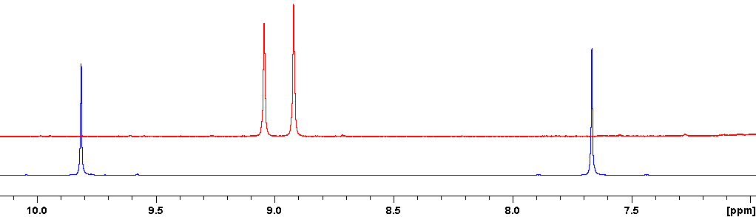
Figure 2: Comparison of the ¹H NMR spectra of DFF (blue spectrum) and the corresponding cyclic poly‐(2,5‐furanylene vinylene) (red spectrum) (DMSO-d₅, 400 MHz, 25 °C) (Entry 3, Table 1).

The formation of a mixture of only cyclic PFV has been definitively confirmed by the MALDI analysis, which indicates the presence of cyclooligomers composed of 8, 12-15 furylene-vinylene units (see Figure 3).

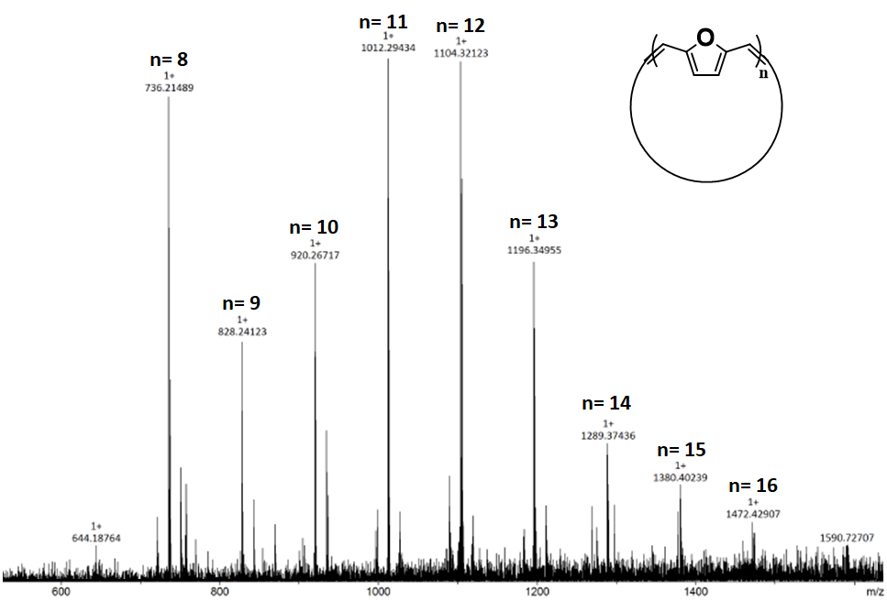
Figure 3: High-Resolution MALDI spectrum of PFV (Entry 3, Table 1).

UV-Vis analysis confirmed the formation of highly conjugated systems. The UV-Vis spectra of DFF and the corresponding PFV are reported in Figure 4. DFF showed an absorption band at 270-300 nm, while for the cyclic oligomer, the absorption band was shifted to a higher wavelength at ≈340 nm, due to the extended π-conjugation.

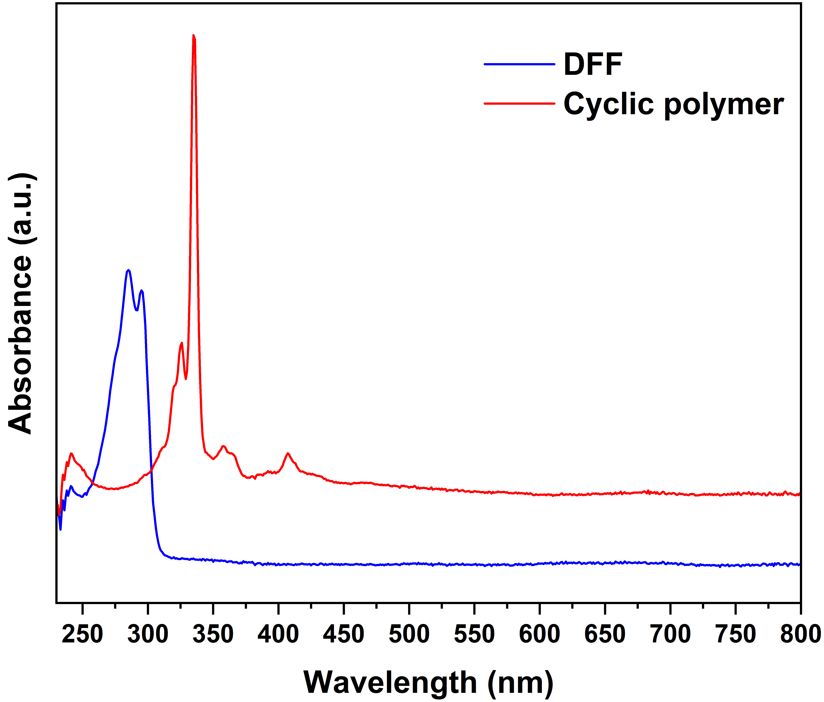
Figure 4: Absorbance spectra of DFF and cyclic oligomer. (Entry 3, Table 1).
The cyclic oligomer was found in amorphous form, as observable from the 2θ range 5-30° of the WAXD diffraction pattern in Figure 5.
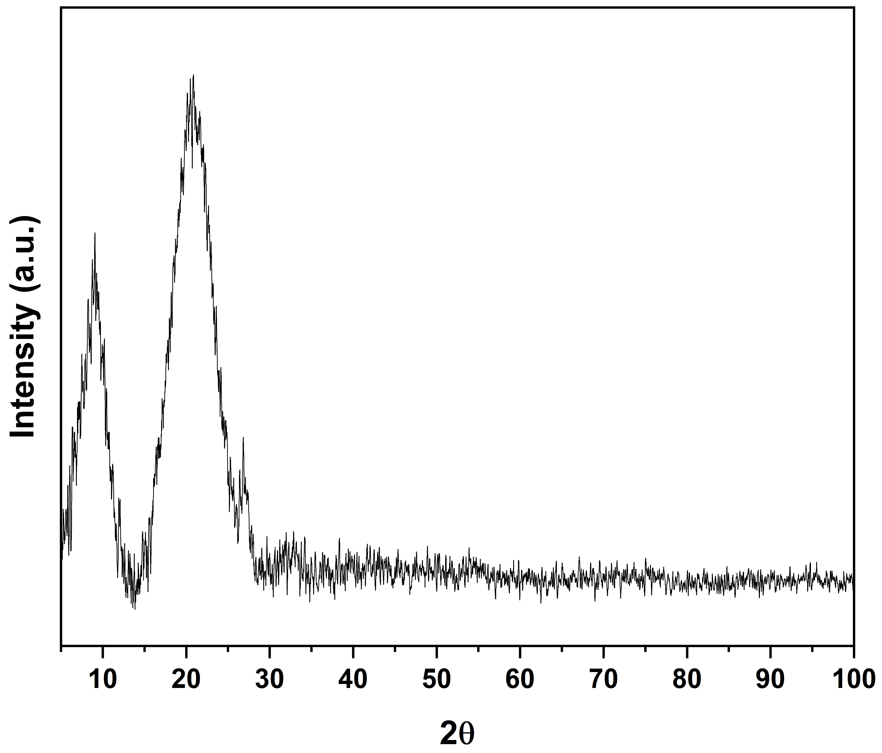
Figure 5: WAXD pattern of cyclic polymer. (Entry 3, Table 1).
The Nyquist plot reported in Figure 6 and calculated from EIS measurements at OCP shows a polymer resistance of 708 kΩ and a capacitance of 46.6 pF. The conductivity in DC current is low, in the order of magnitude of a dielectric system. The relative dielectric constant ε, calculated from eq. 1, is around 83.8, which makes the polymer suitable for making capacitors.
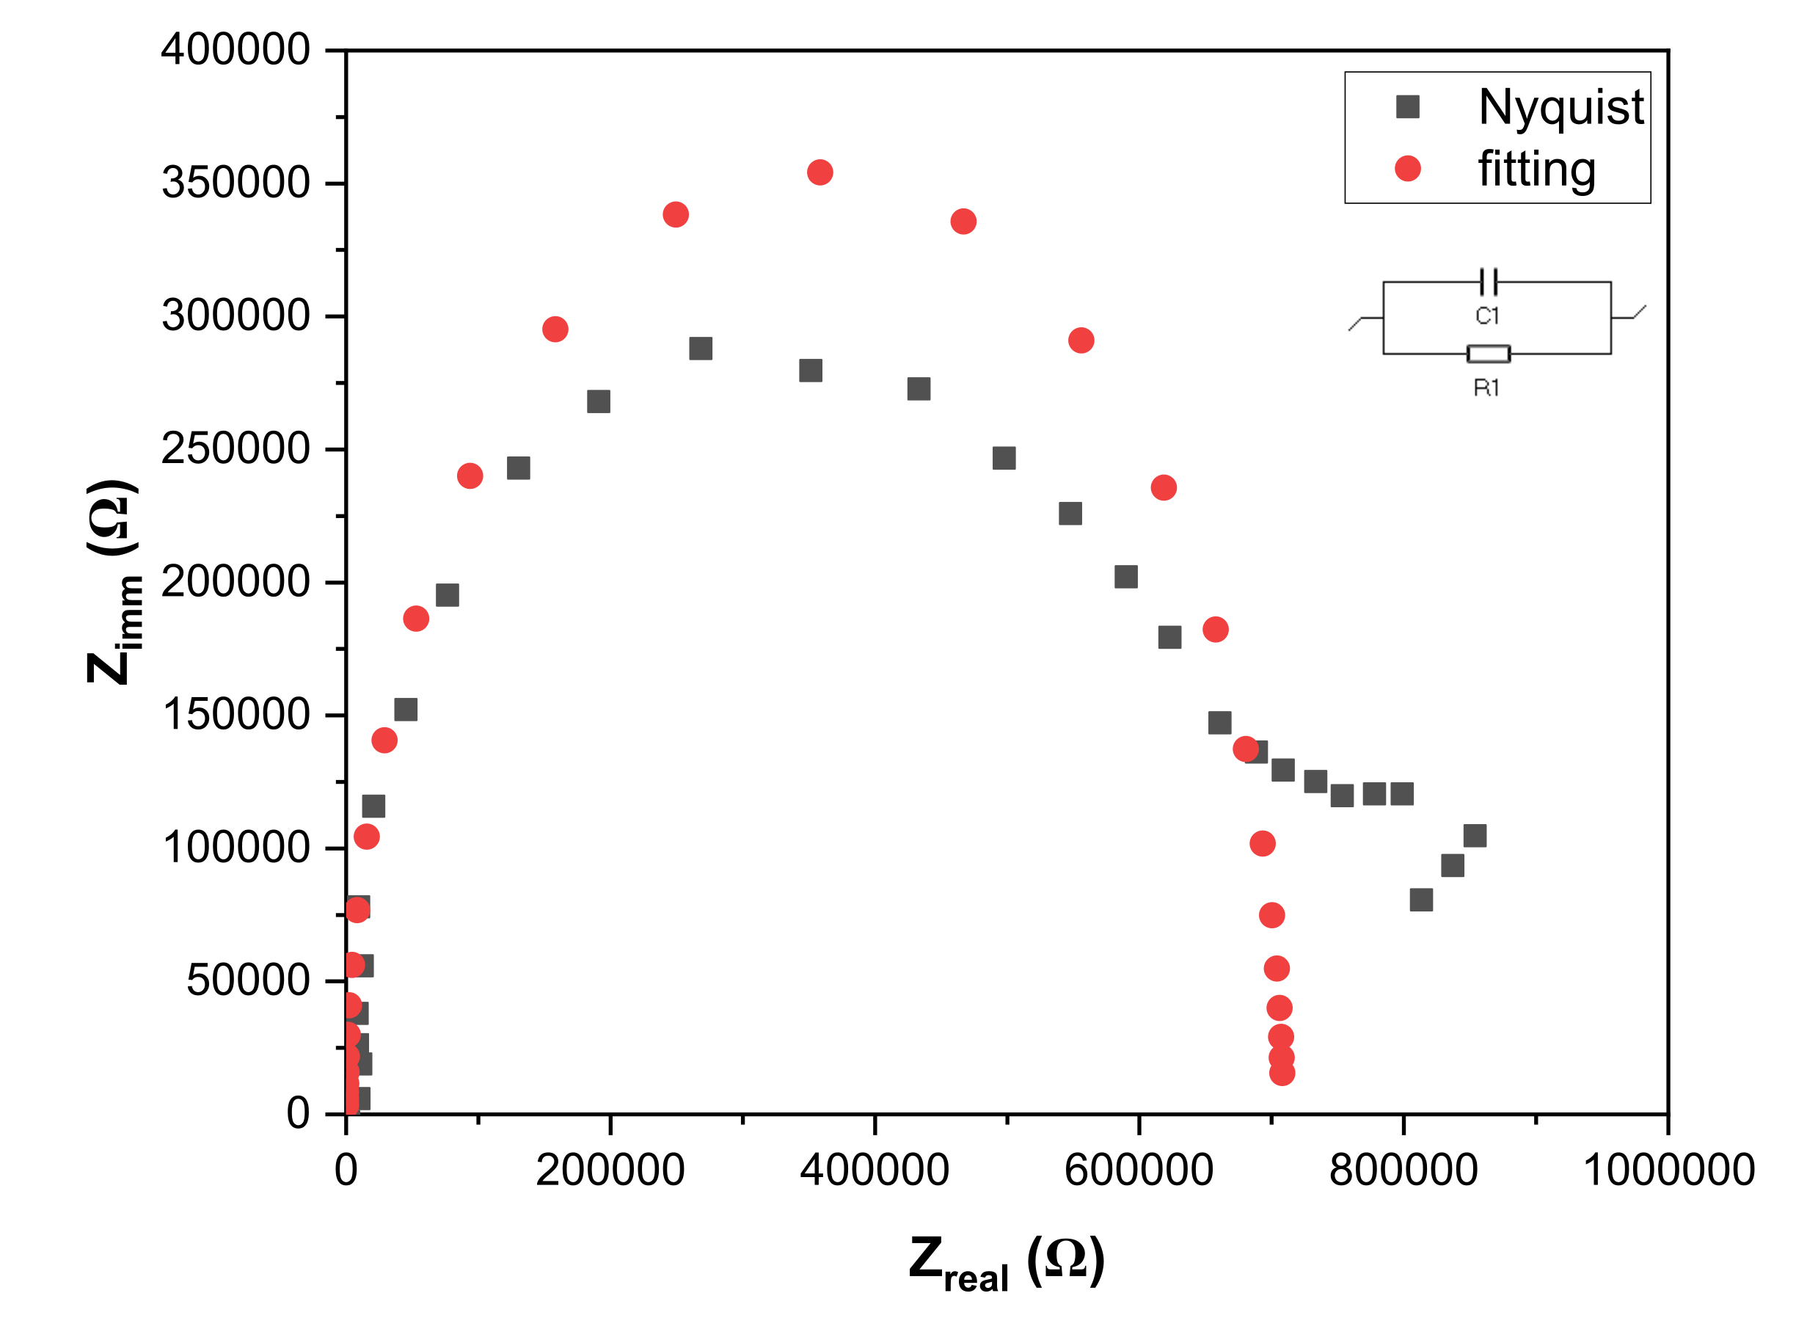
Figure 6: Electrochemical impedance spectroscopy of the polymer, Nyquist plot (grey) and fitting of the Nyquist plot (red) with the R₁/C₁ equivalent circuit.
$$C= \frac{{Area}_{disk}}{{thickness}_{disk}}*ε*ε_{0}$$ | (1)

5. Conclusions
The optimization of the reaction conditions for the homocoupling of DFF via McMurry reaction (temperature, Zn/TiCl₄ ratio, solvent, reaction time) to obtain cyclic PFV were investigated in this study. The combination of TiCl₄ with an excess of Zn afforded the formation of cyclic PFV with high selectivity.
NMR and MALDI-TOF analysis confirmed the presence of cyclic species. UV-Vis further confirmed the presence of an extended π-conjugated system, and by WAXD analysis, an amorphous structure was found.
EIS measurements show a predominant dielectric behaviour of the polymer, which is suitable for making capacitors.

Acknowledgments
The authors are grateful to Dr. Patrizia Iannece, Dr. Patrizia Oliva, Dr. Mariagrazia Napoli, Dr. Veronica Iuliano, Dr. David Hermann Lamparelli, and Dr. Ivano Immediata from the University of Salerno for technical support.
Financial support is gratefully from: i) Ministero dell’Università della Ricerca (Ministry of University and Research, MUR, Rome, Italy) for the grant “PRIN2022 Finanziato dall’Unione europea-Next Generation EU, Missione 4, Componente 1-CUP: D53D23017260001”; ii) Università degli Studi di Salerno (University of Salerno, Fisciano, SA, Italy) for the grants FARB ORSA224812, FARB ORSA239513, and FARB ORSA247407.

References
Joseph J. Bozell, Gene R. Petersen, 2010, Technology development for producing biobased products from biorefinery carbohydrates—the US Department of Energy’s “Top 10” revisited. Green Chem., 12, 539–554.
A. Gandini, T.M. Lacerda., 2022, Furan polymers: State of the Art and Perspectives. Macromol. Mater. Eng. 307, 2100902.
A.W. Cooke, K.B. Wagener, 1991, An Investigation of Polymerization via Reductive Coupling of Carbonyls. Macromolecules, 24, 1404-1407.
A. Buonerba, S. Impemba, A. D. Litta, C. Capacchione, S. Milione, A. Grassi, 2018, Aerobic Oxidation and Oxidative Esterification of 5-Hydroxymethylfurfural by Gold Nanoparticles Supported on Nanoporous Polymer Host Matrix. ChemSusChem, 11, 3139–3149.
A. Buonerba, V. Speranza, C. Capacchione, S. Milione, A. Grassi, 2018, Improvement of Tensile Properties, Self-Healing and Recycle of Thermoset Styrene/2-Vinylfuran Copolymers via Thermal Triggered Rearrangement of Covalent Crosslink. European Polymer Journal, 99, 368–377.
A. Buonerba, R. Lapenta, S. Ortega Sánchez, C. Capacchione, S. Milione, A. Grassi, A Comprehensive Depiction of the Furan-Maleimide Coupling via Kinetic and Thermodynamic Investigations of the Diels-Alder Reaction of Poly(styrene–co-2-vinylfuran) with Maleimides, ChemistrySelect 2017, 2, 1605.
J. Liu, H. Zang, H. Dong, L. Meng, L. Jiang, L. Jiang, Y. Wang, J. Yu, Y. Sun, W. Hu, A.J. Heeger, 2015, High mobility emissive organic semiconductor. Nature Communications, 6, 10032.
L. Dou, Y. Liu, Z. Hong, G. Li, Y. Yang, 2015, Low-Bandgap Near-IR Conjugated Polymers/Molecules for Organic Electronics. Chemical Reviews, 115, 12633-12665.
S.-T. Chiu, H.-Y. Chiang, Y.-J. Lin, Y.-Y. Lu, H. Tanaka, T. Hosokai, M. Horie, 2018, Self-assembly and ring-opening metathesis polymerization of cyclic conjugated molecules on highly ordered pyrolytic graphite. Chem. Commun., 54, 5546-5549.

