 CHEMICAL ENGINEERING TRANSACTIONS  VOL. , 2025 | A publication of  
The Italian Association
of Chemical Engineering
Online at www.cetjournal.it

Guest Editors: Paolo Ciambelli, Luca di Palma
Copyright © 2025, AIDIC Servizi S.r.l.
ISBN 979-12-81206-20-5; ISSN 2283-9216

Production and Characterization of PLGA Nanocapsules Loaded with Doxycycline Hyclate by Using a Supercritical Technology
Sonia Sarnelli, Ernesto Reverchon, Lucia Baldino*
Department of Industrial Engineering, University of Salerno, Via Giovanni Paolo II, 132, 84084, Fisciano (SA), Italy
lbaldino@unisa.it
In this work, poly-lactic-co-glycolic acid (PLGA) nanocapsules loaded with doxycycline hyclate (DOX) were produced by using a supercritical carbon dioxide-based process, called Supercritical Emulsion Extraction (SEE). DOX was used as a model drug, since a prolonged release is needed to avoid frequent administration. Starting from a water-oil-water (w₁-o-w₂) double emulsion, the organic solvent was removed from the oil phase through supercritical CO₂. The resulting nanocapsules showed a unimodal particles distribution, with a mean size of 170 ± 75 nm and an encapsulation efficiency of 66%. Morphological analysis was performed by field emission scanning electron microscope (FE-SEM), showing spherical-shaped nanoparticles. The same loaded nanoparticles were also produced by the conventional method, based on the evaporation of the solvent from the double emulsion. In this case, aggregated nanoparticles with low entrapment efficiency (i.e., 18%) were obtained. In vitro drug release tests performed on PLGA loaded nanocapsules produced by SEE showed a prolonged and controlled release of DOX.
  - Introduction
Drug delivery systems based on biopolymeric nanoparticles offer significant advantages in enhancing drugs therapeutic efficacy, reducing their side effects and improving their bioavailability (Opriș et al., 2024). Conventional drug administration methods are characterized by several limitations, such as rapid clearance, poor biocompatibility, and uncontrolled drug release. Biopolymeric nanoparticles, instead, allow a controlled and targeted drug delivery through a passive targeting mechanism, without the need for surface modification (Geszke-Moritz and Moritz, 2024). Moreover, the polymeric shell promotes the formation of a stable structure that improves drug encapsulation efficiency and protects it from degradation during blood circulation (Elmowafy et al., 2023).
Poly-lactic-co-glycolic acid (PLGA) is one of the most widely used biopolymers to produce biopolymeric nanoparticles for medical or pharmaceutical purposes, since it is biocompatible, biodegradable, and approved by the Food and Drug Administration (FDA) (Yang et al., 2024). Indeed, PLGA-based systems can be used to encapsulate different types of active pharmaceutical ingredients, like proteins, antibiotics, antioxidant compounds and nucleic acids (Kumar et al., 2024). However, the main properties of PLGA nanoparticles, expressed in terms of size, morphology, drug encapsulation efficiency and drug release kinetics, are highly influenced by their production method (Marecki et al., 2024).
Different methods can be used to produce biopolymeric nanoparticles, such as nanoprecipitation, spray drying, and dispersion polymerization. Emulsion-based techniques are the most efficient and widely used, since they allow the encapsulation of both hydrophilic and hydrophobic molecules (de Almeida Campos et al., 2024; Kakran and Antipina, 2014). For example, a water-oil-water (w₁-o-w₂) double emulsion allows the encapsulation of hydrophilic compounds, ensuring their stability and controlled release. In this case, the internal water phase (w₁) was formed by an aqueous solution in which the active principle is solubilized; instead, the oily phase was obtained by solubilizing a fixed amount of biopolymer in the organic solvent (e.g., ethyl acetate, chloroform or dichloromethane). Surfactants characterized by a high hydrophilic-lipophilic balance (HLB) value (e.g., Tween 80) can be added to the external water phase (w₂) to obtain a stable emulsion (Cao et al., 2021).
Conventional methods, such as double emulsion solvent evaporation or extraction, are based on the production of biopolymeric nanoparticles by removing the organic solvent from the oil phase (Ito and Makino, 2004). However, both methods show several drawbacks: for instance, the emulsion solvent evaporation method requires a long time for the complete evaporation of the solvent, working at high temperature or low pressure. Therefore, aggregation phenomena between droplets may occur, resulting in the formation of polydisperse nanoparticles with low drug encapsulation efficiency (Della Porta and Reverchon, 2008). Emulsion solvent extraction, instead, involves the use of a large amount of an organic solvent to extract the one used for the emulsion preparation, leading to biopolymeric nanoparticles with high solvent residual (Kouhjiani et al., 2024).
Supercritical Emulsion Extraction (SEE) is an innovative and continuous process based on supercritical carbon dioxide (SC-CO₂), proposed as an efficient and eco-friendly alternative to conventional extraction/evaporation techniques. SC-CO₂ is used to selectively extract the organic solvent from the oil phase of a single or double emulsion, producing solvent-free biopolymeric nanoparticles (Palazzo et al., 2021). Moreover, the shrinkage factor (SF%) is very low, since nanoparticles retained their initial droplet dimension. Therefore, SEE process allows the production of biopolymeric nanoparticles with high drug encapsulation efficiency, good control of particle size and size distribution, low solvent residue and high stability over time (Palazzo et al., 2020).
In this work, PLGA nanocapsules loaded with doxycycline hyclate (DOX) were produced by using SEE, operating at 38 °C and 80 bar. For comparison purposes, the double emulsion solvent evaporation method (SE) was also performed. Doxycycline hyclate, an antibiotic with antibacterial and antitumoral properties, was selected as a model drug, since its prolonged release is required to reduce the frequency of administration (Meoli et al., 2025). Therefore, the obtained nanoparticles were characterized in terms of particle size distribution, DOX encapsulation efficiency and morphological properties. In vitro drug release tests were also performed to study the DOX release mechanism from PLGA nanoparticles.
  - Materials and Methods
    - Materials
Tween 80 (Mw= 1310 g/mol) and doxycycline hyclate in powdered form (DOX, Mw= 512.94 g/mol) were purchased from Sigma-Aldrich (Milan, Italy). Poly-lactic-co-glycolic acid (PLGA, 50:50, Mw= 38,000-54,000 g/mol, Resomer RG 504 H) was purchased from Evonik Industries (Essen, Germany); ethyl acetate (EA, purity ≥99.7%) was purchased from Carlo Erba Reagents (Milan, Italy). Carbon dioxide (CO₂, purity ˃99.4%) was purchased from Morlando Group Srl (Naples, Italy).
    - Emulsion preparation
A double emulsion with a water-oil-water (w₁-o-w₂) composition ratio of 1:19:80 w/w/w was prepared. The internal water phase (w₁) was obtained by using distilled water as a solvent and dissolving 1% (w/w) of DOX with respect to the amount of PLGA. A fixed amount of PLGA (750 mg) was solubilized in ethyl acetate at room temperature to obtain the organic phase (o). To stabilize the emulsion, ethyl acetate-saturated water containing 1% (w/w) Tween 80 was used as the external water phase (w₂). The primary emulsion (w₁-o) was obtained by dispersing the internal water phase into the oil phase, using an ultrasonic probe at 160 W for 1 min (Branson Digital Sonifier, mod. 450, 1/200-inch micro-tip, 20 kHz, 400 W). The single w₁-o emulsion was, then, dispersed in the w₂ phase, by using a rotor-stator type emulsifier at 7000 rpm for 6 min (Silverson Machines Ltd., mod. L4RT, Waterside, Chesham, UK). To reduce droplet size, the secondary emulsion was also ultrasonicated at 120 W for 2 min.
    - Supercritical Emulsion Extraction
SEE is a continuous process in which SC-CO₂ and the emulsion are fed in countercurrent. SEE plant consists of a packed column filled with stainless steel packings. The temperature along the column was controlled using six temperature controllers (TC1-TC6, Gordon J/Series 93, Watlow, Milan, Italy); instead, the pressure was measured using a pressure gauge (mod. MP1, OMET, Lecco, Italy). A high-pressure pump (mod. Milroyal B, Milton Roy, Pont Saint-Pierre, France) was used to introduce CO₂ from the bottom of the column, while a Gilson pump (mod. 305, Villiers Le Bel, France) ensured the introduction of the emulsion from the top. A separator is located downstream of the top of the column to recover the organic solvent. The pressure in the separator is regulated by using a backpressure valve. Particle suspensions are collected in a stainless-steel vessel located at the bottom of the column, through an on/off valve. Process operating conditions were optimized in previous works (Palazzo et al., 2021): i.e., pressure of 80 bar, temperature of 38 °C, CO₂ mass flow rate of 1.2 kg/h, emulsion volumetric flow rate of 2.4 mL/min, and a liquid-to-gas (L/G) ratio of 0.1 on a mass basis. Further explanations about SEE process are reported in (Campardelli et al., 2024).
At the end of the process, the particle suspension was centrifuged at 6500 rpm and 0 °C for 30 min. The collected nanoparticles were, then, resuspended in ultrapure water, whereas the supernatant was retained to evaluate the encapsulation efficiency of doxycycline hyclate. The washing step of PLGA nanoparticles by centrifugation was repeated two times at the same operating conditions to remove the supernatant from the aqueous suspension. Powdered biopolymeric nanoparticles were recovered by vacuum filtration using a 0.1 µm pore membrane (Millipore, Burlington, USA).
    - Emulsion solvent evaporation
To compare the conventional and innovative methods, solvent evaporation (SE) was performed using the same emulsion formulation processed by SEE. The double emulsion was stirred at 300 rpm and 38 °C to induce the evaporation of ethyl acetate and achieve the solidification of particles. The resulting particle suspension was centrifuged and washed to obtain dried nanoparticles, according to the same protocol used for SEE process.
    - Nanoparticle characterization techniques
The droplet size distributions (DSDs) and particle size distributions (PSDs) were measured using a dynamic light scattering (DLS, mod. Zetasizer Nano S, Worcestershire, UK). Each sample was analysed in triplicate and the results were reported in terms of polydispersity index (PDI), mean diameter (MD) and standard deviation (SD). The shrinkage factor percentage (SF%) was calculated using Eq (1):
SF% = [1-(nanoparticles mean size/droplets mean size)] x 100 (1)
The morphology of PLGA nanoparticles was observed using a field emission scanning electron microscope (FE-SEM, Carl Zeiss, mod. Supra 35) after coating the powdered samples with a gold layer (thickness: 250 Å).
The encapsulation efficiency (EE%) of doxycycline hyclate was determined by using an indirect method. The absorbance of DOX in the supernatant was measured at λ= 273 nm using a UV-Vis spectrophotometer (mod. Cary 60 UV-Vis, Agilent Technologies, Santa Clara, USA) (Gholse et al., 2022). The encapsulation efficiency was calculated as follows (Eq (2)):
EE% = [1-(DOX_{supernatan}t/DOX_{loaded})] x 100 (2)
where: DOX_{supernatant} represents the amount of unencapsulated drug, while DOX_{loaded} corresponds to the initial drug mass used for emulsion preparation.
To further confirm the presence of DOX within PLGA nanoparticles, Fourier Transform Infrared Spectroscopy (FT-IR) analysis was performed using a FT-IR spectrophotometer (mod. IRTracer-100). The samples were prepared by mixing powdered nanoparticles with KBr (mass ratio of 1:100) and scanned within the 4000-400 cm⁻¹ range, with a resolution of 2 cm⁻¹. To perform drug release tests, 2 mg of dried nanoparticles were added into a dialysis bag (cut-off of 14,000 Da) pre-activated with ethylenediaminetetraacetic acid (EDTA). The bag was, then, immersed in 100 mL of phosphate buffer saline (PBS) at pH 7.4, used as release medium. The temperature was fixed at 37 °C and the system was continuously stirred at 150 rpm. The release of DOX from PLGA nanoparticles was monitored by measuring the variation of the absorbance during time. A calibration curve was used to correlate absorbance values with DOX concentration.
  - Results and Discussion
    - Production of PLGA loaded nanoparticles by SE
PLGA nanoparticles loaded with DOX were produced by SE starting from a double emulsion technique, as described in section 2.2. DLS analysis was performed for both the emulsion (E) and nanoparticle suspension (NPs), and the results are summarized in Table 1.
Doxycycline encapsulation efficiency into PLGA nanoparticles was relatively low, reaching only 18%. Therefore, the same formulation was used to produce DOX loaded PLGA nanoparticles by using the innovative process (SEE).
    - Production of PLGA loaded nanocapsules by SEE
Table 1 shows the comparison between DLS results related to the double emulsion (E) and nanoparticles (NPs) produced by SE and SEE process.
Table 1. DLS results of nanocapsules produced by SE and SEE
SE | MD, nm | SD, nm | PDI | SEE | MD, nm | SD, nm | PDI
E | 168 | 66 | 0.155 | E | 170 | 75 | 0.196
NPs | 168 | 61 | 0.130 | NPs | 169 | 73 | 0.188

The shrinkage factor (SF%) was very low and equal to 0.65% for SEE samples. These results underlined the efficiency of the proposed innovative technique, where the enhanced mass transfer properties of SC-CO₂ enabled a rapid solvent removal. Indeed, DLS analysis confirmed that PSD and DSD overlapped (Figure 1). Stability tests performed for up to 30 days showed the long-term stability of both the emulsion (E) and nanoparticles suspension (NS), as confirmed by negligible variations observed in MD and PDI values. Moreover, the encapsulation efficiency of doxycycline hyclate was equal to 66%.

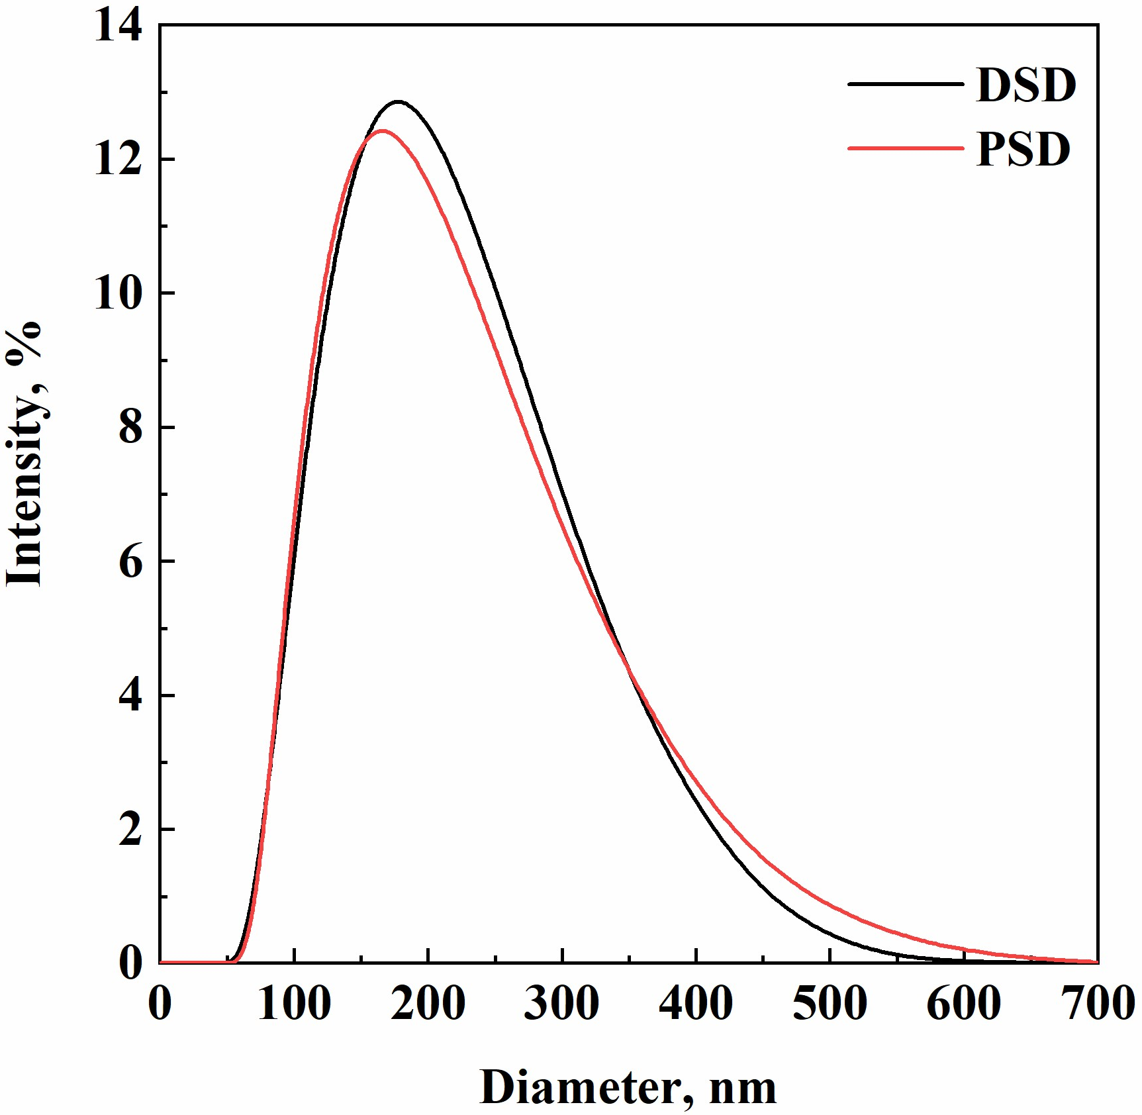
Figure 1: Comparison between DSD and PSD of DOX-loaded nanocapsules produced by SEE
FT-IR analysis was performed on DOX powder, PLGA empty nanoparticles, and PLGA nanoparticles loaded with the drug (Figure 2). The FT-IR spectrum of PLGA empty NPs showed the characteristic peaks of PLGA (Portaccio et al., 2015): at 1098 cm⁻¹ and 1176 cm⁻¹ related to O-C-C and C-C-O stretching from ester, respectively; at 1770 cm⁻¹ associated with the stretching vibration of the carbonyl group; at 2948 cm⁻¹ and 2996 cm⁻¹ related to the asymmetric stretching vibration of CH₂ and CH₃ groups, respectively. These peaks are also observed in the spectrum of PLGA loaded nanocapsules. On the other hand, the spectrum of doxycycline hyclate showed characteristic peaks around 700 cm⁻¹ associated with −OH group, at 1500−1600 cm⁻¹ due to the aromatic ring, and at 1650 cm⁻¹ related to −NH₂ group (Patil et al., 2019). The presence of the same peaks in the spectrum of PLGA nanoparticles confirmed the successful encapsulation of DOX.

Figure 2: FT-IR spectra of doxycycline hyclate, PLGA empty nanocapsules, and PLGA loaded nanocapsules
    - Morphological analysis
Morphological analysis was carried out on dried nanocapsules obtained from both processes by using FE-SEM. SEM images (Figures 3a-b) showed that agglomerated nanocapsules with irregular shape were produced by SE; nanocapsules obtained by SEE were instead characterized by a smooth surface, spherical shape, and nanometric size, in line with the results obtained from DLS analysis.
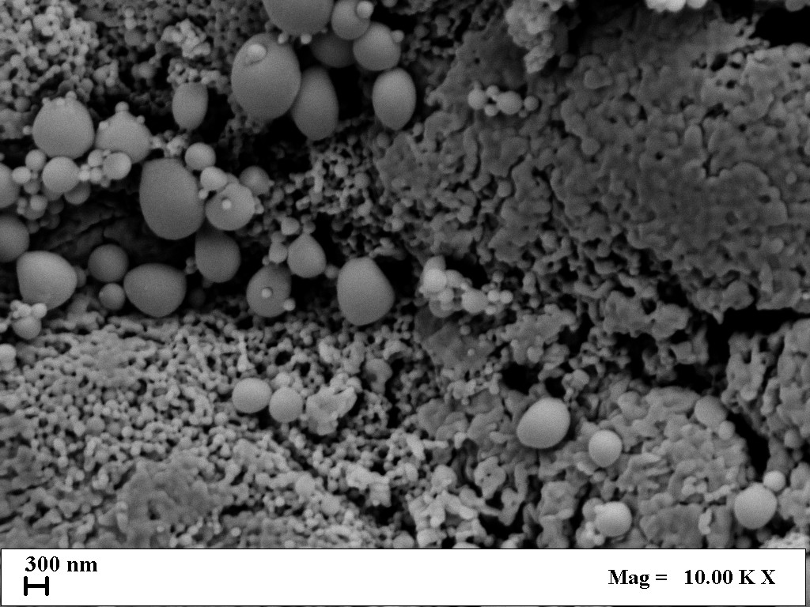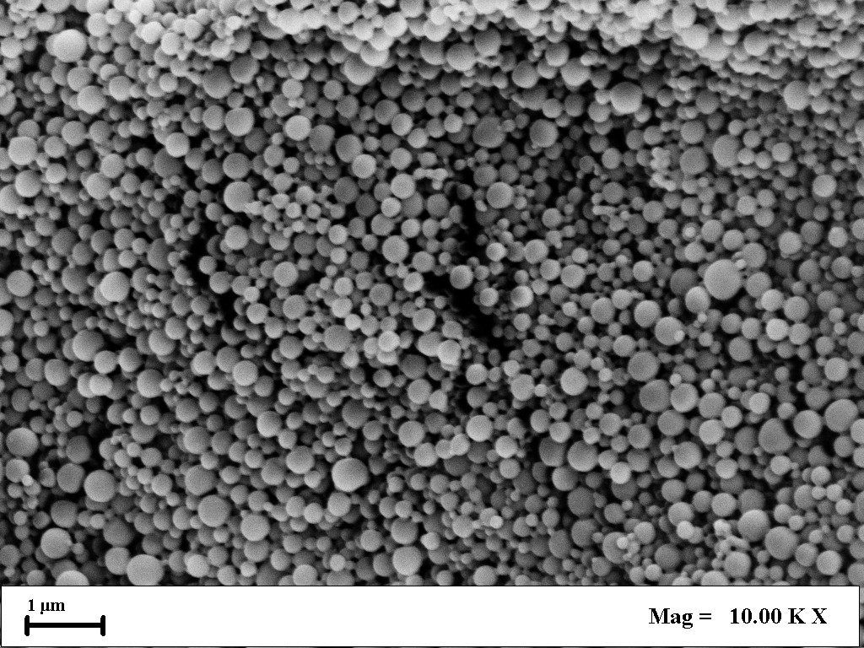
(a) (b)
Figure 3: FE-SEM images of loaded PLGA nanocapsules produced by different processes: (a) SE, (b) SEE
    - DOX release mechanism
DOX release mechanism from PLGA nanocapsules was studied only for loaded PLGA nanocapsules obtained by SEE. Figure 4 shows drug release profiles, plotted as the ratio C_{t}/C_{eq} against time (min), where: C_{t} is the concentration of DOX measured at a specific time, whereas C_{eq} is the maximum concentration of released DOX.

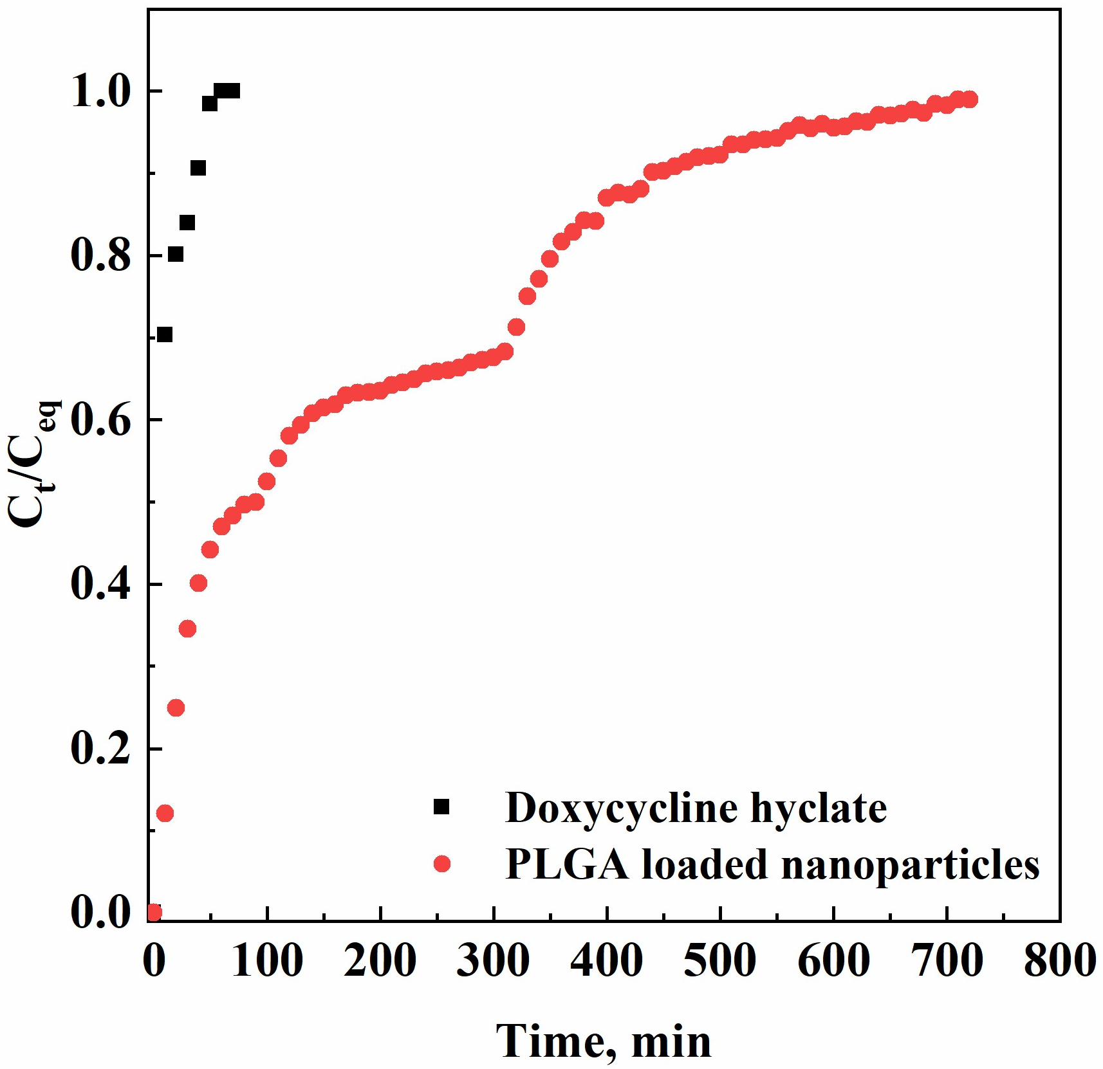
Figure 4: DOX release profile from untreated powder and PLGA nanocapsules
These results demonstrated that untreated DOX was released within 60 min; whereas DOX encapsulated in PLGA nanocapsules required approximately 750 min for the complete release. In more detail, three different phases can be identified: an initial burst effect during the first 90 min, a diffusion-controlled phase during the next 210 min, and a final phase controlled by polymer degradation in the release medium.

    - Conclusions
A comparative study between the emulsion solvent evaporation method and supercritical emulsion extraction demonstrated that SEE is a promising process for the production of PLGA nanocapsules with increased stability over time and high encapsulation efficiency (equal to 66%).
FE-SEM analysis also confirmed that nanocapsules produced by SEE were characterized by a regular morphology and spherical shape. Moreover, drug release experiments revealed that PLGA nanocapsules allowed a controlled and prolonged release of DOX: the pure drug was released within 60 min; whereas the encapsulated one within 750 min.
These promising results suggest that further studies of SEE process could lead to the development of advanced drug delivery systems.
References
Campardelli, R., Bufalini, C., Palazzo, I., Casazza, A.A., Ferrari, P.F., Firpo, G., Perego, P., Reverchon, E., 2024, Encapsulation of Arthrospira Platensis Polyphenolic Extract Using Supercritical Emulsion Based Process, The Journal of Supercritical Fluids, 4784250.
Cao, G., Du, T., Bai, Y., Yang, T., Zuo, J., 2021, Effects of surfactant molecular structure on the stability of water in oil emulsion, Journal of Petroleum Science and Engineering, 196, 107695.
de Almeida Campos, L.A., de Souza, J.B., de Queiroz Macêdo, H.L.R., Borges, J.C., de Oliveira, D.N., Cavalcanti, I.M.F., 2024, Synthesis of polymeric nanoparticles by double emulsion and pH-driven: encapsulation of antibiotics and natural products for combating Escherichia coli infections, Applied Microbiology and Biotechnology, 108(1), 1-13.
Della Porta, G., Reverchon, E., 2008, Nanostructured microspheres produced by supercritical fluid extraction of emulsions, Biotechnology and Bioengineering, 100(5), 1020-1033.
Elmowafy, M., Shalaby, K., Elkomy, M.H., Alsaidan, O.A., Gomaa, H.A., Abdelgawad, M.A., Mostafa, E.M., 2023, Polymeric nanoparticles for delivery of natural bioactive agents: recent advances and challenges, Polymers, 15(5), 1123.
Geszke-Moritz, M., Moritz, M., 2024, Biodegradable polymeric nanoparticle-based drug delivery systems: comprehensive overview, perspectives and challenges, Polymers, 16(17), 2536.
Gholse, Y.N., Chaple, D.R., Kasliwal, R.H., 2022, Development and validation of novel analytical simultaneous estimation based UV spectrophotometric method for doxycycline and levofloxacin determination, Applied Sciences, 12(4), 5458-5478.
Ito, F., Makino, K., 2004, Preparation and properties of monodispersed rifampicin loaded poly(lactide-co-glycolide) microspheres, Colloids Surfaces Part B Biointerfaces, 39, 17–25.
Kakran, M., Antipina, M.N., 2014, Emulsion-based techniques for encapsulation in biomedicine, food and personal care, Current Opinion in Pharmacology, 18, 47-55.
Kouhjani, M., Jaafari, M.R., Kamali, H., Abbasi, A., Tafaghodi, M., Mousavi Shaegh, S.A., 2024, Microfluidic-assisted preparation of PLGA nanoparticles loaded with insulin: a comparison with double emulsion solvent evaporation method, Journal of Biomaterials Science, Polymer Edition, 35(3), 306-329.
Kumar, M., Mahmood, S., Chopra, S., Bhatia, A., 2024, Biopolymer based nanoparticles and their therapeutic potential in wound healing–A review, International Journal of Biological Macromolecules, 131335.
Marecki, E.K., Oh, K.W., Knight, P.R., Davidson, B.A., 2024, Poly (lactic-co-glycolic acid) nanoparticle fabrication, functionalization, and biological considerations for drug delivery, Biomicrofluidics, 18(5), 7.
Meoli, C.M., Riccardi, D., Baldino, L., 2025, Optimization of Chitosan-Coated Niosomes Encapsulating Doxycycline Hyclate for pH-Responsive Drug Release, Industrial & Engineering Chemistry Research, in press.
Opriș, O., Mormile, C., Lung, I., Stegarescu, A., Soran, M.L., Soran, A., 2024, An overview of biopolymers for drug delivery applications, Applied Sciences, 14(4), 1383.
Palazzo, I., Lamparelli, E.P., Ciardulli, M.C., Scala, P., Reverchon, E., Forsyth, N., Maffulli, N., Santoro, A., Della Porta, G., 2021, Supercritical emulsion extraction fabricated PLA/PLGA micro/nano carriers for growth factor delivery: Release profiles and cytotoxicity, International Journal of Pharmaceutics, 592, 120108.
Palazzo, I., Raimondo, M., Della Porta, G., Guadagno, L., Reverchon, E., 2020, Encapsulation of health-monitoring agent in poly-methyl-methacrylate microcapsules using supercritical emulsion extraction, Journal of Industrial and Engineering Chemistry, 90, 287-299.
Patil, M.P., Piad, L.L.A., Bayaraa, E., Subedi, P., Tarte, N.H., Kim, G.D., 2019, Doxycycline hyclate mediated silver–silver chloride nanoparticles and their antibacterial activity, Journal of Nanostructure in Chemistry, 9, 53-60.
Portaccio, M., Menale, C., Diano, N., Serri, C., Mita, D.G., Lepore, M., 2015, Monitoring production process of cisplatin‐loaded PLGA nanoparticles by FT‐IR microspectroscopy and univariate data analysis, Journal of Applied Polymer Science, 132(3).
Yang, J., Zeng, H., Luo, Y., Chen, Y., Wang, M., Wu, C., Hu, P., 2024, Recent Applications of PLGA in drug delivery systems, Polymers, 16(18), 2606.

