 CHEMICAL ENGINEERING TRANSACTIONS  VOL. , 2025 | A publication of  
The Italian Association
of Chemical Engineering
Online at www.cetjournal.it

Guest Editors: Paolo Ciambelli, Luca di Palma
Copyright © 2025, AIDIC Servizi S.r.l.
ISBN 979-12-81206-20-5; ISSN 2283-9216

Micronization of Levan, a Fructose-based amphiphilic polymer, using supercritical CO₂ as antisolvent
Stefania Mottolaª, Álvaro González-Garcinuño^{b}, Antonio Tabernero^{b}, Stefano Cardeaª, Eva Martín del Valle^{b}, Iolanda De Marco^{a,*}
ª Department of Industrial Engineering, University of Salerno, Via Giovanni Paolo II, 132, 84084 Fisciano, Salerno, Italy
^{b} Department of Chemical Engineering, University of Salamanca, Plaza de los Caídos s/n, 37001, Salamanca, Spain
*idemarco@unisa.it

Levan is a fructose polysaccharide with potential applications in biomedicine and the food industry, as it can form particles in water (approximately 120 nm) through a self-assembly process. Despite this phenomenon, the levan size in powdered form cannot be controlled using conventional techniques, which hinders its use in various applications where the powdered form is required.
Based on the previous fact, the supercritical antisolvent technique (SAS) was used to process levan (previously synthesized with a cell-free methodology) to obtain the polymer in powdered form with a controlled particle size distribution. Specifically, particles ranging from 300 to 500 nm were obtained depending on the experimental conditions (pressure and temperature), but always working above the mixture critical point of the solvent-antisolvent system (CO₂-DMSO). Moreover, nimesulide as a model drug was coprecipitated with the polymer, obtaining a controlled-release drug delivery system. These results highlighted that amphiphilic polymers (levan) can be processed with supercritical CO₂ to control the particle size of the polymer in powdered form.
  - Introduction
Levan is a fructose-based homopolysaccharide consisting of β-2,6-linked fructose chains with β-2,1-linked branch points. This nonionic polysaccharide has exceptional properties, including low intrinsic viscosity and high adhesive strength. Furthermore, levan are biocompatible and biodegradable and can spontaneously form colloidal dispersions containing particles through a self-assembly process (Kırtel and Combie, 2022).
Amphiphilic polymers like levan, with their unique properties, find applications in various fields, from food and pharmaceuticals to wound healing, corrosion inhibition, adhesives, and biomedicine. The versatility of levan in these different fields not only testifies to its potential but also should inspire further exploration and innovation.
Current research focuses on optimizing levan for medical purposes, including enhancing the efficiency of its synthesis, increasing its stability, and functionalizing it to be more effective against certain diseases. The biodegradability and non-toxic nature of levan make it a valuable resource for sustainable and safe medical applications, particularly in drug delivery, tissue regeneration, and wound healing.
Levan’s ability to form gels and its compatibility with various types of drugs make it an ideal candidate for drug delivery systems. Levan was already used in this form as a delivery system for anticancer drugs. Some recent research has shown that levan-based formulations could gradually release the drug, improving the drug’s therapeutic efficacy while reducing systemic toxicity. This controlled release also increased drug retention in cancer tissues (Domżał-Kędzia et al., 2023).
Levan also possesses natural antibacterial properties, helping reduce the risk of infections at the wound site when applied. Moreover, Levan’s structure allows it to be used as a carrier for cancer vaccines. The results showed that levan helped to enhance immune responses against the tumour, showing promise as a delivery agent for cancer immunotherapies (Paul et al., 2023).
The non-toxic nature of levan makes it a safe choice for in vivo applications. It is also biodegradable, meaning that once its purpose has been served, it will naturally break down without causing harm (Mouro et al., 2024).
Specific existing or forthcoming applications of levan may necessitate its utilization in powdered form and with a specific particle size. For instance, the size of the particles is pivotal in the delivery through nasal and pulmonary routes; additionally, it is feasible to create composites where levan is incorporated in solid form. It is also essential that the distribution of particle sizes remains narrow to prevent the formation of aggregates to ensure the desired release of the drug in the specific site. (Młynek et al.,2023)
Levan shows a great capacity to encapsulate and stabilize hydrophobic substances, which positions it as a promising carrier for such drugs.
Considering this fact, the supercritical antisolvent technique (SAS) was employed to transform levan (synthesised using a cell-free method) into powdered form while ensuring a controlled distribution of particle sizes. The SAS process is selected for the main advantages that it shows in the Micronization of pharmaceutically active compounds; in fact, this process allows to obtain particles with dimensions useful for the delivery of the drug with a narrow distribution, and the final product of this process presents no residual solvent; that is a key factor when it is considered the human health. (Badens et al, 2018)
To test the behaviour of Levan as a carrier, Nimesulide (NIM) as model drug was coprecipitated with the polymer to obtain a controlled-release drug delivery system and highlight that amphiphilic polymers (levan) can be processed with supercritical CO₂ as carriers of hydrophobic drugs.
2. Materials and methods
2.1 Materials
The materials used are CO₂ (purity 99 %) purchased by Morlando Group S.p.A. (Sant’Antimo, Italy); dimethylsulfoxide (DMSO, purity 99.5 %) purchased by Carlo Erba (Cornaredo, Italy); Nimesulide (NIM) supplied by Merck (Milan, Italy). The enzyme Fructosyltransferase 68S from Bacillus subtilis, essential for levan production, was supplied by Creative Enzymes (New York, USA) using AFORA reactors.
2.2 Methods
2.2.1 Levan synthesis
Levan was synthesized using a cell-free method. The detailed procedure is reported in previous work (González-Garcinuño et al.,2019): the synthesis was performed in 100 mL of a solution with a total concentration of sucrose equal to 90 g·L⁻¹ at 37 °C and a total enzyme concentration (levansucrase) of 0.2 mg·L⁻¹. After 72 hours, the polymer was isolated by adding 300 mL of ethanol to the reaction mixture and then stored at −20 °C for 24 h. The polymer was then recovered by centrifugation (10 min at 10,000 rpm) using Eppendorf Centrifuge 5804 (Germany) to separate the solvent; the final step was freeze-dried (Telstar lyophilizer, Spain) at −55 °C and 0.1 mbar until the obtainment of dry polymers.

2.2.2 SAS micronization procedure
SAS’s plant core component is a stainless-steel cylindrical vessel with a volume of 500 cm³ that is the principal unit of the process where the precipitation occurs. Carbon dioxide (the antisolvent) and the liquid solution (DMSO + solute) were injected by using two high-pressure pumps to achieve the desired pressure. CO₂ was pre-cooled in a refrigerating bath before entering the precipitation chamber, while the liquid solution was introduced through a nozzle to ensure atomization. The Proportional Integral Derivative (PID) controller and heating bands controlled the inside temperature, while the pressure was regulated using a micrometric valve. For all the tests performed in this experimental work, the temperature was set at 40°C. Conversely, the pressure was one of the parameters modified to understand the effect of the micronization. A porous filter with 0.1 μm pores was used to collect the precipitated powders and allow the CO₂-solvent mixture to pass through. The CO₂ flow rate was measured using a rotameter, set to 30 g·min⁻¹ for all experimental tests.
Before each test, the solution containing the polymers alone or the mix of drug and polymer with different drug-to-polymer ratios was prepared. The CO₂ was pumped into the precipitation chamber during the experiment until the desired conditions were reached. Then, the liquid solution was injected to initiate solute micronization; in this work, the fluid flow rate was set at 1 mL·min⁻¹. CO₂ was pumped for a calculated period after injection to guarantee the complete removal of solvent residues. At the end of the experiment, CO₂ was stopped, and the vessel was depressurized to atmospheric pressure to collect the dry powder. All the conditions selected for the tests were selected to operate above the critical point (MCP) calculated for the mixture CO₂+DMSO by using an isofugacity approach with PR-EOS with Van der Waals mixing rule (one single interaction parameter). For this system, the calculated parameters are a pressure of around 80-85 bar at 313 K. The study of the critical point of the mixture allows for a better understanding of the effect of the operating variables on the final morphology. More detailed information about the procedure and the scheme of the SAS plant has been reported in previous work. (De Marco and Franco, 2020)
.

2.2.3 Characterisation methods
The morphology of the materials was analyzed using a LEO 1525 FESEM (Carl Zeiss SMT AG). All the samples were dispersed onto a carbon tab affixed to an aluminium stub and subsequently laminated with gold for 120 seconds using a sputter coater. Multiple FESEM images of each component were captured to ensure the uniformity of the sample.
The particle distribution and the standard deviation were measured from FE-SEM images; the diameters of about 1000 particles were collected by using Sigma Scan Pro image version 5.0 analysis software. Particle size distributions (PSDs) were evaluated by Microcal Origin Software (version 2018) fitting the data with a log-normal function.
The dissolution tests of NIM were performed with a Cary 60 UV/vis spectrophotometer at a wavelength of 382 nm.
To compare the dissolution rates of unprocessed samples and coprecipitates, 5 mg of the pure drug and a quantity of samples that theoretically contained the same amount were weighted. The powders were put in a paper filter with adequate porosity and incubated in 200 mL of phosphate-buffered saline solution (PBS) at pH 7.4, continuously stirred at 200 rpm, and at a temperature of 37 °C.
The absorbance was measured continuously during the release using the software kinetics until all the nimesulide had been released from the particles into the outer PBS medium.
Following this, to calculate the final entrapment efficiency of the process, the absorbance was related to the concentration of NIM by using a calibration curve. This calibration curve was built using highly diluted standards at various NIM concentrations in PBS with a pH of 7.4.
  - Results and discussion
    - Micronization of Levan
The initial phase of the experimentation focused on examining Levan micronization to explore its potential use as a polymeric carrier for SAS coprecipitation. In previous work, a preliminary study on the role of operating pressure on the structure and dimensions was investigated to obtain levan in powdered form (Mottola et al., 2024).
To understand the effect of the SAS technique in micronizing levan, Figure 1 illustrates the image of levan raw polymer, and the particles obtained after a micronization experiment.
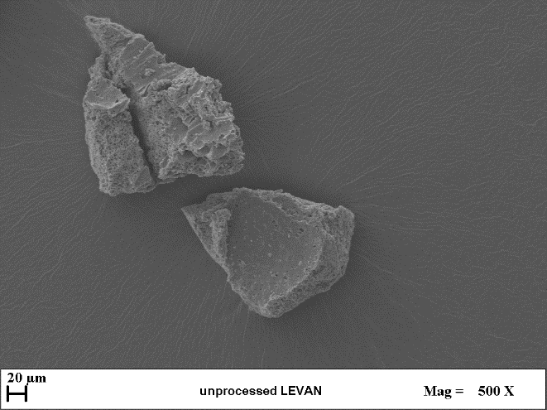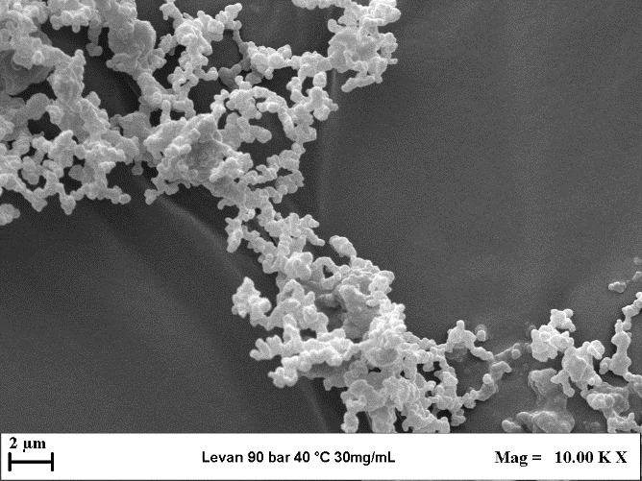
Figure 1. SEM image of unprocessed levan and SAS processed levan at 90 bar, 40°C and total concentration of 30mg/mL.
It can be observed that, after its cell-free production, levan appears as a flakes-shaped material with dimensions bigger than 100 µm and with no homogenous distribution. Starting from the preliminary work on the feasibility of the SAS process using the Levan polymers, the Micronization test shows that the shape of the Levan is different after the process. After the process, it obtained particles with submicrometric dimensions. From these earlier results, where three different pressure conditions were investigated, in particular, 90, 120 and 150 bar, the best conditions for micronizing Levan were set in correspondence of a pressure of 90 bar, a temperature of 40 °C, and a total concentration of 30 mg/mL.
    - Coprecipitation of Nimesulide and Levan
After the preliminary test to assess the processability of levan by using the SAS process, also the coprecipitation of levan with a hydrophobic drug was performed to understand how the levan can be used as a carrier for active compounds and how this amphiphilic polymer can modulate the release in aqueous solution.
As indicated in Table 1, the pressure's effect on pure levan's final particle morphology was investigated; after that, a pressure equal to 90 bar was allowed for the particles with a mean diameter equal to 0.4 µm. Then, the best drug-to-polymer ratio was studied for the SAS coprecipitation tests by maintaining constant the total concentration (Ctot) of the polymer in the solution.
Table 1. Performed tests of the pure Levan and NIM:Levan at fixed temperature of 40°C, and total concentration of 30 mg/mL by varying pressure and the drug-to-polymer ratio. (ASMP= Agglomerate submicroparticles; SMP = submicroparticles).
Test number | Pressure  (bar) | Drug-to-polymer ratio  w:w | Morphology | m.d. ± s.d.  (μm)
1 | 90 | 0:1 | SMP | 0.37±0.29
2 | 120 | 0:1 | SMP | 0.31±0.23
3 | 150 | 0:1 | SMP | 0.28±0.26
4 | 90 | 1:5 | ASMP | -
5 | 90 | 1:10 | SMP | 0.55± 0.3
6 | 90 | 1:20 | SMP | 0.38± 0.15

The SEM images of the particles obtained from the different tests are reported in Figure 2:

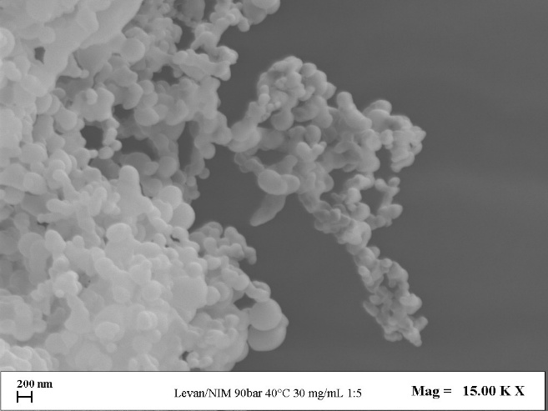 | 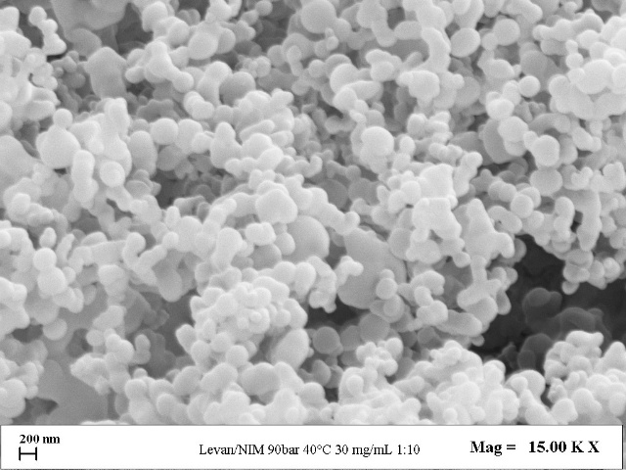
(a) | (b)
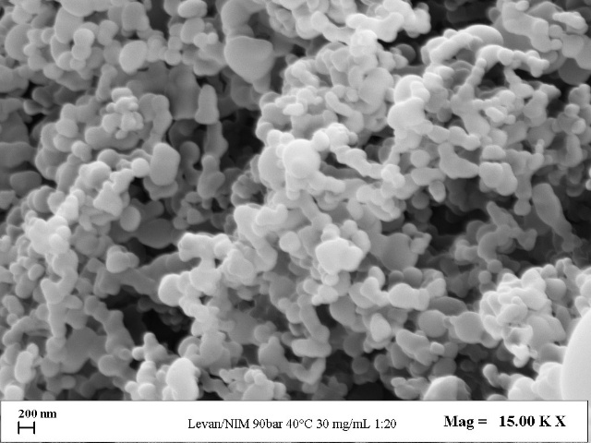

(c) | (d)
Figure 2. FESEM images of SAS coprecipitated NIM: Levan at different drug-to-polymers ratios: (a) 1:5 w:w, (b) 1:10 w:w, (c) 1:20 w:w, and (d) comparison between granulometric distributions.
In the case of the coprecipitated powders obtained with a drug-to-polymer ratio equal to 1:5, the particles appeared to be coalescent, so the granulometric distribution cannot be evaluated. In the other two cases, it can be observed that the coprecipitate NIM: levan has microparticle dimensions ranging from 0.38 to 0.55 µm, so the drug-to-polymer ratio variation influences the particles' mean diameters and as expected, a smaller drug to polymer ratio also allows to obtain a narrow granulometric distribution of the particles.
The efficient coprecipitation of NIM and levan can be understood by exploring their molecular interactions. During the precipitation process, various types of interactions may occur between NIM and levan. One primary interaction is hydrogen bonding between the -OH groups of the fructose chains in levan and the -OH or -SO₂NH groups of NIM molecules. (Marinopoulou et al.,2020)
The dissolution rates of pure NIM and SAS coprecipitates NIM: Levan at ratios of 1:5, 1:10 and 1:20 (w:w) were evaluated using UV/vis spectroscopy. The drug dissolution profiles, shown in Figure 3, represent the percentage of NIM dissolved in PBS at pH 7.4 over time.

Figure 3. Dissolution curves of NIM: Levan coprecipitate and pure NIM.
Pure NIM dissolved completely within approximately 250 minutes, whereas the SAS-processed NIM: Levan formulations took around 130 minutes. This indicates that the dissolution rates of these coprecipitates are 2 times faster than that of the pure drug. The increased release rate of the co-precipitate can be easily explained by examining the hydrophilicity of levan. In fact, coprecipitation with a hydrophilic polysaccharide promotes the diffusion of water into the matrix by aiding the dissolution of the NIM. Additionally, during the coprecipitation process, the crystallinity of nimesulide may be reduced, leading to amorphisation. This decrease in crystallinity decreases the energy required for solubilization in water, resulting in a higher dissolution rate (Guijin Liu et al., 2020). Regarding NIM entrapment efficiency, all composite samples exhibited values between 80 and 90%.
  - Conclusions
This study explores using Levan as a novel polymeric carrier for SAS coprecipitation; starting from a preliminary study, it can be assessed that using a lower exercise pressure allows to obtain particles with a higher mean diameter that is essential for the encapsulation of the drug in the polymeric matrices. For this reason, the operative pressure for the coprecipitation test is selected as equal to 90 bar. The coprecipitation tests were performed by using Nimesulide as a model drug.
SAS coprecipitation of NIM: Levan was investigated by varying drug to polymer ratio, again identifying 90 bar and 30 mg/mL concentrations as the best conditions. The drug-to-polymer ratio was adjusted from 1:5 to 1:20 (w:w), producing agglomerate coprecipitated sub-microparticles in the case of 1:5 w:w and more spherical sub-microparticles with average sizes of 0.38 µm and 0.55 µm, for 1:20 and 1:10 respectively.
Dissolution tests indicated that employing Levan as a polymeric carrier in the coprecipitation process was effective, as the SAS composite particles accelerated release of NIM; the release time of the coprecipitated sample was halved compared to pure Nimesulide. These findings are encouraging for the development of controlled-release formulations.

References
Badens E., Masmoudi Y., Mouahid A., Crampon C., 2018, Current situation and perspectives in drug formulation by using supercritical fluid technology, The Journal of Supercritical Fluids, Volume 134,
De Marco I. and Franco P., 2020, Production of Eudragit/Ampicillin Microparticles by Supercritical Antisolvent Coprecipitation; Chemical Engineering transaction, vol.79.
Domżał-Kędzia M., Ostrowska M., Lewińska A., Łukaszewicz M., 2023. Recent Developments and Applications of Microbial Levan, A Versatile Polysaccharide-Based Biopolymer Molecules 28, no. 14: 5407.
González-Garcinuño A., Tabernero A., Marcelo G., Sebastián V., Arruebo M., Santamaría J., Martín del Valle E., 2019, Differences in levan nanoparticles depending on their synthesis route: microbial vs cell-free systems, International Journal of Biological Macromolecules, 137, pp. 62-68,
Kırtel, O., Combie, J. 2022, Levan. In: Oliveira, J.M., Radhouani, H., Reis, R.L. (eds) Polysaccharides of Microbial Origin. Springer, Cham.
Liu G., Gong L., Zhang J., Wu Z., Deng H., Deng S., Development of nimesulide amorphous solid dispersions via supercritical anti-solvent process for dissolution enhancement, 2020, European Journal of Pharmaceutical Sciences, Volume 152.
Marinopoulou A., Christoﬁlos D., Arvanitidis J., Raphaelides S.N., 2020, Interaction of Tretinoin and Nimesulid with Amylose Matrices, Starch, Volume 73, Issues 1-2.
Młynek M., Trzciński J.W., Ciach T., 2023, Recent Advances in the Polish Research on Polysaccharide-Based Nanoparticles in the Context of Various Administration Routes Biomedicines 11, no. 5: 1307.
Mottola S., Viscusi G., Garcinuño A.G., Tabernero A., Cardea S., Martín del Valle E.M., Gorrasi G., De Marco I., 2024, Controlling particle size of levan in powder form with different technologies, International Journal of Biological Macromolecules, Volume 280, Part 1.
Mouro C., Gomes A.P., Gouveia I.C., 2024. Microbial Exopolysaccharides: Structure, Diversity, Applications, and Future Frontiers in Sustainable Functional Materials, Polysaccharides 5, no. 3: 241-287.
Mummaleti G., Sarma C., Yarrakula S., Urla R., GazulaH., 2024, Production, properties and applications of levan polysaccharide, Food and Humanity, Volume 3.
Paul P., Nair R., Mahajan S., Gupta U., Aalhate M., Maji I., Singh P.K., 2023, Traversing the diverse avenues of exopolysaccharides-based nanocarriers in the management of cancer, Carbohydrate Polymers, Volume 312.

