 CHEMICAL ENGINEERING TRANSACTIONS  VOL. xxx, 2025 | A publication of  
The Italian Association
of Chemical Engineering
Online at www.cetjournal.it

Guest Editors: Fabrizio Bezzo, Flavio Manenti, Gabriele Pannocchia, Almerinda di Benedetto
Copyright © 2025, AIDIC Servizi S.r.l.
ISBN 979-12-81206-17-5; ISSN 2283-9216

Biosynthesis and Characterization of Fe Nanoparticles with Quinoa Leaf Extracts: Potential for Environmental Remediation
Eliana Mullisaca Contreras ^{a,}*, Benito H. Fernandez Ochoa ^{b}, Eusebio G. Peralta Julliri ª, Máximo Cisnero Tejeira ^{c}; Fiorella V. Guere Salazar ^{d}, Elmer Benites-Alfaro^{e}, William C. Santos Tello ^{f}.
ª Universidad Nacional de Juliaca, Puno Perú.
^{b} Universidad Nacional del Altiplano, Puno, Perú
^{c} Universidad Nacional José Faustino Sánchez Carrión, Huacho, Perú.
^{d} Universidad Nacional Mayor de San Marcos, Facultad de Ingeniería Industrial, Lima Perú
^{e} Universidad César Vallejo, Escuela de Ingeniería Ambiental, Av. Alfredo Mendiola 6232, Los Olivos Lima, Perú
^{f} Universidad Continental, Av. Alfredo Mendiola 5210, Los Olivos, Lima
*e.mullisaca@unaj.edu.pe

The biosynthesis of iron nanoparticles with quinoa leaf extracts represents a breakthrough in green nanotechnology, offering an environmentally friendly method that improves biocompatibility. The objective of the research was the biosynthesis of Fe nanoparticles (NpFe) with quinoa leaf extracts and their respective characterization, through the recognition of functional groups, composition, crystalline structure and morphology of the nanoparticles, using FTIR, X-ray fluorescence, X-ray diffraction and TEM analysis, respectively. Nanoparticles with diameters ranging from 1 to 100 nm and composed of 74.4 % oxygen and 21.1 % iron were obtained, presenting an amorphous structure influenced by the plant matrix. Their coating with OH⁻ groups derived from phenolic compounds increases their potential in a wide range of applications, from drug delivery and cancer therapies to environmental remediation and the development of advanced sensors. Furthermore, their potential in agriculture to enhance nutrient absorption and as remediation agents underscores their versatility. This sustainable approach not only reduces the use of harmful chemicals, but their characteristics also give nanoparticles advantages and new possibilities in various scientific and technological fields.
  - Introduction
Faced with the problems of heavy metal contamination, nanoparticles have become a highly effective solution method for the remediation of these contaminants in various environmental matrices such as water and soil, due to their unique physicochemical properties, such as high surface area, reactivity, adsorption capacity and selectivity that make them especially suitable for remediation; within them, iron nanoparticles have precipitation, reduction and oxidation mechanisms (Yadav et al., 2024) (Manwani et al., 2024). Nanoparticles can be used in various forms (Maryam and Gul, 2023), they have high efficiency attributed to their small size and large surface area that increase contact with contaminants (Damiri et al., 2022). It is also important when nanoparticles are synthesized by biological methods, with respect for the environment and with greater profitability than when done by chemical methods; For example, biogenic nanoparticles synthesized from plant extract, which have proven to be very promising in the removal of heavy metals (Real and Benites, 2021) (Benites-Alfaro et al., 2023) (Gómez et al., 2023).
The metal removal mechanisms of nanoparticles are primarily their adsorbent properties, their large surface area, and functional groups (Lee et al., 2019). They sometimes act by reducing metals to their less toxic form or catalyzing their degradation, as with iron nanoparticles. Iron nanoparticles are characterized by the ability to be easily separated by an external magnetic field, which facilitates recovery and reuse (Kumari et al., 2020).
Nanoparticles can be used in the remediation of contaminated soils, where they have demonstrated high efficiency in immobilizing heavy metals, and in wastewater treatment using nano adsorbent and nanofilter membranes as supports (Kumari et al., 2020). While nanoparticles offer significant advantages, their use must be cautious, considering potential environmental risks and toxicity, and their safe and sustainable use must be assumed (Shwetha and Ramanna, 2023).
Within this range of applications, to do so safely and overcome some disadvantages, the research objective focused primarily on the synthesis of nanoparticles with environmental characteristics using a plant extract from quinoa leaves; this would yield nanoparticles that can act by taking advantage of the synergistic effects of their structure.
  - Methodology
To obtain iron nanoparticles by reducing ferric chloride with phenolic extract of quinoa leaves, the following steps were followed:
    - Preparation of quinoa leaf extract.
- 200 g of fresh quinoa leaves were collected and washed.
- The quinoa leaves were dried at 50 °C for 24 hours.
- The leaves (5 g) were placed in a 1-liter beaker. To prepare the extract, a 1:10 % w/v ethanol solution was added to the quinoa leaves and left to stand for 24 hours.
- The extract was then filtered to separate the solution.
- This extract was subsequently analysed.
2.2 Biosynthesis of iron nanoparticles
The procedure followed was:
- Initially, 100 mL of a 0.1 M FeCl₃ solution was prepared in an Erlenmeyer flask, yielding a yellow solution.
- Subsequently, 25 mL of the 0.1 M FeCl3 solution was taken and 25 mL of quinoa leaf extract was added drop by drop (1:1 ratio), observing the colour change from yellow to black. The pH was then measured, recording a value of 3.12. NaOH 1 M was added to adjust the pH to 4.12, as scientific literature states that a pH in the range of 4 to 5 is optimal for obtaining nanoparticles (Kumar et al., 2015 and Mystrioti et al., 2016). At that moment, the solution turned a deep black colour, and the presence of a precipitate was observed (see Figure 1).
- The solution was then centrifuged at 10,000 rpm in 50 mL Falcon tubes for 10 minutes.
- The precipitate was washed three times with a 50 % v/v acetone-alcohol solution, then dried for 24 hours at 50 °C (see Figure 2). The precipitate was weighed giving 0.5 g.
- The precipitate obtained was iron nanoparticles, which were then characterized accordingly and stored in an amber glass bottle at room temperature.

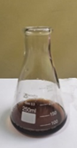 | 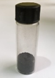
Figure 1: Black precipitate, corresponding to iron nanoparticles in quinoa extract. | Figure 2: Iron nanoparticles
2.3 Mechanism of formation of iron nanoparticles:
When mixing the FeCl3 solution with the polyphenols contained in the plant extract of quinoa leaves, the mechanism of chemical balance of Eq. (1) is presented.

2Fe⁺³ + 3R-C₆H₃(OH)₂ Fe° + FeO + 3 R-C₆H₃O₂ +6 H⁺ | (1)
The reaction indicates that a polyphenol is oxidized to quinone, this transformation allows the reduction of FeCl₃ to FeO and Fe° (Mohan Kumar et al., 2013), so it is deduced that the nanoparticles obtained in the research would be formed by Fe°, FeO (characteristic black colour) with the presence of polyphenols in an acidic medium (Mystrioti et al., 2016). It is corroborated by other studies where they used Eucalyptus Globulus (Andrade-Zavaleta et al., 2022), tea (Xiao et al., 2020), Moringa Olifeira (Gautam et al., 2020b); olive (Essien et al., 2018), which reported the same constituents.
2.4 Characterization of iron nanoparticles
The characterization of the iron (Fe) nanoparticles biosynthesized with quinoa leaf extract using the above procedure, in terms of size, was performed by transmission electron microscopy (TEM). A Thermo Scientific Talos f200i microscope was used, with a working voltage of 200 kV. For this purpose, the Fe nanoparticle sample to be characterized was dispersed in an ethyl alcohol solution. A microdroplet was taken and placed in the aforementioned equipment on a copper grid support.
The composition and crystalline structure of the nanoparticles were characterized by fluorescence and X-ray diffraction in the 2 Ɵ range, respectively, using a Rigaku Miniflex 600 X-ray diffractometer equipped with a radiation source with a 40 kV/15 mA setting. The functional groups present in the extract and the iron nanoparticles were evaluated by Fourier transform infrared spectra (FTIR) in the range of 4000-650 cm⁻¹ with a Perkin Elmer brand spectrophotometer, Frontier FTIR/NIR model.
  - Results
3.1 Identification of phenolic compounds in quinoa leaves
FTIR spectra were used to identify phenolic compounds in quinoa leaves that acted as reducers of FeCl₃ and formed iron nanoparticles (NpFe); the results are shown in Figure 3. It can be observed that it records wavelength peaks of 3341.49 cm⁻¹ which identify the presence of hydroxyl groups OH- found in the phenolic compounds of the extract; there is also a sharp peak at 2983.19 cm⁻¹ which indicates vibrations due to the presence of C-H groups from CH₂ and CH groups, indicative of the presence of an aromatic ring (Ar-H) in the extract (Somchaidee and Tedsree, 2018).
The same graph shows peaks at 1638.38 cm⁻¹ related to C-N stretching vibrations of secondary amines (Pavan Kumar et al., 2020). There are spectra in the bands of 1412.97 and 1308.94 cm⁻¹ that correspond to the bending of OH- groups, as well as in the stretching bands at 1044.90 and 877.07 cm⁻¹ due to the vibrational stretching of the C-O group of polyols (Garole et al., 2018).
In this way, FTIR spectroscopy confirmed the presence of phenolic compounds in the quinoa leaf extract, which are reducing agents and stabilizers of ferric chloride (FeCl₃) for the biosynthesis of iron nanoparticles; this was corroborated by Andrade-Zavaleta et al. (2022), who confirmed the reducing action of phenolic compounds from eucalyptus leaves to form iron oxide (FeO) nanoparticles. Awwad and Salem (2013) also assert in a study that phenolic functional groups are responsible for the protection and stabilization of nanoparticles.
3.2 Identification of phenolic functional groups in iron nanoparticles (NpFe):
In the reduction process of iron chloride (FeCl₃ 0.1 M) with phenolic extract of quinoa leaves, the color of the solution changed from yellow to black, thus confirming the formation of iron nanoparticles (NpFe) (Abdelfatah et al., (2021); that is, this happens due to the complexation of Fe⁺³ with the phenolic groups present in the vegetable extract of quinoa leaves, when the interaction occurs in the metal-ligand form through the C=O bond. It should be noted that, in the reduction process for the formation of the NpFe, there was a decrease in pH from 5 to 2.14, due to the generation of H⁺ in the process when phenols were added.
The iron nanoparticles (NpFe) were subjected to FTIR analysis to identify the functional groups present coating the nano adsorbents. The results presented in the spectrum (see Figure 4), it is observed that, in the flat bands at 3227.46 cm⁻¹ corresponds to stretching vibrations of oxydryl radicals (OH⁻), characteristic of the presence of alcoholic and phenolic groups with the presence of hydrogen bonds (Somchaidee and Tedsree, 2018); according to Vázquez-Guerrero et al, (2021), indicate that the presence of OH⁻ radicals on the external surface of the nanoparticle allow the adsorption of metals on the nanoparticle. The absorption peaks between 1396.3 cm⁻¹ to 1563.09 cm⁻¹ would correspond to the stretching vibration C=O, C-O and COO⁻ carboxyl groups, these results are close to that reported by Önal et al., (2019) whose peaks were presented in the range of 1595 cm⁻¹ to 1378 cm⁻¹ and adduce to the presence of the aforementioned functional groups.
In general, the IR spectra showed that the Fe nanoparticles are coated by different functional groups of the plant extract, contributing to the formation of covalent bonds that stabilize the nanoparticle and accelerate the adsorption processes, because they provide interaction sites on the surface of the nanoparticle (Pavan Kumar et al., 2020). So also, it is also established that the band located at 1351.4 cm⁻¹ is due to C-N stretching or OH⁻ bending vibrations (Gautam et al., 2020). Likewise, it is observed and predicted that the stretching vibration of carboxylic acids, ketones and esters are present at peaks 1275.4 cm⁻¹ to 1028.42 cm⁻¹, while the absorption peaks at 866.97 cm⁻¹ and 789.64 cm⁻¹ are attributed to the stretching vibration of asymmetric C-O bond of phenolic groups and OH⁻ bond (Somchaidee and Tedsree, 2018).

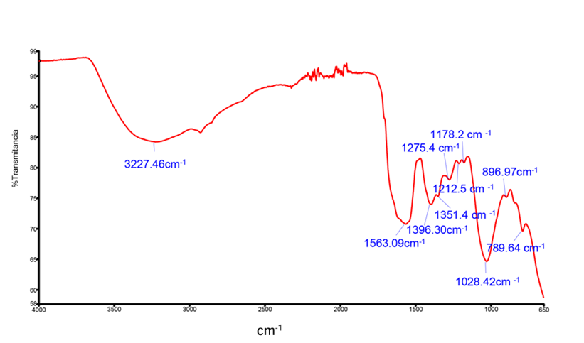 | 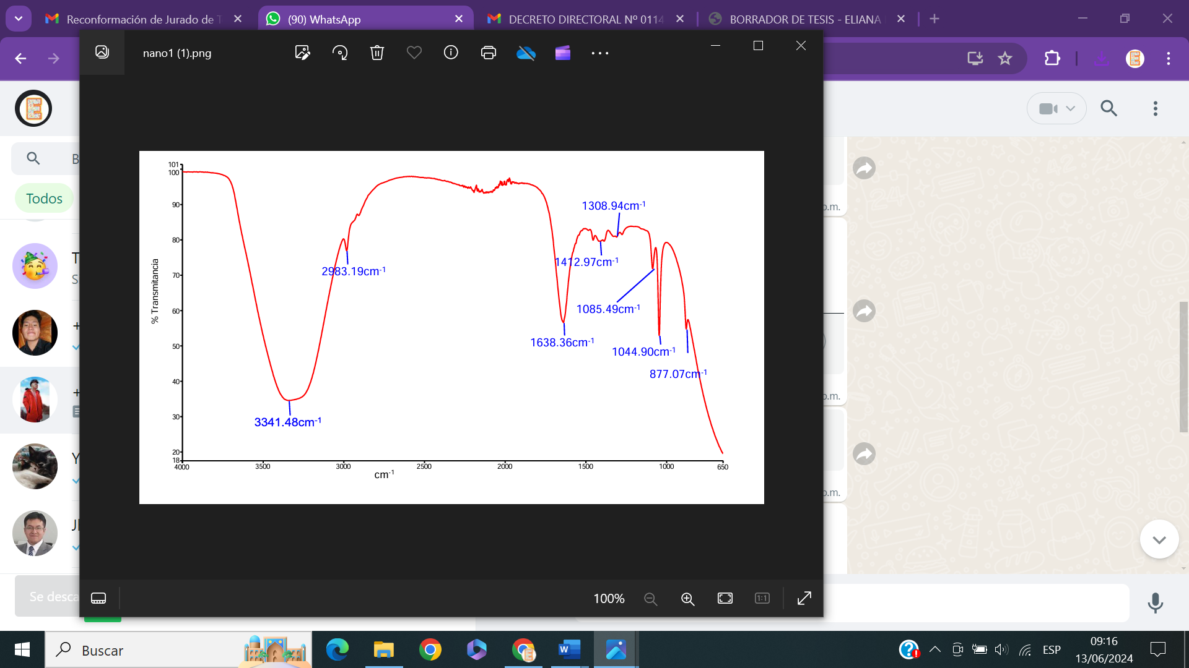
Figure 3: Functional groups determined by FTIR in the quinoa leaf extract | Figure 4: Functional groups determined by FTIR on the surface of Fe nanoparticles
3.4 Characterization of iron nanoparticles (NpFe)
The iron nanoparticles were characterized using Transmission Electron Microscopy (TEM) to determine the morphology (size and shape) of the nanoparticles, as recommended by the scientific literature (M. Gupta et al., 2020; V. K. Gupta et al., 1998). In Figure 5 a,b,c, heterogeneous particles of sizes between 1-100 nm are observed, with ordered and rough shapes (Figure 5c) attributable to crystalline Fe (Arancibia-Miranda et al., 2014; Yang et al., 2019), as well as the presence of degenerated amorphous iron oxide and hydroxide (Giasuddin et al., 2007; Xi et al., 2010), respectively. Abdelfatah et al. (2021) suggest that the heterogeneity of the particles would provide information about their high surface area and reactivity towards contaminants and would facilitate active sites for physical exchanges and chemical reactions (Pavan Kumar et al., 2020).

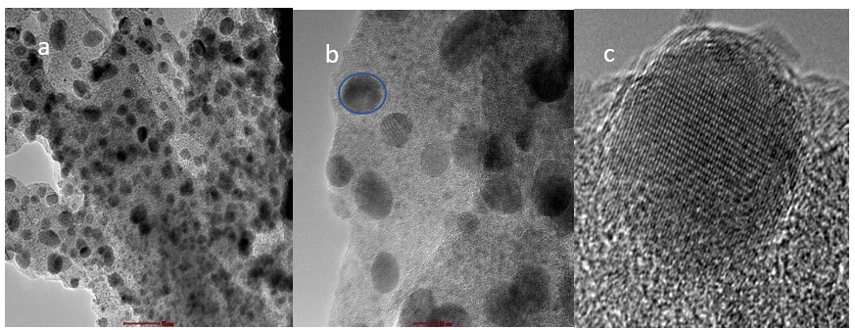
Figure 5: Micrographs of Fe nanoparticles biosynthesized with quinoa leaves
The images in Figure 5 show agglomerated nanoparticles, which give a circular shape and a larger size (Figure 5b). This agglomeration of nanoparticles occurs due to the variety of polyphenols present in the plant extracts that are involved in the research matrix (Ebrahiminezhad et al., 2017; Giasuddin et al., 2007). This agglomeration happens due to the magnetic and electrostatic interaction between the functional groups present in the plant extract and the Fe (Yang et al., 2019). The results obtained are consistent with those reported by Önal et al., (2019) and Andrade-Zavaleta et al., (2022), who claim to have observed agglomerations in the obtained nanoparticles and infer that they may possibly be linked to organic stabilizing agents, which would be related to the organic functions observed in the FTIR. In short, the biosynthesized nanoparticles with plant extract exhibit heterogeneous morphology, a characteristic that facilitates the sorption processes as it presents active sites for physical and chemical exchanges (Pavan Kumar et al., 2020)

3.5 Composition percentages of iron nanoparticle constituents
The black color of the nanoparticles would indicate the presence of iron oxides (Kumar et al., 2015; Mystrioti et al., 2016). We proceeded to determine the chemical composition of the nanoparticles by applying X-Ray Fluorescence, whose results evidenced particles with 19.4 % Fe and 74.4% O and according to the scientific literature corresponds to Fe₂O₃ in hydrated form and with the presence of other components, due to the characteristic polymorphism of iron oxide (Tucek et al., 2012). In the research of Garole et al., (2018), they indicate to have found percentages of 78.9 % and 21.1 % for Fe and O respectively, and infer that these percentages are close to Fe₃O4. The results show the amorphous nature (See Figure 6), which would be related to the matrix of the polyphenol extract supporting the nanoparticles (Giasuddin et al., 2007), observed in Figure 5a, not allowing to visualize the crystallinity of the nanoparticles. These results are in agreement with those reported by Shahwan et al. (2011), who also found amorphous structures in iron nanoparticles synthesized with tea and Moringa Olifeira (Vázquez-Guerrero et al., 2021).

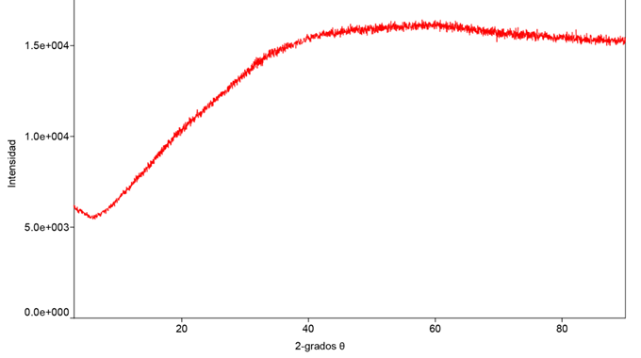
Figure 6. X-ray diffraction of Fe nanoparticles
  - Conclusion
Fe nanoparticles were biosynthesized with quinoa leaf extract, their characterization by TEM confirmed the presence of nanoparticles with a diameter of 1 to 100 nm, X-ray fluorescence showed that they were made up of 19.4 % Fe and 74.4 % O; X-ray diffraction also indicated the amorphous nature of the nanoparticles and FTIR allowed to identify the presence of phenolic groups in the structure of the nanoparticles, which act as stabilizing and protective agents for the nanoparticles, giving them special characteristics such as adsorption by electrostatic interaction.
References
Abdelfatah A., Fawzy M., Eltaweil A., and El-Khouly M., 2021, Green Synthesis of Nano-Zero-Valent Iron Using Ricinus Communis Seeds Extract: Characterization and Application in the Treatment of Methylene Blue-Polluted Water. ACS Omega, 6(39), 25397–25411, </doi.org/10.1021/acsomega.1c03355.>
Andrade-Zavaleta K., Chacon-Laiza Y., Asmat-Campos D., and Raquel-Checca N., 2022, Green Synthesis of Superparamagnetic Iron Oxide Nanoparticles with Eucalyptus globulus Extract and Their Application in the Removal of Heavy Metals from Agricultural Soil. Molecules, 27(4), 1–25, < doi.org/10.3390/molecules27041367.>
Arancibia-Miranda N., Baltazar S. E., García A., Romero A. H., Rubio M. A., & Altbir D., 2014, Lead removal by nano-scale zero valent iron: Surface analysis and pH effect. Materials Research Bulletin, 59, 341–348, <doi.org/10.1016/j.materresbull.2014.07.045>
Awwad M., and Salem, M., 2013, A Green and Facile Approach for Synthesis of Magnetite Nanoparticles. Nanoscience and Nanotechnology, 2(6), 208–213, <doi.org/10.5923/j.nn.20120206.09>
Benites-Alfaro E., Rivera L.T., Vergara A.S., Castaneda-Olivera C.A., Ccuro F.M., 2023. Green Silver Nanoparticles in Improvement of Physicochemical and Microbiological Properties of Tannery Wastewater. Chemical Engineering Transactions 101, 31–36, <doi.org/10.3303/CET23101006>
Damiri F., Andra S., Kommineni N., Balu S.K., Bulusu R., Boseila A.A., Akamo D.O., Ahmad Z., Khan F.S., Rahman M.H., Berrada M., Cavalu S., 2022. Recent Advances in Adsorptive Nanocomposite Membranes for Heavy Metals Ion Removal from Contaminated Water: A Comprehensive Review. Materials 15, 5392, <doi.org/10.3390/ma15155392>
Ebrahiminezhad A., Zare-Hoseinabadi A., Berenjian A., & Ghasemi Y., 2017, Green synthesis and characterization of zero-valent iron nanoparticles using stinging nettle (Urtica dioica) leaf extract. Green Processing and Synthesis, 6(5), 469–475, <doi.org/10.1515/gps-2016-0133>
Essien E. A., Kavaz D., and Solomon M. M., 2018, Olive leaves extract mediated zero-valent iron nanoparticles: synthesis, characterization, and assessment as adsorbent for nickel (II) ions in aqueous medium. Chemical Engineering Communications, 205(11), 1568–1582, <doi.org/10.1080/00986445.2018.1461089>
Garole V. J., Choudhary B. C., Tetgure S. R., Garole D. J., and Borse A. U., 2018, Detoxification of toxic dyes using biosynthesized iron nanoparticles by photo-Fenton processes. International Journal of Environmental Science and Technology, 15(8), 1649–1656, <doi.org/10.1007/s13762-017-1510-0>
Gautam P., Shivalkar S., and Banerjee S., 2020, Synthesis of M. oleifera leaf extract capped magnetic nanoparticles for effective lead [Pb (II)] removal from solution: Kinetics, isotherm and reusability study. Journal of Molecular Liquids, 305m, <doi.org/10.1016/j.molliq.2020.112811>
Giasuddin A. B. M., Kanel S. R., and Choi, H., 2007, Adsorption of humic acid onto nanoscale zerovalent iron and its effect on arsenic removal. Environmental Science and Technology, 41(6), 2022–2027, <doi.org/10.1021/es0616534>.
Gómez M.M., Aguinaga D.L., Castaneda-Olivera C.A., Paredes M.R., Mendivil V.T., Benites-Alfaro E., 2023. Reduction of Organic Matter and Bacteria in Surface Waters of the Huatanay River using Chitosan Nanoparticles. Chemical Engineering Transactions 101, 67–72, <doi.org/10.3303/CET23101012>
Gupta, M. Singh Tomar R., and Mishra R. K., 2020, Factors Affecting Biosynthesis of Green Nanoparticles. Our Heritage, 68(30), 10535–10555, <www.researchgate.net/publication/339875496>
Gupta V. K., Mohan D., and Sharma, S. 1998, Removal of lead from wastewater using bagasse fly ash - a sugar industry waste material. Separation Science and Technology, 33(9), 1331–1343, <doi.org/10.1080/01496399808544986>
Kumar B., Smita K., Cumbal L., Debut A., Camacho J., Hernández-Gallegos E., Chávez-López M. de G., Grijalva M., Angulo Y., Rosero G., 2015, Pomosynthesis and biological activity of silver nanoparticles using Passiflora tripartita fruit extracts, Advanced Materials Letters, 6(2), 127–132, doi.org/10.5185/amlett.2015.5697
Kumari P., Kumar S., Singhal A., 2020, Chapter 29 - Magnetic nanoparticle-based nanocontainers for water treatment, in: Nguyen-Tri, P., Do, T.-O., Nguyen, T.A. (Eds.), Smart Nanocontainers, Micro and Nano Technologies,. Elsevier, pp. 487–498, <doi.org/10.1016/B978-0-12-816770-0.00029-0>
Lee L.Z., Ahmad Zaini M.A., Shu Hui T., 2019, Porous nanomaterials for heavy metal removal, in: Handbook of Ecomaterials. pp. 469–494, <doi.org/10.1007/978-3-319-68255-6_27>
Manwani S., Awasthi G., Gupta S., Awasthi A., Shekhar Y., Awasthi K. K., 2024. Nanoparticle-Based Bioremediation Approach for Elimination of Heavy Metals from Wastewater 1, 1era Ed. ed.
Maryam S., Gul A., 2023, Heavy Metal Remediation by Nanotechnology, in: Newman L., Ansari A.A., Gill S.S., Naeem M., Gill R. (Eds.), Phytoremediation: Management of Environmental Contaminants, Volume 7. Springer International Publishing, Cham, pp. 571–597, <doi.org/10.1007/978-3-031-17988-4_26>
Mohan Kumar K., Mandal B. K., Siva Kumar K., Sreedhara Reddy P., and Sreedhar B., 2013, Biobased green method to synthesise palladium and iron nanoparticles using Terminalia chebula aqueous extract. Spectrochimica Acta - Part A: Molecular and Biomolecular Spectroscopy, 102, 128–133, <doi.org/10.1016/j.saa.2012.10.015>
Mystrioti C., Xanthopoulou T. D., Tsakiridis P. E., Papassiopi N., and Xenidis A., 2016, Comparative evaluation of five plant extracts and juices for nanoiron synthesis and application for hexavalent chromium reduction. Science of the Total Environment, 539, 105–113, <doi.org/10.1016/j.scitotenv.2015.08.091>
Önal E. S., Yatkin T., Aslanov T., Ergüt M., Özer A., 2019, Biosynthesis and Characterization of Iron Nanoparticles for Effective Adsorption of Cr(VI), International Journal of Chemical Engineering, 2019(Vi), <doi.org/10.1155/2019/2716423>
Pavan Kumar G., Shivalkar S., Banerjee S., 2020, Synthesis of M. oleifera leaf extract capped magnetic nanoparticles for effective lead [Pb (II)] removal from solution: Kinetics, isotherm and reusability study, Journal of Molecular Liquids, 305, <doi.org/10.1016/j.molliq.2020.112811>
Real C. and Benites E., 2021. Green Silver Nanoparticles for Effluent Treatment with Brl Blue Dye in the Textile Industry. Chemical Engineering Transactions 84, 223–228, <doi.org/10.3303/CET2184038>
Shahwan T., Abu Sirriah S., Nairat M., Boyaci E., Eroĝlu A. E., Scott T. B., and Hallam K. R.,2011, Green synthesis of iron nanoparticles and their application as a Fenton-like catalyst for the degradation of aqueous cationic and anionic dyes. Chemical Engineering Journal, 172(1), 258–266, <doi.org/10.1016/j.cej.2011.05.103>
Shwetha A., Ramanna N., 2023, Efficacy of Nanoparticles in Water Treatment, Journal of Mines, Metals and Fuels 71, 1775–1784, <doi.org/10.18311/jmmf/2023/35877>
Somchaidee P., Tedsree K., 2018, Green synthesis of high dispersion and narrow size distribution of zero-valent iron nanoparticles using guava leaf (Psidium guajava L) extract, Advances in Natural Sciences: Nanoscience and Nanotechnology, 9(3), <doi.org/10.1088/2043-6254/aad5d7>
Tucek J., Tucek P., Cuda J., Filip J., Pechousek J., Macha L., Zboril R., 2012, Iron (III) oxide polymorphs and their manifestations in in-field 57Fe Mössbauer spectra, AIP Conference Proceedings Conference 2012, < 10.1063/1.4759474 >.
Vázquez-Guerrero A., Cortés-Martínez R., Alfaro-Cuevas-villanueva R., Rivera-Muñoz E. M., Huirache-Acuña R., 2021, CD(II) and PB(II) adsorption using a composite obtained from moringa oleifera lam. cellulose nanofibrils impregnated with iron nanoparticles, Water (Switzerland), 13(1), <doi.org/10.3390/w13010089>
Xi Y., Mallavarapu M., and Naidu R., 2010, Reduction and adsorption of Pb²⁺ in aqueous solution by nano-zero-valent iron - A SEM, TEM and XPS study, Materials Research Bulletin, 45(10), 1361–1367, doi.org/10.1016/j.materresbull.2010.06.046
Xiao C., Li H., Zhao Y., Zhang X., Wang X., 2020, Green synthesis of iron nanoparticle by tea extract (polyphenols) and its selective removal of cationic dyes, Journal of Environmental Management, 275(August), 1–11, <doi.org/10.1016/j.jenvman.2020.111262>
Yadav J., Rani M., Shanker U., Sillanpaa M., 2024, Forging the advances of iron-based nanomaterials by functionalizing charge carriers regions for eradication of heavy metal ion contamination, Inorganic Chemistry Communications 164, 112440., <doi.org/10.1016/j.inoche.2024.112440>
Yan W., Herzing A. A., Kiely C. J., and Zhang W. X., 2010, Nanoscale zero-valent iron (nZVI): Aspects of the core-shell structure and reactions with inorganic species in water, Journal of Contaminant Hydrology, 118(3–4), 96–104, <10.1016/j.jconhyd.2010.09.003>.

