 CHEMICAL ENGINEERING TRANSACTIONS  VOL. , 2025 | A publication of  
The Italian Association
of Chemical Engineering
Online at www.cetjournal.it

Guest Editors: Paolo Ciambelli, Luca di Palma
Copyright © 2025, AIDIC Servizi S.r.l.
ISBN 979-12-81206-20-5; ISSN 2283-9216

Performance and challenges in the implementation of polymeric hollow fiber membranes for CO₂ capture from textile industry emissions
Guillermo Díaz-Sainz*, Stephanie Arias-Lugo, Lucía Gómez-Coma, Angel Irabien
Departamento de Ingenierías Química y Biomolecular, Unversidad de Cantabria, Avenida de los Castros s/n, 39005, Santander, Spain
diazsg@unican.es
Global warming and climate change are strongly associated with industrial production and fossil fuel consumption, as these are major contributors to CO₂ emissions. Despite global efforts to promote industrial sustainability, substantial emissions persist, leading to a rising CO₂ concentration in the atmosphere. To mitigate these emissions, CO₂ capture, storage, and utilization strategies are extensively studied in the last years. Among various CO₂ capture technologies, polymeric membranes have gained attention due to their high efficiency, selectivity, and competitive market advantages. However, their scalability for high industrial flow rates remains a challenge due to the low technology readiness level (TRL) of current systems.
This study investigates a novel CO₂ capture system employing polymeric hollow fiber membranes (Airrane Co Ltd, PermSelect®, and UBE Corporation Europe). The system was tested in a laboratory-scale setup using real industrial emissions from the textile industry, with CO₂ concentrations ranging from 0.5% to 6%. Textile industry gas streams with 0.5% CO₂ exhibited low permeate flux (maximum 8.5 cm³·cm⁻²·s⁻¹), with minimal pressure influence. However, when the highest concentration was tested with 7% CO₂, the UBE membrane demonstrated promising performance, achieving a CO₂ permeance of 84.0 GPU and selectivities of 21.8 (CO₂/N₂) and 3.6 (CO₂/O₂).
Overall, this study demonstrates the feasibility of CO₂ capture using polymeric membranes. The results highlight the need for advanced materials and improved system configurations to enhance CO₂ purity and efficiency, laying the foundation for future industrial-scale applications.
  - Introduction
The accumulation of CO₂ in the atmosphere has intensified due to increased industrial production and energy consumption. In fact, the latest measurements conducted by the National Oceanic and Atmospheric Administration reveal values close to 427 ppm, indicating an increase of 3 ppm in the last 12 months (NOAA, 2025). Consequently, aligning with the European Union’s goal of achieving net-zero emissions by 2050, it is necessary to make significant efforts in production chains and in the substitution of fossil fuels to mitigate CO₂ emissions. Among the most promising strategies are CO₂ capture, storage, and utilization, with capture being a critical step for the success of subsequent processes. Membrane-based separation technologies have emerged as a selective and efficient alternative to conventional methods (Dai and Deng, 2024). It is necessary to address challenges to large industrial flow rates with the same effectiveness as other technologies at a larger scale. Despite this, polymeric membranes, particularly at the pilot scale, have demonstrated high efficiency, positioning them as strong candidates for industrial-scale implementation. Nevertheless, pilot plant tests are rarely conducted with real gases, making it difficult to evaluate membrane poisoning in the presence of various components, even at trace levels in industrial streams.
Among commercially available polymeric membranes, polydimethylsiloxane (PDMS), polysulfone (PSF), and polyimide (PI) are promising materials. Polysulfone is particularly attractive due to its low cost and high chemical resistance, while PDMS and polyimide are highly permeable and considered robust materials for gas separation (Checchetto et al., 2024). Thus, although numerous studies have investigated these membranes under controlled laboratory conditions using synthetic gas, their performance with real flue gas streams remains less explored. Understanding their behavior under realistic conditions is essential for identifying key challenges and guiding future advancements toward multi-stage system designs.
In this context, the VALCO2-T project (Figure 1) aims to decarbonize the textile sector by validating a novel electrocatalytic route powered by photovoltaic energy. This approach involves the electro-reduction of CO₂ and the oxidation of waste to produce value-added products, ultimately reducing the carbon footprint of current processes by utilizing CO₂ capture streams. The project is a collaboration between the University of Cantabria (project coordinator), Textil Santanderina, S.A. (a hard-to-abate sector targeted for decarbonization), and APRIA Systems, S.L. (an engineering company responsible for building the CO₂ capture and conversion units for the textile industry).
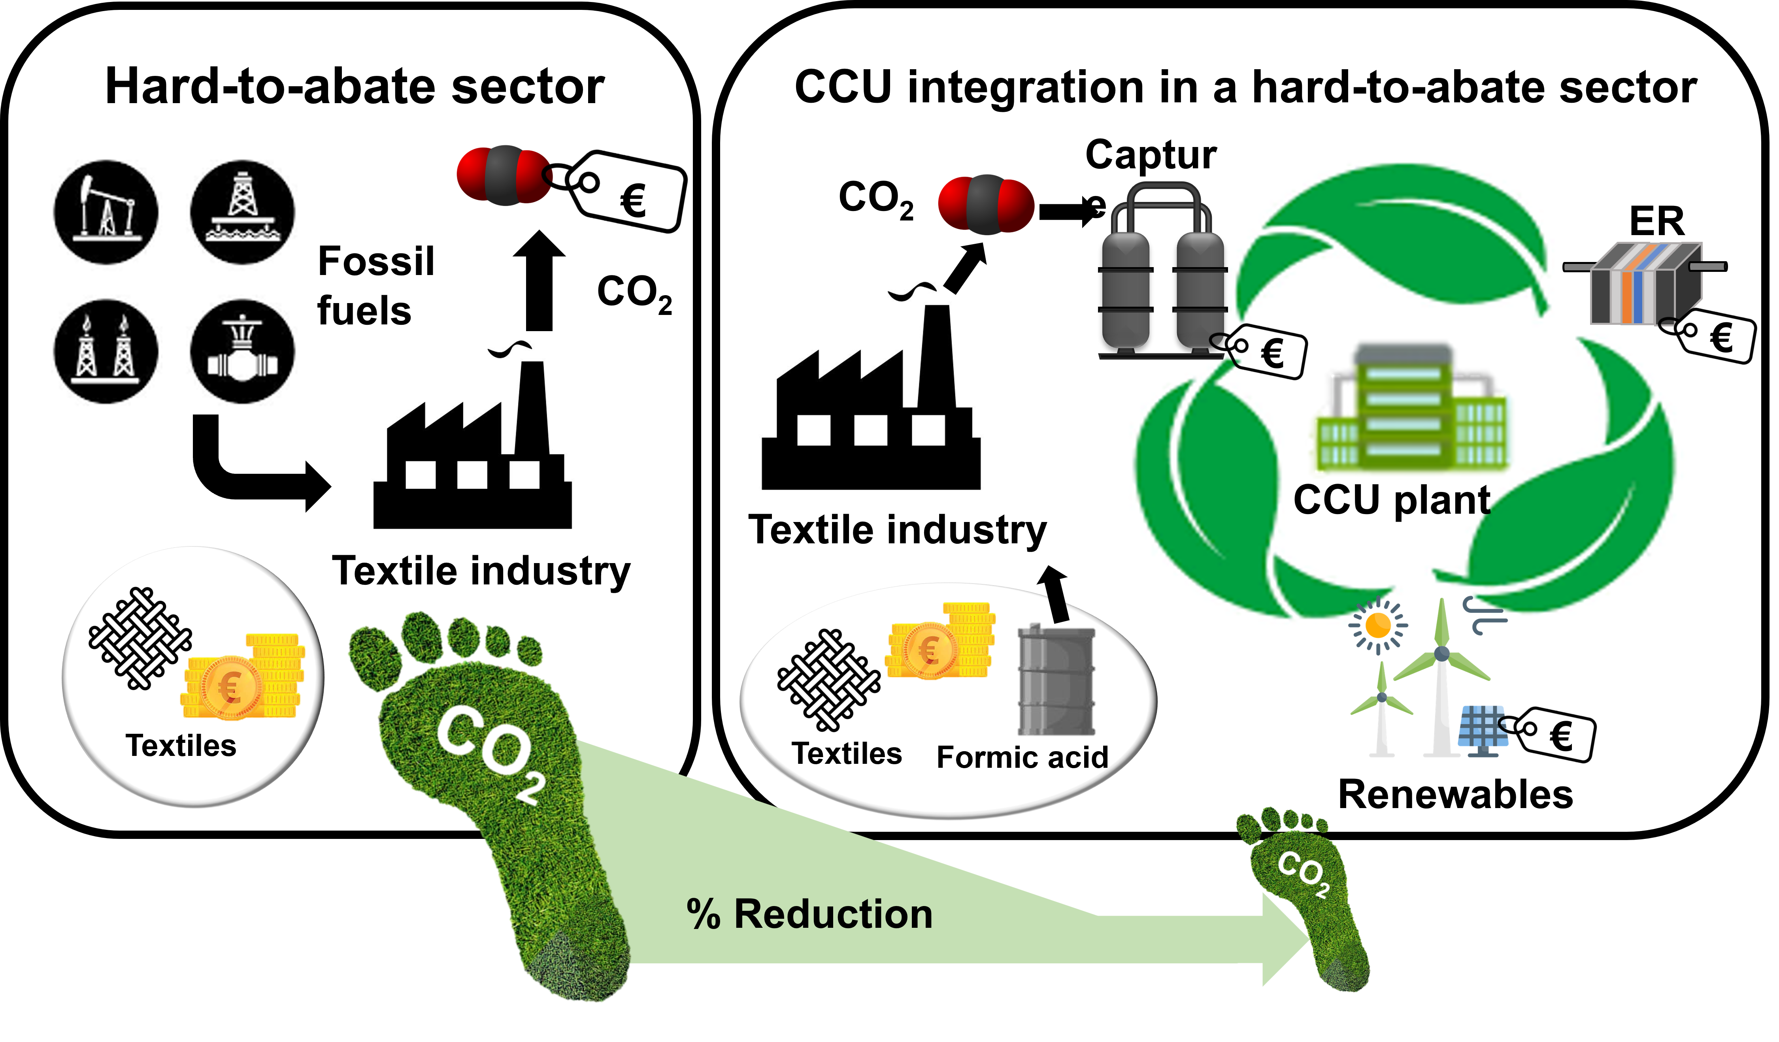
Figure 1: VALCO₂-T project.

The primary objective of this study is to evaluate CO₂ capture using three commercial polymeric membranes—polysulfone, PDMS, and polyimide —with real flue gas streams from the textile industry, an area that has been scarcely explored in the literature. To achieve this ambitious goal, testing various membrane materials under different conditions is necessary, along with adjusting key process parameters, including pressure, flow rate, and feed gas composition, which varies depending on the selected sampling point.
  - Methodology
This section presents the main elements and methods used for the evaluation of CO₂ capture with different membranes under various operating conditions.
    - Membrane module properties
In this study, three commercial membrane modules from leading manufacturers in the gas separation industry were selected based on their material properties and suitability for CO₂ capture. The selected membranes include polysulfone (Airrane), PDMS (PermSelect®), and polyimide (UBE Corporation Europe). Table 1 provides the detailed specifications of these membranes as supplied by the manufacturers.
Table 1: Specifications of the selected membranes (Airrane, PermSelect® and UBE Corporation Europe).
Manufacturer | Airrane | PermSelect® | UBE Corporation Europe
Material | PSF | PDMS | PI
Model | MCH-1006A 1 | PDMSXA-1000 | CO-0302SES
Specific area (cm²) | 1822 | 1000 | 2626
Number of fibers | 2000 | 1280 | 1100
Fiber thickness (µm) | 110 | 55 | 200
Pressure operation (barg) | ≤6 | ≤3 | ≤10

These membrane modules differ in material composition, surface area, and structural properties, influencing their performance under varying operating conditions.

    - Experimental system
The experimental setup is designed to evaluate CO₂ separation using membrane technology. Experiments are conducted in a single-stage membrane separation system, which is adaptable to each tested membrane. Industrial textile emissions, stored in 50 L pressurized bottles (up to 14 bar), are introduced into the system through a mass flow controller (Alicat Scientific™, model MC-50SCCM-D/5M, USA) to ensure precise flow regulation. The gas is then directed through fluorinated polyvinylidene (PVDF) tubing (8 mm outer diameter) to the membrane module, where separation occurs via selective permeation, following the solution-diffusion mechanism.
A needle valve regulates system pressure, maintaining the necessary pressure differential across the membrane. During the experiments, the permeate pressure is kept constant at 1 bar. The flow rates of both the permeate and retentate streams are measured using rotameters (Omega™, model FLDA3224C, USA, and Omega™, model FLDA3210G, USA). The composition of each stream is determined using a gas analyzer (GeoTech G110, CO₂ 0–100%), which measures O₂ concentration via an electrochemical cell and CO₂ concentration using infrared detection.
A schematic representation of the experimental system is provided in Figure 2.

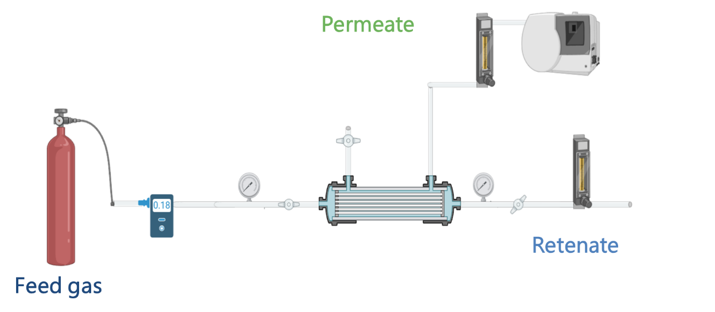
Figure 2: Schematic representation of the experimental system.

    - Gas streams characterization
As previously mentioned, gas samples were collected from three locations within the textile facility: the oven (Textile 1) and two boiler units (Textile 2 and Textile 3). The sampling point significantly influences the gas composition, particularly the concentrations of key compounds such as CO₂, O₂, and N₂. Table 2 presents the detailed composition of the gas streams after controlled sampling.
Table 2: Concentration (%) of key gaseous compounds in textile industry samples.
Components | Textile 1 | Textile 2 |  | Textile 3
CO₂ | 0.5 | 4.0 |  | 5.6
O₂ | 18.0 | 13.0 |  | 8.0
N₂ | 81.5 | 83.0 |  | 81.8

    - Figures of merit
Using the data obtained under the defined operating conditions, four key parameters were calculated to evaluate membrane performance: permeate flux (J_{i}), CO₂ recovery ($R_{CO_{2}})$, CO₂ permeance (P_{i}), and selectivity ($α_{i/j}$). These metrics not only provide critical insights into the efficiency and separation capacity of the membranes during the CO₂ capture process but also allow for a rigorous comparison with other membranes presented in the literature.
In this sense, the permeate flux represents the volumetric flow rate of a specific component per unit membrane area and is given by Equation (1):
$$J_{i}\left(\frac{{cm}^{3}}{{cm}^{2}·s}\right)=\frac{Q_{i p} ({{cm}^{3}}/s)}{A ({cm}^{2})}$$ | (1)
where $J_{i}$ is the permeate flux of component i, $Q_{i p}$ is the volumetric flow rate of component i in the permeate, and $A$ is the membrane surface area.

On the other hand, the CO₂ recovery measures the fraction of CO₂ in the feed stream that passes to the permeate side. It is calculated using the Equation 2:
$$R_{CO_{2}} \left(\%\right)=\frac{Q_{{CO}_{2} p} \left({mL}/{min}\right)}{Q_{{CO}_{2} in} \left({mL}/{min}\right)}·100$$ | (2)
being $Q_{{CO}_{2} p}$the volumetric flow rate of CO₂ in the permeate and $Q_{{CO}_{2} in}$(mL⁄min) the volumetric flow rate of CO₂ in the feed stream.
For its part, the CO₂ permeance measures the membrane's ability to allow CO₂ to pass under a pressure differential and is expressed as:
$$P_{i} \left(GPU\right)= \frac{J_{i}\left(\frac{{cm}^{3}}{{cm}^{2}·s}\right)}{\overline{{∆p}_{i}}(cmHg)}·{10}^{6}$$ | (3)
where $\overline{{∆p}_{i}}$ is the average pressure gradient of component i across the membrane.

Finally, selectivity ($α_{i/j})$ indicates how effectively CO₂ is separated relative to other gases in the feed stream. It is given by Equation 4:
$$α_{i/j}=\frac{P_{i} }{P_{j}}$$ | (4)
where P_{i} and P_{j} are the permeances of components i and j, respectively.
  - Results and discussion
This section presents and discusses the main results achieved in CO₂ capture according to the merit figures described earlier, using different membrane materials.
    - CO₂ capture with gases of the Textile 1 stream
Initial measurements were conducted using a polysulfone membrane (PermSelect®) with the Textile 1 sample to assess the behaviour of the experimental setup. The feed flow rate was varied between 650 and 1500 mL/min, while the pressure gradient ranged from 4 to 6 bar. Due to the low CO₂ concentration in the sample (0.5%), the CO₂ permeate flow was negligible, reaching only about 6 cm³·cm⁻²·s⁻¹, significantly lower than the permeate flux of the other major components at a flow rate of 650 mL/min. This limited CO₂ permeation can be attributed to the pressure gradient, which only reached 0.002 bar, insufficient for effective CO₂ separation.
In contrast, N₂ exhibited the highest permeate flux, reaching up to 1600 cm³·cm⁻²·s⁻¹, with a pressure gradient of 3.6 bar. Additionally, the CO₂ purity in the permeate stream remained similar to the feed stream, with a concentration of approximately 0.2% CO₂, indicating no significant enrichment.
Another parameter analyzed was CO₂ recovery, which decreased as the feed flow rate increased. This reduction is explained by an inherent trade-off in the process: while increasing the flow rate leads to higher CO₂ purity levels, it also limits the membrane's ability to selectively allow CO₂ to permeate. This limitation arises because the reduced contact time between the gas and the membrane decreases the duration available for CO₂ diffusion through the membrane fibers.
    - CO₂ capture with gases of the Textile 2 and 3 streams
Since the results from Textile 1 were not promising due to the low concentration of CO₂, a new sampling point, Textile 2, was selected at a reboiler in the textile facility. The CO₂ concentration in the Textile 2 sample was higher at 4.0%, while the O₂ and N₂ concentrations were lower compared to Textile 1, as shown in Table 2. The results for this new sample are presented in Table 3, utilizing both Airrane and PermSelect® membranes.
Table 3: CO₂ Permeance and Selectivity Results at a Feed Flow Rate of 650 mL/min and Maximum Feed Flow Rate for Each Membrane for the textile 2 sample.
Membrane | Feed flow rate (mL/min) | Permeance CO₂ (GPU) | CO₂/N₂ selectivity | CO₂/O₂ selectivity
Airrane | 650 | 32.6 | 6.3 | 1.9
Airrane | 1500 | 69.4 | 12.6 | 2.2
PermSelect® | 650 | 30.8 | 9.5 | 4.3
PermSelect® | 1000 | 35.4 | 10.1 | 4.6
For the CO₂ capture from the stream coming from Textile 3, in addition to the two membranes studied so far, the UBE membrane was also used, as some recent studies recommend in the literature (Koutsiantzi et al., 2023). This sample exhibits the highest CO₂ concentration and the lowest O₂ concentration, making it an ideal candidate for evaluating the UBE membrane’s performance.
For the Textile 3 sample, a feed flow rate of 1500 mL/min was maintained to simulate pilot scale conditions. The Airrane and PermSelect® membranes were also tested to enable a rigorous with the UBE membrane. Pressure gradients were selected based on membrane type: Airrane: 4, 5, and 6 bar; PermSelect®: 2, 3, and 4 bar, and UBE: 4, 5, 6, and 7 bar. These values align with manufacturer specifications for each membrane type. The results for the Textile 3 sample are summarized in Table 4.
Table 4: CO₂ Permeance and Selectivity Results at a Feed Flow Rate of 1500 mL/min for the textile 3 sample.
Membrane | Permeance CO₂ (GPU) | $$α_{{{CO}_{2}}/{N_{2}}}$$ | $$α_{{{CO}_{2}}/{O_{2}}}$$
Airrane  PermSelect® | 58.4 | 8.2 | 1.4
Airrane  PermSelect® | 18.9 | 6.1 | 2.9
UBE | 84.0 | 21.8 | 3.6

The results in Table 4 provide insight into the performance of three membranes—Airrane, PermSelect®, and UBE—in terms of CO₂ permeance and selectivity during CO₂ capture from the Textile 3 sample at a feed flow rate of 1500 mL/min. The key parameters measured include CO₂ permeance (GPU) and the selectivity of CO₂ over N₂ and O₂.
The UBE membrane exhibits the highest CO₂ permeance, averaging 84.0 GPU, outperforming both Airrane and PermSelect®. This superior permeance indicates that the UBE membrane is more efficient in facilitating CO₂ transport through its membrane. High CO₂ permeance is crucial for large-scale separation, reinforcing UBE’s potential for industrial CO₂ capture applications.
In contrast, the Airrane membrane demonstrates a moderate CO₂ permeance of 58.4 GPU, which, while effective, is lower than that of the UBE membrane. This suggests that Airrane may be less suitable for large-scale applications requiring high CO₂ throughput. This trend remains consistent across the tested pressure range (4, 5, and 6 bar).
The PermSelect® membrane has the lowest CO₂ permeance, averaging 18.9 GPU, indicating a reduced CO₂ transport capacity compared to the other two membranes. This lower performance may be attributed to the membrane's material properties or structure, which could limit its applicability in high-efficiency CO₂ capture processes.
Regarding selectivity, the UBE membrane also performs best, achieving a CO₂/N₂ selectivity of 21.8 and CO₂/O₂ selectivity of 3.6. These values highlight its strong ability to separate CO₂ from N₂ and O₂, making it particularly advantageous for applications where high CO₂ purity is required. High selectivity ensures that CO₂ permeates efficiently while minimizing the passage of unwanted gases.
All membranes were evaluated over approximately three months, showing no issues with stability or durability. This suggests that these membranes could operate reliably in a pilot-scale demonstration for an extended period.

    - Robeson plot
Figure 3 presents the results of this study introduced in the context of the Robeson plot. Additionally, Figure 3 compares this study’s results with well-established membranes such as Polyactive™ and Polaris, alongside other membranes composed of similar materials. Although the performance achieved in these experiments falls short of high-performance membranes like Polyactive™ and Polaris, the results are comparable to those of other membranes made from similar materials.
For example, the test with Textile 3 shows a decrease in CO₂ permeance, likely due to the use of real gas mixtures in the experiments. However, the CO₂/N₂ selectivity is similar to that of a high-efficiency PDMS membrane tested with a synthetic mixture. This underscores the significance of experiments conducted with gases from the textile industry using the membrane material employed in this study, as they provide valuable insights for the scientific community by demonstrating good performance under conditions closer to real industrial settings.

Figure 3. Comparison of CO₂ separation performance in this study with that of other well-established membranes, showing their position relative to the Robeson upper bound, adapted to GPU units.
As discussed, the presence of other compounds compatible with the membrane materials, such as O₂ (which is abundant in the feed stream), may compete with CO₂ for permeation, thereby affecting CO₂ permeance. This point highlights the importance of conducting experiments with real gases to gain a more realistic understanding of membrane separation behavior under practical conditions. Additionally, studying CO₂/O₂ separation is particularly important due to the similarity in their molecular sizes and physical properties, which hinders effective separation via the solution-diffusion mechanism—the principal transport process in dense membranes. This aspect has not been explored as extensively as CO₂/N₂ separation, and no Robeson upper bound exists for direct comparison of CO₂/O₂ separation performance.
  - Conclusions
This study highlights the potential of polymeric hollow fiber membranes for CO₂ capture using gases from the textile industry, especially at higher CO₂ concentrations (≥6%), with the UBE membrane demonstrating superior high performance. Membrane effectiveness varies significantly with CO₂ concentration, emphasizing the importance of selecting membranes tailored to specific industrial gas compositions, particularly due to the challenges in separating CO₂ from O₂. Carbon dioxide capture from low-concentration streams (e.g., 0.5% CO₂) remains challenging, highlighting the need for advanced membrane materials tailored for such applications. To achieve industrial-scale CO₂ capture, further improvements in membrane materials and system configurations are crucial to enhancing both CO₂ purity and overall capture efficiency. Therefore, this work contributes to advancing knowledge by demonstrating that the membranes studied here are not only competitive for CO₂ capture but also suitable for use with real gas streams.
Acknowledgments
The authors gratefully acknowledge financial support through project PLEC2022-009398 (MCIN/AEI/10.13039/501100011033 and Unión Europea Next GenerationEU/PRTR) and the project “Captura de CO₂ en industria cementera (CAPT-CO₂) under the INNOVA 2022 grant program, co-financed by the European Union through the FEDER Program of Cantabria.
References
Checchetto R., De Angelis M.G, Minelli M. 2024, Membranes for CO₂ capture and separation: Progress in research and development for industrial applications, Separation and Purification Technology, 346, 127401.
Koutsiantzi C., Kampylafka A., Zouboulis A., Mitrakas M., Kikkinides E.S. 2023, Theoretical and experimental study of CO₂ removal from biogas employing a hollow fiber polyimide membrane, Sustainable Chemistry and Pharmacy, 35, 101221.
Dai Z., Deng L., 2024, Membranes for CO₂ capture and separation: Progress in research and development for industrial applications, Separation and Purification Technology, 335, 126022.
NOAA, 2025, National Oceanic and Atmospheric Administration <https://www.noaa.gov/> accessed 10.04.2025.

