Map 2: Bologna, town centre and Mixing Conference venue
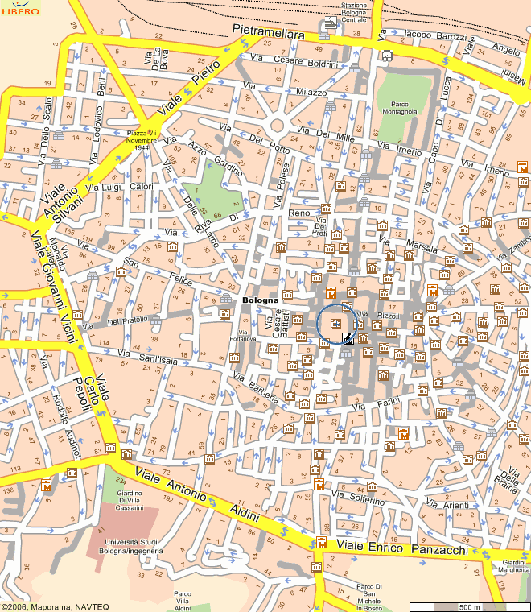
4
1
3
2
6
5
●
●
●
●
●
●
●
●
●
●
●
●
C
7
●
●
C
Main Place (“Piazza Maggiore”) in the town centre

1 , Faculty of Engineering, Conference venue
2 , Railway Station & Terminus of the shuttle from/to the airport
3 , Hotel Excelsior
4 , Hotel Europa
5 , Hotel Tre Vecchi, Hotel Regina
6 , Palazzo Re Enzo (Conference Dinner)
7 , Hotel San Mamolo
● ● bus stops: green, bus Nos. 32 & 33; purple, bus No. 20

