HOW TO GET TO THE CONFERENCE VENUE
FROM THE BUS STOPS NEARBY

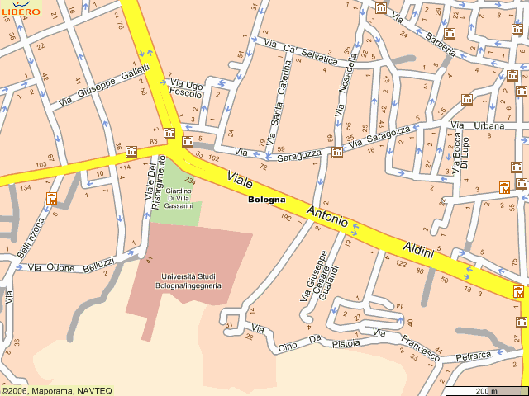
●32
●33
32●
●33
20●

20●
20●

1
G

The area is marked by the name of the ancient gate (Porta Saragozza)

G
the ancient gate
1
the Faculty of Engineering (uphill)
● bus stops, line 20
● bus stops, lines 32 and 33
on foot from/to the bus stops to/from the Faculty of Engineering

by car (note that very limited parking facility is available)

