CONFERENCE AREA INSIDE THE ‘NEW’ BUILDING

First Floor
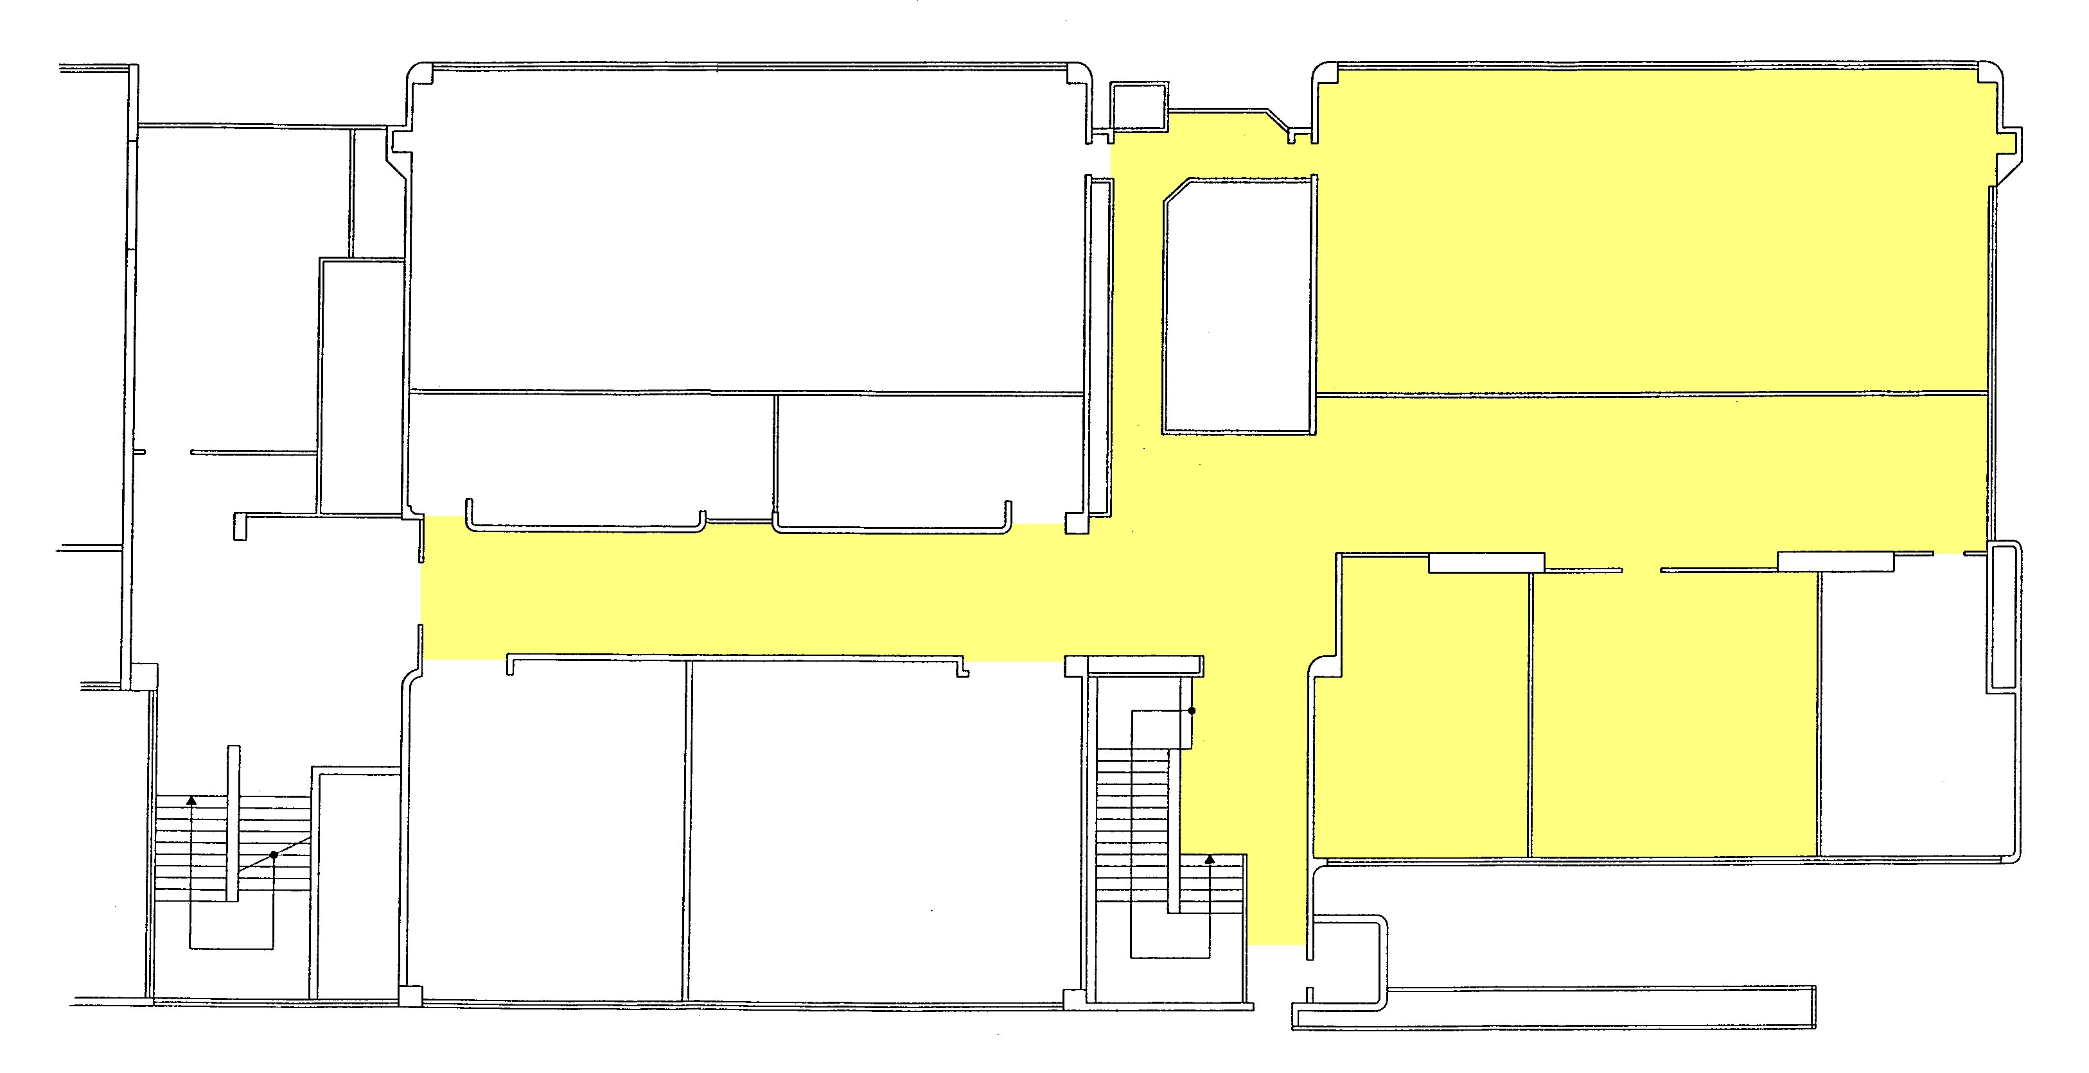
Conference Room 6-1
Secretariat
Internet
Point
Exhibition

Second Floor
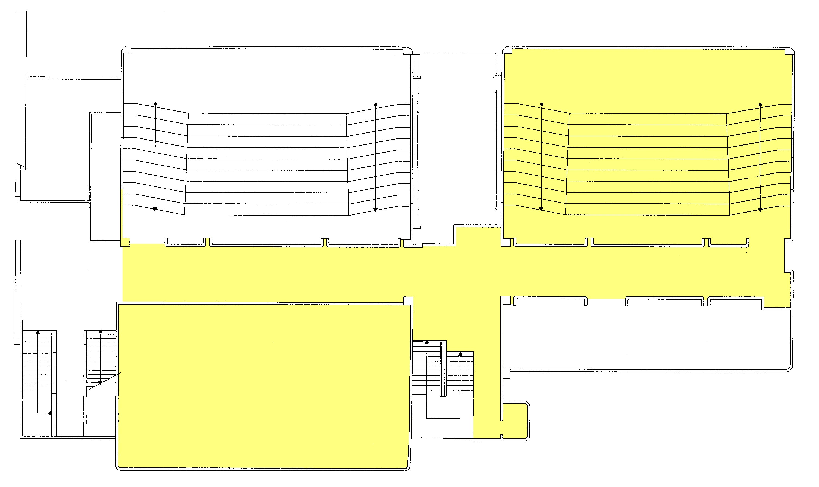
Conference Room 6-1
Coffee breaks and Poster area
Terrace – Coffee breaks
Coffee breaks and Poster area

Ground floor: Entrance & Toilets

normal ways in/out
alternative ways in/out

