Map 1: Bologna, overall map

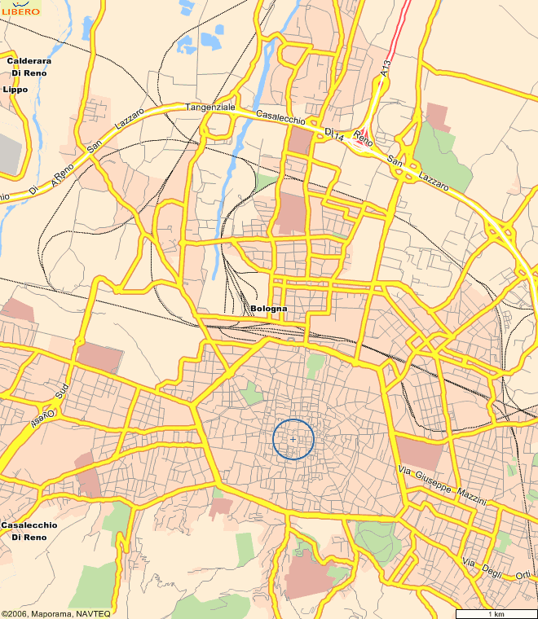
1
2
A

C

C Main Place (“Piazza Maggiore”) in the town centre

1 Faculty of Engineering, Conference venue

2 Railway Station & Terminus of shuttle from/to the airport

A Airport

