|  |  |
| --- | --- |
| cetlogo ***CHEMICAL ENGINEERING TRANSACTIONS***  ***VOL. xxx, 2025*** | A publication of  aidiclogo_grande |
| The Italian Association  of Chemical Engineering  Online at www.cetjournal.it |
| Guest Editors: Bruno Fabiano, Valerio Cozzani  Copyright © 2025, AIDIC Servizi S.r.l. **ISBN** 979-12-81206-xx-y; **ISSN** 2283-9216 | |

A Robust Resilience Methodology for Tacking Safety of Hydrogen Refueling Stations

Chao Chena,\*, Zihan Lua, Ruixuan Gea, Yanjun Chenb, Xinxin Tana, Li Moc

a School of Petroleum Engineering, Southwest Petroleum University, Chengdu, China

b Southwest Oil and Gas Field Safety Research Institute, Chengdu, China

c School of Mechanical Engineering, Southwest Petroleum University, Chengdu, China

*\**Corresponding author: Chao Chen; Email: [chenchaoswpu@gmail.com](mailto:chenchaoswpu@gmail.com)

The safety of hydrogen refuelling stations, as key infrastructure for hydrogen energy applications, is critical in the global energy transition. Hydrogen refuelling station assessment methods focus on reliability and ignore the restoration process after disruption. This study focuses on the resilience of hydrogen refuelling station and introduces a probabilistic approach to assess the resilience of hydrogen refuelling stations. Bayesian network (BN) is utilized as a tool to assess and analyze the resilience. A Dynamic Bayesian Network (DBN)-based methodology is developed to probabilistically assess the resilience of a hydrogen refueling station by incorporating the time course of adaptation and restoration into the analysis of system function. The time required to recover 90% of the lost resilience is determined. The proposed methodology introduces a novel way to define resilience based on a hydrogen refueling station system's functionality changing during and after a disruption.

* 1. Introduction

As a highly promising clean energy for the 21st century, Hydrogen plays a pivotal role in moving towards a more sustainable energy path. Hydrogen refueling stations, as the infrastructure for storing and supplying hydrogen, are being widely constructed and applied. However, the flammable and high diffusion rate of hydrogen poses a great security threat, and the operation of the hydrogen refueling station faces huge challenges. Currently, many scholars made many explorations on the safety of hydrogen refuelling stations. (Li et al.,2024) developed a new dynamic quantitative risk assessment methodology that combines fault trees and DBN model to get the probability of hydrogen leakage,fire,and explosion, and the domino effect of hydrogen refuelling stations was also be considered. (Liu et al.,2023) applied FLACS software to analyze the influence of speed of weed on different fields at hydrogen refueling station. (Borgheipour et al.,2021) applied the Bow-tie and Bayesian Network to quantify and dynamically analyze the risk of hydrogen leakage. (Kim et al.,2022) carried out a QRA of a mobile hydrogen refueling station and investigated the potential hazards associated with two hydrogenation points. A hazard identification analysis and damage condition assessment for liquid hydrogen in transfer operations to determine the cause of the liquid hydrogen leakage was conducted(Aneziris et al.,2024). (Baroud et al.,2014) conducted a quantitative assessment of the system's resilience, which considers the recovery status of performance losses over time. A DBN model was applied to dynamically assess the resilience of subsea pipelines system after exposure to corrosion (Yazdi et al.,2022). (Yodo et al.,2017) developed a DBN model to simulate the resilience of a complex power distribution system over time. A systematic framework based on systems engineering is proposed, focusing on the reliability of the learning process by combining Hidden Markov Models with the Baum-Welch algorithm(Vairo et al.,2023).

Despite the progress mentioned above, there are still significant gaps in research related to the resilience of hydrogen refuelling stations, especially in terms of emergency response and resilience after a spill. Based on the summary of the definition of resilience in engineering, the resilience of a hydrogen refuelling station is its ability to maintain normally operate or quickly restore to a normal state under multiple disruptions. Improving the resilience of hydrogen refuelling stations not only helps to improve their safety and reduce the impact of failures, but also ensures the protection of public safety and the environment in the event of emergencies. Research into the changing resilience of hydrogen energy infrastructures is an important academic focus. Therefore, a method to dynamically assess the resilience of hydrogen refueling stations by applying DBN is proposed.

* 1. Methodology

The methodology for assessing the resilience of hydrogen refuelling stations will be detailed in the methodology section. Resilience, as an important property of engineered systems, is essential to ensure that systems can continue to operate under various disturbances. The attribute of resilience not only reflects the ability of a system to respond effectively to disturbances throughout its life cycle, but is also a key indicator of how resilient the system is.

* + 1. Attributes of resilience

The resilience of an engineered system consists of four properties, namely (I) absorption, (ii) adaptation, (iii) restoration, and (iv) learning, which represent the ability of the system to absorb, adapt, restore, and learn after a disruption during its lifetime (Francis and Bekera,2014). Absorption, adaptation, restoration, learning capacity and disruption are key elements in measuring system resilience. The absorption ability is reflected in a system to automatically absorb disturbances and reduce sensitivity to external shocks. The ability of a system to restore some of its functions by adjusting its own operation without relying on external repair is adaptation. The ability of a system to return to its normal state after being disturbed through external repair measures or self-adjustment is restoration. Learning is another system capability that absorbs a set of past experiences and improves the system accordingly to cope with future disruptions.

With the in-depth understanding of resilience, quantitative methods of assessing resilience have received increasing attention. One popular approach is to apply a resilience curve, as shown in Figure 1. It can be seen that during the disruption, the system state changes from S1 to S2 and the function drops dramatically from F1 to F2. After the system function reaches its lowest point, the system begins to repair itself. The system changes state from S2 to S3 through adaptation, and the system functionality improves from F2 to F3 during adaptation. Adaptation is a temporary measure to cope with a disruption. Restoration means that external maintenance pushes the system out of the interrupted state and into a new, significantly more stable state, S4, which has F4 functionality. The ability to absorb, adapt, restore, and learn affects how the system functions over the entire time period from t1 to t4. The symbols in Figure 1 are described below:

S1: At the moment t1, when a disruption occurs, function F1 is in its normal operating state.

S2: Disturbed state of function F2 at time t2.

S3: When the adaptation action is completed at time t3, it has the state of function F3.

S4: New state of function F4 at time t4 when restoration is complete.

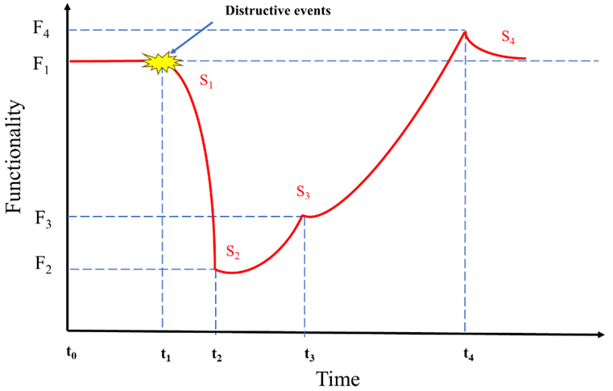

Figure 1. Functionality curve of a hydrogen refueling station over time(Hosseini et al.,2016).

* + 1. Dynamic Bayesian networks

Dynamic Bayesian Network is expanded form Bayesian Network that incorporate time dimension considerations. BN represents the probabilistic dependencies among variables through directed acyclic graphs. In contrast, dynamic Bayesian networks further introduce the time dimension. They are capable of handling the uncertainty information that varies over time and are used for modeling and reasoning about the states of a system and its evolutionary processes. Eq. (1) represents the joint probability distribution of DBN (Chang et al.,2019).

|  |  |
| --- | --- |
|  | (1) |

DBN is widely applied in risk assessment due to its ability to encompass a wide range of states and incorporate the temporal dimension by presenting probabilistic correlations between cause and effect in a dynamic manner using nodes and directed arcs (Khakzad,2015). It has the advantages of strong ability to handle uncertainty, natural expression of causality, flexibility, real-time updating and dynamic assessment, and wide range of applications. These advantages make DBN an important tool and method in the field of resilience assessment. DBN was applied to engineering system resilience modelling scenarios, where the resilience of a system over time is modelled by quantitatively analysing and summing the resilience attributes of reliability and restoration.

* + 1. Resilience assessment methods for hydrogen refueling stations

As shown in Figure 1, four states are applied to quantify the resilience of a hydrogen refueling station. The rate of transition between states is dependent on its ability to absorb, adapt, restore, and learn at each stage. A flowchart for the hydrogen refueling station resilience assessment method is proposed, as shown in Figure. 2.

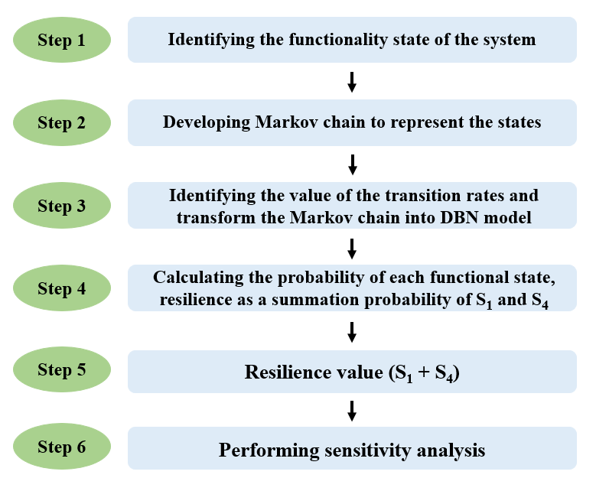

Figure 2. Flowchart of the proposed methodology.

Firstly, identify the functional states of the system and develop a Markov chain to present the states of system, where all states are decomposed into sub-states. For example, the functional state of absorption is decomposed into redundancy, preventive measures, and robustness in top-down order. This operation continuesto advance until a detailed resilience structure of the system is derived. Secondly, the Markov chain is converted into DBN by obtaining the transition probabilities λ0, μ0, λ1, μ1 of the four functional states. The conditional probabilities in the DBN model are converted from the probabilities of the transition states in the Markov chain model. Finally, the probabilities corresponding to each functional state are computed, after which these probabilities are aggregated.

The transition rate is determined by the attributes of resilience. When the system has a high absorption rate, the functionality degradation rate during t1 and t2 is low, indicating a lower λ0. This indicates that the probability of transition from state S1 to S2 is low. Strong adaptation and restoration enhance the values of μ0 and μ1. High learning capabilities can help to decrease λ0 and increase the values of μ0 and μ1. Conditional probabilities are calculated based on historical data such as the mean time to repair (MTTR). At present, there still seems to be a lack of evaluation studies on the resilience of hydrogen refuelling stations, but it has been applied extensively in other sectors, including the chemical processing industry, electrical engineering and undersea pipelines. Some of the data references are from similar chemical plants and other relevant sectors.A DBN model was developed to quantify the resilience of hydrogen refueling stations，as shown in Figure 3. The DBN topology consists of six nodes: a sub-node representing the functional state of the system and five nodes (absorbtion, adaption, restoration, learning, and disruption). It is assumed that the node “disruption” has both yes and no two states. Assume that the disruption occurs at time step 0 after the system starts working, and that the disruption status at time step 0 is set to “yes”. It is assumed that the functional change between t1 and t4 follows an exponential failure mode, and the resilience loss from functional degradation is negligible compared to the disruption. The resilience before the disruption is assumed to be 1. The resilience of a hydrogen refueling station is measured based on the probability that the system maintains a normal state or recovering from an abnormal state to a normal state at each time step during and after the disruption.

Absorption, adaptation and restoration are the main factors influencing the resilience of hydrogen refuelling stations, it is also influenced by other factors, including learning, external factors and the system itself. The core elements affecting the absorptive capacity of a system include redundancy, robustness, and preventive actions, (Yodo and Wang,2016). Maintenance and mitigative measure are factors affecting restoration (Vugrin et al.,2011). Each of these influencing factors is presented as high or low. After the modelling exercise, the resilience of the hydrogen refuelling station is quantitatively expressed as the sum of the probabilities of transferring from the initial state S1 to a more stable state S4 at each time step.

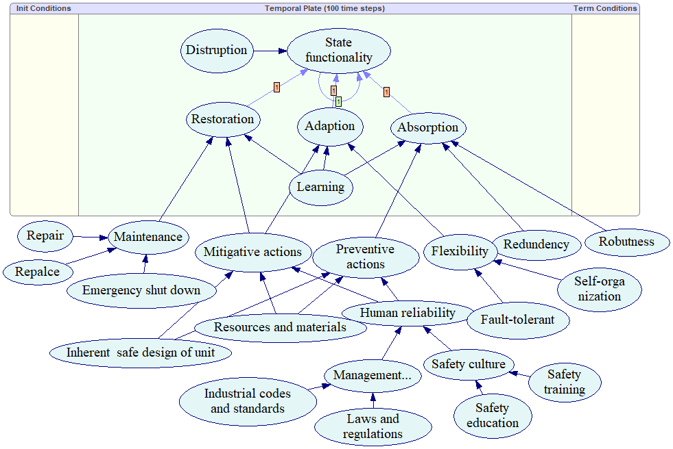

Figure 3. Hydrogen refuelling station resilience assessment DBN model.

* 1. Results and discussion

Figure 4 shows the results of the resilience assessment of the hydrogen refuelling station. It can be seen from Figure 4 shows a gradual decrease in resilience, with resilience reaching a minimum value of 0.37 at time slice 𝑡 = 11. In order for the time element of resilience to be represented, the time demanded for 90% of the lost resilience of the system to be recovered after the disruption can be calculated. Within 35 time slices (i.e., 46 - 11 = 35), the performance loss recovers to 90% from the lowest point, which is equal to 0.937 (i.e., 0.90× (1 - 0.37) + 0.37). The time-related functional states are shown in Figure 5. The probability of state S1 drops to approximately 0.1 at time slice 15. The probabilities of S2 and S3 peaksed at 0.45 and 0.21 at time slices 8 and 14, respectively.

A sensitivity analysis is performed to identify the key factors affecting the resilience of the hydrogen refuelling station. In Figure. 6, the resilience of the final stabilization under different settings of the influencing factors is represented by two different coloured lines. The red line has a value of 0.982 which represents the resilience when all influencing factors are in a high state. The black line represents the resilience of the hydrogen refuelling station when only one node fails (in a low state) while the other nodes remain in a high state. The resilience is lowest when the “replace “node fails, followed by the “repair” node, the “inherent safe design” node, and the “emergency shut down” node. The remaining nodes have a relatively minor impact on the resilience of the hydrogen refueling station. Figure 6 can be used to support decision-making in the allocation of hydrogen refueling station resources. In order to design a resilient system, more resources should be invested to enhance the capacity of equipment replacement、repair、inherent safety design, and emergency shutdown.

Project Path: C:\Users\lzhyk\OneDrive\文档\OriginLab\User Files\UNTITLED.opju
PE Folder: /UNTITLED/Folder1/
Short Name: Graph1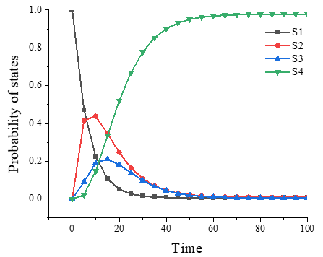

Figure 4. Dynamic resilience of the system. Figure 5. The time-dependent of state’s probability.

Project Path: C:\Users\lzhyk\Desktop\新建文件夹\2.opju
PE Folder: /2/Folder3/
Short Name: Graph4

Figure 6. Sensitivity analysis of the contributing factors.

* 1. Conclusions

This work presents an approach to assessing resilience as a function of time. A methodology to dynamically assess the resilience of a hydrogen refueling station using DBN is proposed and a model for resilience assessment based on DBN of a hydrogen refueling station is developed, which is constructed based on the definition of resilience and fully incorporates the evolutionary properties of resilience in the time dimension and its probabilistic attributes. The sensitivity analysis of the influencing factors was completed by setting up different states of the node, and it was concluded that the factor with the greatest influence on the resilience of the hydrogen refueling station was “repair”. After reaching its lowest point at time slice t=11, the resilience of the hydrogen refueling station recovers 90% of its performance loss within 35 time slices. Future research will focus on improving the DBN model by incorporating more complex and diverse influencing factors, making the assessment results of hydrogen refueling station resilience more accurate and reliable.

Acknowledgments

This study was supported by the Sichuan Province Science and Technology Support Program (Grant No. 25GJHZ0214 and 2023YFS0412) and the National Natural Science Foundation of China (Grant No. 52402433 and 52372344).

References

Aneziris O., Koromila I., Nivolianitou Z., Venetsanos A.,2024, Hazard Identification of Liquid Hydrogen in Transfer Operations. Chemical Engineering Transactions,111, 457-462.

Baroud H., Ramirez‐Marquez J.E., Barker K., Rocco C.M.,2014, Stochastic Measures of Network Resilience: Applications to Waterway Commodity Flows. Risk Analysis. 34, 1317-1335.

Borgheipour H., Tehrani G.M., Eskandari T., Mohammadieh O.C., Mohammadfam I.,2021, Dynamic risk analysis of hydrogen gas leakage using Bow-tie technique and Bayesian network. International Journal of Environmental Science and Technology. 18, 3613-3624.

Chang Y., Wu X., Zhang C., Chen G., Liu X., Li J., Cai B., Xu L.,2019, Dynamic Bayesian networks based approach for risk analysis of subsea wellhead fatigue failure during service life. Reliability Engineering & System Safety. 188,454-462.

Francis R., Bekera B.2014, A metric and frameworks for resilience analysis of engineered and infrastructure systems. RELIABILITY ENGINEERING & SYSTEM SAFETY. 121,90-103.

Hosseini S., Barker K., Ramirez-Marquez J.E.2016, A review of definitions and measures of system resilience. RELIABILITY ENGINEERING & SYSTEM SAFETY. 145,47-61.

Khakzad N.2015, Application of dynamic Bayesian network to risk analysis of domino effects in chemical infrastructures. Reliability Engineering & System Safety. 138,263-272.

Kim D.-H., Lim J.-Y., Park W.-I., Joe C.-H.2022, Quantitative risk assessment of a mobile hydrogen refueling station in Korea. International Journal of Hydrogen Energy. 47,33541-33549.

Li Y., Lin Y., Qi J.2024, Dynamic risk assessment method for urban hydrogen refueling stations: A novel dynamic Bayesian network incorporating multiple equipment states and accident cascade effects. International Journal of Hydrogen Energy. 54,1367-1385.

Liu K., He C., Yu Y., Guo C., Lin S., Jiang J.2023, A study of hydrogen leak and explosion in different regions of a hydrogen refueling station. International Journal of Hydrogen Energy. 48,14112-14126.

Vairo T., Pettinato M., Reverberi A.P., Milazzo M.F., Fabiano B.2023, An approach towards the implementation of a reliable resilience model based on machine learning. Process Safety and Environmental Protection. 172,632-641.

Vugrin E.D., Warren D.E., Ehlen M.A.2011, A resilience assessment framework for infrastructure and economic systems: Quantitative and qualitative resilience analysis of petrochemical supply chains to a hurricane. Process safety progress. 30.

Yazdi M., Khan F., Abbassi R., Quddus N.2022, Resilience assessment of a subsea pipeline using dynamic Bayesian network. Journal of Pipeline Science and Engineering. 2.

Yodo N., Wang P.2016, Engineering resilience quantification and system design implications: A literature survey(Review). School of Mechanical and Aerospace Engineering, Seoul National University, Seoul 151-742, South Korea; Department of Mechanical Engineering, University of Maryland at College Park, College Park, MD 138,111408.

Yodo N., Wang P., Zhou Z.2017, Predictive Resilience Analysis of Complex Systems Using Dynamic Bayesian Networks. IEEE Transactions on Reliability. 66, 761-770.