|  |  |
| --- | --- |
| cetlogo ***CHEMICAL ENGINEERING TRANSACTIONS***  ***VOL. xxx, 2025*** | A publication of  aidiclogo_grande |
| The Italian Association  of Chemical Engineering  Online at www.cetjournal.it |
| Guest Editors: Bruno Fabiano, Valerio Cozzani  Copyright © 2025, AIDIC Servizi S.r.l. **ISBN** 979-12-81206-xx-y; **ISSN** 2283-9216 | |

A comprehensive numerical study of the behaviour of an LH2 storage tank in the event of a fire

Aliasghar Hajhariria\*, Robert Eberweina, Davide Campleseb, Giordano E. Scarponib, Frank Otrembaa , Valerio Cozzanib, Holger Seidlitzc

a BAM – Department for Dangerous Goods and Accident Mechanics, Unter den Eichen 44-46, 12203 Berlin (Germany)

b LISES - Department of Civil, Chemical, Environmental and Material Engineering, Alma Mater Studiorum – University of Bologna, via Terracini 28, 40131, Bologna (Italy)

c BTU - Department of Mechanical Engineering, Electrical and Energy Systems, Chair of Polymer-based Lightweight Design,– Brandenburg University of Technology, Platz der Deutschen Einheit 1, Konrad-Wachsmann-Allee 13, 03046 Cottbus (Germany)

\*aliasghar.hajhariri@bam.de

As the world moves towards green energy production, effective storage and transportation solutions become essential. To support this transition, energy carriers with minimal or zero environmental impact are required. Liquified hydrogen represents a promising candidate due to its emissions-neutral properties. However, its highly flammable nature necessitates adherence to strict safety codes and standards. Storing hydrogen often requires advanced super-insulation materials. To enhance the safety of cryogenic hydrogen storage tanks under extreme conditions, such as those encountered during fire accidents, it is crucial to understand the thermal behaviour of the tank. Predicting pressurization and potential failure in advance demands a robust and comprehensive model. However, still such models suffer lack of detailed heat transfer models which account for various sub-processes during an accident scenario. Hence, this study introduces a comprehensive model for the pressurization of cryogenic tanks equipped with multi-layer insulation (MLI) systemsin the event of fire, which comprises several sub-models. These sub-models account for heat transfer phenomena through the thermal insulation at nominal conditions and its thermal degradation during fire exposure, the fluid, the internal pressurization, and the performance of the pressure relief valve. This study provides valuable insights into the safety and the behaviour of hydrogen storage tanks under thermal loads.

* 1. Introduction

With the advancement of renewable energy technology and the increase in energy production, the need for a suitable energy carrier is felt more than ever before. Hence, various low- and zero-impact energy carriers regarding climate change, such as hydrogen, have been introduced. Specifically, the adoption of LH2 (liquified hydrogen) as a promising alternative energy carrier is attributed to its carbon-free combustion properties and its high volumetric energy density discussed in DNV (2021) and Jafarzadeh (2016). However, the extremely low boiling point of LH2 (20.3 K at atmospheric pressure (NIST, 2019) and the high flammability of hydrogen-air mixtures (Crowl & Jo, 2007) pose significant safety challenges in its storage and transportation. To enhance the safety of such a storage system, a thermal superinsulation technology, such as multilayer insulation (MLI) combined with vacuum is required. MLI is currently favored for LH2 transport (Pehr, 1996), which could be combined with vapor-cooled shields. Different studies such as Camplese et al. (2024) and Ustolin et al. (2022) introduces this type of insulation (mostly used in mobile applications) which has been optimized for minimal volume and low density e.g., for applications with stringent space and weight limitations.

Despite MLI effectiveness in limiting heat transfer, study of Eberwein et al. (2024) shows that this insulation is susceptible to thermal degradation under high thermal loads. Work of Pehr (1996) and van Wingerden (2022) also demonstrated insufficient insulation capability in real-scale LH2 fire tests. Moreover, study of Camplese et al. (2024) reveal that thermal insulation degradation may leads to an increase in the thermal stresses of the cryogenic tank, which contributes to rapid tank pressurization. This effect compromises the structural integrity of the tank and may potentially result in catastrophic events such as Boiling Liquid Expanding Vapor Explosions (BLEVEs) and fireballs (Ustolin et al., 2021). However, there are still a few studies in which a whole tank including all sections and parameters are studied whereas such extreme boundary conditions are adressed. Hence, these outcomes underscore the need for a robust model to evaluate the safety of LH2 tanks under fire exposure scenarios.

This study proposes an advanced thermodynamic numerical multi-zone model for predicting the LH2 tank response, incorporating an MLI degradation sub-model due to fire exposure (Hajhariri et al., 2024). The model simulates the thermal response and pressurization of the tank, accounting for pressure relief valve (PRV) activation and insulation deterioration at elevated boundary temperatures.  
This work further develops the lumped model proposed by Scarponi et al. (2016) and incorporates the correlations introduced by Wang et al. (2016) to calculate the heat transfer coefficient. For the sake of comparison, the model considers the tank properties and experimental conditions outlined in the study by Pehr (1996). The thermodynamic properties of the fluid are calculated based on the partial derivative of Helmholtz energy using the CoolProp package (Bell et al., 2014).

* 1. Methodology

Various modeling approaches exist for analyzing tank pressurization. Each has distinct objectives and underlying principles. These approaches can be categorized into equilibrium and non-equilibrium models. In the equilibrium approach, it is assumed that the liquid and gas phases are in thermodynamic equilibrium. As a result, the fluid is represented by a single node, which is characterized by its thermodynamic state. However, factors such as high heat influx into the tank and the potential degradation of insulation may lead to a rapid rise in evaporation rates, causing the internal pressure to escalate significantly and the equilibrium state cannot represent the actual thermodynamic behavior of the tank.

Conversely, the non-equilibrium approach accounts for the dynamic thermal behavior of the tank. In such models, the pressure increase is driven by the rise in the vapor phase temperature within the ullage, while the bulk liquid phase temperature may remain relatively lower. This distinction makes non-equilibrium models more appropriate for predicting the thermal response and pressurization of cryogenic tanks under scenarios involving fire or high thermal loads.

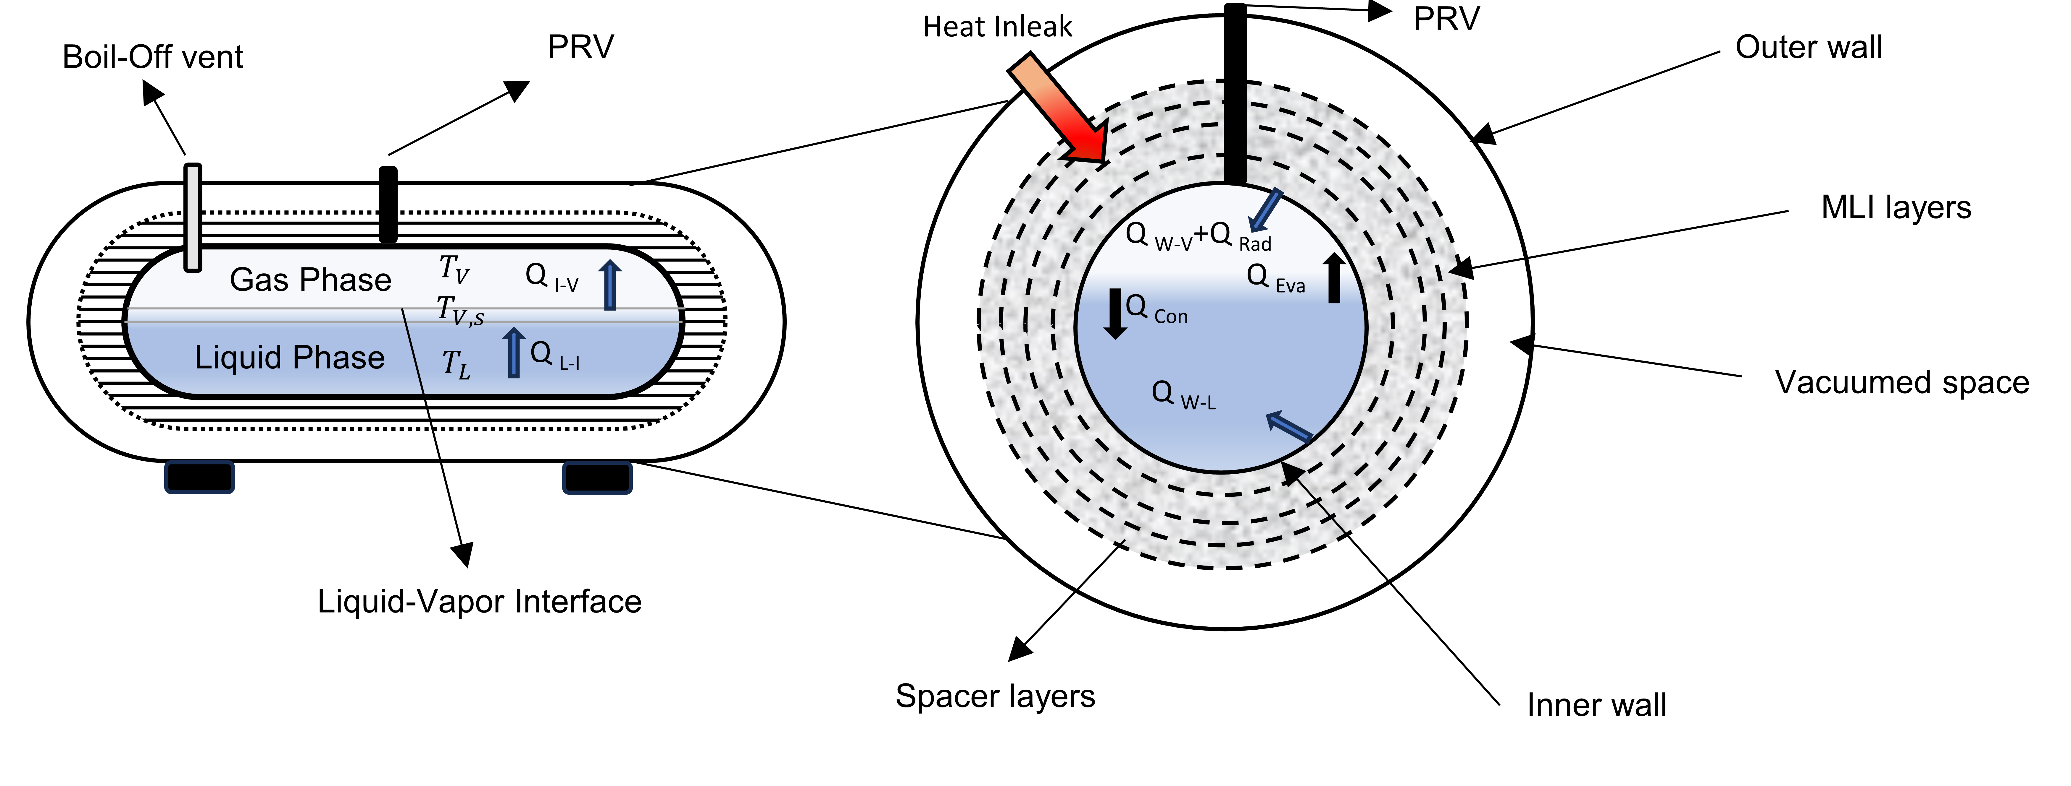

Figure 1 Schematic of double-walled tank and heat transfers used for the model.

In this study, a numerical multi-zone modeling approach is proposed to investigate the behavior of a liquid hydrogen (LH₂) tank under fire-like thermal loads. The multi-zone model comprises several sub-models, each dedicated to specific aspects of the system, including the thermal degradation of the MLI, liquid fill level dynamics, internal tank pressurization, and the onset of pressure relief valve (PRV) activations.

Figure 1 illustrates the tank's division into three sections, where the vapor phase is separated from the liquid phase by a massless interface. This interface represents vapor in a saturated state, while the liquid and vapor phases remain in sub-cooled and superheated conditions, respectively.

Studies by Camplese et al. (2024) and Hajhariri et al. (2024b) reveal the vulnerability of various types of MLI insulation to high thermal loads. Thermal degradation of this type of insulation leads to a release of degradation products and an increase of pressure in the vacuum space (Eberwein et al., 2024) which increases the heat flow within the insulation.

To predict pressurization, the thermal and material balances of the cryogenic fluid are summarized in Table 1. In the model, the heat transfer by the surfaces that stay in contact with the vapor and the liquid is considered separately, as shown in Figure. 1. The model assumes a horizontal tank similar to the one tested by Pehr (1996) during the BMW fire test. For this study, a non-combustible MLI based on Aluminum as reflective foil and glass paper as spacer like the one used in the study by Hajhariri et al. (2024b) was considered. The heat transfer from the fire to the tank calculated according to the procedure proposed in the same work.

Table 1. Heat transfer and mass balances for the fluid part.

|  |  |  |
| --- | --- | --- |
| **Energy conservation** | | |
| Liquid phase | $$\frac{d(ρ_{L}h_{L}V_{L})}{dt}=Q_{W-L}+Q_{I-L}+Q_{Con }- Q_{Eva}+Q_{Rad}$$ | (1) |
| Vapour phase | $$\frac{d(ρ_{V}h_{V}V_{V})}{dt}={\dot{Q}}_{W-V }- Q_{V-I }- Q_{Con}+Q_{Eva}-\frac{d(m_{V})}{dt}h_{V}$$ | (2) |
| **Mass conservation** | | |
| Liquid phase | $$\frac{d(m_{L})}{dt}={\dot{m}}_{Con}-{\dot{m}}_{Eva}$$ | (3) |
| Vapor phase | $$\frac{d(m_{V})}{dt}={\dot{m}}_{Eva}-{\dot{m}}_{Con}-{\dot{m}}_{PRV}-{\dot{m}}_{Boil-Off}$$ | (4) |
| Pressure variation | $$\frac{dP}{dt}=\frac{ρ_{V}}{m_{V}}\left(\frac{P}{ρ_{L}}\frac{d(m_{L})}{dt}+\frac{RT_{V}}{M}\frac{d(m_{V})}{dt}+\frac{Rm_{V}}{M}\frac{d(T_{V})}{dt}\right)$$ | (5) |
| Liquid level (LF) | $$\frac{dLF}{dt}=\frac{m_{L}}{ρ_{L} A_{WL0}}$$ | (6) |
| Interface Temp. | $$T_{int}=T_{V,S}(P)$$ | (7) |
| Evaporation | $$m_{Eva}=A_{LV}α_{Eva}\frac{M^{0.5}P_{L,S}}{{(2πT_{int})}^{0.5}}$$ | (8) |
| Condensation | $$m_{Con}=A_{LV}α_{Con}\frac{M^{0.5}P_{V,S}}{{(2πT_{V})}^{0.5}}$$ | (9) |
| $h, P, ρ,$ $V, T$ represent the enthalpy, system pressure, density,volume of the fluid section and temperature. $\dot{Q}$, $\dot{m}$ are the heat and mass flow rate, $R$ represents the universal gas constant. $M$ shows the molecular weight where $m$ represents the mass of the fluid segment and *α* is evaporation and condensation constants. Subscript $Con$, $Eva, Rad, I, L,V, S ,W, LV, int$ are condensation, evaporation, radiation toward the liquid interface, interface, liquid, vapor, saturation, wall, liquid-vapor interface, and interface, respectively. $A_{WL0}$ is the cross sectional area which is wetted by liquid phase. | | | |

The heat transfer properties of the LH2 such as the convection heat transfer coefficient, and boiling heat transfer equation are adopted from the work of Wang et al. (2016). To predict the temperature distribution in the insulation and in the fluid nodes, two sub-models are coupled together with a thermal balance at the inner wall of the cryogenic storage tank. For the sake of simplicity, the liquid-vapor interface is considered at saturation temperature. The evaporation and condensation couple the mass and energy transfer between the liquid and vapor phases. The evaporation-condensation model is achieved by employing Herz Knudsen model (Knudsen, M., 1967).

The internal temperatures of the liquid and vapor phases are closely linked to the tank’s internal pressure. When the PRV reaches its activation threshold, it releases a portion of the vapor to regulate the system’s pressure. However, if the PRV cannot adequately compensate for the increasing pressurization rate, the pressure may continue to rise, eventually exceeding the tank’s critical endurance limit. This could lead to catastrophic failures, such as a BLEVE.To consider this effect, the model includes the effect of the PRV, using the discharge model described by Scarponi et al. (2016).

Given limitations in the published data (Pehr, 1996), this study adopts a series of assumptions to estimate the likely condition of the tank’s insulation system. The assumptions used in this study are listed in Table 2.

Table 2. Assumptions in this study

|  |  |  |  |
| --- | --- | --- | --- |
| **Name of variable** | **Quantity** | **Name of variable** | **Quantity** |
| $$α_{Eva}, α_{Con}$$ | 0.001 | Outer wall (outer side) emissivity | 0.9 (Worst case consideration) |
| $$Insulation space$$ | 30 mm | Outer wall (inner side), emissivity | 0.27 (Eberwein et al., 2024) |
| # layers | 35 , 40 (Fesmire et al., 2008) | Inner wall emissivity | 0.1 |
| Pressure | $\left\{\begin{aligned}P=100 mbar @ t≤240 s \\ P=1 bar @ t >240 s\end{aligned}\right.$ Pehr, 1996 | Average liquid hydrogen emissivity | 0.1 (relevant inner wall emissivity) |
| $$k_{abs}$$ | 0.08 (Hajhariri et al., 2024a) accounts for MLI deterioration function | Opening and closing threshold of PRV | 4.6 bar 4.1 bar |

* 1. Results and discussion

Figure 2a and 2b show the course of pressure and liquid fill level over time estimated by the experimental and numerical approach, respectively. It worth to note, for the sake of representation, Figure 2a and later Figure 3b represents data per each 10 s, this is why the opening and closing of the PRV shows the peaks. The model underpredicts the experimental pressure between 150 s and 250 s.

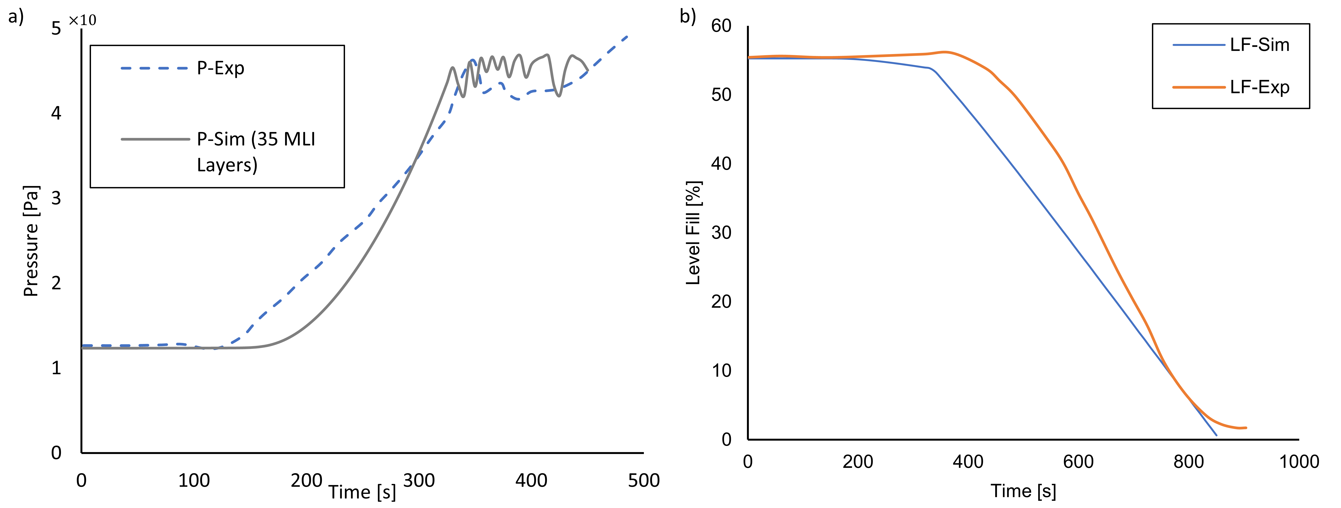

Figure 2 a) course of pressure over time estimated by the experimental and numerical approach. Numerical calculation regards 35 MLI layers. b) Liquid fill level over time. LF-Sim refers to the numerical calculation and LF-Exp refers to the experimental results.  
  
There are two sources of uncertainty that may have contributed to the underprediction:

1. the degradation of the vacuum could not be found from the experimental source,
2. the effect of emissivity variation on the walls of storage system is not considered.

As the energy transition is partially occure through liquid-vapor interface, it is necessary to represent the dynamic energy exchange. Since the vapor phase become super heated phase, the rate of evaporation at the interface is expected to increase. Therefore, these underpredictions may also be related to the choice of evaporation-condensation model. Moreover, the effect of environmental conditions on the fire and its heat transfer (boundary condition) could not be fully represented by the numerical approach.

Figure 3a shows that 15 layers out of 35 MLI layers deteriorated during the fire exposure. The last layer deteriorates shortly after the rapid raise of the pressure curve. This led to a reduction of around 43% of the insulation performance and an increase of the the heat inleak up to 3 times, causing a relevant pressure build up.

The effect of the number of layers is visible in Figure 3b. It can be seen that increasing the number of layers may result in a insulation performance, with delaying tank pressurization.

The model allows also to predict the temperature in the insulation and in the tank walls. The volume-weighte average temperature in vapor wetted solid and in the vapor phase in experimental and simulation are represented inFigure 4. The comparison of the results shows that the temperature of the vapor phase is underpredicted. However, as the temperature of the vapor phase and its respective wall are close to each other, it may shows that the thermocouples which was reading this two temperatures were very close to each other. Therefore it reports a temperature close to wall vicinity. Thus, it is expected that the volumed averaged temperature slightly underpredicts the temperature.

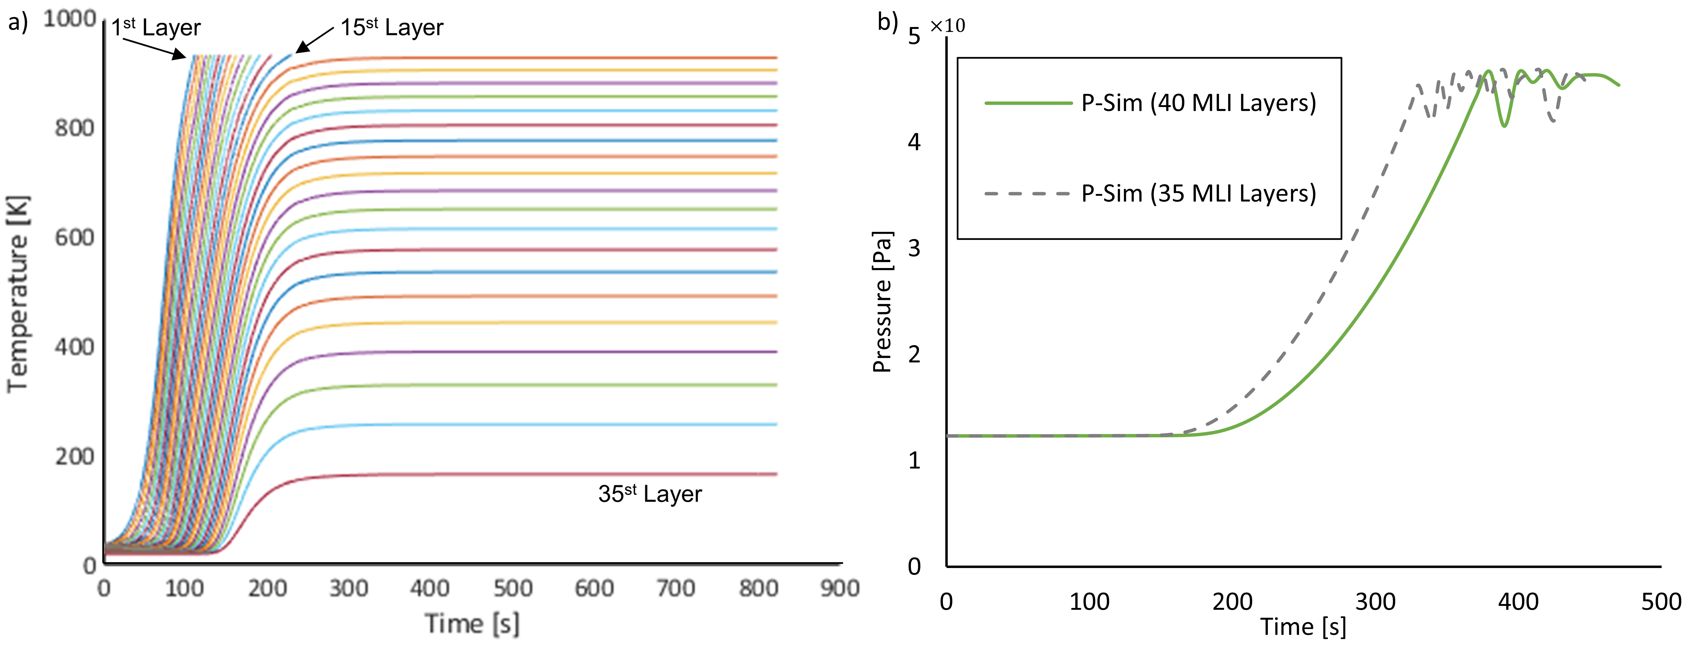

Figure 3 a) The onset of and final time for deterioration of 15 layers of insulation. The first layer deteriorates around 120 s and the 15th layer deteriorate around 250 s. b) Comparison the effect of MLI layers on the prediction of pressurization curve.

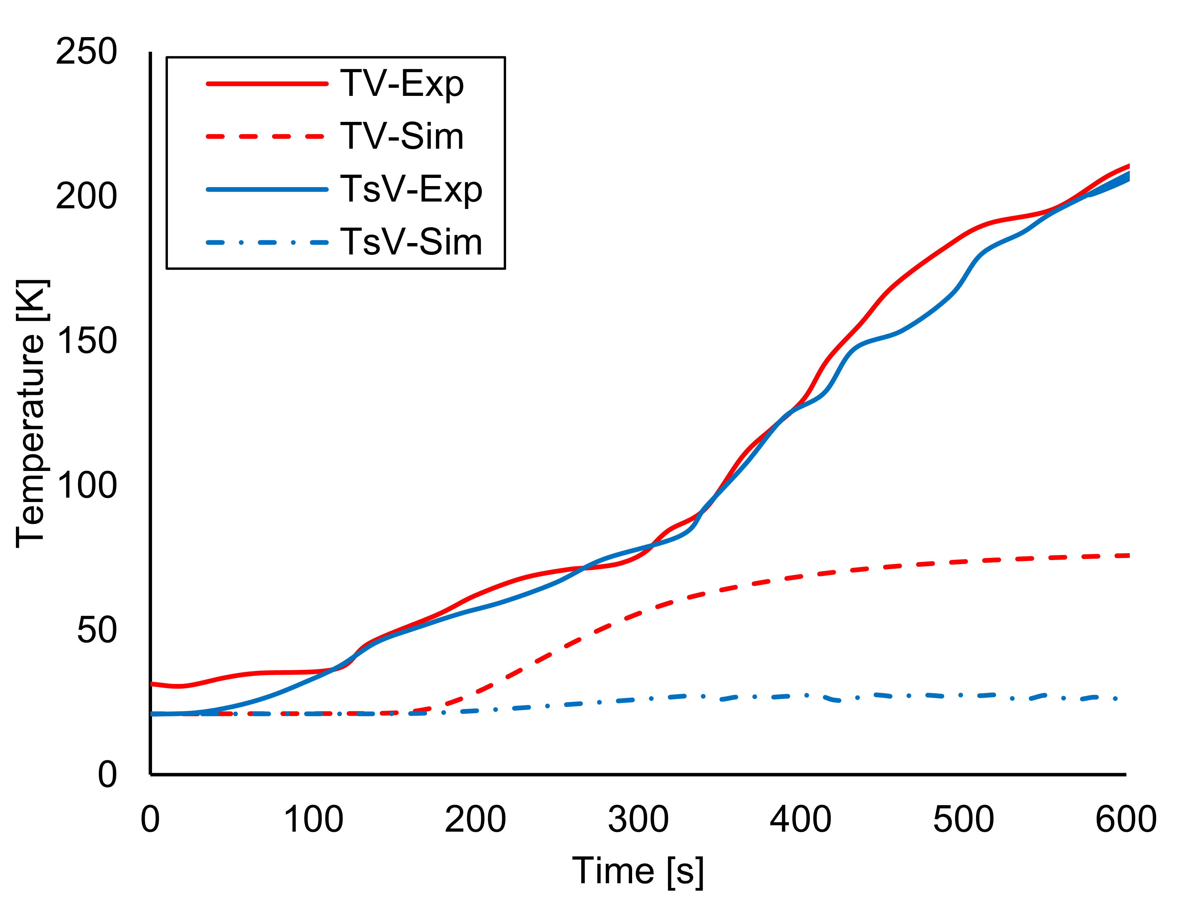

Figure 4 Comparison of the predicted temperature of the vapor section and its wetted respective wall vs the experimental temperature of vapor wetted section and vapor phase.

* 1. Conclusions

The multi-zone model presented in this study is capable of predicting the pressurization of cryogenic tanks (e.g., LOX, LH₂, LN₂, LNG, LPG) under fire exposure. Additionally, the model can estimate the temperature distribution along the inner tank wall and across the insulation layer. It is also capable of reproducing the volume-averaged temperatures of the vapor and liquid phases. Moreover, the model predicts the vulnerability of the insulation system during transient processes, identifying the time points at which thermal degradation of the insulation is likely to occur. The model has been validated against the study by Pehr (1996) and demonstrates agreement of the assumption with the findings of Fesmire et al. (2008), which reported the ideal performance of MLI systems consisting of aluminum foils and glass fiber spacers.The findings from this study provide valuable insights for emergency response planning and optimizing LH₂ tank designs to mitigate fire-induced hazards. Additionally, this model serves as a virtual framework for analyzing and improving the safety of LH₂ storage systems under extreme thermal conditions.

Acknowledgments

This work was undertaken as part of the research project FETLHy, where the authors wish to acknowledge the financial support of the research from the German Federal Ministry for Economic Affairs and Climate.

# References

Bell, I. H., Wronski, J., Quoilin, S., & Lemort, V., 2014, Pure and Pseudo-pure Fluid Thermophysical Property Evaluation and the Open-Source Thermophysical Property Library CoolProp. Industrial & Engineering Chemistry Research, 53(6), 2498-2508. doi:10.1021/ie4033999

Camplese, D., Scarponi, G. E., Chianese, C., Hajhariri, A., E. R., Otremba, F., & Cozzani, V., 2024, Modeling the performance of Multilayer Insulation in Cryogenic Tanks undergoing external Fire Scenarios. Process Saf. Environ. Prot, doi:https://doi.org/10.1016/j.psep.2024.04.061

Crowl, D. A., & Jo, Y. D., 2007, The hazards and risks of hydrogen. Journal of Loss Prevention in the Process Industries, 20(2), 158-164.

DnV, G. L., 2021, SAFER, SMARTER and Greener, LNG as marine fuel.

Eberwein, R., Hajhariri, A., Camplese, D., Scarponi, G. E., Cozzani, V., & Otremba, F., 2024, Experimental Investigation on the Behavior of Thermal Super Insulation Materials for Cryogenic Storage Tanks in Fire Incidents. Process Saf. Environ. Prot., 187, 240-248. doi:10.1016/j.psep.2024.04.131

Fesmire, J., Augustynowicz, S., & Scholtens, B., 2008, ROBUST MULTILAYER INSULATION FOR CRYOGENIC SYSTEMS. AIP Conf. Proc., 985, pp. 1359–1366. doi:https://doi.org/10.1063/1.2908494

HAJHARIRI, A., EBERWEIN, R., CAMPLESE, D., SCARPONI, G. E., COZZANI, V., OTREMBA, F., & SEIDLITZ, H., 2024b, Non-Combustible MLI Based Insulation Behavior Under Fire Condition-Experimental and Numerical Investigation. Process Safety and Environmental Prot.

Hajhariri, A., Eberwein, R., Perrone, L. P., Cozzani, V., Otremba, F., & Seidlitz, H., 2024a, Study the impact of spacer at thermal degradation process of MLI-based insulation in fire condition. J. Loss Preven. Proce. Ind., 92(10).

Jafarzadeh, S., 2016, Energy efficiency and emission abatement in the fishing fleet.

NIST, 2019, National Institute for Standards and Technology, Standard Reference Database Number 69, doi:https://doi.org/10.18434/T4D303

Pehr, K., 1996, Experimental examinations on the worst-case behaviour of LH2/LNG tanks for passenger cars. Proc. 11th World Hydrogen Energy Conference, 2169-2186, Stuttgart, Germany.

Scarponi, G. E., Landucci, G., Ovidi, F., & Cozzani, V., 2016, Lumped model for the assessment of the thermal and mechanical response of LNG tanks exposed to fire, Chemical Engineering Transactions, 307-312.

Ustolin, F., Iannaccone, T., Cozzani, V., Jafarzadeh, S., & Paltrinieri, N., 2021, Time to Failure Estimation of Cryogenic Liquefied Tanks Exposed to a Fire, Proceedings of the 31st European Safety and Reliability Conference, 19-23, Angers, France.

Ustolin, F., Scarponi, G., Iannaccone, T., V., C., & Paltrinieri, N., 2022, Cryogenic Hydrogen Storage Tanks Exposed to Fires: a CFD study, Chem. Eng. Trans., 535-540, doi:https://doi.org/10.3303/CET2290090

van Wingerden, K., Kluge, M., Habib. A., K., Ustolin, F., & Paltrinieri, N., 2022, Medium-scale tests to investigate the possibility and effects of BLEVEs of storage vessels containing liquified hydrogen, 17th EFCE, 90, 547-552, doi:10.3303/CET2290092

Wang, L., Li, Y., Zhang, F., Xie, F., & Ma, Y., 2016, Correlations for calculating heat transfer of hydrogen pool boiling. Int. J. Hydrogen Energ., 41(38), 17118-17131, doi:https://doi.org/10.1016/j.ijhydene.2016.06.254