|  |  |
| --- | --- |
| cetlogo ***CHEMICAL ENGINEERING TRANSACTIONS***  ***VOL. xxx , 2025*** | A publication of  aidiclogo_grande |
| The Italian Association  of Chemical Engineering  Online at www.cetjournal.it |
| Guest Editors: Bruno Fabiano, Valerio Cozzani  Copyright © 2025, AIDIC Servizi S.r.l. **ISBN** 979-12-81206-xx-y; **ISSN** 2283-9216 | |

Investigation of realistic fire scenarios involving cryogenic storage tanks

Robert Eberwena, Jennifer Heßmanna, Jan Wernera, Giordano Emrys Scarponib, Valerio Cozzanib, Frank Otrembaa

a Bundesanstalt für Materialforschung und -prüfung (BAM), Unter den Eichen 87, 12205 Berlin, Germany

b Alma Mater Studiorum - Università di Bologna, Dipartimento di Ingegneria Civile, Chimica, Ambientale e dei Materiali, via Terracini 28, 40131 Bologna, Italy

[robert.eberwein@bam.de](mailto:robert.eberwein@bam.de)

The number of vehicles using or transporting cryogenic fuels such as Liquefied Hydrogen (LH2) or Liquefied Natural Gas (LNG) increases fast in the land transportation sector. Does this also entail new risks for instance from a BLEVE? A key to answer this question is to research representative fires by its characterization and its effect on the insulation. At BAM’s technical test side in Germany, a test series was started to answer this question among others. This paper presents results on a pool fire under a colorimeter, that simulates a tank. The investigation points out, that the full fire characterization approach allows to represent the fire. The findings are relevant for the investigation of a representative design fire that is applicable for the approval and improvement of tanks as well as to research accident scenarios and their consequences.

* 1. Introduction

In the course of decarbonizing the energy industry, cryogenic energy carriers are seen as having great potential. This is because they allow significantly higher volumetric energy densities to be achieved than when these energy carriers are stored at typical ambient temperatures (Adler and Martins, 2023). This is important for numerous applications, such as those found in all transport sectors. Important cryogenic energy carriers include liquefied hydrogen (LH2) and liquefied natural gas (LNG).

The challenge is to keep the energy carrier cold for a long time. This is achieved by the implementation of thermal super-insulations (TSI) systems that combine vacuum with multilayer insulations (MLI), microspheres, or perlites (Peschka, 1992). These systems have proven to be effective in several, mostly stationary, applications. However, due to the short period of use, the low number of documented incidents, and the still few investigations carried out in the field, the exploitation of such systems in the road transport sector still suffers from insufficient knowledge about the course and consequences of incidents. In this context, accidents involving collisions, fires, and their combination on the road are likely and can cause exceptional stresses on the tank and its insulation system, ultimately leading to tank failure (Vollmacher, 2018; Konersmann et al. 2014). The reduction of risks is based on the continuous improvement of codes and standards for design, operation, and handling procedures for first responders, and requires knowledge about the process of the incident (Bradley et al., 2021)

In this concern, cryogenic tanks in different fire incidents were investigated by Pehr (1996), Kamperveen et al. (2016), and van Wingerden et al. (2022). Furthermore, the behaviour of different types of TSI during high-temperature exposure was investigated by experimental (Eberwein et al.,2024a, Eberwein et al. 2024b) and numerical investigations (Camplese et al., 2024). In the above studies on TSIs the effect of temperature gradients and constant high temperatures over time were investigated based on regulations typically applied for the approval of tanks (GTR 13, 2013; ECE R 110, 2018) and on temperature curves defined in standards like the ISO-Curve (ISO 834-1, 1999), the Hydrocarbon Curve (EN 1991-1-2, 2021), or ZTV curve (ZTV Ing, 2023). The temperature range by this assumption is from 590°C up to approx. 1350°C. Furthermore, the duration of thermal exposure varies from minutes to hours.

This study investigates the heat transfer into a tank from realistic fires in the transport sector. Therefore, an experimental approach and first results are presented. For the experiments, a calorimeter that simulates a tank was placed above a fire source. The calorimeter was a tank filled with water, that contained several thermocouples which enabled to calculate the accumulated heat and heat flow into the tank over time based on the water temperature. Furthermore, the temperature in the fire was measured at several positions. The results build the fundament to formulate a design fire and for its application on tanks for the storage of cryogenic fluids.

These results are relevant to increase the safety, trust, and acceptance in tanks for the storage of cryogenic fluids and to improve the thermal insulation methods. Also, these results are relevant for the assessment of incidents, and the development of emergency measures.

* 1. Fire Characterisation

In land transport, cryogenic storage tanks are in use as fuel tanks for heavy good vehicles (HGV) or for the bulk transport of cryogenic fluids for instance. Relevant fires that could thermally load a tank come from pool fires of fuel or operating materials that leak out and form flammable pools under vehicles, tire fires triggered by warm brakes or burning pools, fires of vehicle components, such as the carbines of an HGV, or transportation goods that may represent flammable fluids or solids (Studiengesellschaft Stahlanwendung, 1995).

A fire is the exothermic reaction of a fire load with an oxidizer when its ignition energy is exceeded. After the exothermic reaction, the heat dissipates to the environment by radiation, convection, and conduction. The importance of the individual heat transfer modes depends on various parameters, such as the fire load and its products, additional combustible material in the nearby area, which can influence the overall fire load and the products, the ambient conditions such as wind speed, turbulence, temperature, and the geometry of the object/materials involved in the fire. Part of the dissipation pathways could also be a tank standing in a fire, as shown in Figure 1, together with significant heat transfer modes. Understanding tanks behaviour in a fire scenario requires to take into accont several heat transfer mechanisms over time.

Radiative and convective heat transfer between the fire and the tank

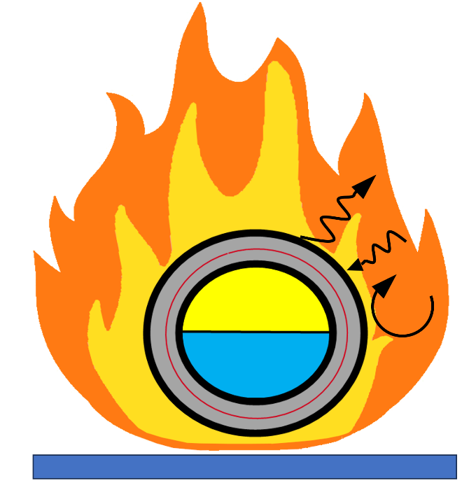

Heat transfer by the wall system from the fire to the stored fluid

Fire load for instance from a pool, tires, the carbine of a HGV, or transport goods

Vapor

Liquid

*Figure 1. Relevant heat flows from a fire load into the fluid stored in a tank.*

To simulate the interaction of a fire and the fluid inside a tank by experiments or numerical approaches, different methods are in application, that regard different parts of the overall transfer process.

One of them is the Heat Release Rate (HRR) approach, which is the rate at which the chemical energy of the fuel is released during the combustion. This approach quantifies the fire source well (Kashkarov, 2018), but does not regard the heat transfer from the fire to the tank.

Another approach is to define a fire temperature in accordance with the standards as GTR13 (2013) or ECE R 110 (2018) for describing the fire or as defined as standard curves in ISO 834-1 (1999), EN 1991-1-2 (2021), or RABT (2006). The approach does not consider radiation as a heat transfer mode, which is particularly effective at high temperatures, but is also highly dependent on the gaseous components in the fire as well as the surface properties of the tank.

On the contrary, the full fire characterization approach regards the convective and radiative heat transfer between a fire and an object in a fire, as applied for instance in ISO 21843 (2023). Therefore, the approach allows to describe temperature-dependent material degradation and to estimate the heat flow close to realistic conditions. This is useful to research and test non-homogenous wall structures that can change their properties over time in an incident with fire. These conditions exist for tanks with thermal superinsulation, as applied for the storage of cryogenic fluids. With this approach, the heat flow $\dot{q}$ from the fire to the tank can be calculated by equation 1, regarding the Stefan-Boltzmann constant $σ$ with 5.67x10-8 W/(m2K4), the emissivity of the fire $ε_{F}$ and the outer tank wall $ε_{W}$, the temperature of the fire $T_{F}$ and the outer tank wall $T_{W}$, and the heat transfer coefficient from the fire to the outer wall $h_{F}$ (Morgen, 2015). To use this approach representative values for the fire emissivity are needed, which can be estimated by relevant experiments as presented in this paper.

|  |  |  |
| --- | --- | --- |
|  | ( | 1) |

* 1. Method

To measure the heat flow from a fire into a tank over time a calorimeter was used, which can be placed at the location of interest. The calorimeter was based on an Intermediate Bulk Container (IBC) from stainless steel, which was 0.9 m wide, 0.95 m deep, and 1.1 m high and filled with 900 l of water. The heat coming from the combustible material and absorbed by the calorimeter was estimated by equation 2 regarding the water volume $V$, its density $ρ$ (1000 kg/m³), its specific heat capacity $c$ (4190 J/(kgK)) and the temperature $T_{avg}$, considered as the average value of 5 thermocouples (TC) T1 to T5.

|  |  |  |
| --- | --- | --- |
| $Q= VρcT_{avg}$ | ( | 2) |

A pump was installed in the IBC that mixed the water to uniformize the water temperature. Additionally, T1 to T5 were distributed in the flow of the pump over the height of the IBC. The external wall of the IBC was coated black with a high-temperature resistant colour with an emissivity of 0.85 and equipped with the 5 TCs TF1 to TF5 (see Figure 2) which measures the temperature of the fire (the thermocouples did not touch the wall). The fire could be strongly influenced by wind. To reduce this potential effect walls were installed next to the test .

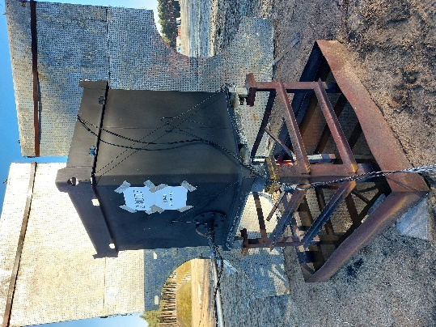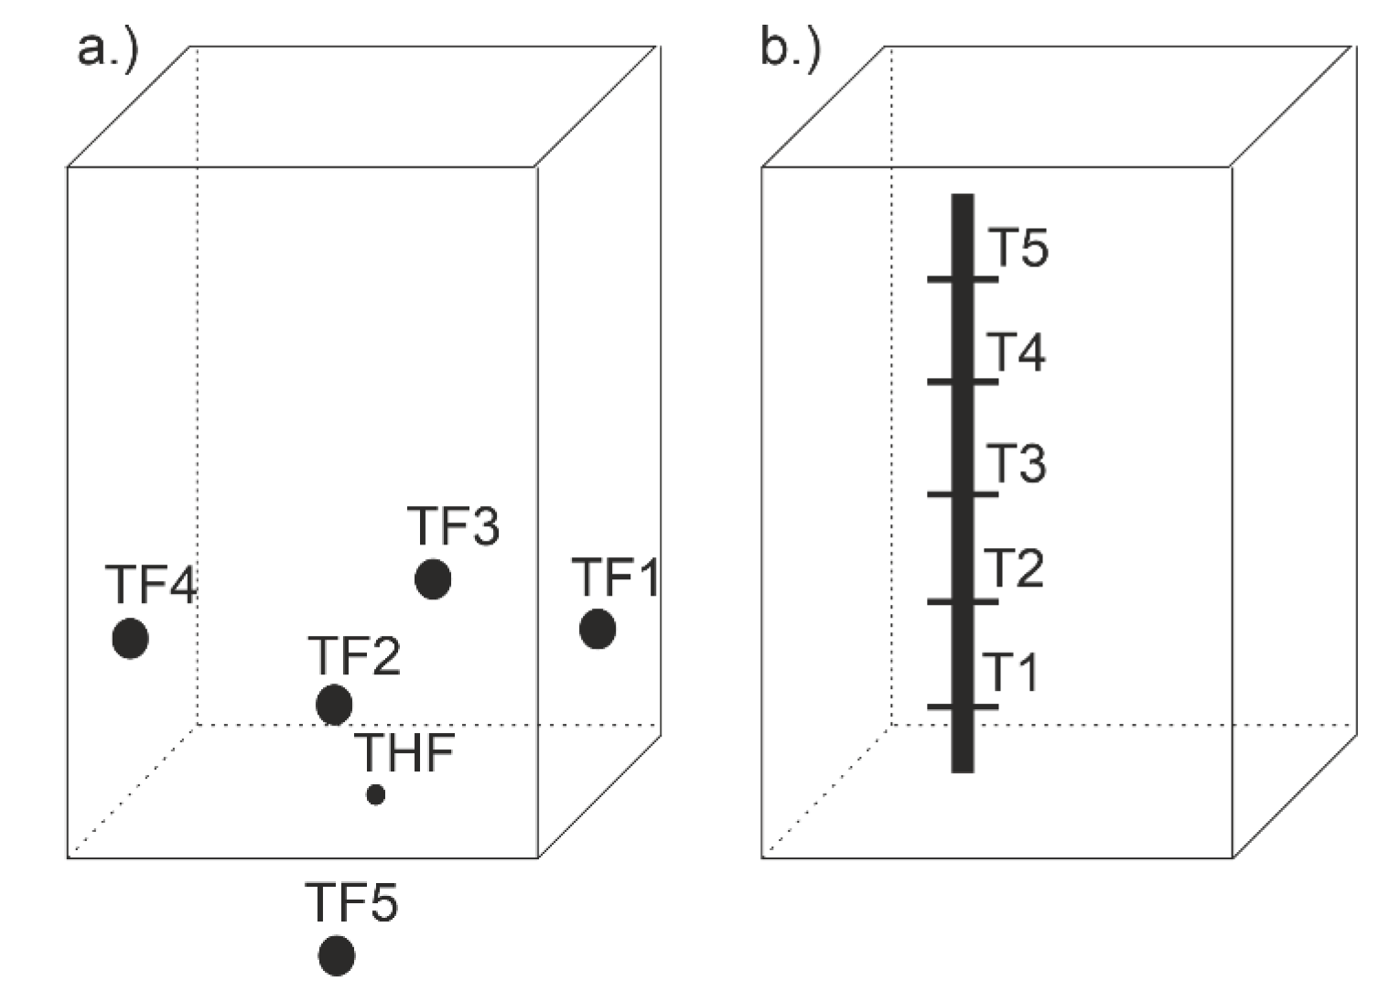

(a)

(b)

(c)

*Figure 2. The Intermediate Bulk Container (IBC) used as a calorimeter in the tests (a), that was equipped with the Thermocouples (TC) TF1 to TF5 that measure the fires temperature close to the IBC’s walls (b) and the TC T1 to T5 that measure the water temperature (c).*

The scenario considered in the present work is a diesel pool fire generated as the consequence of a pool formation of diesel after a leakage of one typical HGV-tank. To simulate such a scenario a 1.6 m wide, 1.6 m deep and 0.25 m high pan was filled with 200 l of ethanol and electrically ignited. The amount of ethanol represents the fire load of 130 l diesel. The bottom of the calorimenter was placed in the center of the pan at a distance of 1 m. The test setup is illustrated in Figure 2.

The experimental setup provides data on the fire temperature and the energy transferred to the calorimeter. The latter can be used to fully characterize the fire using corresponding assumptions via Equation 1 and the scheme presented Figure 3. Within the tests, the wall temperature $T_{W}$ was not measured, this was calculated by equation 3 regarding the specific heat flow $\dot{q}$ observed in the experiments over time, the heat transfer coefficient $h_{W}$ from the wall to the water ( assumed as 1000 W/m²), and the water average temperature $T_{avg}$.

|  |  |  |
| --- | --- | --- |
| $T_{W}={\frac{\dot{q}}{h_{W}}+ T}_{avg}$ | ( | 3) |
|  |  |  |

2.1. Calculate accumulated heat $Q(t)$ over time $t$

2.2. Built polynom $Q_{polynom}(t)$ that fits the course of $Q(t)$

Deviation by time

+ calculate area- specific values

3.1.Built specific heat flow $\dot{q}(t)$ over time $t$ from $Q(t)$

3.2.Built polynom ${\dot{q}}_{polynom}(t)$ over time from

4. Calculate the fire emissivity $ε_{F}$ while comparing the measured flame temperature with the calculated flame temperature based-on equation 1

Calorimeter

Fire

* 1. Compare TF1 to TF 5

over time

* 1. Built Average of TF1 to TF5 for any timestep
  2. Built Max of TF1 to TF5

for any timestep

Figure 3 Scheme for the data analysis.

* 1. Results and Discussion

Based on the scheme shown in Figure 3, Figure 7 to Figure 7 show the experimentally generated and numerically and analytically calculated data. The test started at 7:55 am and the fire burned for about 1 hour. In the test, the average wind velocity was 1 m/s. The visible flames primarily engulfed the bottom of the calorimeter. The side walls, on the other hand, were sometimes alternately exposed to the flickering flames. Therefore, to calculate the specific heat flow the IBC’s bottom surface and 25% of the side walls were regarded, which represents a total surface of 1.9 m². Furthermore, based on the observed low turbulent fire a heat transfer coefficient from the fire to the outer wall $h_{F}$ of 10 W/(m²K) was regarded for the data analysis.

Figure 4 Fire temperatures measured close to the calorimeter.

Figure 5 By the calorimeter accumulated heat and its describing polynom.

Figure 6 Specific heat flow into the calorimeter based on the measured heat over time and its polynome.

|  |  |
| --- | --- |
|  | Fire estimated by polynomic data regarding different $ε_{F}$ |

Figure 7 Measured flame temperature compared to the calorimeter data calculated flame temperature.

Within the test, the calorimeter accumulates a heat of 200 MJ of the approx. 4200 MJ released in the combustion of 200 l ethanol. Here, a maximum specific heat flow of 50 kW/m² was observed that thermally loads the calorimeter for several minutes. In real conditions, even lower heat flows can introduce the spread of the fire to the vehicle’s components and vehicles next to the fire. By the calorimetric data, the fire temperature close to the wall was calculated. While regarding an emissivity of the fire between 1 and 0.6 the course of the fire temperature is predicted close to the measured temperature over time. Here, the mean fire-emissivity of 0.8 represents the average course of the fire temperature with a maximum temperature of 760°C regarding the polynomic approach. The value could be assumed for the characterization of such a fire. In addition, the set of generated data gives orientation to deal with realistic fires in incidents with tanks.

The findings are relevant for the approval requirements of tanks and for investigating the consequences of accidents with fires. On the other side, this is only one of several potential fire loads that can results form accident involving HGVs.Further investigation is needed to characterize other credible fire scenarios using the approach proposed in the study.

# Conclusion

This paper deals with the research on representative fires and their characterization which is relevant for the evaluation of the safety of tanks for the storage of cryogenic fluids such as liquefied hydrogen (LH2), liquefied natural gas (LNG), liquefied oxygen (LOX) or liquefied nitrogen (LN2). These tanks require thermal super-insulation whose evaluation of the condition in the event of a fire requires knowledge of the expected fire temperature and the ratio of heat transport modes by thermal radiation and convection. To evaluate the representative inputs for the full fire characterization approach, a pool fire was first experimentally investigated, in which a calorimeter was placed, that simulated a tank. Based on the comparison of the experiment generated and post-processing data, it was found that the fire average heat flux temperature could be reproduced regarding a fire emissivity of 0.8. This finding can be used for first evaluations of tanks behaviour and safety in fire scenarios. Further studies are needed regarding other fire loads to get a range of potential fires-emissivity and representative time spans. This knowledge could allow to find a representative design fire applicable for the approval and improvement of tanks and to assess the consequences of accident scenarios.

# Acknowledgments

The authors wish to acknowledge the financial support of the research from the German Federal Ministry for Economic Affairs and Climate and the German Federal Ministry for Digital and Transport.

Nomenclature

- specific heat capacity

- heat transfer coefficient, W/m²

$\dot{q}$– heat flow, Wm-2

– time, s

– heat, J

- Temperature, K or °C

- volume, m³

$ε$– emissivity

$ρ$– density, kgm-3

- Stefan-Boltzmann constant, Wm-2K-4

**Subscripts**

F – Fire

W – Wall

avg – Average

Polynom - Polynom

References

Adler E.J., Martins J.R.R.A., 2023, Hydrogen-Powered Aircraft: Fundamental Concepts, Key Technologies, and Environmental Impacts, Prog Aerosp Sci, pp. 1-59, DOI: 10.1016/j.paerosci.2023.100922

Bradley I., Scarponi G.E., Otremba F., Birk A.M., 2021. An Overview of Test Standards and Regulations relevant to the Fire Testing of Pressure Vessels. Process Saf. Environ. Prot. 145, pp. 150–156. https://doi.org/10.1016/j.psep.2020.07.047

Camplese D., Scarponi G.E., Chianese C., Hajhariri A., Eberwein R., Otremba F., Cozzani V., 2024, Multilayer Insulation in Cryogenic Tanks Undergoing External Fire Scenarios, Process Saf Environ 186, pp. 1169 -182, https://doi.org/10.1016/j.psep.2024.04.061

Eberwein R., Hajhariri A., Camplese D. Scarponi G.E., Cozzani V., Otremba F., 2024a, Experimental Investigation on the Behavior of Thermal Super Insulation Materials for Cryogenic Storage Tanks in Fire Incidents, Process Saf Environ, https://doi.org/10.1016/j.psep.2024.04.131

Eberwein R., Hajhariri A., Camplese D. Scarponi G.E., Cozzani V., Otremba F., 2024b, Experimental Research of a Tank for a Cryogenic Fluid with a Wall Rupture in a Fire Scenario, 15th ISHPMIE, Naples, https:\\doi.org\10.5281/zenodo.12515711

Kamperveen J.P., Spruijt M.P.N., Reinders J.E.A., 2016, Heat Load Resistance of Cryogenic Storage Tanks – Results of LNG Safety Program, TNO Report

Kashkarov S., Makarov D., Molkov V., 2018, Effect of a Heat Release Rate on Reproducibility of Fire Test for Hydrogen Storage Cylinders, Int. J. Hydrogen Energy 43, https://doi.org/10.1016/j.ijhydene.2018.04.047

Konersmann R., Reich F., Balke C., 2014, Zu den Risiken des Transports von Flüssigerdgas mit Straßentankwagen, Technische Sicherheit, Band 4, pp. 37-43

Morgen J. et al., SFPE, Handbook of Fire Protection Engineering, Vol. 5, New York, Springer, 2016

Pehr K., 1996, Experimental Examinations on the Worst-Case Behaviour of LH2/LNG Tanks for Passenger cars. Proc. 11th World Hydrogen Energy Conference Stuttgart

Peschka W., 1992, Liquid Hydrogen – Fuel of the Future, Springer-Verlag, Wien New York

van Wingerden K., Kluge M., Habib A.K., Ustolin F., Paltrinieri N., Medium-scale Tests to Investigate the Possibility and Effects of BLEVEs of Storage Vessels Containing Liquified Hydrogen, 17th EFCE, Prague, pp.1-6, 2022, https://doi.org/10.3303/CET2290092

Studiengesellschaft Stahlanwendung, 1995, Fires in Transport Tunnels: Report on Full-scale Tests; Eureka-Project EU 499: FIRETUN, Band 141, Band 145

Vollmacher K., 2018, Accident Involving LNG Truck, CTIF Commission for Extrication & New Technology, 2018

EN 1991-1-2, 2021, Eurocode 1: Actions on structures - Part 1-2: General actions - Actions on structures exposed to fire

ISO 834-1, 1999, Fire-Resistance Tests - Elements of Building Construction - Part 1: General Requirements

ISO 21843, 2023, Determination of the Resistance to Hydrocarbon Pool Fires of Fire Protection Materials and Systems for Pressure Vessels

UN ECE R-110, 2018, Rev. 4

UN GTR 13, 2013, Rev.1, Global Technical Regulation on Hydrogen and Fuel Cell Vehicles

ZTV Ing, 2023, Zusätzliche Technische Vertragsbedingungen und Richtlinien für Ingenieurbauten, Bundesministerium für Digitales und Verkehr