|  |  |
| --- | --- |
| cetlogo ***CHEMICAL ENGINEERING TRANSACTIONS***  ***VOL. xxx, 2025*** | A publication of  aidiclogo_grande |
| The Italian Association  of Chemical Engineering  Online at www.cetjournal.it |
| Guest Editors: Bruno Fabiano, Valerio Cozzani  Copyright © 2025, AIDIC Servizi S.r.l. **ISBN** 979-12-81206-xx-y; **ISSN** 2283-9216 | |

Identification and Control of Combustible Dust Hazards

Paul Amyottea,\*, Mohammad Alauddina, Chris Cloneyb, Christina Clarkec, Kayleigh Rayner Brownd

|  |  |
| --- | --- |
| a | Department of Process Engineering and Applied Science, Dalhousie University, Halifax, NS, Canada |
| b | Dust Safety Science, Halifax, NS, Canada |
| c | Coastal Process Safety, Dartmouth, NS, Canada |
| d | Jensen Hughes, Dartmouth, NS, Canada  paul.amyotte@dal.ca |

This paper describes application of a Plan/Do/Check/Act training scheme to the identification of combustible dust hazards and the prevention and mitigation of combustible dust fire and explosion risks. The geographical focus of the research is the eastern Canadian province of Nova Scotia. It was determined that over the 20-year period from 2003 – 2023, wood, paper, and grain processing industries contributed significantly to the data base of combustible dust incidents (in addition to several coal mine explosions in prior years). This finding, along with the results of a combustible dust regulatory analysis, formed the basis for development of eight training modules and three one-page guidesheets centred on the fundamental rights of frontline workers to know about hazards, participate in hazard remediation, and refuse work with unacceptable risk – all in relation to combustible dusts.

* 1. Introduction

A comprehensive research project has been undertaken to address the occurrence of dust fires and explosions in industrial enterprises located in the province of Nova Scotia, Canada. The primary goal is to provide the local workforce with up-to-date guidance on the identification of combustible dust hazards and appropriate control measures to prevent dust fires and explosions. We also aim to facilitate protection of workers from the consequences of dust fires and explosions, which are typically viewed as process safety incidents arising due to completion of the explosion pentagon (Figure 1). Although most effectively addressed by a safety management system approach, there remains a strong occupational safety component to reducing the risk from combustible dust hazards. The current project is therefore focussed largely on personal safety.

The project results will also be beneficial for dust explosion risk reduction on a global basis, given that the research methodology is grounded in the best-practice cycle of Plan/Do/Check/Act (PDCA) found in comprehensive safety training schemes worldwide (DiBeradinis, 1999): (i) conducting a needs analysis, (ii) setting appropriate learning objectives, (iii) deciding on presentation styles and preparing presentation materials, (iv) evaluating instruction, and (v) providing feedback on instruction. These steps are evident in the specific project objectives discussed in detail, along with the project findings, in Sections 2, 3, and 4.

Figure 1: Explosion pentagon consisting of the five essential elements for a dust explosion (Amyotte et al., 2019)

* 1. Combustible Dust Loss History

Identification of the loss history in Nova Scotia with respect to fires and explosions involving combustible dusts was undertaken as a component of the first PDCA step (conducing a needs analysis) by: (i) reviewing legal cases and regulations, (ii) searching newspapers and other publications, (iii) conducting outreach to local museums and other archival institutions, and (iv) contacting local police/fire departments as well as union offices. During this work, the project team identified the need for verification of all incidents by independent means. AI systems such as ChatGPT were found to report numerous incidents that did not actually occur.

The analysis was focused on the previous two decades, with the exception of an initial historical review of explosions in Nova Scotia coal mines. Figure 2 illustrates that the majority of non-coal related incidents during the period 2003 – 2023 occurred in industries dealing with wood, paper, and grain processing. The prevalence of the industrial hazards presented by wood and grain dust in particular is consistent with global trends identified in the 2023 Combustible Dust Incident Report compiled by Dust Safety Science (Cloney, 2023).

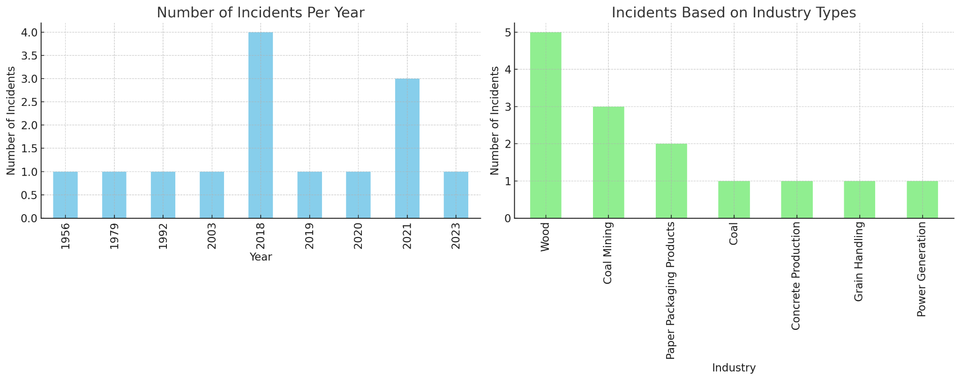

Figure 2: Verified dust explosion incidents (quantitative count by year and industry)

Nova Scotia has a rich history of coal mining activity carrying with it an unfortunate legacy of major fires and explosions underground. (The industry continues to this day, although on a much-reduced scale.) The events shown in Figure 2 for the years 1956 (Springhill Mine), 1979 (No. 26 Colliery), and 1992 (Westray Mine) claimed 39, 12, and 26 lives, respectively. Figure 3 (left) shows surface damage at the Westray site in Plymouth, Nova Scotia, which is indicative of the destructive overpressures generated in the mine workings. Figure 3 (right) also illustrates the personal tragedy that often accompanies an industrial dust explosion.

Of all the incidents reviewed in the current work, the Westray disaster has had the most significant impact on safety legislation in the province. The current Nova Scotia Occupational Health and Safety Act (OHS, 2024) has been shaped to a large extent by Westray – in particular, formalization in the Act of workers’ rights to: (i) know about the hazards they might encounter while performing their work, (ii) participate in making safety-related decisions in the workplace, and (iii) refuse to perform work they consider to be unsafe. (See also Section 4).

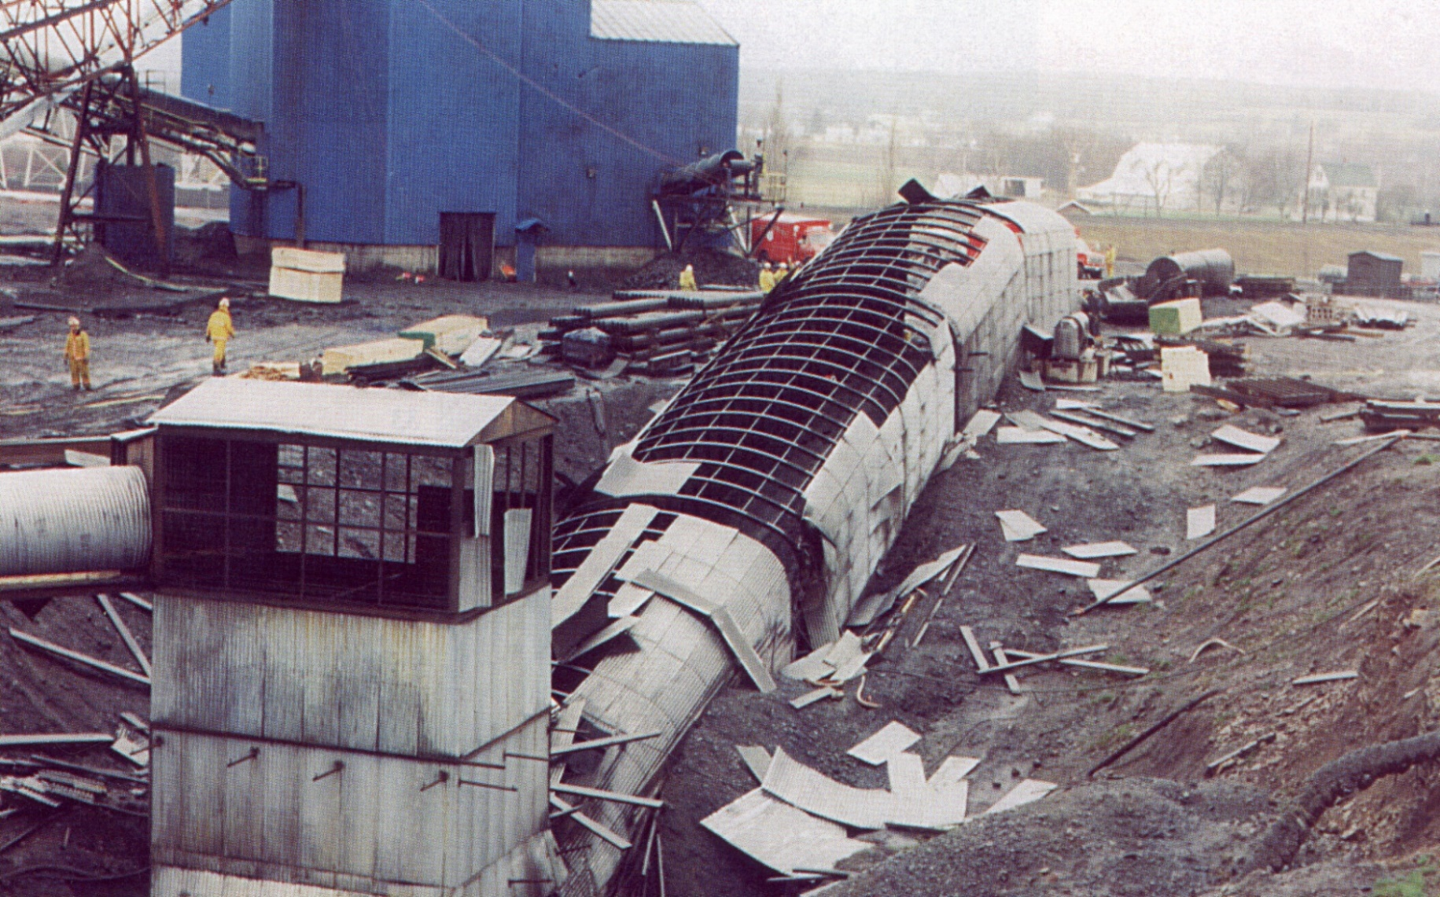 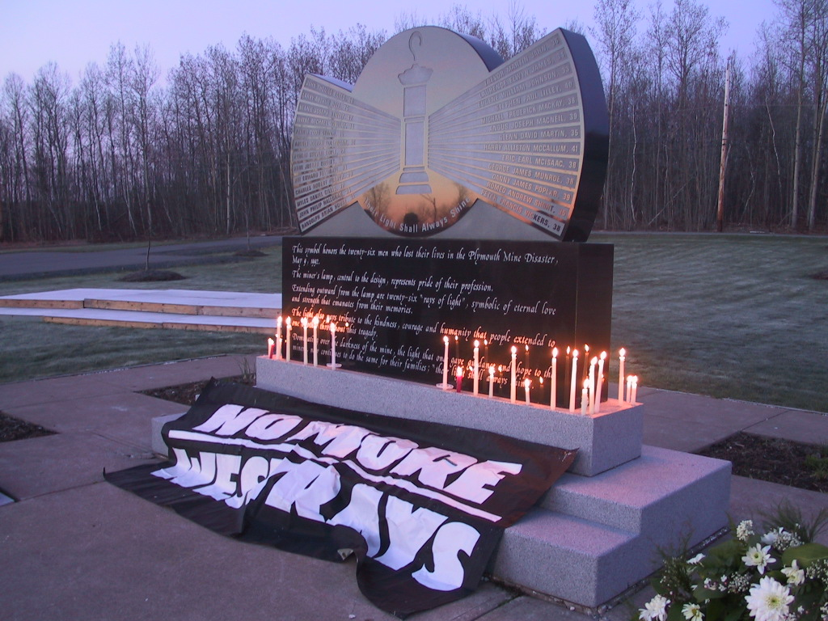

Figure 3: Left – Damage to portal at No. 1 main, Westray mine (Richard, 1997); Right – Westray memorial with rays of light from a miner’s lamp showing the names and ages of the 26 deceased miners (Di Menna, 2012; photograph by Peter Boyle, courtesy of United Steelworkers)

* 1. Combustible Dust Regulations and Standards

Determination of the status of provincial, national, and international safety regulations and standards addressing the hazards of combustible dusts was also undertaken as a component of the first PDCA step (conducting a needs analysis). As discussed by Amyotte & Lupien (2017), an inescapable factor in such work is the nature of process safety and occupational safety regulation in Canada. Constitutional authority over most process industry plants rests with the provinces and territories rather than the federal government; further, the vast majority of safety regulation performed at the provincial/territorial level by the governing bodies listed in Table 1 deals explicitly only with occupational health and safety (OHS).

Table 1: Provincial and territorial safety governing bodies in Canada

|  |  |
| --- | --- |
| Jurisdiction | Governing Body |
| Alberta | Occupational Health and Safety, Alberta Labour |
| British Columbia | WorkSafeBC |
| Manitoba | Workplace Safety and Health Branch (WSH), Department of Labour, Consumer Protection and Government Services |
| New Brunswick | WorkSafeNB |
| Newfoundland and Labrador | WorkplaceNL |
| Northwest Territories; Nunavut | Workers’ Safety and Compensation Commission of the Northwest Territories and Nunavut |
| Nova Scotia | Occupational Health and Safety Division, Department of Labour, Skills and Immigration |
| Ontario | Ministry of Labour, Training and Skills Development |
| Prince Edward Island | Workers’ Compensation Board |
| Quebec | Commission des normes, de l'équité, de la santé et de la sécurité du travail (CNESST) |
| Saskatchewan | WorkSafe Saskatchewan |
| Yukon | Occupational Health and Safety Branch, Yukon Workers' Compensation, Health and Safety Board |

Legislative frameworks for OHS typically adopt a hierarchical structure, with Acts representing the highest level. Acts, encompassing broad mandates such as a general duty clause, refrain from elaborating on specific hazards such as combustible dust. Falling under the Acts, regulations, codes, and guidelines provide specific criteria and guidance on how to achieve compliance. Most provinces and territories in Canada have some reference to combustible dust at the regulation level, with varying levels of detail.

In general, provincial and territorial OHS regulations discuss combustible dust in sections pertaining to specific industries or activities. Several jurisdictions do have general clauses related to combustible dust, but these have minimal detail. For example, some regulations include dust in the definition of flammable and combustible substances and require reduction of explosive atmospheres and ignition sources, but do not offer specifics on dust hazards and mitigation measures. Nowhere in Canadian OHS regulations is there currently a section on the hazards associated with combustible dust encompassing all industries and providing specific details on how to appropriately manage the ensuing risk. This situation, however, is rapidly evolving.

In 2012, the western Canadian province of British Columbia experienced two major sawmill explosions resulting in four deaths and 44 injuries. Much like the 1992 Westray mine explosion in Nova Scotia, these events have led the British Columbia government to develop new safety legislation – in this case, an all-industry detailed regulation specifically covering combustible dust hazards. Prominently featured in this work is the requirement for a Dust Hazard Analysis (DHA), which is a Process Hazard Analysis (PHA) tailored to combustible dust hazards. At the time of writing the current paper, legislation enactment and enforcement is imminent.

Consistent with other provinces and territories (with the above exception of British Columbia), Nova Scotia does not have an all-encompassing regulation related to combustible dust mitigation and control. Consistent again with other Canadian jurisdictions, there are some references to combustible dust in sections applicable to specific industries and activities. Most notable are the Underground Mining Regulations, which provide considerable detail on combustible dust hazards. While the general duty clauses and requirements for hazard assessments are designed to include all hazards and therefore encompass combustible dust, there is no specific direction in the regulations that applies across all industries and activities. There are, however, ongoing efforts aimed at improving combustible dust awareness and management in high-risk areas. These include a comprehensive review of dust collectors in government buildings (2010), a risk assessment conducted for the grain elevator in the city of Halifax (2022), and upcoming publication of a Combustible Dust Reference Sheet.

* 1. Combustible Dust Training Materials

Development and dissemination of occupational training materials on combustible dust hazards, aimed at protection of the individual worker who is exposed to such hazards, was undertaken in accordance with the remainder of the PDCA steps (setting appropriate learning objectives, deciding on presentation styles and preparing presentation materials, evaluating instruction, and providing feedback on instruction).

* + 1. Setting appropriate learning objectives

Bloom’s Taxonomy, in conjunction with the previously described needs analysis (Sections 2 and 3), provides a practical framework to establish learning (or instructional) objectives. The six levels in Bloom’s Taxonomy are as follows: (i) remember, (ii) understand, (iii) apply, (iv) analyze, (v) evaluate, and (vi) create (Waterloo, 2024). This cognitive hierarchy can be coupled with appropriate action verbs (e.g., state, explain, or formulate) to avoid the use of leading verbs (e.g., know, learn, or appreciate) that are difficult to measure (Felder & Brent, 1997). It is therefore essential to consider what trainees should be asked to do to demonstrate their knowledge, learning, and appreciation of a given topic; these activities should then become the learning objectives.

The above approach was utilized to develop learning objectives as a necessary first step for each of the training modules described in Section 4.2. The learning objectives are, for the most part, centred around the cognitive levels of remembering, understanding, and applying. This is intentional, given that the combustible dust training material is primarily intended for frontline workers who are at the direct interface between the hazard and the individual. A process safety management (PSM) approach would require activities aimed at analysis, evaluation, and creation on a system-wide level. This is outside the scope of the current work, which should be viewed as complementary to the need for a PSM system to address combustible dust hazards.

* + 1. Deciding on presentation styles and preparing presentation materials

The needs analysis (Sections 2 and 3) also informed the actual topics selected for coverage in the training material. Based on the nature of previous incidents in Nova Scotia (Section 2), and the province’s approach to regulation of combustible dust hazards (Section 3), the modules identified in Table 2 were developed.

Table 2: Combustible dust hazard training modules

|  |  |
| --- | --- |
| Number | Title |
| 1 | Identification and Awareness of Combustible Dust Hazards and Your Right to Know |
| 2 | Examples of Combustible Dust Incidents in Nova Scotia |
| 3 | Ignition Sources |
| 4 | Dust Processing and Handling Equipment at Risk of Fires and Explosions |
| 5 | Identifying and Managing Hazardous Scenarios Involving Combustible Dust |
| 6 | Controls for Combustible Dust Hazards |
| 7 | Combustible Dust Hazards and Your Right to Refuse Unsafe Work |
| 8 | Combustible Dust Hazards and Your Right to Participate |

The presentation style was selected to be a series of focussed, text-based documents with multiple examples and extensive graphics (diagrams and photographs). These can be used in either a self-study format or activities such as safety moments held before team meetings. The modules are accompanied by a guidesheet giving details of combustible dust resources available online, including videos and incident reports produced by the U.S. Chemical Safety and Hazard Investigation Board (e.g., CSB, 2009, 2023). The overall training package will thus appeal to both reflective and active learners, as well as verbal and visual leaners (Felder, 1996).

As mentioned in Section 4.1, the presentation material for each of the modules shown in Table 2 was developed by first identifying learning objectives specific to the topic. Representative examples are given in Table 3.

Table 3: Example learning objectives for dust hazard training modules

|  |  |
| --- | --- |
| Module | Learning Objective |
| 1 | Describe a worker’s right to know about how combustible dust hazards can affect their health and safety. Define “combustible dust”. State common materials known to be combustible as a dust. |
| 2 | List at least three confirmed dust explosions that have occurred in Nova Scotia, including the type of combustible dust involved. |
| 4 | Identify a typical area in your own facility where a dust fire or explosion could occur. |
| 6 | Describe the hierarchy of controls. State the most preferred and effective type of control. |
| 8 | State at least one activity you can undertake in your own organization to actively participate in addressing combustible dust hazards. |

Modules 1, 7, and 8 in Table 2 address the worker rights enshrined in the Nova Scotia Occupational Health and Safety Act (OHS, 2024): know, refuse, and participate, respectively. (See Section 2.) Because of the critical importance of these rights with regard to the internal responsibility system – the foundation of OHS (2024) – separate guidesheets were developed to accompany these modules; an example is given in Figure 4.The guidesheets were modeled after the Process Safety Beacon (CCPS, 2024) produced by the Center for Chemical Process Safety. As described by Hendershot (2019), the Beacon is a one-page document with photographs and other graphics, having a target audience of plant operators, maintenance workers, and other frontline personnel. The intent is to provide guidance on actions that can be taken within the scope of a worker’s job responsibility.

Figure 4: Example guidesheet from training material package

* + 1. Evaluating instruction

The objective of this step is to evaluate the competency of both the trainers and trainees (i.e., instructors and learners) with respect to the desired learning objectives. This will be ongoing as the training material is disseminated to industry in Nova Scotia.

At the time of writing the current paper, planning is underway to trial a subset of the training modules (Table 2) in a graduate-level university course on dust explosions. Although this is clearly not the intended audience of frontline, operational workers, it is anticipated that some revisions to module content will arise in terms of clarity of presentation and alignment with the stated learning objectives.

* + 1. Providing feedback on instruction

The objective of this step is to provide feedback to the trainers and trainees (i.e., instructors and learners) with respect to the efficacy of the training provided. Again, this will be ongoing as the training material is disseminated to industry in Nova Scotia. Also, as indicated in Section 4.3, the planned graduate-level trial will afford an opportunity for feedback to both sides of the learning equation.

* 1. Conclusion

Combustible dusts are an insidious hazard that know no geographical or industrial boundaries. Risk reduction with respect to dust fires and explosions requires process safety initiatives for protection of people, business assets and operations, and the natural environment, as well as occupational safety considerations for protection of individual workers. The current work has demonstrated the usefulness of a needs analysis in the form of incident and regulatory reviews to guide the development of training material. Early incorporation of appropriate learning objectives was also found to be essential to meeting the project objective of outreach to workers on the frontline of facilities handling and processing combustible dusts.

Acknowledgments

Funding under the Occupational Health and Safety Education Trust Fund administered by the Occupational Health and Safety Division of the Safety Branch (Nova Scotia Department of Labour, Skills and Immigration) is gratefully acknowledged.

References

Amyotte, P.R., Clouthier, M.P., Khan, F.I., 2019, Dust explosions: An overview, Chapter 1 in Methods in Chemical Process Safety, Volume 3, P. Amyotte & F. Khan (Editors), Elsevier/Academic Press, Cambridge, MA, pp. 1-5.

Amyotte, P.R., Lupien, C.S., 2017, Elements of process safety management, Chapter 3 in Methods in Chemical Process Safety, Volume 1, F. Khan (Editor), Elsevier/Academic Press, Cambridge, MA, pp. 87-148.

CCPS, 2024, Process Safety Beacon, Center for Chemical Process Safety, American Institute of Chemical Engineers, New York, NY: https://www.aiche.org/ccps/process-safety-beacon (last accessed Nov 17, 2024).

Cloney, C., 2023, Combustible Dust Incident Report, Dust Safety Science, Halifax, Canada.

CSB, 2009, Inferno: Dust Explosion at Imperial Sugar, Video (9:29), U.S. Chemical Safety and Hazard Investigation Board, Washington, DC.

CSB, 2023, Fatal Combustible Dust Explosions at Didion Milling Inc., Investigation Report No. 2017-07-I-WI, U.S. Chemical Safety and Hazard Investigation Board, Washington, DC.

DiBeradinis, L.J. (Editor), 1999, Handbook of Occupational Health and Safety, John Wiley & Sons, Inc., New York, NY.

Di Menna, J., 2012, Safety haven, Canadian Chemical News, 64 (9), 24-27.

Felder, R.M., 1996, Matters of style, ASSE Prism, 6 (4), 18-23.

Felder, R.M. & Brent R., 1997, Objectively speaking, Chemical Engineering Education, 31, 178-179.

Hendershot, D., Lessons from Dennis Hendershot, Section 29.3.3 in What Went Wrong? Case Histories of Process Plant Disasters and How They Could Have Been Avoided, 6th Edition, T. Kletz & P. Amyotte, Elsevier/Butterworth-Heinemann, Oxford, UK, pp. 559-561.

OHS, 2024, Occupational Health and Safety Act, Chapter 7 of the Acts of 1996, Province of Nova Scotia, Halifax, Canada.

Richard, K.P., Justice, 1997, The Westray Story – A Predictable Path to Disaster, Report of the Westray Mine Public Inquiry, Province of Nova Scotia, Halifax, Canada.

Waterloo, 2024, Bloom’s Taxonomy, Centre for Teaching Excellence, University of Waterloo, Waterloo, Canada: https://uwaterloo.ca/centre-for-teaching-excellence/catalogs/tip-sheets/blooms-taxonomy (last accessed Nov 17, 2024).