 CHEMICAL ENGINEERING TRANSACTIONS  VOL. xxx, 2025 | A publication of  
The Italian Association
of Chemical Engineering
Online at www.cetjournal.it
Guest Editors: Bruno Fabiano, Valerio Cozzani
Copyright © 2025, AIDIC Servizi S.r.l.
ISBN 979-12-81206-xx-y; ISSN 2283-9216

Predictive Assessment of Organic/Mineral Dust Explosion
José Serrano^{a,b}, André Laurentª, Fabrice Putier^{b}, Laurent Perrinª, Olivier Dufaud^{a,*}
ªUniversité de Lorraine, CNRS, LRGP, F-54000 Nancy, France
^{b}Tecaliman, 44323 Nantes, France
olivier.dufaud@univ-lorraine.fr
Incorporating mineral dust into organic powders is a common practice in industries such as pharmaceuticals, food production, and cosmetics to enhance product functionality. However, these additions can significantly alter the ignition sensitivity and explosion severity of the mixtures, complicating risk assessments performed without comprehensive experimental testing. This study focused on animal feed products and developed empirical models to predict explosion safety parameters - Minimum Ignition Energy (MIE), maximum explosion overpressure (P_{max}), and deflagration index (K_{St}) - for organic-mineral powder mixtures with varying chemical properties and particle sizes, in a control bounding approach. The experimental campaign was designed using a combined Design of Experiments strategy. Key factors for model development included inerting mechanisms (such as heat sink and scavenging of free radicals), characteristic Particle Size Distribution (PSD) diameters, and the fuel fraction in the mixture. The MIE model demonstrated an outstanding 98 % accuracy in recommending suitable types A and B Flexible Intermediate Bulk Containers (FIBC). Additionally, explosion severity parameters were reliably predicted within a confidence interval that extends 50 % beyond standard experimental variability. The proposed methodology and models thus provide a strategic and practical tool for implementing inherent safety principles during the formulation of powder mixtures.
  - Introduction
Combustible powders can explode when dispersed at sufficient concentrations in the presence of an oxidant, forming an explosive atmosphere (ATEX). Under these conditions, an ignition source with sufficient energy can initiate dust deflagration (Amyotte, 2006). Moreover, the confinement degree of the ATEX can amplify explosion severity, potentially triggering devastating domino effects through secondary explosions (Eckhoff, 2016). For instance, between 1785 and 2012, powders used in the agri-food industry accounted for approximately 40% of reported dust explosions worldwide (Yuan et al., 2015). However, implementing safety measures based on inherent safety principles, such as adding non-combustible (inert) powders to combustible ones (Dufaud et al., 2012), can significantly mitigate explosion risks to personnel and assets in powder-handling industries.
In the animal feed industry, mineral powders are incorporated to dilute active ingredients and enhance the flowability and palatability of complex formulations called “premixes.” These mixtures, composed of organic blends containing vitamins, amino acids, and cereals, are subsequently used to produce compound feed tailored to the nutritional needs of livestock (European Parliament, 2003). While the primary purpose of adding minerals is not explosion prevention, modifying their chemical and physical properties, such as Particle Size Distribution (PSD), can be regarded as an application of the moderation principle of inherent safety. Notably, the mineral content in such products can reach up to 95 % effectively removing contamination drawbacks associated with admixing inert powders. Therefore, modifications of the inert material properties can prevent the formation of ATEX zones or mitigate explosion consequences (Directive 2014/34/EU, 2014).
Despite their potential, assessing dust explosion risks remains challenging due to the numerous factors influencing dust mixture ignition and deflagration phenomena. Process conditions and material properties significantly affect ignition sensitivity, characterized here by the Minimum Ignition Energy (MIE), and explosion severity, described by the maximum overpressure (P_{max}) and deflagration index (K_{St}), of organic-mineral dust mixtures. These properties include each mixture component’s chemical composition, mass fraction, and PSD. For instance, inert powders exert a heat sink effect during ignition and deflagration, but their chemical nature determines their thermal quenching efficiency and potential actions on combustion kinetic mechanisms. Minerals that moderate ignitability and explosibility through purely thermal mechanisms, such as stable oxides and carbonates, dissipate combustion heat via conduction and convection or through thermal decomposition, releasing inert gases and altering the diffusivity of reactive species (Wang et al., 2021). Conversely, minerals decomposing into alkali or halogen compounds (e.g., NaCl, KCl, NaHCO₃) chemically interfere with combustion kinetics by scavenging reactive radicals and terminating chain-branching reactions (Janès et al., 2014).
The chemical inerting mechanism is generally more effective in mitigating explosion severity than thermal effects alone (Zheng et al., 2021). The inerting efficiency also depends on other material properties, such as the thermal decomposition temperature (T_{decomp}), particularly when this temperature is lower than the organic pyrolysis onset temperature (Reding and Shiflett, 2019). For example, Chen et al. (2022b) demonstrated that NaHCO₃ exhibited enhanced inerting efficiency compared to Na₂CO₃, attributed to its lower T_{decomp} despite both undergoing chemical inerting mechanisms. Furthermore, the mass fraction of inert powders plays a crucial role. Addai et al. (2016) observed that increasing the non-combustible fraction in a combustible mixture raises the MIE, with ignition effectively inhibited at a 60-80 % threshold.
Similarly, the PSD of mineral powders significantly influences inerting efficiency due to increased particle surface area and reduced heating times in the flame front during deflagration (Zhong et al., 2022). However, the optimal PSD for minerals does not necessarily align with that of organic powders, as particle shape and cohesion forces impact mixture dispersibility (Amez et al., 2023). Additionally, Serrano et al. (2023) reported significant breakage of mineral particles during explosion severity tests conducted in the 20-L Siwek sphere, potentially leading to overestimations of inerting efficiency.
The ignition and explosion behaviors of organic-mineral mixtures involve a complex interplay of factors, complicating the development of predictive models. Recent numerical models estimate the MIE of powder mixtures based solely on the thermal effects of mineral particles (Chen et al., 2022a). However, the broad range of chemical properties of mineral powders in industrial contexts represents a significant gap in these models. Consequently, this study aims to investigate the synergistic effects of the mineral’s chemical nature and PSD on the MIE, P_{max}, and K_{St} parameters of organic-mineral binary mixtures. An extensive experimental campaign was conducted using experimental plans aligned with the Design of Experiments (DoE – factorial and Response Surface Methodology (RSM)) approach, focusing on powders and particle size ranges commonly employed in the animal feed sector. The resulting database was used to develop empirical models based on bounding controls using dimensionless correlations. These models aim to provide industry-specific recommendations for mixture formulation, promoting the application of the moderation principle of inherent safety.
  - Materials and methods
Figure 1 presents a flowchart summarizing the methods used to develop the predictive models. The following sections provide detailed descriptions of the main steps followed in this study.
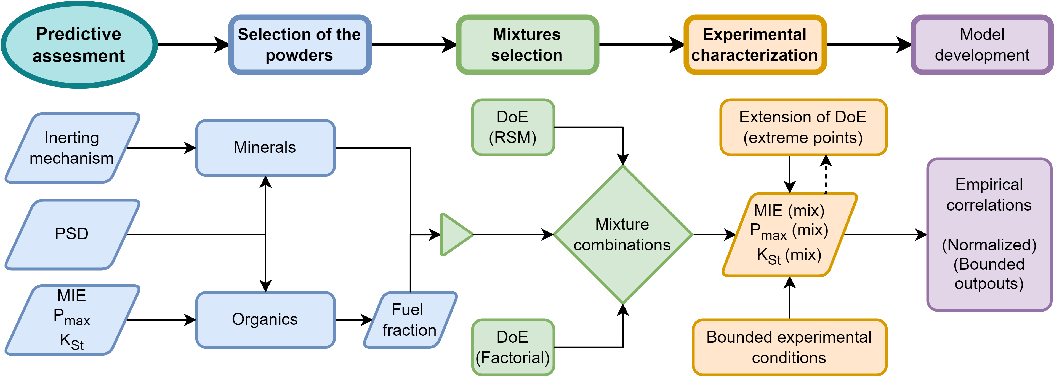
Figure 1: Summary of the methodology employed to develop empirical predictive models for the explosion safety parameters of organic-mineral powder mixtures.
    - Selection of organic and mineral raw materials
Organic powders were selected based on their common use in premix formulations, either as additives (e.g., amino acids and vitamins) or carriers (e.g., cereals). This selection considered feedback from industrial partners (surveys), chemical properties, and explosion safety parameters (MIE, P_{max}, and K_{St}). Figure 2 lists the selected 14 organic powders. For instance, DL-Methionine (an additive) was chosen for its widespread use in optimizing nitrogen retention during livestock digestion, its high sensitivity (MIE = 10 - 30 mJ depending on its PSD), and its ability to cause severe explosions (P_{max} ≈ 8 bar, K_{St} ≈ 130 bar m/s) (IFA, 2024).
The ignitability and explosibility of the selected powders were determined using the modified Hartmann tube (MIKE3) and the 20-L sphere, respectively, following the guidelines of ISO/IEC 80079-20-2:2016, without altering their physical properties (e.g., no sieving or grinding). Characterization results indicated that 50 % of the selected raw materials had MIE values exceeding 1000 mJ (indicating almost insensitivity to ignition), with average P_{max} and K_{St} values of 7.1 bar and 100 bar m/s, respectively.
To increase the validity range of models, it was necessary to expand the range of MIE, P_{max}, and K_{St} values. Some samples were sieved using a vibrating sieve shaker to reduce the fraction of coarse (less reactive) particles, while others were sieved into various PSD ranges. This enabled the evaluation of the influence of characteristic diameters, such as the median diameter (D₅₀), measured using a laser diffraction granulometer.
Figure 2 illustrates the K_{St}, MIE, and D₅₀ results of the raw and sieved organic powder samples, demonstrating a wide variability in chemical and physical properties, ignition likelihoods, and explosion severities. For instance, the organic powders range from highly reactive samples, such as niacin (MIE = 3 - 10 mJ; K_{St} = 240 bar m/s; St-2 class), to nearly insensitive samples, such as wheat middlings (MIE > 1000 mJ; K_{St} = 39 bar m/s; St-1 class). This variability ensures robust predictive capability and high-quality input data for developing models. It also allows industrial partners to optimize formulations by modifying parameters such as the D_{50.}
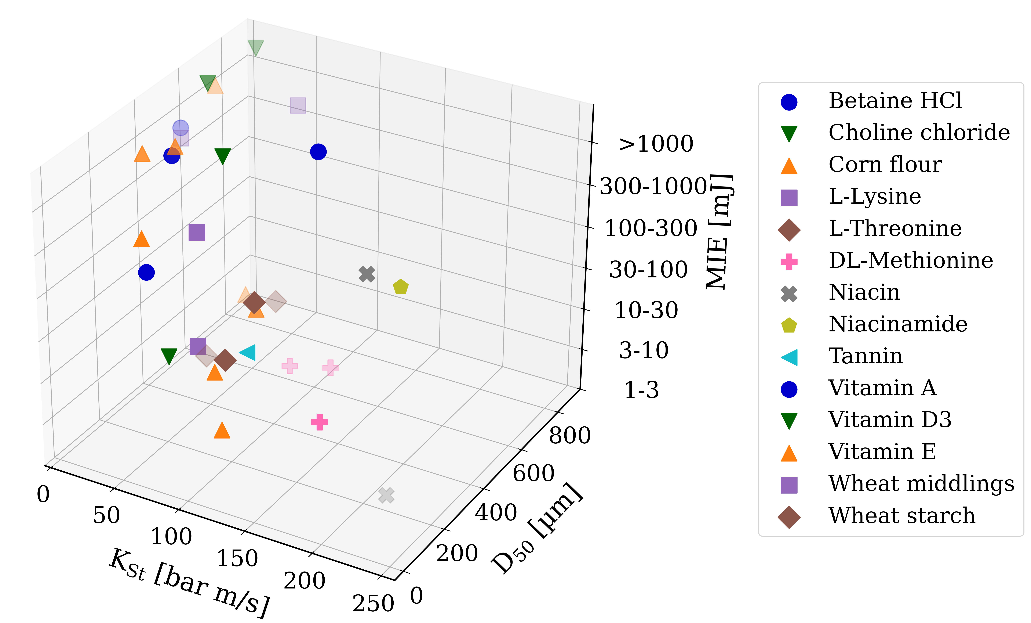
Figure 2: Explosibility and ignitability characterization of organic powders used in premix manufacturing.
Mineral powders were selected based on their chemical properties, inerting mechanisms, and feedback from industrial partners. Table 1 lists the six chosen mineral powders, categorized by inerting mechanism: convective/conductive heat sink (HS), heat sink thermal effects combined with thermal decomposition (HS-T), and combined effects of heat sink, thermal decomposition and chemical inerting (HS-T-Ch)
Table 1: Physical properties of the mineral powders commonly used in premix manufacturing.
Mineral powder | Inerting mechanism | T_{decomp} (°C) | D₅₀ [µm]
 |  |  | 20 – 40 | 50 – 150 | 150 – 300 | 380 – 700
CaCO₃ | HS-T | 730 | X | X | X | X (2 samples)
NaHCO₃ | HS-T-Ch | 130 | X | X (2 samples) | X | X
NaCl | HS-T-Ch | 890 | X | X | X | X
MgO | HS | >2800 | X | X | X | X
ZnSO₄ | HS-T | 680 |  | X
ZnO | HS | 2300 | X

Each inerting category includes two minerals with distinct physical properties, such as NaHCO₃ and NaCl (which are classified as HS-T-Ch), with different thermal decomposition temperatures (T_{decomp}). This enabled an evaluation of T_{decomp}’s influence on inerting efficiency. Similar to organic powders, mineral powders were sieved into various PSD ranges (Table 1) to evaluate the influence of particle size on inerting efficiency, improve mixing quality (reducing polydispersity), and enable PSD parameters adjustments in the predictive model. These bounded PSD ranges also ensure comparable characteristic diameters between the mineral samples, facilitating the evaluation of the effects of inerting mechanisms.
    - Experimental characterization of MIE, P_{max}, and K_{St}
The MIE of organic-mineral mixtures was determined at ignition delay times ranging from 120 to 150 ms, with an inductance of 1 mH to simulate incendiary ignition sources (Eckhoff, 2016). The dust mixture mass was set according to the ignitable range of the pure organic powders, capped at 3.6 g (nominal dust cloud concentration close to 3000 g/m³) in line with potential ATEX scenarios and good practices (ASTM E2019-03R19).
Explosion severity (P_{max} and K_{St}) was characterized using the 20-L Siwek sphere equipped with a rebound nozzle and two 5 kJ pyrotechnic ignitors, following ISO/IEC 80079-20-2:2016. Mixture concentrations were determined based on the concentration ranges at which the pure components exhibited their K_{St} values, ensuring comparable fuel-equivalence ratios and optimizing the experimental trials to determine the K_{St} value of the mixture. Concentrations within the 20-L sphere were capped at 2500 g/m³ to minimize turbulence levels and oxygen content disturbances before ignition.
    - Experimental plan
The selection of organic-mineral mixtures followed a Design of Experiments (DoE) approach, combining full factorial screening analyses with response surface methodology (RSM). Factors considered included fuel fraction, PSD of both components and inerting mechanism. The initial experimental plans were supplemented with additional tests involving powders with distinct chemical properties to validate correlations and address gaps. For example, worst-case scenarios were investigated, such as highly reactive organic particles (St-2, MIE < 10 mJ) mixed with coarse minerals exhibiting HS inerting. 90% of the experimental database, consisting of 215 MIE tests and 210 K_{St} determination tests, was used to train empirical models and the remaining 10% for validate them.
    - Model development
The predictive model for MIE was developed using the harmonic model framework, which has demonstrated high predictive proficiency for combustible powder mixtures (Dufaud et al., 2012; Hosseinzadeh et al., 2015). Inerting effects were modeled using a logistic function, with activation slopes and thresholds dependent on the synergistic effects of PSD and inerting mechanism. For P_{max} and K_{St}, dimensionless polynomial expressions were employed to assess the relative influence of admixed minerals. The PSD ratio between mineral and organic powders emerged as a significant factor, correlating with thresholds where explosion risks were fully mitigated.
The models were optimized to predict ranges rather than exact values, aligning with industry needs for risk assessment by control bounding methodology. They were based on 200 mixtures involving powders with D₅₀ values between 10 and 900 µm and fuel fractions ranging from 10 wt.% to 95 wt.%. Specific model details are not disclosed due to confidentiality agreements with industrial partners.
  - Results
This section presents the main findings on the validation of the developed models with experimental results.
    - Predictive assessment of electrostatic ignition sensitivity
The predictive proficiency of the developed model for the MIE of organic-mineral mixtures is shown in Figure 3. The shaded regions in the figure denote the recommended types of Flexible-Intermediate-Bulk-Containers (FIBC) for safe storage (ISO/IEC 61340-4-4:2018) and the sensitivity categories suggested by generally accepted good practices (Janès et al., 2008). The model identified the primary factors influencing the inerting effect of mineral powders on MIE in the following hierarchy: PSD, inerting mechanism, and T_{decomp}. The threshold at which ignition inhibition occurred varied across the tested mineral powders (from 40 to 90 wt%), reflecting the complex interplay of these factors. The model demonstrated outstanding accuracy in predicting MIE ranges for the tested mixtures. Specifically, it achieved 98 % accuracy in recommending suitable FIBC types (A and B), which are mostly used in the animal feed industry (Figure 3). Additionally, the model accurately identified scenarios where ignition was inhibited, outperforming the conservative estimates of the harmonic model. This highlights its practical utility for providing safety recommendations during powder mixture formulation. However, slight misestimations in the predictions are attributable to the assumptions and simplifications made during model development. For instance, the correlations did not fully account for the synergistic effects of enhanced mixture dispersibility (e.g., coarse mineral powders disrupting the cohesive trend of tiny organic particles).
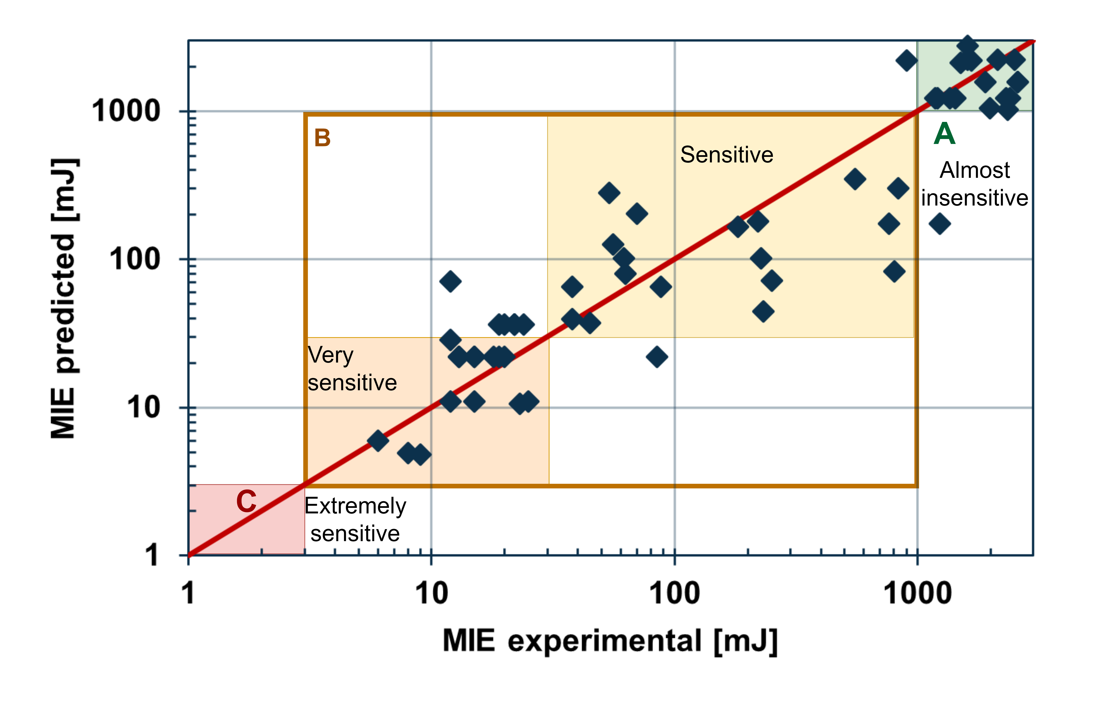
Figure 3: Validation of the organic-mineral MIE predictive model based on sensitivity categories and FIBC types.
    - Predictive assessment of explosion severity parameters
The predictive model for P_{max} demonstrated strong agreement with the experimental data. Among the factors analyzed, the inerting mechanism followed by T_{decomp} emerged as the most significant determinant of inerting performance. For example, the model estimated that approximately 20 wt.% NaHCO₃ (D₅₀ = 200 µm) was enough to reduce the explosibility of a highly reactive Niacin sample (St-2) to St-1 class, compared to 60 wt.% CaCO₃ required to achieve the same inerting effect. In addition, the validation results for the K_{St} model are depicted in Figure 4, which illustrates its agreement with experimental data. The shaded regions correspond to St-classes, while the confidence bands represent a 50 % margin beyond the standard experimental test variability (ASTM E1226-19). The K_{St} model exhibited outstanding agreement with the experimental data, particularly for mixtures within the St-1 class. The PSD of mineral powders was a less significant factor due to particle breakage during dust dispersion in the 20-L sphere. Consequently, the hierarchy of factors influencing K_{St} was: inerting mechanism, T_{decomp,} and PSD. This hierarchy is illustrated in the magnified region of Figure 4, where, for a given mixture, NaHCO₃ led to the least severe explosions, followed by NaCl. The model also intentionally adopted a conservative approach, overpredicting explosion severity for mixtures with experimental values below 20 bar.m/s. Notably, the model was trained using data that included mixtures where explosibility was enhanced due to improved dispersibility caused by insufficient concentrations of inert minerals (Serrano et al., 2023). Again, the mineral’s PSD was a less significant factor in this scenario due to the particle breakage phenomenon during dispersion. Nevertheless, the current models do not account for synergistic chemical interactions between the mixture components.
Figure 4: Validation of the KSt predictive model for organic-mineral mixtures.
  - Conclusions
Predicting powder mixtures’ explosion severity and electrostatic ignition sensitivity is inherently complex due to variability in chemical properties, PSD, and composition of blend components. This study addressed these challenges using a DoE approach that identified the correlations of key influencing factors: fuel fraction, inerting mechanism, and PSD. The experimental findings provided valuable insights into the mechanisms driving organic-mineral explosion risks, which were integrated into empirical models. These models effectively estimated the ranges and thresholds commonly used in risk assessments for powder-handling operations, particularly in the animal feed industry. The proposed methods and models were converted into a strategic and practical software tool for implementing inherent safety principles during powder mixture formulation. They can be integrated into existing formulation software to enable safer and more efficient designs. Moreover, these models provide a rapid, cost-effective screening method for prioritizing mixtures for further ignitability and explosibility tests. They can be extended to other industrial sectors handling powder mixtures.
Acknowledgments
The authors would like to acknowledge the support of Club EMIX partners.
References
Addai, E.K., Gabel, D., Krause, U., 2016. Experimental investigations of the minimum ignition energy and the minimum ignition temperature of inert and combustible dust cloud mixtures. J Hazard Mater 307, 302–311.
Amez, I., Castells, B., León, D., García-Torrent, J., Medic, L., 2023. Experimental study on inert products, moisture, and particle size effect on the minimum ignition energy of combustible dusts. J Loss Prev Process Ind 81.
Amyotte, P., 2006. Solid inertants and their use in dust explosion prevention and mitigation. J Loss Prev Process Ind 19, 161–173.
Chen, T., Van Caneghem, J., Degrève, J., Verplaetsen, F., Berghmans, J., Vanierschot, M., 2022a. A numerical model for the calculation of the minimum ignition energy of pure and mixture dust clouds. Process Safety and Environmental Protection 164, 271–282.
Chen, X., Lu, K., Xiao, Y., Su, B., Wang, Y., Zhao, T., 2022b. Investigation on the Inhibition of Aluminum Dust Explosion by Sodium Bicarbonate and Its Solid Product Sodium Carbonate. ACS Omega 7, 617–628.
Directive 2014/34/EU, 2014. Directive 2014/34/EU on the harmonisation of the laws of the Member States relating to equipment and protective systems intended for use in potentially explosive atmospheres (recast). Official Journal of the European Union 309–356.
Dufaud, O., Perrin, L., Bideau, D., Laurent, A., 2012. When solids meet solids: A glimpse into dust mixture explosions. J Loss Prev Process Ind 25, 853–861.
Eckhoff, R., 2016. Explosion Hazards in the Process Industries. Elsevier.
European Parliament, 2003. Regulation (EC) No 1831/2003. Official Journal of the European Union 29–43.
Hosseinzadeh, S., Norman, F., Verplaetsen, F., Berghmans, J., Van den Bulck, E., 2015. Minimum ignition energy of mixtures of combustible dusts. J Loss Prev Process Ind 36, 92–97.
IFA, 2024. GESTIS-DUST-EX Database: Combustion and explosion characteristics of dusts. Institute for Occupational Safety and Health of the German Social Accident Insurance [IFA].
Janès, A., Chaineaux, J., Carson, D., Le Lore, P.A., 2008. MIKE 3 versus HARTMANN apparatus: Comparison of measured minimum ignition energy (MIE). J Hazard Mater 152, 32–39.
Janès, A., Vignes, A., Dufaud, O., Carson, D., 2014. Experimental investigation of the influence of inert solids on ignition sensitivity of organic powders. Process Safety and Environmental Protection 92, 311–323.
Reding, N.S., Shiflett, M.B., 2019. Characterization of Thermal Stability and Heat Absorption for Suppressant Agent/Combustible Dust Mixtures via Thermogravimetric Analysis/Differential Scanning Calorimetry. Ind Eng Chem Res 58, 4674–4687.
Serrano, J., Nowicki, A., Perrin, L., Dufaud, O., 2023. Effect of Particle Size Distribution and Inerting Mechanism on Explosion Severity of Organic/Mineral Mixtures. Chem Eng Trans 104, 55–60.
Wang, Qiuhong, Fang, X., Wen, H., Shu, C.-M., Luo, Z., Xu, Q., Wang, Qingfeng, Sheng, Y., 2021. Explosion hazards of colored powders and the effects of suppressant powder materials. Powder Technol 390, 11–19.
Yuan, Z., Khakzad, N., Khan, F., Amyotte, P., 2015. Dust explosions: A threat to the process industries. Process Safety and Environmental Protection 98, 57–71.
Zheng, L., Yu, Y., Yang, J., Zhang, Q., Jiang, J., 2021. Inhibiting effect of inhibitors on ignition sensitivity of wood dust. J Loss Prev Process Ind 70.
Zhong, Y., Li, X., Jiang, J., Liang, S., Yang, Z., Soar, J., 2022. Inhibition of Four Inert Powders on the Minimum Ignition Energy of Sucrose Dust. Processes 10.

