|  |  |
| --- | --- |
| cetlogo ***CHEMICAL ENGINEERING TRANSACTIONS***  ***VOL. xxx, 2025*** | A publication of  aidiclogo_grande |
| The Italian Association  of Chemical Engineering  Online at www.cetjournal.it |
| Guest Editors: Bruno Fabiano, Valerio Cozzani  Copyright © 2025, AIDIC Servizi S.r.l. **ISBN** 979-12-81206-xx-y; **ISSN** 2283-9216 | |

A New Vulnerability Model for Atmospheric Storage Tanks under Intense Wind Solicitations

Di Talia Valentina\*, Alessandro Tugnoli, Valerio Cozzani

LISES – Dipartimento di Ingegneria Civile, Chimica, Ambientale e dei Materiali, Alma Mater Studiorum – Università di Bologna, via Terracini 28, 40131 Bologna (Italy).

\*valentina.ditalia2@unibo.it

Natech events are technological accidents triggered by natural hazards that occur in chemical and process plants. Natural hazards associated with intense wind phenomena - such as cyclones, extra-tropical storms, and tornadoes - are currently raising particular concern due to ongoing climate change, which is expected to cause a general increase in their frequencies and an exacerbation of their intensities in the near future. However, the currently available models to assess the damage probability (i.e. vulnerability models) of the most common equipment items in relation to intense wind phenomena in the Natech Quantitative Risk Assessment framework are scarce and often non-exhaustive.

The present study contributes to fill this gap proposing novel generalized vulnerability models for atmospheric storage tanks subject to wind solicitations. The developed models are in the form of probit equations and allow an estimate of the probability of equipment damage associated with different wind velocities, explicitly addressing the potential catastrophic rupture of the tanks due to overturning and sliding phenomena. The results are demonstrated by a notional case study offering an example of the results obtainable in the context of Natech Quantitative Risk Assessment (QRA). Overall, the novel vulnerability models can support the definition of more robust preventive and mitigative measures to improve the resilience of chemical and process plants.

* 1. Introduction

Accidents triggered by natural hazards, referred to as Natechs, can be caused by various types of natural hazards, with meteorological events such as tropical and extra-tropical storms being of particular concern based on historical data (Mesa-Gómez et al., 2020). In fact, over the past seventy years, tropical storms have caused 50% of Natech accidents, while extra-tropical storms account for 12% (Ricci et al., 2021). Additionally, the intensification of these natural events, driven primarily by climate change, presents new challenges for managing their impacts (Jung and Lackmann, 2023). Notably, this will likely increase the difficulty of preventing and mitigating Natech events triggered by intense wind phenomena in the future (Pilone et al., 2021). Atmospheric storage tanks are known to be particularly vulnerable to intense wind solicitations in the context of the chemical and process industry (EC Joint Research Centre, 2018) and, as demonstrated by Hurricanes Katrina and Rita, the catastrophic rupture of this equipment can lead to the release of significant amounts of hazardous substances (Cruz and Krausmann, 2013).

The need for simplified models to estimate failure conditions and to assess the vulnerability of atmospheric storage tanks in relation to intense wind phenomena, enabling the inclusion in the QRA of Natech triggered by intense wind phenomena, is evident. However, current vulnerability models remain limited, as they focus on individual tank damage but not loss of containment (e.g., Bernier and Padgett, 2019). On these bases, this study aims to develop generalized vulnerability models for assessing the damage probability of self-anchored fixed-roof atmospheric tanks designed in accordance with the sizing guidelines provided by the API-650 Standard (American Petroleum Institute, 2020) for welded oil storage tanks, also considering the probability associated with different loss of inventory levels.

* 1. Method

This paper develops generalized vulnerability models for the assessment of the damage probability associated with self-anchored fixed-roof atmospheric storage tanks designed in accordance with the International Standard API-650 subjected to wind solicitations. Damage probability *P* is modelled as a function of the wind speed associated with the mechanisms of damage under investigation *v* (Salzano et al., 2003), as presented in Eq(1) and Eq(2), since the literature indicates this is the most common method used for defining vulnerability models in the Natech setting

$P\left(v\right)$*= $\frac{1}{\sqrt{2π}}$ $\int_{-∞}^{Y -5}{\exp\left(\frac{{-v}^{2}}{2}\right)} dv$*  (1)

$Y= A+B ln\left(v\right)$ (2).

In the equations, *Y* is the probit variable, which can be determined by defining the probit coefficients *A* and *B*. Referring to this approach, the present work intended to determine the vulnerability functions *V* that correlate the damage probability with the probit variable *Y,* as shown in Eq(3)

$P\left(v\right)$*= $V(Y)$* (3).

Notably, Eq(4) allows the assessment of the combined probability compatible with a reference loss of inventory level $i$, represented through the release classes defined in Section 2.2

$P_{i}(v)=ξ_{i} V_{i} \left(Y_{i}\right)$ (4).

In the equation, *ξi* is a numerical coefficient representing the complement of the probability of having a release of a reference entity and *Vi* a vulnerability function dependent on the probit variable associated with a specific level of loss of containment *Yi*.

In order to develop the novel generalized vulnerability models, a set of reference self-anchored fixed-roof atmospheric tanks was defined for model calibration in compliance with API-650 design guidelines. The most significant damage mechanisms for self-anchored fixed-roof tanks were identified, and specific mechanical models were established in order to correlate tank features with the wind load resulting in damage. After setting these bases, the cumulative damage probability for each tank in the set and damage mechanism was computed through Monte Carlo simulations. The results obtained were statistically analyzed and generalized on the basis of specific dimensional classes of tanks defined within the analysis.

* + 1. Definition of a set of reference tanks

A set of 18 reference self-anchored, fixed-roof atmospheric storage tanks was defined based on the general sizing guidelines provided in the international standard API-650. For reference, the volume of tanks ranges from 25 to 16,000 m3. The shell height and diameter of each tank were specified directly according to the Standard. The shell thickness was determined by taking the average of the thickness values across all courses specified in the API. For simplicity, the roof thickness was assumed to be equal to the shell thickness, and roof heights were calculated using an average slope of 6:12. In the analysis, a maximum corrosion allowance of 3.2 mm was considered (Ahmad, 2006).

* + 1. Identification of relevant damage mechanisms and release classes

The damage mechanisms selected for the present analysis are overturning and sliding, with the assumption of a catastrophic rupture in both cases. This specific choice takes into account that the bottoms of atmospheric storage tanks are not self-supporting, making them vulnerable to plate detachment, which can lead to a rapid, large-scale release of the tank's contents, similar to a catastrophic failure.

Given the significance of the entity of loss of inventory for the vulnerability analysis, three distinct release classes were defined based on different filling levels of the tanks. Specifically, the classes represent specific releasable inventories correspondent to the 10%, 50%, and 90% of the tank capacity and are modelled through the following filling level ranges: [0.05, 0.1], [0.1, 0.5], and [0.5, 0.9], respectively. It is to be noted that a minimum filling level of 0.05 was assumed, considering that the tank is never empty.

* + 1. Definition of mechanical models

The method involved the definition of the mechanical models for the two damage mechanisms under analysis. The models aim to correlate the characteristics of the atmospheric tanks with the wind load corresponding to damage. The input values accounted for in the mechanical models are shell height, shell diameter, average shell thickness, bottom thickness, minimum bottom plate yield stress, roof thickness, roof height, friction factor, steel density, and the density of the hazardous substances stored in the tank. Clearly enough, representative values for some of these parameters were defined according to the API-650 Standard and the literature.

The mechanical model defined to address the damage mechanism overturning is based on the stability criteria provided by API-650 to verify the necessity of anchorage for fixed-roof atmospheric tanks. The Standard provides three criteria: two in the case of empty tank conditions and one in the case of liquid-filled conditions. Given that the current method is designed for the Natech QRA context and, therefore, aims to take into account the expected entity of the loss of containment event in the case of equipment damage, only the criterion that account for the liquid-filled condition is considered.

On the other hand, the model to address the damage mode sliding is based on the criterion provided by API-650 to verify the sliding friction resistance to fixed-roof atmospheric tanks subjected to lateral wind loads. It is assumed that sliding occurs if the resulting horizontal force on the tank due to wind exceeds the static friction force resulting from the net vertical force on the tank.

For the sake of clarity, a representation of the forces accounted for in the models for the two damage mechanisms is presented in Figure 1.

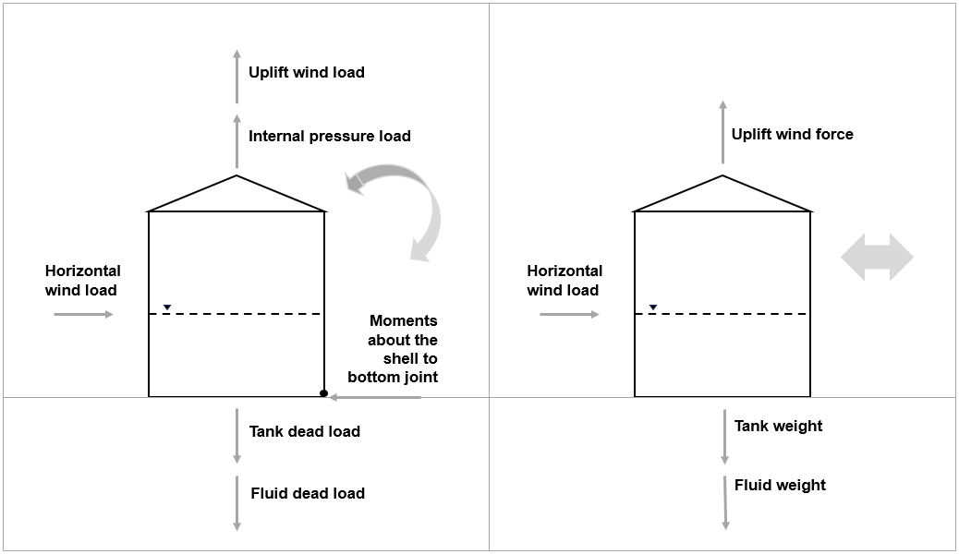

Figure 1 – Panel a) Representation of damage mechanisms: Panel a) Overturning; Panel b) Sliding (adapted from API-650).

It is to note that the effect of the local obstacles on wind profile was not accounted in this phase.

* + 1. Vulnerability curves for individual tanks

Monte Carlo simulations are a statistical technique used to estimate the behavior of a system by generating random samples from a defined probability distribution. In this study, Monte Carlo simulations were conducted for each tank of the reference set by employing the mechanical models established (see Section 2.3) with the aim of assessing the preliminary cumulative damage probability functions associated with each tank. A total of 10,000 iterations were performed per tank, employing a random sampling approach.It is worth noting that the two damage mechanisms, overturning and sliding, were considered independent and, thus, were evaluated separately. In the simulations, the wind velocity associated with damage was modelled as a function of the tank parameters through the mechanical models identified, and a probability distribution in a defined range was attributed to the parameters filling level and corrosion allowance, as presented in Table 1.

Table 1: Monte Carlo Simulations aleatory parameters.

|  |  |  |
| --- | --- | --- |
| **Parameter** | **Range** | **Probability distribution function** |
| Filling level (all release classes together) | 0.05-0.90 | Uniform |
| Filling level (release class 10%) | 0.05-0.10 | Uniform |
| Filling level (release class 50%) | 0.10-0.50 | Uniform |
| Filling level (release class 90%) | 0.50-0.90 | Uniform |
| Corrosion allowance | 0-3.2 mm | Uniform |

Considering that the fluid pressure represents a significant resistance force while assessing both overturning and sliding, the filling level was accounted as an aleatory parameter in the simulations. In the case that no reference level of loss of containment is considered in the assessment, a filling level range of 0.05 to 0.9 was employed. On the other hand, when the release classes were considered, specific filling level ranges were utilized. In both cases, a uniform probability distribution is assumed.The corrosion allowance can also be regarded as a significant parameter for the two damage mechanisms under analysis, as it represents the age and state of maintenance of the tank. Considering that the actual corrosion allowance of the tank at the moment of damage cannot be anticipated, all values within the initial corrosion allowance of 0 mm and 3.2 mm were deemed equally probable. Therefore, a uniform distribution was assumed also in this case. Notably, the use of uniform distributions was selected to account for maximum uncertainty. Alternative distributions were considered but were not used due to insufficient empirical data to justify specific parameterization. However, if specific information on the history of the filling level becomes available, a more appropriate distribution could be adopted to better reflect actual conditions.

The remaining parameters considered in the mechanical models were evaluated through fixed values.

* + 1. Definition of generalized vulnerability models

The cumulative damage probability functions associated with each tank were analyzed statistically to lay the groundwork for the definition of the generalized vulnerability models. A step-wise regression analysis was conducted to assess the correlation between wind velocity, given damage probabilities, and a set of tank characteristics for each damage mechanism. The analysis pinpointed the tank parameters that most influence the vulnerability of the tanks. The analysis revealed distinct patterns for the two damage mechanisms and for tanks with specific geometrical characteristics, leading to the classification of tanks into Dimensional Classes (DCs). Specifically, the classes DC1 and DC2 were defined for overturning, where DC1 applies to tanks with the product of diameter and shell height less than 200 m², and DC2 applies to tanks with the product of diameter and shell height greater than or equal to 200 m². Similarly, DC3 and DC4 were defined for sliding, with the same dimensional criteria as for overturning.

A lower-bound envelope method was employed to select a reference cumulative distribution function for each of the four DCs. Generalized damage models in the form of probit equations were then derived based on the cumulative distribution function simulations selected, as presented in Table 2.

Table 2: Probit models defined for overturning and sliding.

|  |  |  |  |  |
| --- | --- | --- | --- | --- |
|  | **DC1** | **DC2** | **DC3** | **DC4** |
| A | -52.0653 | -89.0766 | -14.759 | -11.6285 |
| B | 15.4489 | 25.2343 | 4.4186 | 3.3705 |

For the sake of example, a representation of the models developed for DC1 and DC2 is provided in Figure 2.

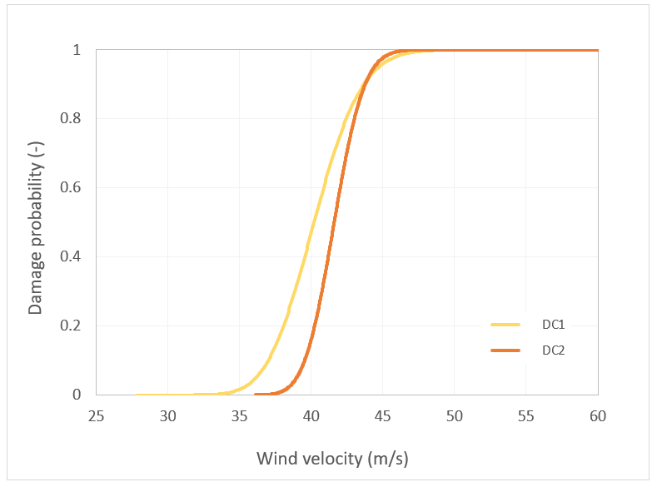

Figure 2 - Probit models defined for dimensional classes DC1 and DC2.

As previously discussed, the overall probability associated with a given damage mechanism can be determined using Eq(1), Eq(2), and Eq(3) by applying the probit coefficients presented in Table 1. It is to be noted that the expected wind velocities are to be input in meters per second when using the generalized probit models.

The analysis also enabled the development of generalized models aligned with the three release classes defined in Section 2.2. For the sake of example, the probit models for dimensional class DC1 are provided in Table 3.

Table 3: Probit models defined for dimensional class DC1 considering the three release classes.

|  |  |  |  |  |  |  |
| --- | --- | --- | --- | --- | --- | --- |
|  | **A10%** | **B10%** | **A50%** | **B50%** | **A90%** | **B90%** |
| DC1 | -262.9451 | 75.0549 | -100.429 | 28.9189 | -133.882 | 36.9357 |

The assessment of the probability of loss inventory associated with the three release classes, 10%, 50%, and 90%, is to be performed through Eq(4) by employing the specific probit coefficients for each release class.

* 1. Case study

A notional case study is presented to demonstrate the application of the developed generalized vulnerability models in the Natech QRA context. Its specific goal is the evaluation of the damage probability associated with the simultaneous occurrence of overturning and sliding referring to selected representative wind speeds. Additionally, an example of application in relation to a reference level of loss of inventory is provided.

Two self-anchored atmospheric storage tanks, designed according to the International Standard API-650 and located within a fictitious process plant in Europe, are considered. The key geometrical characteristics of the tanks, including diameter (*D*), shell height (*H*), and shell thickness (*t*), are provided in Table 4.

Table 4: Essential geometrical features of Tank A and Tank B.

|  |  |  |  |
| --- | --- | --- | --- |
| **Tank ID** | **D (m)** | **H (m)** | **t (mm)** |
| A | 9 | 18 | 5 |
| B | 15 | 18 | 7 |

Considering that the tanks are filled with light crude oil with a density of 860 kg/m3, the maximum releasable inventories for tanks A and B are 1030 m³ and 2860 m³, respectively (considering a maximum filling level of 0.9).

Three expected wind velocities were selected for the application, referring to the NATHAN hazard map for extra-tropical storms (Munich Re, 2011): 30, 40, and 55 m/s. Notably, the design wind speed for the tanks is set at 25 m/s, which is a typical value for most of Europe not considering coastal areas (Kabošová et al., 2020).

* 1. Results

The damage probabilities of the two tanks were assessed for the expected wind velocities considering the damage mechanisms overturning and sliding independently by employing the developed generalized vulnerability models by means of Eq(1), Eq(2), and Eq(3). According to the dimensional class definition provided in Section 2.5, the models for DC1 were employed for overturning and DC3 for sliding. On the other hand, for Tank B, the DC2 model was used for overturning, and the DC3 model for sliding. Once the probabilities for each damage mechanism were determined by employing the models presented in Table 1, the combined probability associated with the simultaneous occurrence of both overturning and sliding was assessed through Eq(5)

$P_{ov\&sl }=1-\left(1-P_{ov} \right)(1-P_{sl})$ (5),

acknowledging that these damage mechanisms are likely to occur together. The results of this application are summarized in Table 5.

Table 5: Damage probabilities for Tank A and Tank B for the reference wind velocities.

|  |  |  |
| --- | --- | --- |
| **v (m/s)** | **Tank A** | **Tank B** |
| 30 | <1\*10-6 | <1\*10-6 |
| 40 | 4.7\*10-1 | 1.6\*10-1 |
| 55 | 1 | 1 |

The results demonstrate that the developed models enable a straightforward assessment of the damage probability of fixed-roof atmospheric storage tanks designed according to API-650 based on the dimensional classes defined (i.e., the analysis requires only the diameter and shell height of the tank in input). It is also apparent that, as expected, the overall vulnerability of the tanks increases with wind speed. Specifically, at wind velocities close to the design wind speed of 25 m/s, the probabilities are negligible for all tanks (<1×10⁻⁶), and as wind speeds increase, the probabilities of damage rise significantly.

For a more comprehensive analysis, the vulnerability models defined for the three release classes can be employed in the probability associated with a specified loss of inventory level. To provide an example, the combined probabilities of overturning and sliding obtained accounting for an average filling level of Tank A of 0.5 (i.e., release class 50%) are provided in Table 6.

Table 6: Combined probability of overturning and sliding associated with the release class 50% for Tank A.

|  |  |  |  |
| --- | --- | --- | --- |
|  | **30 m/s** | **40 m/s** | **55 m/s** |
| Pov&sl,50% (-) | <1\*10-6 | 4.2\*10-1 | 4.7\*10-1 |

These values – which were calculated by employing Eq(4) and Eq(5) - can be employed directly in the QRA of Natech accidents triggered by intense wind phenomena in the case that the average filling level of the tanks is a known datum.

* 1. Conclusions

The generalized vulnerability models developed in this study offer a new and straightforward approach for assessing the vulnerability of self-anchored fixed-roof atmospheric storage tanks designed according to the API-650 Standard under intense wind solicitations. It is worth mentioning that historical accident data reinforce the relevance of our model. For instance, Hurricanes Katrina and Rita caused severe damage to atmospheric storage tanks, leading to large-scale hazardous substance releases (Cruz and Krausmann, 2013). While these cases do not provide direct vulnerability functions, they highlight the need for robust predictive models.

The models address the damage mechanisms of overturning and sliding and assume catastrophic failure in the event of damage. The introduction of three release classes, which enable the evaluation of the probability of loss of inventory associated with releases of different entities accounting for the average filling level of the tanks, is a significant aspect of this study. One limitation is the potential influence of local air turbulence and recirculation flows caused by adjacent tanks. While our model provides a generalized vulnerability assessment, these local flow phenomena could affect the wind loads experienced by each tank, potentially increasing instability.

The methodology and models introduced want to be a step forward in incorporating natural hazard scenarios associated with intense wind phenomena into Natech quantitative risk assessments. Additionally, the approach could be employed to evaluate the vulnerability of other equipment types. Overall, this research aims to enhance the resilience of critical infrastructure, enabling better preparedness for Natech accidents triggered in particular by extra-tropical and tropical storms.

References

American Petroleum Institute, 2020, API 650: Welded Steel Tanks for Oil Storage.

Bernier C., Padgett J.E., 2019, Fragility and risk assessment of aboveground storage tanks subjected to concurrent surge, wave, and wind loads, Reliability Engineering & System Safety, 191, 106571.

Cruz A.M., Krausmann E., 2013, Vulnerability of the oil and gas sector to climate change and extreme weather events, Climatic Change, 121(1), 41–53.

EC Joint Research Centre, 2018, Understanding Natech risk due to storms: Analysis, lessons learned and recommendations, Publications Office.

Jung C., Lackmann G.M., 2023, Changes in tropical cyclones undergoing extra-tropical transition in a warming climate: Quasi-idealized numerical experiments of North Atlantic landfalling events, Geophysical Research Letters, 50(8), e2022GL101963.

Kabošová, L., Kmeť, S., & Katunský, D. (2020). Wind flow around buildings of basic shapes with and without a wind-adaptive envelope. Selected Scientific Papers - Journal of Civil Engineering, 15(1), 59–75.

Mesa-Gómez A., Casal J., Sánchez-Silva M., Muñoz F., 2020, Advances and gaps in Natech quantitative risk analysis, Processes, 9(1), 40.

Munich Re. (2011). NATHAN World Map of Natural Hazards. <catalogue.unccd.int/Map\_NATHAN%20-%20World%20map%20of%20natural%20hazards.pdf> accessed 9.9.2024.

Pilone E., Casson Moreno V., Cozzani V., Demichela M., 2021, Climate change and NaTech events: A step towards local-scale awareness and preparedness, Safety Science, 139, 105264.

Ricci F., Casson Moreno V., Cozzani V., 2021, A comprehensive analysis of the occurrence of Natech events in the process industry, Process Safety and Environmental Protection, 147, 703–713.

Salzano E., Iervolino I., Fabbrocino G., 2003, Seismic risk of atmospheric storage tanks in the framework of quantitative risk analysis, Journal of Loss Prevention in the Process Industries, 16, 403-409.